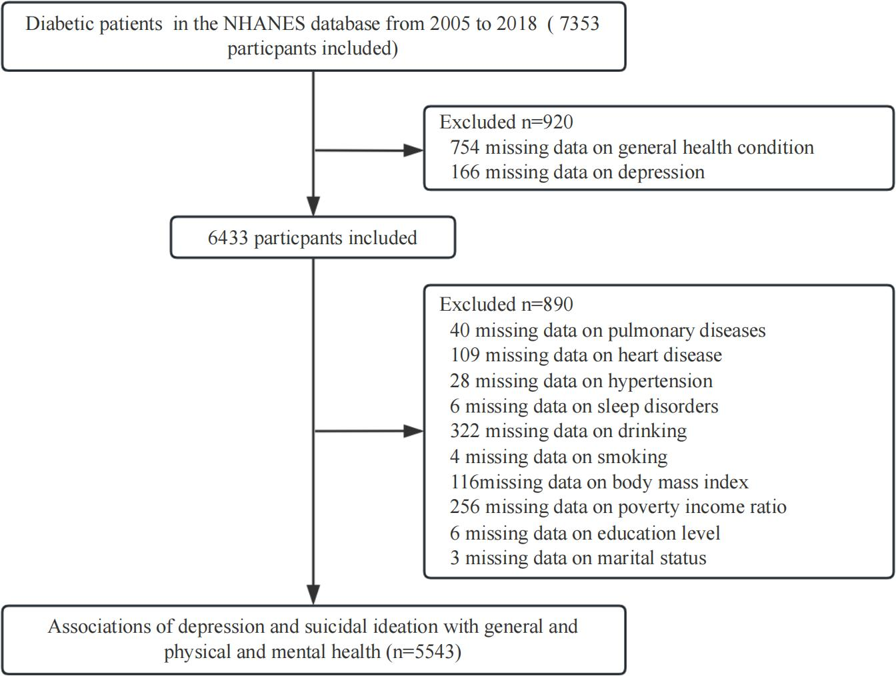
Supplementary Fig. 1 Flow diagram of the sample selection of the influence of comorbid depression and suicidal ideation on the general health status of diabetic patients.
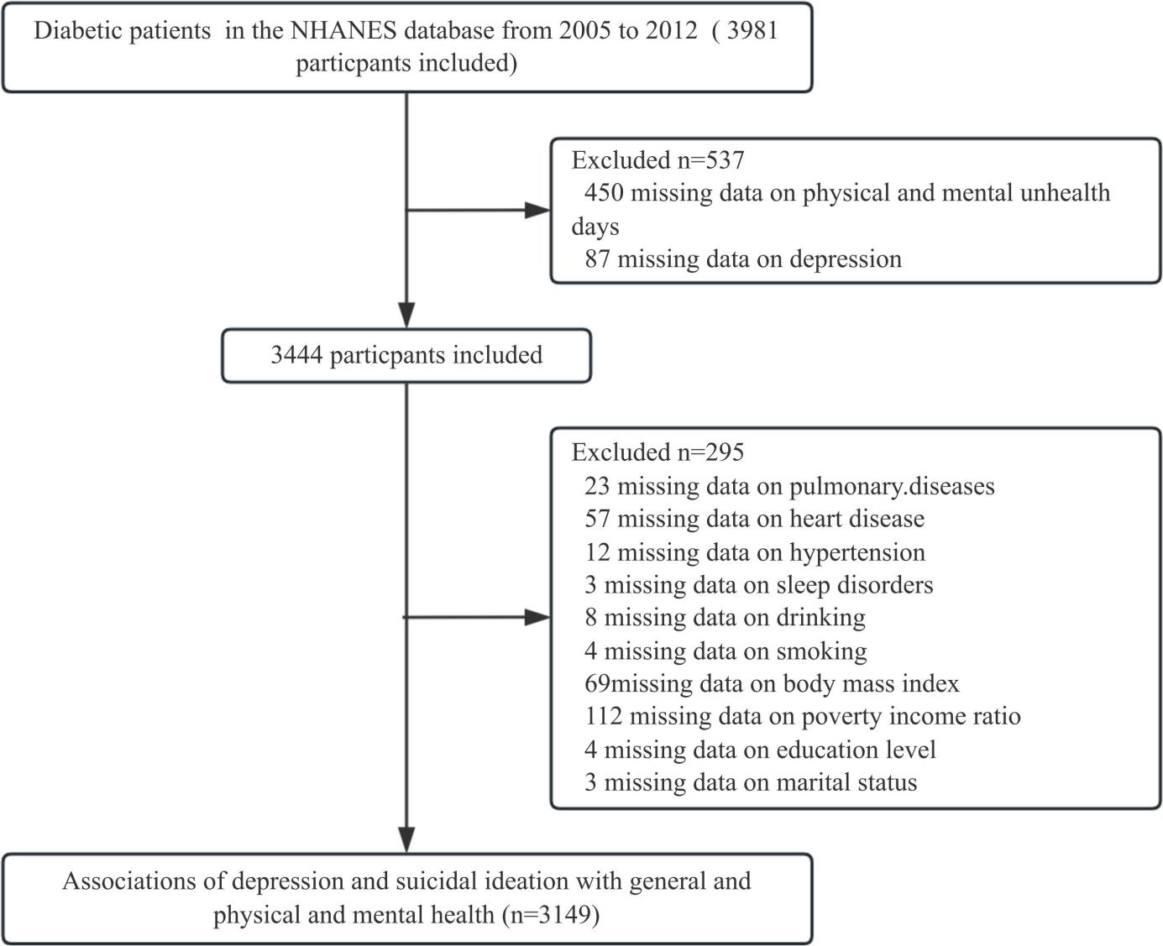
Supplementary Fig. 2 Flow diagram of the sample selection of the influence of comorbid depression and suicidal ideation on the physical and mental health status of diabetic patients.
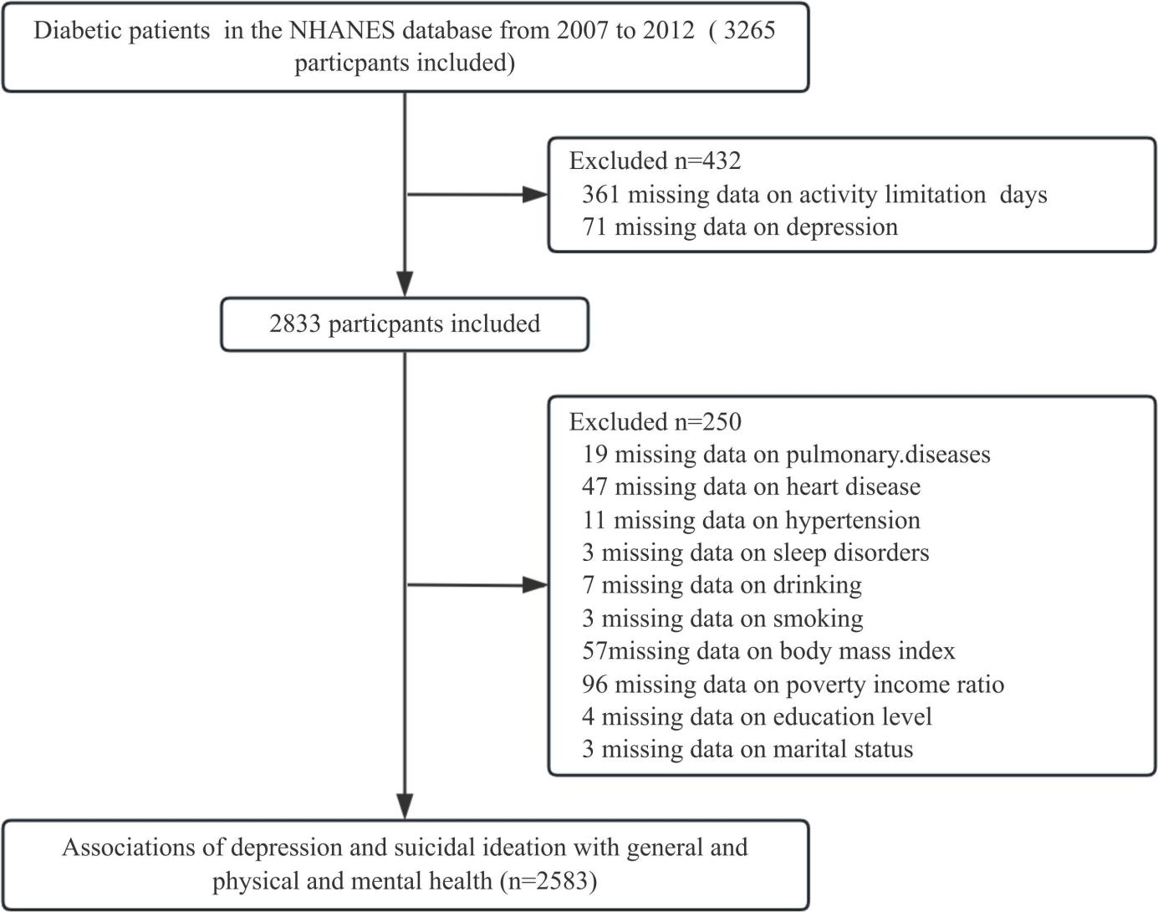
Supplementary Fig. 3 Flow diagram of the sample selection of the influence of comorbid depression and suicidal ideation on the activity limitation days of diabetic patients.
Supplementary table 1 Multivariate regression analysis of the association of depression and suicidal ideation with general health statuss among diabetic patients.
Variable | n.total | n.event_% | Model Ⅰª | P | Model Ⅱ^{b} | P | Model Ⅲ^{c} | P | Model Ⅳ^{d} | P
Variable | n.total | n.event_% | OR (95%CI) | P | OR (95%CI) | P | OR (95%CI) | P | OR (95%CI) | P
PHQ-9e score | 5543 | 469 (8.5) | 1.19 (1.17–1.21) | < 0.001 | 1.17 (1.15–1.19) | < 0.001 | 1.17 (1.15–1.19) | < 0.001 | 1.16 (1.14–1.18) | < 0.001
Depression symptoms
No | 4882 | 269 (5.5) | 1(Ref) |  | 1(Ref) |  | 1(Ref) |  | 1(Ref)
Yes | 661 | 200 (30.3) | 7.44 (6.05–9.15) | < 0.001 | 5.95 (4.77–7.43) | < 0.001 | 5.66 (4.52–7.08) | < 0.001 | 4.81 (3.82–6.06) | < 0.001
Severity of depression
No | 3874 | 147 (3.8) | 1(Ref) |  | 1(Ref) |  | 1(Ref) |  | 1(Ref)
Mild | 1008 | 122 (12.1) | 3.49 (2.72–4.49) | < 0.001 | 3.18 (2.46–4.12) | < 0.001 | 3.15 (2.43–4.08) | < 0.001 | 2.83 (2.18–3.69) | < 0.001
Moderate | 391 | 91 (23.3) | 7.69 (5.77–10.24) | < 0.001 | 6.44 (4.76–8.72) | < 0.001 | 6.17 (4.54–8.38) | < 0.001 | 5.25 (3.84–7.18) | < 0.001
Moderately severe to severe | 270 | 109 (40.4) | 17.16 (12.8–23.03) | < 0.001 | 13.46 (9.84–18.42) | < 0.001 | 12.66 (9.23–17.36) | < 0.001 | 10.53 (7.60–14.58) | < 0.001
Suicidal ideation
No | 5278 | 402 (7.6) | 1(Ref) |  | 1(Ref) |  | 1(Ref) |  | 1(Ref)
Yes | 265 | 67 (25.3) | 4.10 (3.06–5.51) | < 0.001 | 3.21 (2.35–4.38) | < 0.001 | 2.97 (2.17–4.06) | < 0.001 | 2.56 (1.85–3.54) | < 0.001
Notes: ªModel Ⅰ: no adjusted.
^{b}Model Ⅱ: adjusted for age + gender + race/ethnicity + marital status + education level + annual family income + body mass index + physical activity.
^{c}Model Ⅲ: Model Ⅱ+ smoking status + alcohol consumption.
^{d}Model Ⅳ: Model Ⅲ + hypertension + heart disease + pulmonary diseases + sleep disorders + hyperlipidemia.
^{e}PHQ-9: Patient Health Questionnaire-9.
Supplementary table 2 Multivariate regression analysis of the association of depression and suicidal ideation with physically unhealthy days among diabetic patients.
Variable | n.total | Model Ⅰª | P | Model Ⅱ^{b} | P | Model Ⅲ^{c} | P | Model Ⅳ^{d} | P
Variable | n.total | β (95%CI) | P | β (95%CI) | P | β (95%CI) | P | β (95%CI) | P
PHQ-9e score | 3149 | 0.83 (0.76–0.90) | < 0.001 | 0.80 (0.73–0.87) | < 0.001 | 0.78 (0.71–0.85) | < 0.001 | 0.74 (0.67–0.81) | < 0.001
Depression symptoms
No | 2774 | 0(Ref) |  | 0(Ref) |  | 0(Ref) |  | 0(Ref)
Yes | 375 | 10.27 (9.25–11.29) | < 0.001 | 9.53 (8.48–10.58) | < 0.001 | 9.23 (8.17–10.29) | < 0.001 | 8.60 (7.53–9.66) | < 0.001
Severity of depression
No | 2228 | 0(Ref) |  | 0(Ref) |  | 0(Ref) |  | 0(Ref)
Mild | 546 | 4.87 (4.00–5.73) | < 0.001 | 4.61 (3.73–5.49) | < 0.001 | 4.56 (3.68–5.43) | < 0.001 | 4.22 (3.34–5.10) | < 0.001
Moderate | 223 | 10.51 (9.23–11.78) | < 0.001 | 9.96 (8.65–11.26) | < 0.001 | 9.69 (8.38–11.01) | < 0.001 | 9.08 (7.77–10.40) | < 0.001
Moderately severe to severe | 152 | 12.29 (10.77–13.82) | < 0.001 | 11.73 (10.17–13.28) | < 0.001 | 11.42 (9.86–12.98) | < 0.001 | 10.81 (9.25–12.38) | < 0.001
Suicidal ideation
No | 2993 | 0(Ref) |  | 0(Ref) |  | 0(Ref) |  | 0(Ref)
Yes | 156 | 6.92 (5.32–8.51) | < 0.001 | 6.12 (4.54–7.70) | < 0.001 | 5.72 (4.13–7.30) | < 0.001 | 5.23 (3.66–6.80) | < 0.001
Notes: ªModel Ⅰ: no adjusted.
^{b}Model Ⅱ: adjusted for age + gender + race/ethnicity + marital status + education level + annual family income + body mass index + physical activity.
^{c}Model Ⅲ: Model Ⅱ+ smoking status + alcohol consumption.
^{d}Model Ⅳ: Model Ⅲ + hypertension + heart disease + pulmonary diseases + sleep disorders + hyperlipidemia.
^{e}PHQ-9: Patient Health Questionnaire-9.
Supplementary table 3 Multivariate regression analysis of the association of depression and suicidal ideation with mentally unhealthy days among diabetic patients.
Variable | n.total | Model Ⅰª | P | Model Ⅱ^{b} | P | Model Ⅲ^{c} | P | Model Ⅳ^{d} | P
Variable | n.total | β (95%CI) | P | β (95%CI) | P | β (95%CI) | P | β (95%CI) | P
PHQ-9e score | 3149 | 1.00 (0.95–1.05) | < 0.001 | 0.96 (0.91–1.02) | < 0.001 | 0.95 (0.90–1.01) | < 0.001 | 0.94 (0.89–1.00) | < 0.001
Depression symptoms
No | 2774 | 0(Ref) |  | 0(Ref) |  | 0(Ref) |  | 0(Ref)
Yes | 375 | 12.35 (11.53–13.18) | < 0.001 | 11.57 (10.72–12.41) | < 0.001 | 11.37 (10.52–12.22) | < 0.001 | 11.03 (10.17–11.9) | < 0.001
Severity of depression
No | 2228 | 0(Ref) |  | 0(Ref) |  | 0(Ref) |  | 0(Ref)
Mild | 546 | 4.89 (4.20–5.57) | < 0.001 | 4.51 (3.82–5.21) | < 0.001 | 4.48 (3.79–5.17) | < 0.001 | 4.37 (3.67–5.07) | < 0.001
Moderate | 223 | 10.58 (9.57–11.59) | < 0.001 | 10.03 (9.00–11.06) | < 0.001 | 9.83 (8.80–10.87) | < 0.001 | 9.62 (8.57–10.67) | < 0.001
Moderately severe to severe | 152 | 17.32 (16.12–18.53) | < 0.001 | 16.62 (15.40–17.85) | < 0.001 | 16.48 (15.25–17.71) | < 0.001 | 16.21 (14.96–17.46) | < 0.001
Suicidal ideation
No | 2993 | 0(Ref) |  | 0(Ref) |  | 0(Ref) |  | 0(Ref)
Yes | 156 | 10.26 (8.92–11.60) | < 0.001 | 9.38 (8.06–10.70) | < 0.001 | 9.12 (7.80–10.44) | < 0.001 | 8.74 (7.43–10.06) | < 0.001
Notes: ªModel Ⅰ: no adjusted.
^{b}Model Ⅱ: adjusted for age + gender + race/ethnicity + marital status + education level + annual family income + body mass index + physical activity.
^{c}Model Ⅲ: Model Ⅱ+ smoking status + alcohol consumption.
^{d}Model Ⅳ: Model Ⅲ + hypertension + heart disease + pulmonary diseases + sleep disorders + hyperlipidemia.
^{e}PHQ-9: Patient Health Questionnaire-9.
Supplementary table 4 Multivariate regression analysis of the association of depression and suicidal ideation with activity limitation days among diabetic patients.
Variable | n.total | Model Ⅰª | P | Model Ⅱ^{b} | P | Model Ⅲ^{c} | P | Model Ⅳ^{d} | P
Variable | n.total | β (95%CI) | P | β (95%CI) | P | β (95%CI) | P | β (95%CI) | P
PHQ-9e score | 2583 | 0.89 (0.82–0.97) | < 0.001 | 0.87 (0.79–0.95) | < 0.001 | 0.83 (0.75–0.91) | < 0.001 | 0.80 (0.72–0.89) | < 0.001
Depression symptoms
No | 2260 | 0(Ref) |  | 0(Ref) |  | 0(Ref) |  | 0(Ref)
Yes | 323 | 10.67 (9.53–11.81) | < 0.001 | 9.98 (8.82–11.15) | < 0.001 | 9.42 (8.25–10.58) | < 0.001 | 8.93 (7.74–10.11) | < 0.001
Severity of depression
No | 1800 | 0(Ref) |  | 0(Ref) |  | 0(Ref) |  | 0(Ref)
Mild | 460 | 4.85 (3.87–5.84) | < 0.001 | 4.73 (3.76–5.71) | < 0.001 | 4.64 (3.67–5.61) | < 0.001 | 4.41 (3.43–5.38) | < 0.001
Moderate | 184 | 9.64 (8.19–11.10) | < 0.001 | 9.11 (7.64–10.58) | < 0.001 | 8.58 (7.11–10.05) | < 0.001 | 8.14 (6.65–9.62) | < 0.001
Moderately severe to severe | 139 | 14.32 (12.67–15.97) | < 0.001 | 13.96 (12.30–15.62) | < 0.001 | 13.36 (11.7–15.02) | < 0.001 | 12.93 (11.24–14.61) | < 0.001
Suicidal ideation
No | 2453 | 0(Ref) |  | 0(Ref) |  | 0(Ref) |  | 0(Ref)
Yes | 130 | 7.91 (6.10–9.72) | < 0.001 | 7.15 (5.38–8.93) | < 0.001 | 6.48 (4.71–8.24) | < 0.001 | 6.01 (4.25–7.76) | < 0.001
Notes: ªModel Ⅰ: no adjusted.
^{b}Model Ⅱ: adjusted for age + gender + race/ethnicity + marital status + education level + annual family income + body mass index + physical activity.
^{c}Model Ⅲ: Model Ⅱ+ smoking status + alcohol consumption.
^{d}Model Ⅳ: Model Ⅲ + hypertension + heart disease + pulmonary diseases + sleep disorders + hyperlipidemia.
^{e}PHQ-9: Patient Health Questionnaire-9.
Supplementary table 5 Analysis of risk factors for health-related quality of life (HRQoL) in diabetic patients.
Variable | General health status |  | Physical unhealth days  per month |  | Mental unhealth days  per month |  | Activity limitation days  per month
Variable | OR (95%CI) | P_value | β (95%CI) | P_value | β (95%CI) | P_value | β (95%CI) | P_value
Education Level: ref. = Less than 9th grade
9–11th grade | 0.58 (0.42 ~ 0.79) | 0.001 | -1.44 (-2.56~-0.31) | 0.012 | 0.28 (-0.64 ~ 1.19) | 0.551 | 0.57 (-0.7 ~ 1.83) | 0.381
High school/GED | 0.46 (0.34 ~ 0.63) | < 0.001 | -1.87 (-2.96~-0.77) | 0.001 | -0.27 (-1.16 ~ 0.61) | 0.548 | -0.27 (-1.52 ~ 0.97) | 0.666
Some college or AA degree | 0.41 (0.30 ~ 0.57) | < 0.001 | -0.99 (-2.11 ~ 0.13) | 0.082 | 0.42 (-0.49 ~ 1.32) | 0.369 | 0.74 (-0.52 ~ 2.00) | 0.250
College graduate or above | 0.33 (0.21 ~ 0.53) | < 0.001 | -2.07 (-3.37~-0.77) | 0.002 | -0.67 (-1.73 ~ 0.38) | 0.212 | -0.41 (-1.88 ~ 1.05) | 0.579
Annual family income: ref. = Low
Middle | 0.82 (0.65 ~ 1.04) | 0.105 | -0.97 (-1.80~-0.15) | 0.021 | -0.72 (-1.39~-0.06) | 0.034 | -1.23 (-2.17~-0.29) | 0.010
High | 0.55 (0.40 ~ 0.76) | < 0.001 | -1.42 (-2.39~-0.45) | 0.004 | -1.15 (-1.93~-0.36) | 0.004 | -1.65 (-2.74~-0.56) | 0.003
Smoking status: ref. = Never
Former | 1.13 (0.87 ~ 1.46) | 0.355 | 0.58 (-0.2 ~ 1.36) | 0.146 | -0.02 (-0.65 ~ 0.62) | 0.962 | 0.18 (-0.7 ~ 1.06) | 0.691
Current | 1.30 (0.96 ~ 1.77) | 0.088 | 1.13 (0.13 ~ 2.13) | 0.027 | 1.12 (0.31 ~ 1.93) | 0.007 | 2.82 (1.69 ~ 3.94) | < 0.001
Alcohol consumption: ref. = Never
Former | 1.18 (0.86 ~ 1.61) | 0.300 | 0.85 (-0.17 ~ 1.87) | 0.103 | 0.18 (-0.65 ~ 1.01) | 0.671 | 0.84 (-0.31 ~ 1.99) | 0.153
Mild | 0.66 (0.47 ~ 0.94) | 0.021 | -0.04 (-1.10 ~ 1.02) | 0.943 | 0.12 (-0.74 ~ 0.98) | 0.781 | -0.66 (-1.85 ~ 0.53) | 0.278
Moderate | 0.70 (0.45 ~ 1.09) | 0.111 | 0.10 (-1.28 ~ 1.47) | 0.892 | 1.07 (-0.04 ~ 2.19) | 0.060 | -0.48 (-2.05 ~ 1.09) | 0.552
Heavy | 1.02 (0.69 ~ 1.51) | 0.930 | 0.32 (-1.00 ~ 1.64) | 0.631 | 0.51 (-0.56 ~ 1.58) | 0.351 | -0.24 (-1.71 ~ 1.24) | 0.755
Hypertension: Yes vs No | 1.53 (1.22 ~ 1.93) | < 0.001 | 0.36 (-0.34 ~ 1.06) | 0.316 | 0.35 (-0.21 ~ 0.92) | 0.220 | 0.90 (0.11 ~ 1.69) | 0.026
Heart disease: Yes vs No | 1.82 (1.43 ~ 2.33) | < 0.001 | 2.09 (1.22 ~ 2.95) | < 0.001 | -0.33 (-1.04 ~ 0.37) | 0.353 | 1.20 (0.21 ~ 2.19) | 0.018
Pulmonary diseases: Yes vs No | 1.81 (1.44 ~ 2.28) | < 0.001 | 2.38 (1.56 ~ 3.21) | < 0.001 | 0.55 (-0.12 ~ 1.22) | 0.107 | 1.37 (0.45 ~ 2.29) | 0.004
Sleep disorder: Yes vs No | 1.20 (0.94 ~ 1.54) | 0.137 | 0.58 (-0.43 ~ 1.59) | 0.260 | 1.82 (1.00 ~ 2.64) | < 0.001 | 0.79 (-0.35 ~ 1.93) | 0.176
Hyperlipidemia: Yes vs No | 1.16 (0.83 ~ 1.60) | 0.384 | -0.02 (-1.00 ~ 0.96) | 0.973 | -0.08 (-0.87 ~ 0.72) | 0.847 | -0.27 (-1.39 ~ 0.86) | 0.642
Notes: Each risk factor was adjusted for age, gender, race/ethnicity, marital status, education level, annual family income, body mass index, physical activity, smoking status, alcohol consumption, hypertension, heart disease, pulmonary diseases, sleep disorders, hyperlipidemia, and depression (including suicidal ideation) except the risk factor itself.
Supplementary table 6 Multivariate regression analysis (final model) of the association of depression and suicidal ideation with health-related quality of life (HRQoL) among diabetic patients (excluding patients with gestational diabetes).
Variable | General health conditions |  |  | Physically unhealthy days |  |  | Mentally unhealthy days |  |  | Activity limitation days
Variable | OR (95%CI) | P |  | β (95%CI) | P |  | β (95%CI) | P |  | β (95%CI) | P
PHQ-9e score | 1.15 (1.13–1.17) | < 0.001 |  | 0.74 (0.66–0.82) | < 0.001 |  | 0.96 (0.90–1.02) | < 0.001 |  | 0.81 (0.73–0.90) | < 0.001
Depression symptoms
No | 0(Ref) |  |  | 0(Ref) |  |  | 0(Ref) |  |  | 0(Ref)
Yes | 4.79 (3.77–6.10) | < 0.001 |  | 8.64 (7.53–9.76) | < 0.001 |  | 11.37 (10.48–12.26) | < 0.001 |  | 9.06 (7.81–10.32) | < 0.001
Severity of depression
No | 1(Ref) |  |  | 0(Ref) |  |  | 0(Ref) |  |  | 0(Ref)
Mild | 2.77 (2.11–3.63) | < 0.001 |  | 4.21 (3.31–5.12) | < 0.001 |  | 4.39 (3.69–5.10) | < 0.001 |  | 4.43 (3.41–5.44) | < 0.001
Moderate | 5.51 (3.99–7.59) | < 0.001 |  | 9.33 (7.96–10.71) | < 0.001 |  | 9.82 (8.75–10.89) | < 0.001 |  | 8.47 (6.91–10.03) | < 0.001
Moderately severe to severe | 9.65 (6.86–13.58) | < 0.001 |  | 10.53 (8.86–12.19) | < 0.001 |  | 16.85 (15.55–18.14) | < 0.001 |  | 12.85 (11.04–14.65) | < 0.001
Suicidal ideation
No | 1(Ref) |  |  | 0(Ref) |  |  | 0(Ref) |  |  | 0(Ref)
Yes | 2.38 (1.69–3.34) | < 0.001 |  | 5.18 (3.55–6.81) | < 0.001 |  | 8.87 (7.52–10.21) | < 0.001 |  | 5.71 (3.87–7.56) | < 0.001
Notes: ªModel Ⅰ: no adjusted.
^{b}Model Ⅱ: adjusted for age + gender + race/ethnicity + marital status + education level + annual family income + body mass index + physical activity.
^{c}Model Ⅲ: Model Ⅱ+ smoking status + alcohol consumption.
^{d}Model Ⅳ: Model Ⅲ + hypertension + heart disease + pulmonary diseases + sleep disorders + hyperlipidemia.
^{e}PHQ-9: Patient Health Questionnaire-9.
Supplementary table 7 Subgroup analysis and interaction analysis.
Subgroup | General health status |  | Physical unhealth days  per month |  | Mental unhealth days  per month |  | Activity limitation days  per month
Subgroup | OR_95CI | P for  interaction | β (95%CI) | P for  interaction | β (95%CI) | P for  interaction | β (95%CI) | P for  interaction
Age |  | 0.249 |  | 0.369 |  | 0.301 |  | 0.628
<50 | 1.63 (0.72 ~ 3.66) |  | 3.20 (0.02 ~ 6.38) |  | 10.04 (6.54 ~ 13.53) |  | 6.79 (3.20 ~ 10.38)
>=50 | 2.83 (1.97 ~ 4.05) |  | 5.36 (3.56 ~ 7.16) |  | 8.35 (6.94 ~ 9.76) |  | 5.68 (3.65 ~ 7.70)
Gender |  | 0.103 |  | 0.244 |  | 0.437 |  | 0.123
Male | 1.74 (0.96 ~ 3.16) |  | 6.43 (4.18 ~ 8.69) |  | 8.38 (6.64 ~ 10.13) |  | 7.97 (5.35 ~ 10.6)
Female | 3.07 (2.06 ~ 4.57) |  | 3.93 (1.72 ~ 6.15) |  | 8.85 (6.89 ~ 10.82) |  | 4.60 (2.21 ~ 6.98)
Education level |  | 0.558 |  | 0.098 |  | 0.496 |  | 0.366
<High school | 2.44 (1.66 ~ 3.58) |  | 5.99 (4.10 ~ 7.89) |  | 8.54 (6.95 ~ 10.14) |  | 5.58 (3.46 ~ 7.70)
>=High school | 2.78 (1.48 ~ 5.23) |  | 3.07 (0.17 ~ 5.97) |  | 9.02 (6.63 ~ 11.40) |  | 7.05 (3.80 ~ 10.30)
Income |  | 0.343 |  | 0.682 |  | 0.051 |  | 0.250
Low | 1.95 (1.20 ~ 3.19) |  | 5.27 (2.75 ~ 7.79) |  | 9.89 (7.67 ~ 12.12) |  | 4.33 (1.49 ~ 7.17)
Middle | 2.79 (1.68 ~ 4.64) |  | 4.18 (1.62 ~ 6.73) |  | 6.77 (4.66 ~ 8.88) |  | 7.63 (4.74 ~ 10.52)
High | 4.02 (1.64 ~ 9.89) |  | 5.34 (1.61 ~ 9.07) |  | 9.04 (6.09 ~ 11.98) |  | 6.64 (2.60 ~ 10.69)
Smoking |  | 0.116 |  | 0.267 |  | 0.627 |  | 0.365
Never | 4.07 (2.46 ~ 6.71) |  | 6.50 (4.15 ~ 8.86) |  | 8.10 (6.06 ~ 10.13) |  | 6.47 (3.82 ~ 9.12)
Former | 2.11 (1.15 ~ 3.89) |  | 5.68 (2.76 ~ 8.60) |  | 9.31 (7.15 ~ 11.47) |  | 7.48 (4.23 ~ 10.73)
Current | 2.09 (1.07 ~ 4.06) |  | 2.68 (-0.52 ~ 5.89) |  | 8.79 (5.77 ~ 11.81) |  | 3.61 (-0.08 ~ 7.30)
Drinking |  | 0.871 |  | 0.318 |  | 0.469 |  | 0.968
Never | 3.83 (1.69 ~ 8.71) |  | 5.39 (1.64 ~ 9.13) |  | 7.90 (4.74 ~ 11.07) |  | 6.66 (2.33 ~ 11.00)
Former | 2.84 (1.72 ~ 4.69) |  | 6.42 (3.74 ~ 9.09) |  | 9.43 (7.31 ~ 11.55) |  | 5.67 (2.55 ~ 8.79)
Current | 2.23 (1.30 ~ 3.83) |  | 3.91 (1.57 ~ 6.24) |  | 7.98 (5.94 ~ 10.02) |  | 6.12 (3.60 ~ 8.64)
Hypertension |  | 0.581 |  | 0.066 |  | 0.950 |  | 0.451
No | 2.54 (1.41 ~ 4.58) |  | 7.41 (4.86 ~ 9.97) |  | 8.62 (6.40 ~ 10.84) |  | 5.58 (2.80 ~ 8.37)
Yes | 2.49 (1.68 ~ 3.69) |  | 4.32 (2.31 ~ 6.33) |  | 8.65 (7.00 ~ 10.29) |  | 6.40 (4.09 ~ 8.70)
Heart disease |  | 0.183 |  | 0.308 |  | 0.922 |  | 0.242
No | 2.85 (1.93 ~ 4.20) |  | 5.82 (4.10 ~ 7.54) |  | 8.79 (7.29 ~ 10.30) |  | 6.82 (4.88 ~ 8.75)
Yes | 2.18 (1.19 ~ 3.99) |  | 2.87 (-0.97 ~ 6.72) |  | 8.41 (5.61 ~ 11.21) |  | 3.32 (-0.96 ~ 7.60)
Pulmonary diseases |  | 0.476 |  | 0.269 |  | 0.018 |  | 0.478
No | 2.81 (1.84 ~ 4.31) |  | 5.88 (4.06 ~ 7.70) |  | 9.74 (8.23 ~ 11.26) |  | 6.61 (4.53 ~ 8.70)
Yes | 2.35 (1.40 ~ 3.93) |  | 3.81 (0.62 ~ 7.00) |  | 6.46 (3.69 ~ 9.24) |  | 4.38 (0.93 ~ 7.83)
Sleep disorder |  | 0.767 |  | 0.155 |  | 0.271 |  | 0.750
No | 2.49 (1.65 ~ 3.78) |  | 5.70 (3.97 ~ 7.43) |  | 9.20 (7.80 ~ 10.61) |  | 5.88 (3.98 ~ 7.78)
Yes | 2.83 (1.66 ~ 4.85) |  | 3.94 (0.03 ~ 7.85) |  | 7.46 (3.73 ~ 11.19) |  | 6.73 (1.83 ~ 11.63)
Hyperlipidemia |  | 0.362 |  | 0.097 |  | 0.584 |  | 0.041
No | 1.37 (0.47 ~ 3.96) |  | 1.88 (-2.27 ~ 6.03) |  | 9.18 (5.44 ~ 12.92) |  | 1.56 (-3.43 ~ 6.55)
Yes | 2.74 (1.94 ~ 3.87) |  | 5.85 (4.15 ~ 7.54) |  | 8.86 (7.45 ~ 10.26) |  | 6.69 (4.80 ~ 8.57)

