Table S1. Definitions of macrovascular complications and the associated data source.
macrovascular complications | ICD-10
stroke | I64
AP | I20
HF | I50

Table S2. Diet component definitions used in the UK Biobank study
Source and definition of healthy diet | Self-reported UK Biobank field code
UK Biobank Food Frequency  Questionnaire at baseline;  1. Fruits: ≥ 3 servings/day  2. Vegetables: ≥ 3 servings/day  3. Fish: ≥2 servings/week  4. Processed meats: ≤1 serving/week  5. Unprocessed red meats: ≤ 1.5 servings/week  6. Whole grains: ≥ 3servings/day  7. Refined grains: ≤1.5 servings/day | 1309, 1319, 1289, 1299, 1329, 1339, 1349, 1369, 1379, 1389, 1438, 1448, 1458, 1468

Table S3. Association of coffee and tea with stroke, AP and HF in the UK Biobank cohort (unadjusted models)

Groups |  | Stroke |  |  | AP |  |  | HF
 |  | HR (95% CI) | P value |  | HR (95% CI) | P value |  | HR (95% CI) | P value
Coffee (cups/d)
0 |  | 1.000 (Ref) |  |  | 1.000 (Ref) |  |  | 1.000 (Ref)
0.5-1 |  | 0.630 (0.491-0.808) | <0.001 |  | 0.818 (0.722-0.927) | 0.002 |  | 0.871 (0.758-1.000) | 0.051
2-4 |  | 0.764 (0.616-0.948) | 0.014 |  | 0.811 (0.723-0.909) | <0.001 |  | 0.899 (0.792-1.020) | 0.099
≥5 |  | 0.855 (0.644-1.33) | 0.275 |  | 0.983 (0.850-1.136) | 0.815 |  | 1.040 (0.885-1.222) | 0.634
Tea (cups/d)
0 |  | 1.000 (Ref) |  |  | 1.000 (Ref) |  |  | 1.00 (Ref)
0.5-1 |  | 0.744 (0.543-1.020) | 0.066 |  | 0.862 (0.731-1.017) | 0.078 |  | 0.682 (0.565-0.823) | <0.001
2-4 |  | 0.702 (0.556-0.885) | 0.003 |  | 0.918 (0.813-1.037) | 0.170 |  | 0.860 (0.755-0.979) | 0.023
≥5 |  | 0.886 (0.697-1.126) | 0.323 |  | 0.997 (0.877-1.135) | 0.967 |  | 0.908 (0.790-1.044) | 0.175
Coffee (cups/d) | Tea (cups/d)
0 | 0 | 1.000 (Ref) |  |  | 1.000 (Ref) |  |  | 1.000 (Ref)
0 | 0.5-1 | 0.755 (0.293-1.946) | 0.561 |  | 1.011 (0.623-1.639) | 0.965 |  | 0.876 (0.534-1.438) | 0.601
0 | 2-4 | 0.944 (0.529-1.686) | 0.846 |  | 1.198 (0.873-1.645) | 0.262 |  | 0.906 (0.656-1.250) | 0.547
0 | ≥5 | 1.345 (0.774-2.339) | 0.293 |  | 1.327 (0.974-1.810) | 0.073 |  | 0.907 (0.661-1.246) | 0.547
0.5-1 | 0 | 0.780 (0.330-1.846) | 0.573 |  | 0.846 (0.528-1.356) | 0.487 |  | 0.905 (0.572-1.433) | 0.671
0.5-1 | 0.5-1 | 0.694 (0.312-1.546) | 0.372 |  | 0.865 (0.568-1.316) | 0.498 |  | 0.572 (0.325-0.853) | 0.009
0.5-1 | 2-4 | 0.700 (0.394-1.242) | 0.222 |  | 1.035 (0.759-1.410) | 0.829 |  | 0.844 (0.618-1.153) | 0.287
0.5-1 | ≥5 | 0.657 (0.360-1.197) | 0.170 |  | 1.016 (0.738-1.398) | 0.924 |  | 0.793 (0.573-1.097) | 0.161
2-4 | 0 | 1.132 (0.639-2.007) | 0.670 |  | 1.037 (0.751-1.432) | 0.825 |  | 0.984 (0.714-1.356) | 0.921
2-4 | 0.5-1 | 0.879 (0.473-1.634) | 0.684 |  | 0.919 (0.652-1.295) | 0.630 |  | 0.633 (0.441-0.910) | 0.014
2-4 | 2-4 | 0.743 (0.427-1.294) | 0.294 |  | 0.972 (0.718-1.317) | 0.857 |  | 0.778 (0.573-1.055) | 0.107
2-4 | ≥5 | 0.793 (0.429-1.464) | 0.458 |  | 1.030 (0.740-1.432) | 0.863 |  | 0.926 (0.664-1.290) | 0.649
≥5 | 0 | 1.155 (0.637-2.096) | 0.635 |  | 1.397 (1.009-1.934) | 0.044 |  | 0.971 (0.693-1.361) | 0.863
≥5 | 0.5-1 | 0.805 (0.377-1.720) | 0.575 |  | 1.166 (0.793-1.714) | 0.436 |  | 0.748 (0.489-1.143) | 0.179
≥5 | 2-4 | 0.594 (0.267-1.323) | 0.203 |  | 0.943 (0.636-1.399) | 0.772 |  | 0.986 (0.669-1.451) | 0.942
≥5 | ≥5 | 1.099 (0.505-2.393) | 0.812 |  | 0.976 (0.624-1.527) | 0.916 |  | 1.122 (0.729-1.725) | 0.601
Abbreviations:AP, angina pectoris; HF, heart failure; CI, confidence interval; HR, hazard ratio; UK Biobank, United Kingdom Biobank.

Table S4. Risk of developing macrovascular complications according to coffee type in the UK Biobank

Coffee types | stroke |  |  | AP |  |  | HF
Coffee types | HR (95% CI) | P value |  | HR (95% CI) | P value |  | HR (95% CI) | P value
Ground coffee vs  instant coffee | 1.294(0.989-1.693) | 0.060 |  | 0.961(0.831-1.111) | 0.592 |  | 1.026 (0.879-1.198) | 0.743
Instant coffee  vs decaffeinated coffee | 1.086(0.811-1.454) | 0.582 |  | 0.871(0.763-0.994) | 0.041 |  | 1.019 (0.876-1.185) | 0.806
Ground coffee  vs decaffeinated coffee | 0.700(0.491-0.999) | 0.049 |  | 1.173(0.984-1.398) | 0.074 |  | 0.939 (0.774-1.141) | 0.528
Multivariable model is adjusted for age, ethnicity, qualification, income, BMI, smoking status, alcohol status, physical activity, diet pattern , HDL, LDL, hypertension and tea intake. Abbreviations: AP, angina pectoris; HF, heart failure; CI, confidence interval; HR, hazard ratio; UK Biobank, United Kingdom Biobank; BMI, body mass index; HDL, high-density lipoprotein; LDL, low-density lipoprotein.

Table S5. Effect of coffee versus tea consumption on incident macrovascular disease in patients with type 2 diabetes mellitus, with exclusion of cases occurring within the first two years of follow-up

Groups |  | stroke | AP | HF
Coffee (cups/d)
0 |  | 1.000 (Ref) | 1.000 (Ref) | 1.000 (Ref)
0.5-1 |  | 0.683(0.525-0.890) | 0.862(0.754-0.986) | 0.880(0.761-1.017)
2-4 |  | 0.810(0.642-1.020) | 0.808(0.714-0.915) | 0.880(0.771-1.006)
≥5 |  | 0.832(0.612-1.130) | 0.980(0.839-1.145) | 0.969(0.817-1.149)
P-value for trend |  | 0.043 | 0.003 | 0.183
Tea (cups/d)
0 |  | 1.000 (Ref) | 1.000 (Ref) | 1.000 (Ref)
0.5-1 |  | 0.754(0.540-1.054) | 0.909(0.761-1.085) | 0.706(0.579-0.862)
2-4 |  | 0.629(0.492-0.805) | 0.907(0.795-1.034) | 0.836(0.729-0.959)
≥5 |  | 0.822(0.639-1.059) | 1.002(0.873-1.151) | 0.901(0.779-1.042
P-value for trend |  | 0.003 | 0.244 | 0.004
Coffee (cups/d) | Tea (cups/d)
0 | 0 | 1.000 (Ref) | 1.000 (Ref) | 1.000 (Ref)
0 | 0.5-1 | 0.479(0.173-1.326) | 0.860(0.520-1.422) | 0.713(0.427-1.192)
0 | 2-4 | 0.607(0.335-1.102) | 0.892(0.641-1.241) | 0.682(0.491-0.946)
0 | ≥5 | 0.956(0.544-1.678) | 1.066(0.773-1.470) | 0.701(0.508-0.968)
0.5-1 | 0 | 0.7430(0.314-1.757) | 0.716(0.433-1.182) | 0.762(0.473-1.227)
0.5-1 | 0.5-1 | 0.613(0.267-1.407) | 0.735(0.467-1.156) | 0.429(0.257-0.717)
0.5-1 | 2-4 | 0.516(0.287-0.930) | 0.830(0.601-1.146) | 0.647(0.471-0.889)
0.5-1 | ≥5 | 0.526(0.285-0.970) | 0.917(0.659-1.276) | 0.641(0.461-0.893)
2-4 | 0 | 0.905(0.506-1.619) | 0.792(0.564-1.110)
2-4 | 0.5-1 | 0.728(0.385-1.378) | 0.815(0.569-1.165) | 0.747(0.538-1.036)
2-4 | 2-4 | 0.526(0.298-0.929) | 0.805(0.587-1.104) | 0.533(0.368-0.774)
2-4 | ≥5 | 0.552(0.294-1.037) | 0.766(0.541-1.085) | 0.585(0.428-0.799)
≥5 | 0 | 0.754(0.405-1.401) | 1.116(0.796-1.565) | 0.704(0.502-0.987)
≥5 | 0.5-1 | 0.574(0.257-1.284) | 0.945(0.629-1.420) | 0.556(0.357-0.867)
≥5 | 2-4 | 0.463(0.207-1.036) | 0.816(0.543-1.227) | 0.782(0.528-1.159)
≥5 | ≥5 | 0.766(0.343-1.714) | 0.816(0.543-1.227) | 0.760(0.483-1.194)
P-value for trend |  | 0.016 | 0.034 | 0.041
Abbreviations:AP, angina pectoris; HF, heart failure; Multivariable model is adjusted for age, ethnicity, qualification, income, BMI, smoking status, alcohol status, physical activity, diet pattern , HDL, LDL, hypertension and we adjusted for coffee in tea analysis or for tea in coffee analysis. Abbreviations: CI, confidence interval; HR, hazard ratio; UK Biobank, United Kingdom Biobank; BMI, body mass index; HDL, high-density lipoprotein; LDL, low-density lipoprotein.

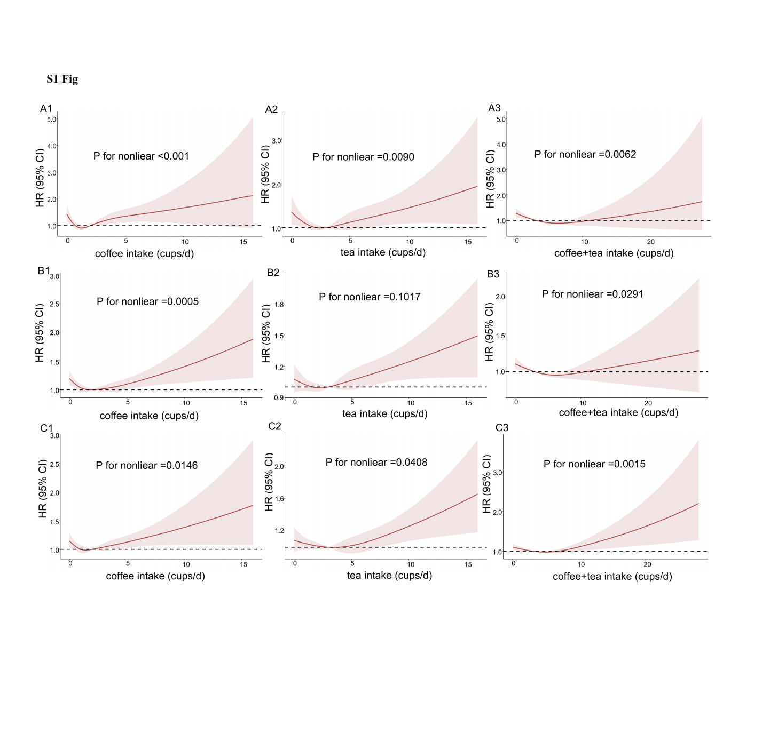
Figure S1 . Unadjusted Restricted Cubic Spline models for the relationship between coffee, tea, and their combination with stroke, AP, and HF. (A1) Coffee and stroke; (A2) Tea and stroke; (A3) Combination of coffee and tea on stroke; (B1) Coffee and AP; (B2) Tea and AP; (B3) Combination of coffee and tea on AP; (C1) Coffee and HF; (C2) Tea and HF; (C3) Combination of coffee and tea on HF. The 95% CIs of the adjusted HR are represented by the shaded area. AP, angina pectoris; HF, heart failure.

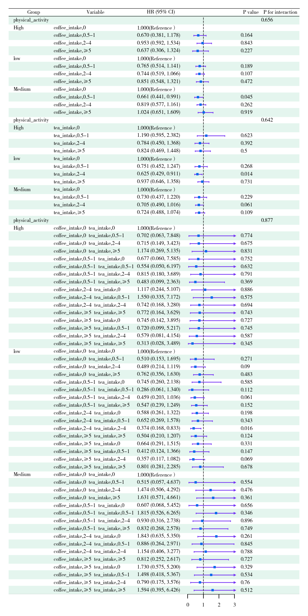
Figure S2 . Association of coffee and tea with stroke in the UK Biobank cohort by physical activity. Multivariable model is adjusted for age, sex, ethnicity, qualification, income, BMI, smoking status, alcohol status, diet pattern , HDL, LDL, hypertension and we adjusted for coffee in tea analysis or for tea in coffee analysis. Abbreviations: CI, confidence interval; HR, hazard ratio; UK Biobank, United Kingdom Biobank; BMI, body mass index; HDL, high-density lipoprotein; LDL, low-density lipoprotein.
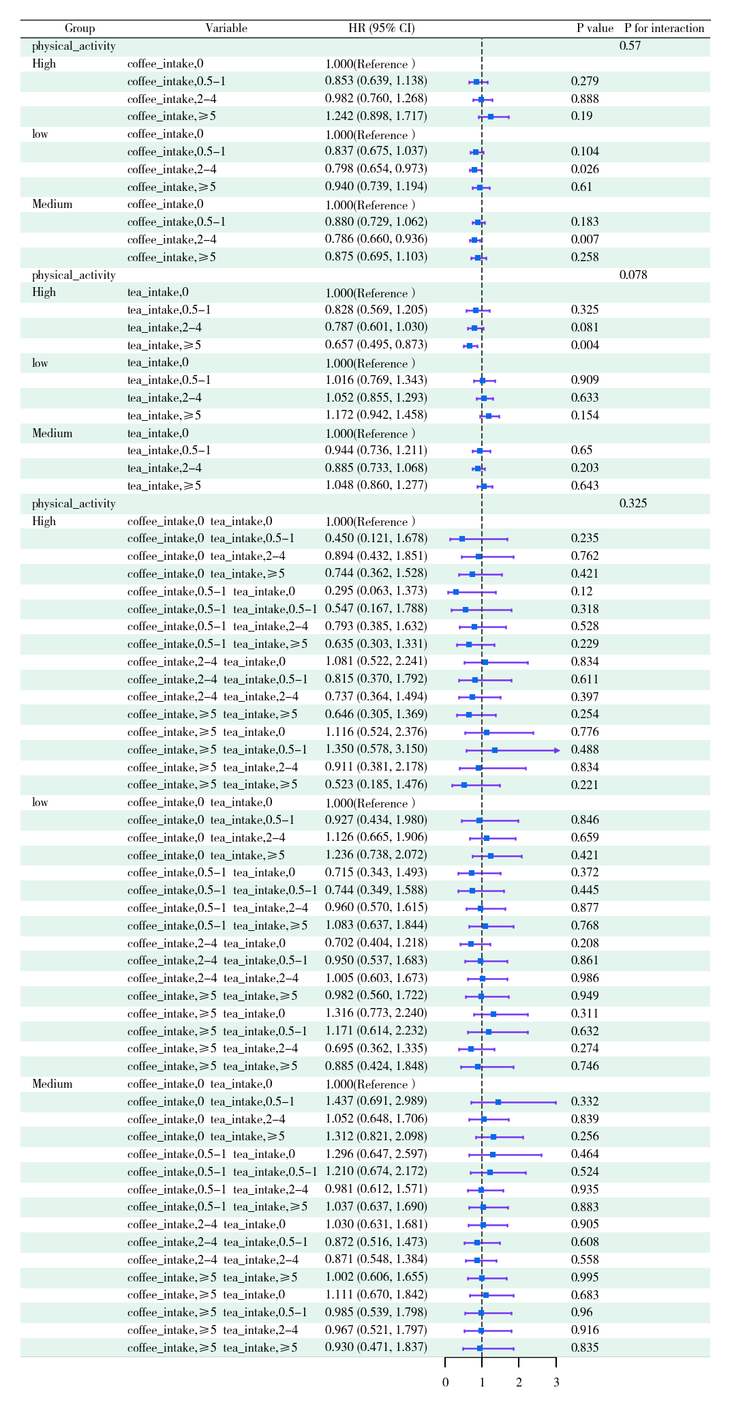
Figure S3 . Association of coffee and tea with AP in the UK Biobank cohort by Physical activity. Multivariable model is adjusted for age, sex, ethnicity, qualification, income, BMI, smoking status, alcohol status, diet pattern , HDL, LDL, hypertension and we adjusted for coffee in tea analysis or for tea in coffee analysis. Abbreviations: CI, confidence interval; HR, hazard ratio; UK Biobank, United Kingdom Biobank; BMI, body mass index; HDL, high-density lipoprotein; LDL, low-density lipoprotein.

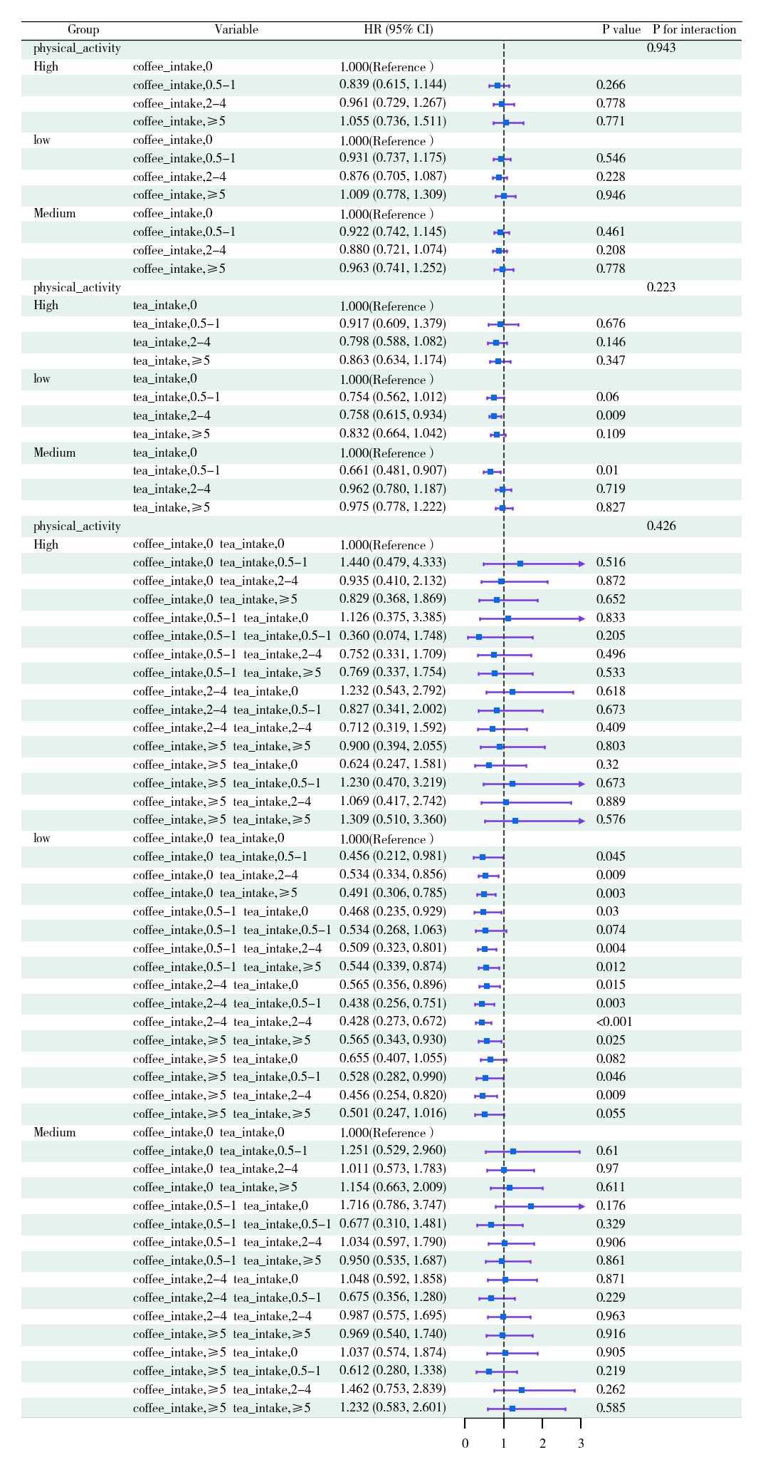
Figure S4 . Association of coffee and tea with HF in the UK Biobank cohort by Physical activity. Multivariable model is adjusted for age, sex, ethnicity, qualification, income, BMI, smoking status, alcohol status, diet pattern , HDL, LDL, hypertension and we adjusted for coffee in tea analysis or for tea in coffee analysis. Abbreviations: CI, confidence interval; HR, hazard ratio; UK Biobank, United Kingdom Biobank; BMI, body mass index; HDL, high-density lipoprotein; LDL, low-density lipoprotein.
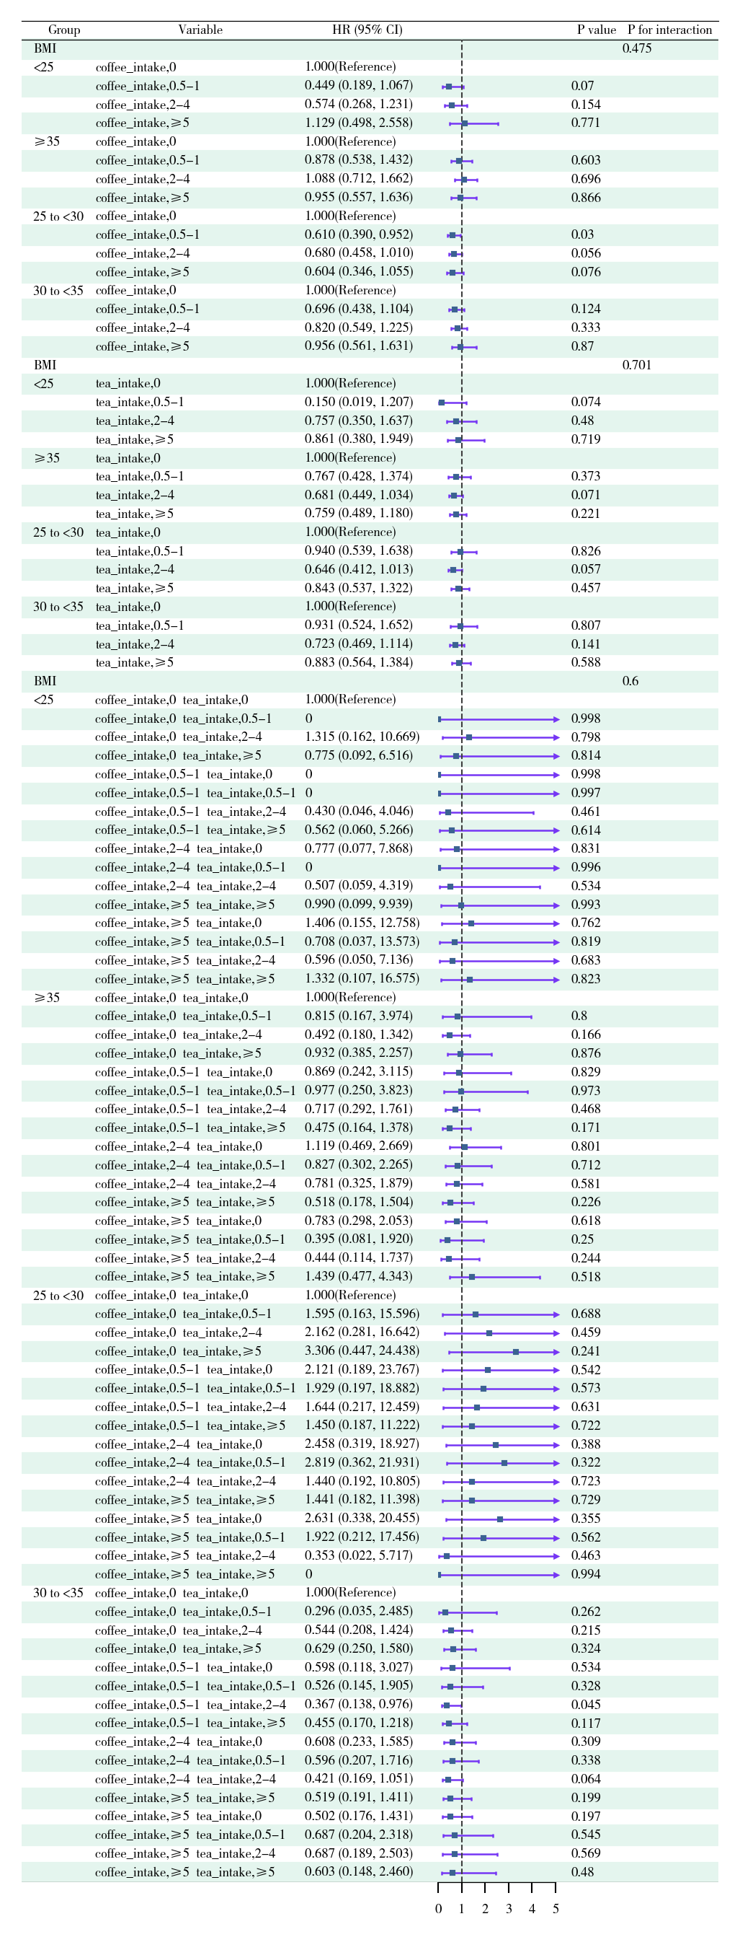
Figure S5 . Association of coffee and tea with stroke in the UK Biobank cohort by BMI. Multivariable model is adjusted for age, sex, ethnicity, qualification, income, Physical activity, smoking status, alcohol status, diet pattern , HDL, LDL, hypertension and we adjusted for coffee in tea analysis or for tea in coffee analysis. Abbreviations: CI, confidence interval; HR, hazard ratio; UK Biobank, United Kingdom Biobank; BMI, body mass index; HDL, high-density lipoprotein; LDL, low-density lipoprotein.
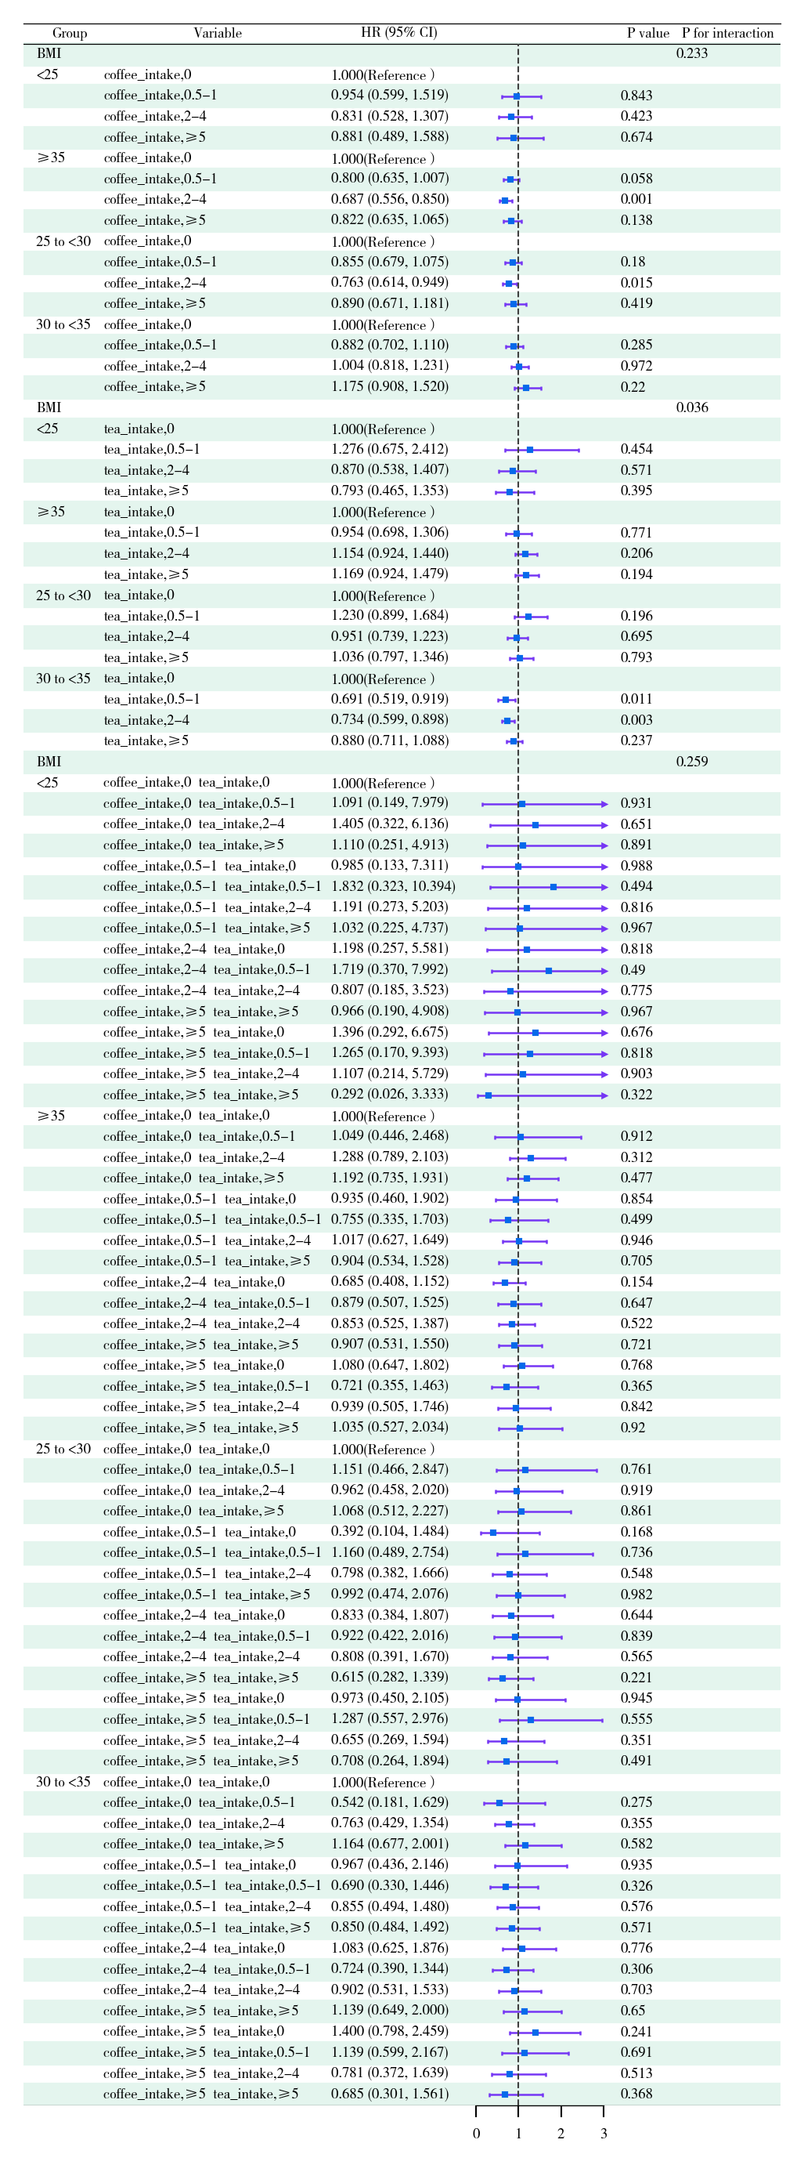
Figure S6 . Association of coffee and tea with AP in the UK Biobank cohort by BMI. Multivariable model is adjusted for age, sex, ethnicity, qualification, income, Physical activity, smoking status, alcohol status, diet pattern , HDL, LDL, hypertension and we adjusted for coffee in tea analysis or for tea in coffee analysis. Abbreviations: CI, confidence interval; HR, hazard ratio; UK Biobank, United Kingdom Biobank; BMI, body mass index; HDL, high-density lipoprotein; LDL, low-density lipoprotein.
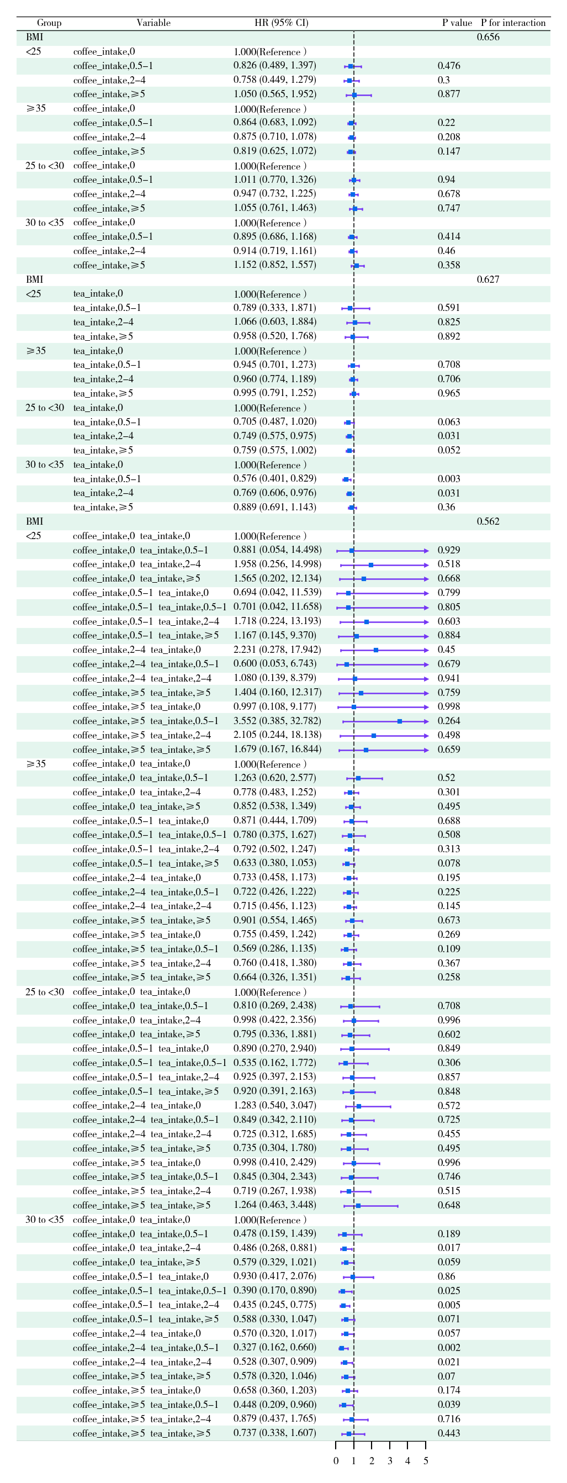
Figure S7 . Association of coffee and tea with HF in the UK Biobank cohort by BMI. Multivariable model is adjusted for age, sex, ethnicity, qualification, income, Physical activity, smoking status, alcohol status, diet pattern , HDL, LDL, hypertension and we adjusted for coffee in tea analysis or for tea in coffee analysis. Abbreviations: CI, confidence interval; HR, hazard ratio; UK Biobank, United Kingdom Biobank; BMI, body mass index; HDL, high-density lipoprotein; LDL, low-density lipoprotein.

