Exercise training and inflammatory adipokines in patients with type 2 diabetes: A systematic review, meta-analysis, and meta-regression
Supplementary Materials

Contents
1.Table 1. PRISMA 2020 Checklist 7
2. Literature search strategy 10
3.Table 2. The study that was excluded after reading the full text and its related reasons 13
4.Table 3: effect of exercise training on different adipokines in T2DM pateints………………..17
5.Table4: Meta regression analysis from changes in adipokines and changes in anthropometrical and clinical outcomes (BMI, fasting glucose, Insulin, and HOMA-IR)………………………………………………………………...17
6. Table 5. General characteristics of included study for Resistin…………………………….....17
7.Table 6. General characteristics of included study for apelin……………………………….....19
8.Table 7. General characteristics of included study for Visfatin……………………………..…21
9.Table 8. General characteristics of included study for Vaspin……………………………....…23
10.Overall adipokines meta-analysis output………………………………………………….......25
11.Table.10-1.Overall adipokines meta -analysis method…………………………………..…....25
12. Figure .10-1.Overall adipokines.Funnel plot……………………………………………..…..25
13.Table .10-2.Overall adipokines .Risk of bias summary…………………………………….…27
14. Figure .10-2.Overall adipokines.Risk of bias graph……………………………………..…...27
15. Table .10-3.Overall adipokines egger bias test…………………………………………………27
16.Figure .10-3.Overall adipokines meta analysis forest plot……………………………….……...29
17.Figure .10-4.Overall adipokines subgroups meta-analysis forest plot……………………….….29
18.Figure .10-5.Overall adipokines type of training subgroup meta-analysis forest plot……….….30
19.Figure .10-6.Overall adipokines length of training period subgroup meta-analysis fores plot….31
20.Figure .10-7.Overall adiopokines gender subgroup meta-analysis output.forest plot………...…32
21.Table .10-4.Overall adipokines subgroups hetrogenity output……………….………………….33
22.Table.10-5.Overall adipokines subgroups meta-analysis output………………………………...33
23.Figure .10-8.Overall adipokines sensitivity analysis forest plot…………..……………………..34
24.Table .10-6.Overall adipokines sensetivity meta-analysis output……………………….…..…..35
25.Table .10-7.Overall meta-regresssion delta BMI output……………………………………..….36
26.Figure .10-9.Overall delta BMI meta-regression. graph……………………………………..….36
27.Table .10-8.Overall meta-regression delta glucose output…………………………………...….36
28.Figure .10-10.Overall meta-regression delta glucose. graph…………………………………….37
29.Table .10-9.Overall meta-regression delta insulin output…………………………………..……37
30.Figure .10-11.Over all meta-regression delta insulin graph………………………………..…….38
31.Table .1-10.Overall meta regression homair output……………………………………………..38
32.Figure .10-12 .Overall meta-regression delta homa-ir graph…………………………………….39
33.20.Apelin meta-analysis and meta-regression output………………………………………….…40
34.Table .20-1.Apelin meta -analysis method………………………………………………………..40
35.Figure.20-1.Apelin funnel plot .publication bias…………………………………………...….…40
36.Table .20-2.Apelin Risk of bias summary…………………………………………………….….41
37.Figure .20-2. Apelin Risk of bias graph……………………………………………………….…42
38.Table .20-3.Apelin egger test output………………………………………………………....…..42
39.Figure .20-3. Apelin overall meta-analysis and hetrogenity forest plot…………………….…....43
40.Figure .20-4.Apelin type of training subgroup analysis forest plot…………………………...…44
41.Figure .20-5. Apelin length of intervention subgroup analysis forest plot…………………....…45
42.Figure .20-6. Apelin gender subgroup analysis forest plot…………………………………..…..46
43.Figure .20-7. Apelin sensetivity analysis forest plot…………………………………….....…….47
44.Table .20-4. Apelin sensetivity analysis……………………………………………………...….48
45.Table .20-5. Apelin meta -regression delta BMI output……………………………………..…...48
46.Figure .20-8.Apelin meta- regression delta BMI. graph……………………………………….….49
47.Table .20-6.Apelin meta -regression delta glucose output…………………………………….….49
48.Figure .20-9.Apelin meta regression delta glucose graph…………………………………..…….50
49.Table .20-7. Apelin meta -regression delta insulin output…………………………………..…...50
50.Figure .20-10. Apelin meta -regression delta insulin graph………………………………..….…51
51.Table .20-8.Apelin meta -regression delta HOMA-IR output……………………………..……..51
52.Figure .20-11. Apelin meta -regression delta HOMA-IR graph…………………………………52
53.30.Resistin meta- analysis and meta-regression output…………………………………………...53
54.Table .30-1.Resistin meta -analysis method……………………………………………………....53
55.Figure .30-1.Resistin funnel plot.graph…………………………………………………………..…..53
56.Table .30-2 .resistin Risk of bias summary……………………………………………………....….54
57.Figure .30-2.Resistin new Risk of bias graph…………………………………………………….......55
58.Table .30-3.Resistin .egger test output .bias test………………………………………………..……55
59.Figure .30-3.Resistin overall and hetrogenity Forest plot………………………………………...…56
60.Figure .30-4.Resistin type of training subgroup analysis. Forest plot………………………….....…57
61.Figure .30-5.Resistin length of training subgroup analysis.Forest plot………………………………58
62.Figure .30-6. Resistin gender subgroup analysis. Forest plot……………………………………..….59
63.Figure .30-7.Resistin sentitivity analysis .graph…………………………………………………..…60
64.Table .30-4 .Resistin sentitivity analysis…………………………………………………………..…61
65.Table .30-5 .Resistin meta- regression delta BMI output………………………………………….…61
66.Figure .30-8. Resistin meta- regression delta BMI .graph…………………………………………....62
67.Table .30-6. Resistin meta -regression delta glucose output…………………………………….…....62
68.Figure .30-9. Resistin meta- regression delta glucose output .graph……………………………....….63
69.Table .30-7 .Resistin meta- regression delta insulin output…………………………………….…..…63
70.Figure .30-10. Resistin meta -regression delta insulin output. graph……………………………...….64
71.Table .30-8. Resistin meta -regression delta HOMA-IR output………………………………………64
72.Figure .30-11. Resistin meta- regression delta HOMA-IR output.graph…………………………...…65
73.40.Visfatin meta -analysis and meta - regression output…………………………………………..….66
74.Table .40-1.Visfatin meta analysis method…………………………………………………………...66
75.Figure .40-1.Visfatin funnel plot.graph…………………………………………………………….….66
76.Table .40-2.Visfatin Risk of bias summary……………………………………………………...….…67
77.Figure .40-2.Visfatin Risk of bias graph………………………………………………………….…....68
78.Table .40-3.visfatin egger test …………………………………………………………………………68
79.Figure .40-3.Visfatin Overall and hetrogenity .Forest plot………………………………………...…..69
80.Figure .40-4.Visfatin Type of training subgroup analysis visfatin.Forest plot………………………...70
81.Figure .40-5.Visfatin. Length of intervention period subgroup analysis visfatin.Forest plot……….…71
82.Figure .40-6.Visfatin.gender subgroup analysis visfatin.Forest plot………………………………..…72
83.Figure .40-7.Visfatin sensetivity analysis .graph…………………………………………………...….73
84.Table .40-4.Visfatin sensetivity analysis ………………………………………………………………74
85.Table .40-5.Visfatin metaregression deltaBMI output…………………………………………………74
86.Figure .40-8.Visfatin metaregression delta BMI.graph……………………………………………...…75
87.Table .40-6.Visfatin meta regression delta glucose output………………………………………….…75
88.Figure .40-9.Visfatin meta regression delta glucose output.graph…………………………………..…76
89.Table .40-7.Visfatin meta regression delta insulin output…………………………………………...…76
90.Figure .40-10.Visfatin meta regression delta glucose output…………………………………………..77
91.Table .40-8.Visfatin meta regression delta HOMA-IR output………………………………………....77
92.Figure .40-11.Visfatin meta regression delta HOMA-IR output……………………………………....78
93.50.Vaspin meta -analysis and meta -regression output……………………………………………...…79
94.Table .50-1.Vaspin meta analysis method……………………………………………………………..79
95.Figure .50-1.Vaspin funnel plot .graph…………………………………………………………….….79
96.Table .50-2.Vaspin Risk of bias summary………………………………………………………….…80
97.Figure .50-2.Vaspin. Risk of bias graph ……………………………………………………………....81
98.Table .50-3.Vaspin egger test bias output………………………………………………………….….81
99.Figure .50-3. Vaspin overall metaanalysis and hetrogenity .Forest plot………………………………81
100.Figure .50-4.Vaspin type of training subgroup.Forest plot……………………………………..……82
101.Figure .50-5.Vaspin length of intervention period subgroup.Forest plot……………………………83
102.Figure .50-6.Vaspin gender subgroup analysis.Forest plot………………………………………..…84
103.Figure .50-7.vaspin sensetivity analysis.graph…………………………………………………….…85
104.Table .50-4.Vaspin sensetivity analysis………………………………………………………….…..86
105.Table .50-5.Vaspin metaregression deltaBMI output……………………………………………..…86
106.Figure .50-8.Vaspin metaregression deltaBMI.graph………………………………………….….…86
107.Table .50-6.Vaspin delta glucose meta regression output…………………………………….…...…87
108.Figure .50-9.Vaspin delta glucose meta regression graph…………………………………….…...…87
109.Table .50-7.Vaspin delta insulin meta regression insulin output……………………………….….…88
110.Figure .50-10.Vaspin delta insulin meta regression graph………………………………………..…..88
111.Table .50-8.Vaspin delta HOMA-IR meta regression output………………………………….….. …88
112.Figure .50-11.Vaspin delta homa-ir metaregression graph………………………………………....…89

Table 1.Prisma 2020 checklist
Section and Topic | Item # | Checklist item | Location where item is reported
TITLE
Title | 1 | Identify the report as a systematic review. | 1
ABSTRACT
Abstract | 2 | See the PRISMA 2020 for Abstracts checklist. | 3-4
INTRODUCTION
Rationale | 3 | Describe the rationale for the review in the context of existing knowledge. | 4-5
Objectives | 4 | Provide an explicit statement of the objective(s) or question(s) the review addresses. | 5
METHODS
Eligibility criteria | 5 | Specify the inclusion and exclusion criteria for the review and how studies were grouped for the syntheses. | 6-7
Information sources | 6 | Specify all databases, registers, websites, organisations, reference lists and other sources searched or consulted to identify studies. Specify the date when each source was last searched or consulted. | 5-6
Search strategy | 7 | Present the full search strategies for all databases, registers and websites, including any filters and limits used. | 6
Selection process | 8 | Specify the methods used to decide whether a study met the inclusion criteria of the review, including how many reviewers screened each record and each report retrieved, whether they worked independently, and if applicable, details of automation tools used in the process. | 7-8
Data collection process | 9 | Specify the methods used to collect data from reports, including how many reviewers collected data from each report, whether they worked independently, any processes for obtaining or confirming data from study investigators, and if applicable, details of automation tools used in the process. | 7-8
Data items | 10a | List and define all outcomes for which data were sought. Specify whether all results that were compatible with each outcome domain in each study were sought (e.g. for all measures, time points, analyses), and if not, the methods used to decide which results to collect. | 7-8
Data items | 10b | List and define all other variables for which data were sought (e.g. participant and intervention characteristics, funding sources). Describe any assumptions made about any missing or unclear information. | 8-9
Study risk of bias assessment | 11 | Specify the methods used to assess risk of bias in the included studies, including details of the tool(s) used, how many reviewers assessed each study and whether they worked independently, and if applicable, details of automation tools used in the process. | 13
Effect measures | 12 | Specify for each outcome the effect measure(s) (e.g. risk ratio, mean difference) used in the synthesis or presentation of results. | 9-10
Synthesis methods | 13a | Describe the processes used to decide which studies were eligible for each synthesis (e.g. tabulating the study intervention characteristics and comparing against the planned groups for each synthesis (item #5)). | 8
Synthesis methods | 13b | Describe any methods required to prepare the data for presentation or synthesis, such as handling of missing summary statistics, or data conversions. | 8
Synthesis methods | 13c | Describe any methods used to tabulate or visually display results of individual studies and syntheses. | 8
Synthesis methods | 13d | Describe any methods used to synthesize results and provide a rationale for the choice(s). If meta-analysis was performed, describe the model(s), method(s) to identify the presence and extent of statistical heterogeneity, and software package(s) used. | 8
Synthesis methods | 13e | Describe any methods used to explore possible causes of heterogeneity among study results (e.g. subgroup analysis, meta-regression). | 8
Synthesis methods | 13f | Describe any sensitivity analyses conducted to assess robustness of the synthesized results. | 8
Reporting bias assessment | 14 | Describe any methods used to assess risk of bias due to missing results in a synthesis (arising from reporting biases). | 8
Certainty assessment | 15 | Describe any methods used to assess certainty (or confidence) in the body of evidence for an outcome. | 8
RESULTS
Study selection | 16a | Describe the results of the search and selection process, from the number of records identified in the search to the number of studies included in the review, ideally using a flow diagram. | 9
Study selection | 16b | Cite studies that might appear to meet the inclusion criteria, but which were excluded, and explain why they were excluded. | 9
Study characteristics | 17 | Cite each included study and present its characteristics. | 9
Risk of bias in studies | 18 | Present assessments of risk of bias for each included study. | 13
Results of individual studies | 19 | For all outcomes, present, for each study: (a) summary statistics for each group (where appropriate) and (b) an effect estimate and its precision (e.g. confidence/credible interval), ideally using structured tables or plots. | 10-14
Results of syntheses | 20a | For each synthesis, briefly summarise the characteristics and risk of bias among contributing studies. | 10-14
Results of syntheses | 20b | Present results of all statistical syntheses conducted. If meta-analysis was done, present for each the summary estimate and its precision (e.g. confidence/credible interval) and measures of statistical heterogeneity. If comparing groups, describe the direction of the effect. | 10-14
Results of syntheses | 20c | Present results of all investigations of possible causes of heterogeneity among study results. | 10-14
Results of syntheses | 20d | Present results of all sensitivity analyses conducted to assess the robustness of the synthesized results. | 10-14
Reporting biases | 21 | Present assessments of risk of bias due to missing results (arising from reporting biases) for each synthesis assessed. | 10-14
Certainty of evidence | 22 | Present assessments of certainty (or confidence) in the body of evidence for each outcome assessed. | 10-14
DISCUSSION
Discussion | 23a | Provide a general interpretation of the results in the context of other evidence. | 15-19
Discussion | 23b | Discuss any limitations of the evidence included in the review. | 15-19
Discussion | 23c | Discuss any limitations of the review processes used. | 19
Discussion | 23d | Discuss implications of the results for practice, policy, and future research. | 15-19
OTHER INFORMATION
Registration and protocol | 24a | Provide registration information for the review, including register name and registration number, or state that the review was not registered. | 5-6
Registration and protocol | 24b | Indicate where the review protocol can be accessed, or state that a protocol was not prepared. | No
Registration and protocol | 24c | Describe and explain any amendments to information provided at registration or in the protocol. | No
Support | 25 | Describe sources of financial or non-financial support for the review, and the role of the funders or sponsors in the review. | 20
Competing interests | 26 | Declare any competing interests of review authors. | 20
Availability of data, code and other materials | 27 | Report which of the following are publicly available and where they can be found: template data collection forms; data extracted from included studies; data used for all analyses; analytic code; any other materials used in the review. | No

2. Litreture strategy
2-1. Google scholar
Search: ((T2DM[Title/Abstract]) OR ((NIDDM[Title/Abstract]) OR (diabetes[Title/Abstract]) AND ((insulin resistance[Title/Abstract]) AND (exercise[Title/Abstract]) OR (strength training [Title/Abstract])OR (resistance training[Title/Abstract]) OR (weight lifting[Title/Abstract]) OR (circuit training[Title/Abstract]) OR (physical activity[Title/Abstract]) OR (endurance training[Title/Abstract]) OR (aerobic training[Title/Abstract]) OR (moderate-intensity continuous training (MICT) [Title/Abstract])OR (concurrent training[Title/Abstract]) OR (combined training[Title/Abstract]) OR (high-intensity interval training [Title/Abstract])OR (high-intensity intermittent training (HIIT) [Title/Abstract]) AND((( resistin [Title/Abstract])OR (apelin[Title/Abstract]) OR (visfatin[Title/Abstract]) OR (vaspin[Title/Abstract]) AND (adipokines[Title/Abstract]) Sort by:
Publication Date
2024/9/23
Results:672

2-2. Embase
Search: ((T2DM[Title/Abstract]) OR ((NIDDM[Title/Abstract]) OR (diabetes[Title/Abstract]) AND ((insulin resistance[Title/Abstract]) AND (exercise[Title/Abstract]) OR (strength training [Title/Abstract])OR (resistance training[Title/Abstract]) OR (weight lifting[Title/Abstract]) OR (circuit training[Title/Abstract]) OR (physical activity[Title/Abstract]) OR (endurance training[Title/Abstract]) OR (aerobic training[Title/Abstract]) OR (moderate-intensity continuous training (MICT) [Title/Abstract])OR (concurrent training[Title/Abstract]) OR (combined training[Title/Abstract]) OR (high-intensity interval training [Title/Abstract])OR (high-intensity intermittent training (HIIT) [Title/Abstract]) AND((( resistin [Title/Abstract])OR (apelin[Title/Abstract]) OR (visfatin[Title/Abstract]) OR (vaspin[Title/Abstract]) AND (adipokines[Title/Abstract]) Sort by:
Publication Date
2024/9/23
Results:286

2-3.Web of science
Search: ((T2DM[Title/Abstract]) OR ((NIDDM[Title/Abstract]) OR (diabetes[Title/Abstract]) AND ((insulin resistance[Title/Abstract]) AND (exercise[Title/Abstract]) OR (strength training [Title/Abstract])OR (resistance training[Title/Abstract]) OR (weight lifting[Title/Abstract]) OR (circuit training[Title/Abstract]) OR (physical activity[Title/Abstract]) OR (endurance training[Title/Abstract]) OR (aerobic training[Title/Abstract]) OR (moderate-intensity continuous training (MICT) [Title/Abstract])OR (concurrent training[Title/Abstract]) OR (combined training[Title/Abstract]) OR (high-intensity interval training [Title/Abstract])OR (high-intensity intermittent training (HIIT) [Title/Abstract]) AND((( resistin [Title/Abstract])OR (apelin[Title/Abstract]) OR (visfatin[Title/Abstract]) OR (vaspin[Title/Abstract]) AND (adipokines[Title/Abstract]) Sort by:
Publication Date
2024/9/23
Results:358
2-4. Pubmed
Search: ((T2DM[Title/Abstract]) OR ((NIDDM[Title/Abstract]) OR (diabetes[Title/Abstract]) AND ((insulin resistance[Title/Abstract]) AND (exercise[Title/Abstract]) OR (strength training "[Mesh]))OR (resistance training"[Mesh])) OR (weight lifting"[Mesh])) OR (circuit training"[Mesh])) OR (physical activity[Title/Abstract]) OR (endurance training[Title/Abstract]) OR (aerobic training[Title/Abstract]) OR (moderate-intensity continuous training (MICT) "[Mesh]))OR (concurrent training"[Mesh])) OR (combined training"[Mesh])) OR (high-intensity interval training(HIIT) "[Mesh]))OR (high-intensity intermittent training (HIIT) "[Mesh])) AND((( resistin [Title/Abstract])OR (apelin[Title/Abstract]) OR (visfatin[Title/Abstract]) OR (vaspin[Title/Abstract]) AND (adipokines[Title/Abstract])Sort by:
Publication Date
2024/9/23
Results:438

2-5.Cochrane
Search: ("Meta-Analysis" [Publication Type])) OR (Systematic review[Title/Abstract])) OR ("Systematic Review" [Publication Type])) AND ((T2DM[Title/Abstract]) OR ((NIDDM[Title/Abstract]) OR (diabetes[Title/Abstract]) AND ((insulin resistance[Title/Abstract]) AND (exercise[Title/Abstract]) OR (strength training [Title/Abstract])OR (resistance training[Title/Abstract]) OR (weight lifting[Title/Abstract]) OR (circuit training[Title/Abstract]) OR (physical activity[Title/Abstract]) OR (endurance training[Title/Abstract]) OR (aerobic training[Title/Abstract]) OR (moderate-intensity continuous training (MICT) [Title/Abstract])OR (concurrent training[Title/Abstract]) OR (combined training[Title/Abstract]) OR (high-intensity interval training [Title/Abstract])OR (high-intensity intermittent training (HIIT) [Title/Abstract]) AND((( resistin [Title/Abstract])OR (apelin[Title/Abstract]) OR (visfatin[Title/Abstract]) OR (vaspin[Title/Abstract]) AND (adipokines[Title/Abstract]) Sort by:
Publication Date
2024/9/23
Results:6

Table 2. The study that was excluded after reading the full text and its related reasons:
Study | - Reason for exclusion
[1] | - Lack of sufficient data
[2] | - Out of age range(children)
[3] | - Lack of sufficient data
[4] | - Lack of sufficient data
[5] | - Lack of sufficient data
[6] | - Lack of sufficient data
[7] | - Lack of sufficient data
[8] | - Lack of sufficient data
[9] | - Lack of sufficient data
[10] | - Lack of sufficient data
[11] | - Lack of sufficient data
[12] | - Lack of sufficient data
[13] | - Lack of sufficient data
[14] | - Lack of sufficient data
[15] | - Lack of sufficient data
[16] | - Lack of sufficient data
[17] | - Out of included criteria (exercise+supplementation)
[18] | - Lack of sufficient data
[19] | - Lack of sufficient data
[20] | - Lack of sufficient data

Reference:
1. Tofighei A, Samadian Z, Mehdizadeh A, Zolfagharei M. The Response of Serum Resistin to Aerobic Exercise and Its Possible Association with Metabolic Indices in Women with Type 2 Diabetes. Medical journal of Tabriz University of Medical Sciences and Health Services. 2014;36(3): 18-25.
2. Lee SS, Kang S. Effects of regular exercise on obesity and type 2 diabete mellitus in Korean children: improvements glycemic control and serum adipokines level. J Phys Ther Sci. 2015;27:1903-7.
3. Souri R, Khosravi N, Yazdan Dost H, Hossein Aiti M A. Comparison of Moderate Intensity Continuous Training and High Intensity Interval Training on Serum Levels of Resistin and Insulin Resistance in Type-2 Diabetic Obese Women. Journal of Sport Biosciences, 2016; 8(3): 365-380. doi: 10.22059/jsb.2016.59504
4. Tofighi A, Samadian Z, Mahdizadeh A. Blood Levels of Resistin, Glycemic Indices and Lipid Profile in Women with Type 2 Diabetes. Journal of diabetes & metabolism. 2016;7:2-7.
5. Yiping Liu ZZ, Jianwei Li, Shaobing Wang, Jiajie Chen, Zhengchao Wang. Changes of leptin, resistin, adiponectin and free fatty acid in the impaired glucose tolerance patients with exercise intervention. Biomedical Research. 2017;28:6241-7.
6. Akbarpour M, Samari Z. The effect of aerobic training and Spirulina supplementation on Resistin and C - reactive protein in women with type 2 diabetes with overweight. Feyz Journal of Kashan University of Medical Sciences. 2020;24:576-84.
7. Rajabi A, Siahkouhian M, Akbarnejad A, Yari M. A Comparison of the Effects of Two Frequencies of Equal Volume Aerobic Exercise and Detraining Following Aerobic Exercise on Body Composition, Metabolic Control and Resistin and Adiponectin Levels in Obese Women with Type 2 Diabetes. Sport Physiology & Management Investigations. 2019;11:23-35.
8. Rezaeimanesh D, Amiri Farsani P. The effect of an 8-week selected aquatic aerobic training period on plasma concentrations Apelin and Resistin in middle-aged men with type 2 diabetes. Journal of Marine Science and Technology. 2020;19:12-21.
9. Nasiri S, Banitalebi E, Faramarzi M. Effects of two Exercise Modalities of Sprint Interval Training and Combined Training (Strength-Aerobic) on Serum Apelin levels and Insulin Resistance in Women with Type 2 Diabetes. Iranian Journal of Nursing Research. 2018;13:40-6.
10. Ghafari M, Banitalebi E, Heidari A. Impact of High-Intensity Interval Training and Concurrent Strength-Endurance Training on the Levels of Some Adipokines Associated with Insulin Resistance in Women with Diabetes Mellitus. Health Research Journal. 2017;2:193-206.
11. Taghipour Asrami A, Ghaedi H, Banitalebi E. Effects of High Intensity Interval Training and Combined Training on Serum Apelin Levels and pancreatic &#x3B2;-cell function in Overweight Type 2 Diabetes Women. Irainian journal of diabetes and obesity. 2018;10:178-86.
12. Hedayatmanesh Z, Saiiari A, Mohammadi F. The Effect of 12 Weeks Swimming Training on Insulin Resistance and Plasma Apelin Levels in Elderly Women with Type 2 Diabetes. Jundishapur Scientific Medical Journal. 2018;17:169-77.
13. Sobhani F, Haghshenas R, Rahimi M. Effect of Eight Weeks Aerobic Training and Supplementation of Green Tea on Apelin Plasma Levels and Insulin Resistance in Elderly Women with Type 2 Diabetes. Journal of Mazandaran University of Medical Sciences. 2019;28:84-93.
14. Ramezani M, Taghian F. The Effect of 8 weeks Aerobic Training and Glycogon Consumption on Serum Apelin and Insulin Resistance in Women with Type 2 Diabetes. Irainian journal of diabetes and obesity. 2019;11:164-72.
15. Seifi L, Daryanoosh F, Samadi M. The Effect of 12 Weeks Aerobic Exercise Training on Visfatin, Chemerin Serum Changes in 45-60 year old Obese Women with Type2 Diabetes. JSSU 2016; 24 (1) :55-64.
16. Magdy MA Ehab KZ, Eman YS. (2016). Effects of Aerobic Exercise Plus Weight Reduction Program on Visfatin Hormone in Diabetic and Non-Diabetic Obese Men. 2016. Med. J. Cairo Univ., Vol. 84: 137-144.
17. Ghorbani M, Hassani A, Donyaei A, Ghadiri M. The Effect of 8-weeks Compound Exercises Training with omega-3 and l-carnitine Supplementation Intake on Serum Levels of Visfatin in Type 2 Diabetic Women. Iranian Journal of Endocrinology and Metabolism 2017; 19 (1) :18-25.
18. Barzegari A, Amouzad Mahdirejei H. Effects of 8 weeks resistance training on plasma vaspin and lipid profile levels in adult men with type 2 diabetes. Caspian J Intern Med. 2014 Spring;5(2):103-8. PMID: 24778786; PMCID: PMC3992237.
19. Amouzad Mahdirejei H, Fadaei Reyhan Abadei S, Abbaspour Seidi A, Eshaghei Gorji N, Rahmani Kafshgari H, Ebrahim Pour M, Bagheri Khalili H, Hajeizad F, Khayeri M. Effects of an eight-week resistance training on plasma vaspin concentrations, metabolic parameters levels and physical fitness in patients with type 2 diabetes. Cell J. 2014 Fall;16(3):367-74. Epub 2014 Oct 4. PMID: 24611142; PMCID: PMC4204186.
20.Najafi, M, Ghazalian F, Gaeini A, Abed Natanzi H, Gholami M. Comparative effects of 12-week interval and continuous trainings on some vasodilation and vasoconstriction factors in patients with type 2 diabetes. The Scientific Journal of Rehabilitation Medicine, 2020; 9(4): 322-332. doi: 10.22037/jrm.2021.114011.2476.

4.Table 3: effect of exercise training on different adipokines in T2DM pateints
Variables | Exercise effect
Variables | Study(n) | Mean difference | 95% CI | p | I²
Resistin | 12 | -1.02 | -1.48 to -0.57 | 0.0001 | 74%
Apelin | 11 | 0.02 | -0.04 to 0.08 | 0.55 | 89%
Visfatin | 9 | -0.70 | -1.07 to -0.32 | 0.0002 | 73%
Vaspin | 7 | 0.00 | -0.00 to 0.00 | 0.69 | 76%

5.Table4: Meta regression analysis from changes in adipokines and changes in anthropometrical and clinical outcomes (BMI, fasting glucose, Insulin, and HOMA-IR).
Variables | ∆ BMI(Kg.m⁻²) |  |  |  |  | ∆ Glucose (mg.dl⁻¹) |  |  |  |  | ∆ Insulin(µU.L⁻¹) |  |  |  |  |  | ∆ HOMA-IR
Variables | b | 95% CI | p |  | b |  | 95% CI | p |  |  |  | b | 95% CI | p |  |  | b |  |  | 95% CI |  |  | p
Resistin | 1.05 | 0.37 -1.37 | 0.002 |  | 0.009 |  | -0.009 - 0.02 | 0.32 |  | -0.12 |  |  | -0.69 - 0.45 | 0.6 |  |  |  | -0.15 |  |  | -0.8 - 0.5 | 0.64
Apelin | 0.006 | -0.1 - 0.12 | 0.9 | 0.006 |  |  | -0.005- 0.18 | 0.13 |  | 0.015 |  |  | -0.03 to 0.06 | 0.5 |  |  | 0.6 |  |  | -0.12 - 1.34 |  |  | 0.1
Visfatin | 1.55 | -0.21-3.31 | 0.08 |  | -0.01 |  | -0.14-0.11 | 0.84 |  | -0.22 |  |  | -0.55-0.9 | 0.1 |  |  | -0.26 |  |  | -1.06-0.54 |  |  | 0.5
Vaspin | 0.5 | -0.1-1.12 | 0.1 |  | -0.003 |  | -0.05-0.04 | 0.9 |  | -0.04 |  |  | -0.23-0.13 | 0.6 |  | -0.29 |  |  | -1.4-0.88 |  |  | 0.62

6. Table 5. General characteristics of included study for Resistin
Effect of exercise on serum concentration of resistin | Session  (minutes) | Frequency  (days/week) | Intervention duration | Exercise intervention | Groups size | Groups | Subjects(n) | Study
↓ | 60 | 3 | 8 weeks | 60-80% MHR, Running | 11  11 | AT  CON | 22 Female (44.95 years) | Valizadeh et al. 2018
↓ | 25-45 | 3 | 6 weeks | 60-75% HRR, aerobic training | 9  7 | AT  CON | 16 Female (AT, 50.5 years; CON, 49.5 years) | Abdi and Mohajer Irvani. 2018
↓ | 60 | 5 | 12 weeks | 70% MHR, Cycling | 17  15 | AT  CON | 32 Both sex (AT, 42.2 years; CON, 46.9 years) | Zhang et al. 2018
↓ | 30-40 | 5 | 8 weeks | 65-70% MHR, walking | 12  12 | AT  CON | 24 Male (60-65 years) | Jafari Ghale No. 2017
↓ | 50 | 3 | 8 weeks | 50-70% MHR (AT) + 30-70% 1RM (RT) | 12  12 | COM  CON | 24 Male (30-50 years) | Afshounpour et al. 2016
↓ | 30-60 | 3 | 8 weeks | 30-70 % Resistance training of the large muscle groups | 12  12 | RT  CON | 24 Male (RT, 46.4 years; CON, 45.6 years) | Afshounpour et al. 2015
↓ | 50 | 3 | 14 weeks | 60-75% MHR, walking | 18  16 | AT  CON | 34 Male (40-50 years) | Ahmed et al. 2013
↓ | 60 | 2 | 1year | 70-80% VO2max Running (treadmill or cycloergometer) | 20  20 | AT  CON | 40 Male (n=23) / Female (n=17) (64.3 years) | Balducci et al.2010
↓ | 60 | 2 | 1year | 70-80% VO2max+80%1RM | 22  20 | COM  CON | 42 Male (n=25) / Female (n=17) (60.6 years) | Balducci et al. 2010
↓ | 60 | 3 | 12 weeks | cycling at the heart rate corresponding to lactate threshold | 12  12 | AT  CON | 42 | Jorge et al. 2010(a) (liza)
↓ | 60 | 3 | 12 weeks | Resistance training of the large muscle groups | 12  12 | RT  CON | 24 Male (n=5) / Female (n=7) (30-70 years) | Jorge et al. 2010(b) (liza)
↓ | 60 | 3 | 12 weeks | RT+AT | 12  12 | COM  CON | 24 Male(n=5)/Female(n=7) (30-70 years) | Jorge et al. 2010(c) (liza)
↓ | 45-60 | 4 | 16 weeks | 50-85% VO2 max, walking and running on treadmill | 28  26 | AT  CON | 54 Male/female (AT, 56.83 years, CON, 62.32 years) | Kadoglou et al. 2007
─ | 60 | 3 | 14 weeks | 60-70% VO2peak, walking | 11  11 | AT  CON | 22 Female (50-70 years) | Giannopoulou et al.2005
↓ | 20-30 min | 3 | 8weeks | 90%MHR  running | 14  14 | HIIT  CON | 28Male( HIIT ,CON:55.6 years) | Salimi Avansar(2019)
AT: aerobic training; CON: control group; COM: combined training; RT: resistance training; MHR: maximum heart rate; HRR: heart rate reserve; 1RM: 1-repetition maximum; VO2max: maximal oxygen consumption; ↓: decrease; ↑: increase; ─: unchanged.
7.Table 6. General characteristics of included study for apelin
Study | Subjects(n) |  | Groups |  | Groups size | Exercise intervention | Intervention duration |  | Frequency  (days/week) |  | Session  (minutes) | Effect of exercise on serum concentration of Apelin
Pahlevaninejad et al. 2019 |  | 16 Female (AT, 47.3 years; CON, 45 years) |  | AT  CON | 8  8 | Yoga exercise |  | 8 weeks |  | 3 | 45-75 | ↓
Asadi Ahangar et al. 2018 |  | 20 Female (AT, 50.8 years; CON, 50 years) |  | AT  CON | 10  10 | 50-70% MHR, Rhythmic movement |  | 8 weeks |  | 3 | 20-40 | ↓
Banitalebi et al. 2018 |  | 28 Female (45-60 years) |  | COM  CON | 14  14 | 60-70% MHR, Treadmill or Ergometer + 1-3 sets (10-15 rep) large muscle groups |  | 10 weeks |  | 2 | 40-60 | ↓
Banitalebi et al. 2018 |  | 28 Female (45-60 years) |  | HIIT  CON | 14  14 | 4 ×30 s maximum intensity interval |  | 10 weeks |  | 2 | 33-53 | ↑
Afshounpour et al. 2016 |  | 28 Male (COM, 40.8 years;  CON, 42 years) |  | COM  CON | 12  12 | 50-70% MHR, aerobic training + 30-70% 1RM (8-20 rep) large muscle groups |  | 8 weeks |  | 3 | 50 | ↑
Afshounpour et al. 2016 |  | 24 Male (AT, 46.4years; CON, 46years) |  | AT  CON | 12  12 | 40-70% MHR, Running |  | 8 weeks |  | 3 | 15-45 | ↑
Afshounpour et al. 2016 |  | 27 Male (RT,46.4years; CON,46years) |  | RT  CON | 15  12 | 30-70% 1RM, large muscle groups |  | 8 weeks |  | 3 | 30-60 | ↓
Aminilari et al. 2014 |  | 30 Female (AT, 52.6 years; CON, 53 years) |  | AT  CON | 15  15 | 40-70% MHR, Running |  | 12 weeks |  | 3 | 25-50 | ↑
Daryanoosh et al. 2014 |  | 30 Female (RT, 51.2 years; CON, 53 years) |  | RT  CON | 15  15 | 50-80% 1RM, 3 sets (8 rep) large muscle groups |  | 12 weeks |  | 3 | NR | ↓
Mohebi et al. 2014 |  | 18 Female (AT, 56.6 years; CON, 51 years) |  | AT  CON | 9  9 | 60-70% MHR, Walking and Running |  | 8 weeks |  | 3 | 30-60 | ↓
Kadoglou et al. 2012 |  | 53 Both sex (19 Male, 34 Female) (AT, 58.4 years; CON, 62.9 years) |  | AT  CON | 26  27 | 60-70% MHR, Walking or Running on a treadmill, cycling |  | 12 weeks |  | 4 | 45-60 | ↑
Kadoglou et al. 2012 |  | 247 Both sex (79 Male, 168 Female) (AT, 58.4years; CON, 62.9 years) |  | AT  CON | 86  161 | 4-7 kcal/min, Walking or cycling, swimming |  | 1 year |  | NR | 2h /week | ↑
AT: aerobic training; CON: control group; COM: combined training; HIIT: high-intensity interval training; RT: resistance training; MHR: maximum heart rate; 1RM:1-repetition maximum; rep: repetitions; NR: non-reported; ↓: decrease; ↑: increase.
8.Table 7. General characteristics of included study for Visfatin .
Study | Subjects(n) | Groups | Groups size | Exercise intervention | Intervention duration | Frequency  (days/week) | Session  (minutes) | Effect of exercise on serum concentration of Vaspin
kadoglou et al(2016) | 249 both sex(63.5 years) | AT  CON | 86  163 | Cycling 7kcal/min | 1year | 2 | NR | ↓
Azimee et al(2012) | 36Male (AT:46.67;  CON:45.5 years) | AT  CON | 18  18 | 40-55%HRR ,cycling ergometer | 8weeks | 3 | 35-50min | ↓
Tofighe et al (a)(2013) | 30 Female (AT:58.33;  CON;61.25 years) | AT  CON | 15  15 | 60-80%MHR, | 12weeks | 3 | 20-50min | ↓
Tofighe et al(b)(2013) | 30 Female (RT:57.12;  CON;61.25 years) | RT  CON | 15  15 | 50-601RM , | 12weeks | 3 | 60min | ↑
Zandi et al (2015) | 22Female (AT:50.75;  CON:55.95 years) | AT  CON | 12  10 | 60-75%MHR,Rhytmic training | 10weeks | 3 | 40-50min | ↓
Soori et al(a)(2015) | 16Female  (HIIT,CON:NR years) | HIIT  CON | 8  8 | 75-90%MHR,running | 16weeks | 3 | 60min | ↑
Soori et al(b)(2015) | 16Female  (AT,CON:NR years) | AT  CON | 8  8 | 40-55%MHR ,walking | 16weeks | 3 | 60min | ↑
Zaree et al (a)(2016) | 23Male (COM:47.3;  CON:46.1 years) | COM  CON | 13  10 | 50-60%1RM,70-80MHHR,Free weight training,Running | 12weeks | 3 | 75min | ↓
Zaree et al (b)(2016) | 23Male (COM:45.6;  CON:46.1 years) | COM  CON | 13  10 | 60-70%1RM,60-70MHR, Free weight training,Running | 12weeks | 3 | 75min | ↓
Zaree et al (c) (2016) | 22Male (COM:47;  CON:46.1 years) | COM  CON | 12  10 | 70-80%1RM,50-60%MHR, Free weight training,Running | 12weeks | 3 | 75min | ↓
Hoseinian et al (a)(2016) | 35Female(COM,CON:45-60years) | COM  CON | 17  18 | 60%MHR,70%1RM,  aerobic training,free weight training | 12weeks | 3 | NR | ↑
Hoseinian et al (b) (2016) | 35Female(HIIT,CON:45-60years) | HIIT  CON | 17  18 | 4-10 wingate test | 12weeks | 3 | NR | ↓
Mehdizadeh et al (a)(2016) | 20 Female(AT:58.33;  CON:61.25 years) | AT  CON | 10  10 | 60-80%MHR.Walking/Running training | 12weeks | 3 | 20-50min | ↓
Mehdizadeh et al(b) (2016) | 20Female(RT:57.12;  CON:61.25 years) | RT  CON | 10  10 | 50-60%1RM.Free wight training | 12weeks | 3 | 60min | ↑
Mehdizadeh et al (c) (2016) | 20 Female(COM:56.5;  CON:61.25 years) | COM  CON | 10  10 | 60-80%MHR.50-60%1RM.Running and free weight training | 12weeks | 3 | 110min | ↓
Dayani et al (2018) | 20Female(COM:44.3;  CON:49.4 years) | COM  CON | 10  10 | 65-70%MHR,55-60%1RM.Running and free weight training | 12weeks | 3 | 80min | ↓
AT: aerobic training; CON: control group; COM: combined training; HIIT: high-intensity interval training; RT: resistance training; MHR: maximum heart rate; 1RM:1-repetition maximum; rep: repetitions; NR: non-reported; ↓: decrease; ↑: increase.

9.Table 8. General characteristics of included study for Vaspin .
Study | Subjects(n) | Groups | Groups size | Exercise intervention | Intervention duration | Frequency  (days/week) | Session  (minutes) | Effect of exercise on serum concentration of Vaspin
Mahdirejie etal(2013) | 18 Male(RT:47.6,CON:49.6 years) | RT  CON | 10  8 | 50%-80%1RM,  Free weight training | 8weeks | 3 | NR | ↑
Khademosharie etal(a)(2014) | 24Female(AT:52.7,  CON:54.1 years) | AT  CON | 12  12 | 60%-70%MHR,Rhytmic training | 5weeks | 6 | 60min | ↑
Khademosharie etal(b)(2014) | 24Female(AT:52.2,  CON:54.1 years) | AT  CON | 12  12 | 60%-70%MHR,Rhythmic training | 10weeks | 3 | 60min | -
Gadir etal(2015) | 18Female(AT:52.12,  CON:52.66 years) | AT  CON | 9  9 | 70%MHR,  Running | 8weeks | 3 | 30-45min | ↑
shahraki and eftekhari (2018) | 24Female(AT:45.44,  CON:43.15 years) | AT  CON | 18  13 | 60%-75%MHR,Jogging | 8weeks | 3 | 60min | ↑
Salimi Avansar(2019) | 28Male( HIIT ,CON:55.6 years) | HIIT  CON | 14  14 | 90%MHR  running | 8weeks | 3 | 20-30min | ↓
Riyahi Malayeri et al(2021) | 16 Female(AT:48.4,CON:45.3 years) | AT  CON | 8  8 | 60-80%HRR,  Aerobic training | 8week | 3 | 60min | ↓
AT: aerobic training; CON: control group; HIIT: high-intensity interval training; RT: resistance training; MHR: maximum heart rate; 1RM:1-repetition maximum; rep: repetitions;↓: decrease; ↑: increase; ─: unchanged.

10.Overall adipokines metaanalysis output

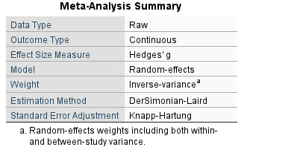
Table.10-1.Overall adipokines meta- analysis method .
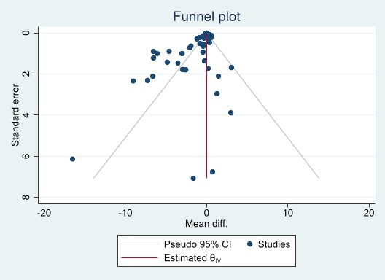
Figure .10-1. Overall adipokines.Funnel plot.

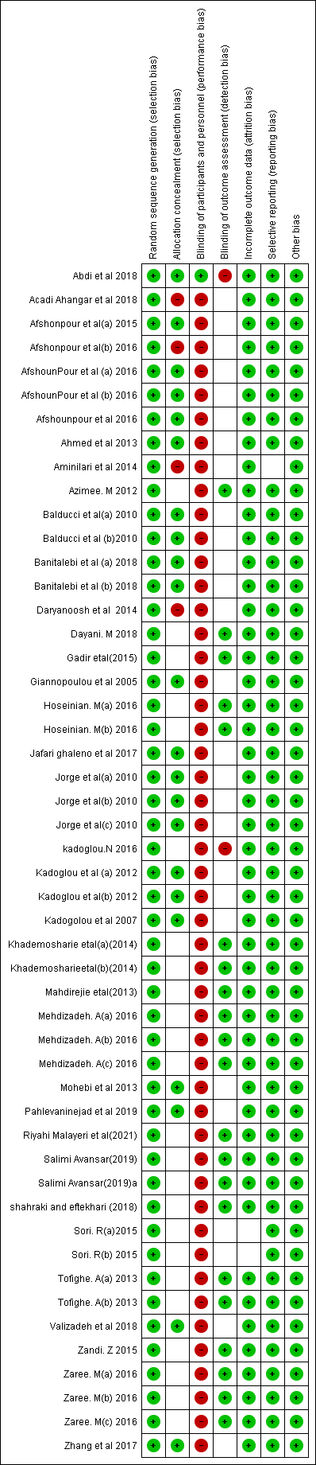
Table .10-2.Overall adipokines .Risk of bias summary.
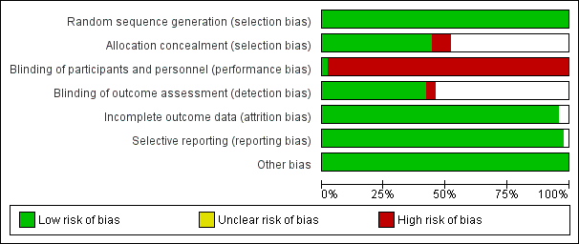
Figure .10-2.Overall adipokines. Risk of bias graph.

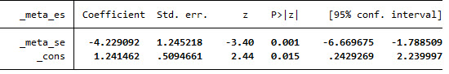
Table .10-3.Overall adipokines egger bias test.

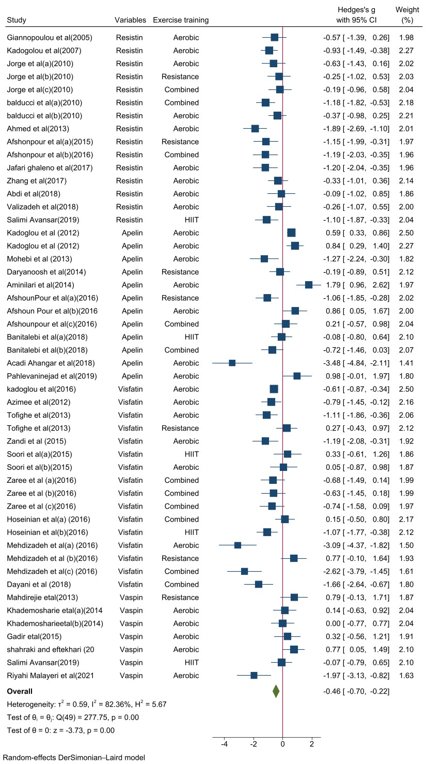

Figure .10-3.Overall adipokines meta- analysis forest plot.

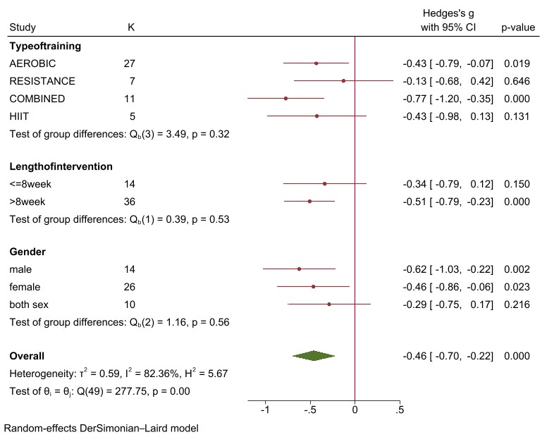

Figure .10-4.Overall adipokines subgroups meta-analysis forest plot.
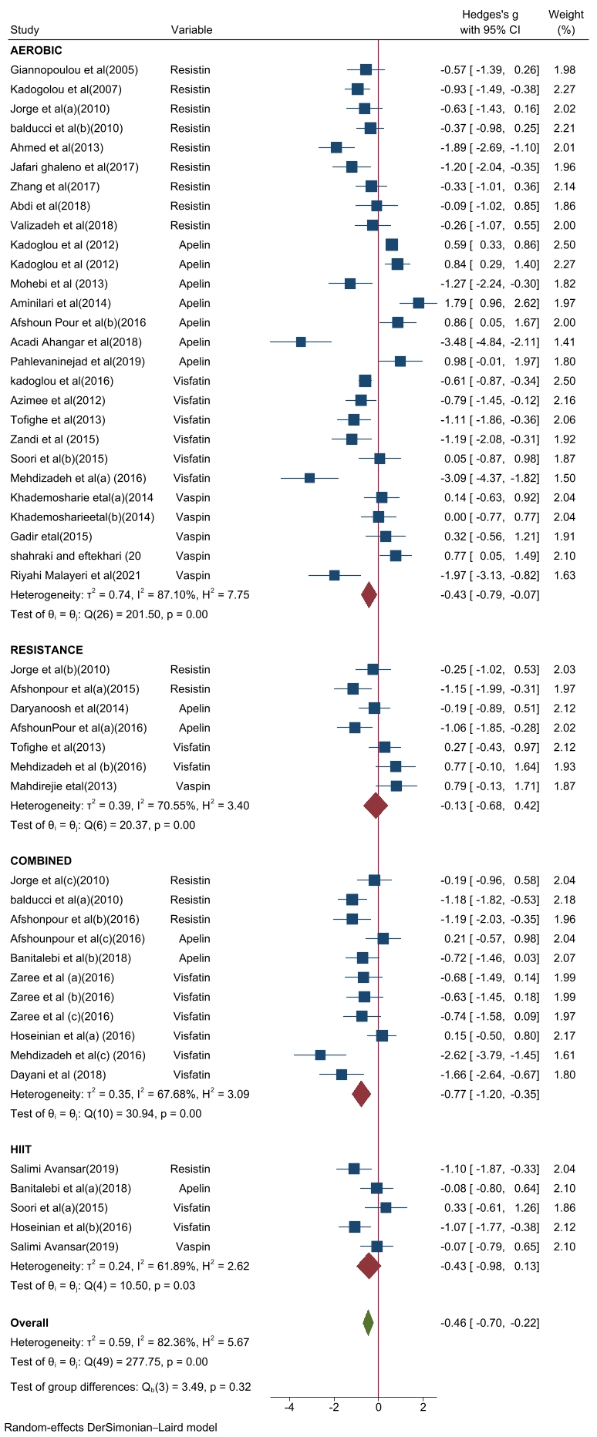

Figure .10-5.Overall adipokines type of training subgroup metaanalysis forest plot

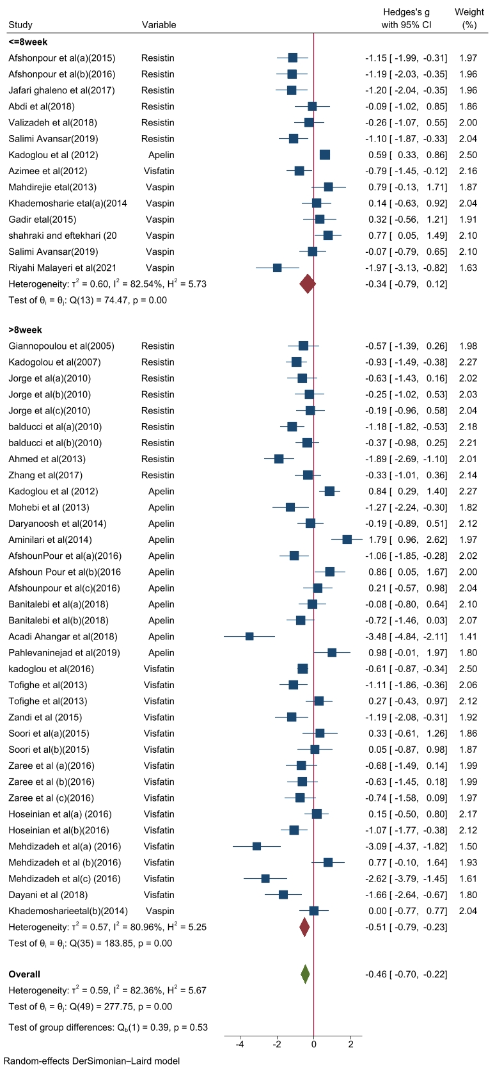
Figure .10-6.Overall adipokines length of training period subgroup metaanalysis fores plot.
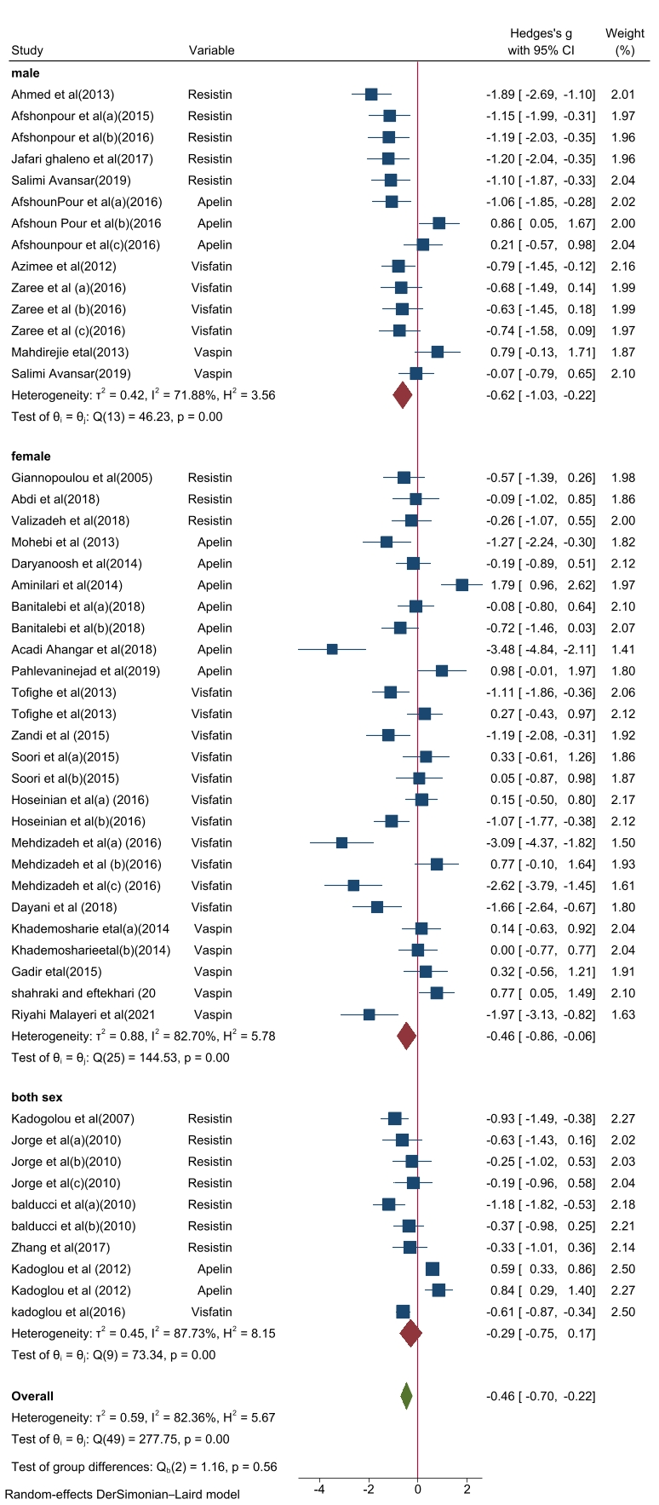
Figure .10-7.Overall adipokines gender subgroup meta-analysis output. forest plot.
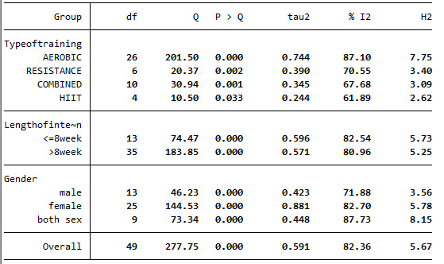
Table .10-4.Overall adipokines subgroups hetrogenity output.
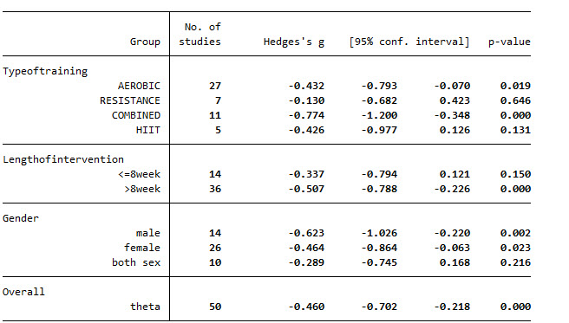
Table.10-5.Overall adipokines subgroups meta-analysis output.
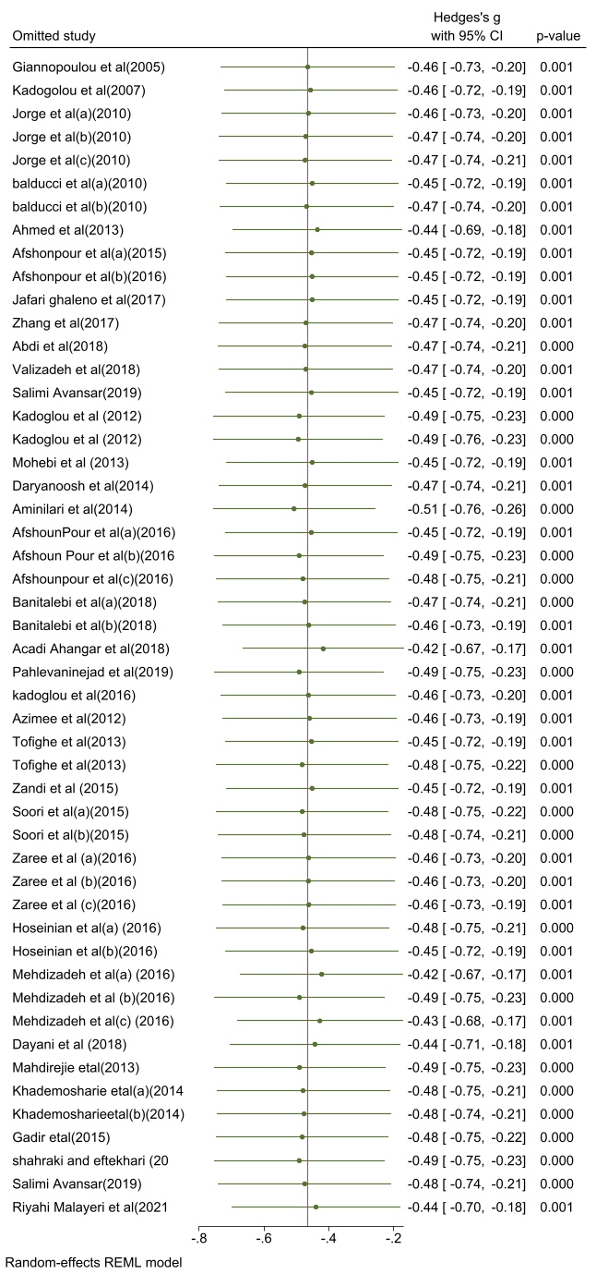
Figure .10-8.Overall adipokines sensitivity analysis forest plot.
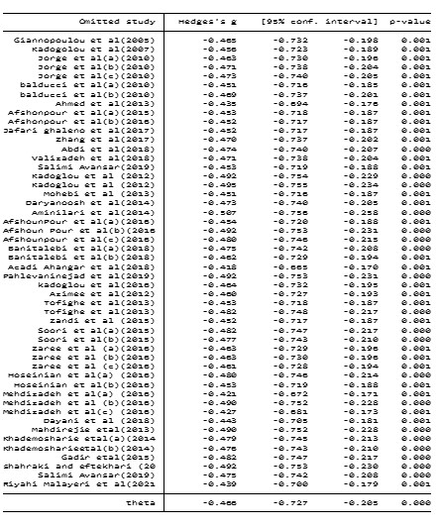
Table .10-6.Overall adipokines sensetivity meta-analysis output.

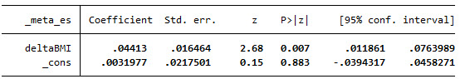
Table .10-7.Overall meta-regresssion delta BMI output.
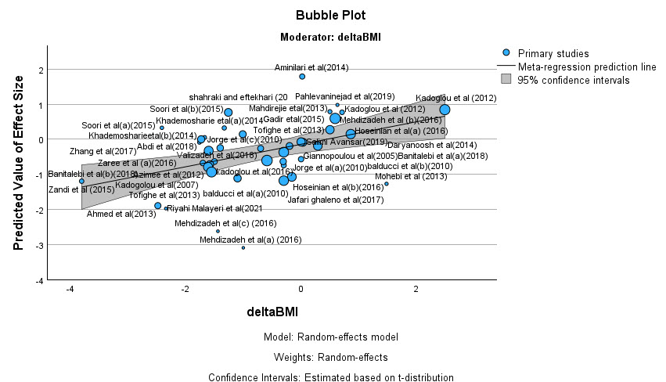
Figure .10-9.Overall delta bmi meta-regression. graph

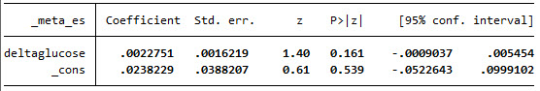
Table .10-8.Overall meta-regression delta glucose output.
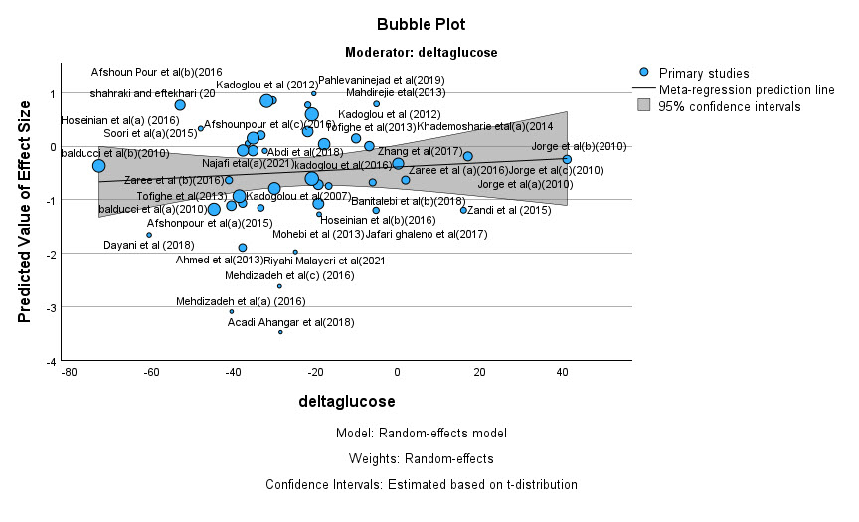
Figure .10-10.Overall meta-regression delta glucose. graph.

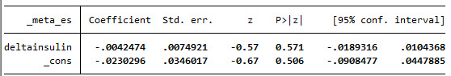
Table .10-9.Overall meta-regression delta insulin output.

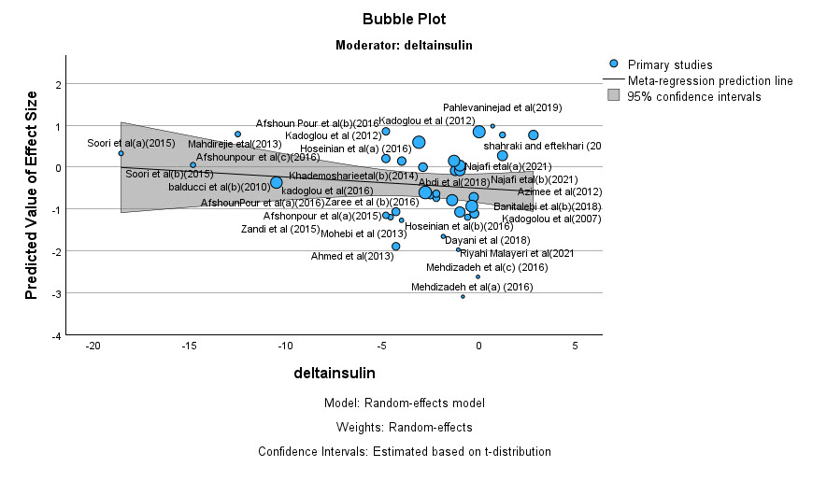
Figure .10-11.Over all meta-regression delta insulin graph.
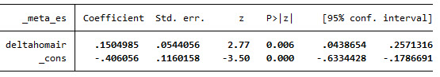
Table .1-10.Overall meta -regression homair output.
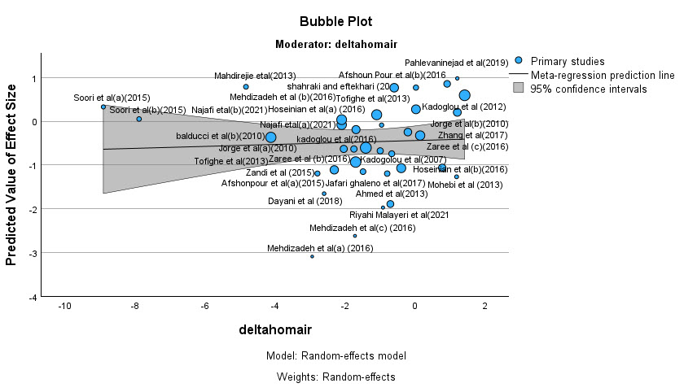 Figure .10-12 .Overall meta-regression delta homa-ir graph.

20.Apelin meta-analysis and meta-regression output

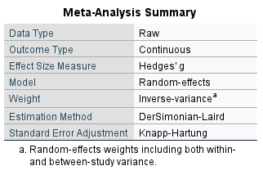
Table .20-1.Apelin meta -analysis method.
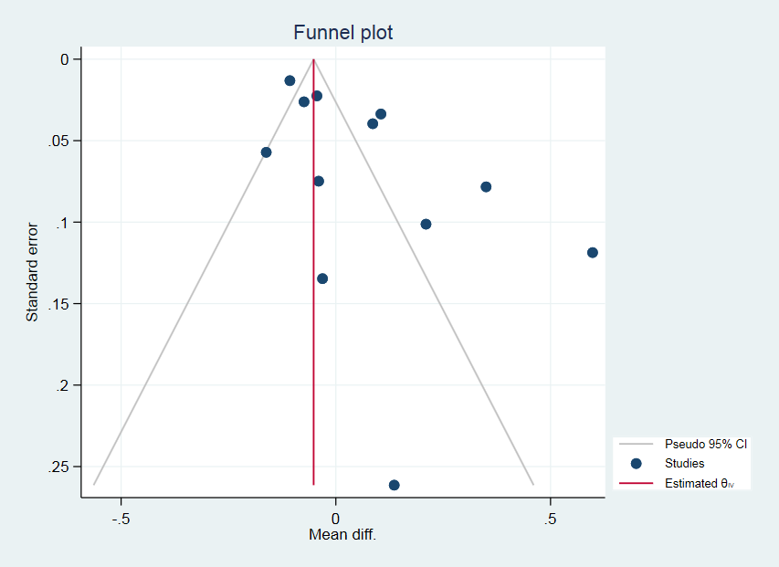
Figure.20-1.Apelin funnel plot .publication bias

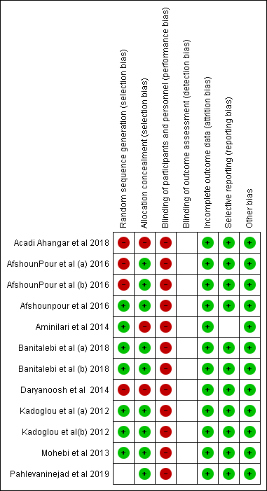
Table .20-2.Apelin Risk of bias summary.
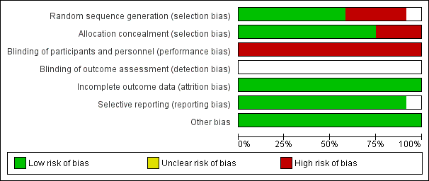
Figure .20-2. Apelin Risk of bias graph

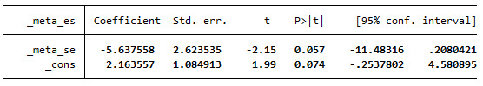
Table .20-3.Apelin egger test output .

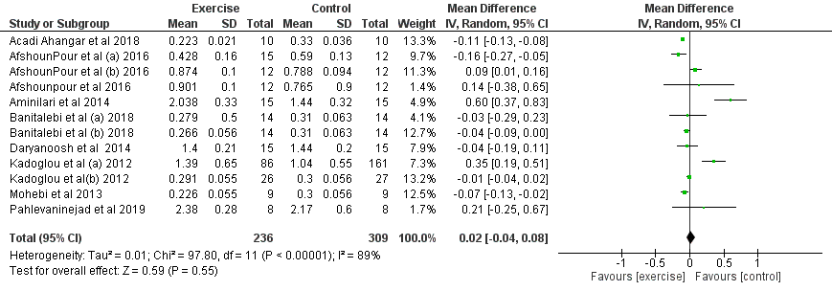
Figure .20-3. Apelin overall meta-analysis and hetrogenity forest plot.
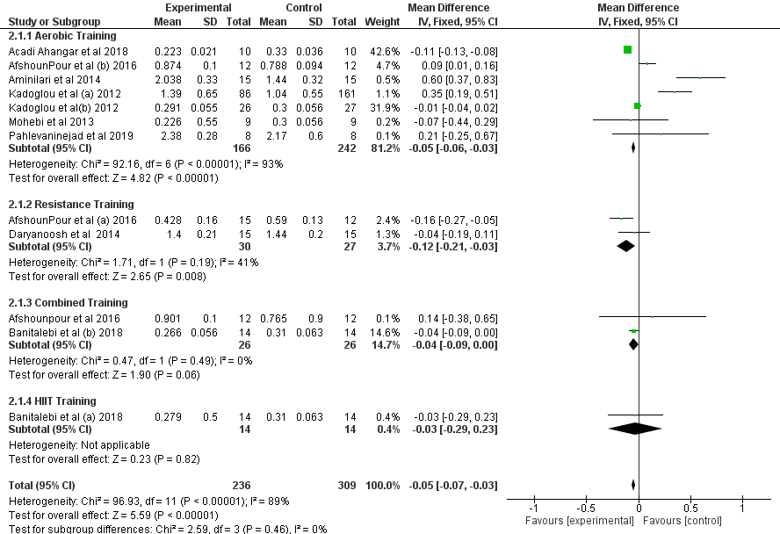
Figure .20-4.Apelin type of training subgroup analysis forest plot.
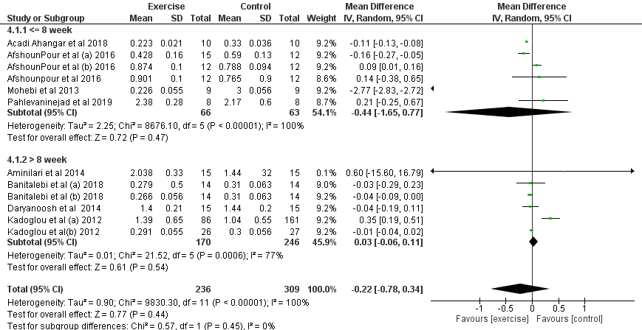

Figure .20-5. Apelin length of intervention subgroup analysis forest plot.
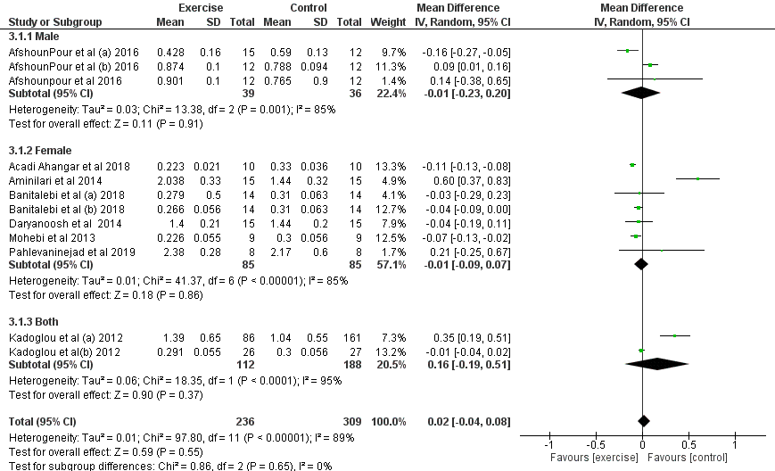
Figure .20-6. Apelin gender subgroup analysis forest plot.
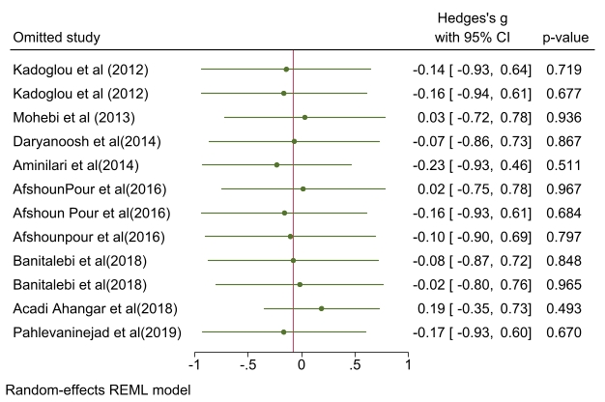

Figure .20-7. Apelin sensetivity analysis forest plot.
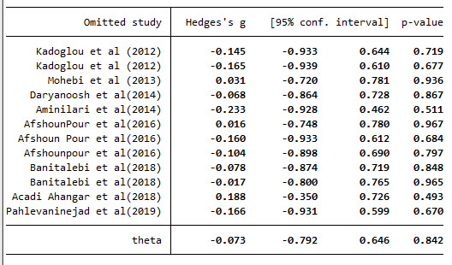
Table .20-4. Apelin sensetivity analysis.

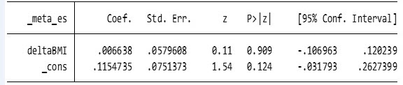
Table .20-5. Apelin meta -regression delta BMI output.
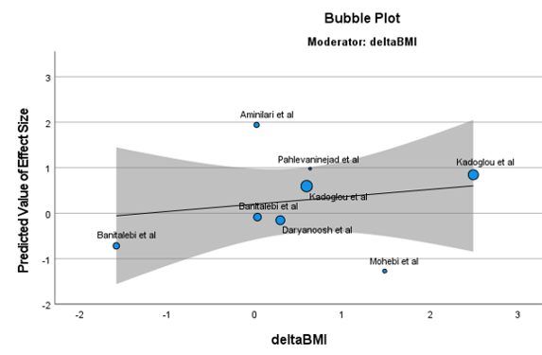
Figure .20-8.Apelin meta- regression delta BMI. graph.

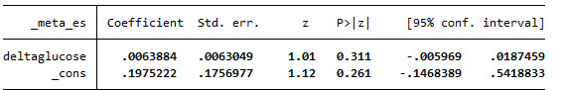
Table .20-6.Apelin meta -regression delta glucose output.

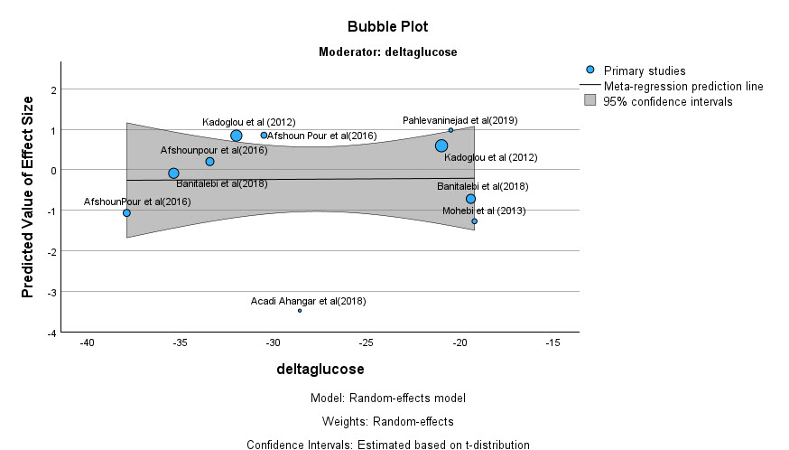
Figure .20-9.Apelin meta -regression delta glucose graph.

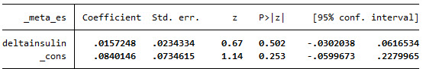
Table .20-7. Apelin meta- regression delta insulin output.
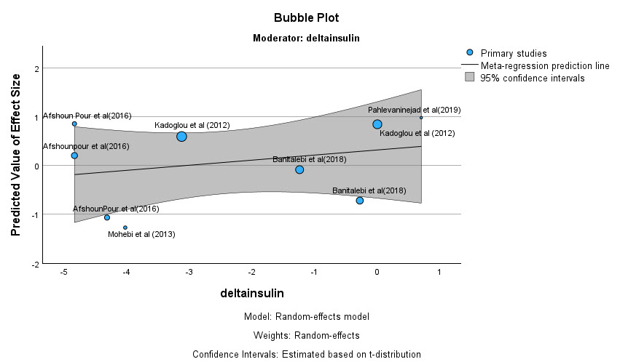
Figure .20-10. Apelin meta -regression delta insulin graph.

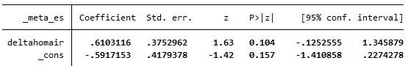
Table .20-8.Apelin meta -regression delta HOMA-IR output.
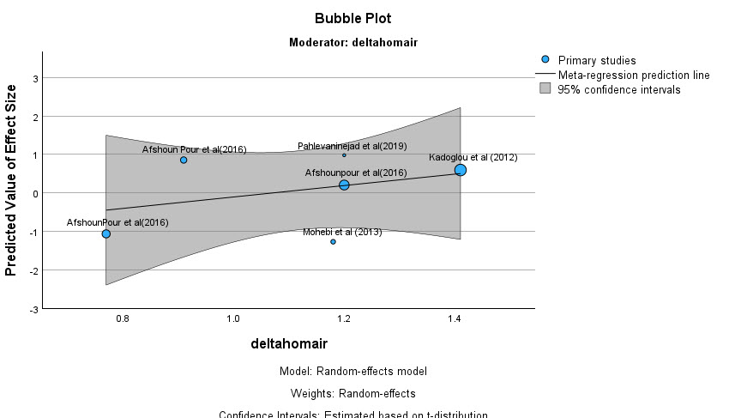
Figure .20-11. Apelin meta- regression delta HOMA-IR graph.

30.Resistin meta- analysis and meta-regression output
Table .30-1.Resistin meta -analysis method.
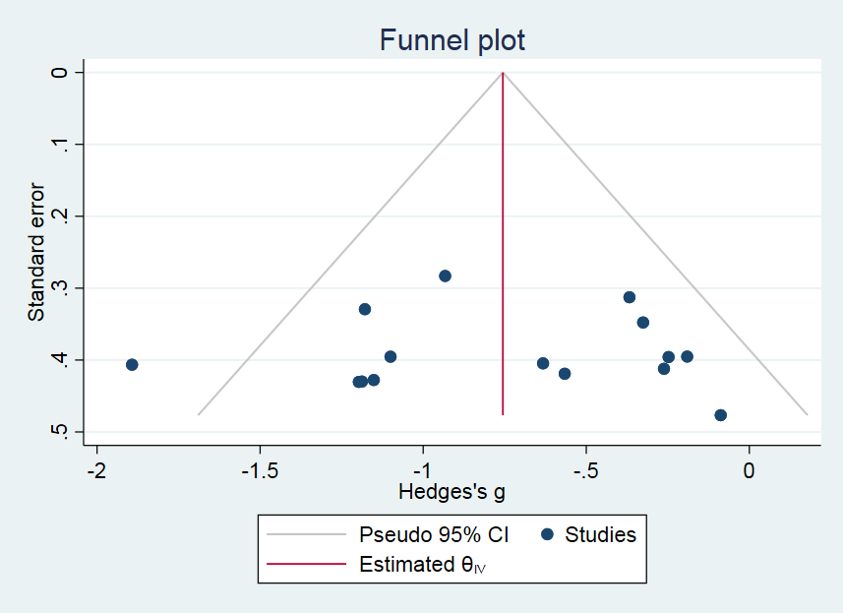
Figure .30-1.Resistin funnel plot.graph.
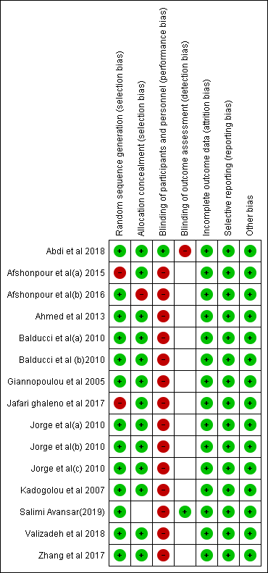
Table .30-2 .resistin Risk of bias summary.

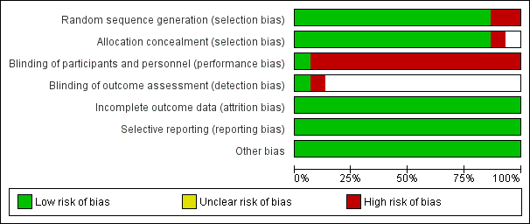
Figure .30-2.Resistin new Risk of bias graph.
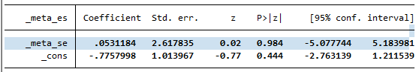
Table .30-3.Resistin .egger test output .bias test.
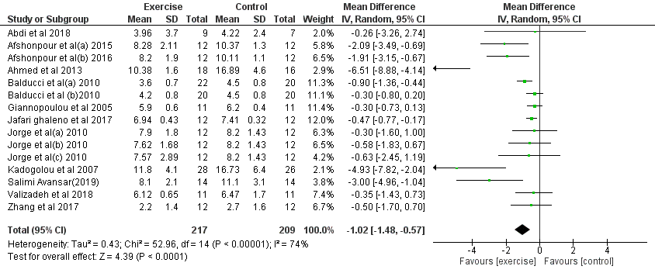
Figure .30-3.Resistin overall and hetrogenity Forest plot.
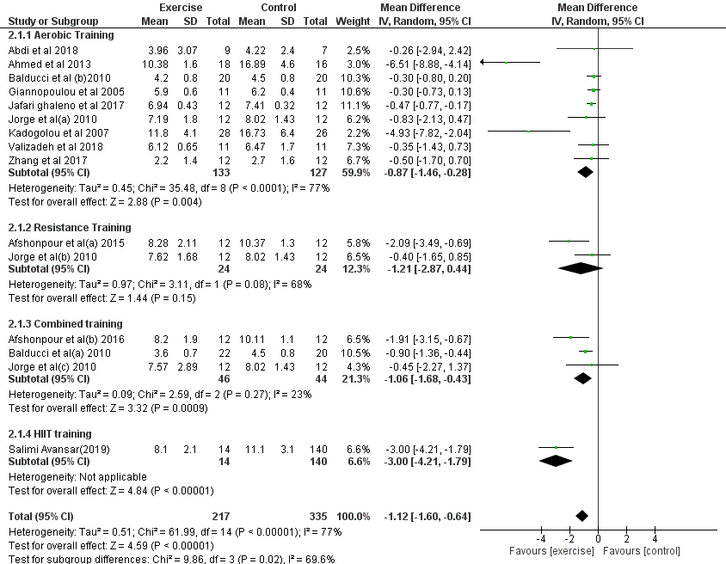
Figure .30-4.Resistin type of training subgroup analysis. Forest plot.
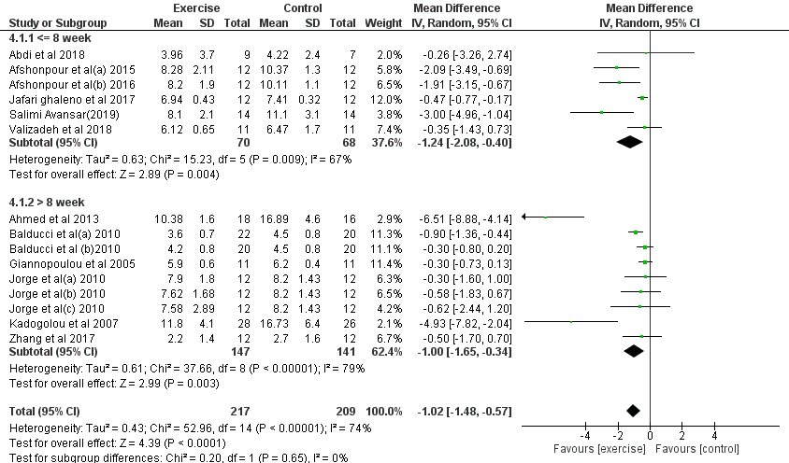
Figure .30-5.Resistin length of training subgroup analysis.Forest plot.
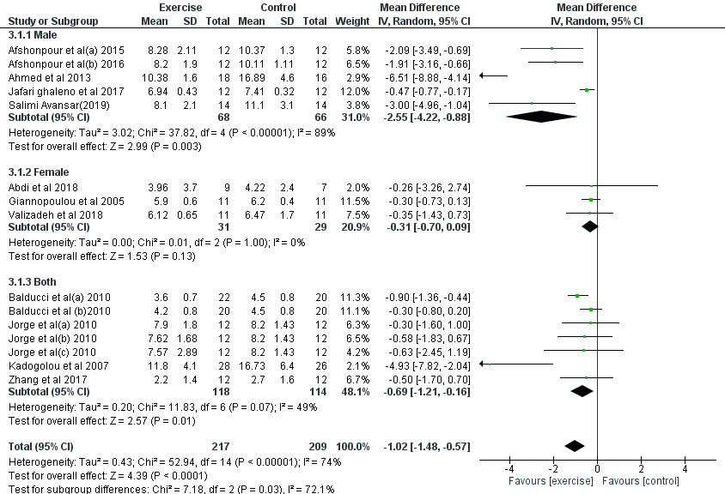
Figure .30-6. Resistin gender subgroup analysis. Forest plot.
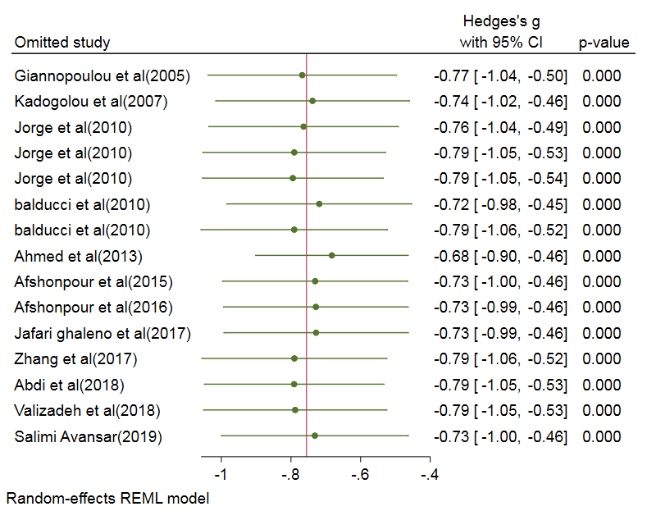
Figure .30-7.Resistin sentitivity analysis .graph.
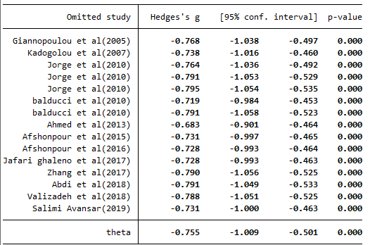
Table .30-4 .Resistin sentitivity analysis.
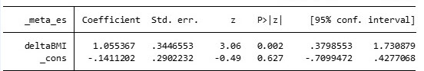
Table .30-5 .Resistin meta -regression delta BMI output.
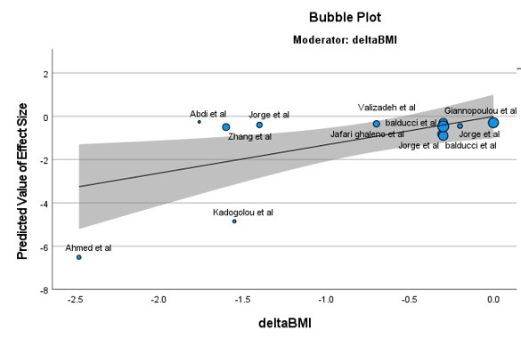 Figure .30-8. Resistin meta- regression delta BMI .graph.

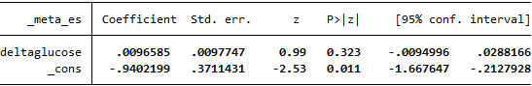
Table .30-6. Resistin meta- regression delta glucose output.

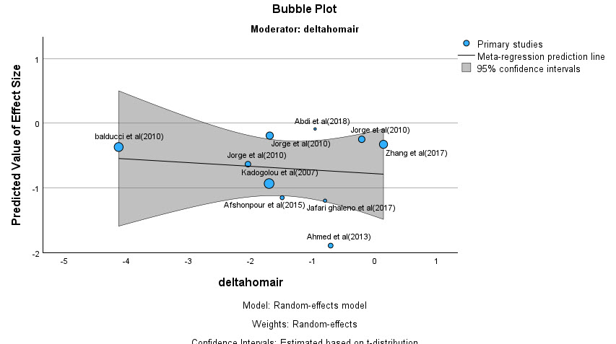
Figure .30-9. Resistin meta- regression delta glucose output .graph.
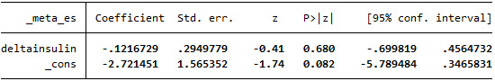
Table .30-7 .Resistin meta -regression delta insulin output.
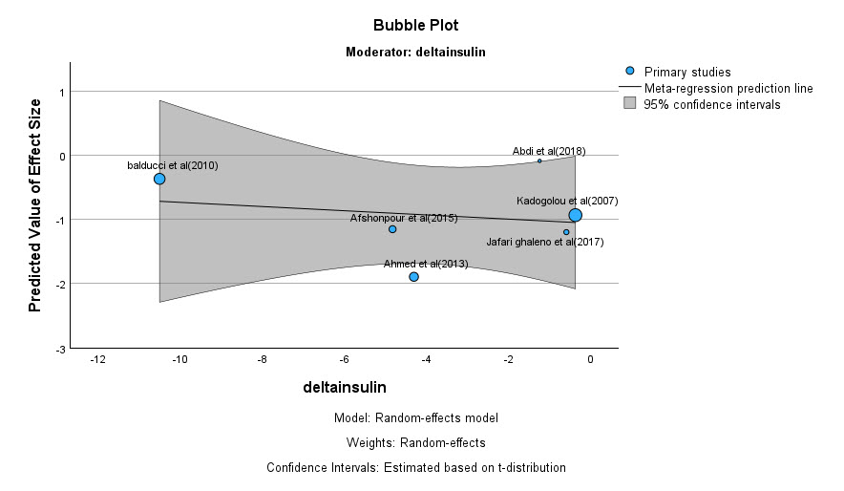 Figure .30-10. Resistin meta- regression delta insulin output. graph.
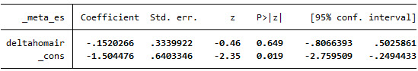
Table .30-8. Resistin meta- regression delta HOMA-IR output.
Figure .30-11. Resistin meta -regression delta HOMA-IR output.graph.

40.Visfatin meta -analysis and meta - regression output

Table .40-1. Visfatin meta- analysis method.
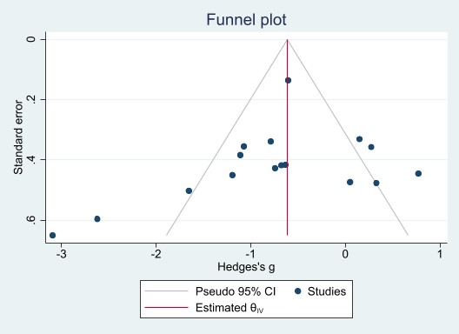
Figure .40-1. Visfatin funnel plot.graph.

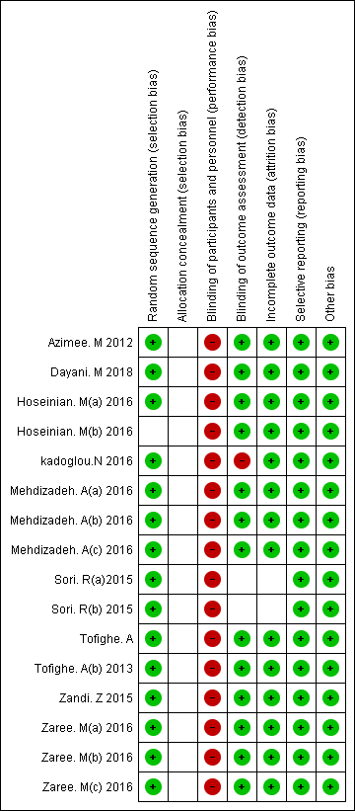
Table .40-2.Visfatin Risk of bias summary.

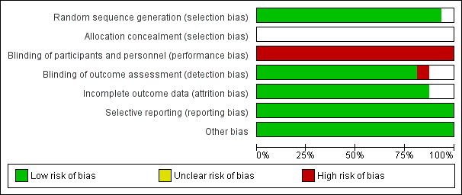
Figure .40-2. Visfatin Risk of bias graph.
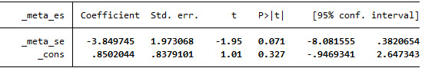
Table .40-3. visfatin egger test.
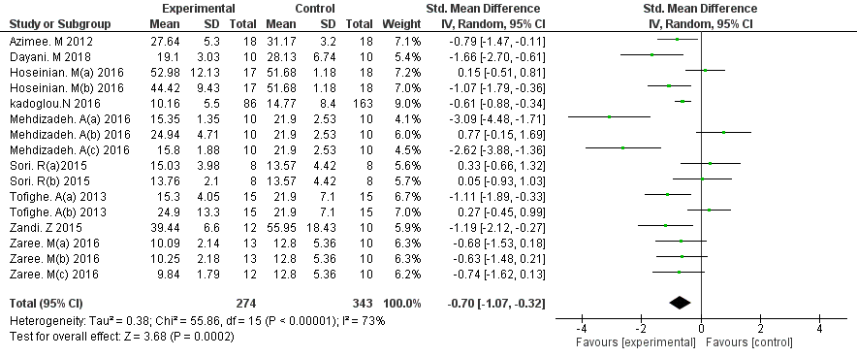
Figure .40-3. Visfatin Overall and hetrogenity. Forest plot.
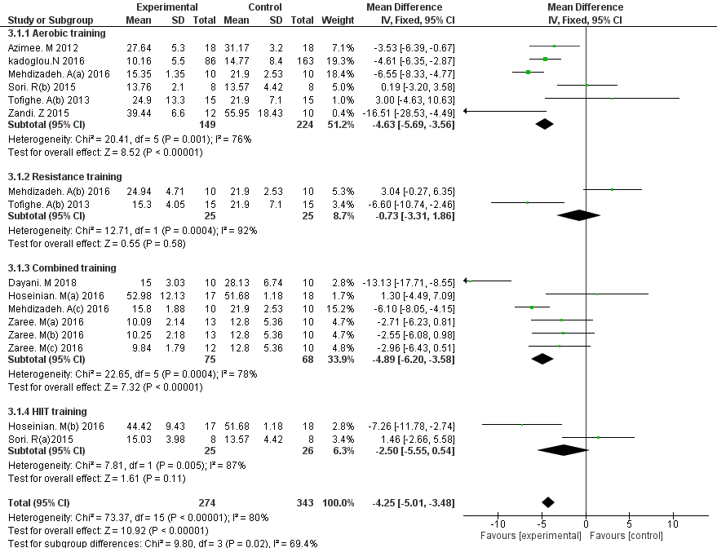

Figure .40-4. Visfatin Type of training subgroup analysis visfatin.Forest plot.
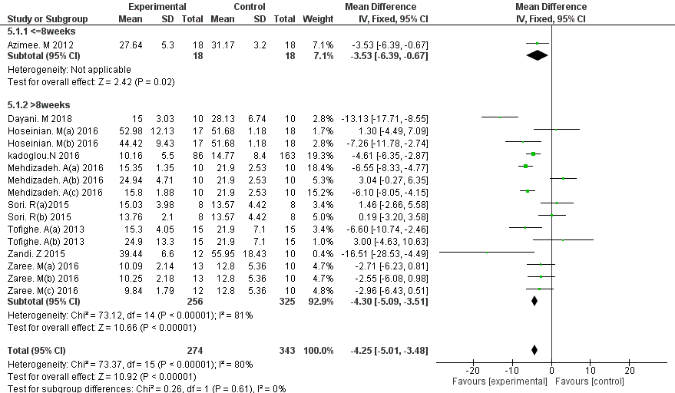

Figure .40-5. Visfatin. Length of intervention period subgroup analysis visfatin.Forest plot.
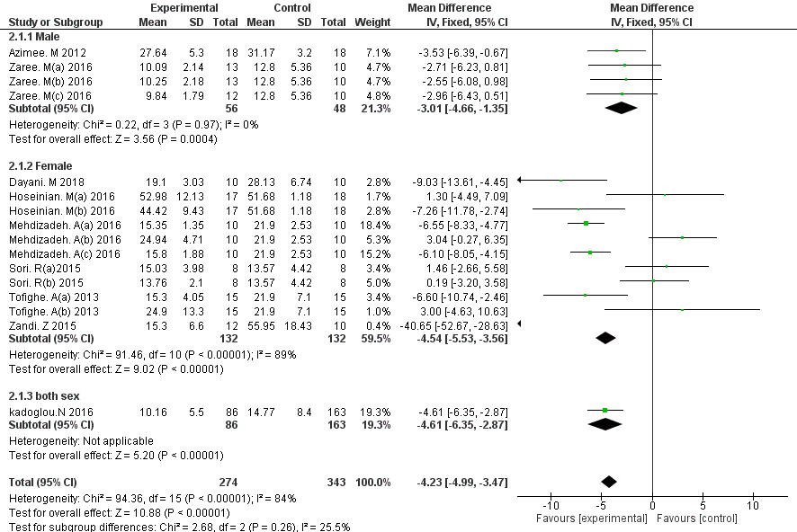

Figure .40-6. Visfatin.gender subgroup analysis visfatin.Forest plot.
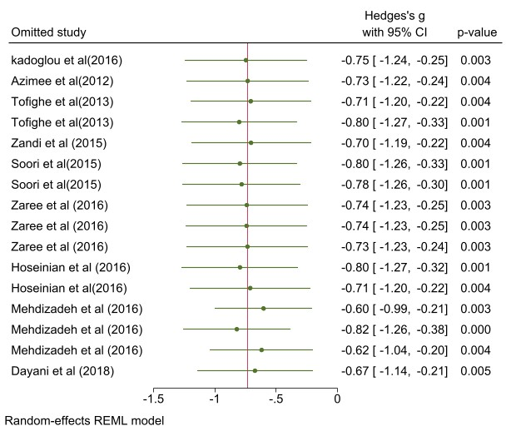

Figure .40-7. Visfatin sensetivity analysis. graph.
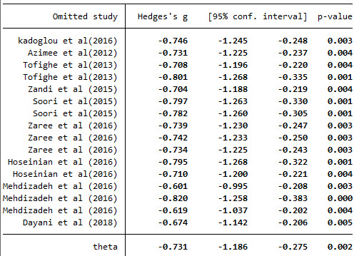

Table .40-4. Visfatin sensetivity analysis.
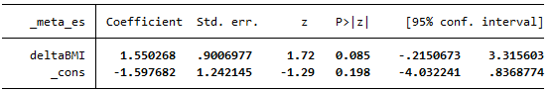
Table .40-5.Visfatin meta-regression delta BMI output.
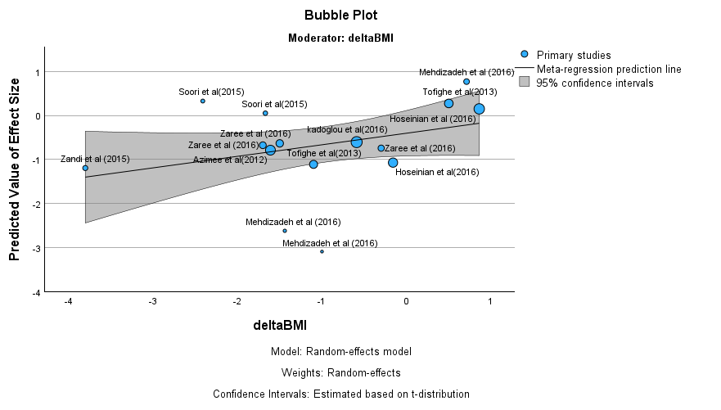
Figure .40-8. Visfatin meta-regression delta BM .graph.

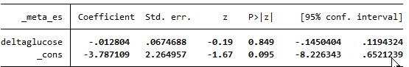
Table .40-6. Visfatin meta- regression delta glucose output.

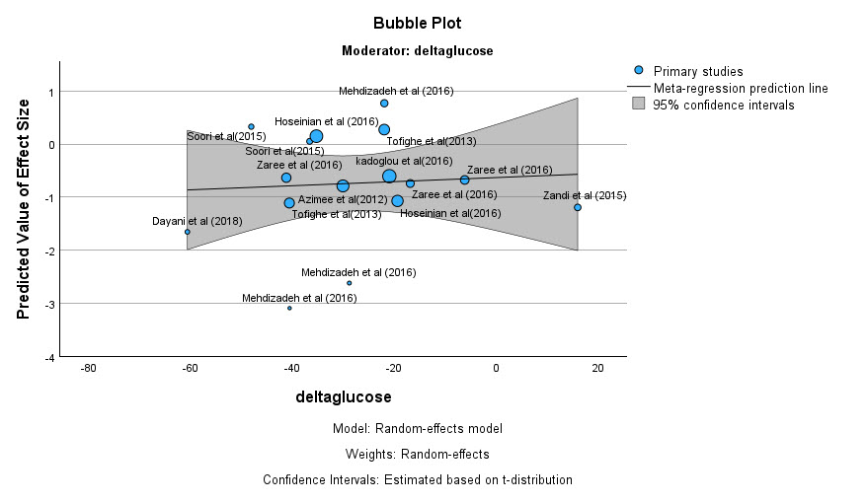
Figure .40-9. Visfatin meta -regression delta glucose output. graph.

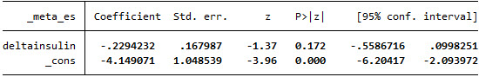
Table .40-7. Visfatin meta- regression delta insulin output.
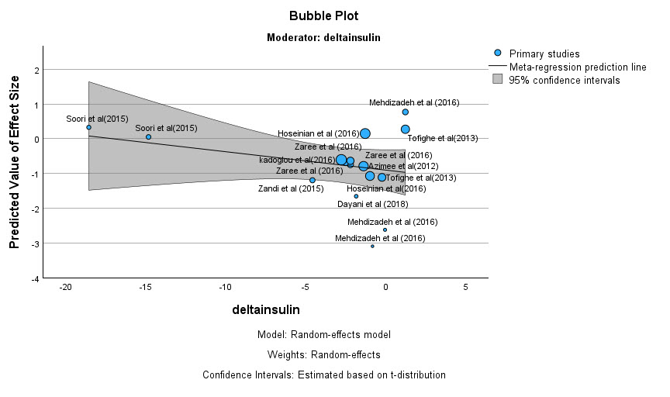
Figure .40-10. Visfatin meta- regression delta glucose output.

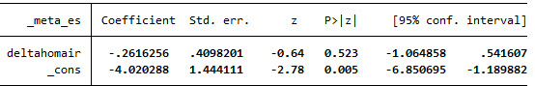
Table .40-8. Visfatin meta- regression delta HOMA-IR output.
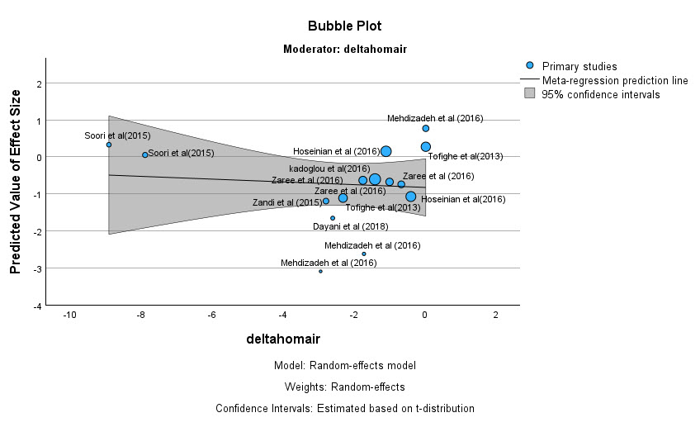

Figure .40-11. Visfatin meta -regression delta HOMA-IR output.

50.Vaspin meta -analysis and meta -regression output
Table .50-1. Vaspin meta -analysis method.
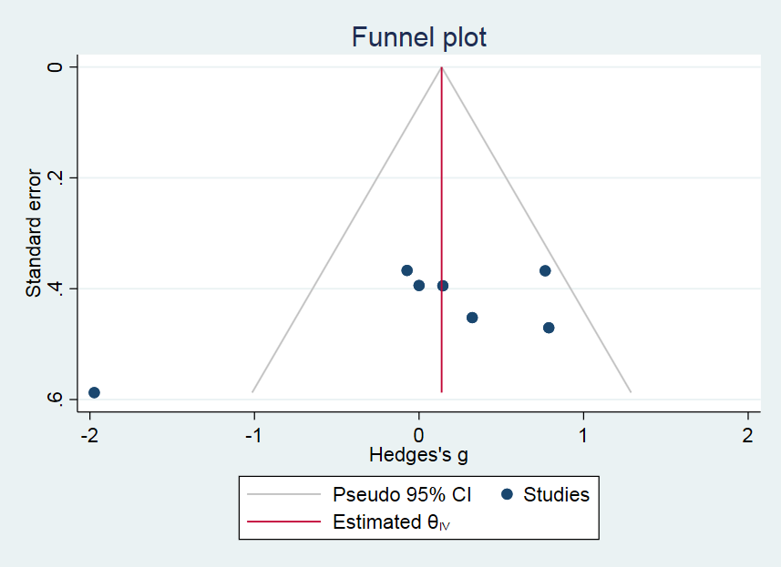
Figure .50-1. Vaspin funnel plot. graph.
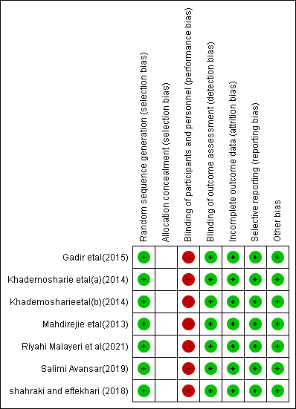
Table .50-2. Vaspin Risk of bias summary.
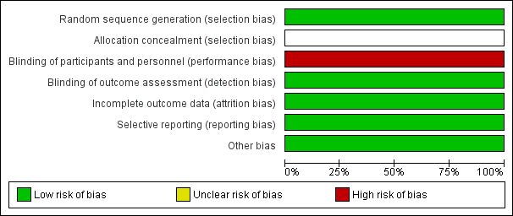
Figure .50-2. Vaspin. Risk of bias graph.
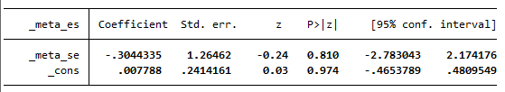

Table .50-3. Vaspin egger test bias output.

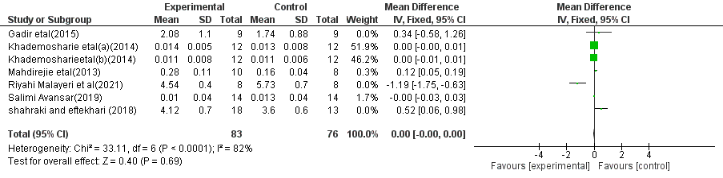
Figure .50-3. Vaspin overall meta-analysis and hetrogenity. Forest plot.
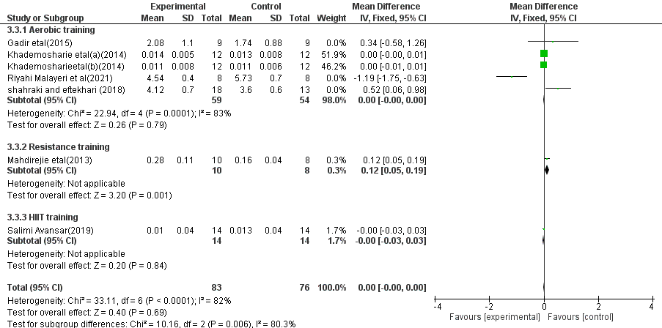

Figure .50-4. Vaspin type of training subgroup.Forest plot.

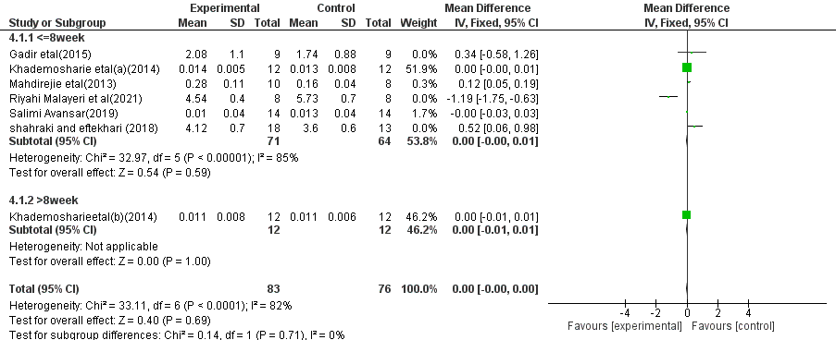

Figure .50-5. Vaspin length of intervention period subgroup.Forest plot.
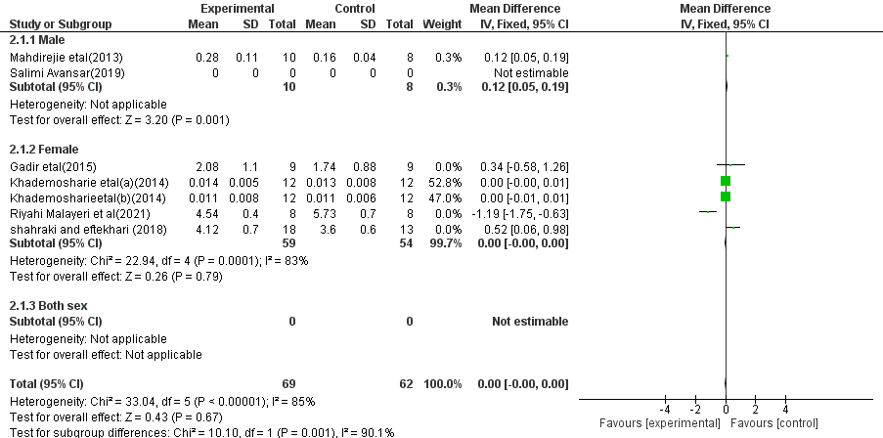

Figure .50-6. Vaspin gender subgroup analysis.Forest plot.
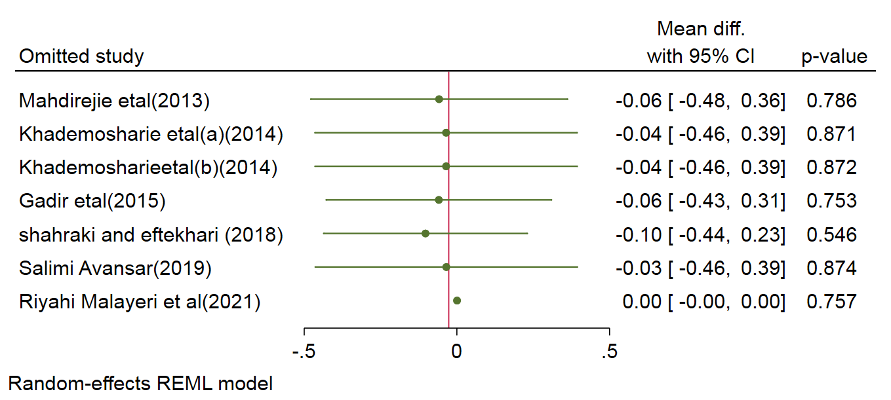

Figure .50-7. vaspin sensetivity analysis.graph.

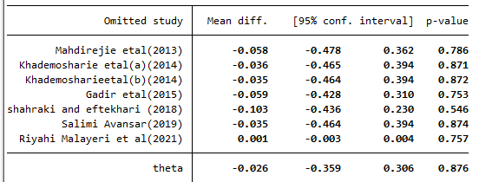
Table .50-4. Vaspin sensetivity analysis.

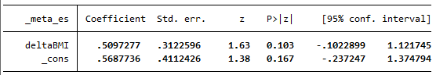
Table .50-5. Vaspin meta-regression delta BMI output.

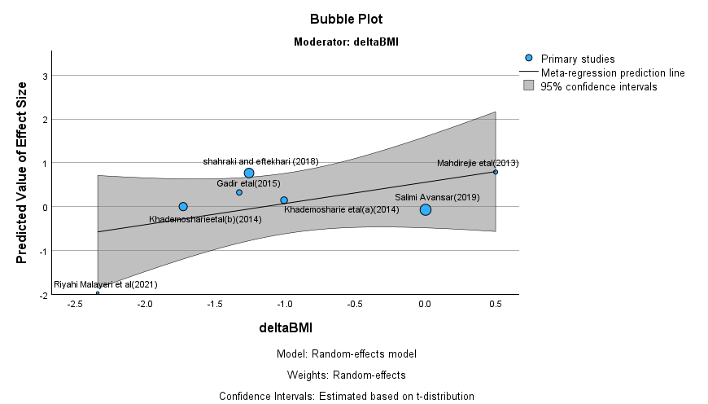

Figure .50-8. Vaspin meta-regression delta BMI. graph.

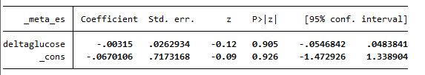
Table .50-6. Vaspin delta glucose meta -regression output.
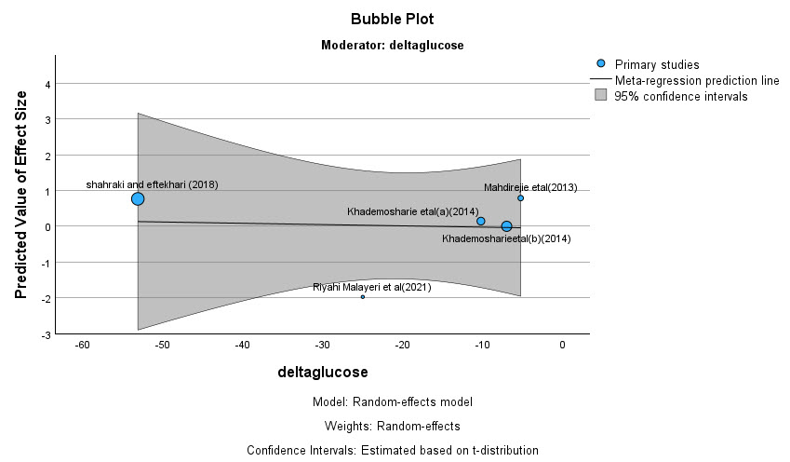
Figure .50-9. Vaspin delta glucose meta -regression graph.

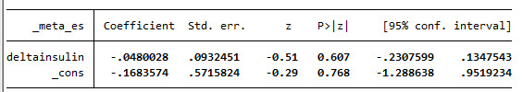
Table .50-7. Vaspin delta insulin meta- regression insulin output.
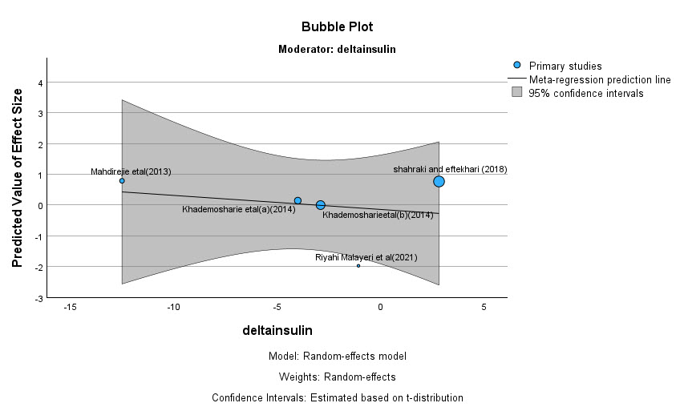
Figure .50-10. Vaspin delta insulin meta -regression graph.

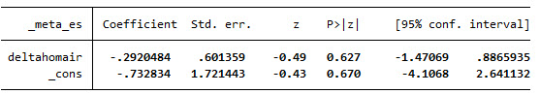
Table .50-8. Vaspin delta HOMA-IR meta- regression output.
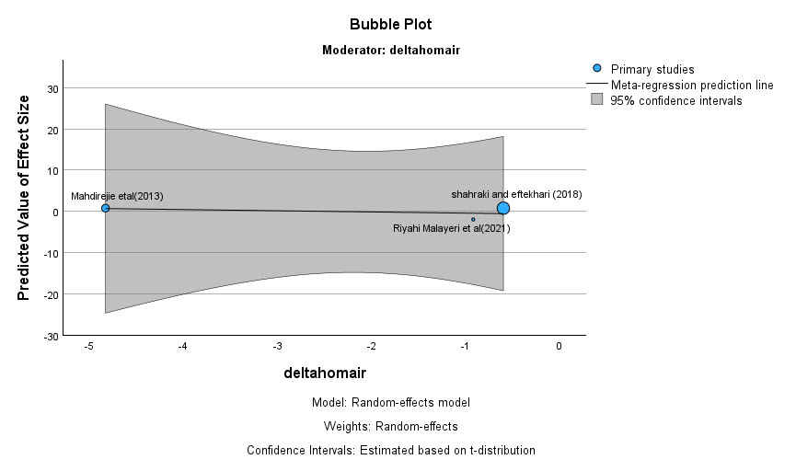

Figure .50-11. Vaspin delta homa-ir meta-regression graph.

