Supplementary Material
Supplementary Figure S1. Calibration of Logistic Regression Models: Hosmer-Lemeshow Goodness-of-Fit Test Results for the Training and Validation Sets
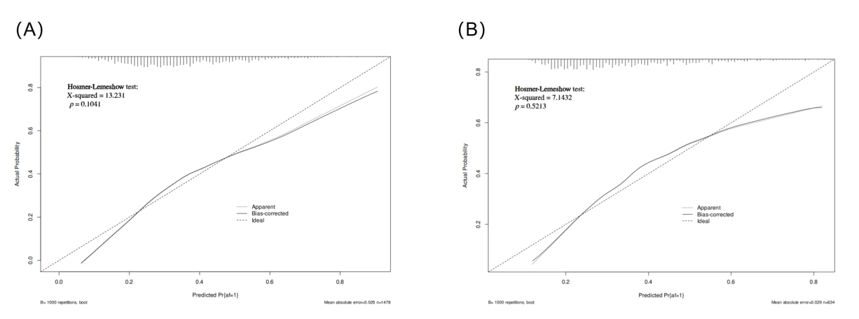
Supplementary Figure S2. ROC curves for the training and validation sets
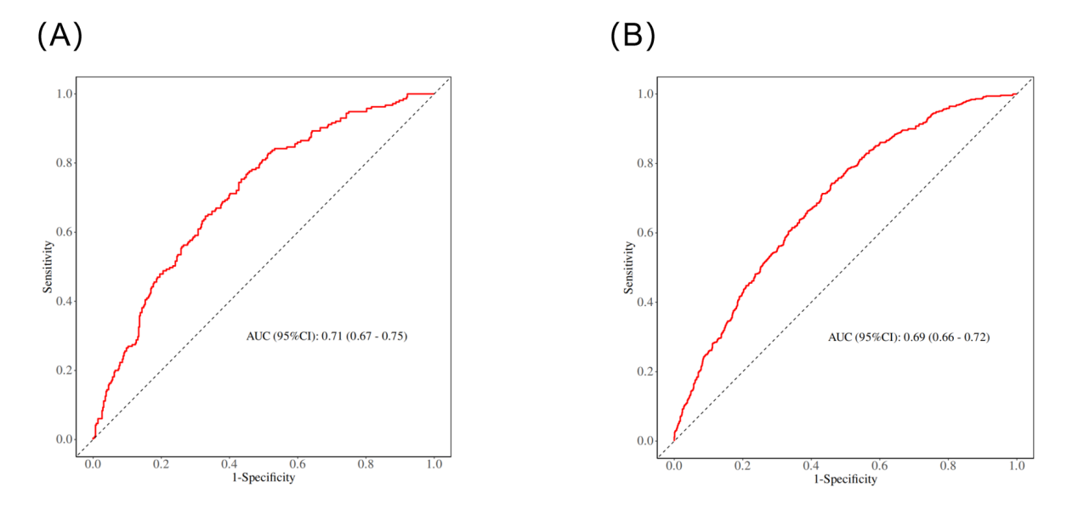
Supplementary Figure S3. The DCA diagram for the training and validation sets
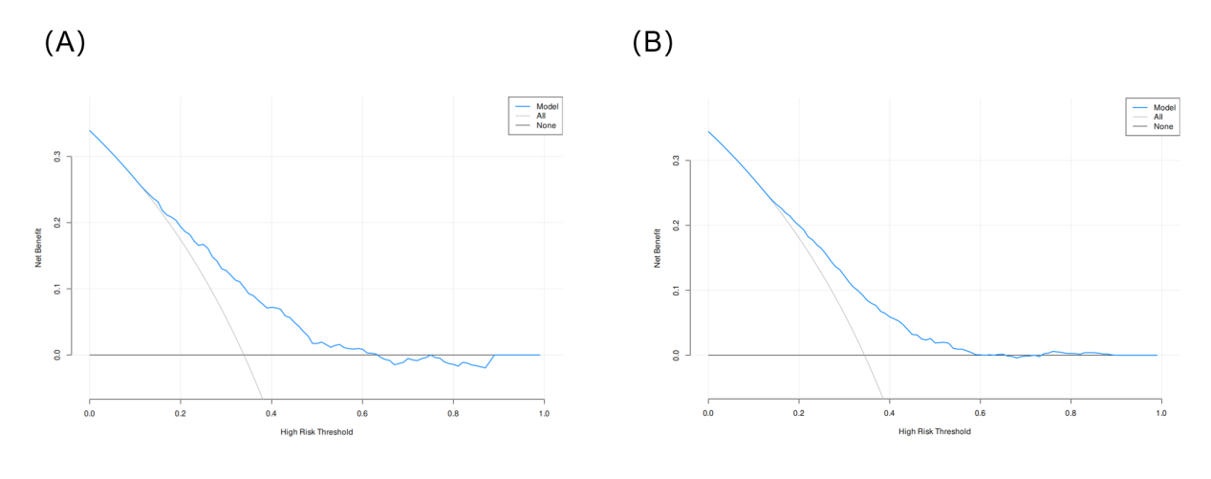

Supplementary Table S1. Training Set and Validation Set
Variables | Total (n = 2112) | Train (n = 1478) | Test (n = 634) | Statistic | P
Age, M (Q₁, Q₃) | 69.00 (62.00, 76.00) | 69.00 (62.00, 76.00) | 69.00 (61.00, 76.00) | Z=-0.06 | 0.952
BMI, M (Q₁, Q₃) | 29.04 (26.27, 32.89) | 29.07 (26.17, 32.87) | 28.93 (26.48, 33.09) | Z=-0.16 | 0.873
Spo2, M (Q₁, Q₃) | 100.00 (98.00, 100.00) | 100.00 (98.00, 100.00) | 100.00 (98.00, 100.00) | Z=-0.53 | 0.597
Temperature, M (Q₁, Q₃) | 97.90 (97.52, 98.40) | 97.90 (97.60, 98.40) | 97.80 (97.50, 98.40) | Z=-0.78 | 0.435
Heart rate, M (Q₁, Q₃) | 80.00 (73.00, 85.00) | 80.00 (73.00, 85.00) | 80.00 (74.00, 85.00) | Z=-0.46 | 0.642
SBP, M (Q₁, Q₃) | 112.00 (101.00, 124.00) | 112.00 (101.00, 123.00) | 113.00 (101.00, 125.75) | Z=-1.37 | 0.172
DBP, M (Q₁, Q₃) | 62.00 (54.00, 70.00) | 62.00 (54.00, 70.00) | 61.50 (54.00, 70.00) | Z=-0.02 | 0.984
MBP, M (Q₁, Q₃) | 75.00 (67.00, 83.00) | 74.00 (67.00, 83.00) | 75.00 (67.00, 83.90) | Z=-0.45 | 0.650
Respiratory rate, M (Q₁, Q₃) | 15.00 (13.00, 18.00) | 15.00 (13.00, 18.00) | 15.00 (13.00, 18.00) | Z=-0.23 | 0.818
Hba1c, M (Q₁, Q₃) | 5.90 (5.50, 6.90) | 5.90 (5.50, 6.80) | 5.90 (5.60, 7.00) | Z=-0.91 | 0.363
Calcium, M (Q₁, Q₃) | 8.21 (8.00, 8.60) | 8.20 (8.00, 8.60) | 8.25 (8.00, 8.60) | Z=-1.61 | 0.106
Chloride, M (Q₁, Q₃) | 107.00 (105.00, 110.00) | 107.00 (105.00, 110.00) | 107.00 (105.00, 109.00) | Z=-0.75 | 0.452
Glucose, M (Q₁, Q₃) | 119.00 (105.00, 138.00) | 117.50 (104.00, 137.00) | 121.00 (106.00, 140.00) | Z=-1.64 | 0.102
SHR, M (Q₁, Q₃) | 0.95 (0.77, 1.12) | 0.95 (0.77, 1.12) | 0.96 (0.78, 1.12) | Z=-0.60 | 0.552
Potassium, M (Q₁, Q₃) | 4.30 (4.00, 4.60) | 4.30 (4.00, 4.60) | 4.30 (4.00, 4.60) | Z=-0.16 | 0.874
Sodium, M (Q₁, Q₃) | 138.00 (136.00, 140.00) | 138.00 (136.00, 140.00) | 138.00 (136.00, 140.00) | Z=-1.73 | 0.084
Hemoglobin, M (Q₁, Q₃) | 10.00 (8.70, 11.50) | 9.95 (8.80, 11.40) | 10.10 (8.53, 11.70) | Z=-0.81 | 0.417
Platelet, M (Q₁, Q₃) | 151.00 (120.00, 194.00) | 149.50 (119.00, 192.75) | 155.00 (124.00, 199.00) | Z=-1.91 | 0.056
RBC distribution width, M (Q₁, Q₃) | 13.30 (12.80, 14.10) | 13.30 (12.72, 14.00) | 13.40 (12.80, 14.10) | Z=-1.12 | 0.264
RBC, M (Q₁, Q₃) | 3.29 (2.85, 3.78) | 3.29 (2.84, 3.74) | 3.30 (2.87, 3.83) | Z=-0.86 | 0.390
WBC, M (Q₁, Q₃) | 11.70 (8.90, 15.12) | 11.60 (8.80, 15.00) | 11.90 (9.10, 15.40) | Z=-1.56 | 0.120
Sofa, M (Q₁, Q₃) | 5.00 (3.00, 6.00) | 5.00 (3.00, 6.00) | 5.00 (3.00, 6.00) | Z=-0.28 | 0.781
Apsiii, M (Q₁, Q₃) | 33.00 (26.00, 43.00) | 33.00 (26.00, 42.00) | 33.00 (26.00, 44.00) | Z=-0.16 | 0.876
Sapsii, M (Q₁, Q₃) | 34.00 (28.00, 41.00) | 34.00 (28.00, 41.00) | 34.00 (29.00, 42.00) | Z=-1.40 | 0.162
Oasis, M (Q₁, Q₃) | 30.00 (25.00, 35.00) | 30.00 (25.00, 35.00) | 30.00 (25.25, 35.00) | Z=-0.67 | 0.503
Charlson, M (Q₁, Q₃) | 4.00 (3.00, 6.00) | 4.00 (3.00, 6.00) | 4.00 (3.00, 6.00) | Z=-0.63 | 0.528
Creatinine, M (Q₁, Q₃) | 0.90 (0.80, 1.10) | 0.90 (0.77, 1.10) | 0.90 (0.80, 1.10) | Z=-0.67 | 0.502
BUN, M (Q₁, Q₃) | 16.00 (13.00, 20.00) | 16.00 (13.00, 20.00) | 16.00 (13.00, 20.24) | Z=-0.53 | 0.594
Ventilation Hour, M (Q₁, Q₃) | 22.00 (10.68, 45.52) | 22.26 (10.46, 45.73) | 22.00 (11.00, 45.25) | Z=-0.45 | 0.654
Gender, n(%) |  |  |  | χ²=0.02 | 0.890
Female | 469 (22.21) | 327 (22.12) | 142 (22.40)
Male | 1643 (77.79) | 1151 (77.88) | 492 (77.60)
Race, n(%) |  |  |  | χ²=3.20 | 0.202
Black | 75 (3.55) | 52 (3.52) | 23 (3.63)
White | 1319 (62.45) | 941 (63.67) | 378 (59.62)
Other | 718 (34.00) | 485 (32.81) | 233 (36.75)
Marital, n(%) |  |  |  | χ²=0.36 | 0.948
Single | 340 (16.10) | 241 (16.31) | 99 (15.62)
Widowed | 167 (7.91) | 115 (7.78) | 52 (8.20)
Divorced | 139 (6.58) | 99 (6.70) | 40 (6.31)
Married | 1466 (69.41) | 1023 (69.22) | 443 (69.87)
Hypertension, n(%) |  |  |  | χ²=0.83 | 0.362
No | 881 (41.71) | 626 (42.35) | 255 (40.22)
Yes | 1231 (58.29) | 852 (57.65) | 379 (59.78)
Cerebrovascular Accident, n(%) |  |  |  | χ²=0.06 | 0.814
No | 1986 (94.03) | 1391 (94.11) | 595 (93.85)
Yes | 126 (5.97) | 87 (5.89) | 39 (6.15)
Chronic Kidney Disease, n(%) |  |  |  | χ²=0.07 | 0.790
No | 1772 (83.90) | 1238 (83.76) | 534 (84.23)
Yes | 340 (16.10) | 240 (16.24) | 100 (15.77)
Cancer, n(%) |  |  |  | χ²=0.41 | 0.524
No | 1847 (87.45) | 1297 (87.75) | 550 (86.75)
Yes | 265 (12.55) | 181 (12.25) | 84 (13.25)
Hyperlipidemia, n(%) |  |  |  | χ²=0.29 | 0.592
No | 610 (28.88) | 432 (29.23) | 178 (28.08)
Yes | 1502 (71.12) | 1046 (70.77) | 456 (71.92)
Heart failure, n(%) |  |  |  | χ²=0.00 | 0.974
No | 1648 (78.03) | 1153 (78.01) | 495 (78.08)
Yes | 464 (21.97) | 325 (21.99) | 139 (21.92)
Myocardial Infarction, n(%) |  |  |  | χ²=1.76 | 0.184
No | 1390 (65.81) | 986 (66.71) | 404 (63.72)
Yes | 722 (34.19) | 492 (33.29) | 230 (36.28)
Ischemic Heart Disease, n(%) |  |  |  | - | 1.000
No | 2 (0.09) | 2 (0.14) | 0 (0.00)
Yes | 2110 (99.91) | 1476 (99.86) | 634 (100.00)
COPD, n(%) |  |  |  | χ²=1.41 | 0.234
No | 1918 (90.81) | 1335 (90.32) | 583 (91.96)
Yes | 194 (9.19) | 143 (9.68) | 51 (8.04)
Diabetes, n(%) |  |  |  | χ²=0.46 | 0.496
No | 1256 (59.47) | 886 (59.95) | 370 (58.36)
Yes | 856 (40.53) | 592 (40.05) | 264 (41.64)
CRRT, n(%) |  |  |  | χ²=0.04 | 0.851
No | 2077 (98.34) | 1453 (98.31) | 624 (98.42)
Yes | 35 (1.66) | 25 (1.69) | 10 (1.58)
Atrial fibrillation, n(%) |  |  |  | χ²=0.05 | 0.815
No | 1388 (65.72) | 969 (65.56) | 419 (66.09)
Yes | 724 (34.28) | 509 (34.44) | 215 (33.91)
Z: Mann-Whitney test, χ²: Chi-square test, -: Fisher exact
M: Median, Q₁: 1st Quartile, Q₃: 3st Quartile

Supplementary Table S2.Variance Inflation Factors (VIF) for Candidate Predictors
Variable Name | VIF
Race | 1.04935638419043
Hypertension | 1.64095731700503
Cerebrovascular Accident | 1.05440840977052
Chronic Kidney Disease | 2.17322242635268
Cancer | 1.08762188365443
Heart failure | 1.66617631355059
CRRT | 1.41049268503578
Age | 2.0070797227347
SBP | 1.17354446021915
RBC Distribution Width | 1.18924349658228
RBC | 1.29029203925432
SOFA | 1.88046057796061
APSIII | 2.4826467298138
SAPSII | 3.82657300408668
OASIS | 1.87294251841495
Charlson index | 3.37912902542014
creatinine | 1.83086954666965
BUN | 2.10799383097839
Ventilation hour | 1.40148004395
marital | 1.16738359725446
Supplementary Table S3. The relationship between SHR and new - onset AF after CABG in anemic patients.
 | Unadjusted |  | Model 1 |  | Model 2 |  | Model 3 |  | Model 4
Categorical | OR, 95% CI | P | OR, 95% CI | P | OR, 95% CI | P | OR, 95% CI | P | OR, 95% CI | P
Low | Reference | - | Reference | - | Reference | - | Reference | - | Reference | -
Moderate | 1.20(0.95,1.52) | 0.1307 | 1.20 (0.94,1.54 ) | 0.1451 | 1.21(0.95 ,1.56 ) | 0.1291 | 1.27 ( 0.98, 1.65 ) | 0.0665 | 1.22 (0.94 , 1.59 ) | 0.1320
High | 1.40(1.10,1.77) | 0.0054 | 1.33 (1.04,1.70 ) | 0.0238 | 1.32(1.04 ,1.69 ) | 0.0253 | 1.38 ( 1.07, 1.78 ) | 0.0131 | 1.33 (1.03 , 1.72) | 0.0290
P for trend | - | 0.0054 | - | 0.0242 | - | 0.0257 | - | 0.0140 | - | 0.0303
Continuous
SHR | 1.91(1.41,2.60) | 0 | 1.78 (1.29,2.46) | 0.0005 | 1.76 (1.28, 2.44) | 0.0006 | 1.74 (1.25, 2.43) | 0.0010 | 1.61 (1.15 , 2.27 ) | 0.0059
Model 1 : Adjusted for demographics (age, race , marital status )
Model 2 : Model 1 + vital signs (SBP)
Model 3 : Model 2 + comorbidities (hypertension (HTN), cerebrovascular disease (CVA), chronic kidney disease (CKD), cancer, heart failure ); + scores ( SOFA score , APSIII score, SAPSII score, OASIS score, Charlson score )
Model 4 : Model 3 + laboratory tests (creatinine, urea nitrogen, rdw red blood cell distribution width, RBC) + treatment (CRRT, ventilation time)

Supplementary Table S4. Regression coefficients and odds ratios of red blood cell indices (RBC and RDW) in Model
Variable | Estimate | 95% CI | OR | 95% CI for OR | P-value
RBC | 0.0548 | -0.1035 to 0.2130 | 1.0563 | 0.9016 to 1.2374 | 0.4974
RDW | 0.0414 | -0.0391 to 0.1219 | 1.0423 | 0.9617 to 1.1297 | 0.3127

Supplementary Table S5. Threshold Effect Analysis Based on GLM
Model Component | Odds Ratio (OR) | 95% CI | P-value
Model 1(Linear Effect) | 1.6270 | 1.1916 – 2.2272 | 0.0023
Threshold Point (W) | 0.5060 | – | –
Model 2: SHR < 0.506 | 8.5941 | 0.1297 – 983.4525 | 0.3392
Model 2: SHR > 0.506 | 1.5668 | 1.1303 – 2.1765 | 0.0072
Log-likelihood Ratio Test | – | – | 0.4485

