Supplementary Materials

Supplementary Table 1. The search queries used for each database and the search results.

Supplementary Table 2. Quality assessment of the studies included in this meta-analysis based on the Newcastle–Ottawa Scale.

Supplementary Figure 1. Forest plot for subgroup analysis of PTX3 levels based on sample type between DR and non-DR groups.

Supplementary Figure 2. Forest plot for subgroup analysis of PTX3 levels based on study design between DR and non-DR groups.

Supplementary Figure 3. Funnel plot evaluating publication bias among the included studies.

Supplementary Figure 4. Sensitivity analysis was performed by recalculating the effect size after sequentially omitting each study.

Table 1. The search queries used for each database and the search results.
 | Query | Results  (January 2025)
PubMed
#1 | "diabetic retinopathy"[MeSH Terms] OR "diabetic angiopathies"[MeSH Terms] OR "diabetic retinopathy"[Title/Abstract] OR "Diabetic retinopathies"[Title/Abstract] OR "DR"[Title/Abstract] OR "Proliferative diabetic retinopathy"[Title/Abstract] OR "PDR"[Title/Abstract] OR "Non-proliferative diabetic retinopathy"[Title/Abstract] OR "NPDR"[Title/Abstract] OR "Diabetic eye disease"[Title/Abstract] OR "diabetic angiopathies"[Title/Abstract] OR "Diabetic microangiopathy"[Title/Abstract] OR "Diabetic microvascular complication"[Title/Abstract] | 173,292
#2 | "PTX3 protein"[Supplementary Concept] OR "pentraxin 3"[Title/Abstract] OR "PTX3"[Title/Abstract] OR "pentraxin 3"[Title/Abstract] OR "PTX-3"[Title/Abstract] OR "Pentraxin-related protein 3"[Title/Abstract] OR "Long pentraxin"[Title/Abstract] OR "TNF-stimulated gene 14"[Title/Abstract] OR "TSG-14 protein"[Title/Abstract] | 2,578
#3 | #1 AND #2 | 29
Embase
#1 | (“Diabetic retinopathy”):ti,ab,kw OR ((“Diabetic retinopathies”):ti,ab,kw) OR ((“DR”):ti,ab,kw) OR ((“Proliferative diabetic retinopathy”):ti,ab,kw) OR ((“PDR”):ti,ab,kw) OR ((“Non-proliferative diabetic retinopathy”):ti,ab,kw) OR ((“NPDR”):ti,ab,kw) OR ((“Diabetic eye disease”):ti,ab,kw) OR ((“Diabetic angiopathies”):ti,ab,kw) OR ((“Diabetic microangiopathy”):ti,ab,kw) OR ((“Diabetic microvascular complication”):ti,ab,kw) | 194,281
#2 | (“Pentraxin 3”):ti,ab,kw OR ((“PTX3”):ti,ab,kw) OR ((“Pentraxin-3”):ti,ab,kw) OR ((“PTX-3”):ti,ab,kw) OR ((“Pentraxin-related protein 3”):ti,ab,kw) OR ((“Long pentraxin”):ti,ab,kw) OR ((“TNF-stimulated gene 14”):ti,ab,kw) OR ((“TSG-14 protein”):ti,ab,kw) | 3,771
#3 | #1 AND #2 | 38
Web of Science
#1 | TS=(“Diabetic retinopathy” OR “Diabetic retinopathies” OR “DR” OR “Proliferative diabetic retinopathy” OR “PDR” OR “Non-proliferative diabetic retinopathy” OR “NPDR” OR “Diabetic eye disease” OR “Diabetic angiopathies” OR “Diabetic microangiopathy” OR “Diabetic microvascular complication”) | 175,162
#2 | TS=(“Pentraxin 3” OR “PTX3” OR “Pentraxin-3” OR “PTX-3” OR “Pentraxin-related protein 3” OR “Long pentraxin” OR “TNF-stimulated gene 14” OR “TSG-14 protein”) | 3,315
#3 | #1 AND #2 | 31
Scopus
#1 | ( TITLE-ABS-KEY ( "Diabetic retinopathy" ) OR TITLE-ABS-KEY ( "Diabetic retinopathies" ) OR TITLE-ABS-KEY ( "DR" ) OR TITLE-ABS-KEY ( "Proliferative diabetic retinopathy" ) OR TITLE-ABS-KEY ( "PDR" ) OR TITLE-ABS-KEY ( "Non-proliferative diabetic retinopathy" ) OR TITLE-ABS-KEY ( "NPDR" ) OR TITLE-ABS-KEY ( "Diabetic eye disease" ) OR TITLE-ABS-KEY ( "Diabetic angiopathies" ) OR TITLE-ABS-KEY ( "Diabetic microangiopathy" ) OR TITLE-ABS-KEY ( "Diabetic microvascular complication" ) ) | 364,675
#2 | ( TITLE-ABS-KEY ( "Pentraxin 3" ) OR TITLE-ABS-KEY ( "PTX3" ) OR TITLE-ABS-KEY ( "Pentraxin-3" ) OR TITLE-ABS-KEY ( "PTX-3" ) OR TITLE-ABS-KEY ( "Pentraxin-related protein 3" ) OR TITLE-ABS-KEY ( "Long pentraxin" ) OR TITLE-ABS-KEY ( "TNF-stimulated gene 14" ) OR TITLE-ABS-KEY ( "TSG-14 protein" ) ) | 3,971
#3 | #1 AND #2 | 68
Total records |  | 166
Additional sources |  | 2
Total records without duplicates |  | 108

Table 2. Quality assessment of the studies included in this meta-analysis based on the Newcastle–Ottawa Scale.
Author, yr (Ref) | Selection |  |  |  | Comparability | Exposure |  |  | Score
Author, yr (Ref) | Definition of cases | Representativeness of the cases | Selection of controls | Definition of controls | Cases and controls matched and/or adjusted by factors | Ascertainment of exposure | Same method | Non-Response rate
Li et al., 2024 | ★ | ★ | ★ | ★ | ★★ | ★ | ★ | – | 8
Hassan et al., 2023 | ★ | – | ★ | ★ | ★ | ★ | ★ | ★ | 7
Ghanim et al., 2023 | ★ | – | ★ | ★ | – | ★ | ★ | – | 5
Hasan et al., 2023 | ★ | – | ★ | ★ | ★ | ★ | ★ | ★ | 7
Gameil et al., 2023 | ★ | ★ | ★ | ★ | ★ | ★ | ★ | ★ | 8
Yang et al., 2021 | ★ | ★ | – | ★ | ★ | ★ | ★ | – | 6
Güngel et al., 2020 | ★ | – | ★ | ★ | – | ★ | ★ | – | 5
Elbana et al., 2019 | ★ | ★ | ★ | ★ | ★ | ★ | ★ | – | 7
Turan et al., 2019 | ★ | – | ★ | ★ | ★ | ★ | ★ | – | 6
Chodkowski et al., 2018 | ★ | – | ★ | ★ | ★★ | ★ | ★ | – | 7
Erdenen et al., 2018 | ★ |  | ★ | ★ | ★ | ★ | ★ | – | 6
Sonbol et al., 2018 | ★ | ★ | – | ★ | ★★ | ★ | ★ | ★ | 8
Hokazono et al., 2018 | ★ | ★ | ★ | ★ | ★ | ★ | ★ | – | 7
Zhou et al., 2016 | ★ | ★ | – | ★ | ★★ | ★ | ★ | – | 7
Yang et al., 2016 | ★ | – | ★ | ★ | ★★ | ★ | ★ |  | 7

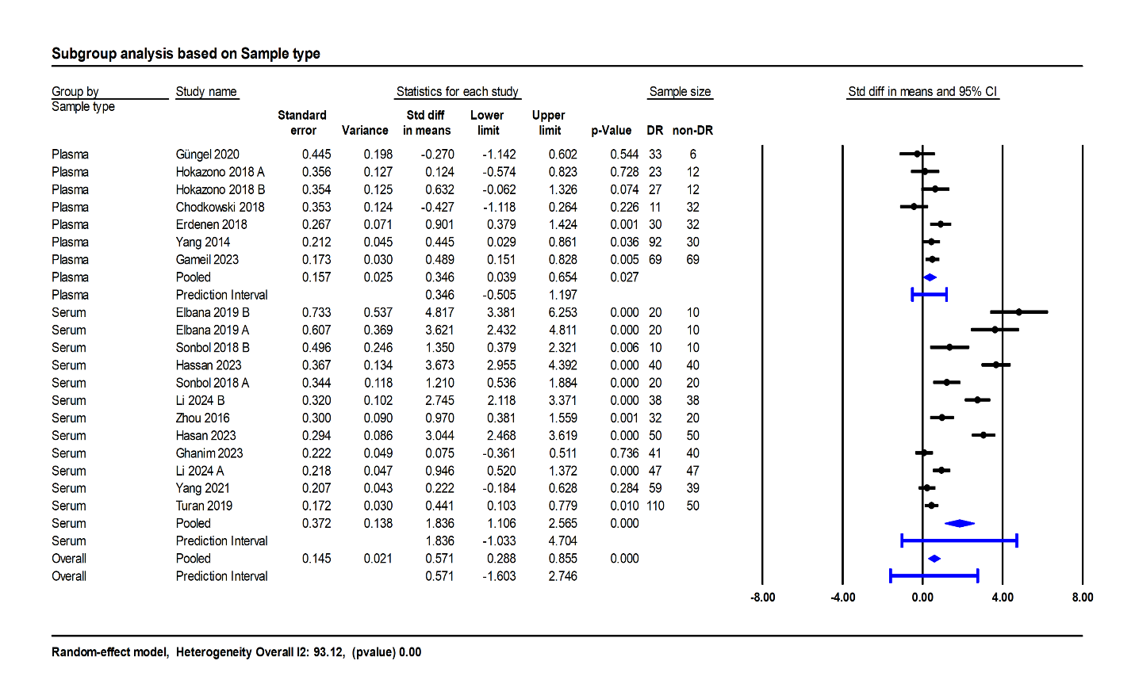
Figure 1. Forest plot for subgroup analysis of PTX3 levels based on sample type between DR and non-DR groups.

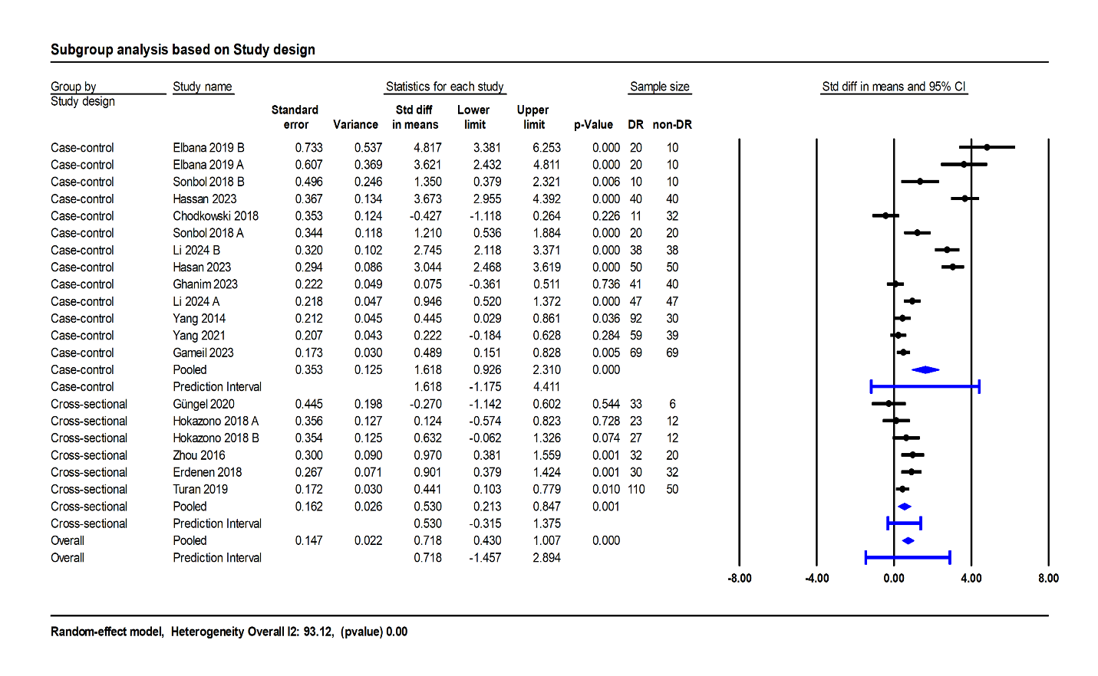
Figure 2. Forest plot for subgroup analysis of PTX3 levels based on study design between DR and non-DR groups.

Figure 3. Funnel plot evaluating publication bias among the included studies.

Figure 4. Sensitivity analysis was performed by recalculating the effect size after sequentially omitting each study.

