Daytime and Nighttime Glycemic Control with Control-IQ Technology vs. Standard Therapy in Type 1 Diabetes: A Systematic Review and Meta-Analysis with Trial Sequential Analysis and GRADE Assessment
Rahma Mogahed Ratebª, Ammar salah^{b}, Ahmed Kertam^{c}, Youssef Adel Youssef Ashmawi^{d}, Nourhan Hatem Mahmoud^{e}, Eslam Afifi^{f}, Ahmed Bayoumi^{d}, Salma Allam^{g}, Mohamed Saad Rakab^{h}.
ªFaculty of Medicine, Assiut University, Assiut, Egypt ; ^{b}Faculty of Medicine, Al-Azhar Assiut University, Assiut, Egypt; ^{c}Faculty of medicine, Ain-shams University, Ain-shams, Egypt; ^{d}Faculty of Medicine, October 6 University, Giza, Egypt; ^{e}Faculty of medicine Suez Canal University, Ismailia, Egypt; ^{f}Faculty of Medicine, Benha University, Benha, Egypt; ^{g}Faculty of Medicine, Galala University, Suez, Egypt; ^{h}Faculty of Medicine, Mansoura University, Mansoura, Egypt.
Corresponding author.
Salma Allam
Faculty of Medicine, Galala University, Suez, Egypt.
+201501000234
Salma.allam@gu.edu.eg

Supplementary Appendix “Daytime and Nighttime Glycemic Control with Control-IQ Technology vs. Standard Therapy in Type 1 Diabetes: A Systematic Review and Meta-Analysis with Trial Sequential Analysis and GRADE Assessment”
Contents
Supplementary figure 1: Risk of bias assessment. 4
Supplementary figure 2: Nighttime Time in the range 70-180mg dl sensitivity analysis. 5
Supplementary figure 3: Time in the range 70-140mg dl sensitivity analysis. 6
Supplementary Figure 4: Time below range 70mg dl sensitivity analysis. 7
Supplementary figure 5: (a) Time below range 54mg/dl, (b) Nightime time below range 54mg/dl, (c) Daytime time below range 54mg/dl. 8
Supplementary figure 6: Time below range 54mg/dl sensitivity analysis. 9
Supplementary figure 7: (a) Time above range 180mg/dl, (b) Nighttime Time above range 180mg/dl, (c) Daytime Time above range 180mg/dl. 10
Supplementary figure 8: Nighttime time above range 180mg/dl sensitivity analysis. 11
Supplementary figure 9: (a) Time above range 300mg/dl, (b) Nighttime time above range 300mg/dl, (c) Daytime time above range 300mg/dl. 12
Supplementary figure 10: (a) Coefficient variation CV, (b) Nighttime coefficient variation CV, (c) Daytime coefficient variation, (d)Mean glucose, (e) Low blood glucose index (LBGI), (f) High blood glucose index (HBGI). 13
Supplementary figure 11: Nighttime coefficient variation CV sensitivity. 14
Supplementary figure 12: Low blood glucose index LBGI sensitivity analysis. 15
Supplementary figure 13: High blood glucose index HBGI sensitivity analysis. 16
Supplementary figure 14: (a) HbA1C level %, (b) Number of patients who achieved HbA1C less than 7% at the end of the trial. 17
Supplementary Figure 15: (a) Diabetic ketoacidosis (DKA), (b) Severe hypoglycemia. 18
Supplementary figure 16: Sensitivity analysis TIR 70-180mg/dl by excluding Forlenza 2019 and Ekhlaspour 2019. 19
Supplementary figure 17: TIR 70-180 mg/dl Sensitivity analysis by excluding Renard 2023. 20
Supplementary figure 18: trial sequential analysis of TBR 70 mg/dl, using random effect model (DL). The required infromation size to detect or reject the mean differenece of -0.42 (C.I: -0.81 to -0.03) reduction has been 1102 patients using the diversity found in the meta anlysis of 72%, with a double sided α of 0.05 and a β of 0.20 (power of 80.0%) the cumulative z-line (blue line) didn’t cross niether convetional statistical siginificance or (RIS) such indicates that the observed diffenrece between Control IQ and control could not be conclusive and more trials are needed. 21
Supplementary figure 19: Mean glucose trail sequential analysis, using random effect model(DL), the (RIS) to detect or reject the mean differenece of -15.98 (C.I: -26.24 to -5.72) reduction has been 413 patients using the diversity found in the meta anlysis of 68%, with a double sided α of 0.05 and a β of 0.20 (power of 80.0%) The cumulative Z- curve (blue full line) passed Superiority boundary sample line which suggest that the cumulative evidence is sufficient to conclude that Control IQ is superior to control group with the existing evidence. 22
Supplementary table 1: Search strategies for all databases: 23
Supplementary table 2: time endpoints of 24-hour, daytime and nighttime data across the included trials. 24
Supplementary table 3: Control-IQ compared to standard therapy in type 1 diabetes GRADE assessment of 24 hour data: 25
Supplementary table 4: Control-IQ compared to standard therapy in type 1 diabetes GRADE assessment of nighttime data: 28

Supplementary figure 1: Risk of bias assessment.

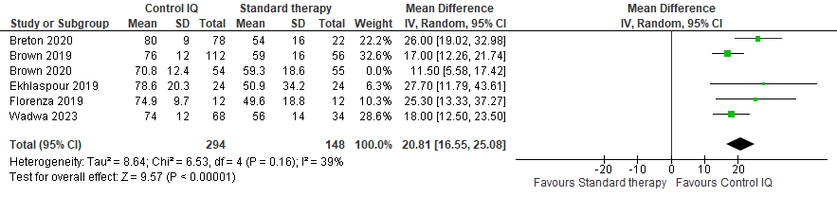

Supplementary figure 2: Nighttime Time in the range 70-180mg dl sensitivity analysis.

Supplementary figure 3: Time in the range 70-140mg dl sensitivity analysis.

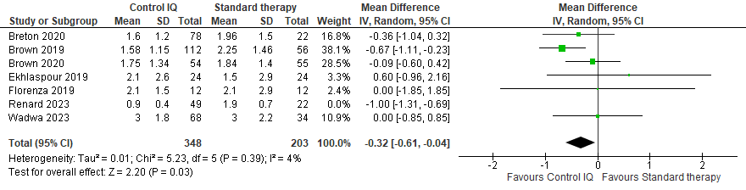

Supplementary Figure 4: Time below range 70mg dl sensitivity analysis.

Supplementary figure 5: (a) Time below range 54mg/dl, (b) Nightime time below range 54mg/dl, (c) Daytime time below range 54mg/dl.

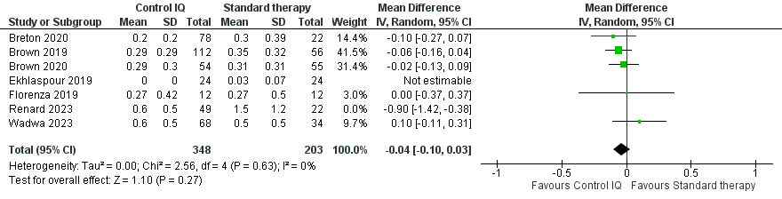

Supplementary figure 6: Time below range 54mg/dl sensitivity analysis.

Supplementary figure 7: (a) Time above range 180mg/dl, (b) Nighttime Time above range 180mg/dl, (c) Daytime Time above range 180mg/dl.

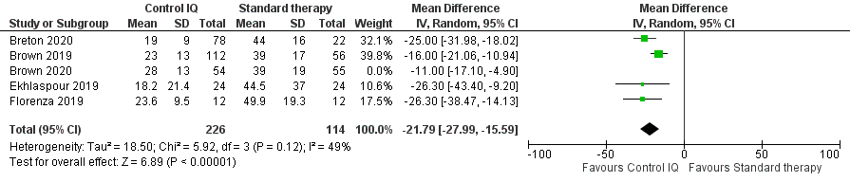

Supplementary figure 8: Nighttime time above range 180mg/dl sensitivity analysis.

Supplementary figure 9: (a) Time above range 300mg/dl, (b) Nighttime time above range 300mg/dl, (c) Daytime time above range 300mg/dl.

Supplementary figure 10: (a) Coefficient variation CV, (b) Nighttime coefficient variation CV, (c) Daytime coefficient variation, (d)Mean glucose, (e) Low blood glucose index (LBGI), (f) High blood glucose index (HBGI).

Supplementary figure 11: Nighttime coefficient variation CV sensitivity.

Supplementary figure 12: Low blood glucose index LBGI sensitivity analysis.

Supplementary figure 13: High blood glucose index HBGI sensitivity analysis.

Supplementary figure 14: (a) HbA1C level %, (b) Number of patients who achieved HbA1C less than 7% at the end of the trial.

Supplementary Figure 15: (a) Diabetic ketoacidosis (DKA), (b) Severe hypoglycemia.

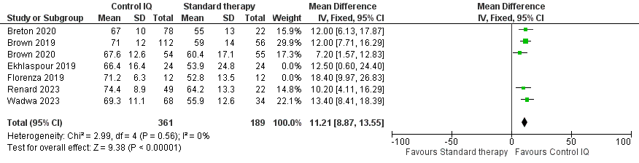

Supplementary figure 16: Sensitivity analysis TIR 70-180mg/dl by excluding Forlenza 2019 and Ekhlaspour 2019.

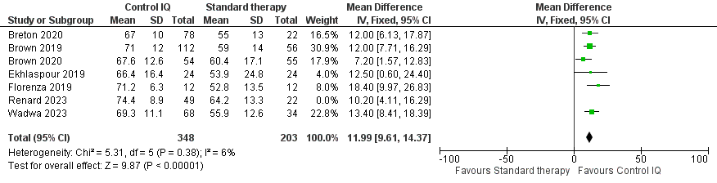

Supplementary figure 17: TIR 70-180 mg/dl Sensitivity analysis by excluding Renard 2023.

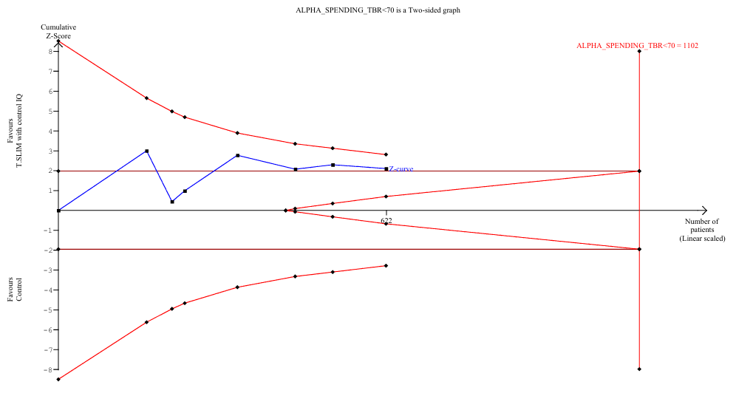

Supplementary figure 18: trial sequential analysis of TBR 70 mg/dl, using random effect model (DL). The required infromation size to detect or reject the mean differenece of -0.42 (C.I: -0.81 to -0.03) reduction has been 1102 patients using the diversity found in the meta anlysis of 72%, with a double sided α of 0.05 and a β of 0.20 (power of 80.0%) the cumulative z-line (blue line) didn’t cross niether convetional statistical siginificance or (RIS) such indicates that the observed diffenrece between Control IQ and control could not be conclusive and more trials are needed.

Supplementary figure 19: Mean glucose trail sequential analysis, using random effect model(DL), the (RIS) to detect or reject the mean differenece of -15.98 (C.I: -26.24 to -5.72) reduction has been 413 patients using the diversity found in the meta anlysis of 68%, with a double sided α of 0.05 and a β of 0.20 (power of 80.0%) The cumulative Z- curve (blue full line) passed Superiority boundary sample line which suggest that the cumulative evidence is sufficient to conclude that Control IQ is superior to control group with the existing evidence.

Supplementary table 1: Search strategies for all databases:
Database | Search strategy | Number of citations
PubMed | Tandem Control-IQ"[All Fields] OR ("t slim"[All Fields] AND "X2"[All Fields] AND ("insulin"[MeSH Terms] OR "insulin"[All Fields] OR "insulin s"[All Fields] OR "insuline"[All Fields] OR "insulinic"[All Fields] OR "insulinization"[All Fields] OR "insulinized"[All Fields] OR "insulins"[MeSH Terms] OR "insulins"[All Fields]) AND "Pump"[All Fields]) OR (("advance"[All Fields] OR "advanced"[All Fields] OR "advancement"[All Fields] OR "advancements"[All Fields] OR "advances"[All Fields] OR "advancing"[All Fields]) AND "hybrid-closed"[All Fields] AND "loop"[All Fields]) OR "Control-IQ"[All Fields] OR "AHCL"[All Fields] | 318
Scopus | TITLE-ABS-KEY ( "Tandem Control-IQ" OR "t:slim X2 Insulin Pump" OR "advanced hybrid-closed loop" OR "Control-IQ" OR "AHCL" ) | 362
Web of Science | "Tandem Control-IQ" OR "t:slim X2 Insulin Pump" OR (advanced hybrid-closed loop) OR "Control-IQ" OR "AHCL" (Topic) | 460
Cochrane library | "Tandem Control-IQ" OR "t:slim X2 Insulin Pump" OR (advanced hybrid-closed loop) OR "Control-IQ" OR "AHCL" | 199

Study ID | 24 hour period | Nighttime | Daytime
Forlenza 2019 | 24 hour | 11 PM to 7 AM | 7 AM to 11 PM
Brown 2019 | 24 hour | 12 AM to 6 AM | 6 AM to 12 PM
Ekhlaspour 2019 | 24 hour | 11 PM to 7 AM | 7 AM to 11 PM
Renard 2023 | 24 hour | _- | _-
Wadwa 2023 | 24 hour | 10 PM to 6 AM | 6 AM to 10 PM
Brown 2020 | 24 hour | 12 AM to 6 AM | 6 AM to 12 PM
Breton 2020 | 24 hour | 12 AM to 6 AM | 6 AM to 12 PM
 | Severe hypoglycemia definitions
Forlenza 2019 | -
Brown 2019 | Severe hypoglycemia: was defined as hypoglycemia leading to the need for assistance because of altered consciousness.
Ekhlaspour 2019 | Severe hypoglycemia had no clear definition
Renard 2023 | Severe hypoglycemia: a hypoglycemic event requiring assistance of another person to actively administer carbohydrate, glucagon, or take other corrective actions due to altered consciousness, seizures, or loss of consciousness.
Wadwa 2023 | Severe hypoglycemia: an event requiring assistance from another person to actively administer carbohydrate, glucagon, or take other corrective actions
Brown 2020 | Severe hypoglycemia: as an event associated with altered mental status and requiring assistance for recovery
Breton 2020 | Severe hypoglycemia: a hypoglycemia leading to the need for assistance because of altered consciousness

Supplementary table 2: time endpoints of 24-hour, daytime and nighttime data across the included trials.

Supplementary table 3: Control-IQ compared to standard therapy in type 1 diabetes GRADE assessment of 24 hour data:
Certainty assessment |  |  |  |  |  |  | Summary of findings
Participants  (studies)  Follow-up | Risk of bias | Inconsistency | Indirectness | Imprecision | Publication bias | Overall certainty of evidence | Study event rates (%) |  | Relative effect  (95% CI) | Anticipated absolute effects
 |  |  |  |  |  |  | With Standard therapy | With Control-IQ | Relative effect  (95% CI) | Risk with Standard therapy | Risk difference with Control-IQ
TIR 70-180 mg/dl
622  (7 RCTs) | not serious | not serious | not serious | not serious | publication bias strongly suspectedª | ⨁⨁⨁◯  Moderateª | 225 | 397 | - | - | MD 11.75 higher  (9.54 higher to 13.97 higher)
TIR 70-140 mg/dl
547  (6 RCTs) | not serious | not serious | not serious | not serious | publication bias strongly suspectedª | ⨁⨁⨁◯  Moderateª | 201 | 346 | - | - | MD 10.02 higher  (6.71 higher to 13.32 higher)
TBR <70 mg/dl
622  (7 RCTs) | not serious | not serious | not serious | not serious | publication bias strongly suspectedª | ⨁⨁⨁◯  Moderateª | 225 | 397 | - | - | MD 0.42 lower  (0.81 lower to 0.03 lower)
TBR < 54 mg/dl
622  (7 RCTs) | serious^{b} | not serious | not serious | serious^{c} | publication bias strongly suspectedª | ⨁◯◯◯  Very low^{a,b,c} | 225 | 397 | - | - | MD 0.07 lower  (0.19 lower to 0.06 higher)
TAR 180 mg/dl
622  (7 RCTs) | not serious | not serious | not serious | not serious | publication bias strongly suspected^{c} | ⨁⨁⨁◯  Moderate^{c} | 225 | 397 | - | - | MD 10.79 lower  (13.1 lower to 8.49 lower)
TAR > 300 mg/dl
622  (7 RCTs) | not serious | not serious | not serious | not serious | publication bias strongly suspectedª | ⨁⨁⨁◯  Moderateª | 225 | 397 | - | - | MD 2.43 lower  (3.29 lower to 1.57 lower)
Glucose CV
622  (7 RCTs) | serious^{b} | not serious | not serious | not serious | publication bias strongly suspectedª | ⨁⨁◯◯  Low^{a,b} | 225 | 397 | - | - | MD 1.42 lower  (2.22 lower to 0.61 lower)
LBGI
548  (5 RCTs) | serious^{b} | not serious | not serious | serious^{c} | publication bias strongly suspectedª | ⨁◯◯◯  Very low^{a,b,c} | 188 | 360 | - | - | MD 0.15 lower  (0.32 lower to 0.02 higher)
CI: confidence interval; MD: mean difference

Explanations
a. asymmetrical distribution of the studies on the funnel plot.
b. Two studies, contributing to 50% or more of the analysis weight, showed high risk of bias.
c. A wide confidence interval that does not exclude the appreciable harm or benefit.

Supplementary table 4: Control-IQ compared to standard therapy in type 1 diabetes GRADE assessment of nighttime data:
Certainty assessment |  |  |  |  |  |  | Summary of findings
Participants  (studies)  Follow-up | Risk of bias | Inconsistency | Indirectness | Imprecision | Publication bias | Overall certainty of evidence | Study event rates (%) |  | Relative effect  (95% CI) | Anticipated absolute effects
 |  |  |  |  |  |  | With Standard therapy | With Control IQ | Relative effect  (95% CI) | Risk with Standard therapy | Risk difference with Control IQ
TIR 70-180 mg/dl
551  (6 RCTs) | not serious | not serious | not serious | not serious | publication bias strongly suspectedª | ⨁⨁⨁◯  Moderateª | 203 | 348 | - | - | MD 19.29 higher  (14.6 higher to 23.98 higher)
TIR 70-140 mg/dl
301  (3 RCTs) | serious^{b} | not serious | not serious | not serious | publication bias strongly suspectedª | ⨁⨁◯◯  Low^{a,b} | 123 | 178 | - | - | MD 14.72 higher  (5.93 higher to 23.5 higher)
TBR 70 mg/dl
551  (6 RCTs) | serious^{b} | not serious | not serious | not serious | publication bias strongly suspectedª | ⨁⨁◯◯  Low^{a,b} | 203 | 348 | - | - | MD 0.57 lower  (0.9 lower to 0.23 lower)
TBR 54 mg/dl
349  (4 RCTs) | serious^{b} | not serious | not serious | serious^{c} | none | ⨁⨁◯◯  Low^{b,c} | 147 | 202 | - | - | MD 0.02 lower  (0.21 lower to 0.16 higher)
TAR 180 mg/dl
449  (5 RCTs) | serious^{b} | not serious | not serious | not serious | publication bias strongly suspectedª | ⨁⨁◯◯  Low^{a,b} | 169 | 280 | - | - | MD 19.35 lower  (25.62 lower to 13.08 lower)
TAR 300
349  (4 RCTs) | serious^{b} | not serious | not serious | not serious | publication bias strongly suspectedª | ⨁⨁◯◯  Low^{a,b} | 147 | 202 | - | - | MD 3.01 lower  (4.18 lower to 1.83 lower)
Glucose CV
551  (6 RCTs) | not serious | not serious | not serious | serious^{c} | publication bias strongly suspected^{b} | ⨁⨁◯◯  Low^{b,c} | 203 | 348 | - | - | MD 1.57 lower  (3.48 lower to 0.34 higher)
CI: confidence interval; MD: mean difference

Explanations
a. asymmetrical distribution of the studies on the funnel plot.
b. Two studies, contributing to 50% or more of the analysis weight, showed high risk of bias.
c. A wide confidence interval that does not exclude the appreciable harm or benefit.

