Efficacy of Intermittently Scanned Continuous Glucose Monitoring in Patients with Types 1 or 2 Diabetes receiving insulin therapy: A Systematic Review and Meta-Analysis
Mayra Souza Botelho¹, Julia Simões Correa Galendi¹, Mariana Andrades Fiorini Monteiro Novo¹, Vania dos Santos Nunes-Nogueira¹
¹Department of Internal Medicine, São Paulo State University (UNESP), Medical School, Botucatu, São Paulo, Brazil

Supplementary File

- Table S1. The reasons for the exclusion of the 15 studies reviewed……….3
- Table S2. FGMS-associated cutaneous adverse events……………………..4
- Subgroup and sensitivity analyses of HbA1c
Figure S1. Subgroup analysis according to type of diabetes mellitus………………………………………………………………………5
Figure S2. Sensitivity analysis separating studies with high risk of bias from those with low risk…………………………………………………………..6
- Subgroup and sensitivity analyses of Time before range (TRB)
Figure S3. Subgroup analysis according to type of diabetes mellitus………………………………………………………...……………6
Figure S4. Sensitivity analysis separating studies with high risk of bias from those with low risk……………………………………………...…………..7
- Subgroup and sensitivity analyses patient-reported outcome using the Diabetes Treatment Satisfaction Questionnaire (DTSQ)
Figure S5. Subgroup analysis according to type of diabetes mellitus……………………………………………………………….…….7
Figure S6. Sensitivity analysis separating studies with high risk of bias from those with low risk…………………………………………………………8
- Meta-regression graph of HbA1c
Figure S7. Metarregression of HbA1c , used variables: mean age of the participants, duration of diabetes, mean HbA1c at baseline visit, duration of intervention………………………………………………………………..8
Figure S8. Metarregression of HbA1c , variable used: mean age………...9
- Meta-analysis of Hypoglycemia
Fig S9. Meta-analysis of the event rate in hypoglycemia level 1…………9
Fig S10. Meta-analysis of the event rate in hypoglycemia level 2………..9
- Publication Bias
Figure S11. Confunnel plot HBA1c of meta-analysis of HbA1c………10
Figure S12. . Confunnel plot HBA1c of meta-analysis of DTSQ………10
- Proportion Meta-Analysis
Figure S13. Meta-analysis of the overall frequency of participants who discontinued FGMS due to cutaneous adverse events……………………11
- Search Strategies…………………………………………………………12

Table S1. The reasons for the exclusion of the 15 studies reviewed
Author (year) | Reason for Exclusion
Aronson (2022) | T2DM without insulin therapy
Choe (2022) | The intervention group received CGM associated with structured education, which the control group did not receive.
Furler (2020) | Only 50% of participants were using insulin
Guo (2023) | Both arms were using SMBG
Haskova (2020) | Both arms were SMBG
Hermanns (2019) | Both arms were using FGMS
Jugnee (2017) | Conference abstract
Lee (2022) | Both arms were using FGMS
Li (2021) | Conference abstract
Low (2021) | No outcome of interest
McMorrow (2020) | Only 50% of participants were using insulin
Messaaoui (2022) | No group with SMBG
O'Connor (2024) | 97% T2DM, and 43% were newly diagnosed
Rama Chandran (2024) | Only 29.5% of patients used basal insulin
Reddy (2018) | No group with SMBG
Rose (2021) | Extension phase of an included RCT (control arm also used FGMS)
Sehgal (2023) | Aults with type 1 diabetes were randomized to use isCGM or DIY-rtCGM. No group with SMBG
Yan (2022) | Both arms were using FGM
FGMS: Flash glucose monitoring system, SMBG: Self-monitored blood glucose method, T2DM: Type 2 diabetes, isCGM: intermittently scanned continuous glucose monitoring, rtCGM: real time continuous glucose monitoring

Table S2. FGMS-associated cutaneous adverse events
Study (year) | Adverse Event | Actions taken
Ajjan (2019) | - Superficial thrombophlebitis (mild)  - Redness (mild) | - Resolved without treatment  - Partially resolved with non-prescription creams
Bolinder (2016) | - Allergy (one severe, three moderate)  - Itching (mild)  - Rash (mild)  - Insertion-site symptom (four severe)  - Erythema (one severe, one mild)  - Edema (moderate); | No information
Haak (2017) | - Sensor-adhesive reactions (two severe, six moderate and one mild) | - All resolved with topical preparations
Jefferies (2023) | - One local reaction (erythema, dryness, and irritation)  - One episode of cutaneous reaction to a skin tape fixation | - Data not repeated due to subject choice  - Not repeated once the tape fixation was removed
Leelarathna (2022) | - One skin reaction to sensor | No information
Yan (2023) | - Three (5.56%) participants reported skin oedema at the device insertion site. | No information

Figure S1. Subgroup analysis of HbA1c according to type of diabetes mellitus

Figure S2. Sensitivity analysis of HbA1c separating studies with high risk of bias from those with low risk
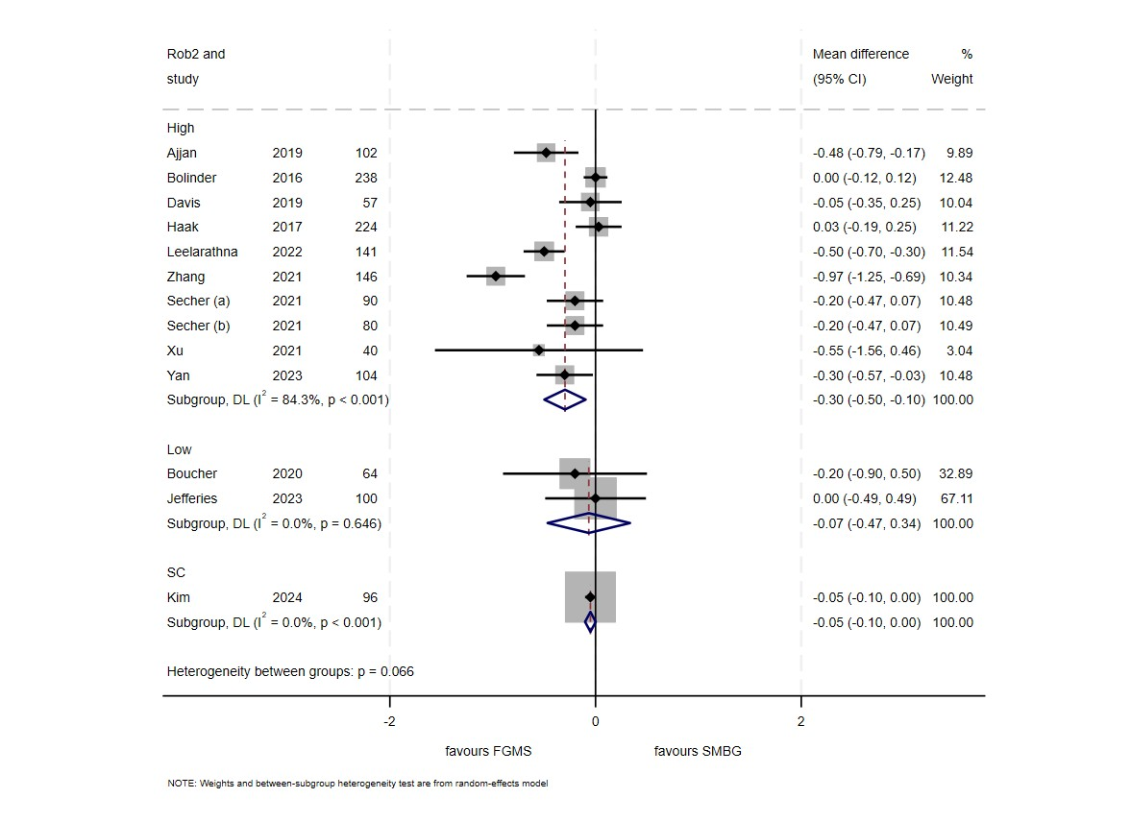
Figure S3. Subgroup analysis of TBR according to type of diabetes
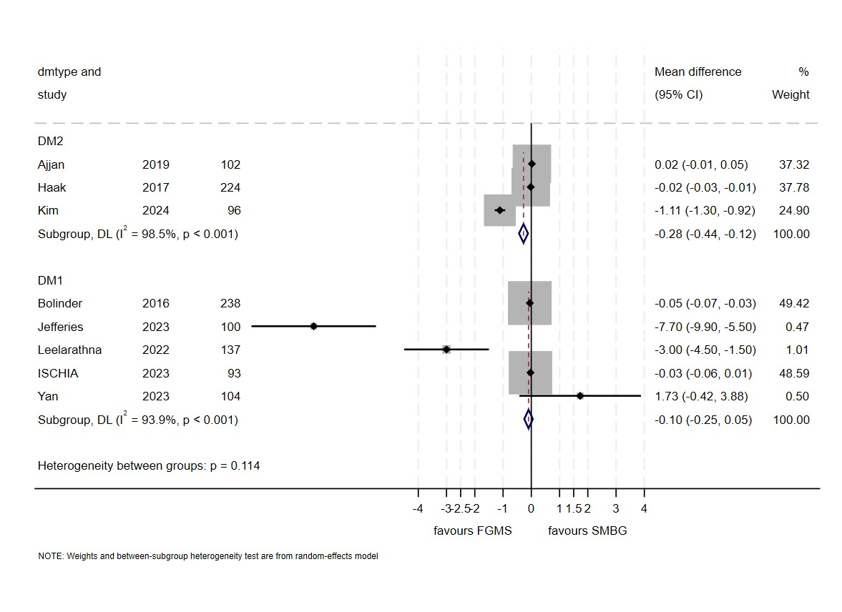
Figure S4. Sensitivity analysis of TBR separating studies with high risk of bias from those with low risk
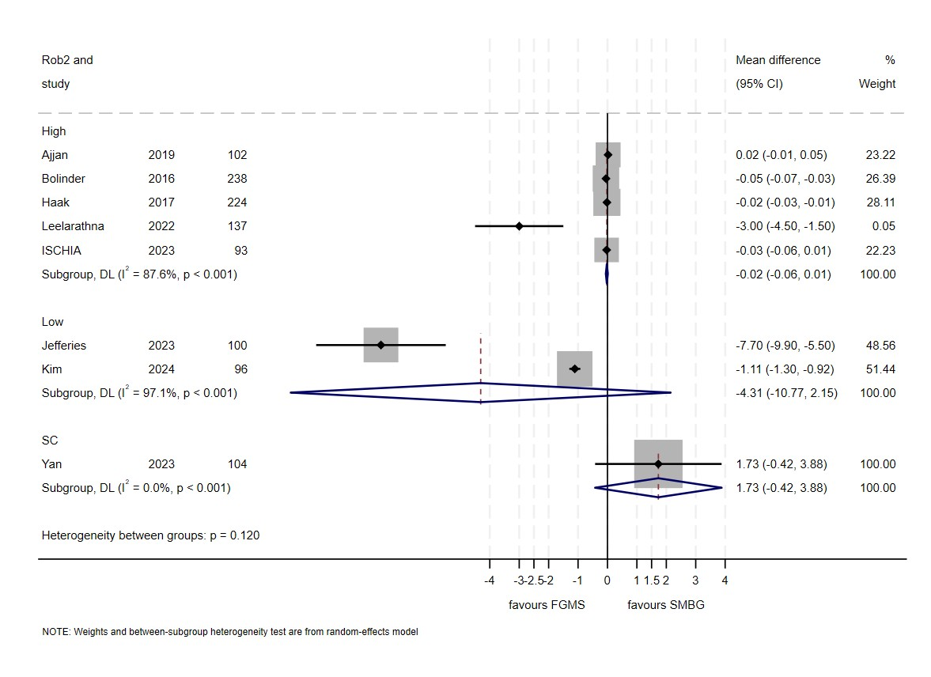
Figure S5. Subgroup analysis of DTSQ according to type of diabetes mellitus

Figure S6. Sensitivity analysis of DTSQ separating studies with high risk of bias from those with low risk
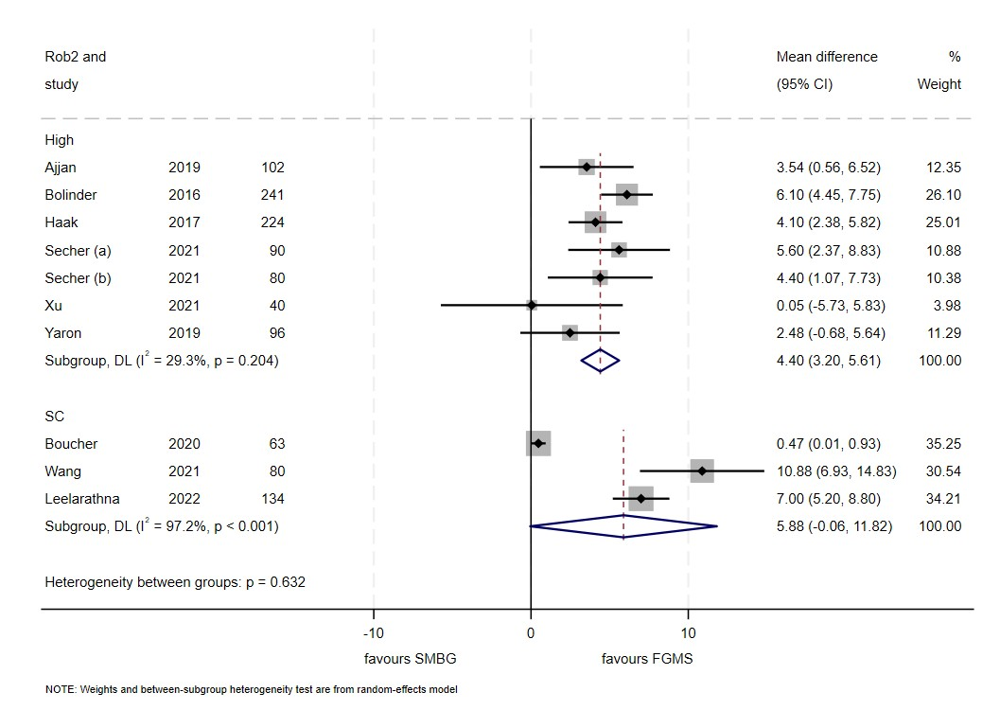
Figure S7. Metarregression of HbA1c , used variables: mean age of the participants, duration of diabetes, mean HbA1c at baseline visit, duration of intervention

Figure S8. Metarregression of HbA1c , variable used: mean age

Fig S9. Meta-analysis of the event rate in hypoglycemia level 1
S10. Meta-analysis of the event rate in hypoglycemia level 2

Figure S11. Confunnel plot HBA1c of meta-analysis of HbA1c…

Figure S12. Confunnel plot HBA1c of meta-analysis of DTSQ

Figure S13. Meta-analysis of the overall frequency of participants who discontinued FGMS due to cutaneous adverse events
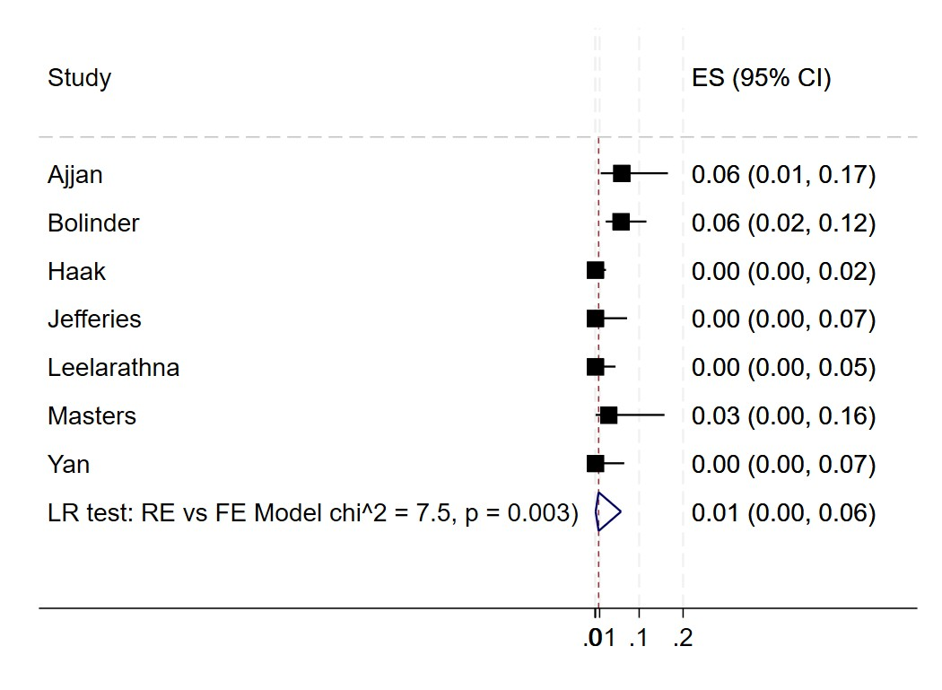

Search Strategies

PUBMED: 22/06/2024
Item | Busca | Term | Hits
Diabetes Mellitus, Type 2 | #1 | "Diabetes Mellitus, Type 2"[Mesh] OR (Diabetes Mellitus, Noninsulin-Dependent) OR (Diabetes Mellitus, Ketosis Resistant) OR (Ketosis-Resistant Diabetes Mellitus) OR (Diabetes Mellitus, Non Insulin Dependent) OR (Diabetes Mellitus, Non-Insulin-Dependent) OR (Non-Insulin-Dependent Diabetes Mellitus) OR (Diabetes Mellitus, Stable) OR (Stable Diabetes Mellitus) OR (Diabetes Mellitus, Type II) OR(NIDDM) OR (Diabetes Mellitus, Noninsulin Dependent) OR (Diabetes Mellitus, Maturity-Onset) OR (Diabetes Mellitus, Maturity Onset) OR (Maturity-Onset Diabetes Mellitus) OR (Maturity Onset Diabetes Mellitus) OR (MODY) OR (Diabetes Mellitus, Slow-Onset) OR (Diabetes Mellitus, Slow Onset) OR (Slow-Onset Diabetes Mellitus) OR (Type 2 Diabetes Mellitus) OR (Noninsulin-Dependent Diabetes Mellitus) OR (Noninsulin Dependent Diabetes Mellitus) OR (Maturity-Onset Diabetes) OR (Diabetes, Maturity-Onset) OR (Maturity Onset Diabetes) OR (Type 2 Diabetes) OR (Diabetes, Type 2) OR (Diabetes Mellitus, Adult-Onset) OR (Adult-Onset Diabetes Mellitus) OR (Diabetes Mellitus, Adult Onset) | 279,032
Diabetes Mellitus type 1 | #2 | "Diabetes Mellitus, Type 1"[Mesh] OR (Diabetes Mellitus, Insulin-Dependent) OR (Diabetes Mellitus, Insulin Dependent) OR (Insulin-Dependent Diabetes Mellitus) OR (Diabetes Mellitus, Insulin-Dependent, 1) OR (Diabetes Mellitus, Juvenile-Onset) OR (Diabetes Mellitus, Juvenile Onset) OR (Juvenile-Onset Diabetes Mellitus) OR (Type 1 Diabetes Mellitus) OR (Diabetes Mellitus, Sudden-Onset) OR (Diabetes Mellitus, Sudden Onset) OR (Mellitus, Sudden-Onset Diabetes) OR (Sudden-Onset Diabetes Mellitus) OR (Diabetes Mellitus, Type I) OR (IDDM) OR (Insulin-Dependent Diabetes Mellitus 1) OR (Insulin Dependent Diabetes Mellitus 1) OR (Juvenile-Onset Diabetes) OR (Diabetes, Juvenile-Onset) OR (Juvenile Onset Diabetes) OR (Diabetes Mellitus, Brittle) OR (Brittle Diabetes Mellitus) OR (Diabetes Mellitus, Ketosis-Prone) OR (Diabetes Mellitus, Ketosis Prone) OR (Diabetes, Autoimmune) OR (Autoimmune Diabetes) OR (Ketosis-Prone Diabetes Mellitus) OR (young people with diabetes) OR (Diabetes, Juvenile Onset) | 169,946
Intermittently Scanned Continuous Glucose Monitoring | #3 | "Continuous Glucose Monitoring"[Mesh] OR (Flash Glucose Monitoring) OR (FreeStyle Libre 2) OR (Flash-glucose Monitoring) OR (Intermittently Scanned Continuous Glucose Monitoring) OR (FreeStyle libre) OR (Flash GM) | 2,296
Blood Glucose Self-Monitoring | #4 | "Blood Glucose Self-Monitoring"[Mesh] OR (Blood Glucose Self Monitoring) OR (Glucose, Blood, Self-Monitoring) OR (Self-Monitoring, Blood Glucose) OR (Blood Glucose Self-Monitorings) OR (Glucose Self-Monitoring, Blood) OR (Glucose Self-Monitorings, Blood) OR (Self Monitoring, Blood Glucose) OR (Self-Monitorings, Blood Glucose) OR (Glucose, Blood, Self Monitoring) OR (Blood Sugar Self-Monitoring) OR (Blood Sugar Self Monitoring) OR (Blood Sugar Self-Monitorings) OR (Self-Monitoring, Blood Sugar) OR (Self-Monitorings, Blood Sugar) OR (Sugar Self-Monitoring, Blood) OR (Sugar Self-Monitorings, Blood) OR (Home Blood Glucose Monitoring) OR (Monitoring, Home Blood Glucose) | 13,888
randomized controlled trial | #5 | (randomized controlled trial[pt] OR controlled clinical trial[pt] OR randomized[tiab] OR placebo[tiab] OR drug therapy[sh] OR randomly[tiab] OR trial[tiab] OR groups[tiab] NOT (animals [mh] NOT humans [mh])) | 5,319,277
 | # 7 | #1 OR #2 | 384,266
 | #8 | #3 AND #4 AND #5 AND 7 | 461

PUBMED Filter
#5 Sensitivity-maximizing version (2008 revision); PubMed format. https://work.cochrane.org/pubmed
EMBASE: 22/06/2024
Item | Busca | Termos | Hits
'Intermittently Scanned Continuous Glucose Monitoring' | #1 | 'flash glucose monitoring system'/exp | 47
 | #2 | 'Flash-glucose Monitoring'/exp | 87
 | #3 | 'Intermittently Scanned Continuous Glucose Monitoring'/exp | 30
 | #4 | 'FreeStyle libre pro'/exp | 116
 | #5 | ‘FreeStyle Libre 2'/exp | 60
 | #6 | ‘FreeStyle Libre 1'/exp | 21
 |  | 'Flash GM'/exp
 | #7 | ‘FreeStyle Libre flash’/exp | 17
 | #8 | ‘FreeStyle Libre pro flash’'/exp | 11
 | #9 | ‘FreeStyle Libre 3'/exp | 17
 | #10 | #1 OR #2 OR #3 OR #4 OR #5 OR #6 OR #7 OR #8 OR #9 | 377
Diabetes Mellitus typo 2 | #11 | ‘non insulin dependent diabetes mellitus'/exp OR 'adult onset diabetes' OR 'adult onset diabetes mellitus' OR 'diabetes mellitus type 2' OR 'diabetes mellitus type ii' OR 'diabetes mellitus, maturity onset' OR 'diabetes mellitus, non insulin dependent' OR 'diabetes mellitus, non-insulin-dependent' OR 'diabetes mellitus, type 2' OR 'diabetes mellitus, type II' OR 'diabetes type 2' OR 'diabetes type II' OR 'diabetes, adult onset' OR 'dm 2' OR 'insulin independent diabetes' OR 'insulin independent diabetes mellitus' OR 'ketosis resistant diabetes mellitus' OR 'maturity onset diabetes' OR 'maturity onset diabetes mellitus' OR 'niddm' OR 'NIDDM (non insulin dependent diabetes mellitus)' OR 'non insulin dependent (type 2) diabetes mellitus' OR 'non insulin dependent diabetes' OR 'non-insulin-dependent diabetes mellitus' OR 'noninsulin dependent (type 2) diabetes mellitus' OR 'noninsulin dependent diabetes' OR 'noninsulin dependent diabetes mellitus' OR 'T2DM' OR 'TIIDM' OR 'type 2 (insulin independent) diabetes' OR 'type 2 diabetes' OR 'type 2 diabetes mellitus' OR 'type II diabetes' OR 'type II diabetes mellitus' OR 'non insulin 'dependent diabetes mellitus'
Diabetes Mellitus typo 1 | #12 | ‘insulin dependent diabetes mellitus'/exp OR 'diabetes mellitus type 1' OR 'diabetes mellitus type I' OR 'diabetes mellitus, insulin dependent' OR 'diabetes mellitus, insulin-dependent' OR 'diabetes mellitus, juvenile onset' OR 'diabetes mellitus, type 1' OR 'diabetes mellitus, type I' OR 'diabetes type 1' OR 'diabetes type I' OR 'diabetes, juvenile' OR 'DM 1' OR 'early onset diabetes mellitus' OR 'IDDM' OR 'IDDM1' OR 'insulin dependent diabetes' OR 'insulin-dependent diabetes mellitus' OR 'juvenile diabetes' OR 'juvenile diabetes mellitus' OR 'juvenile onset diabetes' OR 'juvenile onset diabetes mellitus' OR 'mckusick 22210' OR 'T1DM' OR 'type 1 diabetes' OR 'type 1 diabetes mellitus' OR 'type I diabetes' OR 'type I diabetes mellitus' OR 'insulin dependent diabetes mellitus'
 | #13 | #11 OR #12 | 435,040
 | #14 | #10 AND #13 | 273

ENTRAL COCHRANE:23/06/2024
Item | Busca | Termos | Hits
 | #1 | MeSH descriptor: [Continuous Glucose Monitoring] explode all trees | 21
 | #2 | (flash glucose monitoring):ti,ab,kw | 352
 | #3 | (FreeStyle Libre 2):ti,ab,kw | 263
 | #4 | (Intermittently Scanned Continuous Glucose Monitoring):ti,ab,kw | 109
 | #5 | (FreeStyle libre):ti,ab,kw | 307
 | #9 | #1 OR #2 OR #3 OR #4 OR #5 (Word variations have been searched) | 623

