Catalogue

Figure S1. Flow Chart of participant screening in NHANES and CHARLS cohorts. 3
Figure S2. The multivariable-adjusted OR of stroke among the participants varied with eGDR levels. . 4
Table S1 Validation of the Proportional Hazards Assumption in Cox Regression Models for the Association between Variables and Mortality in NHANES Study. 5
Figure S3. Validation of the Proportional Hazards Assumption for Cox Regression Models. 6
Table S2. Validation of the Proportional Hazards Assumption in Cox Regression Models for the Association between Variables and Stroke Incidence and Mortality in CHARLS Study. 8
Figure S4. Validation of the Proportional Hazards Assumption for Cox Regression Models. . 9
Table S3. Association Between eGDR and prevalence of Stroke by Specific Baseline Characteristics in NHANES Study. 11
Table S4. Association Between eGDR And Risk of Mortality by Specific Baseline Characteristics in NHANES Study. 13
Table S5. Direct and indirect effects of eGDR on the risk of Stroke and Mortality Among Participants with Stroke in NHANES Study. 15
Table S6. Association Between eGDR and Stroke After Including Participants with Missing Covariates in NHANES Study. 16
Table S7. Association Between eGDR and Mortality After Excluding Participants with Missing Covariates in NHANES Study. 17
Table S8. Association Between eGDR and Stroke After Including Participants Aged 20 years or older in NHANES Study. 18
Table S9. Association Between eGDR and Mortality After Including Participants Aged 20 years or older in NHANES Study. 19
Table S10. Multi-factor competing risk model compared the association between eGDR and mortality in the NHANES study. 20
Table S11. Baseline characteristics of 6873 participants by tertile of eGDR in CHARLS study 21
Table S12. Characteristics of 6721 participants by tertile of eGDR in CHARLS Study excluding with history of stroke at baseline or lost to follow-up. 23
Table S13. Association between eGDR and incident stroke and all-cause mortality in CHARLS study. 25
Table S14. Random-Effects Meta-Analysis of eGDR and All-Cause Mortality from the fully-adjusted models (Model 3). 26
Table S15. STROBE Checklist 27

NHANES | CHARLS
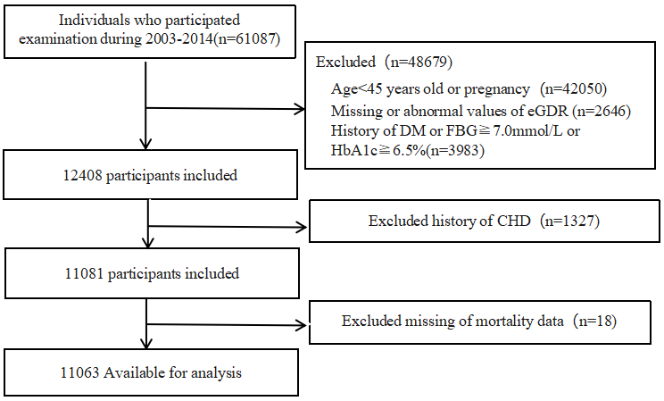 | 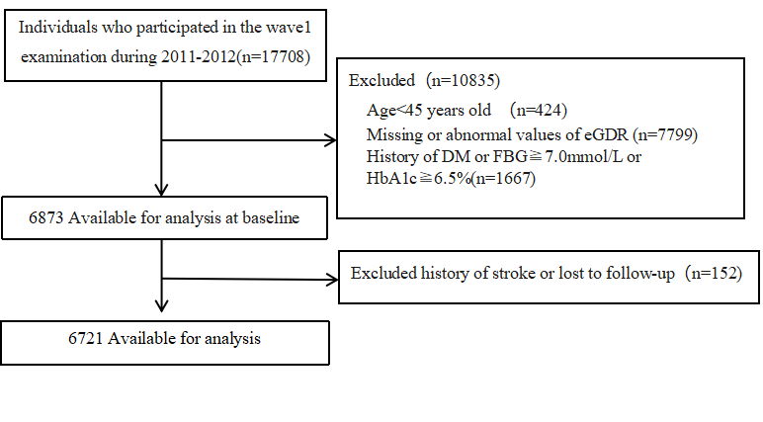

Figure S1. Flow Chart of participant screening in NHANES and CHARLS cohorts.

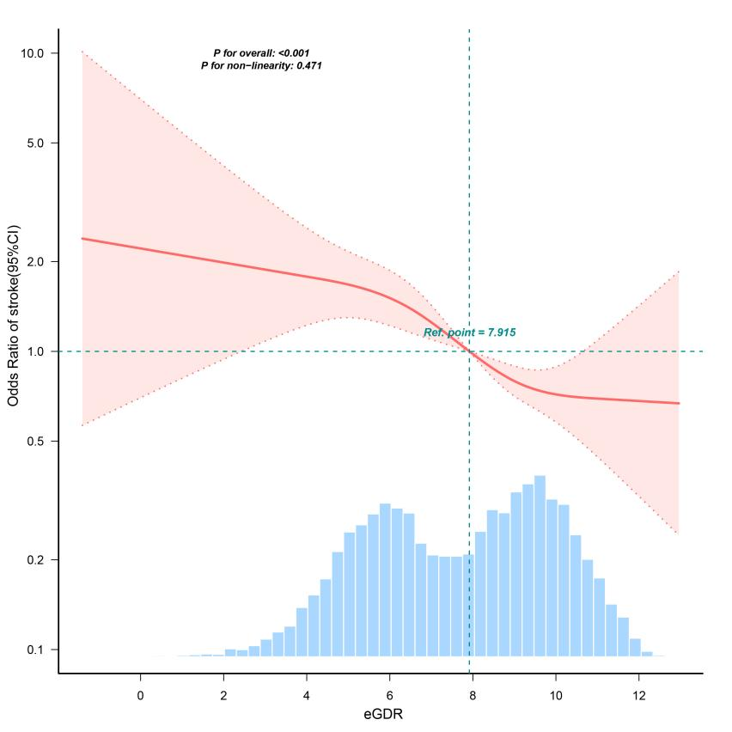

Figure S2. The multivariable-adjusted OR of stroke among the participants varied with eGDR levels. The solid line represents the multivariable-adjusted OR, and the dashed line represents the 95% CI from the RCS regression. Logistic regression analysis was adjusted for age, sex, education, smoking status, alcohol consumption, marital status, race, PIR, BMI, LDL-C, Cho, TG, and Lipid-lowering drugs.

Table S1 Validation of the Proportional Hazards Assumption in Cox Regression Models for the Association between Variables and Mortality in NHANES Study.
Variable | All-cause mortality |  |  | CVD mortality |  |  | Cerebrovascular diseases mortality
Variable | Chi-sq | P-value |  | Chi-sq | P-value |  | Chi-sq | P-value
Sex | 3.308 | 0.069 |  | 0.208 | 0.649 |  | 0.205 | 0.651
Age | 2.471 | 0.116 |  | 0.087 | 0.768 |  | 0.09 | 0.764
PIR | 1.576 | 0.209 |  | 2.872 | 0.09 |  | 2.862 | 0.091
Race | 1.615 | 0.806 |  | 4.484 | 0.344 |  | 4.485 | 0.344
Education | 1.133 | 0.889 |  | 1.074 | 0.898 |  | 1.09 | 0.896
Smoking status | 3.746 | 0.154 |  | 2.815 | 0.245 |  | 2.824 | 0.244
Alcohol consumption | 4.143 | 0.126 |  | 2.448 | 0.118 |  | 2.451 | 0.117
Marital status | 2.787 | 0.095 |  | 1.277 | 0.259 |  | 1.28 | 0.258
BMI | 0.711 | 0.399 |  | 2.883 | 0.089 |  | 3.15 | 0.076
eGDR | 3.214 | 0.241 |  | 0.463 | 0.793 |  | 0.458 | 0.796
Cho | 0.005 | 0.946 |  | 1.22 | 0.269 |  | 1.23 | 0.267
TG | 1.286 | 0.257 |  | 0.135 | 0.714 |  | 0.136 | 0.712
LDL-C | 0.095 | 0.758 |  | 3.478 | 0.062 |  | 3.496 | 0.062
Lipid-lowering drugs | 0.001 | 0.979 |  | 0.404 | 0.525 |  | 0.401 | 0.526
GLOBAL | 28.349 | 0.257 |  | 30.624 | 0.104 |  | 30.653 | 0.103

A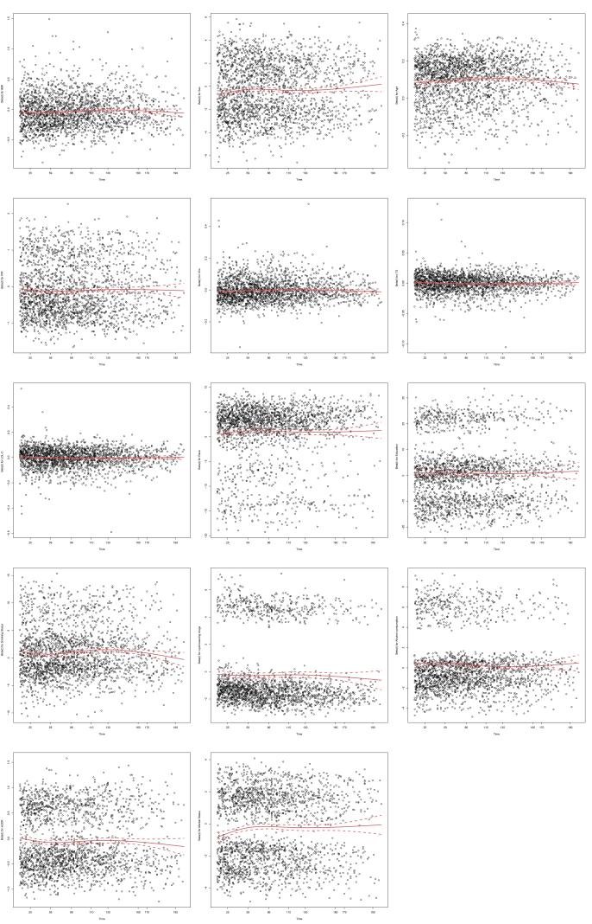 | B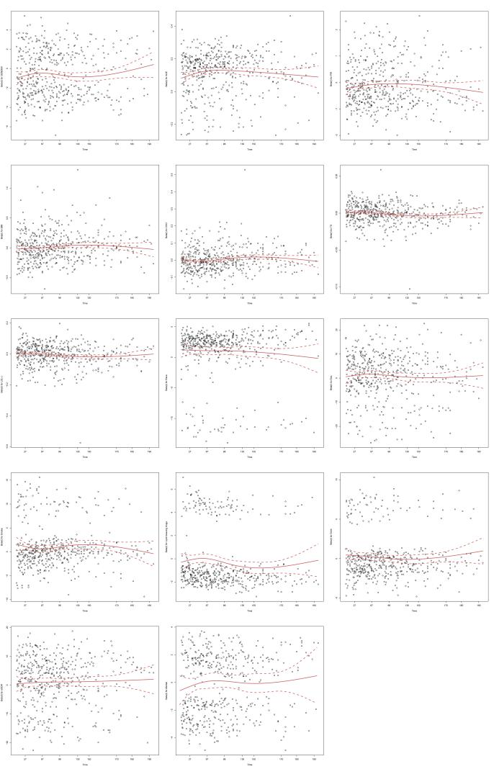 | C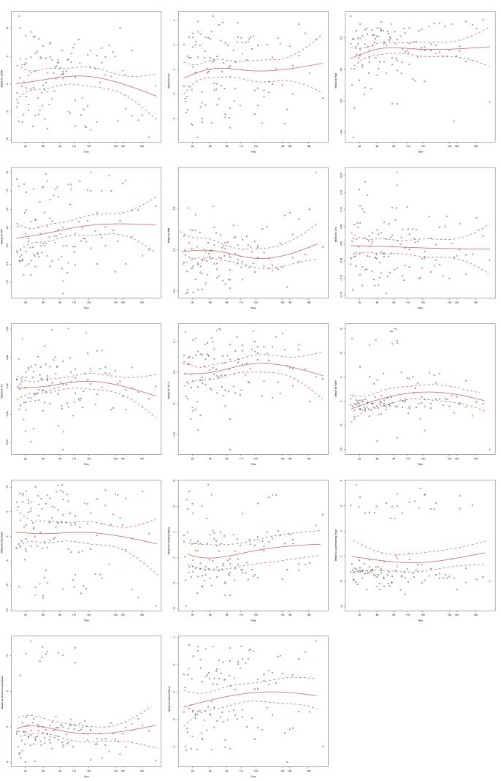

Figure S3. Validation of the Proportional Hazards Assumption for Cox Regression Models. Schoenfeld residual plots assess the proportional hazards assumption for the association between key variables and mortality in the NHANES study. A global test for non-proportional hazards was performed, with a non-significant p-value (> 0.05) indicating the assumption was satisfied. Plots are shown for models predicting (A) all-cause mortality, (B) CVD mortality, and (C) cerebrovascular disease mortality. A relatively flat solid line and a non-significant p-value for each model suggest that the proportional hazards assumption was not violated.

Table S2. Validation of the Proportional Hazards Assumption in Cox Regression Models for the Association between Variables and Stroke Incidence and Mortality in CHARLS Study.
Variable | Stroke |  |  | All-cause mortality
Variable | Chi-sq | P-value |  | Chi-sq | P-value
Sex | 3.606 | 0.058 |  | 0.51 | 0.475
Age | 0.008 | 0.928 |  | 0.512 | 0.474
Education | 1.312 | 0.519 |  | 3.182 | 0.364
Smoking status | 1.251 | 0.535 |  | 1.564 | 0.458
Alcohol consumption | 0.111 | 0.739 |  | 1.523 | 0.217
Marital status | 0.377 | 0.539 |  | 0.018 | 0.894
BMI | 0.073 | 0.787 |  | 0.003 | 0.96
eGDR | 3.214 | 0.2 |  | 0.658 | 0.72
CRP | 0.105 | 0.745 |  | 0.915 | 0.339
UA | 1.364 | 0.243 |  | 2.823 | 0.093
Cho | 0.352 | 0.553 |  | 0.102 | 0.749
TG | 0.009 | 0.926 |  | 0.339 | 0.56
LDL-C | 0.111 | 0.739 |  | 2.202 | 0.333
lipid-lowering drugs | 2.741 | 0.098 |  | 0.063 | 0.802
GLOBAL | 18.977 | 0.215 |  | 14.762 | 0.542

A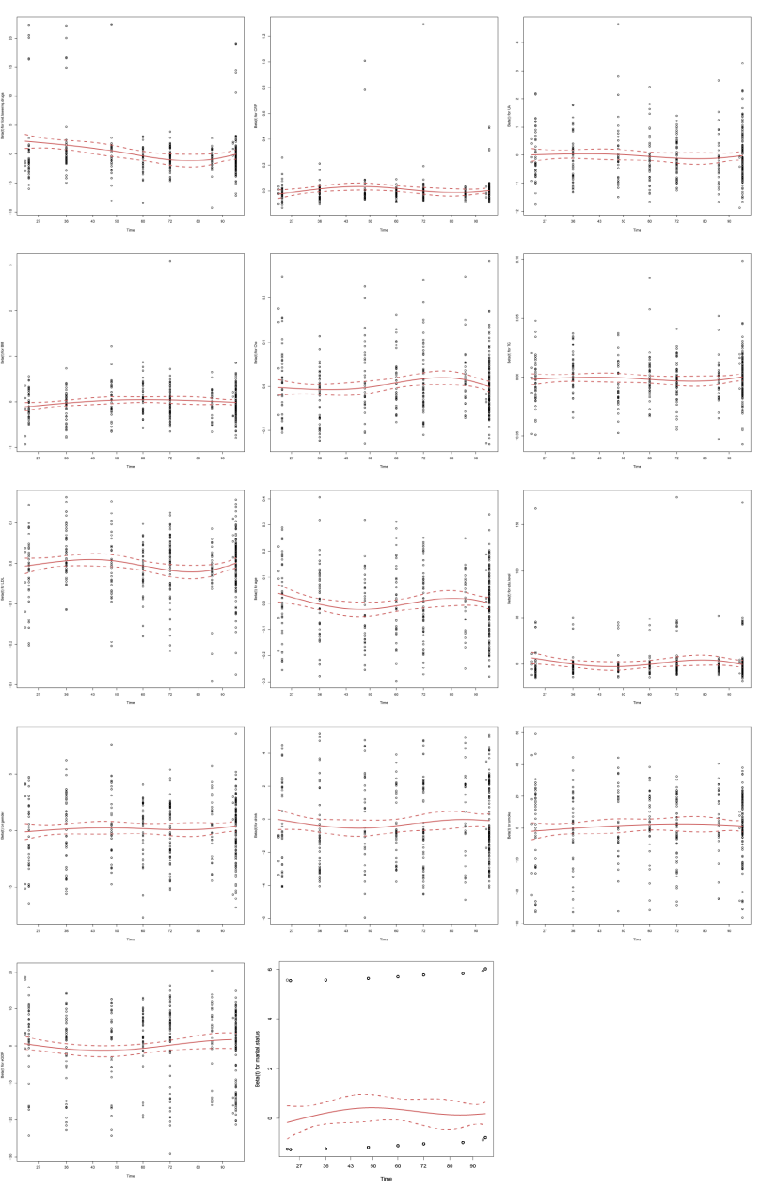 | B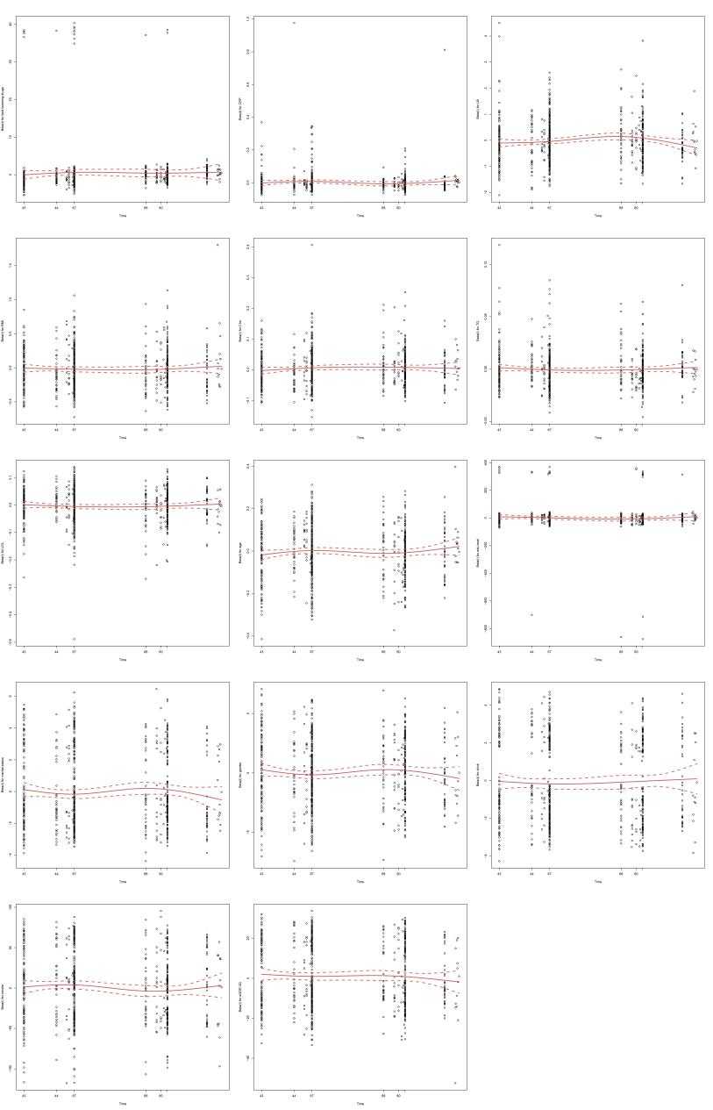

Figure S4. Validation of the Proportional Hazards Assumption for Cox Regression Models. Schoenfeld residual plots assess the proportional hazards assumption for the association between key variables and mortality in the CHARLS study. A global test for non-proportional hazards was performed, with a non-significant p-value (> 0.05) indicating the assumption was satisfied. Plots are shown for models predicting (A) Stroke Incidence, (B) All-cause mortality.

A relatively flat solid line and a non-significant p-value for each model suggest that the proportional hazards assumption was not violated.

Table S3. Association Between eGDR and prevalence of Stroke by Specific Baseline Characteristics in NHANES Study.
Variable | Event, n (%) | Model 1 |  | Model 2 |  | Model 3 |  | P for interaction
Variable | Event, n (%) | OR (95%CI) | P value | OR (95%CI) | P value | OR (95%CI) | P value | P for interaction
Sex
Male | 176 (3.4) | 0.84 (0.79~0.9) | <0.001 | 0.88 (0.82~0.95) | 0.001 | 0.85 (0.78~0.94) | 0.001 | 0.454
Female | 204 (3.5) | 0.82 (0.77~0.87) | <0.001 | 0.86 (0.8~0.92) | <0.001 | 0.83 (0.76~0.91) | <0.001
Age
<60 | 91 (1.7) | 0.79 (0.73~0.86) | <0.001 | 0.8 (0.73~0.87) | <0.001 | 0.78 (0.69~0.88) | <0.001 | 0.013
≥60 | 289 (5.1) | 0.89 (0.85~0.94) | <0.001 | 0.91 (0.86~0.96) | 0.001 | 0.88 (0.81~0.94) | 0.001
BMI
<25 | 122 (3.7) | 0.75 (0.68~0.83) | <0.001 | 0.86 (0.78~0.96) | 0.007 | 0.87 (0.78~0.98) | 0.019 | 0.926
25-30 | 138 (3.3) | 0.73 (0.66~0.8) | <0.001 | 0.85 (0.77~0.95) | 0.003 | 0.87 (0.78~0.97) | 0.011
≥30 | 120 (3.4) | 0.81 (0.74~0.88) | <0.001 | 0.84 (0.76~0.92) | <0.001 | 0.78 (0.69~0.88) | <0.001
Smoking status
Never | 150 (2.7) | 0.84 (0.78~0.9) | <0.001 | 0.88 (0.81~0.95) | 0.001 | 0.85 (0.76~0.94) | 0.002 | 0.263
Former | 151 (4.1) | 0.85 (0.79~0.91) | <0.001 | 0.91 (0.84~0.98) | 0.019 | 0.87 (0.78~0.96) | 0.007
Current | 79 (4.4) | 0.79 (0.71~0.87) | <0.001 | 0.81 (0.73~0.9) | <0.001 | 0.81 (0.71~0.94) | 0.005
Alcohol consumption
No | 296 (3.1) | 0.83 (0.79~0.87) | <0.001 | 0.88 (0.83~0.93) | <0.001 | 0.85 (0.79~0.92) | <0.001 | 0.987
Yes | 84 (5.5) | 0.85 (0.78~0.94) | 0.001 | 0.86 (0.77~0.95) | 0.002 | 0.83 (0.73~0.96) | 0.011
Race
Non-Hispanic White | 219 (3.8) | 0.84 (0.79~0.89) | <0.001 | 0.88 (0.82~0.94) | <0.001 | 0.84 (0.77~0.92) | <0.001 | 0.287
Non-Hispanic Black | 88 (4.2) | 0.86 (0.79~0.95) | 0.002 | 0.87 (0.79~0.97) | 0.008 | 0.87 (0.75~1) | 0.049
Hispanic | 38 (2.6) | 0.85 (0.73~0.98) | 0.026 | 0.9 (0.77~1.06) | 0.205 | 0.91 (0.75~1.12) | 0.37
Non-Hispanic Asian | 14 (1.6) | 0.94 (0.74~1.2) | 0.631 | 0.98 (0.75~1.28) | 0.896 | 1.01 (0.71~1.42) | 0.971
Other Race | 21 (2.7) | 0.68 (0.55~0.83) | <0.001 | 0.71 (0.56~0.88) | 0.003 | 0.55 (0.38~0.78) | 0.001
Model 1: crude. Model 2: age, sex, education, smoking status, alcohol consumption, marital status, race, and PIR. Model 3 is adjusted for model 2 covariates plus BMI, LDL-C, Cho, TG, and Lipid-lowering drugs. Abbreviations: NHANES, National Health and Nutrition Examination Survey. BMI, body mass index.

Table S4. Association Between eGDR And Risk of Mortality by Specific Baseline Characteristics in NHANES Study.
 | All-cause mortality* |  |  | CVD mortality* |  |  | Cerebrovascular diseases mortality*
Subgroup | HR (95%CI) | P value | P for interaction | HR (95%CI) | P value | P for interaction | HR (95%CI) | P value | P for interaction
Sex
Male | 0.96 (0.92~0.99) | 0.014 | 0.553 | 0.94 (0.88~1.01) | 0.104 | 0.647 | 0.81 (0.69~0.95) | 0.011 | 0.895
Female | 0.93 (0.89~0.97) | <0.001 |  | 0.85 (0.77~0.93) | <0.001 |  | 0.95 (0.81~1.11) | 0.512
Age
<60 | 0.87 (0.82~0.93) | <0.001 | 0.323 | 0.76 (0.65~0.89) | 0.001 | 0.044 | 0.71 (0.48~1.06) | 0.093 | 0.881
≥60 | 0.96 (0.93~0.98) | 0.002 |  | 0.92 (0.87~0.98) | 0.006 |  | 0.9 (0.8~1.01) | 0.078
BMI
<25 | 0.93 (0.89~0.97) | 0.001 | 0.252 | 0.89 (0.81~0.98) | 0.02 | 0.004 | 0.96 (0.81~1.14) | 0.653 | 0.341
25-30 | 0.94 (0.9~0.98) | 0.005 |  | 0.96 (0.88~1.06) | 0.441 |  | 0.79 (0.64~0.96) | 0.02
≥30 | 0.95 (0.9~1) | 0.059 |  | 0.81 (0.72~0.9) | <0.001 |  | 0.87 (0.68~1.11) | 0.267
Smoking status
Never | 0.95 (0.91~0.99) | 0.012 | 0.445 | 0.91 (0.83~0.99) | 0.023 | 0.887 | 0.92 (0.78~1.09) | 0.32 | 0.485
Former | 0.95 (0.91~0.99) | 0.009 |  | 0.9 (0.82~0.98) | 0.022 |  | 0.91 (0.77~1.08) | 0.277
Current | 0.92 (0.87~0.98) | 0.007 |  | 0.88 (0.76~1.01) | 0.067 |  | 0.72 (0.51~1) | 0.05
Alcohol consumption
No | 0.94 (0.92~0.97) | <0.001 | 0.128 | 0.91 (0.86~0.97) | 0.004 | 0.259 | 0.89 (0.79~1) | 0.051 | 0.753
Yes | 0.93 (0.88~0.99) | 0.034 |  | 0.82 (0.71~0.96) | 0.014 |  | 0.79 (0.54~1.17) | 0.244
Race
Non-Hispanic White | 0.96 (0.93~0.99) | 0.005 | 0.603 | 0.92 (0.86~0.98) | 0.016 | 0.99 | 0.94 (0.82~1.08) | 0.385 | 0.238
Non-Hispanic Black | 0.93 (0.88~1) | 0.041 |  | 0.88 (0.77~1.01) | 0.079 |  | 0.55 (0.34~0.91) | 0.019
Hispanic | 0.89 (0.81~0.97) | 0.011 |  | 0.82 (0.67~1.01) | 0.06 |  | 0.95 (0.71~1.27) | 0.734
Non-Hispanic Asian | 0.89 (0.78~1.02) | 0.099 |  | 0.91 (0.66~1.25) | 0.564 |  | 0.23 (0.1~0.52) | <0.001
Other Race | 0.97 (0.85~1.12) | 0.724 |  | 0.83 (0.56~1.22) | 0.34 |  | 0.97 (0.63~1.49) | 0.9
*Adjusted for age, sex, education, smoking status, alcohol consumption, marital status, race, PIR, BMI, LDL-C, Cho, TG, and Lipid-lowering drugs. Abbreviations: NHANES, National Health and Nutrition Examination Survey. CVD, cardiovascular disease. BMI, body mass index.

Table S5. Direct and indirect effects of eGDR on the risk of Stroke and Mortality Among Participants with Stroke in NHANES Study.
Mediators | Average Causal Mediation Effects |  |  | P value | Average Direct Effects |  |  | P value | Proportion of Mediated (%) | P value
Mediators | Estimate | Lower 95%CI | Upper 95%CI | P value | Estimate | Lower 95%CI | Upper 95%CI | P value | Proportion of Mediated (%) | P value
Stroke*
TG | 0.0001 | -0.0003 | 0.0006 | 0.498 | -0.0091 | -0.0152 | -0.0046 | <0.0001 | -1.53 | 0.498
Cho | 0.0001 | -0.0001 | 0.0002 | 0.266 | -0.0089 | -0.0149 | -0.0046 | <0.0001 | -0.74 | 0.266
LDL-C | 0.0001 | 0 | 0.0002 | 0.092 | -0.009 | -0.0151 | -0.0046 | <0.0001 | -0.82 | 0.092
HDL-C | -0.0008 | -0.0018 | 0 | 0.044 | -0.0082 | -0.0142 | -0.004 | <0.0001 | 9.08 | 0.044
All-cause mortality*
TG | 0.0001 | -0.0002 | 0.0004 | 0.634 | -0.0043 | -0.0081 | -0.001 | 0.01 | -2.23 | 0.638
Cho | 0 | 0 | 0.0001 | 0.316 | -0.0043 | -0.0081 | -0.0009 | 0.008 | -0.73 | 0.324
LDL-C | 0.0001 | 0 | 0.0002 | 0.1 | -0.0043 | -0.0081 | -0.001 | 0.006 | -1.6 | 0.108
HDL-C | 0.0005 | -0.0002 | 0.0013 | 0.168 | -0.0047 | -0.0086 | -0.0014 | 0.008 | -12.87 | 0.172
CVD mortality*
TG | -0.0001 | -0.0005 | 0.0002 | 0.436 | -0.0079 | -0.0143 | -0.0039 | <0.0001 | 1.6 | 0.436
Cho | 0 | -0.0001 | 0 | 0.916 | -0.008 | -0.0145 | -0.0039 | <0.0001 | 0.02 | 0.916
LDL-C | 0 | 0 | 0.0001 | 0.27 | -0.008 | -0.0146 | -0.0039 | <0.0001 | -0.46 | 0.27
HDL-C | 0.0005 | -0.0002 | 0.0012 | 0.16 | -0.0084 | -0.0151 | -0.0043 | <0.0001 | -6.29 | 0.16
Cerebrovascular diseases mortality*
TG | 0.0001 | 0 | 0.0003 | 0.09 | -0.0011 | -0.0036 | 0.0002 | 0.13 | -13.44 | 0.264
Cho | 0 | 0 | 0 | 0.644 | -0.001 | -0.0035 | 0.0002 | 0.166 | -0.46 | 0.71
LDL-C | 0 | -0.0001 | 0 | 0.45 | -0.001 | -0.0035 | 0.0003 | 0.176 | 1.03 | 0.528
HDL-C | -0.0001 | -0.0004 | 0.0002 | 0.522 | -0.0009 | -0.0034 | 0.0003 | 0.222 | 10.11 | 0.604
Adjusted for age, sex, education, smoking status, alcohol consumption, marital status, race, and PIR.

Table S6. Association Between eGDR and Stroke After Including Participants with Missing Covariates in NHANES Study.
Variable | N | Event, n (%) | Model 1 |  | Model 2 |  | Model 3
Variable | N | Event, n (%) | OR (95%CI) | P value | OR (95%CI) | P value | OR (95%CI) | P value
Continuous variable per unit | 4588 | 171 (3.7) | 0.84 (0.78~0.89) | <0.001 | 0.88 (0.82~0.95) | 0.001 | 0.87 (0.79~0.96) | 0.006
Q1(<6.42) | 1528 | 87 (5.7) | 1(Ref) |  | 1(Ref) |  | 1(Ref)
Q2(6.42-9.18) | 1529 | 50 (3.3) | 0.56 (0.39~0.8) | 0.001 | 0.63 (0.44~0.9) | 0.012 | 0.66 (0.45~0.98) | 0.04
Q3(>9.18) | 1531 | 34 (2.2) | 0.38 (0.25~0.56) | <0.001 | 0.54 (0.35~0.83) | 0.005 | 0.58 (0.36~0.95) | 0.031
Trend test | 4588 | 171 (3.7) | 0.61 (0.5~0.74) | <0.001 | 0.72 (0.58~0.88) | 0.002 | 0.75 (0.59~0.96) | 0.02
Model 1: crude. Model 2: age, sex, education, smoking status, alcohol consumption, marital status, race, and PIR. Model 3 is adjusted for model 2 covariates plus BMI, LDL-C, Cho, TG, and Lipid-lowering drugs. Abbreviations: NHANES, National Health and Nutrition Examination Survey.

Table S7. Association Between eGDR and Mortality After Excluding Participants with Missing Covariates in NHANES Study.
Variable | N | Event, n (%) | Model 1 |  | Model 2 |  | Model 3
Variable | N | Event, n (%) | HR (95%CI) | P value | HR (95%CI) | P value | HR (95%CI) | P value
All-cause mortality
Continuous variable per unit | 4588 | 847 (18.5) | 0.89 (0.86~0.92) | <0.001 | 0.98 (0.95~1.01) | 0.288 | 0.94 (0.9~0.98) | 0.003
Q1(<6.42) | 1528 | 377 (24.7) | 1(Ref) |  | 1(Ref) |  | 1(Ref)
Q2(6.42-9.18) | 1529 | 287 (18.8) | 0.78 (0.67~0.91) | 0.002 | 0.95 (0.81~1.11) | 0.516 | 0.85 (0.72~1.01) | 0.058
Q3(>9.18) | 1531 | 183 (12) | 0.5 (0.42~0.59) | <0.001 | 0.93 (0.77~1.12) | 0.432 | 0.78 (0.63~0.96) | 0.019
Trend test | 4588 | 847 (18.5) | 0.71 (0.66~0.78) | <0.001 | 0.96 (0.88~1.05) | 0.396 | 0.88 (0.79~0.97) | 0.014
CVD mortality
Continuous variable per unit | 4588 | 193 (4.2) | 0.81 (0.76~0.87) | <0.001 | 0.88 (0.82~0.95) | <0.001 | 0.88 (0.8~0.96) | 0.004
Q1(<6.42) | 1528 | 99 (6.5) | 1(Ref) |  | 1(Ref) |  | 1(Ref)
Q2(6.42-9.18) | 1529 | 63 (4.1) | 0.65 (0.48~0.9) | 0.009 | 0.79 (0.58~1.09) | 0.154 | 0.83 (0.59~1.16) | 0.278
Q3(>9.18) | 1531 | 31 (2) | 0.32 (0.21~0.48) | <0.001 | 0.61 (0.4~0.93) | 0.022 | 0.68 (0.42~1.08) | 0.101
Trend test | 4588 | 193 (4.2) | 0.58 (0.48~0.7) | <0.001 | 0.79 (0.65~0.96) | 0.016 | 0.82 (0.66~1.03) | 0.09
Cerebrovascular diseases mortality
Continuous variable per unit | 4588 | 51 (1.1) | 0.81 (0.72~0.91) | 0.001 | 0.87 (0.76~1.01) | 0.067 | 0.74 (0.6~0.9) | 0.002
Q1(<6.42) | 1528 | 32 (2.1) | 1(Ref) |  | 1(Ref) |  | 1(Ref)
Q2(6.42-9.18) | 1529 | 12 (0.8) | 0.39 (0.2~0.75) | 0.005 | 0.49 (0.25~0.95) | 0.036 | 0.33 (0.16~0.69) | 0.003
Q3(>9.18) | 1531 | 7 (0.5) | 0.22 (0.1~0.51) | <0.001 | 0.44 (0.19~1.03) | 0.057 | 0.23 (0.09~0.6) | 0.002
Trend test | 4588 | 51 (1.1) | 0.45 (0.31~0.67) | <0.001 | 0.61 (0.41~0.92) | 0.018 | 0.44 (0.27~0.71) | 0.001
Model 1: crude. Model 2: age, sex, education, smoking status, alcohol consumption, marital status, race, and PIR. Model 3 is adjusted for model 2 covariates plus BMI, LDL-C, Cho, TG, and Lipid-lowering drugs. Abbreviations: NHANES, National Health and Nutrition Examination Survey. CVD, cardiovascular disease.

Table S8. Association Between eGDR and Stroke After Including Participants Aged 20 years or older in NHANES Study.
Variable | N | Event, n (%) | Model 1 |  | Model 1 |  | Model 2
Variable | N | Event, n (%) | OR (95%CI) | P value | OR (95%CI) | P value | OR (95%CI) | P value
Continuous variable per unit | 22330 | 426 (1.9) | 0.76 (0.73~0.79) | <0.001 | 0.87 (0.83~0.91) | <0.001 | 0.82 (0.77~0.87) | <0.001
Q1(<7.82) | 7442 | 289 (3.9) | 1(Ref) |  | 1(Ref) |  | 1(Ref)
Q2(7.82-9.95) | 7443 | 88 (1.2) | 0.3 (0.23~0.38) | <0.001 | 0.54 (0.42~0.69) | <0.001 | 0.55 (0.42~0.71) | <0.001
Q3(>9.9.95) | 7445 | 49 (0.7) | 0.16 (0.12~0.22) | <0.001 | 0.44 (0.32~0.61) | <0.001 | 0.41 (0.29~0.6) | <0.001
Trend test | 22330 | 426 (1.9) | 0.37 (0.32~0.43) | <0.001 | 0.63 (0.54~0.73) | <0.001 | 0.61 (0.52~0.73) | <0.001
Model 1: crude. Model 2: age, sex, education, smoking status, alcohol consumption, marital status, race, and PIR. Model 3 is adjusted for model 2 covariates plus BMI, LDL-C, Cho, TG, and Lipid-lowering drugs. Abbreviations: NHANES, National Health and Nutrition Examination Survey.

Table S9. Association Between eGDR and Mortality After Including Participants Aged 20 years or older in NHANES Study.
Variable | N | Event, n (%) | Model 1 |  | Model 2 |  | Model 3
Variable | N | Event, n (%) | OR (95%CI) | P value | OR (95%CI) | P value | OR (95%CI) | P value
All-cause mortality
Continuous variable per unit | 22330 | 2244 (10) | 0.81 (0.79~0.82) | <0.001 | 0.99 (0.97~1.01) | 0.244 | 0.94 (0.92~0.96) | <0.001
Q1(<6.42) | 7442 | 1381 (18.6) | 1(Ref) |  | 1(Ref) |  | 1(Ref)
Q2(6.42-9.18) | 7443 | 527 (7.1) | 0.38 (0.34~0.42) | <0.001 | 0.85 (0.77~0.94) | 0.002 | 0.8 (0.72~0.89) | <0.001
Q3(>9.18) | 7445 | 336 (4.5) | 0.23 (0.21~0.26) | <0.001 | 0.94 (0.83~1.07) | 0.346 | 0.77 (0.67~0.89) | <0.001
Trend test | 22330 | 2244 (10) | 0.46 (0.43~0.49) | <0.001 | 0.94 (0.89~1) | 0.058 | 0.86 (0.8~0.92) | <0.001
CVD mortality
Continuous variable per unit | 22330 | 494 (2.2) | 0.75 (0.72~0.77) | <0.001 | 0.91 (0.87~0.94) | <0.001 | 0.89 (0.85~0.94) | <0.001
Q1(<6.42) | 7442 | 342 (4.6) | 1(Ref) |  | 1(Ref) |  | 1(Ref)
Q2(6.42-9.18) | 7443 | 99 (1.3) | 0.29 (0.23~0.36) | <0.001 | 0.7 (0.56~0.88) | 0.002 | 0.71 (0.56~0.89) | 0.004
Q3(>9.18) | 7445 | 53 (0.7) | 0.15 (0.11~0.2) | <0.001 | 0.69 (0.51~0.93) | 0.013 | 0.72 (0.52~0.99) | 0.044
Trend test | 22330 | 494 (2.2) | 0.35 (0.31~0.41) | <0.001 | 0.79 (0.69~0.91) | 0.001 | 0.8 (0.69~0.93) | 0.004
Cerebrovascular diseases mortality
Continuous variable per unit | 22330 | 124 (0.6) | 0.78 (0.73~0.83) | <0.001 | 0.95 (0.87~1.04) | 0.25 | 0.89 (0.8~0.99) | 0.036
Q1(<6.42) | 7442 | 84 (1.1) | 1(Ref) |  | 1(Ref) |  | 1(Ref)
Q2(6.42-9.18) | 7443 | 29 (0.4) | 0.34 (0.23~0.52) | <0.001 | 0.87 (0.56~1.33) | 0.513 | 0.82 (0.53~1.27) | 0.367
Q3(>9.18) | 7445 | 11 (0.1) | 0.13 (0.07~0.24) | <0.001 | 0.6 (0.31~1.14) | 0.119 | 0.48 (0.24~0.96) | 0.038
Trend test | 22330 | 124 (0.6) | 0.35 (0.27~0.46) | <0.001 | 0.8 (0.61~1.06) | 0.116 | 0.73 (0.55~0.98) | 0.038
Model 1: crude. Model 2: age, sex, education, smoking status, alcohol consumption, marital status, race, and PIR. Model 3 is adjusted for model 2 covariates plus BMI, LDL-C, Cho, TG, and lipid-lowering drugs. Abbreviations: NHANES, National Health and Nutrition Examination Survey.

Table S10. Multi-factor competing risk model compared the association between eGDR and mortality in the NHANES study.
Variable |  | Model 1 |  | Model 2 |  | Model 3
eGDR | Event, n (%) | HR (95%CI) | P value | HR (95%CI) | P value | HR (95%CI) | P value
All-cause mortality
Continuous variable per unit | 2046 (18.5) | 0.9 (0.89~0.92) | <0.001 | 0.99 (0.97~1.02) | 0.613 | 0.94(0.92~0.97) | <0.001
Q1(<6.38) | 873 (23.7) | 1(Ref) |  | 1(Ref) |  | 1(Ref)
Q2(6.38-9.14) | 731 (19.8) | 0.89(0.81~0.98) | 0.021 | 1.06 (0.96~1.17) | 0.234 | 0.94(0.85~1.05) | 0.259
Q3(>9.14) | 442 (12) | 0.52(0.46~0.58) | <0.001 | 0.96 (0.85~1.08) | 0.466 | 0.78(0.68~0.89) | <0.001
Trend test | 2046 (18.5) | 0.74 (0.7~0.78) | <0.001 | 0.99 (0.93~1.05) | 0.693 | 0.89 (0.83~0.95) | 0.001
CVD mortality
Continuous variable per unit | 463 (4.2) | 0.84(0.81~0.87) | <0.001 | 0.92(0.88~0.96) | <0.001 | 0.9 (0.85~0.95) | <0.001
Q1(<6.38) | 229 (6.2) | 1(Ref) |  | 1(Ref) |  | 1(Ref)
Q2(6.38-9.14) | 154 (4.2) | 0.71(0.58~0.88) | 0.001 | 0.86(0.7~1.06) | 0.163 | 0.83 (0.67~1.02) | 0.078
Q3(>9.14) | 80 (2.2) | 0.37(0.29~0.48) | <0.001 | 0.7(0.54~0.91) | 0.008 | 0.7 (0.52~0.94) | 0.017
Trend test | 463 (4.2) | 0.63 (0.56~0.7) | <0.001 | 0.84(0.75~0.95) | 0.007 | 0.83 (0.72~0.96) | 0.012
Cerebrovascular diseases mortality
Continuous variable per unit | 120 (1.1) | 0.89(0.83~0.95) | 0.001 | 0.96(0.88~1.05) | 0.397 | 0.89 (0.79~1) | 0.044
Q1(<6.38) | 58 (1.6) | 1(Ref) |  | 1(Ref) |  | 1(Ref)
Q2(6.38-9.14) | 39 (1.1) | 0.72(0.48~1.08) | 0.108 | 0.83 (0.55~1.25) | 0.374 | 0.65 (0.41~1.02) | 0.061
Q3(>9.14) | 23 (0.6) | 0.43 (0.27~0.7) | 0.001 | 0.76 (0.46~1.24) | 0.271 | 0.53 (0.29~0.98) | 0.042
Trend test | 120 (1.1) | 0.66(0.53~0.83) | <0.001 | 0.86 (0.68~1.1) | 0.231 | 0.72 (0.53~0.98) | 0.034

Model 1: crude. Model 2: age, sex, education, smoking status, alcohol consumption, marital status, race, and PIR. Model 3 is adjusted for model 2 covariates plus BMI, LDL-C, Cho, TG, and lipid-lowering drugs. Abbreviations: NHANES, National Health and Nutrition Examination Survey.

Table S11. Baseline characteristics of 6873 participants by tertile of eGDR in CHARLS study
Variables | Total (n = 6873) | eGDR(mg/kg/min)
Variables | Total (n = 6873) | Q1(<8.29)  (n = 2290) | Q2(8.29-10.91)  (n = 2292) | Q3(>10.91)  (n = 2291) | P valueª
Age，y | 59.0 ± 9.4 | 61.3 ± 9.6 | 57.9 ± 9.2 | 57.9 ± 9.0 | < 0.001
Sex, n (%) |  |  |  |  | < 0.001
Male | 3273 (47.6) | 1045 (45.6) | 1063 (46.4) | 1165 (50.9)
Female | 3600 (52.4) | 1245 (54.4) | 1229 (53.6) | 1126 (49.1)
Education, n (%) |  |  |  |  | 0.02
Less than 9th grade | 6228 (90.6) | 2104 (91.9) | 2053 (89.6) | 2071 (90.4)
9-11th grade | 561 (8.2) | 159 (6.9) | 212 (9.2) | 190 (8.3)
High school | 70 (1.0) | 22 (1) | 26 (1.1) | 22 (1)
College or above | 14 (0.2) | 5 (0.2) | 1 (0) | 8 (0.3)
Smoking status, n (%) |  |  |  |  | < 0.001
Never | 4116 (59.9) | 1406 (61.4) | 1423 (62.1) | 1287 (56.2)
Former | 586 (8.5) | 213 (9.3) | 221 (9.6) | 152 (6.6)
Current | 2171 (31.6) | 671 (29.3) | 648 (28.3) | 852 (37.2)
Alcohol consumption, n (%) |  |  |  |  | 0.039
No | 4531 (65.9) | 1549 (67.6) | 1514 (66.1) | 1468 (64.1)
Yes | 2342 (34.1) | 741 (32.4) | 778 (33.9) | 823 (35.9)
Marital status, n (%) |  |  |  |  | < 0.001
Not married nor living with a partner | 5765 (83.9) | 1856 (81) | 1955 (85.3) | 1954 (85.3)
Married or living with a partner | 1108 (16.1) | 434 (19) | 337 (14.7) | 337 (14.7)
BMI, kg/m2 | 372.4 ± 9269.1 | 537.4 ± 11123.2 | 275.4 ± 8501.7 | 304.7 ± 7861.2 | 0.577
HbA1c, % | 5.1 ± 0.4 | 5.1 ± 0.4 | 5.1 ± 0.4 | 5.0 ± 0.4 | < 0.001
FBG, mmol/L | 99.9 ± 11.9 | 101.6 ± 11.9 | 100.3 ± 11.7 | 97.9 ± 11.7 | < 0.001
Cho, mg/dl | 192.1 ± 37.3 | 196.7 ± 38.1 | 193.2 ± 36.8 | 186.5 ± 36.3 | < 0.001
HDL, mg/dl | 52.3 ± 15.1 | 49.9 ± 14.3 | 50.8 ± 14.5 | 56.2 ± 15.5 | < 0.001
LDL, mg/dl | 116.7 ± 33.9 | 120.2 ± 35.4 | 118.2 ± 33.4 | 111.7 ± 32.3 | < 0.001
TG, mg/dl | 100.0 (72.6, 144.3) | 113.3 (80.5, 162.0) | 105.3 (74.3, 147.8) | 85.8 (63.7, 119.9) | < 0.001
eGDR, mg/kg/min | 9.5 ± 2.1 | 6.9 ± 0.8 | 10.0 ± 0.7 | 11.6 ± 0.5 | < 0.001
hs-CRP, mg/L | 2.6 ± 7.4 | 3.0 ± 8.4 | 2.3 ± 5.4 | 2.4 ± 8.2 | < 0.001
UA, mg/dL | 4.4 ± 1.2 | 4.7 ± 1.3 | 4.4 ± 1.2 | 4.2 ± 1.2 | < 0.001
SBP, mmHg | 129.9 ± 21.1 | 148.7 ± 20.0 | 123.7 ± 15.8 | 117.2 ± 11.3 | < 0.001
DBP, mmHg | 75.6 ± 11.9 | 84.2 ± 12.0 | 73.2 ± 9.7 | 69.4 ± 8.4 | < 0.001
Hypertension, n (%) |  |  |  |  | < 0.001
No | 4312 (62.7) | 13 (0.6) | 2009 (87.7) | 2290 (100)
Yes | 2561 (37.3) | 2277 (99.4) | 283 (12.3) | 1 (0)
Antihypertensive drugs, n (%) |  |  |  |  | < 0.001
No | 5845 (85.0) | 1340 (58.5) | 2214 (96.6) | 2291 (100)
Yes | 1028 (15.0) | 950 (41.5) | 78 (3.4) | 0 (0)
Hyperlipemia, n (%) |  |  |  |  | < 0.001
No | 3927 (57.1) | 1073 (46.9) | 1240 (54.1) | 1614 (70.4)
Yes | 2946 (42.9) | 1217 (53.1) | 1052 (45.9) | 677 (29.6)
Lipid-lowering drugs, n (%) |  |  |  |  | < 0.001
No | 6661 (96.9) | 2153 (94) | 2238 (97.6) | 2270 (99.1)
Yes | 212 (3.1) | 137 (6) | 54 (2.4) | 21 (0.9)
Stroke, n (%) |  |  |  |  | < 0.001
No | 6753 (98.3) | 2221 (97) | 2260 (98.6) | 2272 (99.2)
Yes | 120 (1.7) | 69 (3) | 32 (1.4) | 19 (0.8)
Values for categorical variables were presented as count (%), mean ± SD. TG variable were presented as median and interquartile range (IQR). Abbreviations: BMI, body mass index; Cho, Cholesterol; TG, triglyceride; hs-CRP: high-sensitivity C-reactive protein; DBP, diastolic blood pressure; eGDR, estimated glucose disposal rate; FBG, Fasting blood glucose; HbA1c, Hemoglobin A1c; HDL-C, high-density lipoprotein cholesterol; LDL-C, low-density lipoprotein cholesterol; SBP, systolic blood pressure; UA, uric acid.
ª P values derived from χ2 tests (categorical variables) or ANOVA (continuous variables) comparing values across tertiles.

Table S12. Characteristics of 6721 participants by tertile of eGDR in CHARLS Study excluding with history of stroke at baseline or lost to follow-up.
Variables | Total (n = 6721) |  | eGDR (mg/kg/min)
Variables | Total (n = 6721) | Q1(<8.30)  (n = 2236) | Q2(8.30-10.91)  (n = 2244) | Q3(>10.91)  (n = 2241) | P value ª
Age，y | 58.9 ± 9.4 | 61.2 ± 9.6 | 57.8 ± 9.2 | 57.7 ± 9.0 | < 0.001
Sex, n (%) |  |  |  |  | < 0.001
Male | 3211 (47.8) | 1024 (45.8) | 1039 (46.3) | 1148 (51.2)
Female | 3510 (52.2) | 1212 (54.2) | 1205 (53.7) | 1093 (48.8)
Education, n (%) |  |  |  |  | 0.03
Less than 9th grade | 6083 (90.5) | 2051 (91.7) | 2008 (89.5) | 2024 (90.3)
9-11th grade | 555 (8.3) | 159 (7.1) | 208 (9.3) | 188 (8.4)
High school | 69 (1.0) | 21 (0.9) | 27 (1.2) | 21 (0.9)
College or above | 14 (0.2) | 5 (0.2) | 1 (0) | 8 (0.4)
Smoking status, n (%) |  |  |  |  | < 0.001
Never | 4020 (59.8) | 1367 (61.1) | 1398 (62.3) | 1255 (56)
Former | 561 (8.3) | 197 (8.8) | 217 (9.7) | 147 (6.6)
Current | 2140 (31.8) | 672 (30.1) | 629 (28) | 839 (37.4)
Alcohol consumption, n (%) |  |  |  |  | 0.044
No | 4421 (65.8) | 1506 (67.4) | 1484 (66.1) | 1431 (63.9)
Yes | 2300 (34.2) | 730 (32.6) | 760 (33.9) | 810 (36.1)
Marital status, n (%) |  |  |  |  | < 0.001
Married or living  with a partner | 5648 (84.0) | 1817 (81.3) | 1917 (85.4) | 1914 (85.4)
Not married nor  living with a partner | 1073 (16.0) | 419 (18.7) | 327 (14.6) | 327 (14.6)
BMI, kg/m2 | 23.2 ± 3.7 | 24.7 ± 3.8 | 24.2 ± 3.3 | 20.8 ± 2.5 | < 0.001
HbA1c, % | 5.1 ± 0.4 | 5.1 ± 0.4 | 5.1 ± 0.4 | 5.0 ± 0.4 | < 0.001
FBG, mmol/L | 5.6 ± 0.7 | 5.6 ± 0.7 | 5.6 ± 0.6 | 5.4 ± 0.7 | < 0.001
Cho, mg/dL | 192.3 ± 37.4 | 197.0 ± 38.2 | 193.3 ± 36.8 | 186.6 ± 36.4
HDL, mg/dL | 52.4 ± 15.0 | 50.2 ± 14.4 | 50.8 ± 14.5 | 56.1 ± 15.4
LDL, mg/dL | 116.9 ± 33.9 | 120.6 ± 35.4 | 118.3 ± 33.3 | 112.0 ± 32.3
TG, mg/dL | 100.0 (72.6, 144.3) | 112.4 (80.5, 161.3) | 104.9 (75.0, 147.8) | 85.8 (63.7, 119.5)
hs-CRP, mg/L | 2.6 ± 7.7 | 3.0 ± 8.2 | 2.2 ± 5.4 | 2.5 ± 9.0 | 0.004
UA, mg/dL | 4.4 ± 1.2 | 4.7 ± 1.3 | 4.4 ± 1.2 | 4.2 ± 1.2 | < 0.001
eGDR, mg/kg/min | 9.5 ± 2.1 | 6.9 ± 0.8 | 10.0 ± 0.7 | 11.6 ± 0.5 | < 0.001
SBP, mmHg | 129.9 ± 21.1 | 149.0 ± 20.0 | 123.5 ± 15.8 | 117.2 ± 11.3 | < 0.001
DBP, mmHg | 75.6 ± 12.0 | 84.4 ± 12.0 | 73.1 ± 9.7 | 69.4 ± 8.4 | < 0.001
Hypertension, n (%) |  |  |  |  | < 0.001
No | 4237 (63.0) | 12 (0.5) | 1984 (88.4) | 2241 (100)
Yes | 2484 (37.0) | 2224 (99.5) | 260 (11.6) | 0 (0)
Antihypertensive drugs, n (%) |  |  |  |  | < 0.001
No | 5738 (85.4) | 1324 (59.2) | 2173 (96.8) | 2241 (100)
Yes | 983 (14.6) | 912 (40.8) | 71 (3.2) | 0 (0)
Hyperlipemia, n (%) |  |  |  |  | < 0.001
No | 3849 (57.3) | 1055 (47.2) | 1218 (54.3) | 1576 (70.3)
Yes | 2872 (42.7) | 1181 (52.8) | 1026 (45.7) | 665 (29.7)
Lipid-lowering drugs, n (%) |  |  |  |  | < 0.001
No | 6515 (96.9) | 2104 (94.1) | 2190 (97.6) | 2221 (99.1)
Yes | 206 (3.1) | 132 (5.9) | 54 (2.4) | 20 (0.9)
Stroke new, n (%) |  |  |  |  | < 0.001
No | 6289 (93.6) | 2019 (90.3) | 2117 (94.3) | 2153 (96.1)
Yes | 432 (6.4) | 217 (9.7) | 127 (5.7) | 88 (3.9)
Values for categorical variables were presented as count (%), mean ± SD. TG variable were presented as median and interquartile range (IQR). Abbreviations: BMI, body mass index; Cho, Cholesterol; TG, triglyceride; hs-CRP: high-sensitivity C-reactive protein; DBP, diastolic blood pressure; eGDR, estimated glucose disposal rate; FBG, Fasting blood glucose; HbA1c, Hemoglobin A1c; HDL-C, high-density lipoprotein cholesterol; LDL-C, low-density lipoprotein cholesterol; SBP, systolic blood pressure; UA, uric acid.
ª P values derived from χ2 tests (categorical variables) or ANOVA (continuous variables) comparing values across tertiles.

Table S13. Association between eGDR and incident stroke and all-cause mortality in CHARLS study.
Variable | Event, n (%) | Model 1 |  | Model 2 |  | Model 3
Variable | Event, n (%) | HR (95%CI) | P value | HR (95%CI) | P value | HR (95%CI) | P value
Stroke
Continuous variable per unit | 432 (6.4) | 0.94 (0.89~0.98) | 0.005 | 0.93 (0.89~0.98) | 0.005 | 0.92 (0.87~0.97) | 0.004
Q1(<8.30) | 217 (9.7) | 1(Ref) |  | 1(Ref) |  | 1(Ref)
Q2(8.30-10.91) | 127 (5.7) | 0.75(0.6~0.93) | 0.009 | 0.73 (0.58~0.91) | 0.006 | 0.72 (0.57~0.91) | 0.006
Q3(>10.91) | 88 (3.9) | 0.69 (0.54~0.89) | 0.004 | 0.69 (0.53~0.89) | 0.004 | 0.65 (0.48~0.87) | 0.004
Trend test | 432 (6.4) | 0.82 (0.72~0.92) | 0.001 | 0.81 (0.72~0.92) | 0.002 | 0.79 (0.68~0.91) | 0.001
All-cause mortality
Continuous variable per unit | 669 (10) | 0.99 (0.95~1.02) | 0.511 | 0.99 (0.96~1.03) | 0.612 | 0.98 (0.94~1.02) | 0.282
Q1(<8.30) | 286 (12.8) | 1(Ref) |  | 1(Ref) |  | 1(Ref)
Q2(8.30-10.91) | 185 (8.2) | 0.86 (0.72~1.04) | 0.125 | 0.88 (0.73~1.06) | 0.185 | 0.86 (0.71~1.05) | 0.133
Q3(>10.91) | 198 (8.8) | 0.93 (0.77~1.11) | 0.406 | 0.93 (0.78~1.12) | 0.466 | 0.88 (0.71~1.08) | 0.215
Trend test | 669 (10) | 0.96 (0.87~1.05) | 0.344 | 0.96 (0.88~1.06) | 0.41 | 0.93 (0.84~1.04) | 0.189
Model 1: crude. Model 2: age, sex, education, smoking status, alcohol consumption, marital status. Model 3 is adjusted for model 2 covariates plus BMI, LDL-C, Cho, TG, Lipid-lowering drugs, hs-CRP, UA.

Table S14. Random-Effects Meta-Analysis of eGDR and All-Cause Mortality from the fully-adjusted models (Model 3).
Analysis Type | Study | HR (95% CI) | P-value | Pooled HR (95% CI) | P-pooled | I²(%) | P-heterogeneity
Continuous variable per unit | NHANES | 0.94 (0.92-0.97) | <0.001 | 0.95 (0.92-0.98) | 0.001 | 68.3 | 0.08
Continuous variable per unit | CHARLS | 0.98 (0.94-1.02) | 0.282
Trend Test | NHANES | 0.89 (0.83-0.95) | 0.001 | 0.90 (0.84-0.97) | 0.006 | 0 | 0.58
Trend Test | CHARLS | 0.93 (0.84-1.04) | 0.189

Model 3 is adjusted for age, sex, education, smoking status, alcohol consumption, marital status, race (NHANES only), PIR (NHANES only), BMI, LDL-C, Cho, TG, Lipid-lowering drugs, hs-CRP (CHARLS only), and UA (CHARLS only).

Table S15. STROBE Checklist
 | Item No | Recommendation | Page /Paragraph
Title and abstract | 1 | (a) Indicate the study’s design with a commonly used term in the title or the abstract | Page 1. Title: Evidence from Two Prospective Cohort Studies
Title and abstract | 1 | (b) Provide in the abstract an informative and balanced summary of what was done and what was found | Page1-3. Abstract includes background, methods, results, and conclusions.
Introduction
Background/rationale | 2 | Explain the scientific background and rationale for the investigation being reported | Page3-4. Background includes the burden of stroke, the association between IR and CVD, and the advantages of eGDR.
Objectives | 3 | State specific objectives, including any prespecified hypotheses | Page 4. The final paragraph of the Background section: "To address this ..."
Methods
Study design | 4 | Present key elements of study design early in the paper | Page 4-5. Methods："prospective cohorts"
Setting | 5 | Describe the setting, locations, and relevant dates, including periods of recruitment, exposure, follow-up, and data collection | Page 4-6. Methods："NHANES (2003-2014)"; "CHARLS (2011-2012)". Mortality assessment section.
Participants | 6 | (a) Give the eligibility criteria, and the sources and methods of selection of participants | Page 4-5. Methods：Participant Cohort
Variables | 7 | Clearly define all outcomes, exposures, predictors, potential confounders, and effect modifiers. Give diagnostic criteria, if applicable | Page 5-6. Methods：Determination of Exposure Factors and Outcome Measures;Mortality assessment;Covariates of interest
Data sources/ measurement | 8* | For each variable of interest, give sources of data and details of methods of assessment (measurement). Describe comparability of assessment methods if there is more than one group | Page4-6. Methods："Questionnaire, physical examination, and laboratory tests"
Bias | 9 | Describe any efforts to address potential sources of bias | Page 7-8. Methods: "Multivariate adjustment, sensitivity analysis (excluding missing/ expanding age range)"
Study size | 10 | Explain how the study size was arrived at | Page 4. Methods：Participant Cohort
Quantitative variables | 11 | Explain how quantitative variables were handled in the analyses. If applicable, describe which groupings were chosen and why | Page 7. Method: Continuous variable of eGDR and tertiles
Statistical methods | 12 | (a) Describe all statistical methods, including those used to control for confounding | Page 7. Method: Clearly list Cox/logistic models, RCS, Fine-Gray models, mediation analysis, subgroup/interaction analysis, and missing data handling.
Statistical methods | 12 | (b) Describe any methods used to examine subgroups and interactions | Page 8. Method: Stratified by age/gender, etc.
Statistical methods | 12 | (c) Explain how missing data were addressed | Page 8. Method: "Deletion Method + Multiple Imputation"
Statistical methods | 12 | (d) If applicable, describe analytical methods taking account of sampling strategy | Not Applicable
Statistical methods | 12 | (e) Describe any sensitivity analyses | Page 8. Method: Statistical Analysis
Results
Participants | 13* | (a) Report numbers of individuals at each stage of study—eg numbers potentially eligible, examined for eligibility, confirmed eligible, included in the study, completing follow-up, and analysed | Page 9. Results: Baseline features
Participants | 13* | (b) Give reasons for non-participation at each stage | Refer to "Fig. S1"
Participants | 13* | (c) Consider use of a flow diagram | Refer to "Fig. S1"
Descriptive data | 14* | (a) Give characteristics of study participants (eg demographic, clinical, social) and information on exposures and potential confounders | Table 1（NHANES）、Table S10-11（CHARLS）
Descriptive data | 14* | (b) Indicate number of participants with missing data for each variable of interest | Refer to "Fig. S1"
Outcome data | 15* | Report numbers of outcome events or summary measures | Page 9,10,12. Results. "380 cases of stroke"; "2,046 deaths"; "432 cases of stroke in CHARLS"
Main results | 16 | (a) Give unadjusted estimates and, if applicable, confounder-adjusted estimates and their precision (eg, 95% confidence interval). Make clear which confounders were adjusted for and why they were included | Table 2-3；Table S12（CHARLS）
Main results | 16 | (b) Report category boundaries when continuous variables were categorized | Table 2-3；Table S12（CHARLS）
Main results | 16 | (c) If relevant, consider translating estimates of relative risk into absolute risk for a meaningful time period | Not Applicable
Other analyses | 17 | Report other analyses done—eg analyses of subgroups and interactions, and sensitivity analyses | Subgroup (Tables S2 - S3), mediation (Table S4), sensitivity (Tables S5 - S8), and meta-analysis (Table S13)
Discussion
Key results | 18 | Summarise key results with reference to study objectives | Page13.Discussion: The first paragraph
Limitations | 19 | Discuss limitations of the study, taking into account sources of potential bias or imprecision. Discuss both direction and magnitude of any potential bias | Page13. The Discussion section concludes by listing three limitations.
Interpretation | 20 | Give a cautious overall interpretation of results considering objectives, limitations, multiplicity of analyses, results from similar studies, and other relevant evidence | Discussion: Comparing literature and exploring mechanisms
Generalisability | 21 | Discuss the generalisability (external validity) of the study results | Discussion: Analysis of Differences between China and the United States and Applicability Limitations
Other information
Funding | 22 | Give the source of funding and the role of the funders for the present study and, if applicable, for the original study on which the present article is based | Declaration: "No funding"

*Give information separately for exposed and unexposed groups.

