Search Report
- PubMed
Number of literature: 131
Search Date: From the database established to December 17, 2024
Search Strategy：
#1 (Acupuncture OR Acupuncture Therapy OR Moxibustion) [MeSH Terms]
#2 (Acupuncture OR Acupuncture Therapy OR Acupuncture Treatment OR Manual Acupuncture OR Acupuncture-moxibustion OR Moxibustion OR Moxabustion OR Warm needle OR Warm Acupuncture OR Thermoacupuncture OR Electroacupuncture OR Electro-acupuncture OR electric acupuncture OR Acupuncture Point OR Point, Acupuncture OR Acupoint OR Pharmacopuncture OR Acupoint injection OR acupuncture injection OR pharmaco-acupuncture OR auricular needle OR Acupunctures, Ear OR Ear Acupuncture OR Ear needle OR earlobe acupuncture OR Auricular Acupuncture OR Auriculotherapy OR Acupuncture, Auricular OR auricular plaster therapy OR auricular point sticking OR Auricular pressure OR Fire needle OR Fire acupuncture OR Acupoint catgut embedding OR Scalp acupuncture OR Scalp needle OR Scalp electroacupuncture OR scalp stimulation OR Eye needle OR Eye acupuncture OR Abdominal acupuncture OR Abdominal needle OR filiform needle OR silver needle OR three-edged needle OR intradermal needle OR Point application OR needle-embedding OR Catgut Embedding OR pricking therapy OR point injection OR Skin Acupuncture) [Title/Abstract]
#3 (Diabetes) [MeSH Terms]
#4 ( (Prediabetic State* OR Diabetes Mellitu* OR Diabete* OR Glucose Intolerance* OR impaired glucose tolerance*) [Title/Abstract]
#5 (Obesity) [MeSH Terms]
#6 (Obesity OR Overweight OR Body Mess Index) [Title/Abstract]
#7 (#1 OR #2) AND (#3 OR #4) AND (#5 OR #6)

2、cochrane
Number of literature: 183
Search Date: From the database established to December 17, 2024
Search Strategy:
#1 MeSH descriptor: [Acupuncture] explode all trees
#2 MeSH descriptor: [Acupuncture Therapy] explode all trees
#3 MeSH descriptor: [Moxibustion] explode all trees
#4(Acupuncture OR Acupuncture Therapy OR Acupuncture Treatment OR Manual Acupuncture OR Acupuncture-moxibustion OR Moxibustion OR Moxabustion OR Warm needle OR Warm Acupuncture OR Thermoacupuncture OR Electroacupuncture OR Electro-acupuncture OR electric acupuncture OR Acupuncture Point OR Point, Acupuncture OR Acupoint OR Pharmacopuncture OR Acupoint injection OR acupuncture injection OR pharmaco-acupuncture OR auricular needle OR Acupunctures, Ear OR Ear Acupuncture OR Ear needle OR earlobe acupuncture OR Auricular Acupuncture OR Auriculotherapy OR Acupuncture, Auricular OR auricular plaster therapy OR auricular point sticking OR Auricular pressure OR Fire needle OR Fire acupuncture OR Acupoint catgut embedding OR Scalp acupuncture OR Scalp needle OR Scalp electroacupuncture OR scalp stimulation OR Eye needle OR Eye acupuncture OR Abdominal acupuncture OR Abdominal needle OR filiform needle OR silver needle OR three-edged needle OR intradermal needle OR Point application OR needle-embedding OR Catgut Embedding OR pricking therapy OR point injection OR Skin Acupuncture):ti,ab,kw
#5 #1 OR #2 OR #3 OR #4
#6 MeSH descriptor: [Diabetes Mellitu] explode all trees
#7 (Prediabetic State* OR Diabetes Mellitu* OR Diabete* OR Glucose Intolerance* OR impaired glucose tolerance*):ti,ab,kw
#8 #6 OR #7
#9 MeSH descriptor: [Obesity] explode all trees
#10 (Obesity OR Overweight OR Body Mess Index):ti,ab,kw
#11 #9 OR #10
#12 #5 AND #8 AND #11
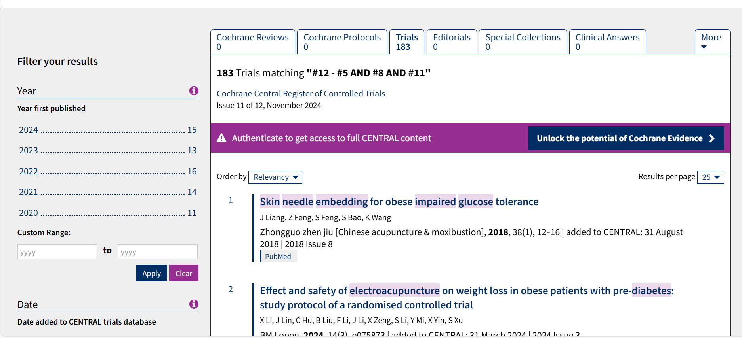
3、embase
Number of literature：261
Search Date：From the database established to December 17, 2024
Search Strategy：
#1 (Acupuncture OR Acupuncture Therapy OR Moxibustion)/exp
#2 (Acupuncture OR Acupuncture Therapy OR Acupuncture Treatment OR Manual Acupuncture OR Acupuncture-moxibustion OR Moxibustion OR Moxabustion OR Warm needle OR Warm Acupuncture OR Thermoacupuncture OR Electroacupuncture OR Electro-acupuncture OR electric acupuncture OR Acupuncture Point OR Point, Acupuncture OR Acupoint OR Pharmacopuncture OR Acupoint injection OR acupuncture injection OR pharmaco-acupuncture OR auricular needle OR Acupunctures, Ear OR Ear Acupuncture OR Ear needle OR earlobe acupuncture OR Auricular Acupuncture OR Auriculotherapy OR Acupuncture, Auricular OR auricular plaster therapy OR auricular point sticking OR Auricular pressure OR Fire needle OR Fire acupuncture OR Acupoint catgut embedding OR Scalp acupuncture OR Scalp needle OR Scalp electroacupuncture OR scalp stimulation OR Eye needle OR Eye acupuncture OR Abdominal acupuncture OR Abdominal needle OR filiform needle OR silver needle OR three-edged needle OR intradermal needle OR Point application OR needle-embedding OR Catgut Embedding OR pricking therapy OR point injection OR Skin Acupuncture) :ti,ab,kw
#3 (Diabetes)'/exp
#4 ( (Prediabetic State* OR Diabetes Mellitu* OR Diabete* OR Glucose Intolerance* OR impaired glucose tolerance*):ti,ab,kw
#5 (Obesity) /exp
#6 (Obesity OR Overweight OR Body Mess Index) :ti,ab,kw
#7 (#1 OR #2) AND (#3 OR #4) AND (#5 OR #6)
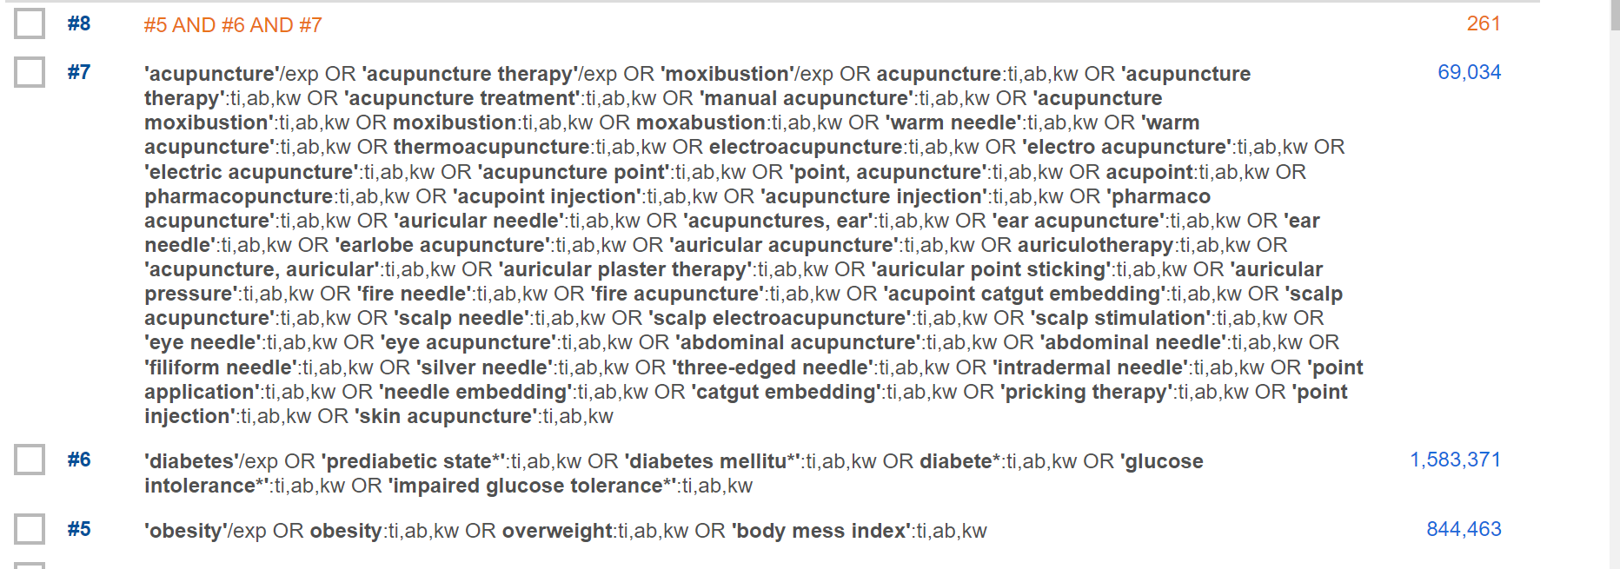
4、CNKI
Number of literature: 557
Search Date: From the database established to December 17, 2024
Search Strategy: ((TKA=('针刺'+'电针'+'针灸'+'刺法'+'体针'+'耳针'+'头针'+'毫针'+'针刺治疗'+'针灸疗法'+'艾灸'+'灸法'+'灸疗'+'灸术'+'温针'+'温针灸'+'针法')) AND (TKA=('肥胖'+'肥胖症'+'超重'+'体重指数')) AND (TKA=('糖尿病'+'糖尿病前期'+'糖耐量受损'+'前驱糖尿病'+'消渴'))) OR ((SU%=('针刺'+'电针'+'针灸'+'刺法'+'体针'+'耳针'+'头针'+'毫针'+'针刺治疗'+'针灸疗法'+'艾灸'+'灸法'+'灸疗'+'灸术'+'温针'+'温针灸'+'针法')) AND (SU%=('肥胖'+'肥胖症'+'超重'+'体重指数')) AND (SU%=('糖尿病'+'糖尿病前期'+'糖耐量受损'+'前驱糖尿病'+'消渴')))
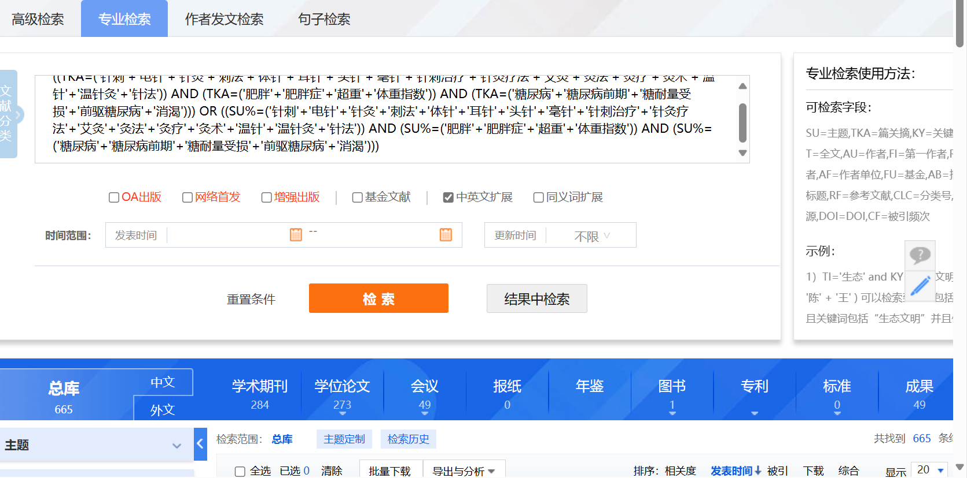
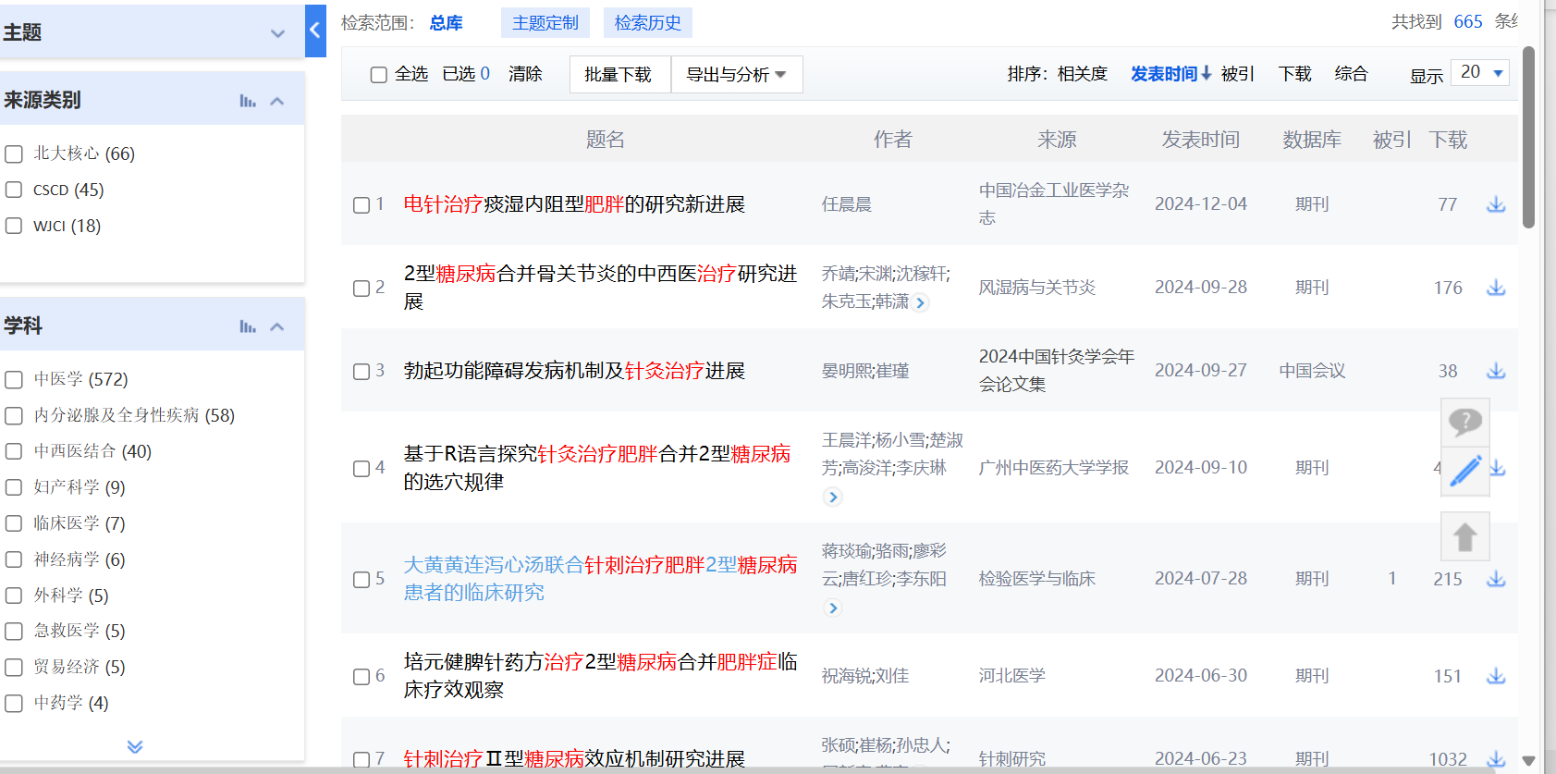
- Wanfang Data
Number of literature: 552
Search Date:From the database established to December 17, 2024
Search Strategy: (主题:("针刺" OR "电针" OR "针灸" OR "刺法" OR "体针" OR "耳针" OR "头针" OR "毫针" OR "针刺治疗" OR "针灸疗法" OR "艾灸" OR "灸法" OR "灸疗" OR "灸术" OR "温针" OR "针法" OR "得气" OR "温针灸" OR "头皮针") AND 主题:("肥胖" OR "肥胖症" OR "超重" OR "体重指数") AND 主题:("糖尿病" OR "糖尿病前期" OR "糖耐量受损" OR "前驱糖尿病" OR "消渴")) OR (题名或关键词:("针刺" OR "电针" OR "针灸" OR "刺法" OR "体针" OR "耳针" OR "头针" OR "毫针" OR "针刺治疗" OR "针灸疗法" OR "艾灸" OR "灸法" OR "灸疗" OR "灸术" OR "温针" OR "针法" OR "得气" OR "温针灸" OR "头皮针") AND 题名或关键词:("肥胖" OR "肥胖症" OR "超重" OR "体重指数") AND 题名或关键词:("糖尿病" OR "糖尿病前期" OR "糖耐量受损" OR "前驱糖尿病" OR "消渴"))
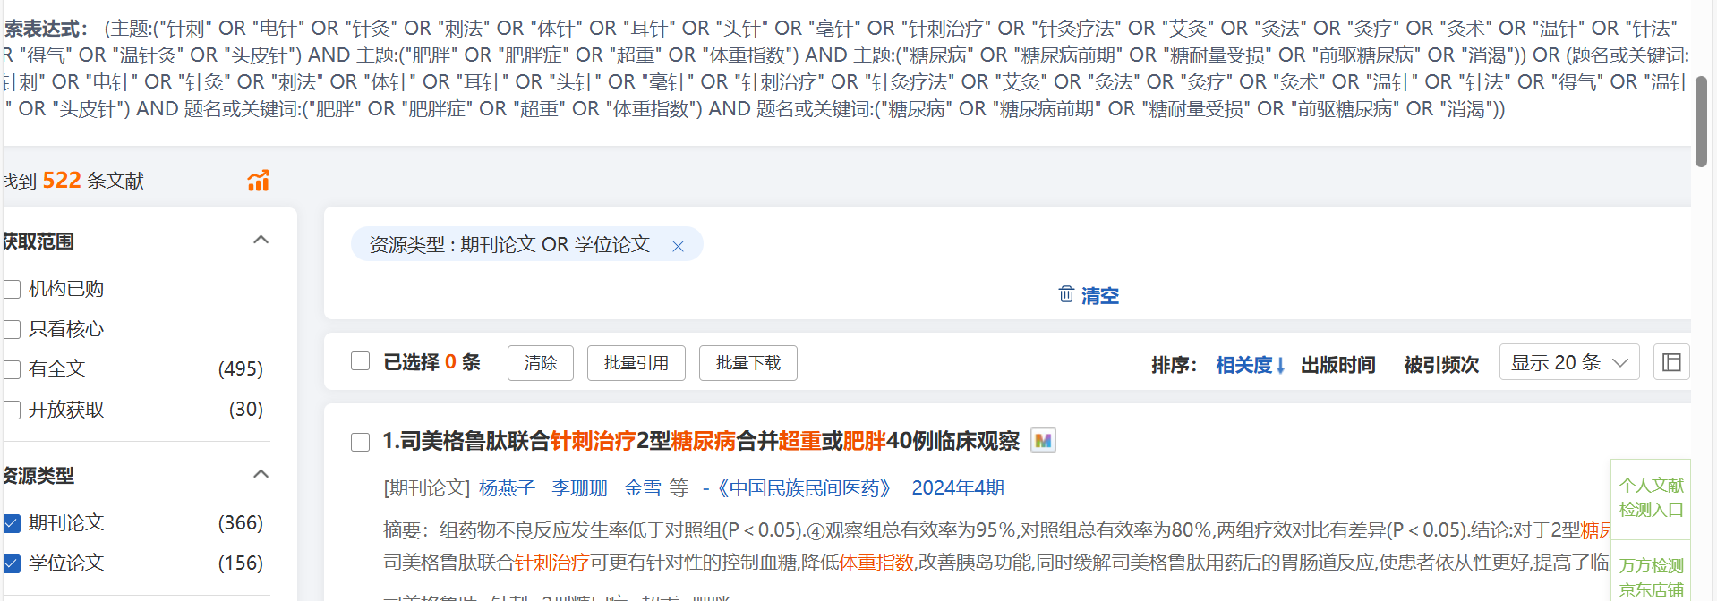
- VIP Database
Number of literature：272
Search Date: From the database established to December 17, 2024
Search Strategy：(M=(肥胖 OR 肥胖症 OR 超重 OR 体重指数) AND M=(糖尿病 OR 糖尿病前期 OR 糖耐量受损 OR 前驱糖尿病 OR 消渴) AND M=(针刺 OR 电针 OR 针灸 OR 刺法 OR 体针 OR 耳针 OR 头针 OR 毫针 OR 针刺治疗 OR 针灸疗法 OR 艾灸 OR 灸法 OR 灸疗 OR 灸术 OR 温针 OR 针法 OR 得气 OR 温针灸 OR 头皮针)) OR (R=(肥胖 OR 肥胖症 OR 超重 OR 体重指数) AND R=(糖尿病 OR 糖尿病前期 OR 糖耐量受损 OR 前驱糖尿病 OR 消渴) AND R=(针刺 OR 电针 OR 针灸 OR 刺法 OR 体针 OR 耳针 OR 头针 OR 毫针 OR 针刺治疗 OR 针灸疗法 OR 艾灸 OR 灸法 OR 灸疗 OR 灸术 OR 温针 OR 针法 OR 得气 OR 温针灸 OR 头皮针))
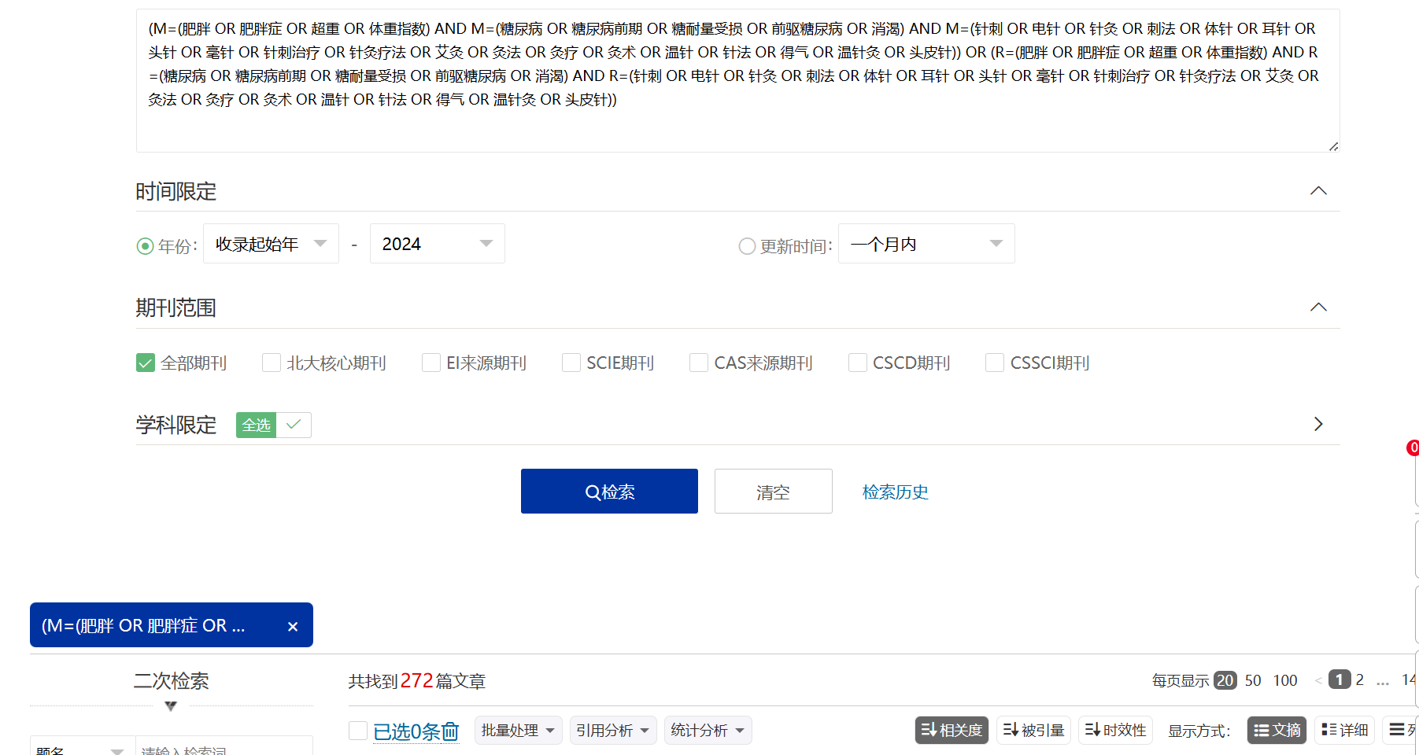
- SinoMed
Number of literature: 465
Search Date: From the database established to December 17, 2024
Search Strategy: (肥胖 OR 肥胖症 OR 超重 OR 体重指数) AND (糖尿病 OR 糖尿病前期 OR 糖耐量受损 OR 前驱糖尿病 OR 消渴) AND (针刺 OR 电针 OR 针灸 OR 刺法 OR 体针 OR 耳针 OR 头针 OR 毫针 OR 针刺治疗 OR 针灸疗法 OR 艾灸 OR 灸法 OR 灸疗 OR 灸术 OR 温针 OR 针法 OR 得气 OR 温针灸 OR 头皮针)
