Supplementary materials
Metabolic Score for Visceral Fat as a Superior Predictor of Frailty in Overweight and Obese Adults: A Cross-Sectional NHANES Analysis (2007–2020)

Content
Supplemental tables | Page
Table 1. Variables in the 49-Item Frailty Index and Their Respective Scorings. | 3-4
Table 2. Detailed description and options of covariables in the NHANES database. | 5
Table 3. P-value Adjustments for METS-VF Quartile Comparisons | 6
Table 4. Multiple testing corrections (Bonferroni and FDR) for subgroup analyses of the association between METS-VF and frailty | 7
Table 5. Sensitivity Analysis of the Association Between METS-VF and Frailty Across Different Adjustment Models | 8
Table 6. Association between METS-VF (continuous) and frailty using alternative FI cut-offs (NHANES 2007–2020). | 9
Table 7. Association between METS-VF and frailty (FI ≥ 0.25) using logistic regression models (NHANES 2007–2020). | 10
Table 8. AUC with 95% CIs and pairwise DeLong test comparisons between METS-VF and other indices | 11
Figure 1. Decision curve analysis (DCA) of METS-VF, BMI, WC, and METS-IR for frailty risk prediction. | 12

Supplementary Table 1 Variables in the 49-Item Frailty Index and Their Respective Scorings.
Variable | Scoring
Cognition
1. Experience confusion/memory problems | Yes = 1, No = 0
Dependence
2. Managing money | Difficulty = 1, No Difficulty = 0
3. Stooping, crouching, kneeling | Difficulty = 1, No Difficulty = 0
4. Lifting or carrying | Difficulty = 1, No Difficulty = 0
5. House chore | Difficulty = 1, No Difficulty = 0
6. Preparing meals | Difficulty = 1, No Difficulty = 0
7. Standing up from armless chair | Difficulty = 1, No Difficulty = 0
8. Getting in and out of bed difficulty | Difficulty = 1, No Difficulty = 0
9. Using fork, knife, drinking from cup | Difficulty = 1, No Difficulty = 0
10. Dressing yourself | Difficulty = 1, No Difficulty = 0
11. Standing for long periods difficulty | Difficulty = 1, No Difficulty = 0
12. Grasp/holding small objects | Difficulty = 1, No Difficulty = 0
13. Attending social event | Difficulty = 1, No Difficulty = 0
14. Push or pull large objects | Difficulty = 1, No Difficulty = 0
15. Walking for a quarter mile difficulty | Difficulty = 1, No Difficulty = 0
16. Walking up 10 steps difficulty | Difficulty = 1, No Difficulty = 0
Depressive Symptoms
17. Have little interest in doing things | Nearly every day = 1, More than half the days = 0.66, Several days = 0.33, Not at all = 0
18. Feeling down, depressed, or hopeless | Nearly every day = 1, More than half the days = 0.66, Several days = 0.33, Not at all = 0
19. Trouble sleeping or sleeping too much | Nearly every day = 1, More than half the days = 0.66, Several days = 0.33, Not at all = 0
20. Feeling tired or having little energy | Nearly every day = 1, More than half the days = 0.66, Several days = 0.33, Not at all = 0
21. Poor appetite or overeating | Nearly every day = 1, More than half the days = 0.66, Several days = 0.33, Not at all = 0
22. Feeling bad about yourself | Nearly every day = 1, More than half the days = 0.66, Several days = 0.33, Not at all = 0
23. Trouble concentrating on things | Nearly every day = 1, More than half the days = 0.66, Several days = 0.33, Not at all = 0
Comorbidities
24. Arthritis | Yes = 1, Suspect = 0.5 No = 0
25. Thyroid problems | Yes = 1, Suspect = 0.5 No = 0
26. Chronic bronchitis | Yes = 1, Suspect = 0.5 No = 0
27. Cancer | Yes = 1, Suspect = 0.5 No = 0
28. Congestive heart failure | Yes = 1, Suspect = 0.5 No = 0
29. Coronary heart disease | Yes = 1, Suspect = 0.5 No = 0
30. Angina | Yes = 1, Suspect = 0.5 No = 0
31. Heart attack | Yes = 1, Suspect = 0.5 No = 0
32. Stroke | Yes = 1, Suspect = 0.5 No = 0
33. Blood pressure | Yes = 1, Suspect = 0.5 No = 0
34. Diabetes | Yes = 1, Suspect = 0.5 No = 0
35. Weak/failing kidneys | Yes = 1, Suspect = 0.5 No = 0
36. Urinary Leakage | Yes = 1, Suspect = 0.5 No = 0
Hospital Utilization and Access to Care
37. Self-rated health | Fair, poor = 1, Excellent, Very good, good = 0
38. Health now compared with 1 year ago | Worse = 1, About the same, better = 0
39. Overnight hospital patient in past year | Yes =1, No =0
40. Frequency of health care use during past year | None = 0, 1-5 = 0,5, More than 5 = 1
41. Number of prescribed medications | None = 0, 1-5 = 0,5, More than 5 = 1
Physical Performance and Anthropometry
42.Body mass index (kg/m²) | < 18.5, ≥ 30 = 1  ≥ 25, < 30 = 0.5  ≥ 18.5,＜ 25 = 0
43. Handgrip strength | MALE:  For BMI ≤ 24, GS ≤ 29  For BMI 24.1-28, GS ≤ 30  For BMI > 28, GS ≤ 32 = 1 | FEMALE:  For BMI ≤ 23, GS ≤ 17  For BMI 23.1-26, GS ≤ 17.3  For BMI 26.1-29, GS ≤ 18  For BMI > 29, GS ≤ 21 = 1
Laboratory Values
44. Glycohemoglobin (%) | 0%-5.7% = 0, >5.7% = 1
45. Red blood cell count (million cells/mL) | M: 4.7-6.1 = 0, Other = 1 | F: 4.2-5.4 = 0, Other = 1
46. Hemoglobin (g/dL) | M: 13.5-18 =0, Other = 1 | F:12-16 = 0, Other = 1
47. Red cell distribution width (%) | 11.6-14.6 = 0, Other = 1
48. Lymphocyte percent (%) | 2040 = 0, Other= 1
49. Segmented neutrophils percent (%) | 40-80 = 0, Other = 1
Abbreviation: BMI, Body mass index; GS, grip strength.
References:
Hakeem FF, Bernabé E, Sabbah W. Association Between Oral Health and Frailty Among American Older Adults. J Am Med Dir Assoc. 2021;22(3):559-563.e2. doi:10.1016/j.jamda.2020.07.023

Supplementary table 2. Detailed description and options of covariables in the NHANES database.
Covariables | Description
Age | Age
Gender | Gender(male female)
Race | Race (Mexican American, Non-Hispanic Black, Non-Hispanic White and Others)
Education level | Education level (< high school, high school and College or above)
Marital status | Marital status(Married/Living with partner, Widowed/Divorced/Separated and Never married)
Poverty income ratio | A ratio of family income to poverty (< 1.3, 1.3–3.5 and >3.5)
BMI | Body mass index (≤20.0 kg/m2, 20-25 kg/m2, 25-30 kg/m2 and >30.0 kg/m2)
Smoking status | Smoking status (former, never and now)
Alcohol consumption | Alcohol consumption (former, heavy, mild, moderate and never)
SB time | The primary exposure variable was self-reported sitting time, assessed through the following question: “On a typical day, how much time do you spend sitting at school, at home, getting to and from places, or with friends, including time spent sitting at a desk, traveling in a car or bus, reading, playing cards, watching television, or using a computer (except for time spent sleeping)?”
PA total time | The composite variable of total physical activity time (minutes per week), derived from NHANES physical activity questionnaire, including moderate and vigorous activities at work, transportation, and leisure-time domains.
Diabetes Mellitus (DM) | Participants were diagnosed as DM if: doctor told you have diabetes, or glycohemoglobin HbA1c(%) >= 6.5, or fasting glucose (mmol/l) >= 7.0, or, random blood glucose (mmol/l) >= 11.1, or two-hour OGTT blood glucose (mmol/l) >= 11.1, or use of diabetes medication or insulin, or asked whether they had diabetes (yes and no)
Hypertension | Participants were diagnosed as Hypertension if: a health professional diagnosis, or NHANES-measured blood pressure 130mmHg or more systolic, or 80mmHg or more diastolic
Cardiovascular Disease (CVD) | The presence of CVD (coronary heart disease, myocardial infarction, stroke, or angina) was determined by participants receiving these diagnoses from a health professional before the survey.

Supplementary Table 3. P-value Adjustments for METS-VF Quartile Comparisons
Comparison | Model | Raw P-value | Bonferroni | FDR
Q2 vs Q1 | Model 1 | 0.64 | 1.000 | 0.740
Q3 vs Q1 | Model 1 | < 0.001 | 0.006 | 0.002
Q4 vs Q1 | Model 1 | < 0.001 | 0.001 | 0.000
Q2 vs Q1 | Model 2 | 0.74 | 1.000 | 0.740
Q3 vs Q1 | Model 2 | < 0.001 | 0.001 | 0.002
Q4 vs Q1 | Model 2 | < 0.001 | 0.001 | 0.000
Model 1: Adjusted for age, gender, race/ethnicity, education level, marital status, and poverty income ratio.
Model 2: Additionally adjusted for smoking status, alcohol use, sleep duration, PA total time and SB time.
Abbreviations: METS-VF, Metabolic Score for Visceral Fat; FDR, False Discovery Rate; PA, Physical activity; SB, Sedentary behavior.

Supplementary Table 4. Multiple testing corrections (Bonferroni and FDR) for subgroup analyses of the association between METS-VF and frailty
Subgroup | Raw P-value | Bonferroni | FDR
Male | 0.12 | 1 | 0.129
Female | < 0.001 | 0.027 | 0.002
Non-Hispanic Black | 0.04 | 1 | 0.051
Non-Hispanic White | 0.001 | 0.027 | 0.002
Mexican American | 0.004 | 0.108 | 0.007
Other races | 0.002 | 0.054 | 0.004
Less than high school | < 0.001 | 0.027 | 0.002
High school | 0.07 | 1 | 0.086
College or above | 0.002 | 0.054 | 0.004
Former | < 0.001 | 0.002 | 0.002
Never | 0.02 | 0.54 | 0.027
Now | 0.09 | 1 | 0.101
Married/Living with partner | 0.004 | 0.108 | 0.007
Widowed/Divorced/Separated | 0.02 | 0.54 | 0.027
Never married | < 0.001 | 0.027 | 0.002
PIR 1.3-3.5 | < 0.001 | 0.027 | 0.002
PIR <1.3 | < 0.001 | 0.027 | 0.002
PIR >3.5 | 0.88 | 1 | 0.880
Age 40-59 | 0.02 | 0.54 | 0.027
Age 20-39 | 0.08 | 1 | 0.094
Age >60 | < 0.001 | 0.027 | 0.002
CVD No | < 0.001 | 0.027 | 0.002
CVD Yes | 0.17 | 1 | 0.176
Hypertension No | 0.01 | 0.27 | 0.016
Hypertension Yes | < 0.001 | 0.027 | 0.002
DM No | < 0.001 | 0.027 | 0.002
DM Yes | 0.02 | 0.54 | 0.027
Footnote)
Raw p-values are derived from subgroup-specific logistic regression models. Bonferroni and FDR (Benjamini–Hochberg) corrections were applied to account for multiple comparisons across subgroups. P-values <0.05 were considered statistically significant after adjustment.
Abbreviations: AOR, Adjusted odds ratio; CI, Confidence interval; PIR, Poverty income ratio; CVD, Cardiovascular disease; HTN, Hypertension; DM, Diabetes mellitus; FDR, False discovery rate.

Supplementary Table 5. Sensitivity Analysis of the Association Between METS-VF and Frailty Across Different Adjustment Models
METS-VF | Crude Model | Model 1 | Model 2 | Model 3
95% CI | 5.458 (4.477, 6.654) | 3.277 (2.419, 4.438) | 3.492 (2.548, 4.787) | 3.769 (2.745, 5.175)
P-value | < 0.001 | < 0.001 | < 0.001 | < 0.001
Crude Model: Unadjusted
Model 1: Adjusted for age, sex, race/ethnicity, education level, marital status, poverty income ratio, smoking, alcohol consumption, sedentary behavior time, sleep duration, and hypertension
Model 2: Same as Model 1, but replaced hypertension with diabetes mellitus
Model 3: Same as Model 1, but replaced hypertension with cardiovascular disease
Abbreviations: METS-VF: Metabolic Score for Visceral Fat; CI: Confidence Interval

Supplementary Table 6. Association between METS-VF (continuous) and frailty using alternative FI cut-offs (NHANES 2007–2020).
 | Crude model |  | Model 1 |  | Model 2
METS-VF~FI cut-off | COR (95%CI) | P-value | AOR (95%CI) | P-value | AOR (95%CI) | P-value
≥ 0.21 | 4.10 (3.32,5.06) | < 0.001 | 4.42 (3.24,6.03) | < 0.001 | 4.48 (3.26,6.16) | < 0.001
≥ 0.30 | 4.93 (3.51,6.92) | < 0.001 | 4.33 (2.76,6.82) | < 0.001 | 4.44 (2.85,6.93) | < 0.001
MTS-VF tertiles
Q1 | ref |  | ref |  | ref
Q2 | 2.17 (1.61,2.93) | < 0.001 | 1.75 (1.23,2.47) | 0.002 | 1.71 (1.22,2.42) | 0.003
Q3 | 4.32 (3.34,5.59) | < 0.001 | 3.23 (2.27,4.58) | < 0.001 | 3.26 (2.31,4.60) | < 0.001
p for trend(character2integer) |  | < 0.001 |  | < 0.001 |  | < 0.001
Footnotes: The crude model was unadjusted. Model 1 was adjusted for age, gender, race/ethnicity, education level, marital status, and PIR. Model 2 was additionally adjusted for smoking status, sleep duration, SB time, PA total time and alcohol consumption.
Abbreviations: AOR, Adjusted odds ratio; CI, Confidence interval; COR, Crude odds ratio; PIR, Poverty income ratio; SB, Sedentary behavior, PA, Physical activity; METS-VF, Metabolic Score for Visceral Fat.

Supplementary Table 7. Association between METS-VF and frailty (FI ≥ 0.25) using logistic regression models (NHANES 2007–2020).
 | Crude model |  | Model 1 |  | Model 2
METS-VF | COR (95%CI) | P | AOR (95%CI) | P | AOR (95%CI) | P
≥ 0.25 | 4.92 (3.89,6.21) | < 0.001 | 5.07 (3.55,7.25) | < 0.001 | 2.25 (1.57,3.24) | < 0.001
Footnotes: The crude model was unadjusted. Model 1 was adjusted for age, gender, race/ethnicity, education level, marital status, and PIR. Model 2 was additionally adjusted for smoking status, sleep duration, SB time, PA total time, alcohol consumption, DM, Hypertension and CVD
Abbreviations: AOR, Adjusted odds ratio; CI, Confidence interval; COR, Crude odds ratio; PIR, Poverty income ratio; SB, Sedentary behavior, PA, Physical activity; METS-VF, Metabolic Score for Visceral Fat; CVD, cardiovascular disease; DM, diabetes mellitus.

Supplementary Table 8. AUC with 95% CIs and pairwise DeLong test comparisons between METS-VF and other indices
Model / Comparison | AUC | 95% CI | DeLong p-value*
METS-VF | 0.685 | 0.666–0.703 | Reference
BMI | 0.610 | 0.589–0.631 | <0.001
WC | 0.641 | 0.622–0.661 | <0.001
METS-IR | 0.617 | 0.597–0.639 | <0.001
Footnotes: *DeLong’s test comparing AUC of each index vs METS-VF.
Abbreviations: AUC, area under the curve; CI, confidence interval; METS-VF, metabolic score for visceral fat; WC, waist circumference; METS-IR, metabolic score for insulin resistance.

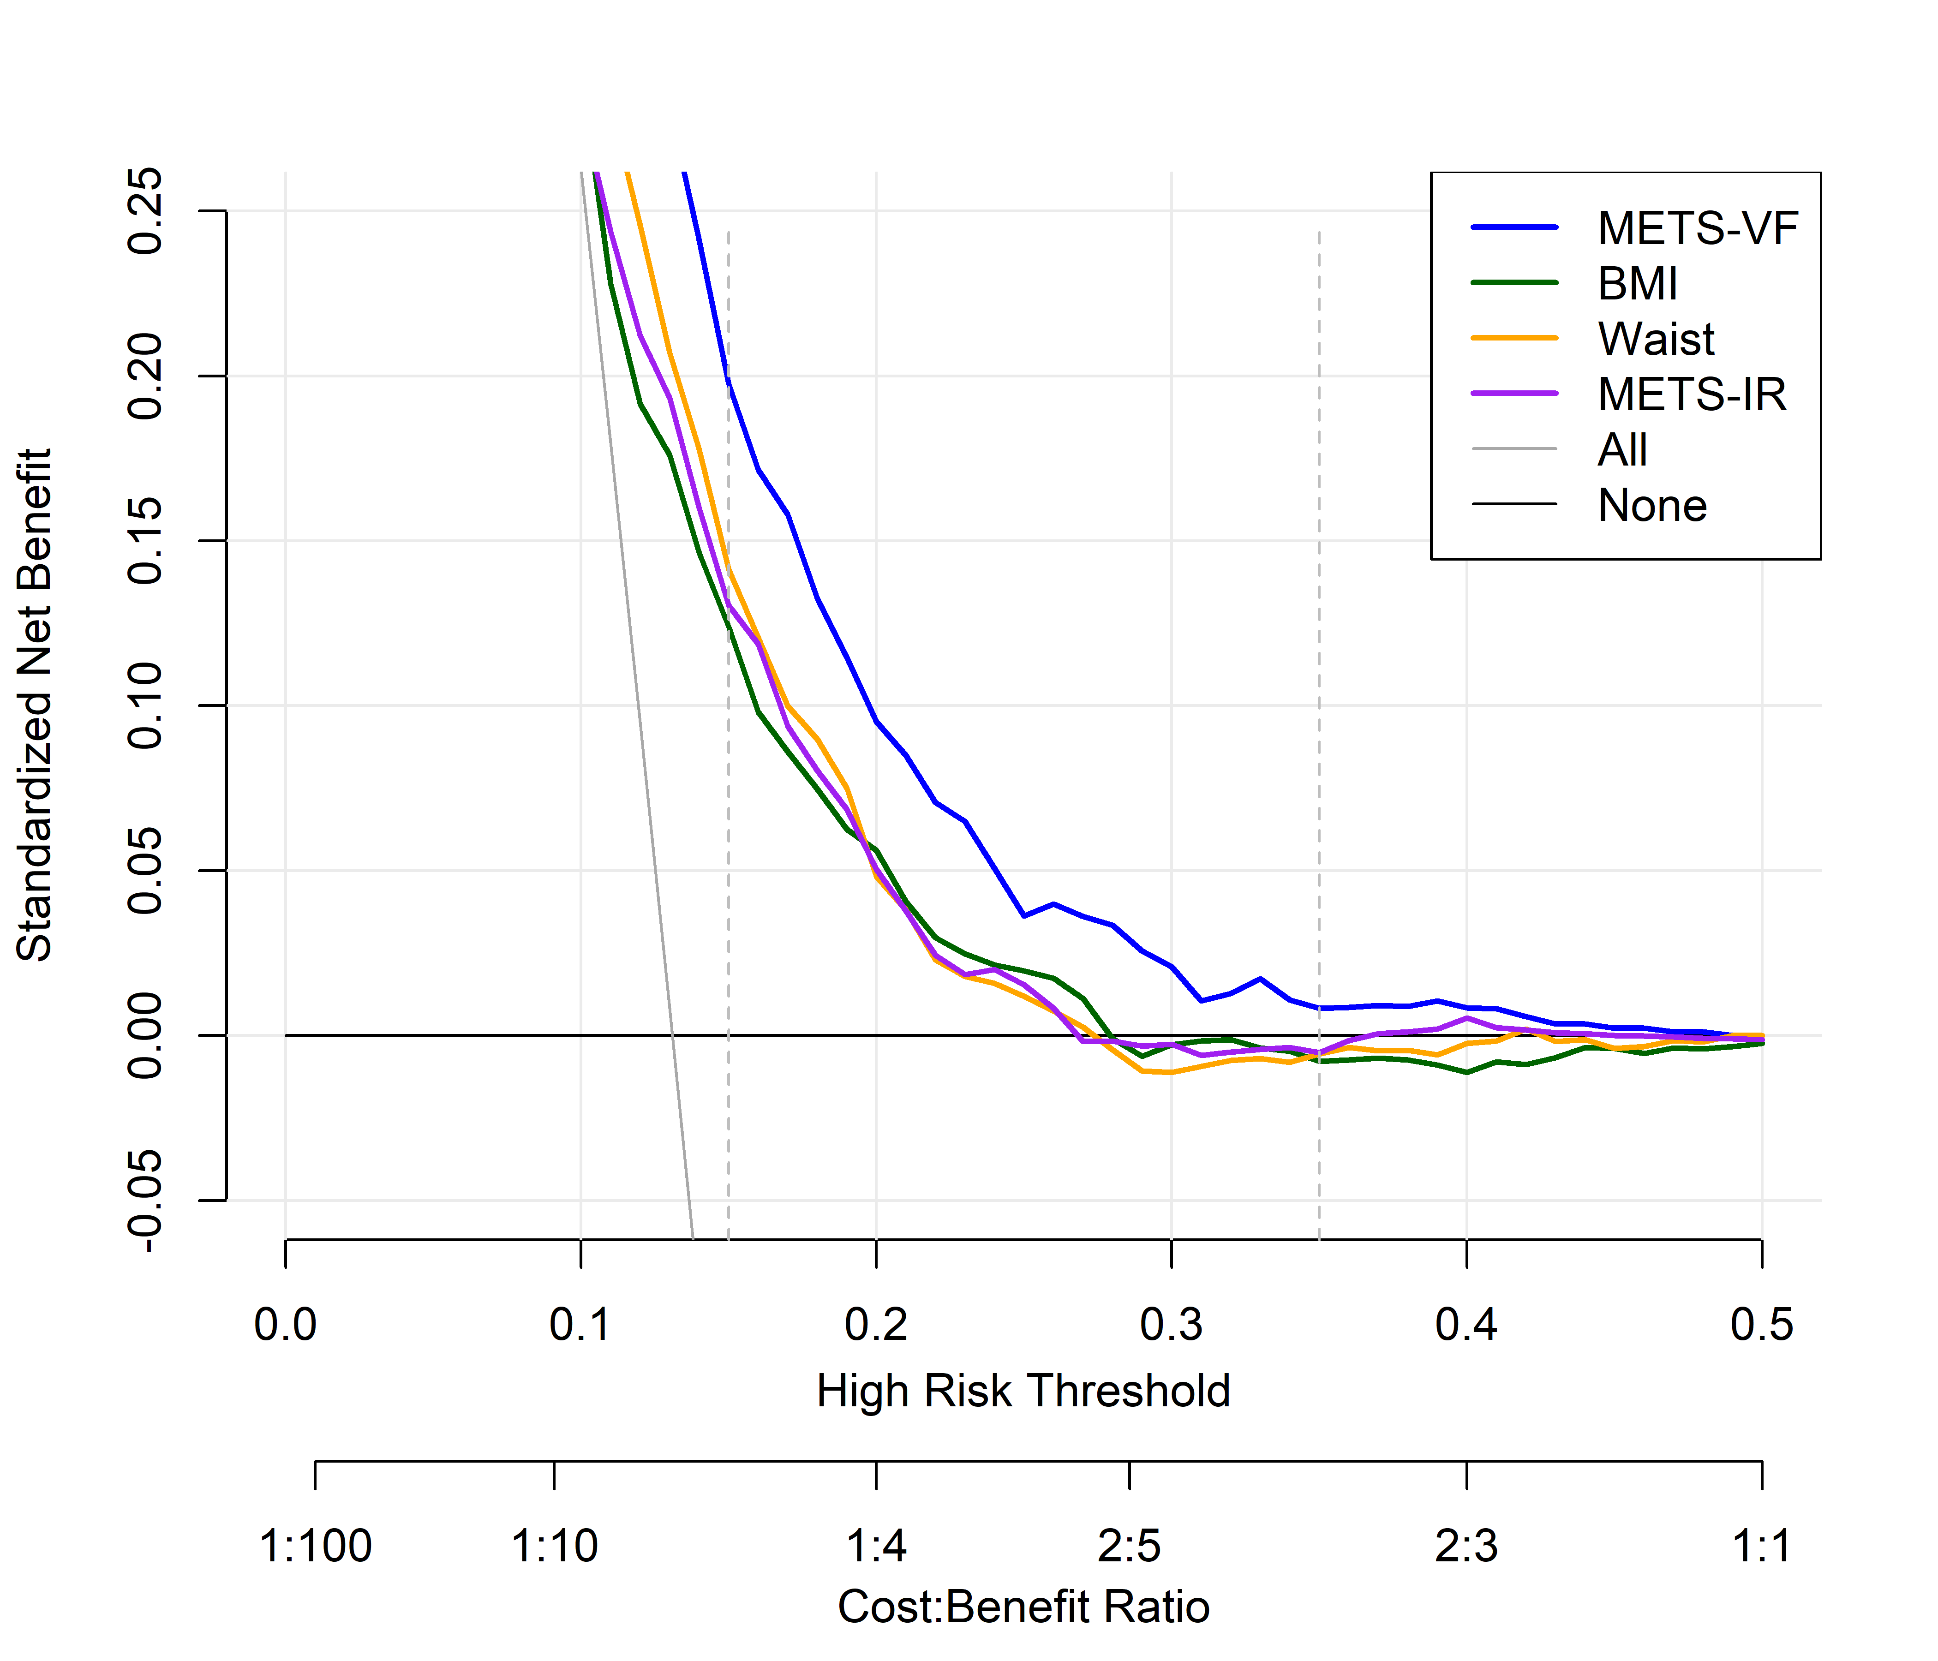
Supplementary Figure 1. Decision curve analysis (DCA) of METS-VF, BMI, WC, and METS-IR for frailty risk prediction.
Abbreviations: METS-VF, metabolic score for visceral fat; WC, waist circumference; METS-IR, metabolic score for insulin resistance; BMI, body mass index; DCA, decision curve analysis.

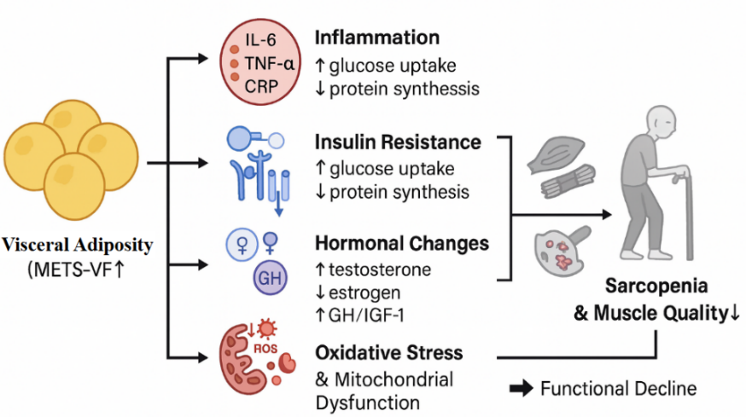
Supplementary Figure 2. Proposed biological mechanisms linking visceral adiposity (METS-VF) to frailty.

