Supplementary Materials of:
Molecular cross-talk via Extracellular Vesicles for the characterization of type I diabetes patients unravels new potential markers of insulin resistance and double diabetes
Maria Concetta Cufaro ^{1,2}, Ilaria Cicalini ², Paola Irma Guidone ³, Paola Lanuti ^{2,4}, Francesca D’Ascanio ^{2,4,5}, Maria Alessandra Saltarelli ⁶, Lorenza Sacrini ⁶, Domenico De Bellis ^{2,4}, Gessica Di Carlo ^{2,7}, Luca Natale ^{1,2}, Damiana Pieragostino ^{1,2}, Piero Del Boccio ^{2,7}, Claudia Rossi ^{2,7} * and Stefano Tumini ⁶
1 Department of Innovative Technologies in Medicine and Dentistry, G. d’Annunzio University of Chieti-Pescara, 66100 Chieti, Italy
2 Center for Advanced Studies and Technology (CAST), G. d’Annunzio University of Chieti-Pescara, 66100 Chieti, Italy
3 UOSVD Paediatrics, Della Murgia Fabio Perinei Hospital, 70022 Altamura (BA), Italy
4 Department of Medicine and Aging Sciences, G. d’Annunzio University of Chieti-Pescara, 66100 Chieti, Italy
5 Department of Humanities, Law and Economics, Leonardo da Vinci University, 66010 Torrevecchia Teatina (CH), Italy
6 Department of Maternal and Child Health, UOSD Regional Center of Paediatric Diabetology, Chieti Hospital, 66100 Chieti, Italy
7 Department of Science, G. d’Annunzio University of Chieti-Pescara, 66100 Chieti, Italy

* Correspondence: Claudia Rossi, claudia.rossi@unich.it, +39 0871 541329

Figure S1. Venn Diagrams of EV quantified proteins in the two comparisons.
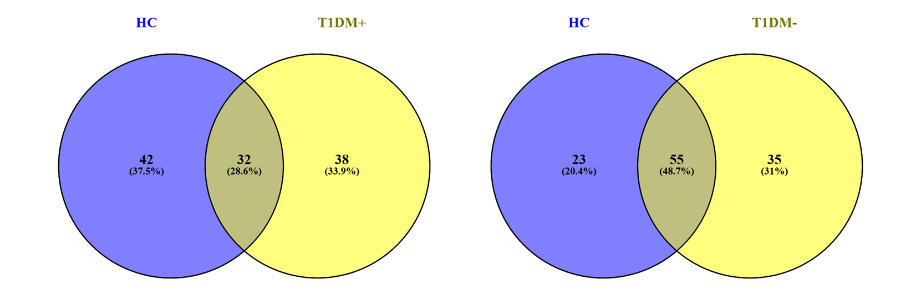
Figure S2. Long-chain ACs that were not significantly different between the clinical groups.
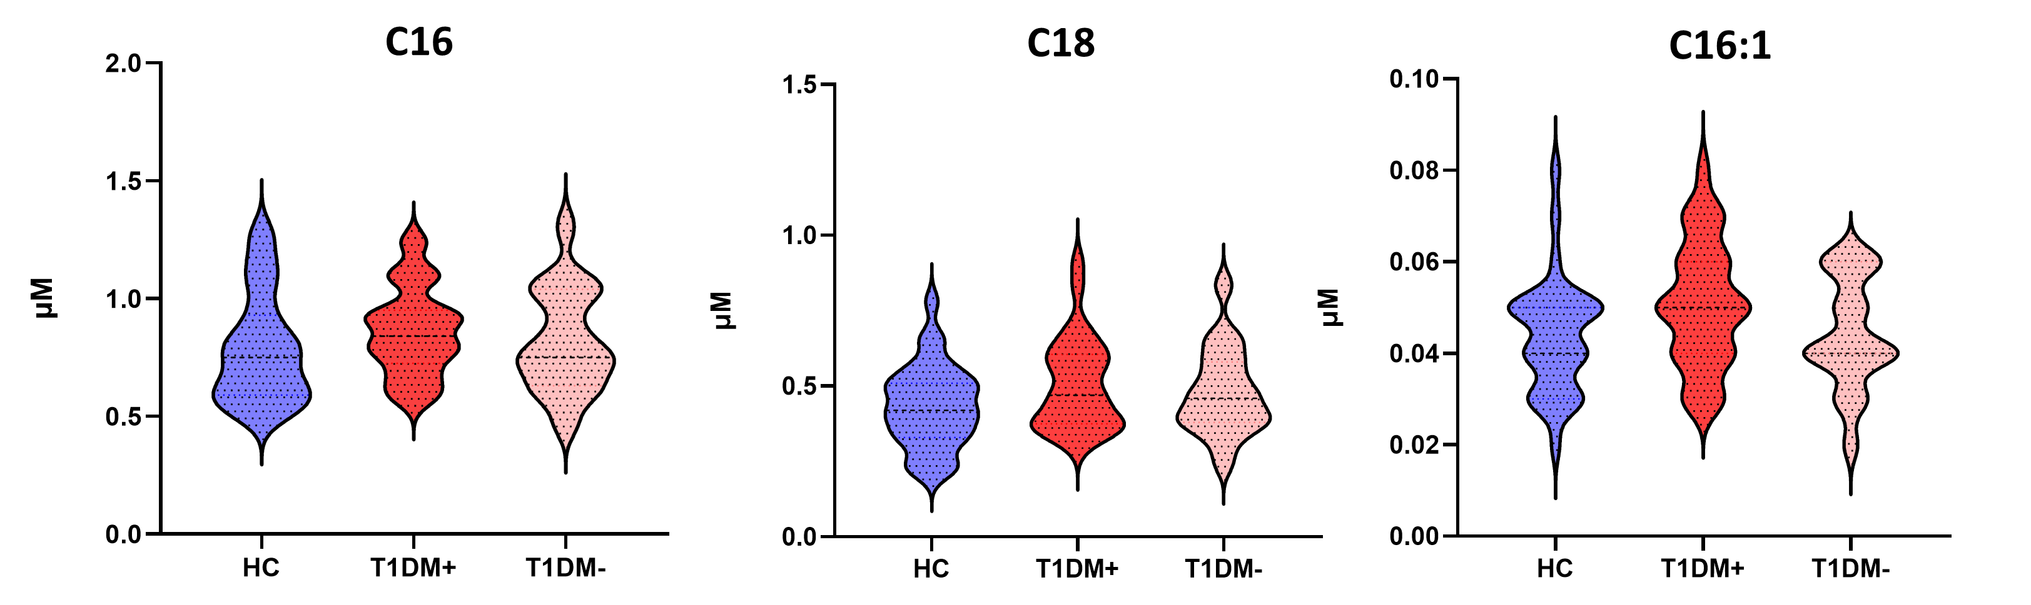
Figure S3. IPA legend interpretation. The ﬁgure shows the colour and shape key for IPA networks.
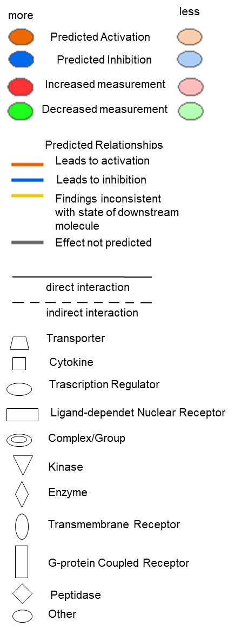

Table S1. General features of the paediatric population involved in the study.
Subjects | total = 52
Males (%) | 53.9
Median age (years) | 13.7 (r: 10.9 – 15.8)
Age > 11 years (%) | 73.1
Years from diagnosis (mean + sd) | 5.7 + 3.6
Height sds (mean + sd) | 0.73 + 1.26
Weight sds | 0.9 + 0.7
BMI sds | 1.64 + 1.13
BMI > 25 Kg/m² (%) | 25 (n=13)
WHtR > 0,50 | 28.8 (n=15)
SBP Z score | 0.17 (r: -0.89 – 0.87)
DBP Z score | 0.38 (r:-0.4-1.31)
HbA1c > 7.5% (%) | 34 (n=18)
HbA1c (%) | 7.2 + 1.1
Glycemic means(last 3 months) | 163 + 32
SD of glycemic mean | 73.5 +19.5
% CV (SD/M%) | 44 + 7
Median eGDR (mg/Kg/min) | 9.6 (r: 7.2 – 11.1)
ISF (mg/dl) | 50 (r: 35 - 80)
Insulin requirement (U/Kg/day) | 0.95 + 0,34
Basal dose/day (U/day) | 20.5 (r: 14 – 30.2)
Basal dose/Kg (U/Kg) | 0.38 + 0.15
I:CHO (breakfast) (gr) | 8.5 (r: 7 - 12)
I:CHO (lunch) (gr) | 10 (r: 7 – 14.2)
I:CHO (dinner) (gr) | 10 (r: 7 – 12.5)
Familiar history for T2DM (%) | 63 (n = 33)
> 2 relatives with T2DM (%) | 28 (n = 15)
LDL> 100 mg/dl (%) | 38 (n = 20)
HDL < 40 mg/dl (%) | 7.7 (n = 4)
Triglicerides > 150 mg/dl (%) | 0.02 (n = 1)
CSII (%) | 17 (n = 9)
Glargine (%) | 28 (n = 15)
Degludec (%) | 53 (n =28)

Table S2. List of median and standard deviation (SD) of DBS aminoacids (AA), free carnitine (C0), acylcarnitines (ACs), succinylacetone (SA), nucleosides and lysophospholipids analyzed.
Analyte | Median T1DM+ | SD | Median T1DM- | SD | Median HC | SD
ALA | 269.78 | 57.76 | 266.07 | 59.16 | 193.65 | 55.25
ARG | 30.69 | 8.62 | 33.64 | 12.37 | 25.64 | 187.28
CIT | 21.47 | 4.64 | 23.24 | 5.11 | 20.36 | 6.26
GLN\LYS | 394.69 | 64.88 | 417.17 | 59.84 | 373.08 | 61.41
GLU | 76.67 | 13.81 | 67.64 | 12.50 | 64.3 | 16.71
GLY | 208.96 | 35.76 | 205.24 | 43.81 | 182.48 | 33.66
LEU\ILE\PRO-OH | 131.90 | 27.78 | 136.83 | 42.47 | 111.61 | 22.77
MET | 13.47 | 5.09 | 13.84 | 5.44 | 10.07 | 2.93
ORN | 63.71 | 15.44 | 62.86 | 17.81 | 57.34 | 115.18
PHE | 42.82 | 8.77 | 41.07 | 9.76 | 32.98 | 7.50
PRO | 125.41 | 30.26 | 129.66 | 58.67 | 103.05 | 29.81
SA | 0.20 | 0.03 | 0.18 | 0.04 | 0.18 | 0.05
TYR | 52.23 | 11.09 | 49.51 | 17.73 | 44.59 | 13.82
VAL | 166.20 | 33.29 | 162.36 | 39.92 | 136.31 | 24.80
ASA-Total | 0.20 | 0.09 | 0.19 | 0.10 | 0.17 | 0.16
ADO | 0.27 | 0.15 | 0.3 | 0.18 | 0.31 | 0.16
C0 | 25.02 | 7.06 | 21.98 | 6.11 | 24.26 | 4.39
C10 | 0.08 | 0.06 | 0.07 | 0.16 | 0.06 | 0.03
C10:1 | 0.04 | 0.03 | 0.04 | 0.04 | 0.03 | 0.01
C10:2 | 0.00 | 0.01 | 0 | 0.00 | 0 | 0.00
C2 | 8.20 | 2.07 | 8.16 | 2.28 | 7.96 | 2.00
C3 | 1.57 | 0.58 | 1.41 | 0.37 | 1.08 | 0.52
C3DC\C4OH | 0.05 | 0.02 | 0.04 | 0.01 | 0.04 | 0.01
C4 | 0.10 | 0.07 | 0.12 | 0.06 | 0.11 | 0.04
C4DC\C5OH | 0.38 | 0.13 | 0.38 | 0.13 | 0.35 | 0.10
C5 | 0.08 | 0.03 | 0.08 | 0.03 | 0.07 | 0.02
C5:1 | 0.01 | 0.00 | 0.01 | 0.00 | 0.01 | 0.00
C5DC\C6OH | 0.04 | 0.01 | 0.04 | 0.01 | 0.04 | 0.01
C6 | 0.02 | 0.01 | 0.02 | 0.02 | 0.02 | 0.01
C6DC | 0.01 | 0.01 | 0.02 | 0.01 | 0.01 | 0.00
C8 | 0.04 | 0.03 | 0.04 | 0.09 | 0.03 | 0.01
C8:1 | 0.02 | 0.01 | 0.01 | 0.01 | 0.01 | 0.01
D-ADO | 0.01 | 0.00 | 0.01 | 0.01 | 0 | 0.01
C12 | 0.02 | 0.01 | 0.02 | 0.02 | 0.02 | 0.01
C12:1 | 0.02 | 0.01 | 0.02 | 0.01 | 0.02 | 0.01
C14 | 0.05 | 0.01 | 0.05 | 0.02 | 0.04 | 0.01
C14:1 | 0.03 | 0.02 | 0.03 | 0.02 | 0.03 | 0.01
C14:2 | 0.01 | 0.01 | 0.01 | 0.01 | 0.01 | 0.00
C14OH | 0.00 | 0.00 | 0 | 0.00 | 0 | 0.00
C16 | 0.84 | 0.19 | 0.75 | 0.22 | 0.75 | 0.23
C16:1 | 0.05 | 0.01 | 0.04 | 0.01 | 0.04 | 0.01
C16:1OH\C17 | 0.04 | 0.01 | 0.04 | 0.01 | 0.03 | 0.01
C16OH | 0.01 | 0.00 | 0.01 | 0.00 | 0.01 | 0.00
C18 | 0.47 | 0.15 | 0.46 | 0.14 | 0.42 | 0.14
C18:1 | 1.00 | 0.26 | 0.93 | 0.19 | 0.86 | 0.22
C18:1OH | 0.01 | 0.00 | 0.01 | 0.00 | 0.01 | 0.00
C18:2 | 0.23 | 0.07 | 0.21 | 0.08 | 0.17 | 0.06
C18:2OH | 0.01 | 0.00 | 0.01 | 0.00 | 0.01 | 0.00
C18OH | 0.00 | 0.00 | 0 | 0.00 | 0 | 0.00
C20 | 0.02 | 0.01 | 0.02 | 0.01 | 0.02 | 0.01
C20:0-LPC | 0.27 | 0.06 | 0.28 | 0.09 | 0.21 | 0.10
C22 | 0.01 | 0.00 | 0.01 | 0.00 | 0.01 | 0.00
C22:0-LPC | 0.18 | 0.05 | 0.18 | 0.06 | 0.14 | 0.05
C24 | 0.02 | 0.01 | 0.02 | 0.01 | 0.02 | 0.01
C24:0-LPC | 0.35 | 0.07 | 0.35 | 0.09 | 0.29 | 0.09
C26 | 0.02 | 0.01 | 0.02 | 0.01 | 0.02 | 0.01
Table S3. Details of protein quantification in T1DM+ EVs vs HC EVs and T1DM- EVs vs HC EVs.
Table S4. Complete list of downstream and upstream predicted by IPA tool in the performed proteomics analyses.

