Table S1. Definitions, calculation formulas, and reference ranges for inflammation-related hematological indices
Variable | Definition / Calculation | Reference Range
AISI | Aggregate inflammatory systemic index = (NEUT# (×10⁹/L) × MONO# (×10⁹/L) × PLT (×10⁹/L)) / LYMPH# (×10⁹/L) | —
BASO# | Basophil count (×10⁹/L) | 0-0.1
BASO% | Basophil percentage (%) | 0-1.0
CALLY | hsCRP–Albumin–Lymphocyte index = Albumin (g/L) × LYMPH#(×10⁹/L) / hsCRP (mg/L) × 104 | —
CAR | hsCRP-to-Albumin ratio = hsCRP (mg/L) / Albumin (g/L) | —
CLR | hsCRP-to-lymphocyte ratio = hsCRP (mg/L) / LYMPH#(×10⁹/L) | —
CWR | hsCRP-to-WBC ratio = hsCRP(mg/L) / WBC(×10⁹/L) | —
DELTA-HE | DELTA-HE = RET-He (pg) − RBC-He (pg) | —
dNLR | Derived Neutrophil-to-Lymphocyte Ratio = NEUT# (×10⁹/L) / (WBC (×10⁹/L) −LYMPH# (×10⁹/L)) | —
EO# | Eosinophil count (×10⁹/L) | 0.02-0.50
EO% | Eosinophil percentage (%) | 0.5-5.0
HCT | Hematocrit (%) | 35.0-50.0
HFLC# | High fluorescence lymphocytes (absolute) | —
HFLC% | High fluorescence lymphocytes (%) | —
HFR | High fluorescence reticulocytes percentage(%) | 0-4
HGB | Hemoglobin (g/dL) | Male: 120-160; Female: 110-150
HsCRP | High-sensitivity C-reactive protein (mg/L) | 0-5
IBI | Inflammatory burden index = (hsCRP(mg/L) × NEUT# (×10⁹/L) ) / LYMPH# (×10⁹/L) | —
IG# | Immature granulocyte count (×10⁹/L) | —
IG% | Immature granulocyte percentage (%) | —
IRF | Immature reticulocyte fraction (%) | —
LFR | Low fluorescence reticulocytes (%) | —
LMR | Lymphocyte-to-monocyte ratio = LYMPH# (×10⁹/L) / MONO# (×10⁹/L) | —
LYMPH# | Lymphocyte count (×10⁹/L) | 0.8-4.0
LYMPH% | Lymphocyte percentage (%) | 20-40
LY-WX | Lymphocyte width index | —
LY-X | Lymphocyte scatter X-axis | —
LY-Y | Lymphocyte scatter Y-axis | —
LY-Z | Lymphocyte scatter Z-axis | —
MACROR | Macrocytic red cell ratio (%) | —
MCH | Mean corpuscular hemoglobin (pg) | 27.0-32.0
MCHC | Mean corpuscular hemoglobin concentration (g/dL) | 320-360
MCV | Mean corpuscular volume (fL) | 82.0-97.0
MFR | Medium fluorescence reticulocytes (%) | —
MHR | Monocyte-to-HDL ratio = MONO# (×10⁹/L) / HDL-C (mmol/L) | —
MICROR | Microcytic red cell ratio (%) | —
MONO# | Monocyte count (×10⁹/L) | 0.12-0.80
MONO% | Monocyte percentage (%) | 3.0-8.0
MO-X | Monocyte scatter parameter X-axis | —
MO-Y | Monocyte scatter parameter Y-axis | —
MO-Z | Monocyte scatter parameter Z-axis | —
MPV | Mean platelet volume (fL) | 7.0-13.0
NE-SFL | Neutrophil fluorescence (instrument parameter) | —
NEUT# | Neutrophil count (×10⁹/L) | 2.0-7.5
NEUT% | Neutrophil percentage (%) | 50.0-75.0
NE-WX | Neutrophil width (instrument parameter) | —
NHR | Neutrophil-to-HDL ratio = NEUT# (×10⁹/L) / HDL-C (mmol/L) | —
NLR | Neutrophil-to-lymphocyte ratio = NEUT#(×10⁹/L) / LYMPH#(×10⁹/L) | —
NMLR | Neutrophil–monocyte-to-lymphocyte ratio = (NEUT# (×10⁹/L) + MONO# (×10⁹/L)) / LYMPH# (×10⁹/L) | —
NPAR | Neutrophil percentage-to-albumin ratio = NEUT% / Albumin (g/L) | —
NPR | Neutrophil-to-platelet ratio = NEUT#(×10⁹/L) / PLT(×10⁹/L) | —
NRBC# | Nucleated red blood cell count | —
NRBC% | Nucleated RBC percentage (%) | —
PAR | Platelet-to-albumin ratio = PLT(×10⁹/L) / Albumin (g/L) | —
PCT | Plateletcrit (%) | 0.11-0.28
PDW | Platelet distribution width | 9.0-17.0
P-LCR | Platelet large cell ratio (%) | 10-50
PLR | Platelet-to-lymphocyte ratio = PLT(×10⁹/L) / LYMPH#(×10⁹/L) | —
PLT | Platelet count (×10⁹/L) | 100-300
PNI | Prognostic nutritional index = Albumin (g/L) + 5×LYMPH# | —
PWR | Platelet-to-WBC ratio = PLT(×10⁹/L) / WBC(×10⁹/L) | —
RAR | RDW-to-albumin ratio = RDW-SD (fl) / Albumin (g/L) | —
RBC | Red blood cell count (×10¹²/L) | 3.5-5.0
RBC-HE | Hemoglobin content per RBC (pg) | —
RBC-O | RBC optical parameter | —
RDW-CV | Red cell distribution width (coefficient of variation) (%) | 11.0-16.0
RDW-SD | Red cell distribution width (standard deviation) (fl) | 35.0-56.0
RET# | Reticulocyte count (×1012/L) | 0.024-0.084
RET% | Reticulocyte percentage (%) | —
RET-HE | Reticulocyte hemoglobin content (pg) | —
RET-RBC-Y | Reticulocyte fluorescence parameter (instrument-derived) | —
RPI | RPI = (RET#(×10⁹/L) / MTOR) × (HCT (%) / 0.45), MTOR = Maturation Time of RBC (days): 1 if HCT ≥40; 1.5 if 30≤HCT<40; 2 if 20≤HCT<30; 2.5 if HCT<20 | —
SII | Systemic immune–inflammation index = (PLT (×10⁹/L) × NEUT# (×10⁹/L) ) / LYMPH# (×10⁹/L) | —
SIRI | Systemic inflammatory response index = (NEUT# (×10⁹/L) × MONO# (×10⁹/L)) / LYMPH# (×10⁹/L) | —
WBC | White blood cell count (×10⁹/L) | 4.0-10.0
WBC-D | WBC differential count | —
WBC-N | WBC count in neutrophil gate | —
Abbreviations: HDL-C, high-density lipoprotein cholesterol.

Table S2. Definition of cardiovascular-kidney-metabolic syndrome stages
Stage | Criteria
Stage 2 | Presence of any of the following: diabetes, hypertension, hypertriglyceridaemia, metabolic syndrome, or an eGFR of 30-60 mL/min/1.73 m²
Stage 1 | Overweight/obesity or prediabetes without meeting criteria for stage 2
Stage 0 | Absence of CKM risk factors, including normal weight (BMI < 23 kg/m²), normoglycemia (no diabetes or prediabetes), normotriglyceridemia, normotensive, and eGFR ≥ 60 mL/min/1.73 m²
Abbreviations: BMI, body mass index; CKM, cardiovascular-kidney-metabolic syndrome; eGFR, estimated glomerular filtration rate.

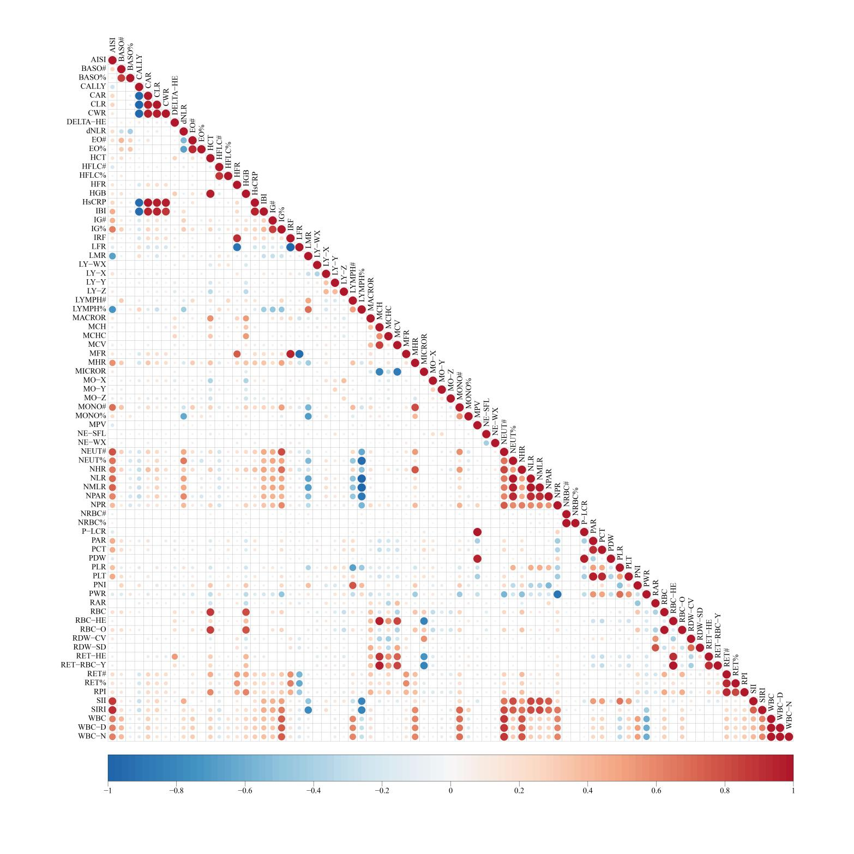Figure S1. Spearman correlation heatmap of inflammation-related hematological profiles.
Table S3. Machine-learning hyperparameter grids and final selected parameters

Model | Hyperparameter | Grid/Search Space | Final Selected Value | Selection Method
Random Forest | ntree | Fixed value | 1000 | Predefined number of trees for model training
 | mtry | Automatic tuning via caret | Caret-optimized value | Optimized through 10-fold cross-validation using caret package
 | nodesize | Default settings | Default value | Used randomForest package default node size parameters
 | importance | TRUE | TRUE | Variable importance calculation enabled
 | Cross-validation | 10-fold CV | 10 folds | 10-fold cross-validation for model validation
LASSO Regression | alpha | Fixed at 1 | 1 | alpha=1 for pure LASSO regularization
 | lambda | Automatic via 10-fold CV | 0.01384 | Selected lambda.min that minimizes misclassification error
 | family | binomial | binomial | Binary classification problem specification
 | type.measure | class | class | Misclassification error used as evaluation metric
 | nfolds | 10 | 10 | 10-fold cross-validation for lambda selection
XGBoost | objective | binary:logistic | binary:logistic | Binary logistic regression objective function
 | eval_metric | rmse | rmse | Root mean square error as evaluation metric
 | eta | Fixed value | 1 | Learning rate set to 1
 | max_depth | Fixed value | 3 | Maximum tree depth limited to 3
 | nrounds | Determined by CV with early stopping | CV-determined | Optimal iterations determined through 10-fold CV with early stopping
 | early_stopping_rounds | 10 | 10 | Early stopping rounds to prevent overfitting
 | nfold | 10 | 10 | 10-fold cross-validation structure

Table S4 Sensitivity analysis excluding participants using antihypertensive, antidiabetic, or lipid-lowering medications in the associations between inflammatory indices and early-stage CKM syndrome.
Variable | Model | Q1 | Q2 | Q3 | Q4 | P for trend
NHR
 | Crude Model | Ref. | 1.98 (1.68,2.33) | 2.73 (2.32,3.22) | 5.55 (4.65,6.62) | <0.0001
 | Model 1 | Ref. | 2.44 (2.04,2.93) | 3.64 (3.03,4.38) | 9.78 (7.98,12.0) | <0.0001
 | Model 2 | Ref. | 2.38 (1.98,2.86) | 3.53 (2.92,4.27) | 9.84 (7.96,12.1) | <0.0001
MHR
 | Crude Model | Ref. | 1.88 (1.60,2.21) | 2.66 (2.26,3.14) | 5.25 (4.41,6.26) | <0.0001
 | Model 1 | Ref. | 2.06 (1.73,2.46) | 3.26 (2.72,3.91) | 7.51 (6.18,9.14) | <0.0001
 | Model 2 | Ref. | 1.97 (1.64,2.36) | 3.13 (2.60,3.76) | 7.26 (5.93,8.90) | <0.0001
RET#
 | Crude Model | Ref. | 1.98 (1.68,2.32) | 3.23 (2.74,3.81) | 5.00 (4.20,5.94) | <0.0001
 | Model 1 | Ref. | 2.16 (1.81,2.59) | 3.83 (3.19,4.61) | 6.79 (5.60,8.24) | <0.0001
 | Model 2 | Ref. | 2.08 (1.73,2.49) | 3.62 (3.00,4.37) | 6.43 (5.28,7.84) | <0.0001
RPI
 | Crude Model | Ref. | 1.55 (1.32,1.82) | 2.77 (2.35,3.26) | 4.49 (3.78,5.34) | <0.0001
 | Model 1 | Ref. | 1.55 (1.30,1.84) | 2.86 (2.39,3.43) | 5.16 (4.27,6.23) | <0.0001
 | Model 2 | Ref. | 1.50 (1.25,1.79) | 2.71 (2.26,3.26) | 4.86 (4.01,5.89) | <0.0001
HFR
 | Crude Model | Ref. | 1.58 (1.35,1.85) | 2.30 (1.95,2.71) | 3.62 (3.06,4.29) | <0.0001
 | Model 1 | Ref. | 1.50 (1.26,1.79) | 2.31 (1.93,2.77) | 3.96 (3.29,4.76) | <0.0001
 | Model 2 | Ref. | 1.46 (1.23,1.75) | 2.25 (1.87,2.71) | 3.82 (3.16,4.61) | <0.0001
CAR
 | Crude Model | Ref. | 2.07 (1.76,2.43) | 3.22 (2.72,3.79) | 4.36 (3.67,5.17) | <0.0001
 | Model 1 | Ref. | 1.86 (1.56,2.21) | 2.92 (2.44,3.50) | 4.36 (3.62,5.24) | <0.0001
 | Model 2 | Ref. | 1.83 (1.53,2.19) | 2.97 (2.47,3.57) | 4.30 (3.56,5.20) | <0.0001
Data are presented as odds ratio (95% confidence interval). Crude Model: There are no covariates were adjusted. Model 1: adjusted for age and sex. Model 2: further adjusted for Model 2: excluding participants taking antihypertensive, antidiabetic, or lipid-lowering medications.Abbreviations: NHR, Neutrophil-to-HDL ratio; MHR, Monocyte-to-HDL ratio; RET#, Reticulocyte count; RPI, Reticulocyte production index; HFR, High-fluorescence reticulocyte ratio; CAR, C-reactive protein to albumin ratio.

Table S5. Sensitivity analysis excluding participants with cancer, mental disorders, liver, respiratory, or autoimmune diseases in the associations between inflammatory indices and early-stage CKM syndrome.
Variable | Model | Q1 | Q2 | Q3 | Q4 | P for trend
NHR
 | Crude Model | Ref. | 1.89 (1.62,2.20) | 2.90 (2.48,3.40) | 5.87 (4.92,7.00) | <0.0001
 | Model 1 | Ref. | 2.33 (1.96,2.77) | 3.98 (3.32,4.78) | 10.5 (8.54,12.9) | <0.0001
 | Model 2 | Ref. | 2.30 (1.93,2.75) | 3.90 (3.24,4.70) | 10.4 (8.44,12.9) | <0.0001
MHR
 | Crude Model | Ref. | 1.84 (1.58,2.15) | 2.57 (2.20,3.01) | 5.42 (4.55,6.45) | <0.0001
 | Model 1 | Ref. | 2.09 (1.76,2.48) | 3.24 (2.71,3.87) | 8.02 (6.58,9.77) | <0.0001
 | Model 2 | Ref. | 2.00 (1.67,2.38) | 3.12 (2.60,3.74) | 7.63 (6.23,9.35) | <0.0001
RET#
 | Crude Model | Ref. | 2.02 (1.73,2.35) | 3.28 (2.80,3.85) | 5.40 (4.55,6.41) | <0.0001
 | Model 1 | Ref. | 2.27 (1.90,2.70) | 4.05 (3.38,4.85) | 7.62 (6.27,9.24) | <0.0001
 | Model 2 | Ref. | 2.16 (1.81,2.59) | 3.87 (3.22,4.66) | 7.28 (5.96,8.88) | <0.0001
RPI
 | Crude Model | Ref. | 1.58 (1.36,1.84) | 2.90 (2.47,3.40) | 4.73 (3.99,5.62) | <0.0001
 | Model 1 | Ref. | 1.57 (1.32,1.86) | 3.08 (2.58,3.68) | 5.46 (4.53,6.60) | <0.0001
 | Model 2 | Ref. | 1.52 (1.28,1.81) | 2.95 (2.46,3.54) | 5.20 (4.28,6.31) | <0.0001
HFR
 | Crude Model | Ref. | 1.61 (1.38,1.87) | 2.32 (1.98,2.71) | 4.05 (3.41,4.81) | <0.0001
 | Model 1 | Ref. | 1.51 (1.27,1.79) | 2.33 (1.96,2.78) | 4.38 (3.63,5.29) | <0.0001
 | Model 2 | Ref. | 1.47 (1.23,1.75) | 2.27 (1.90,2.72) | 4.19 (3.46,5.09) | <0.0001
CAR
 | Crude Model | Ref. | 2.10 (1.80,2.45) | 3.16 (2.70,3.71) | 4.35 (3.68,5.14) | <0.0001
 | Model 1 | Ref. | 1.86 (1.57,2.21) | 2.87 (2.41,3.42) | 4.42 (3.68,5.31) | <0.0001
 | Model 2 | Ref. | 1.86 (1.56,2.21) | 2.90 (2.42,3.47) | 4.39 (3.64,5.30) | <0.0001

Data are presented as odds ratio (95% confidence interval). Crude Model: There are no covariates were adjusted. Model 1: adjusted for age and sex. Model 2: further adjusted for excluding participants with cancer, mental disorders, liver diseases, respiratory diseases, and autoimmune diseases. Abbreviations: NHR, Neutrophil-to-HDL ratio; MHR, Monocyte-to-HDL ratio; RET#, Reticulocyte count; RPI, Reticulocyte production index; HFR, High-fluorescence reticulocyte ratio; CAR, C-reactive protein to albumin ratio.

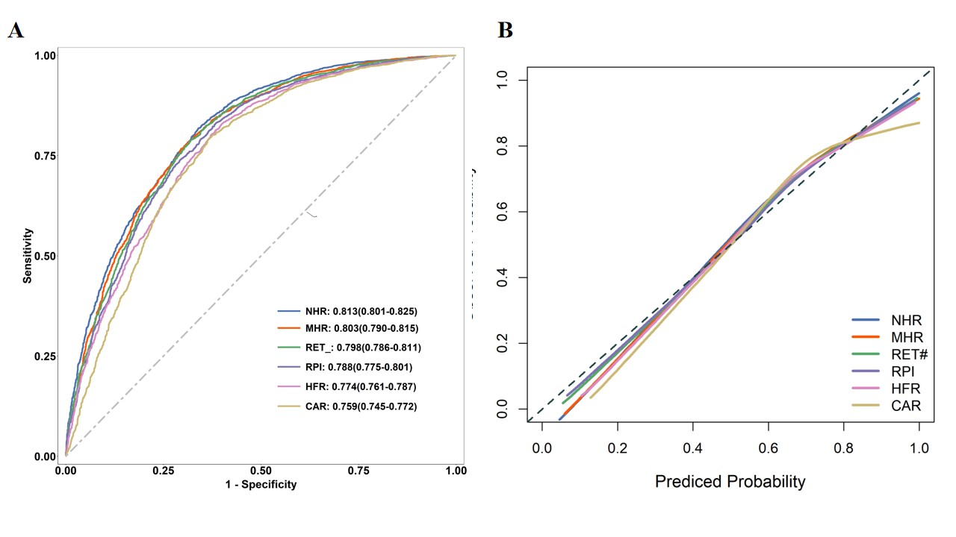
Figure S2. Assessment of prediction model performance for early-stage CKM. (A) Receiver Operating Characteristic (ROC) curve analysis for the prediction model. The diagonal dashed line represents a random guess (AUC = 0.5). (B) Calibration plot of the prediction model. The y-axis represents the observed frequency of early-stage CKM, and the x-axis represents the predicted probability. The dashed diagonal line indicates a perfectly calibrated model.

