Supplementary material
Figure S1 2
Figure S2 2
Figure S3 2
Table S1 3
Table S2 5
Table S3 6
Table S4 8
Table S5. 9
Table S6 10
Table S7 11
Table S8 11

Figure S1 Temporal trends in the proportional distribution of cancer types attributable to high fasting plasma glucose across global and different socioeconomic regions, 1990-2021 ( DALY).
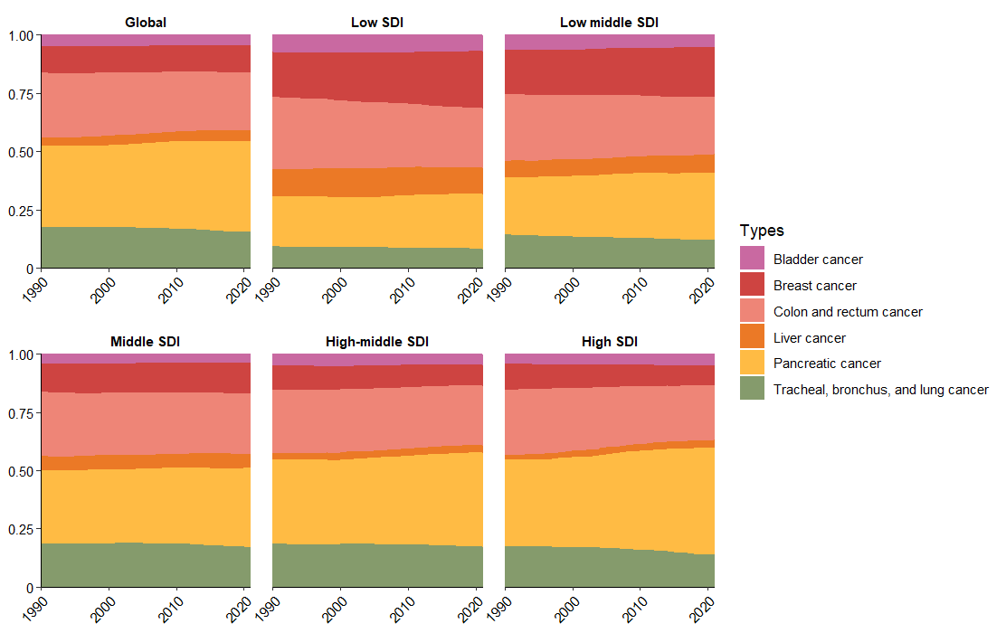
Figure S2 Temporal trends in cancer DALY attributable to high fasting plasma glucose across global and different socioeconomic regions, 1990–2021
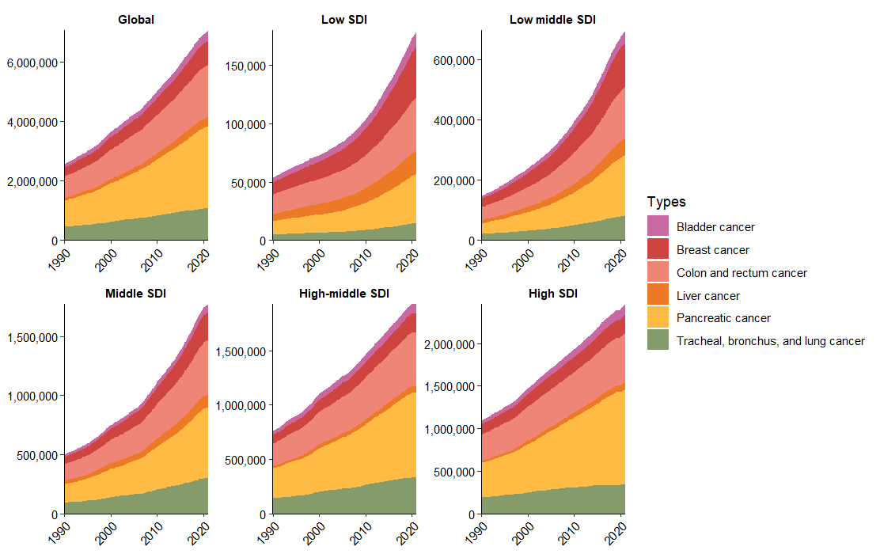
Figure S3 Temporal trends in cancer mortality attributable to high fasting plasma glucose across global and different socioeconomic regions, 1990–2021
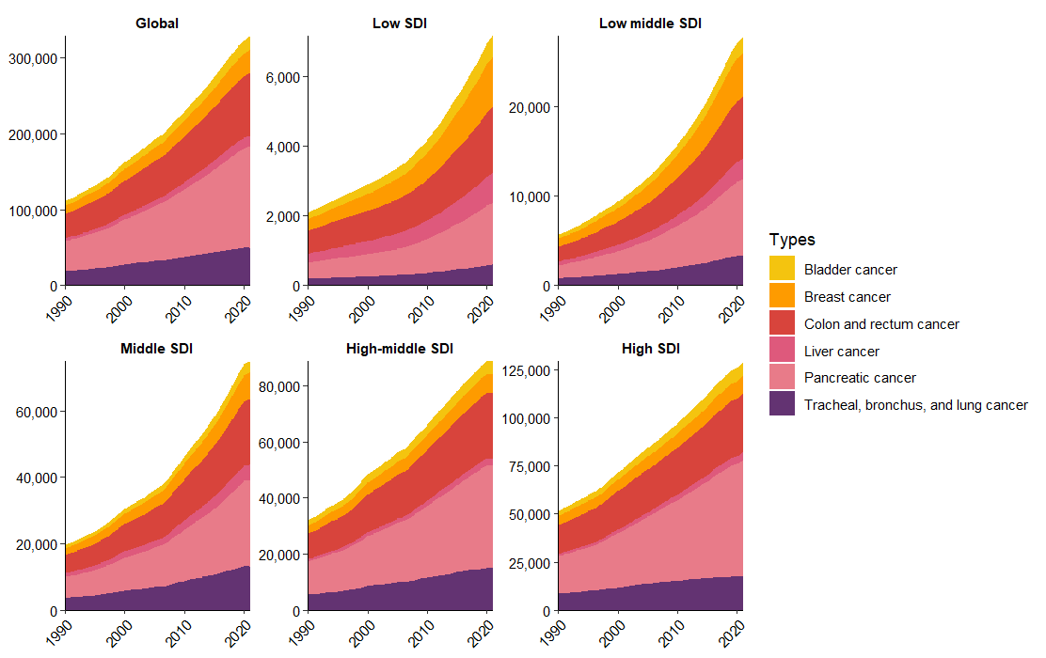
Table S1 Mortality Cases and ASMR of cancer attributable to high fasting plasma glucose in 1990 and 2021, and EAPC of ASMR From 1990 to 2021. ( In the Table, red indicates the maximum or top two EAPC values within each subgroup, while blue represents the minimum or bottom two EAPC values )
 | 1990 |  | 2021 |  | 1990-2021
Characteristics | Mortality cases  (95% UI) | ASMR per 100,000  (95% UI) | Mortality cases  (95% UI) | ASMR per 100,000  (95% UI) | EAPC of ASMR  (95% UI)
Global | 111,322 (12,725 to 212,724) | 3.03 (0.36 to 5.75) | 328,309 (35,241 to 629,883) | 3.88 (0.42 to 7.43) | 0.87 (0.79,0.95)
Sex
Male | 57,949 (7,156 to 110,851) | 2.15 (0.27 to 4.13) | 172,793 (23,021 to 327,553) | 4.36 (0.58 to 8.27) | -
Female | 53,372 (5,569 to 102,932) | 2.02 (0.21 to 3.89) | 155,516 (12,391 to 302,095) | 3.96 (0.32 to 7.68) | -
SDI region
Low | 2,089 (234 to 4,071) | 1.07 (0.13 to 2.08) | 7,155 (559 to 14,549) | 1.62 (0.15 to 3.25) | 1.32 (1.21 to 1.43)
Low-middle | 5,678 (507 to 11,203) | 1.03 (0.1 to 2.02) | 27,799 (2,220 to 55,705) | 2.06 (0.17 to 4.11) | 2.32 (2.29 to 2.35)
Middle | 19,695 (2,100 to 38,556) | 2.13 (0.24 to 4.18) | 74,961 (7,799 to 148,641) | 2.9 (0.31 to 5.76) | 1.07 (1.01 to 1.14)
High-middle | 32,114 (3,618 to 62,511) | 3.38 (0.4 to 6.55) | 88,655 (9,982 to 171,245) | 4.45 (0.5 to 8.58) | 1.02 (0.89 to 1.15)
High | 51,573 (6,246 to 96,333) | 4.56 (0.55 to 8.52) | 129,310 (14,647 to 244,038) | 5.72 (0.64 to 10.75) | 0.78 (0.68 to 0.87)
Region
Andean Latin America | 297 (34 to 604) | 1.59 (0.19 to 3.25) | 1,705 (226 to 3,432) | 2.99 (0.4 to 6.02) | 2.18 (2.05 to 2.3)
Australasia | 946 (137 to 1,750) | 3.99 (0.58 to 7.35) | 2,483 (325 to 4,403) | 4.37 (0.56 to 7.75) | 0.34 (0.3 to 0.38)
Caribbean | 904 (98 to 1,767) | 3.64 (0.4 to 7.1) | 2,427 (305 to 4,813) | 4.49 (0.56 to 8.9) | 0.94 (0.86 to 1.02)
Central Asia | 662 (38 to 1,315) | 1.44 (0.09 to 2.84) | 1,935 (165 to 3,973) | 2.52 (0.23 to 5.17) | 2.36 (2.16 to 2.57)
Central Europe | 6,861 (844 to 13,023) | 4.63 (0.58 to 8.78) | 17,169 (2,250 to 32,251) | 7.33 (0.95 to 13.83) | 1.47 (1.35 to 1.59)
Central Latin America | 2,146 (181 to 4,212) | 2.82 (0.25 to 5.53) | 8,315 (1,051 to 15,876) | 3.4 (0.43 to 6.51) | 0.37 (0.31 to 0.44)
Central Sub-Saharan  Africa | 334 (27 to 657) | 1.74 (0.16 to 3.4) | 1,064 (67 to 2,263) | 2.25 (0.18 to 4.72) | 0.77 (0.56 to 0.99)
East Asia | 22,325 (2,629 to 44,249) | 2.86 (0.35 to 5.6) | 74,954 (8,240 to 145,505) | 3.48 (0.39 to 6.78) | 0.85 (0.66 to 1.04)
Eastern Europe | 6,515 (738 to 12,818) | 2.31 (0.27 to 4.54) | 13,254 (1,772 to 25,285) | 3.66 (0.49 to 6.99) | 1.49 (1.4 to 1.58)
Eastern Sub-Saharan Africa | 668 (103 to 1,303) | 1.1 (0.17 to 2.16) | 2,236 (251 to 4,745) | 1.63 (0.21 to 3.42) | 1.16 (1.06 to 1.27)
High-income Asia Pacific | 8,947 (1,478 to 16,033) | 4.61 (0.77 to 8.26) | 27,109 (4,055 to 48,976) | 4.93 (0.72 to 8.83) | 0.09 (0 to 0.18)
High-income North America | 18,864 (1,795 to 35,579) | 5.22 (0.48 to 9.8) | 47,671 (4,473 to 89,682) | 6.92 (0.65 to 13) | 1.02 (0.83 to 1.2)
North Africa and Middle East | 2,844 (297 to 5,500) | 1.92 (0.21 to 3.69) | 16,256 (1,508 to 31,466) | 3.99 (0.39 to 7.73) | 2.75 (2.63 to 2.88)
Oceania | 58 (1 to 118) | 2.33 (0.1 to 4.7) | 195 (2 to 406) | 2.95 (0.08 to 6.04) | 0.8 (0.77 to 0.82)
South Asia | 4,695 (371 to 9,255) | 0.89 (0.08 to 1.73) | 22,553 (1,317 to 44,414) | 1.6 (0.1 to 3.17) | 1.78 (1.7 to 1.86)
Southeast Asia | 3,640 (363 to 7,339) | 1.64 (0.18 to 3.3) | 17,815 (2,024 to 36,658) | 2.99 (0.36 to 6.08) | 1.87 (1.8 to 1.95)
Southern Latin America | 1,841 (204 to 3,621) | 4.05 (0.46 to 7.95) | 4,979 (705 to 9,383) | 5.55 (0.78 to 10.46) | 1.2 (1.05 to 1.36)
Southern Sub-Saharan Africa | 497 (37 to 1,033) | 2.12 (0.17 to 4.36) | 2,161 (147 to 4,521) | 4.2 (0.3 to 8.78) | 2.49 (2.16 to 2.82)
Tropical Latin America | 2,159 (180 to 4,330) | 2.6 (0.23 to 5.22) | 9,459 (1,057 to 17,941) | 3.73 (0.42 to 7.07) | 1.4 (1.34 to 1.46)
Western Europe | 25,389 (3,029 to 48,818) | 4.19 (0.49 to 8.09) | 51,338 (5,511 to 100,003) | 4.96 (0.51 to 9.72) | 0.62 (0.56 to 0.67)
Western Sub-Saharan Africa | 726 (52 to 1,463) | 0.95 (0.08 to 1.91) | 3,230 (159 to 6,751) | 1.93 (0.12 to 4.02) | 2.43 (2.37 to 2.49)

Table S2 DALYs and ASDR of cancer attributable to high fasting plasma glucose in 1990 and 2021, and EAPC of ASDR From 1990 to 2021. ( In the Table, red indicates the maximum or top two EAPC values within each subgroup, while blue represents the minimum or bottom two EAPC values )
 | 1990 |  | 2021 |  | 1990-2021
Characteristics | DALYs cases  (95% UI) | ASDR per 100,000  (95% UI) | DALYs cases  (95% UI) | ASDR per 100,000  (95% UI) | EAPC of ASDR  (95% UI)
Global | 2,571,484 (263,140 to 4,962,663) | 65.33 (6.94 to 125.91) | 7,051,196 (707,114 to 13,622,171) | 81.35 (8.2 to 157.28) | 0.77 (0.7 to 0.84)
Sex
Male | 1,376,827 (168,716 to 2,620,801) | 76.50 (9.61 to 145.77) | 3,766,201 (521,980 to 7,137,681) | 93.44 (12.98 to 176.81) | -
Female | 1,194,657 (96,160 to 2,325,593) | 56.27 (4.65 to 109.20) | 3,284,995 (187,143 to 6,475,538) | 71.20 (3.93 to 140.42) | -
SDI region
Low | 53,918 (5,444 to 106,702) | 23.81 (2.58 to 46.91) | 179,710 (11,021 to 366,776) | 35.37 (2.57 to 72.36) | 1.2 (1.09 to 1.32)
Low-middle | 147,831 (11,654 to 296,047) | 23.76 (2.02 to 47.03) | 695,466 (45,779 to 1,394,061) | 47.33 (3.37 to 94.71) | 2.3 (2.27 to 2.33)
Middle | 503,081 (50,671 to 988,657) | 47.97 (5 to 94.07) | 1,773,025 (173,256 to 3,498,179) | 64.63 (6.42 to 127.74) | 1.03 (0.97 to 1.08)
High-middle | 764,995 (77,498 to 1,510,467) | 76.09 (7.93 to 149.49) | 1,929,592 (206,397 to 3,750,410) | 96.45 (10.36 to 187.65) | 0.87 (0.76 to 0.98)
High | 1,097,757 (117,681 to 2,085,222) | 99.04 (10.46 to 188.19) | 2,464,410 (269,660 to 4,613,174) | 118.39 (12.81 to 223.26) | 0.62 (0.52 to 0.72)
Region
Andean Latin America | 6,682 (663 to 13,620) | 33.47 (3.49 to 68.16) | 35,948 (4,494 to 72,166) | 61.43 (7.76 to 123.34) | 2.04 (1.94 to 2.14)
Australasia | 20,639 (2,786 to 37,854) | 87.55 (11.79 to 160.33) | 48,749 (5,763 to 87,515) | 92.5 (10.61 to 167.38) | 0.22 (0.18 to 0.26)
Caribbean | 19,350 (1,902 to 37,845) | 75.05 (7.5 to 146.79) | 52,412 (5,951 to 103,756) | 97.13 (11 to 192.26) | 1.08 (1.01 to 1.15)
Central Asia | 17,540 (792 to 35,207) | 36.24 (1.76 to 72.22) | 48,767 (3,751 to 100,592) | 58.04 (4.71 to 119.5) | 1.96 (1.8 to 2.12)
Central Europe | 158,311 (16,975 to 302,351) | 103.8 (11.25 to 197.75) | 352,513 (43,181 to 668,297) | 157.66 (18.93 to 300.01) | 1.36 (1.23 to 1.49)
Central Latin America | 50,857 (3,670 to 99,252) | 61.48 (4.75 to 120.22) | 195,653 (22,982 to 374,106) | 77.32 (9.18 to 147.59) | 0.5 (0.43 to 0.57)
Central Sub-Saharan  Africa | 9,172 (608 to 18,309) | 39.88 (3.13 to 78.01) | 29,316 (1,430 to 63,265) | 51.32 (3.25 to 109.07) | 0.76 (0.54 to 0.98)
East Asia | 581,869 (67,730 to 1,160,005) | 65.32 (7.74 to 129.84) | 1,733,689 (189,645 to 3,358,032) | 77.77 (8.68 to 150.63) | 0.77 (0.62 to 0.92)
Eastern Europe | 163,184 (15,902 to 322,377) | 56.99 (5.61 to 112.58) | 297,283 (36,241 to 572,670) | 83.63 (10.05 to 161.33) | 1.16 (1.06 to 1.25)
Eastern Sub-Saharan Africa | 16,339 (2,346 to 32,083) | 22.91 (3.45 to 44.85) | 53,304 (4,916 to 113,577) | 33.16 (3.61 to 70.3) | 1.05 (0.93 to 1.17)
High-income Asia Pacific | 194,446 (31,446 to 348,548) | 96.02 (15.66 to 171.88) | 450,785 (65,890 to 812,947) | 95.88 (13.64 to 174.8) | -0.16 (-0.26 to -0.05)
High-income North America | 411,731 (32,414 to 772,613) | 118.84 (8.89 to 224.87) | 970,414 (90,674 to 1,827,368) | 147.94 (14.06 to 278.45) | 0.79 (0.63 to 0.95)
North Africa and Middle East | 70,984 (6,949 to 138,902) | 42.27 (4.29 to 82.05) | 397,187 (32,900 to 768,692) | 87.08 (7.65 to 168.23) | 2.67 (2.55 to 2.78)
Oceania | 1,631 (10 to 3,341) | 53.66 (1.2 to 109.37) | 5,405 (-28 to 11,342) | 68.65 (0.63 to 142.54) | 0.81 (0.78 to 0.85)
South Asia | 128,313 (8,628 to 257,201) | 21.3 (1.6 to 42.29) | 577,605 (25,077 to 1,132,425) | 37.87 (1.83 to 74.38) | 1.73 (1.65 to 1.81)
Southeast Asia | 89,545 (7,799 to 181,937) | 35.59 (3.37 to 71.62) | 422,582 (43,840 to 873,690) | 64.16 (6.98 to 131.93) | 1.8 (1.74 to 1.86)
Southern Latin America | 40,523 (3,944 to 80,144) | 86.84 (8.52 to 171.78) | 102,344 (13,623 to 193,902) | 117.01 (15.42 to 222.21) | 1.12 (0.97 to 1.27)
Southern Sub-Saharan Africa | 11,141 (665 to 23,369) | 42.66 (2.81 to 89.21) | 51,065 (3,027 to 106,512) | 89.22 (5.66 to 186.09) | 2.73 (2.39 to 3.08)
Tropical Latin America | 51,757 (3,728 to 103,202) | 56.78 (4.37 to 113.61) | 217,962 (22,747 to 416,292) | 83.89 (8.81 to 160.19) | 1.44 (1.39 to 1.49)
Western Europe | 510,069 (51,747 to 990,848) | 87.75 (8.47 to 170.57) | 928,960 (93,697 to 1,829,719) | 100.37 (9.7 to 198.77) | 0.5 (0.43 to 0.57)
Western Sub-Saharan Africa | 17,399 (941 to 35,521) | 20.15 (1.29 to 40.8) | 79,256 (2,120 to 164,939) | 40.95 (1.79 to 85.67) | 2.41 (2.36 to 2.47)

Table S3. The actual and projected values of ASMR among six cancer types from 1990 to 2031, stratified by cancer types.
Year | Actual or Forecast | ASMR
Year | Actual or Forecast | Bladder cancer | Breast cancer | Colon and rectum cancer | Liver cancer | Pancreatic cancer | Tracheal, bronchus, and lung cancer
1990 | Actual | 0.18 | 0.29 | 0.89 | 0.1 | 1.08 | 0.49
1991 | Actual | 0.18 | 0.29 | 0.9 | 0.1 | 1.09 | 0.5
1992 | Actual | 0.18 | 0.3 | 0.9 | 0.1 | 1.1 | 0.5
1993 | Actual | 0.18 | 0.3 | 0.91 | 0.1 | 1.12 | 0.51
1994 | Actual | 0.18 | 0.31 | 0.92 | 0.1 | 1.13 | 0.51
1995 | Actual | 0.19 | 0.31 | 0.93 | 0.11 | 1.15 | 0.52
1996 | Actual | 0.19 | 0.31 | 0.93 | 0.11 | 1.16 | 0.53
1997 | Actual | 0.19 | 0.31 | 0.94 | 0.12 | 1.18 | 0.54
1998 | Actual | 0.2 | 0.31 | 0.96 | 0.12 | 1.21 | 0.55
1999 | Actual | 0.2 | 0.32 | 0.98 | 0.13 | 1.24 | 0.57
2000 | Actual | 0.21 | 0.32 | 0.99 | 0.13 | 1.27 | 0.58
2001 | Actual | 0.21 | 0.32 | 0.99 | 0.13 | 1.29 | 0.59
2002 | Actual | 0.21 | 0.33 | 0.99 | 0.14 | 1.3 | 0.59
2003 | Actual | 0.21 | 0.33 | 1 | 0.14 | 1.32 | 0.6
2004 | Actual | 0.21 | 0.33 | 1 | 0.13 | 1.34 | 0.6
2005 | Actual | 0.21 | 0.33 | 1 | 0.13 | 1.36 | 0.6
2006 | Actual | 0.21 | 0.33 | 0.98 | 0.14 | 1.37 | 0.6
2007 | Actual | 0.21 | 0.33 | 0.98 | 0.14 | 1.39 | 0.6
2008 | Actual | 0.21 | 0.33 | 0.99 | 0.14 | 1.41 | 0.61
2009 | Actual | 0.21 | 0.33 | 0.99 | 0.15 | 1.43 | 0.61
2010 | Actual | 0.21 | 0.34 | 0.99 | 0.15 | 1.45 | 0.61
2011 | Actual | 0.21 | 0.34 | 0.99 | 0.15 | 1.47 | 0.62
2012 | Actual | 0.21 | 0.34 | 0.99 | 0.15 | 1.49 | 0.62
2013 | Actual | 0.21 | 0.34 | 0.99 | 0.16 | 1.5 | 0.62
2014 | Actual | 0.22 | 0.34 | 0.99 | 0.16 | 1.51 | 0.62
2015 | Actual | 0.22 | 0.35 | 1 | 0.17 | 1.53 | 0.61
2016 | Actual | 0.22 | 0.35 | 1 | 0.17 | 1.55 | 0.61
2017 | Actual | 0.22 | 0.35 | 1 | 0.17 | 1.56 | 0.61
2018 | Actual | 0.22 | 0.36 | 1 | 0.17 | 1.57 | 0.6
2019 | Actual | 0.22 | 0.36 | 1 | 0.17 | 1.59 | 0.6
2020 | Actual | 0.22 | 0.36 | 0.99 | 0.17 | 1.58 | 0.6
2021 | Actual | 0.21 | 0.36 | 0.98 | 0.17 | 1.57 | 0.59
2022 | Forecast | 0.2100 (0.2021, 0.2179) | 0.3637 (0.3558, 0.3716) | 0.9748 (0.9593, 0.9902) | 0.1723 (0.1625, 0.1820) | 1.5718 (1.5555, 1.5881) | 0.5889 (0.5777, 0.6000)
2023 | Forecast | 0.2100 (0.1989, 0.2211) | 0.3659 (0.3569, 0.3750) | 0.9696 (0.9439, 0.9953) | 0.1745 (0.1607, 0.1883) | 1.5797 (1.5500, 1.6094) | 0.5820 (0.5657, 0.5984)
2024 | Forecast | 0.2100 (0.1964, 0.2236) | 0.3682 (0.3581, 0.3783) | 0.9644 (0.9280, 1.0007) | 0.1768 (0.1599, 0.1937) | 1.5909 (1.5492, 1.6326) | 0.5752 (0.5486, 0.6018)
2025 | Forecast | 0.2100 (0.1943, 0.2257) | 0.3705 (0.3595, 0.3816) | 0.9591 (0.9115, 1.0068) | 0.1790 (0.1595, 0.1985) | 1.6038 (1.5514, 1.6562) | 0.5683 (0.5283, 0.6084)
2026 | Forecast | 0.2100 (0.1924, 0.2276) | 0.3728 (0.3609, 0.3847) | 0.9539 (0.8943, 1.0136) | 0.1813 (0.1595, 0.2031) | 1.6176 (1.5557, 1.6794) | 0.5615 (0.5057, 0.6173)
2027 | Forecast | 0.2100 (0.1907, 0.2293) | 0.3751 (0.3623, 0.3878) | 0.9487 (0.8764, 1.0211) | 0.1835 (0.1597, 0.2074) | 1.6318 (1.5614, 1.7022) | 0.5546 (0.4811, 0.6282)
2028 | Forecast | 0.2100 (0.1892, 0.2308) | 0.3774 (0.3639, 0.3909) | 0.9435 (0.8577, 1.0293) | 0.1858 (0.1600, 0.2116) | 1.6463 (1.5682, 1.7244) | 0.5478 (0.4548, 0.6407)
2029 | Forecast | 0.2100 (0.1877, 0.2323) | 0.3797 (0.3654, 0.3939) | 0.9383 (0.8384, 1.0382) | 0.1881 (0.1605, 0.2156) | 1.6609 (1.5757, 1.7461) | 0.5409 (0.4271, 0.6548)
2030 | Forecast | 0.2100 (0.1864, 0.2336) | 0.3819 (0.3670, 0.3969) | 0.9331 (0.8184, 1.0478) | 0.1903 (0.1611, 0.2196) | 1.6756 (1.5838, 1.7674) | 0.5341 (0.3978, 0.6704)
2031 | Forecast | 0.2100 (0.1851, 0.2349) | 0.3842 (0.3687, 0.3998) | 0.9279 (0.7978, 1.0580) | 0.1926 (0.1618, 0.2234) | 1.6903 (1.5923, 1.7883) | 0.5273 (0.3673, 0.6872)

Table S4. The actual and projected values of mortality among the remaining six cancer types from 1990 to 2031, stratified by cancer types.
Year | Actual or Forecast | Number of Deaths
Year | Actual or Forecast | Bladder cancer | Breast cancer | Colon and rectum cancer | Liver cancer | Pancreatic cancer | Tracheal, bronchus, and lung cancer
1990 | Actual | 6092 | 10865 | 31907 | 3750 | 39731 | 18977
1991 | Actual | 6302 | 11231 | 32835 | 3873 | 41060 | 19534
1992 | Actual | 6550 | 11632 | 33940 | 4025 | 42542 | 20167
1993 | Actual | 6792 | 12095 | 35124 | 4187 | 44214 | 20911
1994 | Actual | 7050 | 12527 | 36219 | 4389 | 45793 | 21560
1995 | Actual | 7300 | 12930 | 37329 | 4669 | 47269 | 22426
1996 | Actual | 7557 | 13289 | 38420 | 4937 | 48997 | 23102
1997 | Actual | 7900 | 13675 | 39776 | 5219 | 51135 | 24036
1998 | Actual | 8293 | 14158 | 41509 | 5607 | 53697 | 25236
1999 | Actual | 8735 | 14750 | 43363 | 6015 | 56449 | 26519
2000 | Actual | 9102 | 15251 | 44988 | 6365 | 59213 | 27836
2001 | Actual | 9410 | 15743 | 46406 | 6602 | 61475 | 28794
2002 | Actual | 9667 | 16250 | 47784 | 6816 | 63762 | 29722
2003 | Actual | 9953 | 16804 | 49334 | 6969 | 66350 | 30736
2004 | Actual | 10232 | 17250 | 50559 | 7095 | 69060 | 31772
2005 | Actual | 10543 | 17777 | 51906 | 7317 | 71999 | 32647
2006 | Actual | 10778 | 18261 | 52798 | 7566 | 74567 | 33205
2007 | Actual | 11141 | 18839 | 54314 | 7913 | 77837 | 34240
2008 | Actual | 11578 | 19532 | 56311 | 8407 | 81504 | 35560
2009 | Actual | 11988 | 20189 | 57981 | 8854 | 84984 | 36980
2010 | Actual | 12484 | 20894 | 59992 | 9289 | 88769 | 38090
2011 | Actual | 12922 | 21598 | 61976 | 9679 | 92488 | 39408
2012 | Actual | 13380 | 22324 | 63865 | 10146 | 96434 | 40676
2013 | Actual | 13872 | 23103 | 65775 | 10774 | 100135 | 41863
2014 | Actual | 14377 | 23930 | 67698 | 11444 | 104052 | 43049
2015 | Actual | 14957 | 24933 | 70124 | 11980 | 108383 | 44100
2016 | Actual | 15535 | 25956 | 72576 | 12488 | 113360 | 45451
2017 | Actual | 15991 | 26958 | 74653 | 12955 | 117895 | 46438
2018 | Actual | 16421 | 28049 | 77052 | 13439 | 122659 | 47494
2019 | Actual | 16950 | 29035 | 79489 | 13840 | 127480 | 48743
2020 | Actual | 17357 | 29799 | 81106 | 14233 | 130240 | 49935
2021 | Actual | 17562 | 30568 | 82421 | 14457 | 132753 | 50547
2022 | Forecast | 17767 (17626, 17908) | 31337 (31180, 31494) | 83736 (83132, 84340) | 14681 (14530, 14832) | 135266 (134308, 136224) | 51159 (50705, 51613)
2023 | Forecast | 17972 (17657, 18287) | 32106 (31754, 32458) | 85051 (83701, 86401) | 14905 (14568, 15242) | 137779 (135637, 139921) | 51771 (50756, 52786)
2024 | Forecast | 18177 (17649, 18705) | 32875 (32286, 33464) | 86366 (84107, 88625) | 15129 (14566, 15692) | 140292 (136708, 143876) | 52383 (50684, 54082)
2025 | Forecast | 18382 (17609, 19155) | 33644 (32782, 34506) | 87681 (84374, 90988) | 15353 (14528, 16178) | 142805 (137558, 148052) | 52995 (50508, 55482)
2026 | Forecast | 18587 (17541, 19633) | 34413 (33246, 35580) | 88996 (84519, 93473) | 15577 (14460, 16694) | 145318 (138213, 152423) | 53607 (50240, 56974)
2027 | Forecast | 18792 (17447, 20137) | 35182 (33681, 36683) | 90311 (84552, 96070) | 15801 (14364, 17238) | 147831 (138693, 156969) | 54219 (49888, 58550)
2028 | Forecast | 18997 (17328, 20666) | 35951 (34090, 37812) | 91626 (84483, 98769) | 16025 (14243, 17807) | 150344 (139009, 161679) | 54831 (49459, 60203)
2029 | Forecast | 19202 (17187, 21217) | 36720 (34473, 38967) | 92941 (84318, 101564) | 16249 (14098, 18400) | 152857 (139174, 166540) | 55443 (48958, 61928)
2030 | Forecast | 19407 (17026, 21788) | 37489 (34833, 40145) | 94256 (84064, 104448) | 16473 (13931, 19015) | 155370 (139198, 171542) | 56055 (48390, 63720)
2031 | Forecast | 19612 (16844, 22380) | 38258 (35172, 41344) | 95571 (83725, 107417) | 16697 (13742, 19652) | 157883 (139086, 176680) | 56667 (47758, 65576)
Table S5. Status of risk–outcome pairs considered for inclusion in GBD 2021: added in GBD 2021, or removed in GBD 2021
Risk Name | Outcome Name | Status
High fasting plasma glucose | Colon and rectum cancer | Added in GBD 2021
High fasting plasma glucose | Liver cancer due to NASH | Added in GBD 2021
High fasting plasma glucose | Liver cancer due to other causes | Added in GBD 2021
High fasting plasma glucose | Pancreatic cancer | Added in GBD 2021
High fasting plasma glucose | Tracheal, bronchus, and lung cancer | Added in GBD 2021
High fasting plasma glucose | Breast cancer | Added in GBD 2021
High fasting plasma glucose | Bladder cancer | Added in GBD 2021
High fasting plasma glucose | Ovarian cancer | Removed from GBD 2021
Table S6 EAPCs of the 21 GBD regions from 1990 to 2021.
Location | EAPC of Mortality  (95% UI) | EAPC of DALY  (95% UI) | EAPC of ASMR  (95% UI) | EAPC of ASDR  (95% UI)
East Asia | 4.24 (4.1,4.37) | 3.85 (3.74,3.97) | 0.85 (0.66,1.04) | 0.77 (0.62,0.92)
Southeast Asia | 5.1 (5.04,5.16) | 4.95 (4.88,5.01) | 1.87 (1.8,1.95) | 1.8 (1.74,1.86)
Oceania | 3.98 (3.93,4.03) | 3.97 (3.92,4.03) | 0.8 (0.77,0.82) | 0.81 (0.78,0.85)
Central Asia | 3.93 (3.75,4.12) | 3.67 (3.48,3.86) | 2.36 (2.16,2.57) | 1.96 (1.8,2.12)
Central Europe | 3.07 (2.97,3.18) | 2.66 (2.55,2.78) | 1.47 (1.35,1.59) | 1.36 (1.23,1.49)
Eastern Europe | 2.24 (2.13,2.34) | 1.77 (1.65,1.88) | 1.49 (1.4,1.58) | 1.16 (1.06,1.25)
High-income Asia Pacific | 3.58 (3.43,3.72) | 2.64 (2.47,2.8) | 0.09 (0,0.18) | -0.16 (-0.26,-0.05)
Australasia | 3.17 (3.12,3.23) | 2.85 (2.79,2.91) | 0.34 (0.3,0.38) | 0.22 (0.18,0.26)
Western Europe | 2.43 (2.39,2.48) | 2.07 (2.01,2.12) | 0.62 (0.56,0.67) | 0.5 (0.43,0.57)
Southern Latin America | 3.43 (3.28,3.59) | 3.19 (3.06,3.32) | 1.2 (1.05,1.36) | 1.12 (0.97,1.27)
High-income North America | 3.16 (3.05,3.27) | 2.96 (2.86,3.06) | 1.02 (0.83,1.2) | 0.79 (0.63,0.95)
Caribbean | 3.52 (3.44,3.6) | 3.55 (3.47,3.63) | 0.94 (0.86,1.02) | 1.08 (1.01,1.15)
Andean Latin America | 6.09 (5.94,6.24) | 5.75 (5.63,5.87) | 2.18 (2.05,2.3) | 2.04 (1.94,2.14)
Central Latin America | 4.31 (4.26,4.36) | 4.27 (4.21,4.33) | 0.37 (0.31,0.44) | 0.5 (0.43,0.57)
Tropical Latin America | 5.13 (5.06,5.19) | 4.96 (4.9,5.02) | 1.4 (1.34,1.46) | 1.44 (1.39,1.49)
North Africa and Middle East | 6.13 (5.99,6.28) | 5.99 (5.84,6.14) | 2.75 (2.63,2.88) | 2.67 (2.55,2.78)
South Asia | 5.12 (5.04,5.21) | 4.9 (4.8,4.99) | 1.78 (1.7,1.86) | 1.73 (1.65,1.81)
Central Sub-Saharan Africa | 3.69 (3.4,3.99) | 3.73 (3.4,4.06) | 0.77 (0.56,0.99) | 0.76 (0.54,0.98)
Eastern Sub-Saharan Africa | 3.86 (3.64,4.08) | 3.73 (3.49,3.97) | 1.16 (1.06,1.27) | 1.05 (0.93,1.17)
Southern Sub-Saharan Africa | 5.04 (4.71,5.37) | 5.28 (4.95,5.61) | 2.49 (2.16,2.82) | 2.73 (2.39,3.08)
Western Sub-Saharan Africa | 5.02 (4.94,5.1) | 5.08 (4.97,5.18) | 2.43 (2.37,2.49) | 2.41 (2.36,2.47)

Table S7 Model Performance and Diagnostic Summary of ARIMA Models for ASMR Forecasting
Cancer type | ARIMA(p,d,q) | AIC | MAPE(%) | MASE | ACF1 | Q* (Ljung-Box test) | p-value (Ljung-Box test)
Bladder cancer | ARIMA(0,1,0) | -252.11 | 0.7635 | 0.9722 | -0.0819 | 2.5865 | 0.8587
Breast cancer | ARIMA(0,1,1) | -249.73 | 0.9581 | 1.3935 | 0.0408 | 3.0219 | 0.6966
Colon and rectum cancer | ARIMA(0,2,1) | -201.89 | 0.5661 | 1.0047 | 0.1518 | 9.695 | 0.0843
Liver cancer | ARIMA(0,1,0) | -237.87 | 2.8594 | 1.3344 | -0.2202 | 8.3906 | 0.2109
Pancreatic cancer | ARIMA(1,1,0) | -204.77 | 0.4633 | 0.3657 | 0.01 | 0.8897 | 0.971
Tracheal, bronchus, and lung cancer | ARIMA(0,2,2) | -219.37 | 0.7070 | 0.7944 | 0.0134 | 4.2057 | 0.3789

Table S8 Model Performance and Diagnostic Summary of ARIMA Models for Mortality Forecasting
Cancer type | ARIMA(p,d,q) | AIC | MAPE(%) | MASE | ACF1 | Q* (Ljung-Box test) | p-value (Ljung-Box test)
Bladder cancer | ARIMA(0,2,0) | 343.69 | 0.4492 | 0.1425 | 0.0685 | 2.2152 | 0.8989
Breast cancer | ARIMA(0,2,0) | 350.22 | 0.3149 | 0.0935 | 0.0543 | 1.9321 | 0.9258
Colon and rectum cancer | ARIMA(0,2,0) | 430.93 | 0.3971 | 0.1354 | -0.0501 | 3.8576 | 0.6959
Liver cancer | ARIMA(0,2,0) | 347.63 | 0.7085 | 0.1655 | 0.2404 | 3.2415 | 0.778
Pancreatic cancer | ARIMA(0,2,0) | 458.64 | 0.3806 | 0.1030 | 0.0536 | 2.0873 | 0.9115
Tracheal, bronchus, and lung cancer | ARIMA(0,2,0) | 413.84 | 0.5216 | 0.1702 | -0.1271 | 7.2867 | 0.2951

