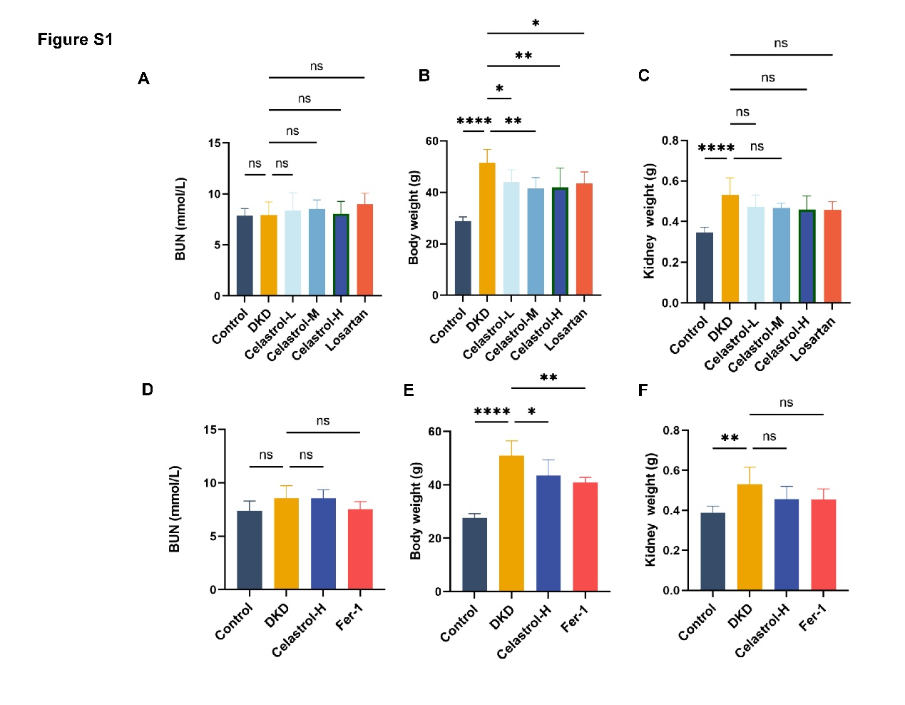
Figure S1 (A-B) The levels of serum blood urea nitrogen (BUN) (mmol/L) in each group were detected using a biosystem fully automatic chemistry analyzer (Hitachi 3100). (C-D) The body weight.in each group. (E-F) The kidney weight.in each group. Data are presented as the mean ± SD, * p< 0.05; **p < 0.01, ****p < 0.0001 (n = 6).

