Supplementary material

The role of hepatocyte growth factor in the relationships between body fat distribution and plasma markers of glucose metabolism
Katarina Zakic, Dennis Freuer, Jakob Linseisen, Christa Meisinger

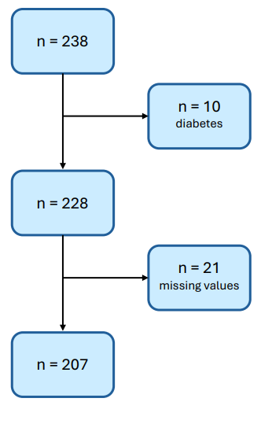
Figure S1: Flowchart showing the selection process for participants included in the regression analyses.

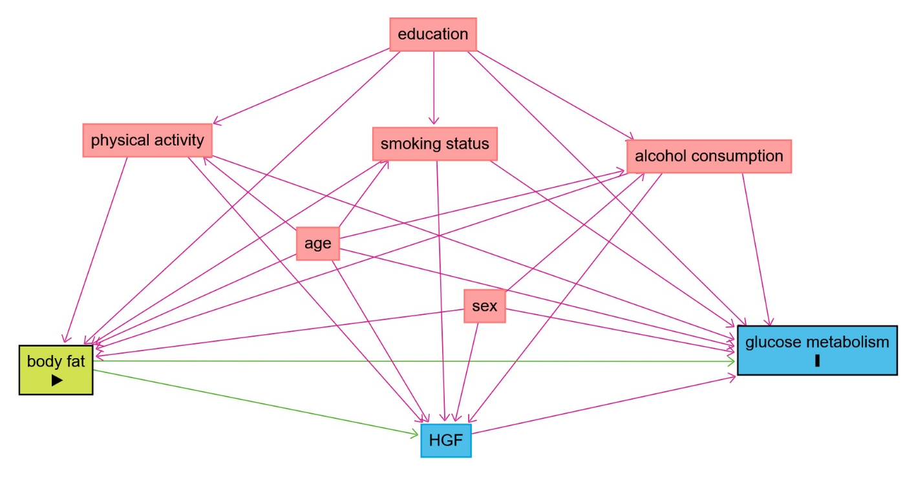
Figure S2: Directed acyclic graph (DAG) used for confounder selection. Red rectangles represent potential confounding factors of the body fat - glucose metabolism association. The blue square at the bottom represents a mediator.

Table S3: Results from Mediation analyses
 | X->M |  |  |  | M->Y |  |  |  |  | Indirect Effect (X->M->Y) |  | Interaction
X | Beta | cil | ciu | P | Beta | cil | ciu | P | Beta | Boot cil | Boot ciu | P(X*M) | Mediation (%)
Fasting plasma glucose levels (mg/dL)
VAT | 26.30 | 7.09 | 45.51 | 0.008 | 0.00 | -0.01 | 0.01 | 0.938 | 0.01 | -0.50 | 0.38 | 0.138 | no mediation
AFMV | 18.54 | 2.59 | 34.50 | 0.023 | 0.00 | -0.01 | 0.01 | 0.832 | 0.03 | -0.30 | 0.30 | 0.402 | no mediation
RFMV | 18.02 | 0.52 | 35.53 | 0.044 | 0.00 | -0.01 | 0.02 | 0.696 | 0.05 | -0.21 | 0.35 | 0.986 | no mediation
BMI | 23.44 | 7.28 | 39.60 | 0.005 | 0.00 | -0.01 | 0.01 | 0.884 | -0.02 | -0.38 | 0.28 | 0.336 | no mediation
WC | 28.04 | 10.42 | 45.66 | 0.002 | 0.00 | -0.02 | 0.01 | 0.806 | -0.05 | -0.51 | 0.32 | 0.092 | no mediation
WHR | 32.84 | 12.38 | 53.29 | 0.002 | 0.00 | -0.01 | 0.02 | 0.772 | 0.07 | -0.41 | 0.57 | 0.147 | no mediation
Two-hour plasma glucose levels (mg/dL)
VAT | 26.14 | 6.45 | 45.83 | 0.010 | 0.06 | 0.01 | 0.10 | 0.010 | 1.48 | -0.96 | 3.68 | 0.172 | 8.3
AFMV | 21.18 | 4.59 | 37.77 | 0.013 | 0.06 | 0.02 | 0.10 | 0.008 | 1.26 | 0.01 | 3.20 | 0.417 | 9.1
RFMV | 18.91 | 0.80 | 37.02 | 0.041 | 0.06 | 0.02 | 0.10 | 0.005 | 1.15 | -0.02 | 3.02 | 0.893 | 7.0
BMI | 26.62 | 9.82 | 43.43 | 0.002 | 0.05 | 0.01 | 0.09 | 0.019 | 1.37 | 0.06 | 3.34 | 0.431 | 8.6
WC | 29.71 | 11.43 | 47.99 | 0.002 | 0.05 | 0.01 | 0.09 | 0.024 | 1.46 | 0.07 | 3.54 | 0.350 | 8.1
WHR | 33.02 | 11.04 | 55.01 | 0.003 | 0.05 | 0.01 | 0.10 | 0.019 | 1.71 | 0.13 | 4.30 | 0.057 | 8.1
HbA1c levels (mmol/mol)
VAT | 26.09 | 6.98 | 45.21 | 0.008 | 0.00 | -0.01 | 0.00 | 0.739 | -0.02 | -0.22 | 0.16 | 0.399 | no mediation
AFMV | 17.68 | 1.84 | 33.52 | 0.029 | 0.00 | -0.01 | 0.01 | 0.861 | -0.01 | -0.13 | 0.12 | 0.439 | no mediation
RFMV | 17.42 | 0.07 | 34.78 | 0.049 | 0.00 | -0.01 | 0.01 | 0.861 | -0.01 | -0.13 | 0.11 | 0.458 | no mediation
BMI | 22.44 | 6.39 | 38.49 | 0.006 | 0.00 | -0.01 | 0.01 | 0.742 | -0.02 | -0.17 | 0.12 | 0.386 | no mediation
WC | 27.11 | 9.58 | 44.65 | 0.003 | 0.83 | 0.16 | 1.51 | 0.015 | -0.03 | -0.18 | 0.14 | 0.178 | no mediation
WHR | 32.37 | 12.05 | 52.69 | 0.002 | 0.00 | -0.01 | 0.01 | 0.719 | -0.03 | -0.21 | 0.17 | 0.069 | no mediation
X represents obesity measures, M the parameters for glucose metabolism, and Y the mediator HGF.

