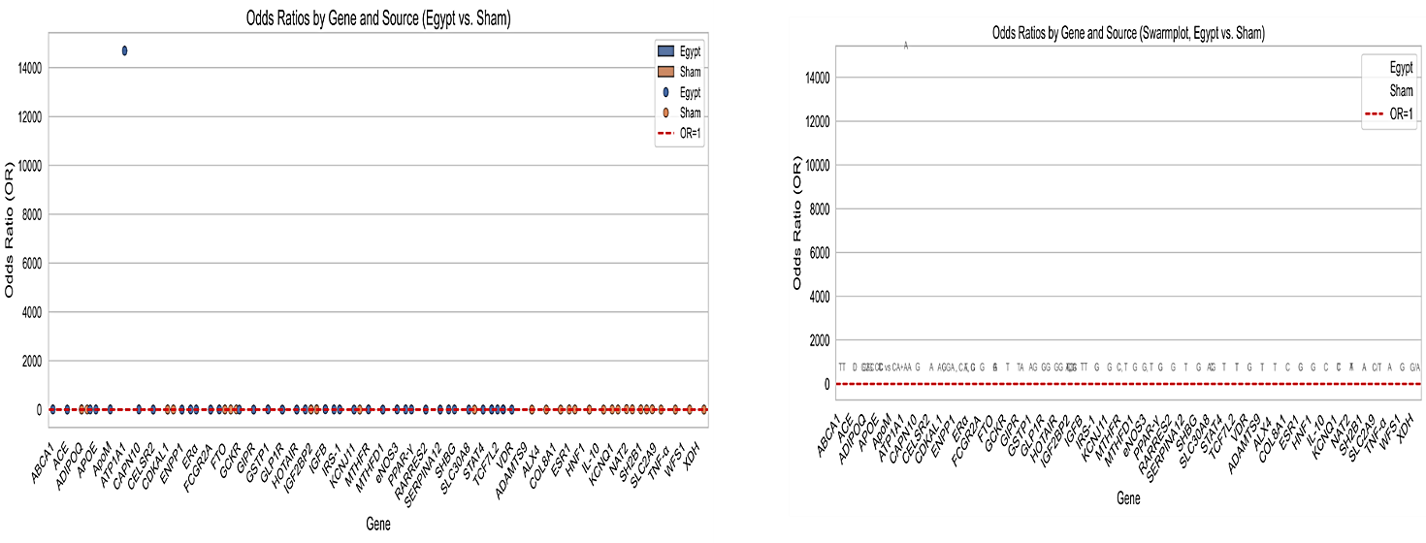
Figure S1: Comparison of Odds Ratios by Gene and Source (Egypt vs. Sham)
Description:
These plots display the distribution of odds ratios (ORs) for various genes comparing the Egypt and Sham groups. The left panel shows a scatterplot of odds ratios for each gene, highlighting both groups (Egypt and Sham) alongside a reference line (OR = 1, in red) indicating no effect. The right panel presents a similar comparison using a swarmplot format, offering a clearer view of data clustering and spread for each gene. Genes are listed along the x-axis, while the y-axis represents the odds ratio values, with large outliers visible for certain genes. The visualizations facilitate the identification of genes with notably different odds ratios between the two sources, as well as the overall distribution of genetic associations.

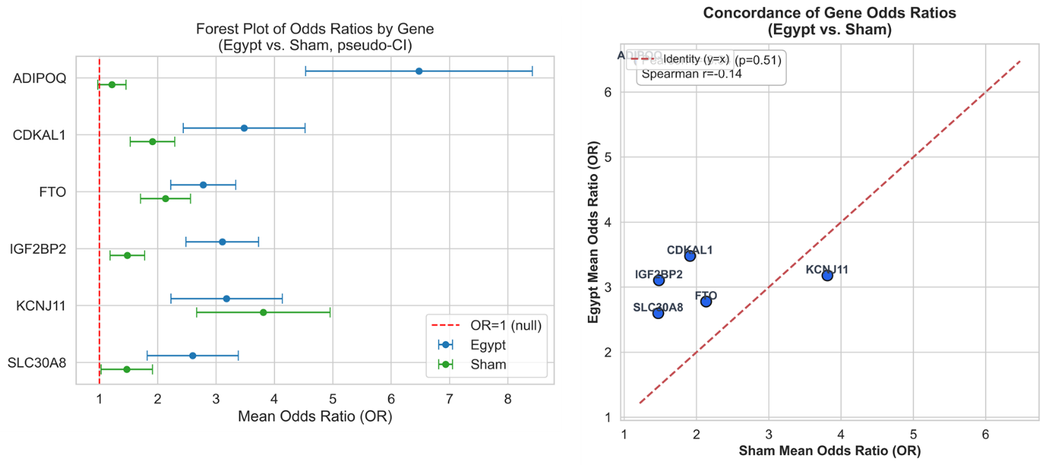
Figure S2: Gene-Specific Odds Ratio Comparisons Between Egypt and Sham Groups

Description:
The left panel presents a forest plot displaying the mean odds ratios (ORs) and pseudo-confidence intervals for six genes in both the Egypt and Sham groups. Each point represents the mean OR for a given gene, with horizontal lines indicating the pseudo-confidence intervals. The vertical dashed red line marks OR = 1, which corresponds to no association. Blue and green colors distinguish the Egypt and Sham groups, respectively. The right panel shows a concordance plot comparing the mean odds ratios for each gene between the Egypt and Sham groups. Each point corresponds to a gene, plotted according to its mean OR in Sham (x-axis) versus Egypt (y-axis). The red dashed line represents the line of identity (y = x), and the plot provides a visual assessment of agreement or divergence between the two groups' gene-specific associations. The Spearman correlation coefficient (r = –0.14, p = 0.51) indicates a lack of significant concordance between odds ratios for the two groups.
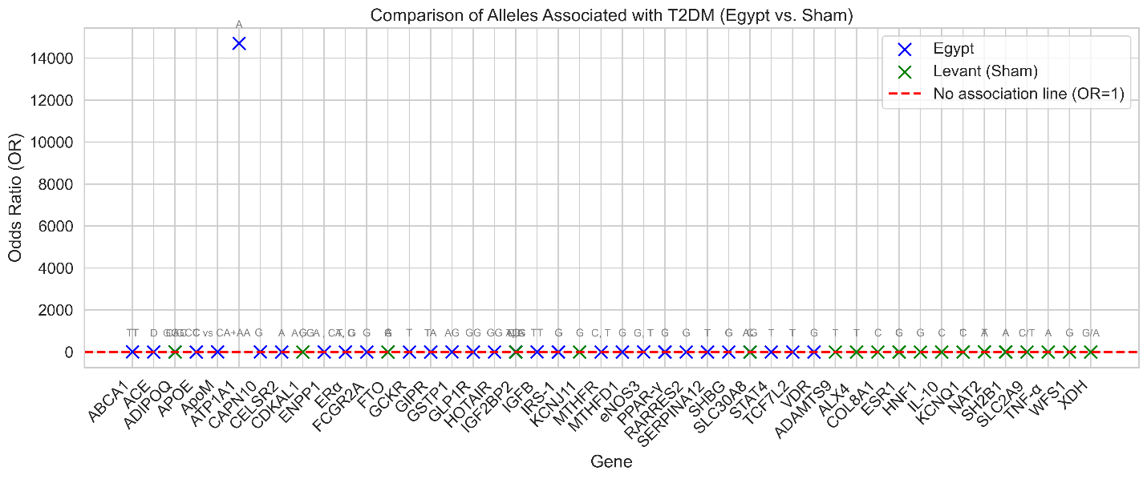
Figure S3: Comparison of Allelic Odds Ratios for T2DM-Associated Genes in Egypt and Levant (Sham) Populations.

Description:
This plot compares the odds ratios (ORs) of alleles associated with type 2 diabetes mellitus (T2DM) across multiple genes between Egyptian and Levantine (Sham) populations. Each gene is displayed along the x-axis, with its associated risk allele indicated. Blue and green crosses represent the odds ratios observed in Egypt and Sham, respectively. The horizontal red dashed line at OR = 1 denotes the null value, indicating no association between allele and disease risk. The visualization highlights genetic loci with elevated or reduced disease risk in each population and allows for direct comparison of effect sizes across diverse genes.

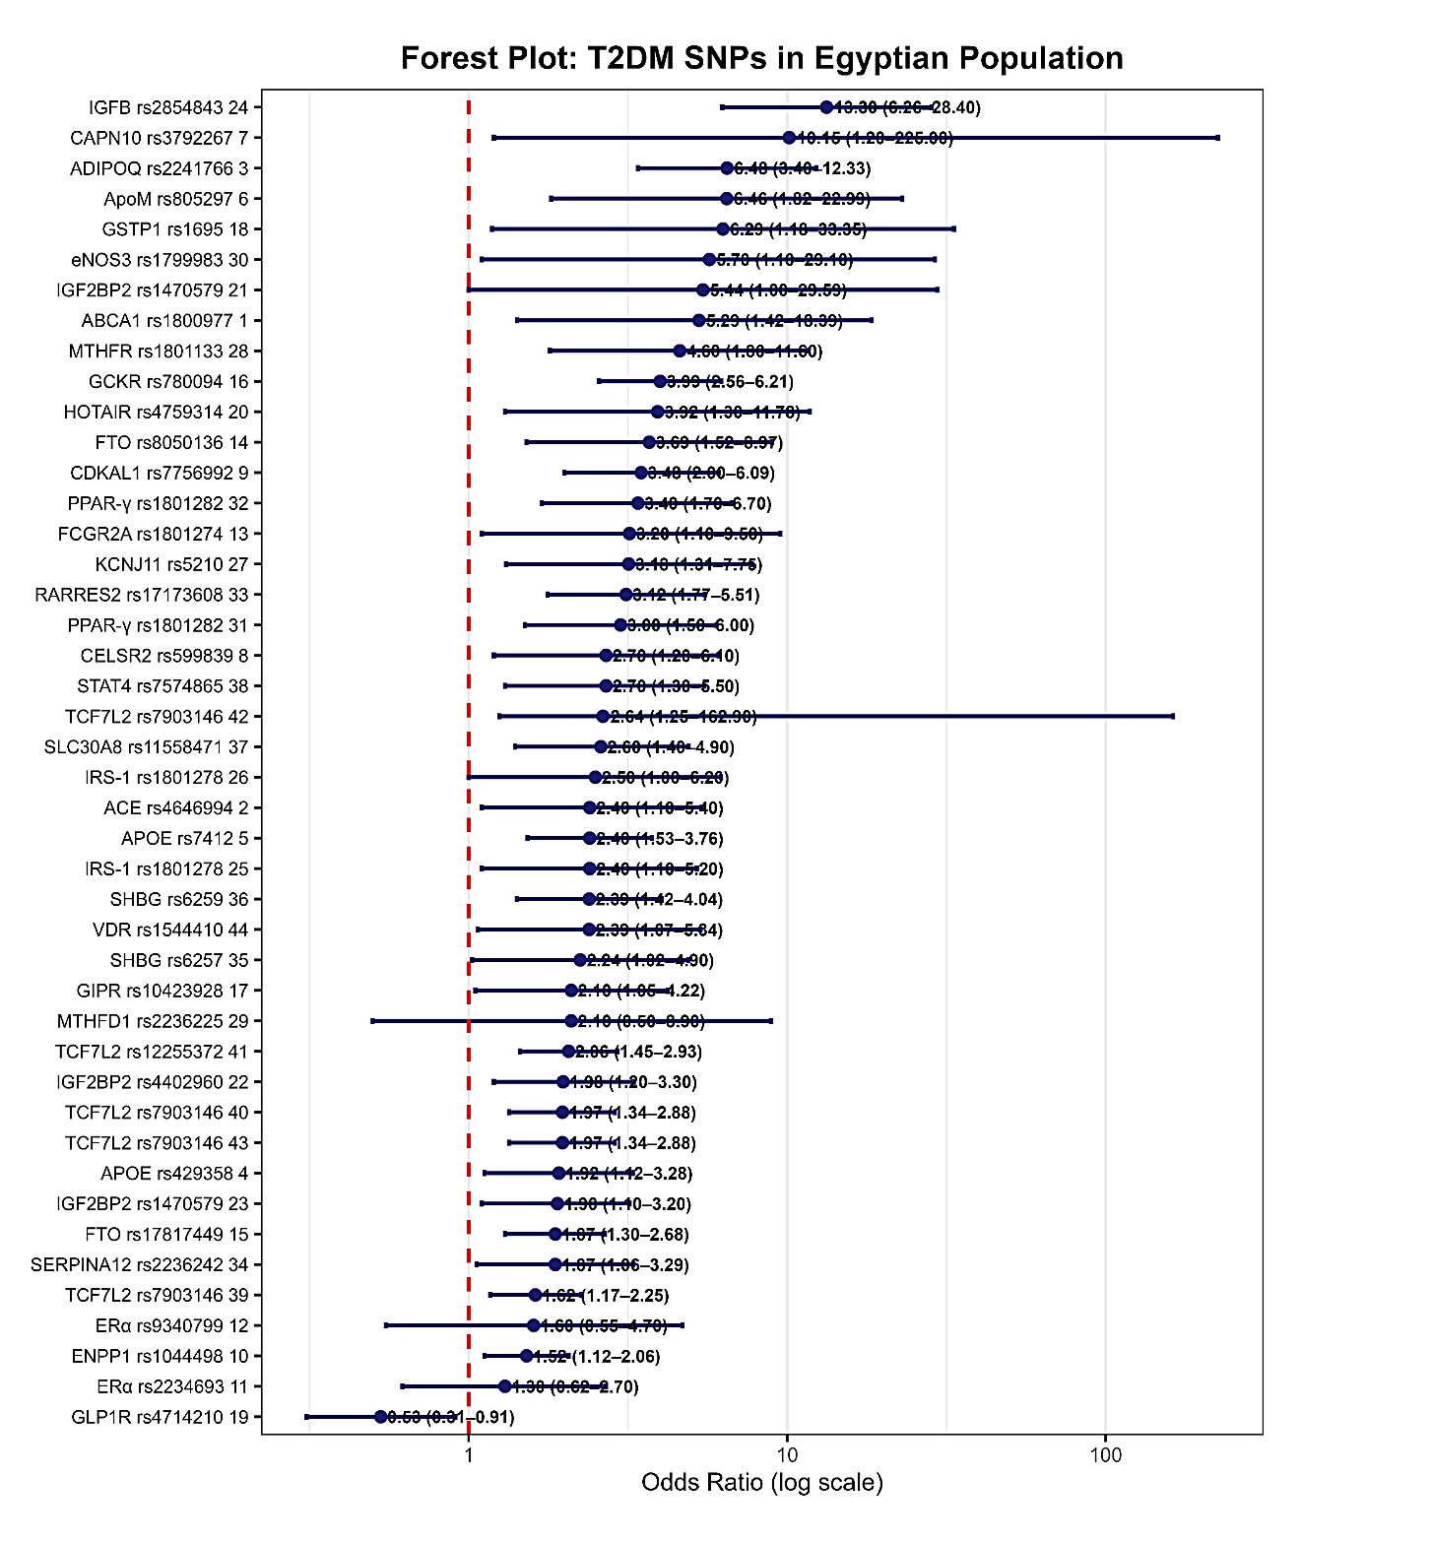
Figure S4: shows the odds ratios and confidence intervals for single nucleotide polymorphisms (SNPs) investigated in only one study each.
Description
Each point represents the odds ratio estimate for a single-study SNP, with horizontal lines indicating the corresponding confidence intervals, all plotted on a logarithmic scale. The vertical red dashed line denotes the null value (odds ratio = 1), indicating no association. SNP identifiers are listed on the y-axis, and their odds ratios with confidence intervals and p-values are shown on the right. No meta-analytic pooling was performed for these SNPs due to the availability of data from only a single study per variant.

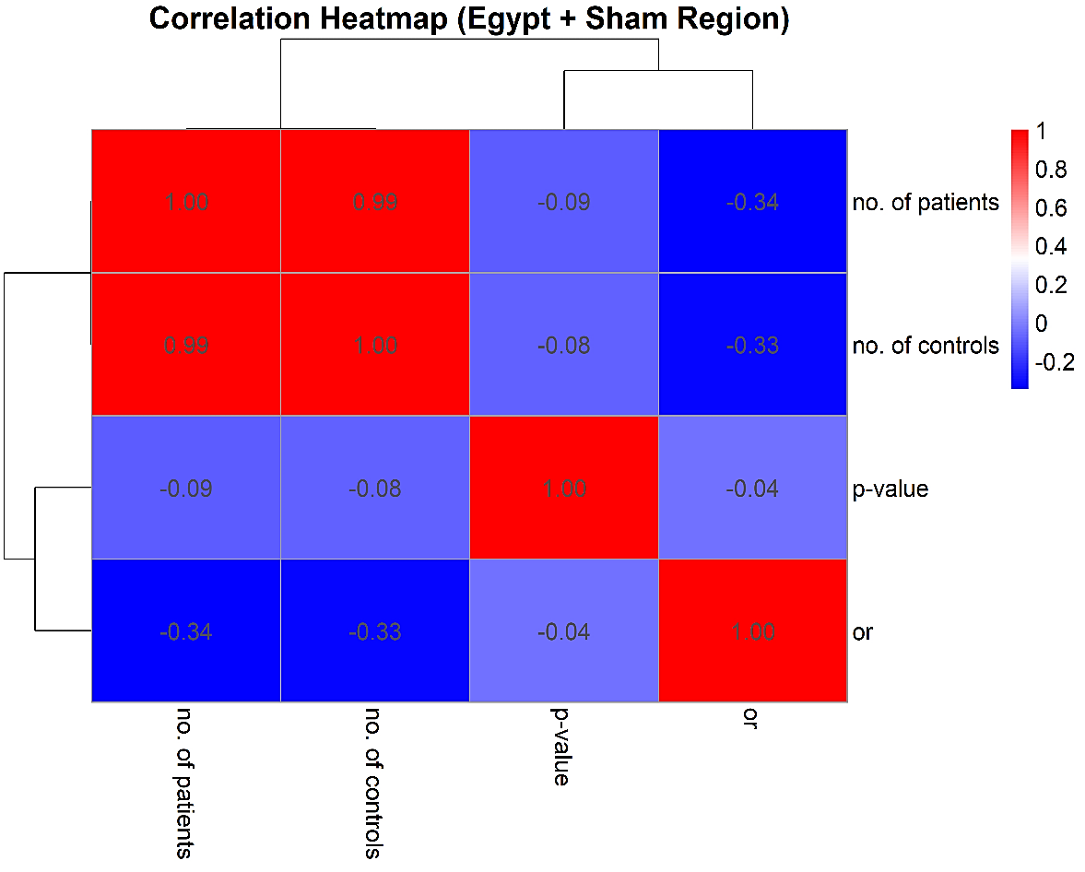

Figure S5: presents a correlation heatmap for the combined Egypt and Sham region dataset.
Description
Visualizing the pairwise correlations among the number of patients, number of controls, odds ratio (or), and p-value across the included studies. Strong positive correlations are observed between the number of patients and number of controls (r = 0.99), while both show moderate negative correlations with the odds ratio (r = –0.34 and –0.33, respectively). The p-value exhibits minimal correlation with the other variables. Colors indicate the direction and strength of correlations, with red representing positive and blue indicating negative correlations. Dendrograms reflect hierarchical clustering of the variables based on their correlation patterns.

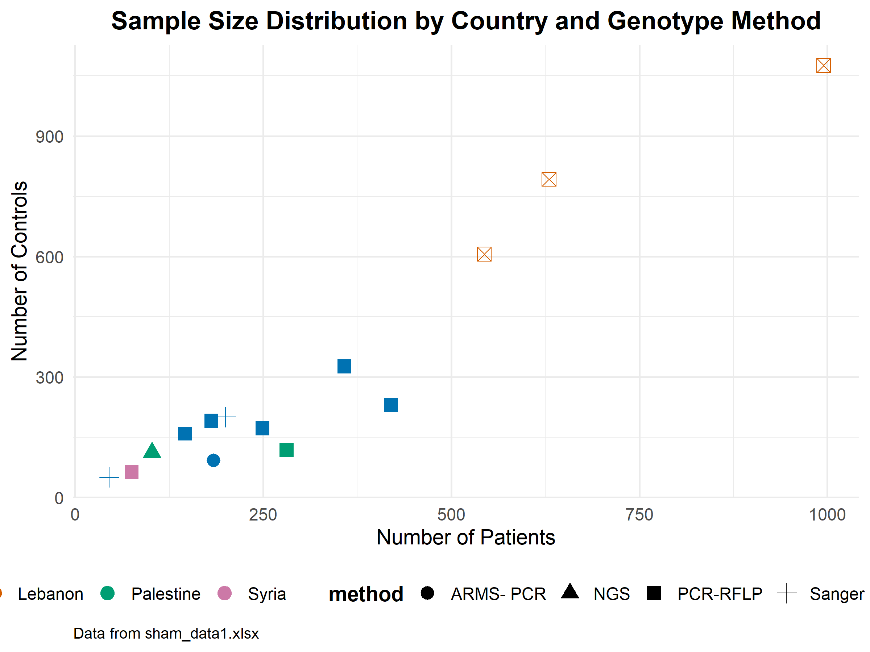
Figure S6: shows the distribution of sample sizes across studies by country and genotyping method.
Description
The scatter plot presents the number of patients (x-axis) versus the number of controls (y-axis) for each study. Points are colored according to country (Lebanon, Palestine, Syria) and shaped by genotyping methodology (ARMS-PCR, NGS, PCR-RFLP, Sanger). This visualization reveals variability in study design and population sampling across regions, with Lebanon contributing several studies with notably large sample sizes. The legend at the bottom identifies both country and method. Data are from the Sham region cohort.

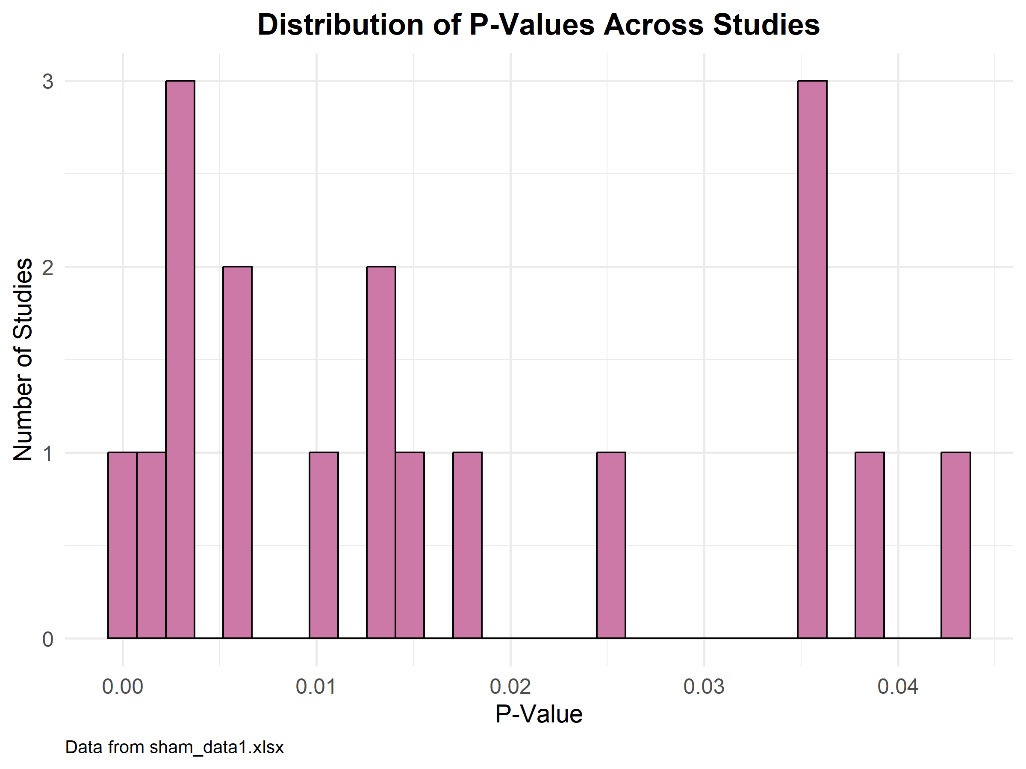
Figure S7: shows the distribution of p-values reported across studies included in the meta-analysis.
Description
The histogram depicts the number of studies (y-axis) for each bin of p-values (x-axis), with data sourced from the Sham region dataset (“sham_data1.xlsx”). The distribution illustrates a range of reported statistical significance, with clusters of studies near common thresholds for significance (p < 0.05), reflecting variability in the strength of genetic associations detected across studies.
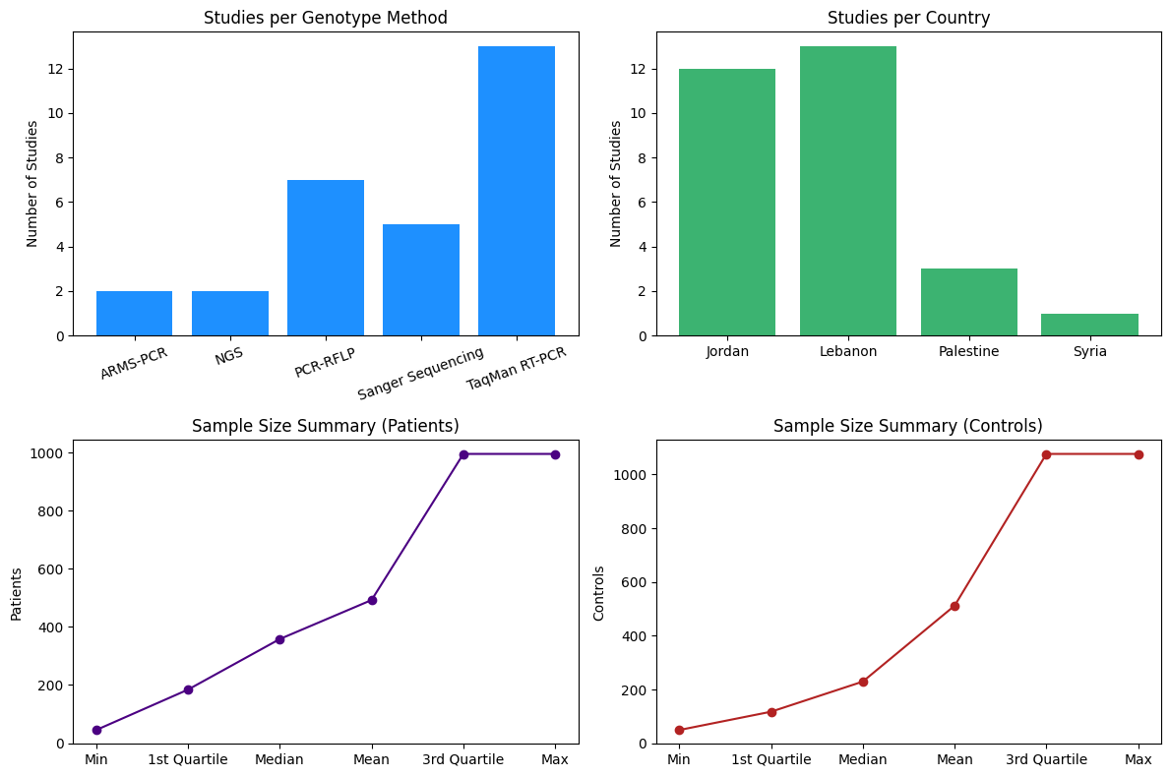Figure S8. Distribution of Studies and Sample Size Summary
Description:
This figure provides an overview of the study characteristics across various genotyping methods, countries, and sample sizes. The top-left panel shows the number of studies per genotyping method, with TaqMan RT-PCR being the most widely used technique, followed by PCR-RFLP, Sanger Sequencing, and others. The top-right panel illustrates the distribution of studies by country, highlighting that Lebanon and Jordan contributed the most studies, while Palestine and Syria had fewer studies represented. The bottom-left panel visualizes the sample size distribution for patients, ranging from a minimum of 42 to a maximum of 995, with the median and mean indicating larger study sizes. The bottom-right panel presents the sample size distribution for controls, similarly showing a wide range of sizes from 50 to 1076, indicating substantial variation across studies.

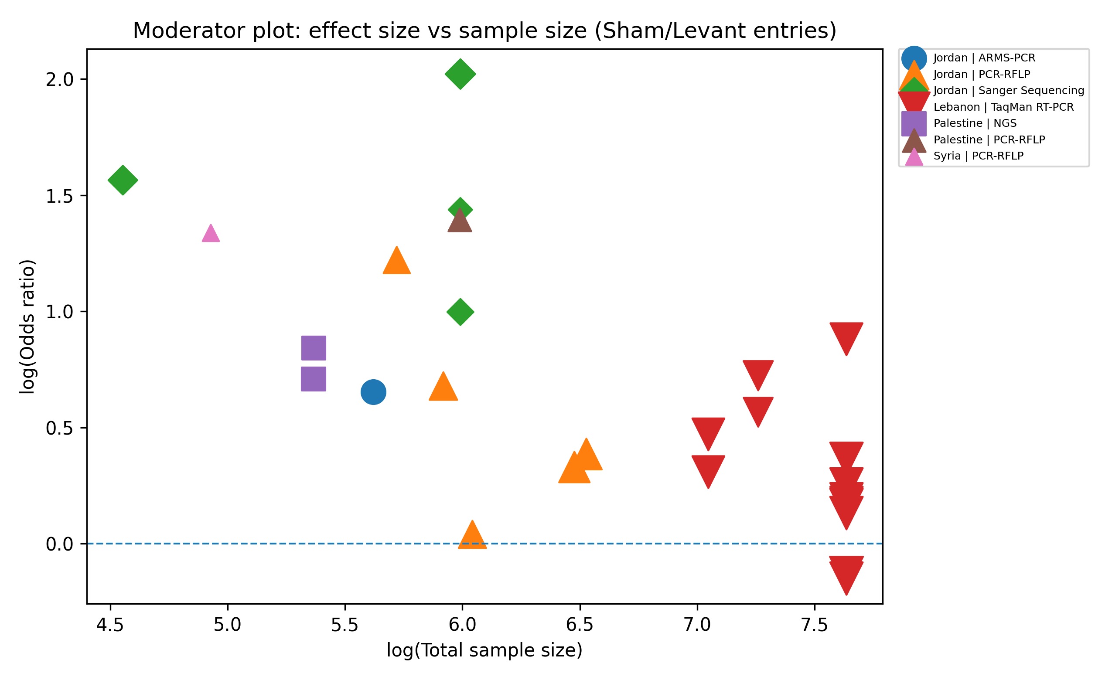
Figure S9: Moderator plot for Sham/Levant cohort (effect size vs sample size, colored by country and shaped by genotyping method).
Description: Bubble plot showing log(odds ratio) as a function of log(total sample size) for Sham/Levant variant-level entries. Points are colored by country and marker shapes represent genotyping methodology; point size reflects the random-effects inverse-variance weight. The figure illustrates the small-study pattern observed in meta-regression, where smaller studies tend to report more extreme effects.

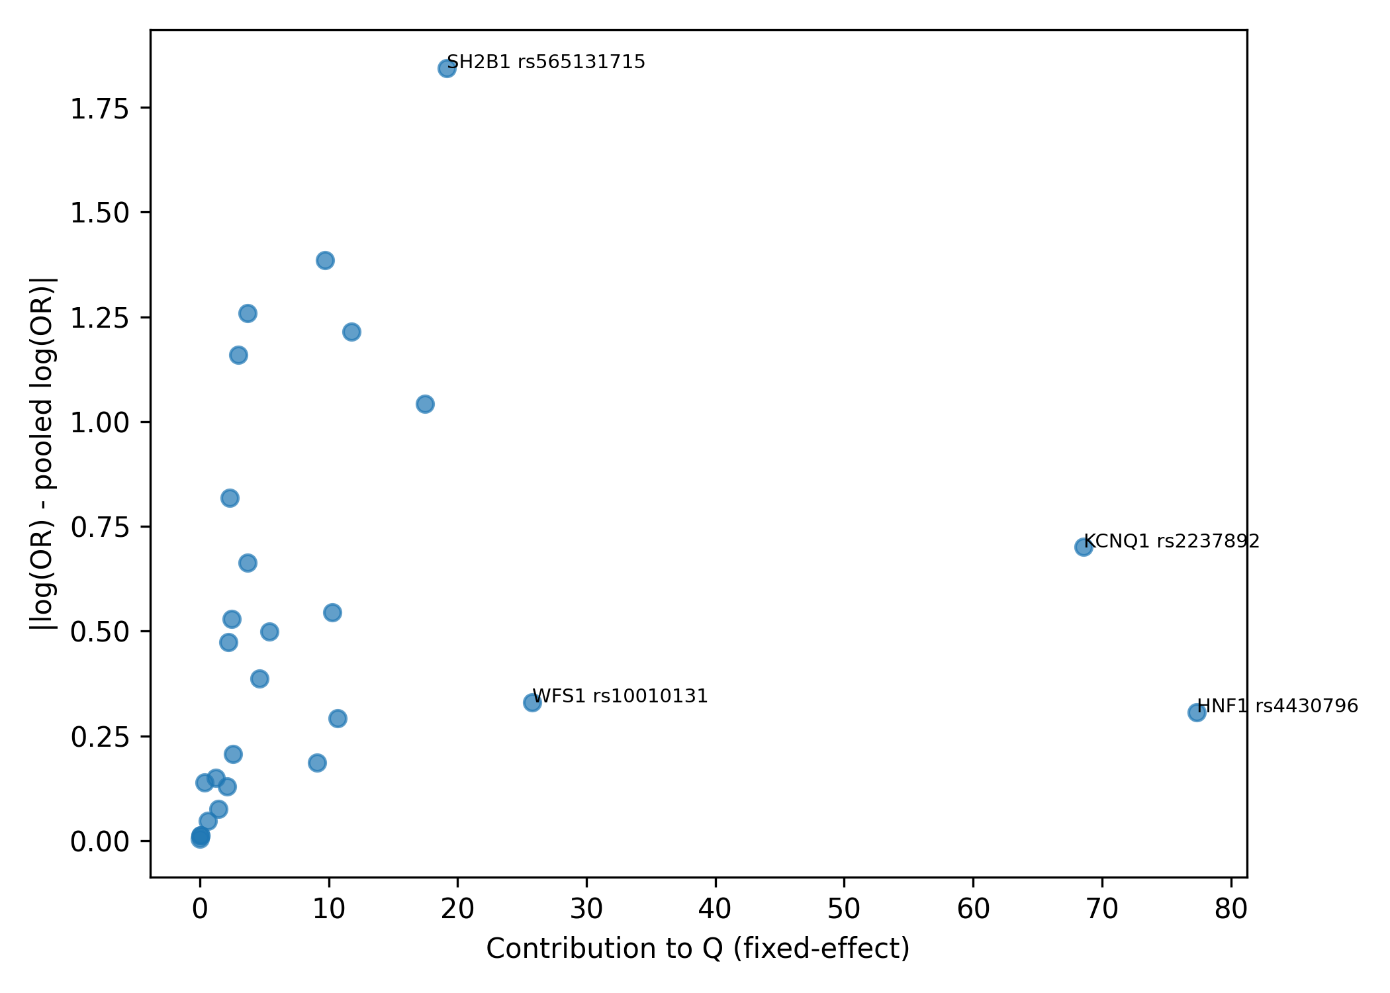
Figure S10: Baujat-style influence diagnostic for Sham/Levant cohort

Description: Scatter plot of each variant-level entry's contribution to Cochran's Q (x-axis) versus its influence on the pooled random-effects estimate (y-axis), computed as the absolute change in the pooled log(OR) under leave-one-out analysis. The most influential variants are annotated. This diagnostic highlights a small number of entries that disproportionately drive heterogeneity.

