Table S1. Prisma checklist
Section and Topic | Item # | Checklist item | Location where item is reported
TITLE
Title | 1 | Identify the report as a systematic review. | P.1
ABSTRACT
Abstract | 2 | See the PRISMA 2020 for Abstracts checklist. | P.1
INTRODUCTION
Rationale | 3 | Describe the rationale for the review in the context of existing knowledge. | P.2-3
Objectives | 4 | Provide an explicit statement of the objective(s) or question(s) the review addresses. | P.2-3
METHODS
Eligibility criteria | 5 | Specify the inclusion and exclusion criteria for the review and how studies were grouped for the syntheses. | P.4
Information sources | 6 | Specify all databases, registers, websites, organisations, reference lists and other sources searched or consulted to identify studies. Specify the date when each source was last searched or consulted. | P.3-4
Search strategy | 7 | Present the full search strategies for all databases, registers and websites, including any filters and limits used. | Supplementary File Table S2
Selection process | 8 | Specify the methods used to decide whether a study met the inclusion criteria of the review, including how many reviewers screened each record and each report retrieved, whether they worked independently, and if applicable, details of automation tools used in the process. | P.4-5
Data collection process | 9 | Specify the methods used to collect data from reports, including how many reviewers collected data from each report, whether they worked independently, any processes for obtaining or confirming data from study investigators, and if applicable, details of automation tools used in the process. | P.4-5
Data items | 10a | List and define all outcomes for which data were sought. Specify whether all results that were compatible with each outcome domain in each study were sought (e.g. for all measures, time points, analyses), and if not, the methods used to decide which results to collect. | P.4-5
Data items | 10b | List and define all other variables for which data were sought (e.g. participant and intervention characteristics, funding sources). Describe any assumptions made about any missing or unclear information. | P.4-5
Study risk of bias assessment | 11 | Specify the methods used to assess risk of bias in the included studies, including details of the tool(s) used, how many reviewers assessed each study and whether they worked independently, and if applicable, details of automation tools used in the process. | P.5
Effect measures | 12 | Specify for each outcome the effect measure(s) (e.g. risk ratio, mean difference) used in the synthesis or presentation of results. | P.5-6
Synthesis methods | 13a | Describe the processes used to decide which studies were eligible for each synthesis (e.g. tabulating the study intervention characteristics and comparing against the planned groups for each synthesis (item #5)). | P.5-6
Synthesis methods | 13b | Describe any methods required to prepare the data for presentation or synthesis, such as handling of missing summary statistics, or data conversions. | P.5-6
Synthesis methods | 13c | Describe any methods used to tabulate or visually display results of individual studies and syntheses. | P.5-6
Synthesis methods | 13d | Describe any methods used to synthesize results and provide a rationale for the choice(s). If meta-analysis was performed, describe the model(s), method(s) to identify the presence and extent of statistical heterogeneity, and software package(s) used. | P.5-6
Synthesis methods | 13e | Describe any methods used to explore possible causes of heterogeneity among study results (e.g. subgroup analysis, meta-regression). | P.5-6
Synthesis methods | 13f | Describe any sensitivity analyses conducted to assess robustness of the synthesized results. | P.5-6
Reporting bias assessment | 14 | Describe any methods used to assess risk of bias due to missing results in a synthesis (arising from reporting biases). | P.5-6
Certainty assessment | 15 | Describe any methods used to assess certainty (or confidence) in the body of evidence for an outcome. | P.5-6
RESULTS
Study selection | 16a | Describe the results of the search and selection process, from the number of records identified in the search to the number of studies included in the review, ideally using a flow diagram. | P.6, Figure 1
Study selection | 16b | Cite studies that might appear to meet the inclusion criteria, but which were excluded, and explain why they were excluded. | Supplementary File Table S3
Study characteristics | 17 | Cite each included study and present its characteristics. | P6, Table 1
Risk of bias in studies | 18 | Present assessments of risk of bias for each included study. | P.6-7, Figure 2
Results of individual studies | 19 | For all outcomes, present, for each study: (a) summary statistics for each group (where appropriate) and (b) an effect estimate and its precision (e.g. confidence/credible interval), ideally using structured tables or plots. | P.7-10, Figure 3-4,Table 2
Results of syntheses | 20a | For each synthesis, briefly summarise the characteristics and risk of bias among contributing studies. | P.6-10
Results of syntheses | 20b | Present results of all statistical syntheses conducted. If meta-analysis was done, present for each the summary estimate and its precision (e.g. confidence/credible interval) and measures of statistical heterogeneity. If comparing groups, describe the direction of the effect. | P.6-10
Results of syntheses | 20c | Present results of all investigations of possible causes of heterogeneity among study results. | P.6-10
Results of syntheses | 20d | Present results of all sensitivity analyses conducted to assess the robustness of the synthesized results. | P.6-10
Reporting biases | 21 | Present assessments of risk of bias due to missing results (arising from reporting biases) for each synthesis assessed. | P.6-10
Certainty of evidence | 22 | Present assessments of certainty (or confidence) in the body of evidence for each outcome assessed. | P.6-10
DISCUSSION
Discussion | 23a | Provide a general interpretation of the results in the context of other evidence. | P.11-14
Discussion | 23b | Discuss any limitations of the evidence included in the review. | P.14
Discussion | 23c | Discuss any limitations of the review processes used. | P.14
Discussion | 23d | Discuss implications of the results for practice, policy, and future research. | P.11-14
OTHER INFORMATION
Registration and protocol | 24a | Provide registration information for the review, including register name and registration number, or state that the review was not registered. | Supplementary File Table S4
Registration and protocol | 24b | Indicate where the review protocol can be accessed, or state that a protocol was not prepared. | P.3
Registration and protocol | 24c | Describe and explain any amendments to information provided at registration or in the protocol. | P.3
Support | 25 | Describe sources of financial or non-financial support for the review, and the role of the funders or sponsors in the review. | Supplementary File Table S4
Competing interests | 26 | Declare any competing interests of review authors. | P.16
Availability of data, code and other materials | 27 | Report which of the following are publicly available and where they can be found: template data collection forms; data extracted from included studies; data used for all analyses; analytic code; any other materials used in the review. | P.16

From: Page MJ, McKenzie JE, Bossuyt PM, Boutron I, Hoffmann TC, Mulrow CD, et al. The PRISMA 2020 statement: an updated guideline for reporting systematic reviews. BMJ 2021;372:n71. doi: 10.1136/bmj.n71

Table S1. The detailed search strategy
Database | Search Strategy
Pubmed | #1="Diabetes Mellitus, Type 2"[MeSH Terms] OR "Diabetes Mellitus, Type 2"[Title/Abstract] OR "T2DM"[Title/Abstract] OR "Noninsulin Dependent Diabetes Mellitus"[Title/Abstract] OR "Non-Insulin-Dependent Diabetes Mellitus"[Title/Abstract] OR "Maturity-Onset Diabetes Mellitus"[Title/Abstract] OR "Adult-Onset Diabetes Mellitus"[Title/Abstract] OR "Ketosis-Resistant Diabetes Mellitus"[Title/Abstract] OR "NIDDM"[Title/Abstract] OR "Type 2 Diabetes"[Title/Abstract] OR ("type 2"[Title/Abstract] AND ("diabet*"[Title/Abstract] OR "Diabetes Mellitus"[Title/Abstract]))  #2="time restricted feeding"[Title/Abstract] OR "time restricted eating"[Title/Abstract] OR "time restricted diet"[Title/Abstract] OR "time restricted fasting"[Title/Abstract] OR "time restricted meal intake"[Title/Abstract] OR "TRE"[Title/Abstract] OR "TRF"[Title/Abstract] OR ("time restricted"[Title/Abstract] AND ("feed*"[Title/Abstract] OR "diet*"[Title/Abstract] OR "fast*"[Title/Abstract] OR "meal*"[Title/Abstract]))  #3=#1 AND #2
Embase | #1=('non insulin dependent diabetes mellitus'/exp OR 'type 2 diabetes mellitus'/exp)  #2="type 2 diabetes":ti,ab,kw OR "T2DM":ti,ab,kw OR "NIDDM":ti,ab,kw OR "non insulin dependent diabetes":ti,ab,kw OR ("type 2" NEAR/3 diabet*):ti,ab,kw  #3=#1 OR #2  #4='time restricted feeding'/exp  #5='time restricted feeding':ti,ab,kw OR 'time restricted eating':ti,ab,kw OR 'time restricted diet':ti,ab,kw OR 'time restricted fasting':ti,ab,kw OR 'time restricted meal intake':ti,ab,kw OR (('time restricted' NEAR/3 (feed* OR eat* OR diet* OR fast* OR meal*)):ti,ab) OR 'trf':ti,ab,kw OR 'tre':ti,ab,kw  #6=#4 OR #5  #7=#3 AND #6
Web of Science | #1=TS=("Diabetes Mellitus, Type 2" OR "T2DM" OR "Noninsulin Dependent Diabetes Mellitus" OR "Non-Insulin-Dependent Diabetes Mellitus" OR "Maturity-Onset Diabetes Mellitus" OR "Adult-Onset Diabetes Mellitus" OR "Ketosis-Resistant Diabetes Mellitus" OR "NIDDM" OR "Type 2 Diabetes" OR ("Type 2" NEAR/3 (Diabet* OR "Diabetes Mellitus")))  #2=TS=("Time Restricted Feeding" OR "Time Restricted Eating" OR "Time Restricted Diet" OR "Time Restricted Fasting" OR "Time Restricted Meal Intake" OR "TRF" OR "TRE" OR ("time restricted" NEAR/3 (feed* OR eat* OR diet* OR fast* OR meal*)))  #3=#1 AND #2
Cochrane Library | #1=[MeSH DESCRIPTOR "Diabetes Mellitus, Type 2" EXPLODE ALL]  #2="diabetes mellitus, type 2":ti,ab,kw OR "t2dm":ti,ab,kw OR "noninsulin dependent diabetes mellitus":ti,ab,kw OR "non-insulin-dependent diabetes mellitus":ti,ab,kw OR "maturity-onset diabetes mellitus":ti,ab,kw OR "adult-onset diabetes mellitus":ti,ab,kw OR "ketosis-resistant diabetes mellitus":ti,ab,kw OR "niddm":ti,ab,kw OR "type 2 diabetes":ti,ab,kw OR ("type 2" NEAR/3 diabet*):ti,ab,kw  #3=#1 OR #2  #4="time restricted feeding":ti,ab,kw OR "time restricted eating":ti,ab,kw OR "time restricted diet":ti,ab,kw OR "time restricted fasting":ti,ab,kw OR "time restricted meal intake":ti,ab,kw OR ("time restricted" NEAR/3 (feed* OR eat* OR diet* OR fast* OR meal*)):ti,ab,kw OR "TRF":ti,ab,kw OR "TRE":ti,ab,kw  #5=#3 AND #4
Scopus | #1=TITLE-ABS-KEY("Diabetes Mellitus,Type 2" OR "T2DM" OR "Noninsulin Dependent Diabetes Mellitus" OR "Non-Insulin-Dependent Diabetes Mellitus" OR "Maturity-Onset Diabetes Mellitus" OR "Adult-Onset Diabetes Mellitus" OR "Ketosis-Resistant Diabetes Mellitus" OR "NIDDM" OR "Type 2 Diabetes" OR ("Type 2" W/3 (Diabet* OR "Diabetes Mellitus")))  #2=TITLE-ABS-KEY("time restricted feeding" OR "time restricted eating" OR "time restricted diet" OR "time restricted fasting" OR "time restricted meal intake" OR ("time restricted" W/3 (feed* OR eat* OR diet* OR fast* OR meal*)))  #3=#1 AND #2

Table S2 Excluded studies and reasons for exclusion
No． | PMID/DOI/… | Author | Non-interventional study | Non-T2DM | Non-TRE | No full text | No available data
1 | NCT03809299 | Jill Crandall |  | ×
2 | NCT04062773 | Ebaa Al Ozairi |  |  |  |  | ×
3 | NCT04155619 | Courtney Peterson |  |  |  |  | ×
4 | NCT04463277 | Hameed |  | ×
5 | 10.1016/j.appet.2021.105138 | Bjerre et al.2021 |  | × |  | ×
6 | ChiCTR2100052582 | Ren et al.2021 |  |  |  |  | ×
7 | NL-OMON20271 | / |  |  |  |  | ×
8 | 10.1097/01.hjh.0000746884.70877.d6 | Rastogi S |  |  |  | ×
9 | 10.7759/cureus.19348 | Mahreen Saeed | ×
10 | ACTRN12624001281583 | Andrew Reynolds |  |  |  |  | ×
11 | 10.2337/db22-28-OR | Carbonel A |  |  |  | ×
12 | CTRI/2022/07/044356 | Muley Arti S |  |  |  |  | ×
13 | 10.1177/2164957X221096590 | Deshmane A. |  |  |  | ×
14 | NCT05290246 | Lisa Chow |  |  |  |  | ×
15 | NCT05365529 | Pam Taub |  |  |  |  | ×
16 | 10.1016/j.metabol.2021.154983 | Rastogi S. |  |  |  | ×
17 | 10.1016/j.jcjd.2023.10.246 | Iglesies-Grau J. |  |  |  | ×
18 | IRCT20230917059447N1 | Sakineh Shab-bidar |  |  |  |  | ×
19 | WOS:001084581000078 | Johnston JD |  |  |  | ×
20 | 10.3390/nu15245058 | Spyridon N Karras |  | ×
21 | 10.3389/fendo.2023.1143799 | Zoltan Kender |  |  | ×
22 | NCT05860413 | Felicia Steger |  |  |  |  | ×
23 | NCT06118931 | Amy Kirkham |  |  |  |  | ×
24 | NCT06152588 | Jonas S Quist |  |  |  |  | ×
25 | 10.2337/db23-52-LB | Nijjar A. |  |  |  | ×
26 | 10.1007/s00125-023-05969-6 | Parr E.B. |  |  |  | ×
27 | 10.1016/j.cdnut.2023.101560 | Pavlou V |  |  |  | ×
28 | 10.1159/000530456 | Phung A |  |  |  | ×
29 | TCTR20230131002 | Naparat Sukkriang |  |  |  |  | ×
30 | 10.2337/db23-1613-P | Termannsen AD |  |  |  | ×
31 | WOS:001343351201194 | Davies KAB |  |  |  | ×
32 | 10.1016/j.diabres.2024.111492 | Inamdar A. |  |  |  | ×
33 | 10.2337/db24-1663-P | Kramer CK |  |  |  | ×
34 | 10.1186/s13098-023-01234-3 | Yasmin Atwa Mohamed |  |  | ×
35 | 10.2337/db24-634-P | Nijjar A |  |  |  | ×
36 | 10.7326/j23-0117 | Joseph M Pappachan | ×
37 | KCT0010125 | Nan Hee Kim |  |  |  |  | ×
38 | ChiCTR2500097502 | Tao Huang |  |  |  |  | ×
39 | 10.1186/s12916-024-03595-6 | Zheng Yixuan |  | ×
40 | 10.1007/s00125-023-06045-9 | Domenico Tricò |  |  | ×
41 | 10.2337/db24-2083-LB | Pavlou Vasiliki |  |  |  | ×
42 | WOS:001389206200116 | Pavlou Vicky |  |  |  | ×
43 | 10.1001/jama.2023.21874 | Emily Harris et al.2023 |  |  |  | ×
44 | 10.1002/osp4.730 | Adrian Brown et al.2024 |  | ×
45 | 10.1159/000538577 | G. Stage Hansen |  |  |  |  | ×
46 | 10.2337/dc22-1622 | Anna Obermayer |  |  | ×
47 | 10.1038/s41591-023-02287-7 | Xiao Tong Teong |  | ×
48 | 10.1016/j.diabres.2025.112081 | Bravo-Garcia AP et al.2025 |  |  | ×
49 | 10.7759/cureus.57624 | Aditi R Deshmane 2024 |  |  |  |  | ×
50 | 10.7759/cureus.53680 | Smriti Rastogi et al.2024b | ×
51 | 10.7759/cureus.56902 | Smriti Rastogi et al.2024a | ×

Table S3. Funding and registration information for the included studies
Author/Year | Country | Registration | Find
Parr et al. 2024 | Australia | ACTRN12620000453987 | Diabetes Australia (20YG-PARE, 2020); Australian Catholic Univ. Return-to-Work Grants (2022; 2023)
Che et al. 2021 | China | ChiCTR-IPR-15006371 | National Natural Science Foundation of China (No. 81671835); the Key Projects of Tianjin Natural Science Foundation (No. 19JCZDJC36900); Tianjin Commission of Science and Technology (Nos. RC20165 and ZC20143)
Pavlou et al. 2024 | USA | NCT05225337 | Department of Kinesiology and Nutrition, University of Illinois Chicago
Pavlou et al. 2023 | USA | NCT05225337 | Department of Kinesiology and Nutrition, University of Illinois Chicago
Hegedus et al. 2024 | USA | NCT04536480 | National Institutes of Health (K23DK134801, UL1TR001855, UL1TR000130, 1P50MD017344,1R01DK130851,R01CA258222);American Diabetes Association (11-22-ICTSN-32); Sacchi Foundation; Southern California Center for Latino Health.
Kaercher Kramer et al.2024 | Canada | NCT05717127 | Canadian Institutes of Health Research (CIHR) (PJT 166091 to C.K.K.)
Andriessen et al. 2022 | Netherlands | NCT03992248 | ZonMw and Diabetes Fonds
Termannsen et al. 2025 | Denmark | NCT05375695 | Novo Nordisk Foundation and the Danish Diabetes Association
Parr et al.2023 | Australia | ACTRN12618000938202 | European Society for Clinical Nutrition (ESPEN), Novo Nordisk Foundation Challenge Grant (NNF14OC0011493)
Parr et al. 2020 | Australia | ACTRN12618000938202 | European Society for Clinical Nutrition (ESPEN), Novo Nordisk Foundation Challenge Grant (NNF14OC0011493)
Zimmermann et al. 2024 | USA | NR | University of Wisconsin-Madison Division of General Internal Medicine Pilot Grant Award
Arnason et al. 2017 | Canada | NR | Department of Medicine, University of Saskatchewan, and the College of Pharmacy and Nutrition, University of Saskatchewan

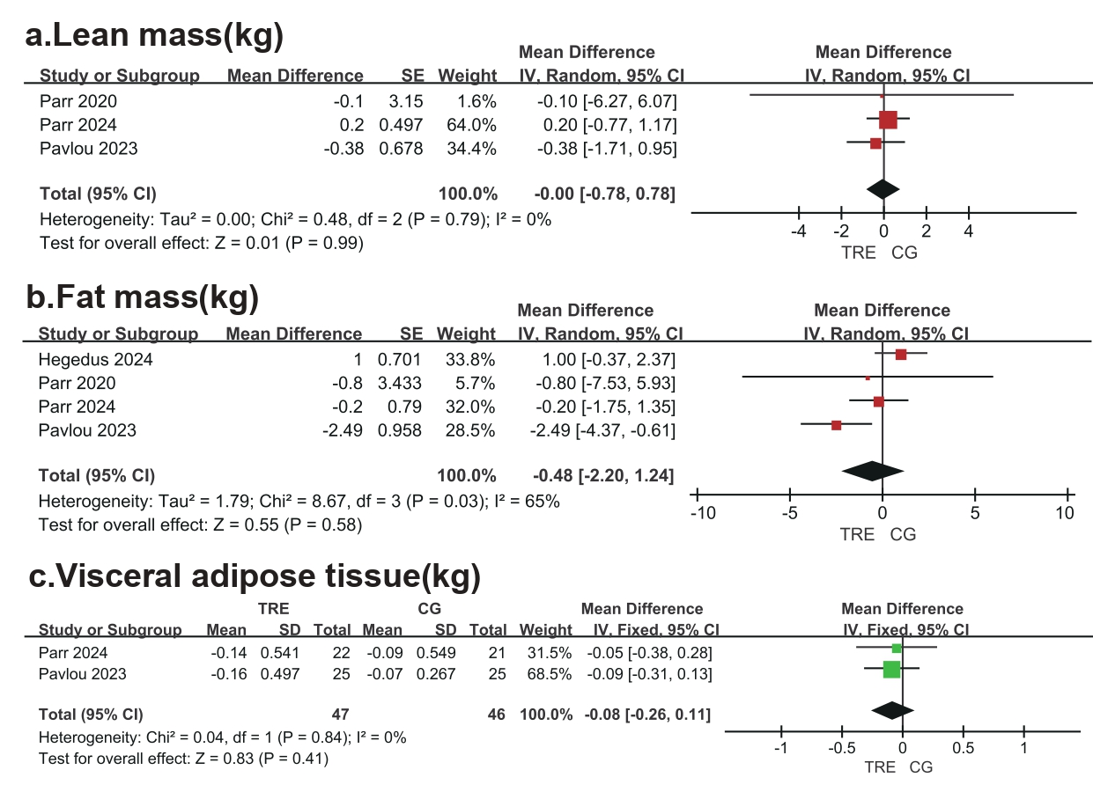
Figure S1. Forest plot of anthropometric parameters outcomes. a) lean mass(kg), b) fat mass(kg), c) visceral adipose tissue(kg).

Figure S2. Forest plots of blood lipid outcomes. a) TG (Triglyceride, mmol/L), b) TC (Total cholesterol, mmol/L), c) LDL (low-density lipoprotein, mmol/L), d) HDL (high-density lipoprotein, mmol/L).
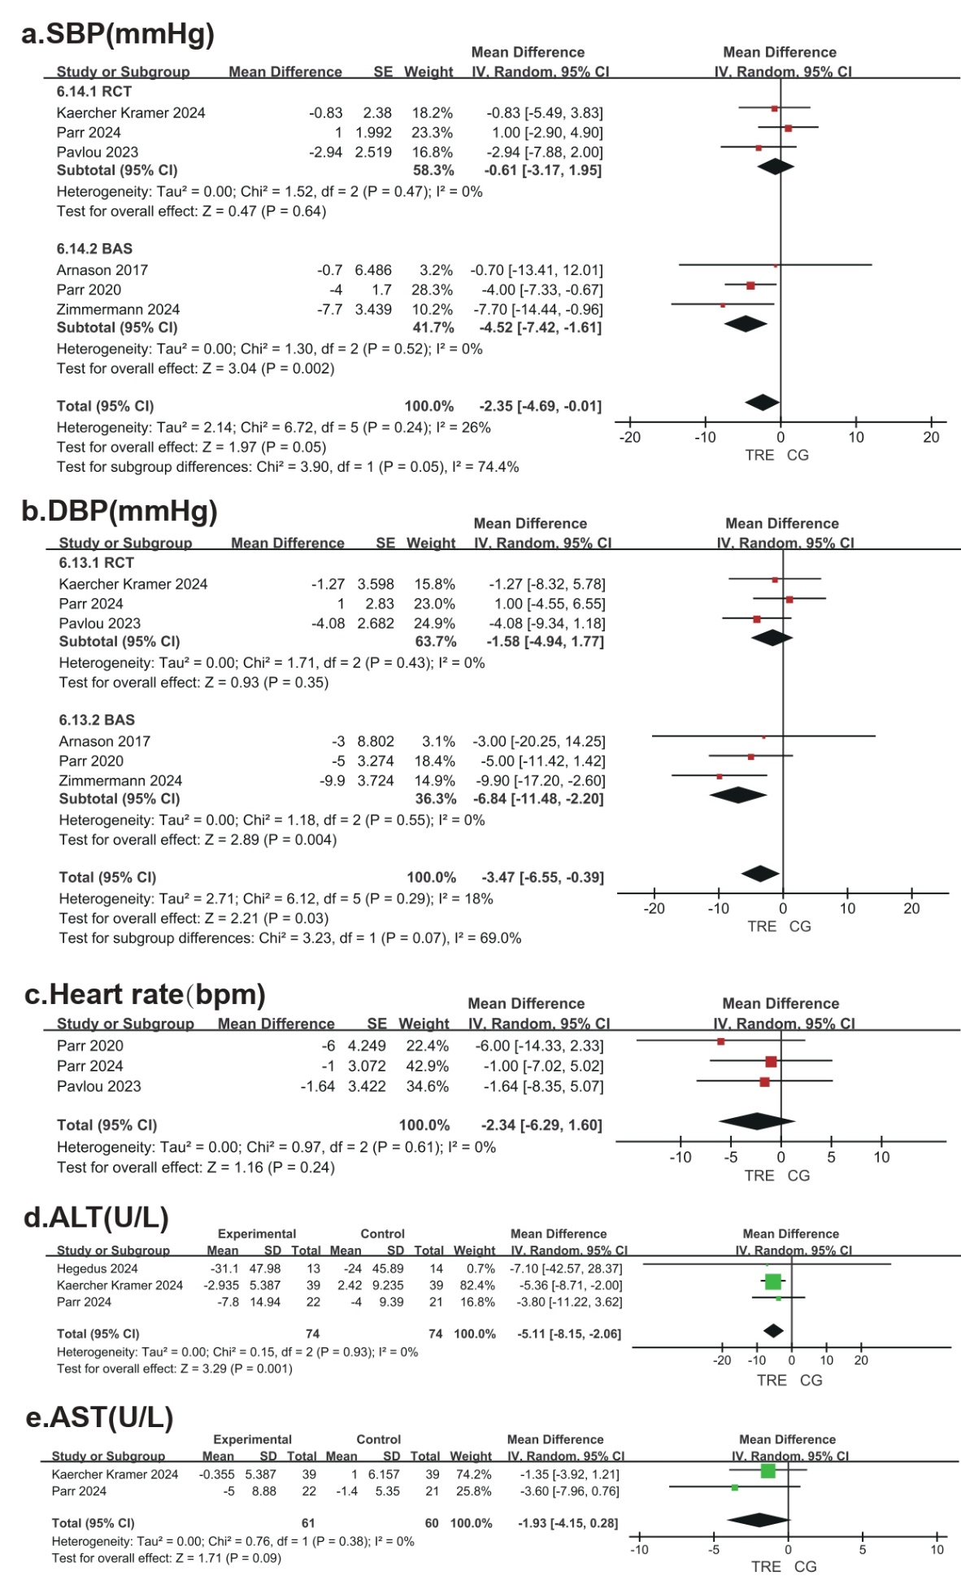
Figure S3. Forest plots of physiological parameters outcomes. a) SBP (systolic blood pressure, mmHg), b) DBP (diastolic blood pressure, mmHg), c) Heart rate(bpm), d) ALT(U/L), e) AST(U/L)
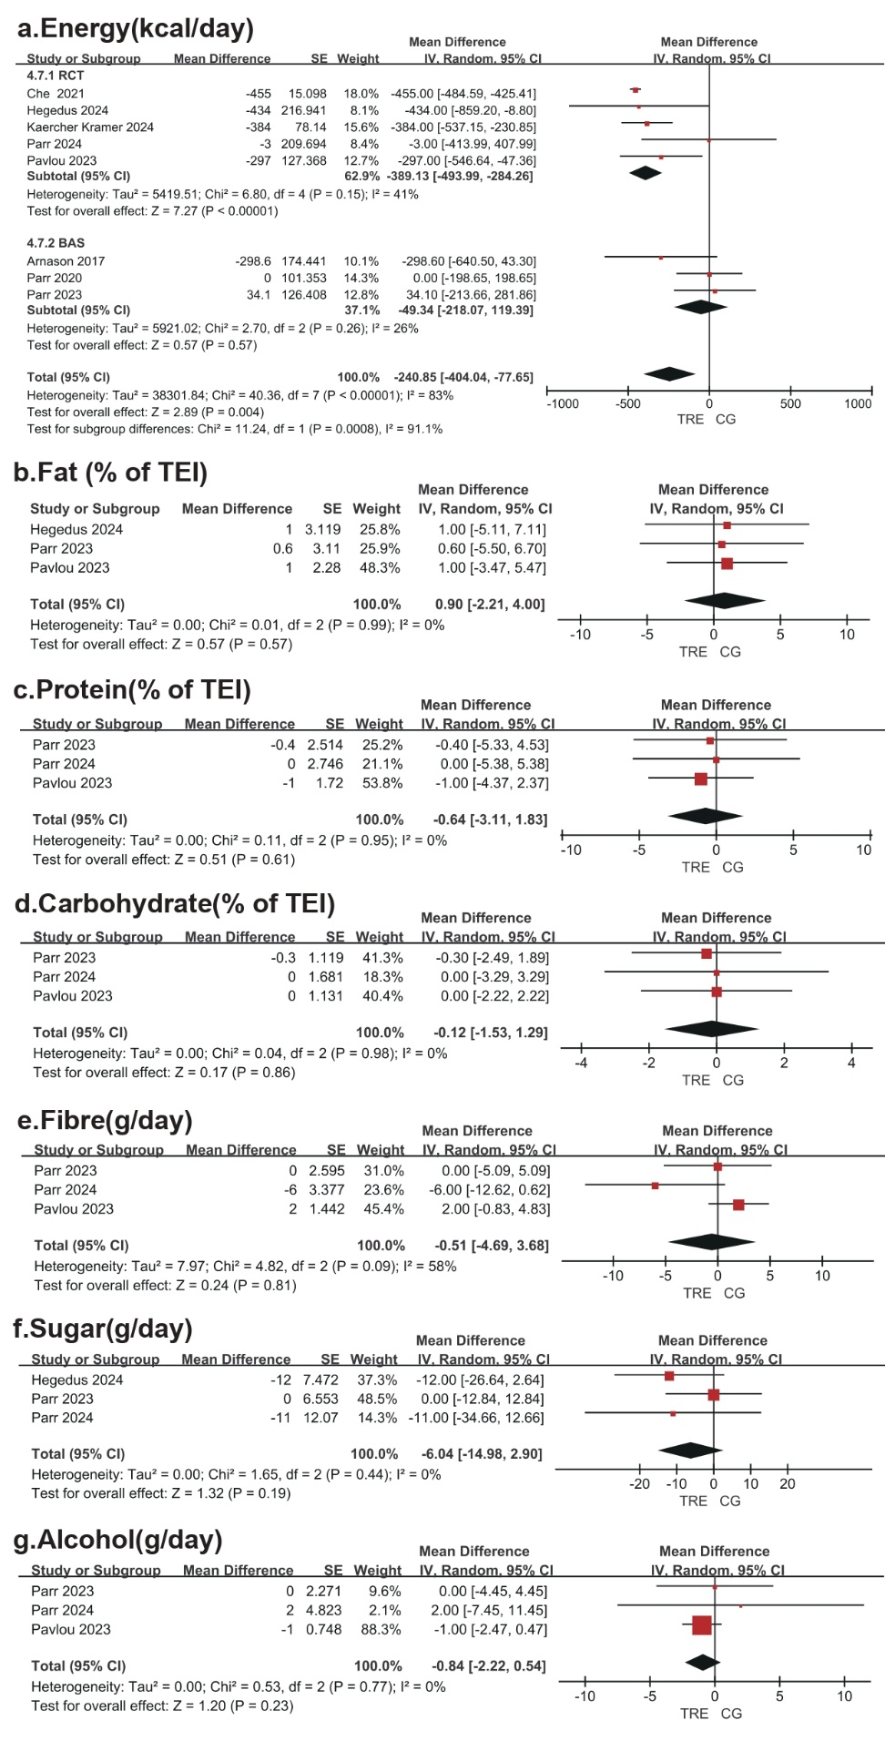
Figure S4. Forest plots of dietary intake outcomes. a) Energy (kcal/day), b) Fat (% of TEI), c) Protein (% of TEI), d) Carbohydrate (% of TEI), e) Fibre (g/day), f) Sugar (g/day), g) Alcohol(g/day)
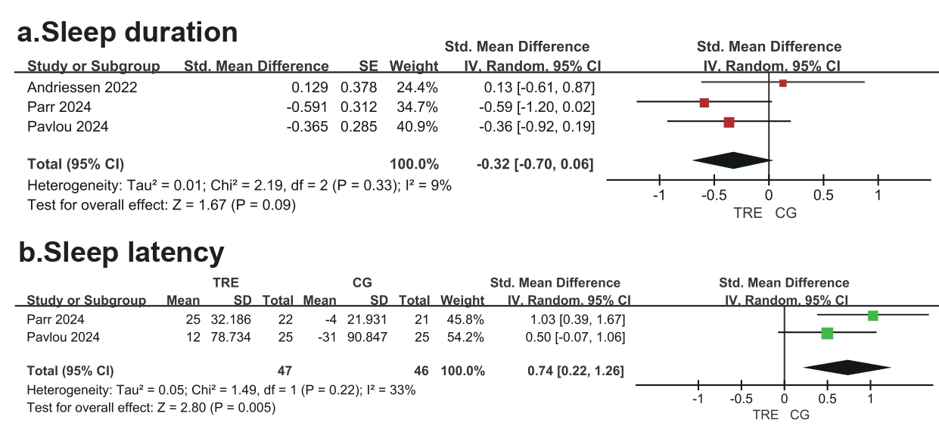
Figure S5. Forest plots of sleep outcomes. a) Sleep duration, b) Sleep latency

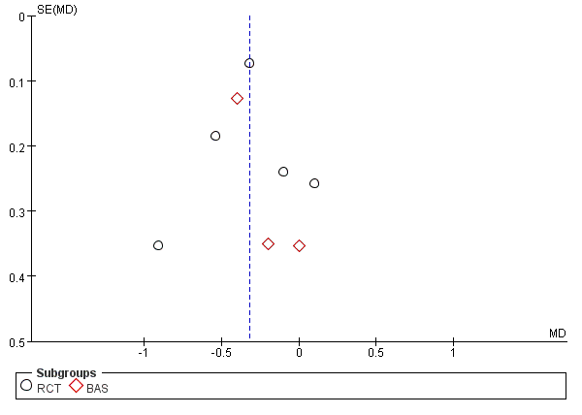
Figure.S6. Funnel plot analysis for HbA1c.

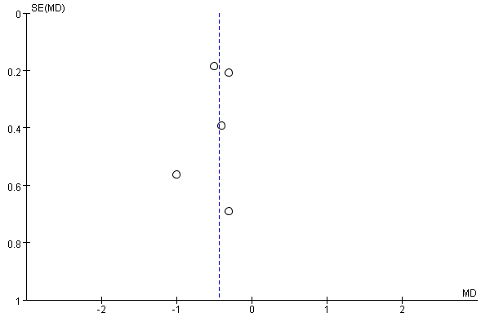
Figure.S7. Funnel plot analysis for fasting blood glucose.

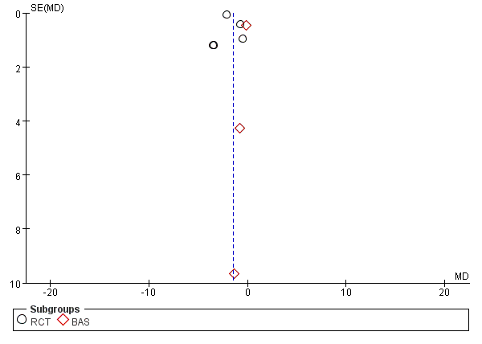
Figure.S8. Funnel plot analysis for body weight.
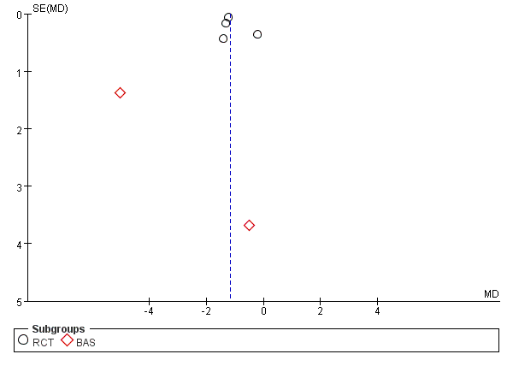
Figure.S9. Funnel plot analysis for BMI.

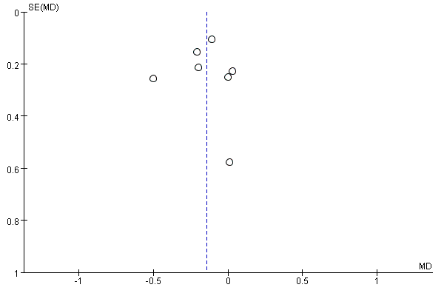
Figute.S10. Funnel plot analysis for triglycerides (TG).
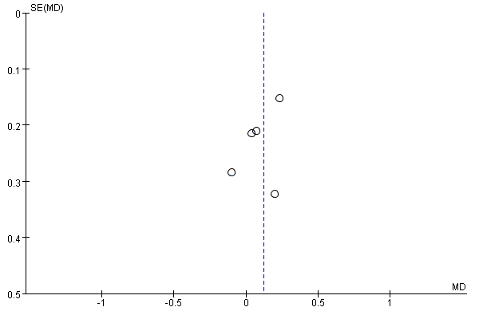
Figure.S11. Funnel plot analysis for total cholesterol (TC)

