Supplementary Material 4

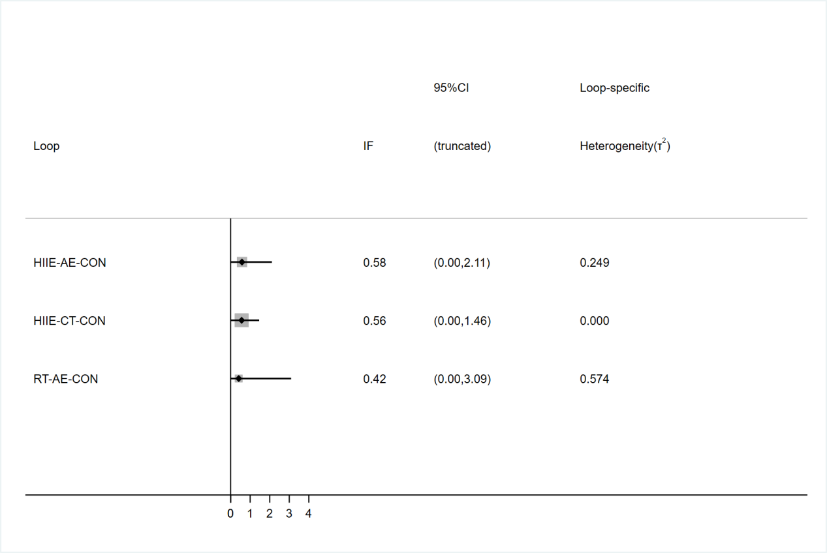
Figure 1. Local inconsistency for BW.

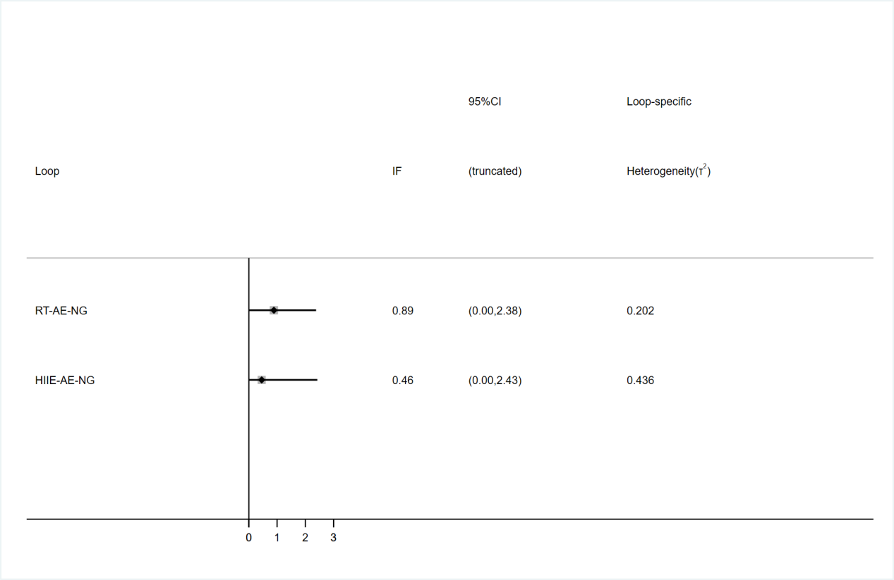
Figure 2. Local inconsistency for WC.
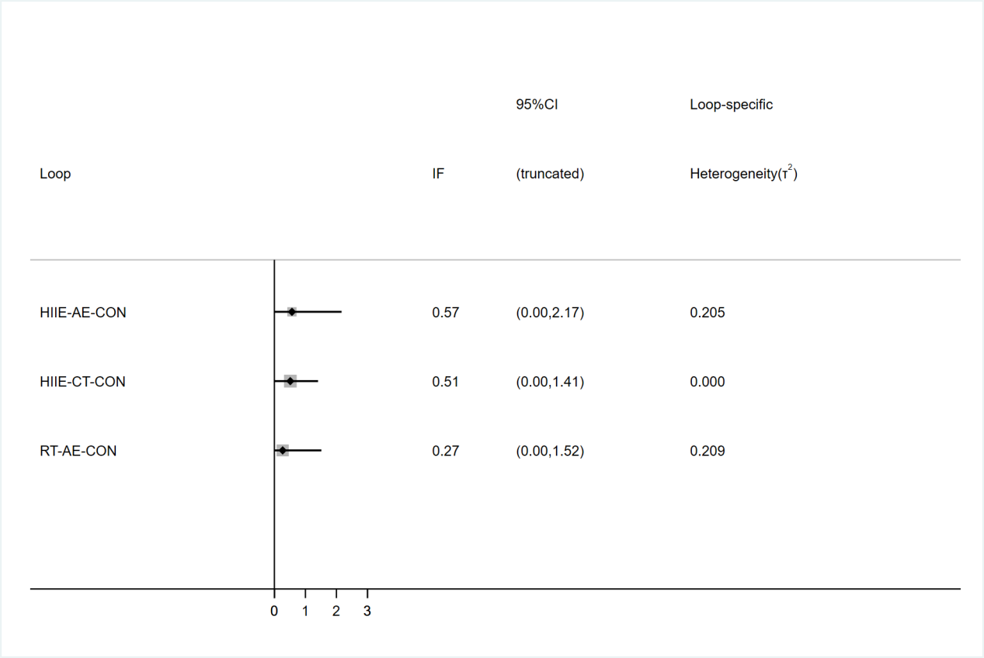
Figure 3. Local inconsistency for BMI.
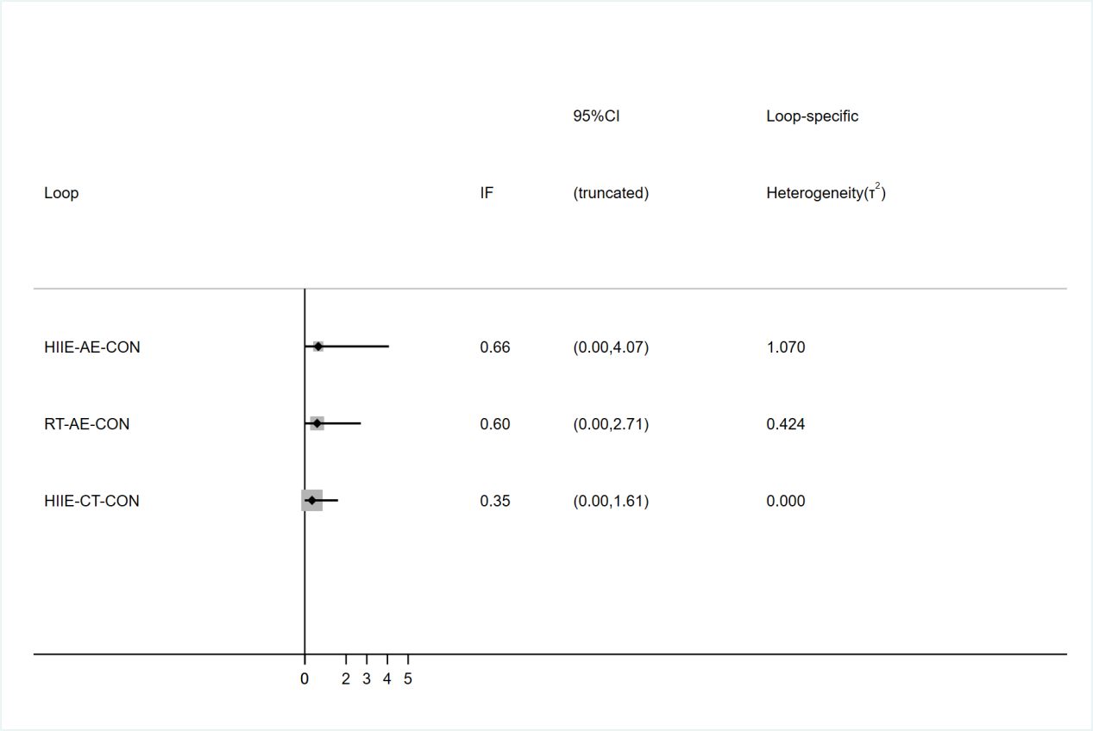
Figure 4. Local inconsistency for PBF.
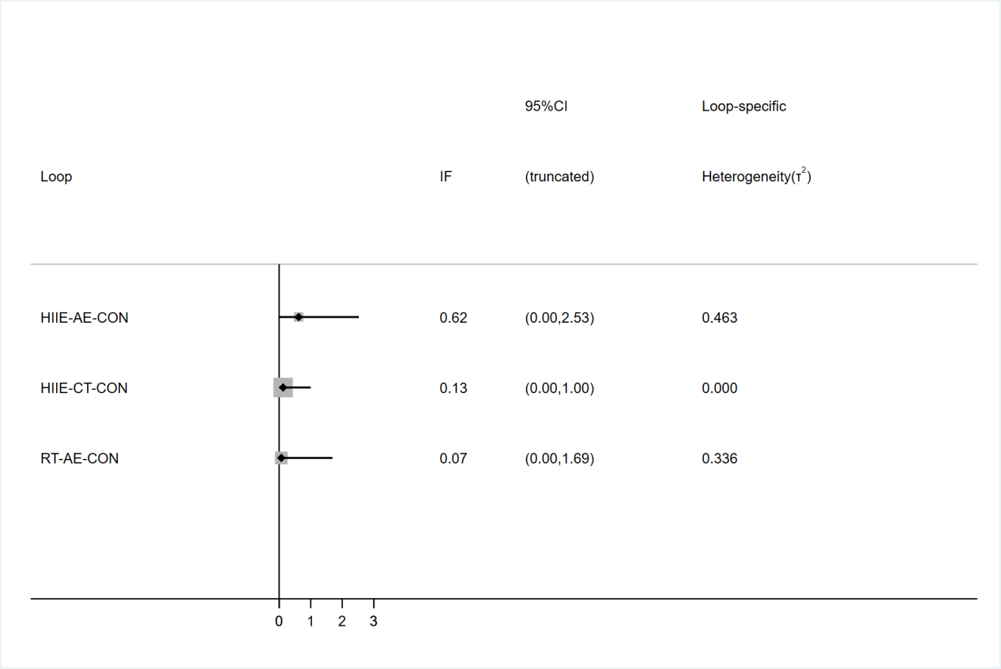
Figure 5. Local inconsistency for FBG.
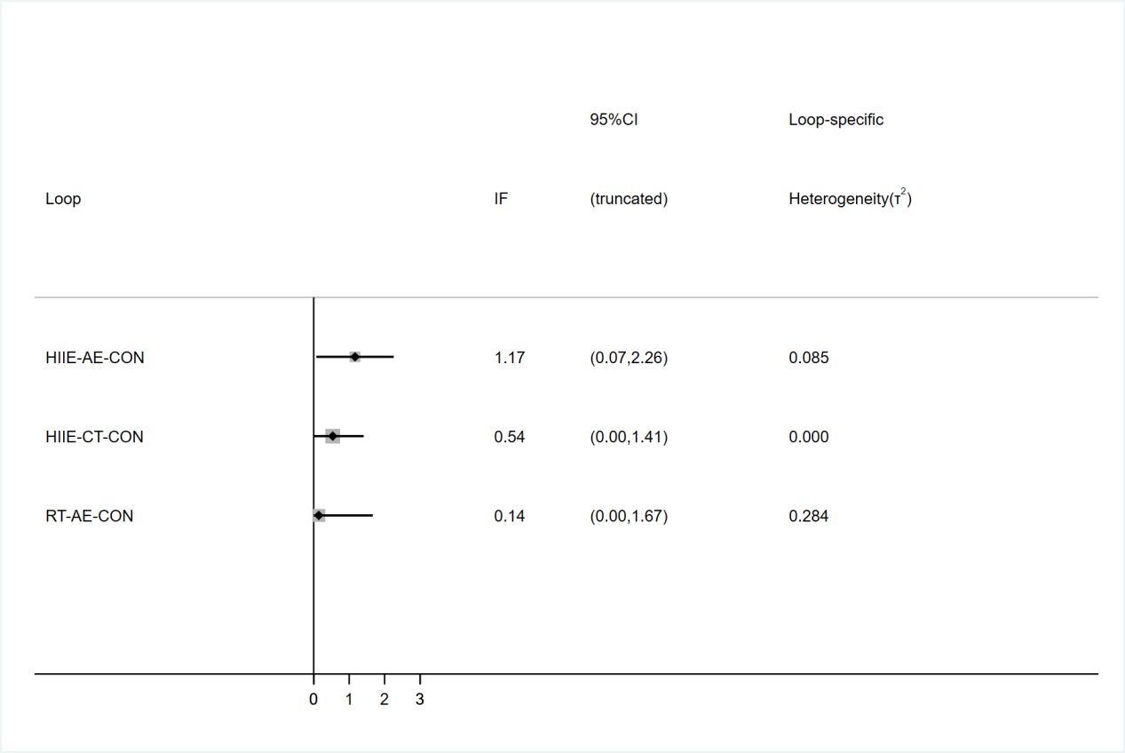
Figure 6. Local inconsistency for HbA1c.

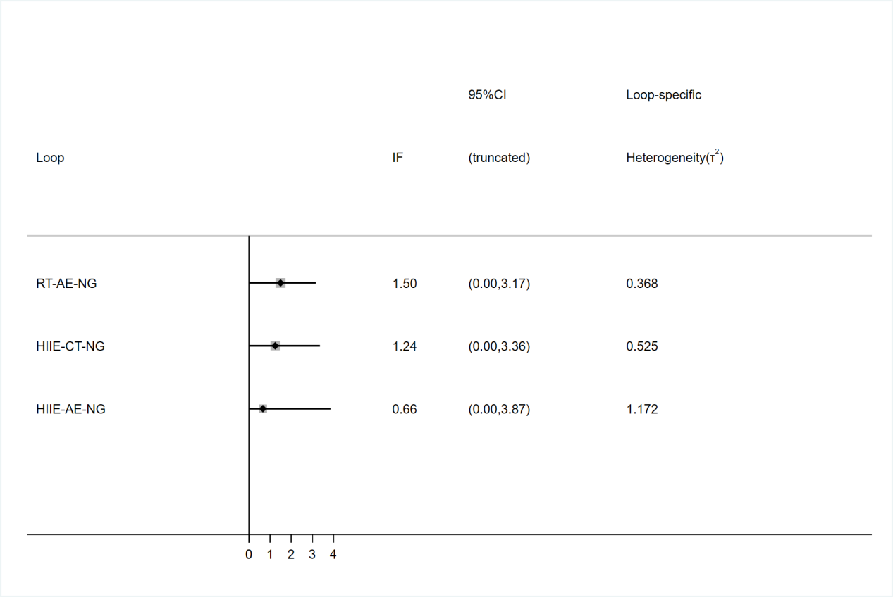
Figure 7. Local inconsistency for FINS.

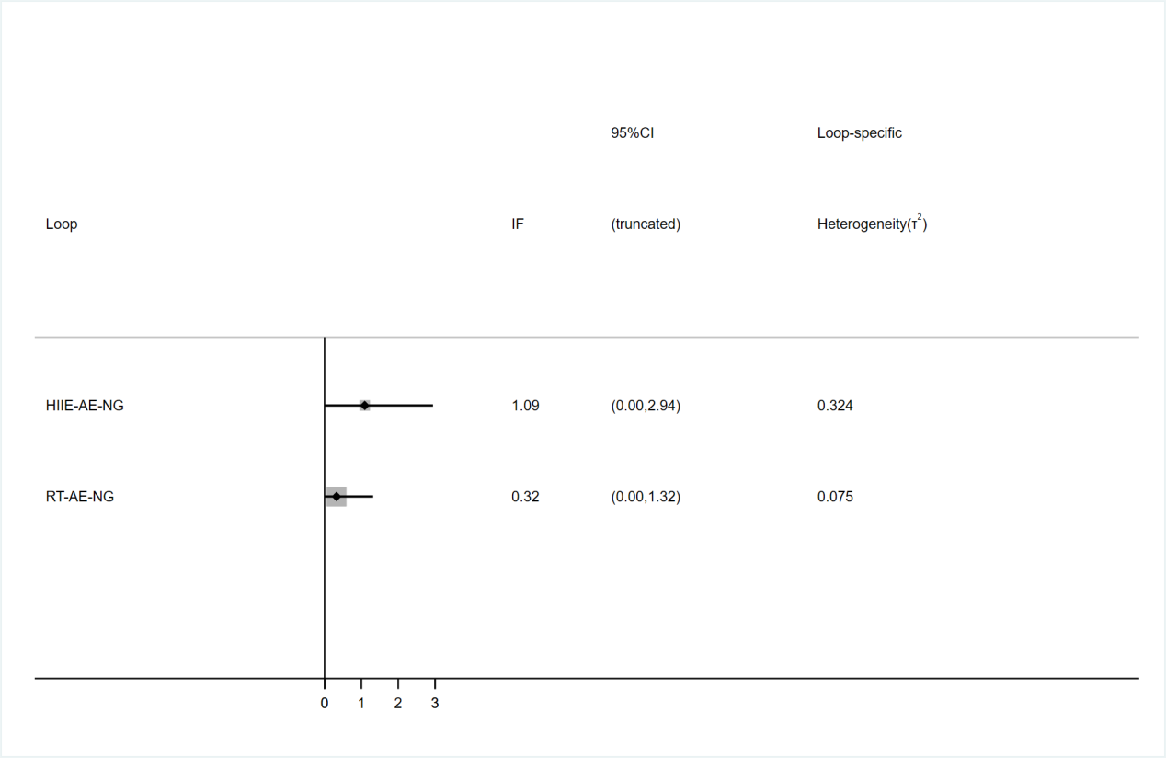
Figure 8. Local inconsistency for TG.
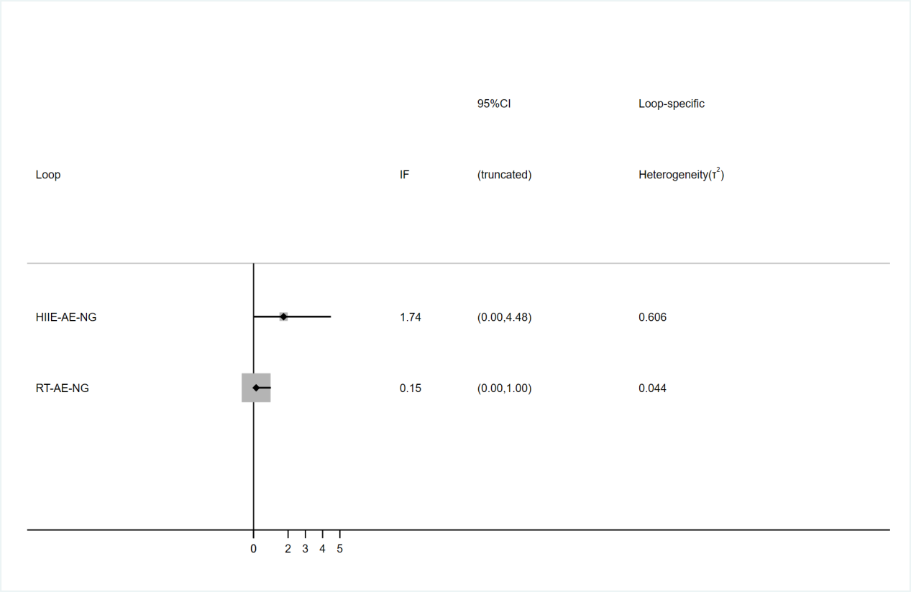
Figure 9. Local inconsistency for HDL

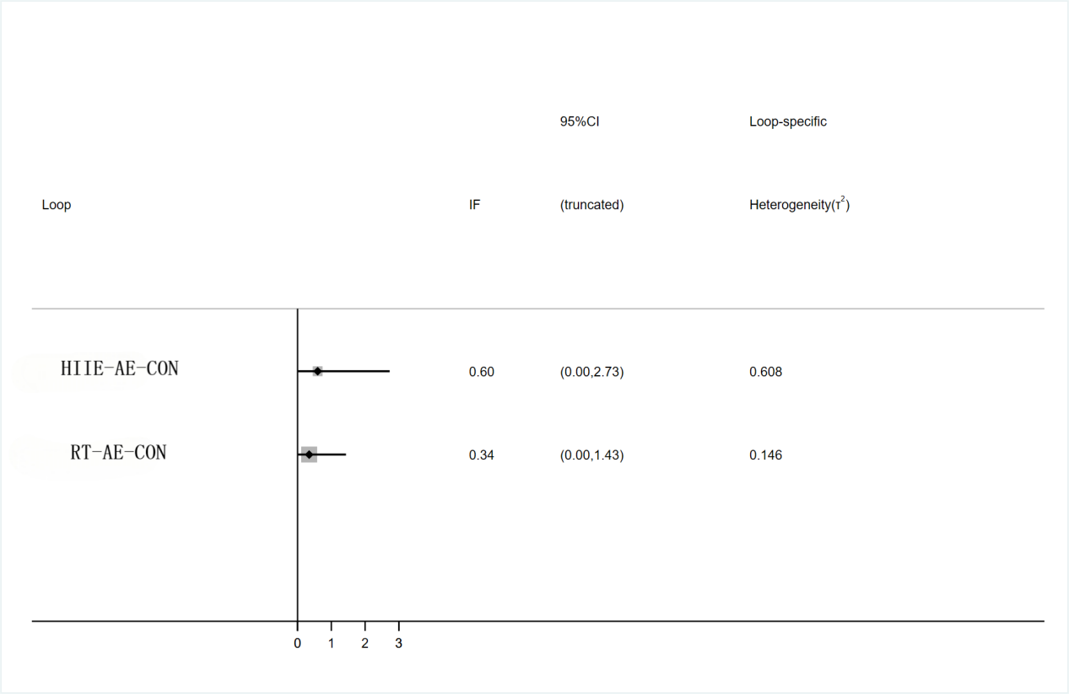
Figure 10. Local inconsistency for LDL.
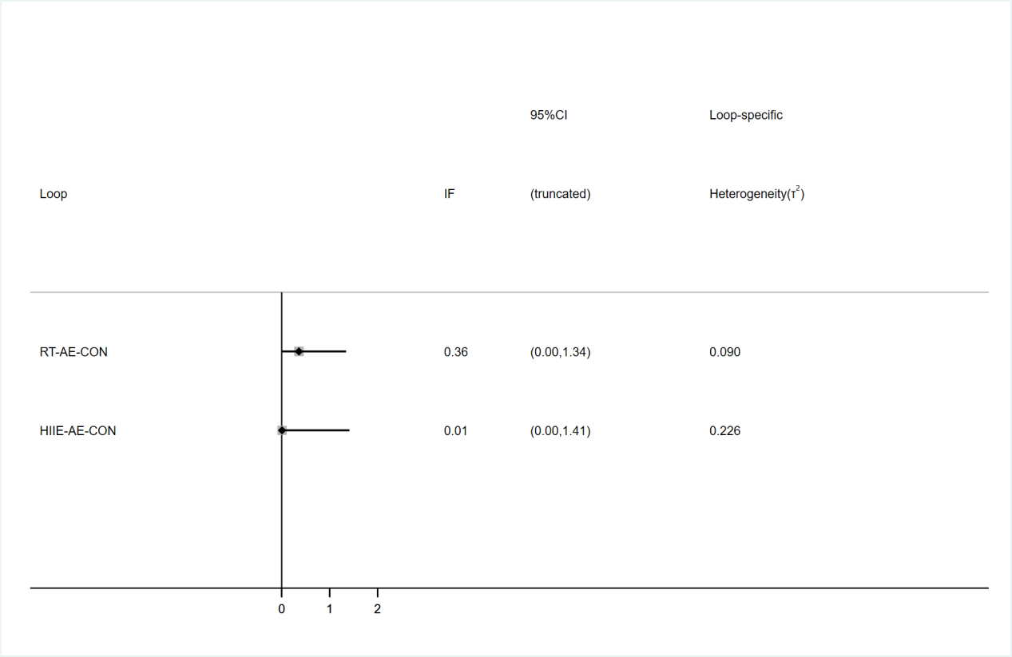
Figure 11. Local inconsistency for TC.

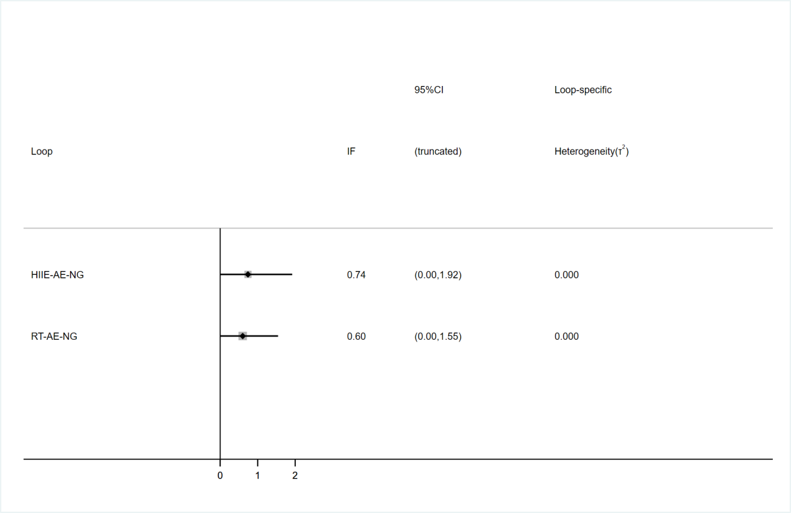
Figure 12. Local inconsistency for SBP.

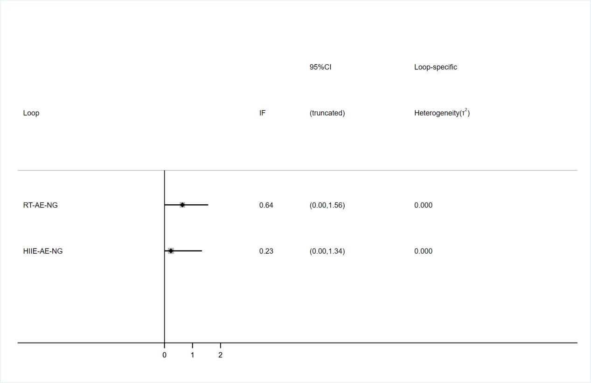
Figure 13. Local inconsistency for DBP.

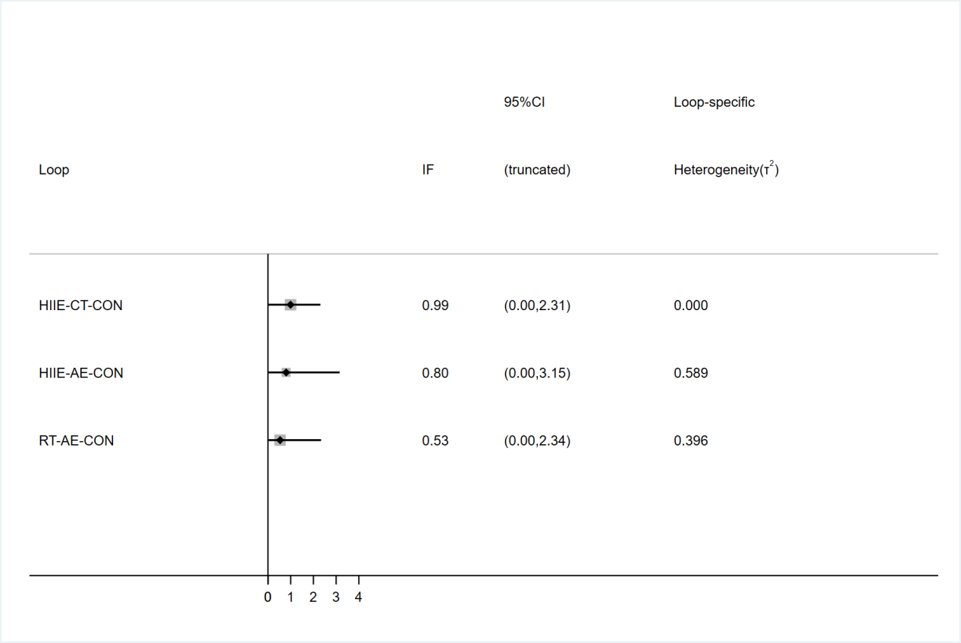
Figure 14. Local inconsistency for VO₂max.

