Supplementary Material 5

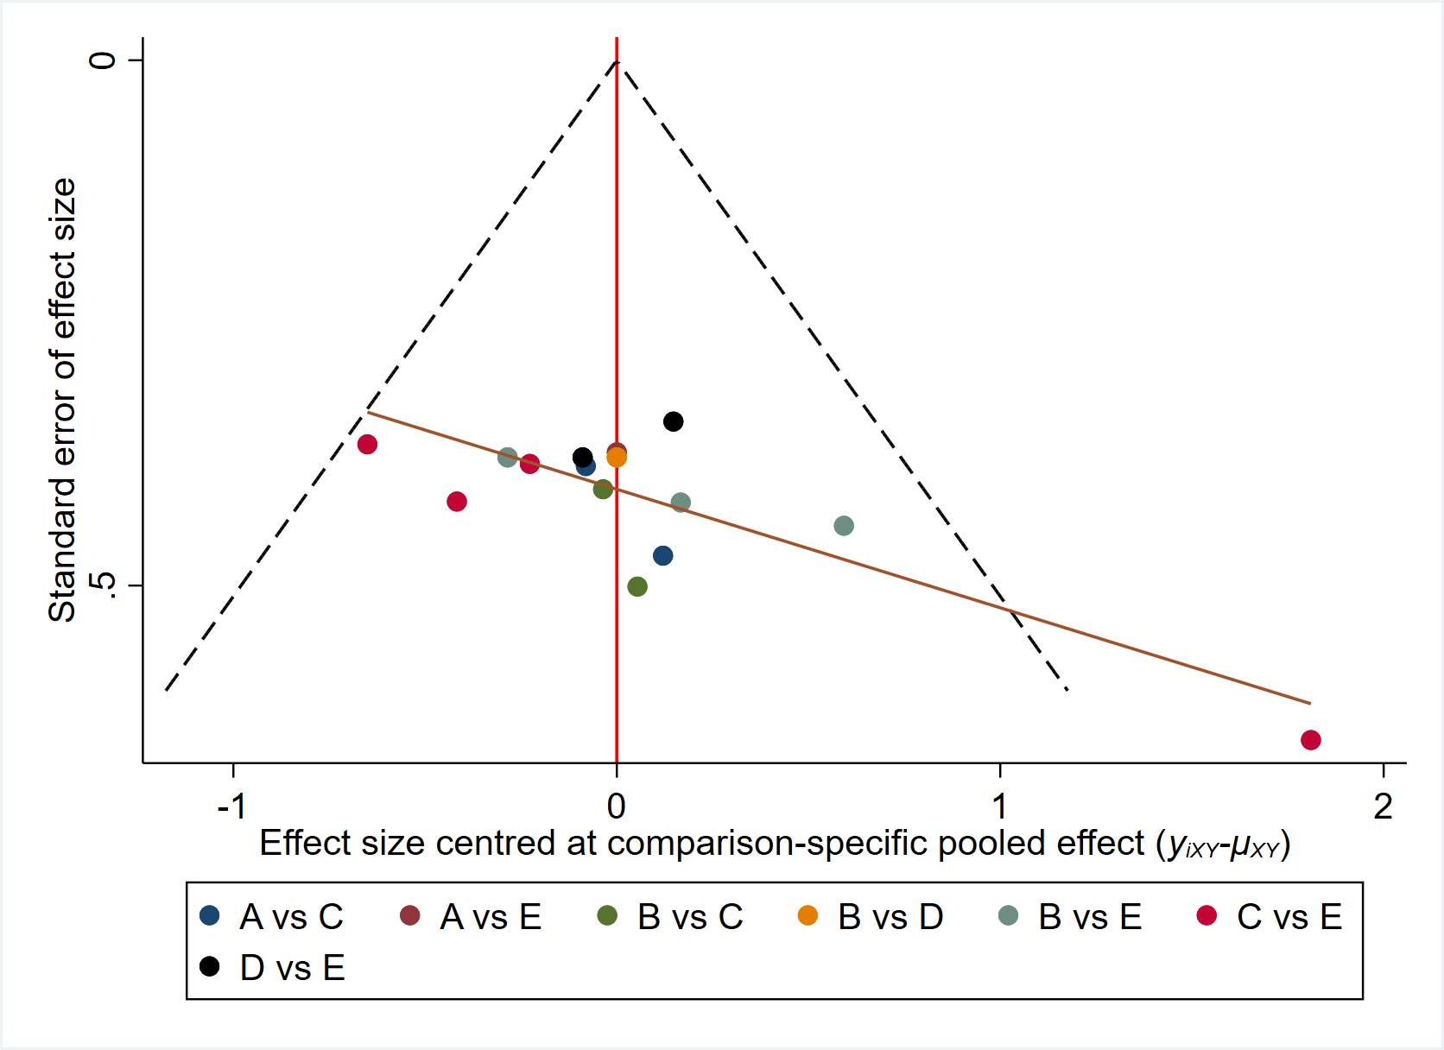
Figure 1. Network meta-analysis funnel plots for BW.
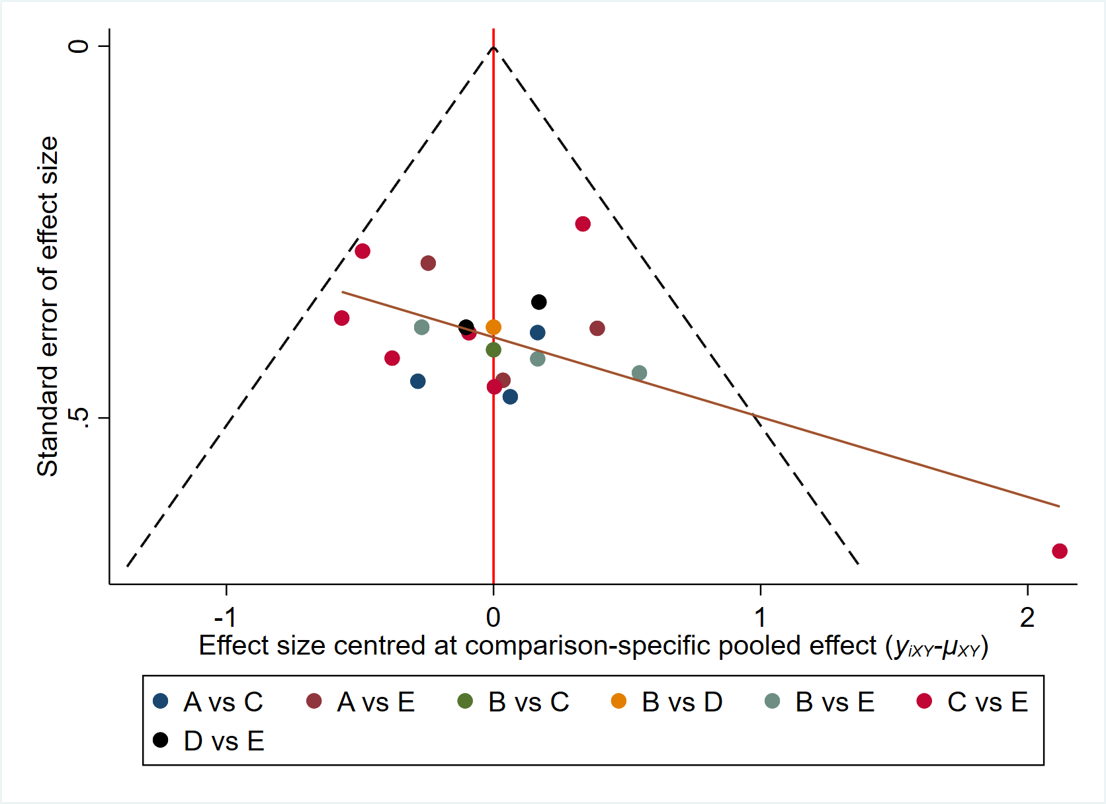
Figure 2. Network meta-analysis funnel plots for BMI.
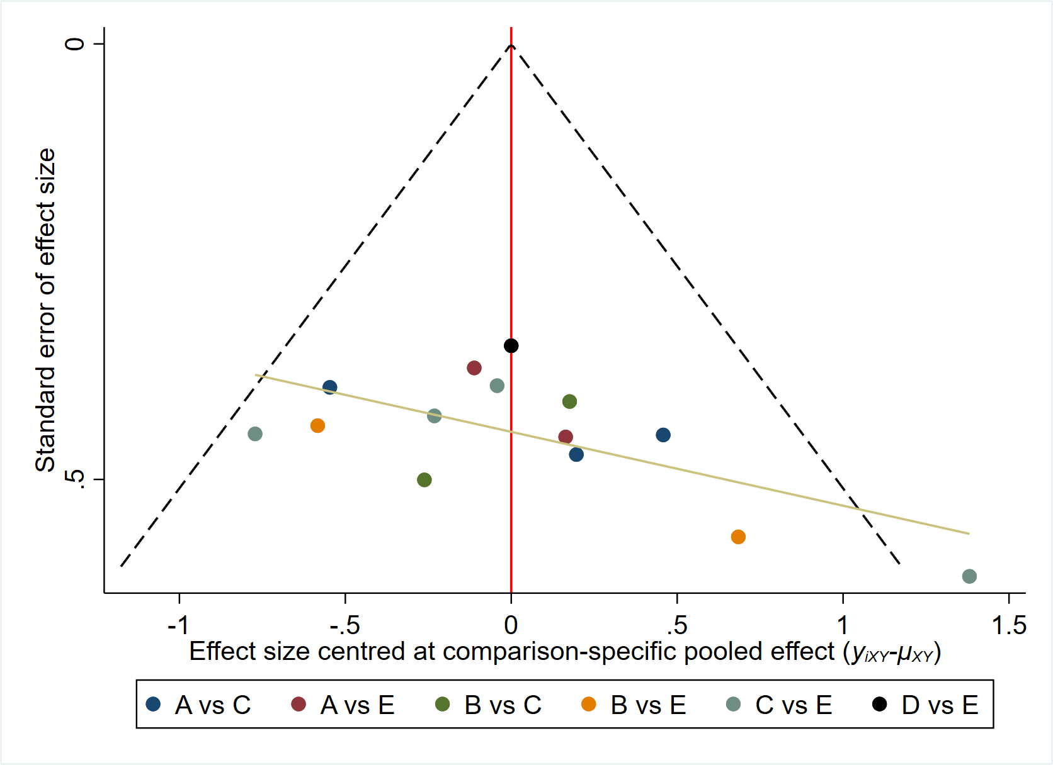
Figure 3. Network meta-analysis funnel plots for WC.
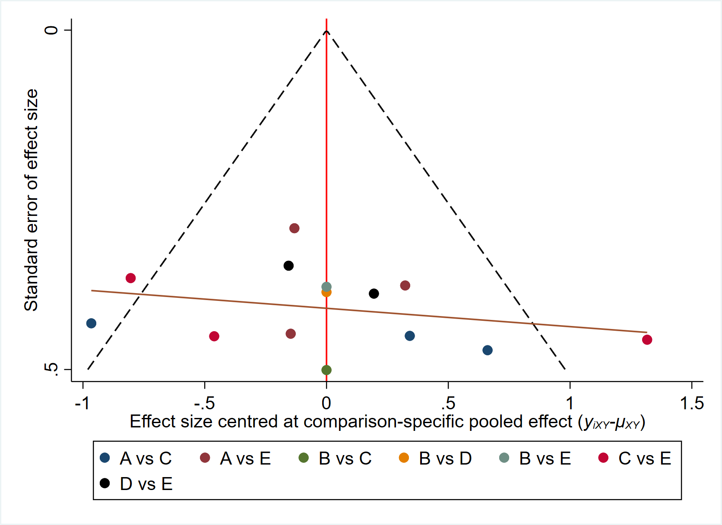
Figure 4. Network meta-analysis funnel plots for PBF.
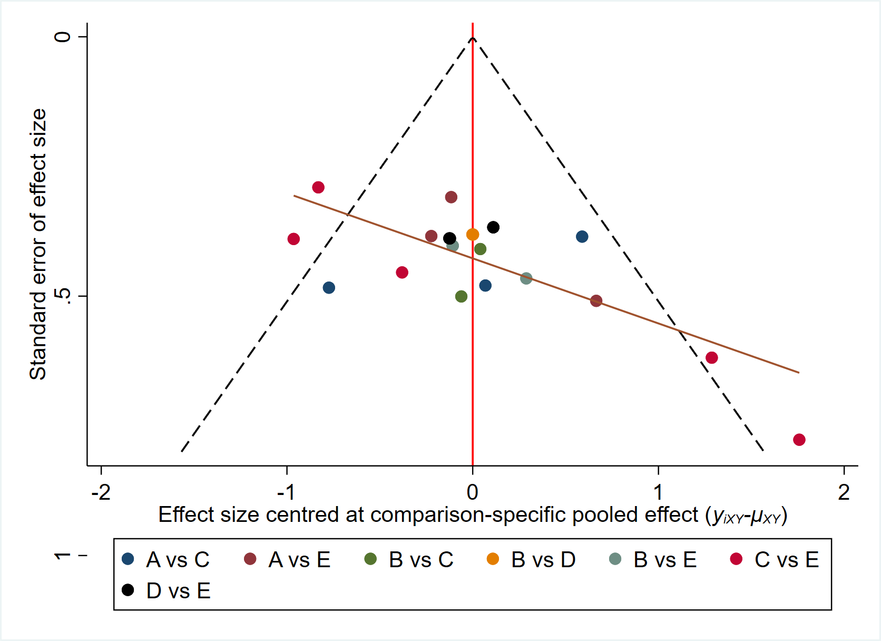
Figure 5. Network meta-analysis funnel plots for FBG.
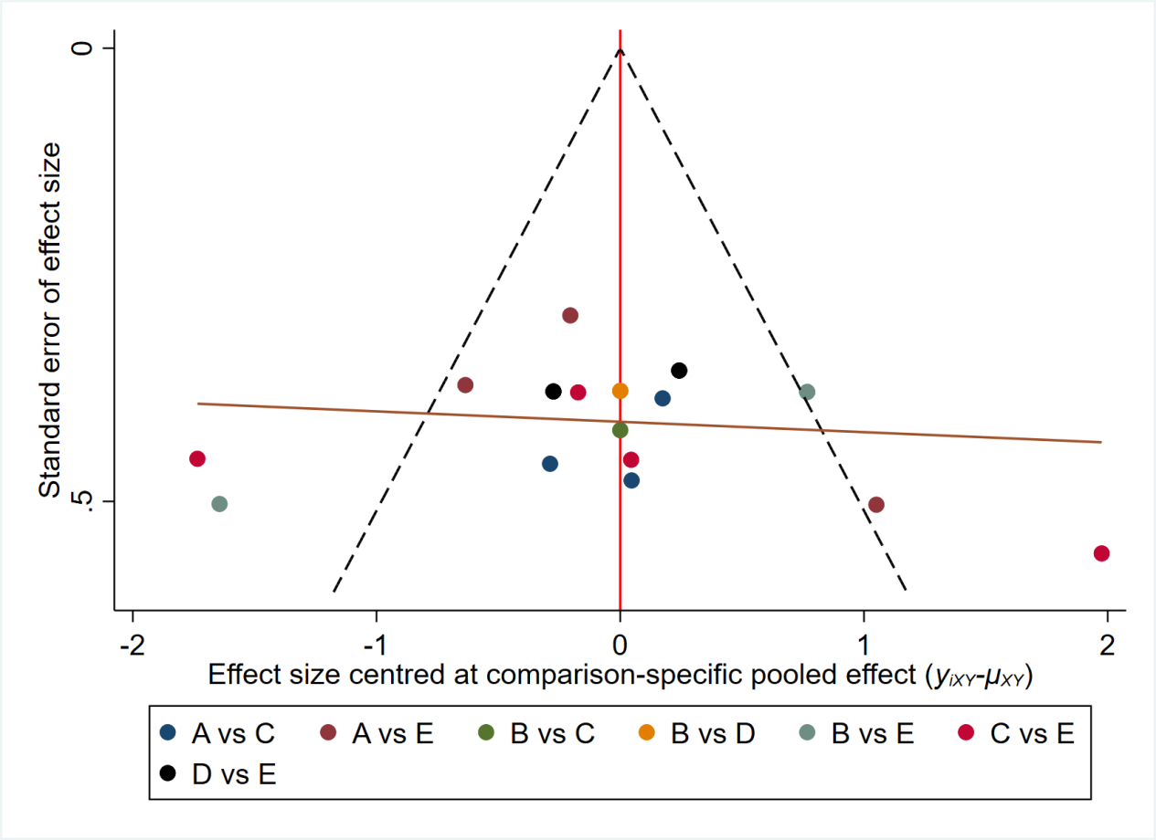
Figure 6. Network meta-analysis funnel plots for FINS.
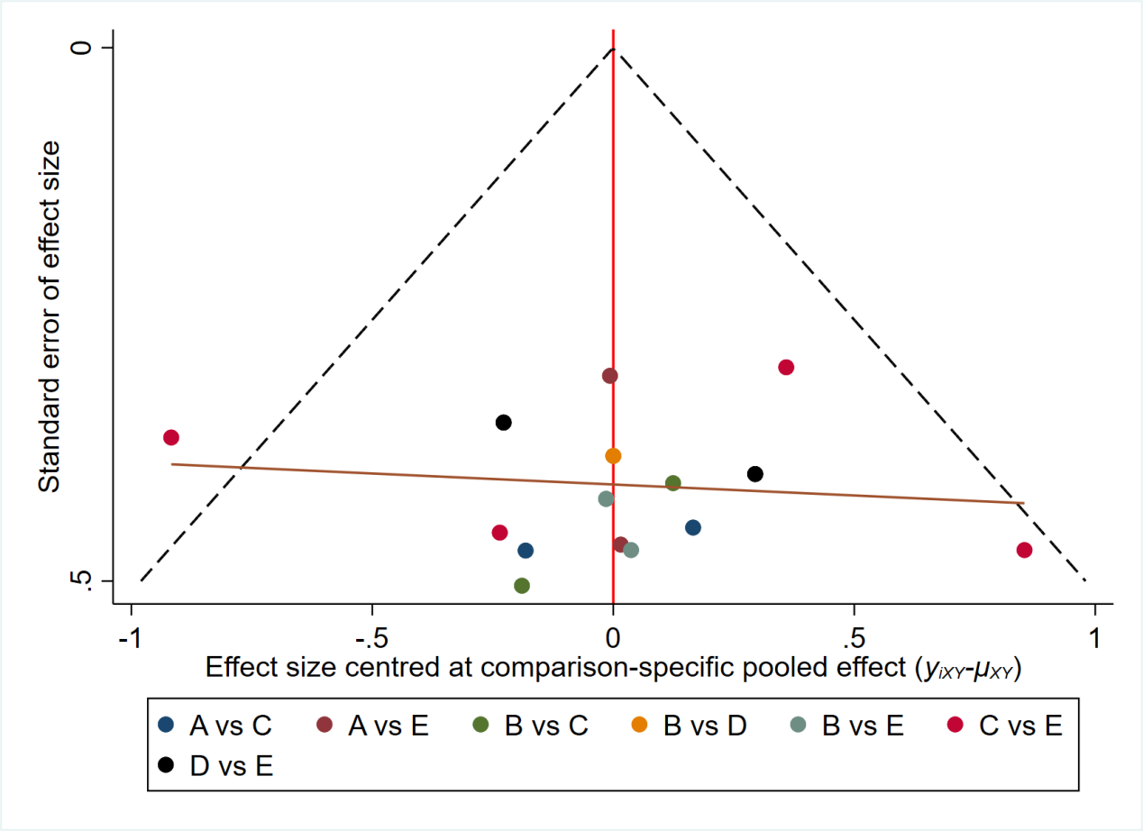
Figure 7. Network meta-analysis funnel plots for HbA1c.
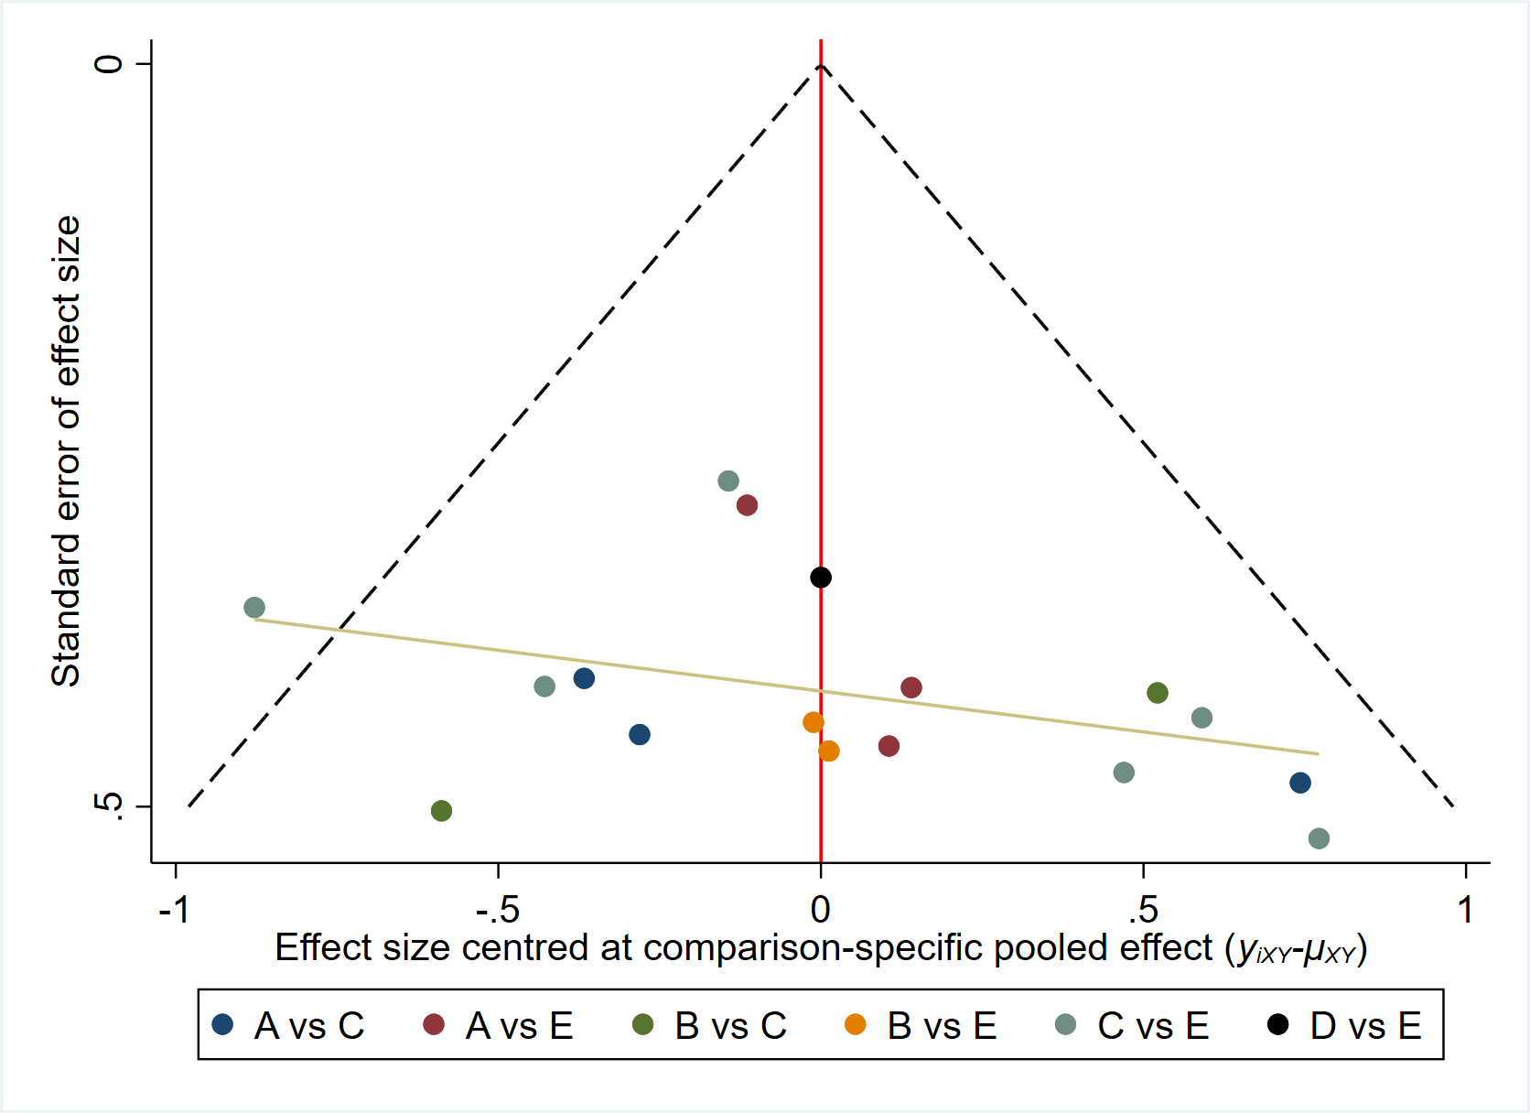
Figure 8. Network meta-analysis funnel plots for TC.
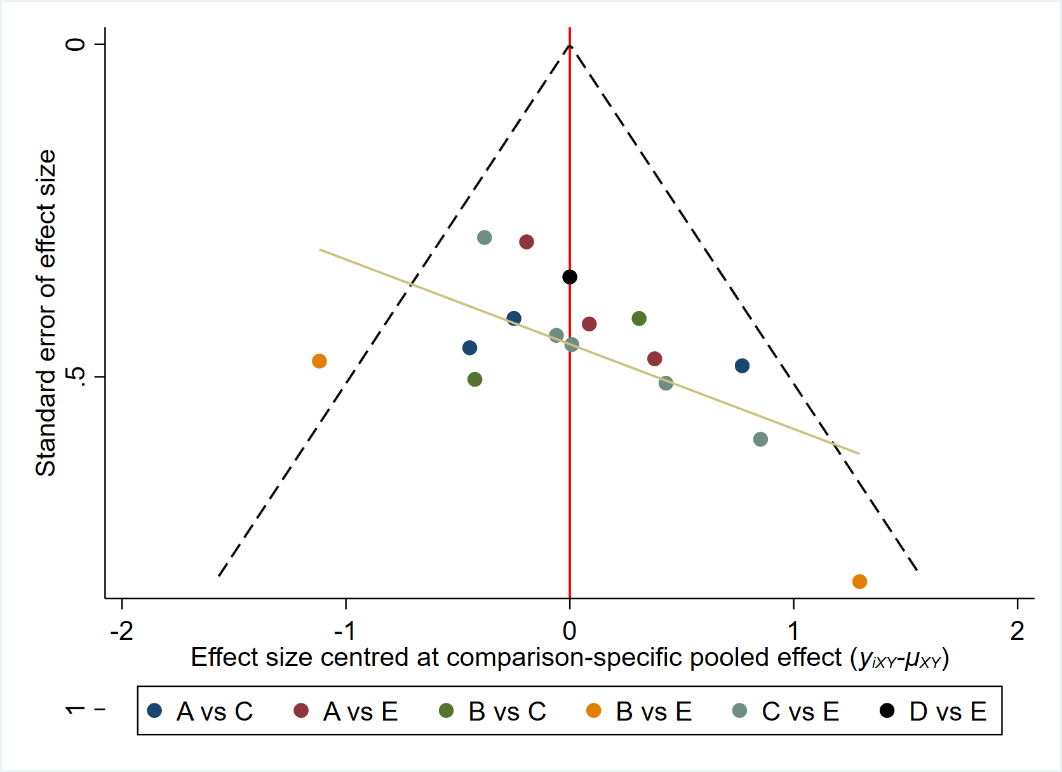
Figure 9. Network meta-analysis funnel plots for TG.
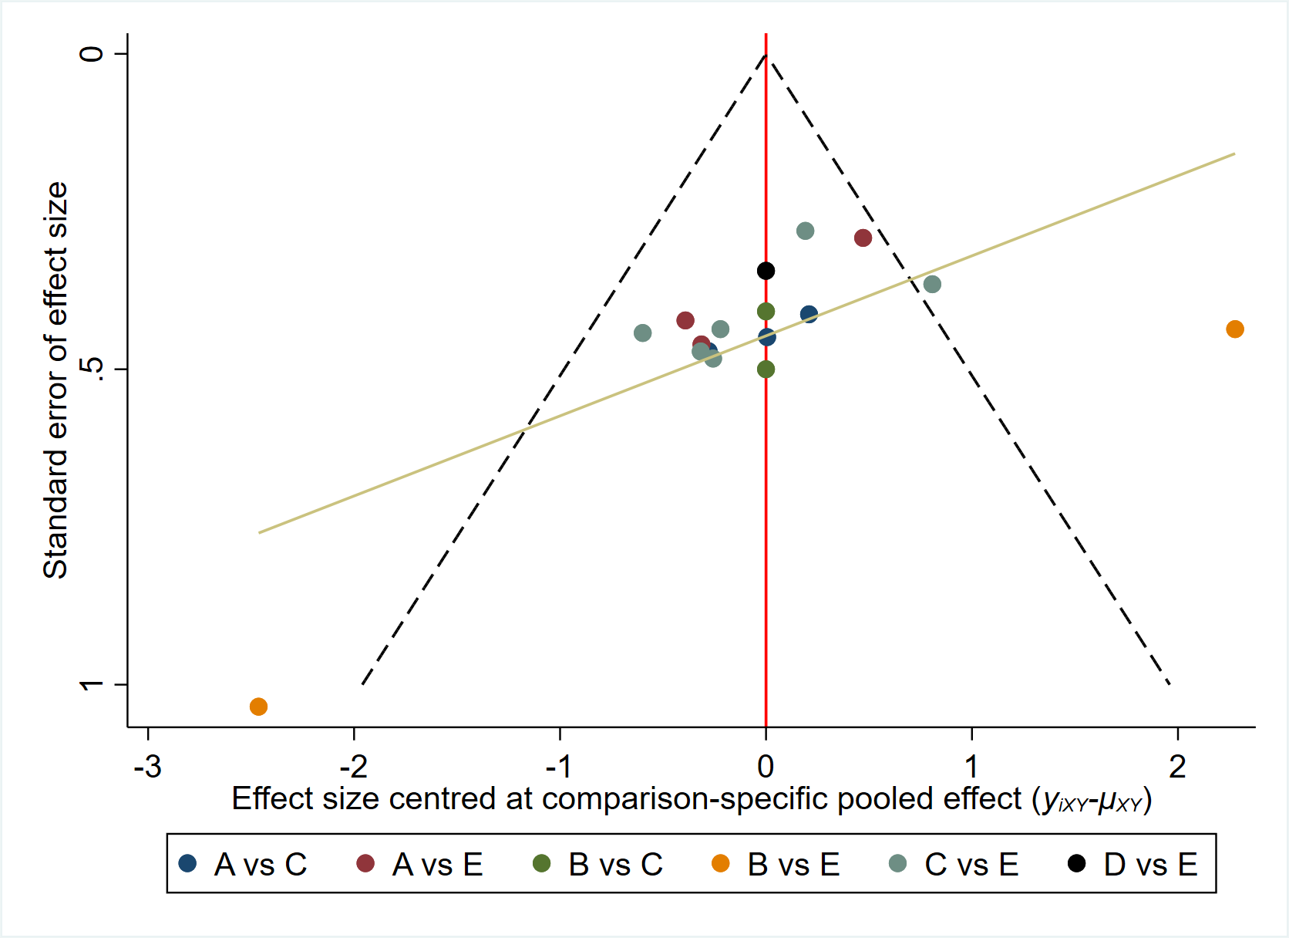
Figure 10. Network meta-analysis funnel plots for HDL.
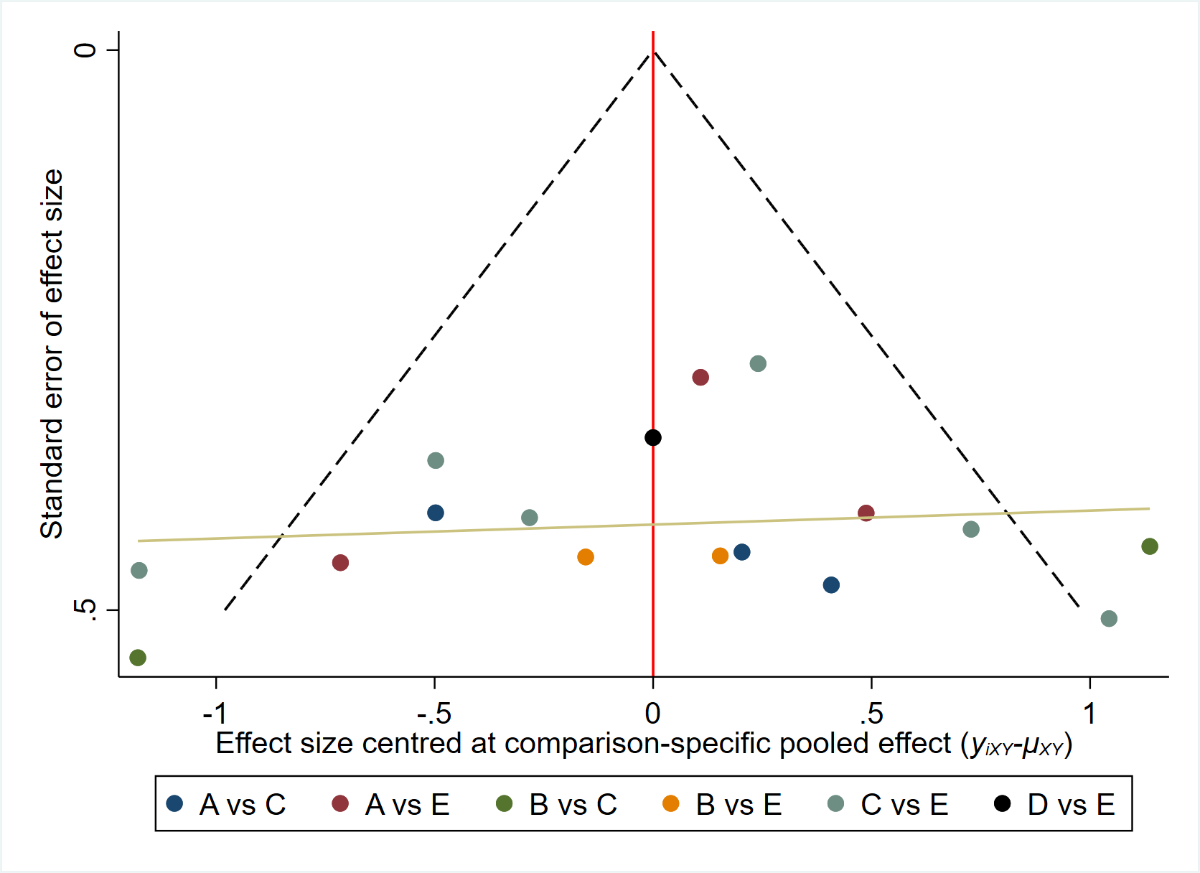
Figure 11. Network meta-analysis funnel plots for LDL.
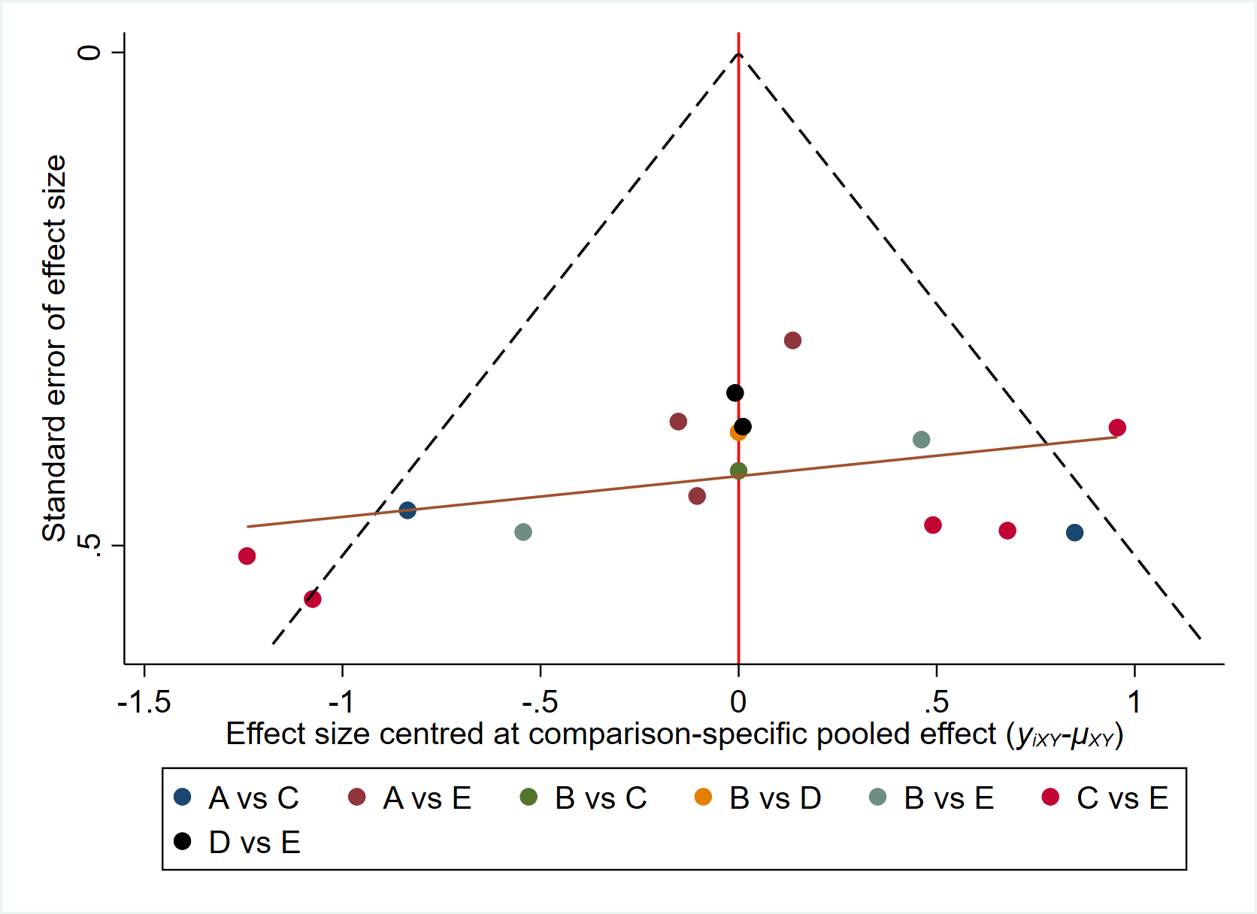
Figure 12. Network meta-analysis funnel plots for VO₂max.
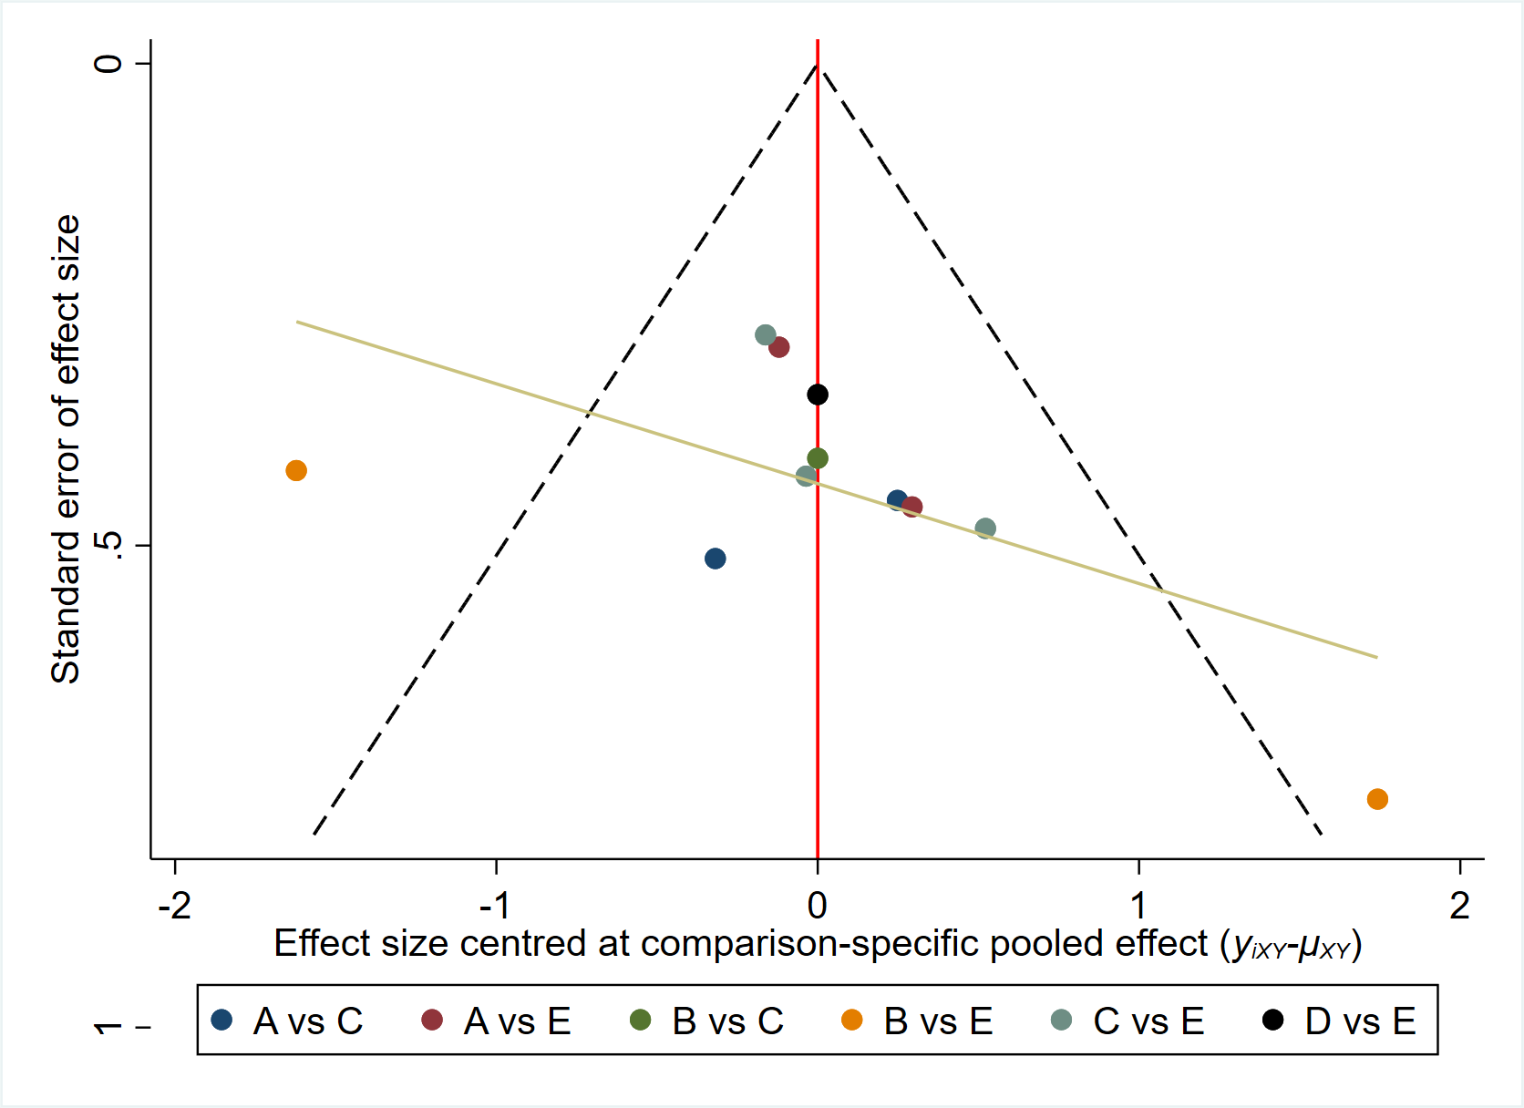
Figure 13. Network meta-analysis funnel plots for SBP.
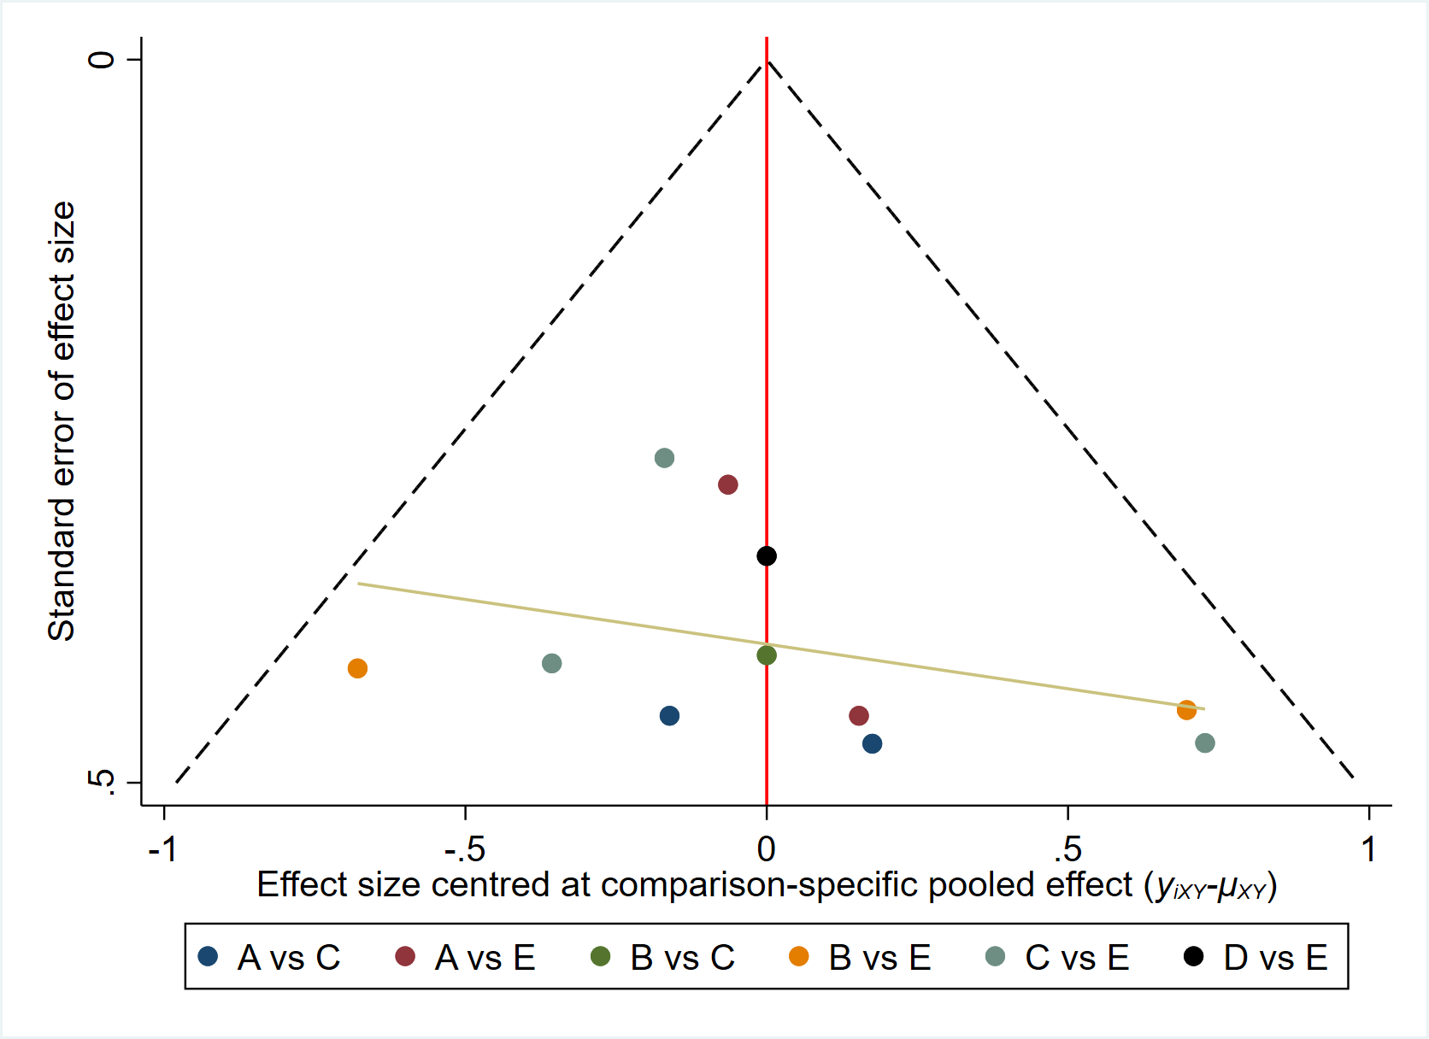
Figure 14. Network meta-analysis funnel plots for DBP.

