Supplementary Material 6

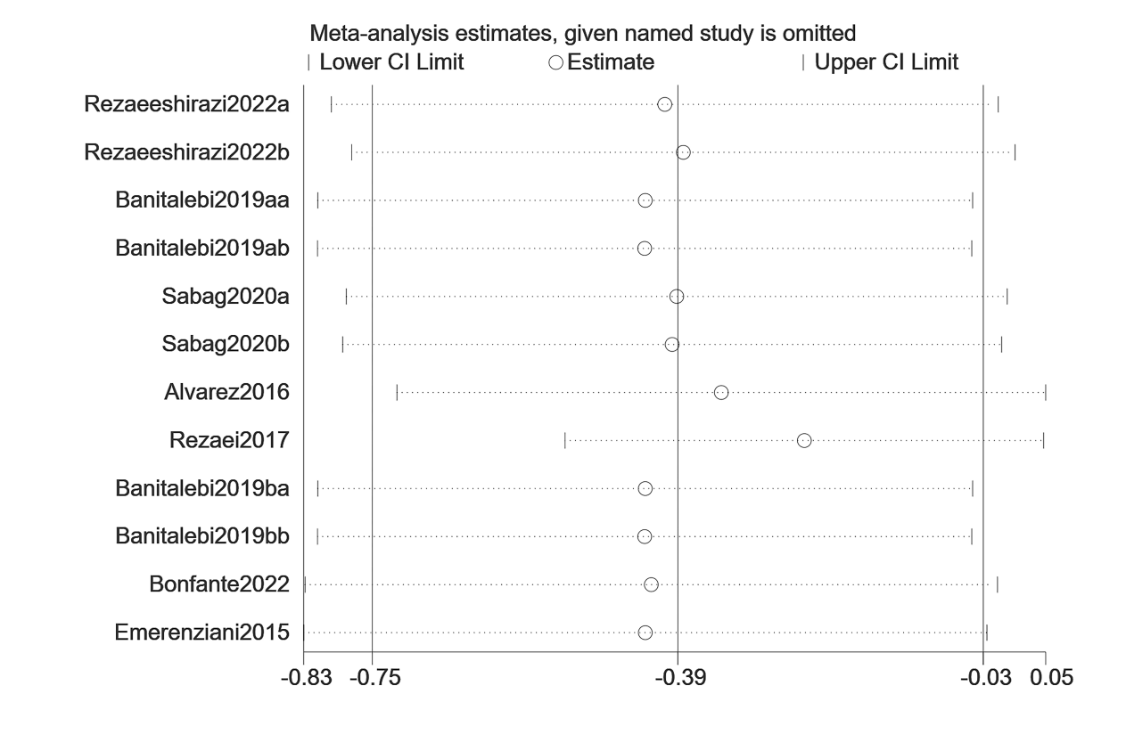
Figure 1.Sensitivity analyses for BW.
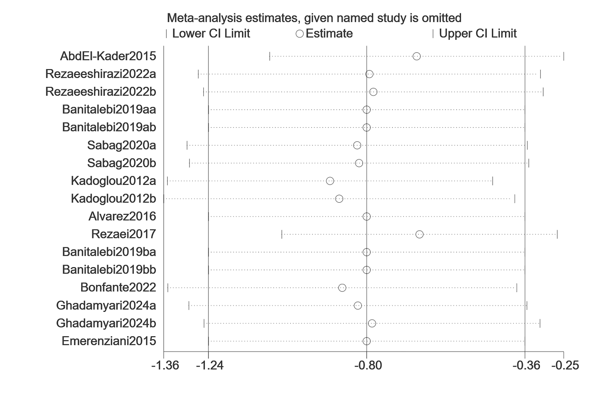
Figure 2.Sensitivity analyses for BMI.
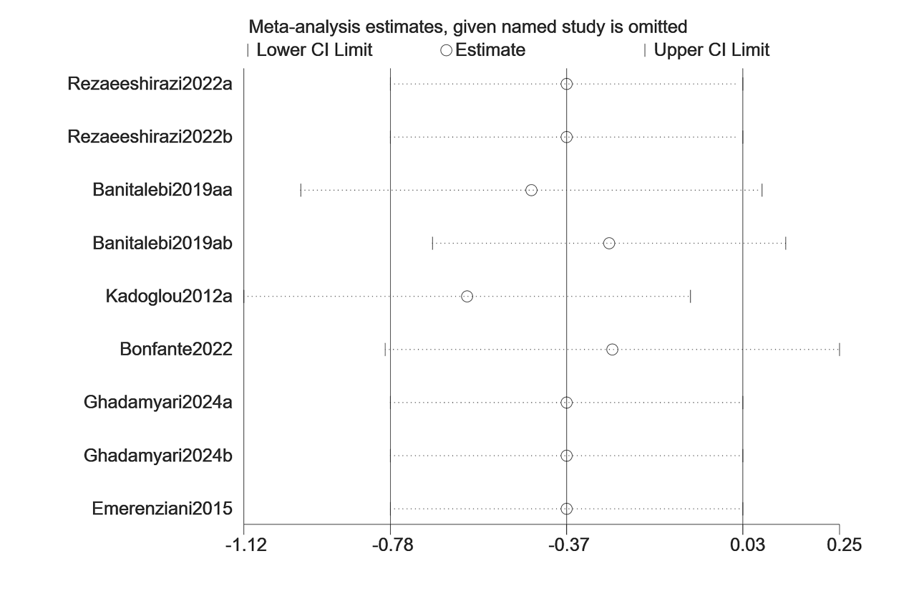
Figure 3.Sensitivity analyses for PBF.
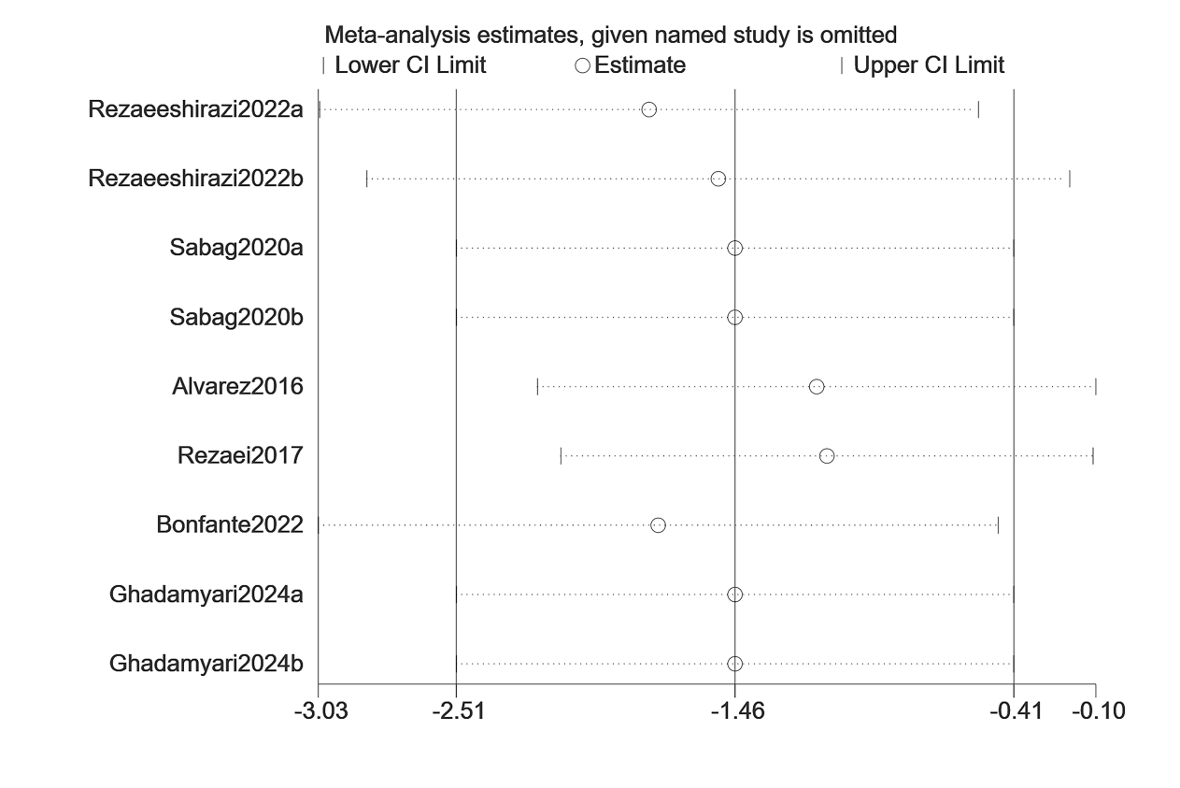
Figure 4.Sensitivity analyses for WC.
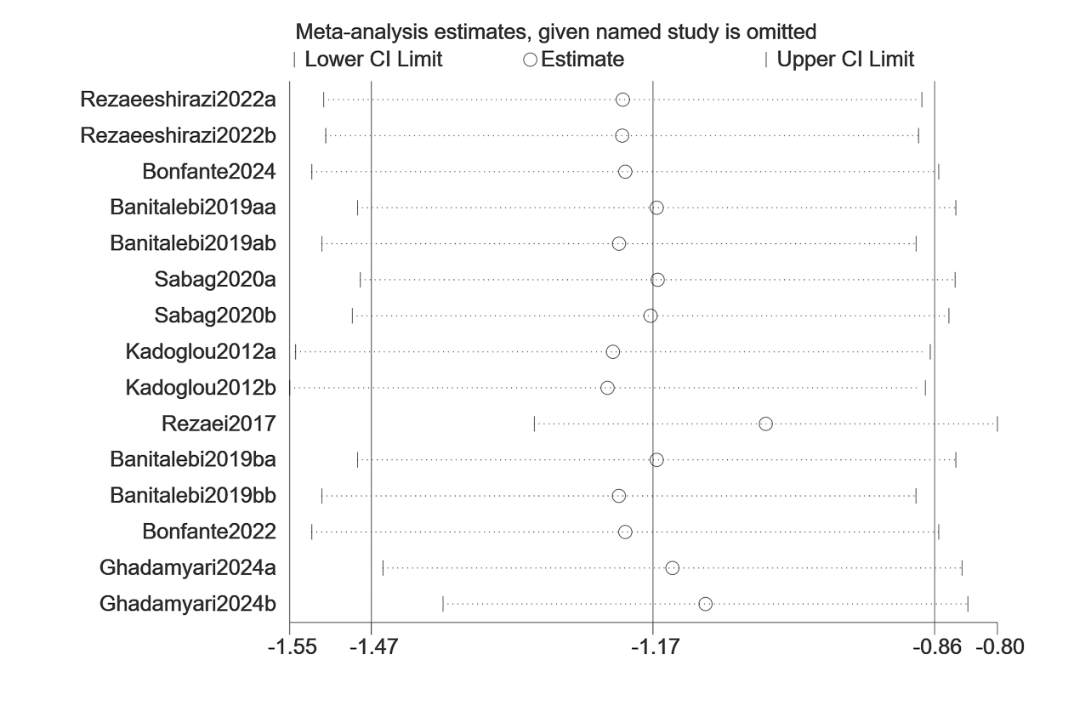
Figure 5.Sensitivity analyses for FBG.
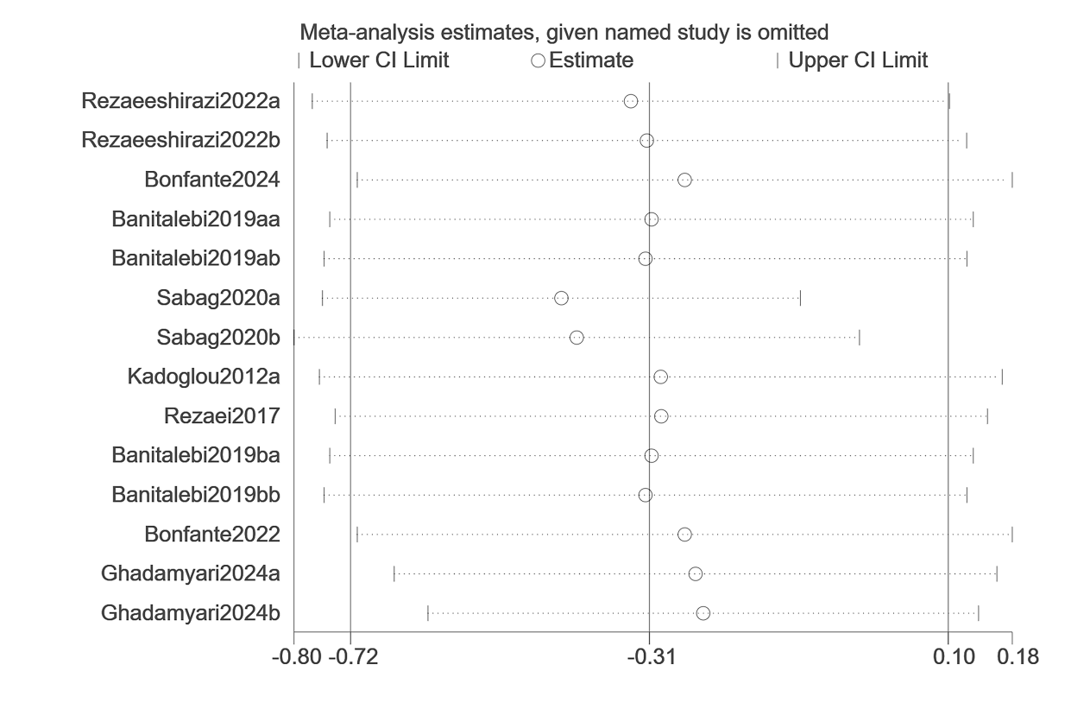
Figure 6.Sensitivity analyses for FINS.
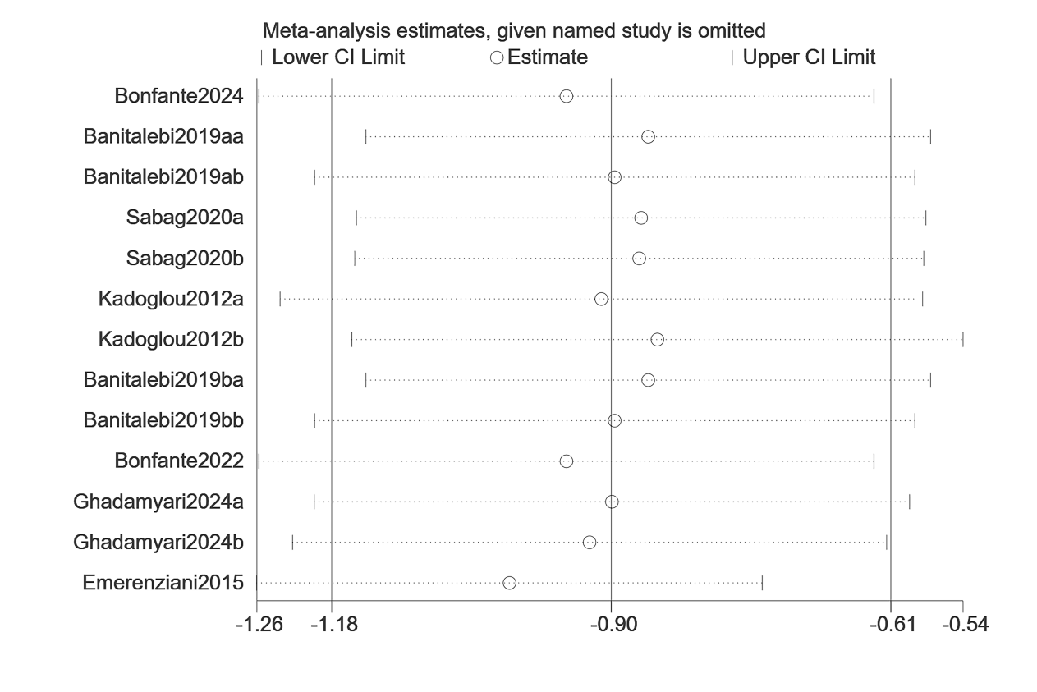
Figure 7.Sensitivity analyses for HbA1c.
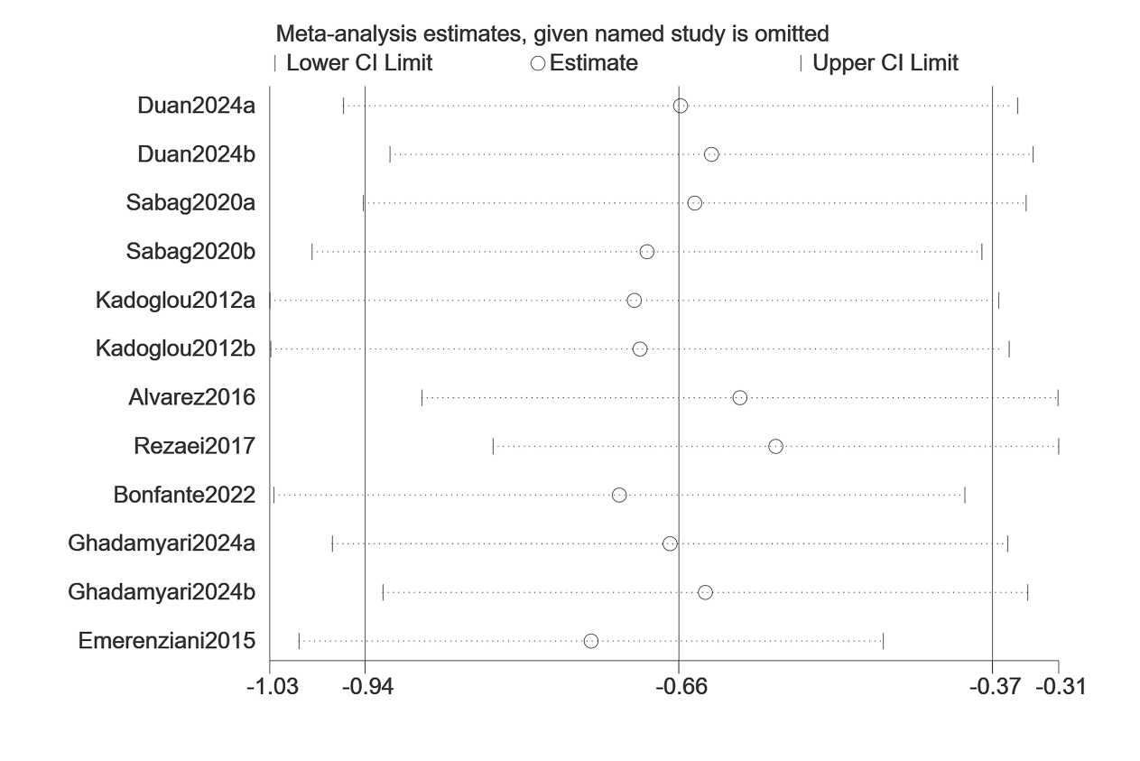
Figure 8.Sensitivity analyses for TC.
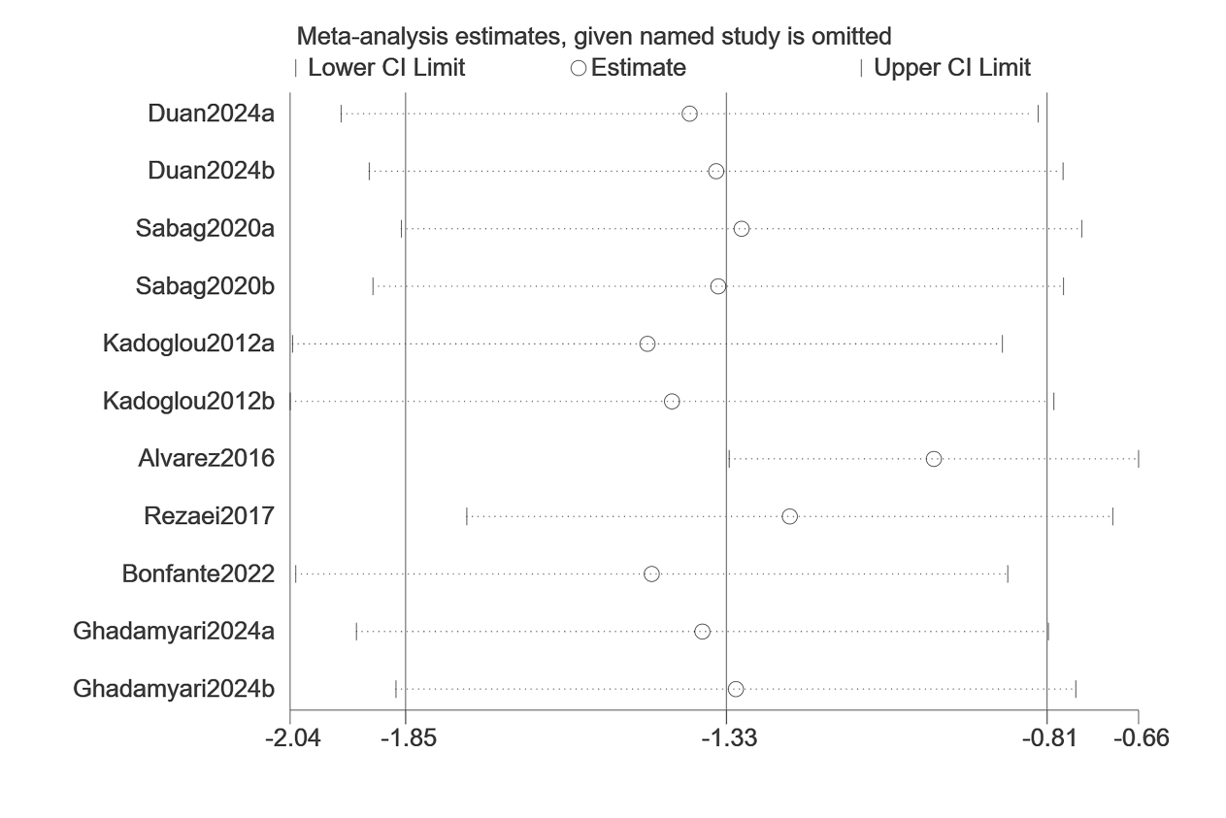
Figure 9.Sensitivity analyses for TG.
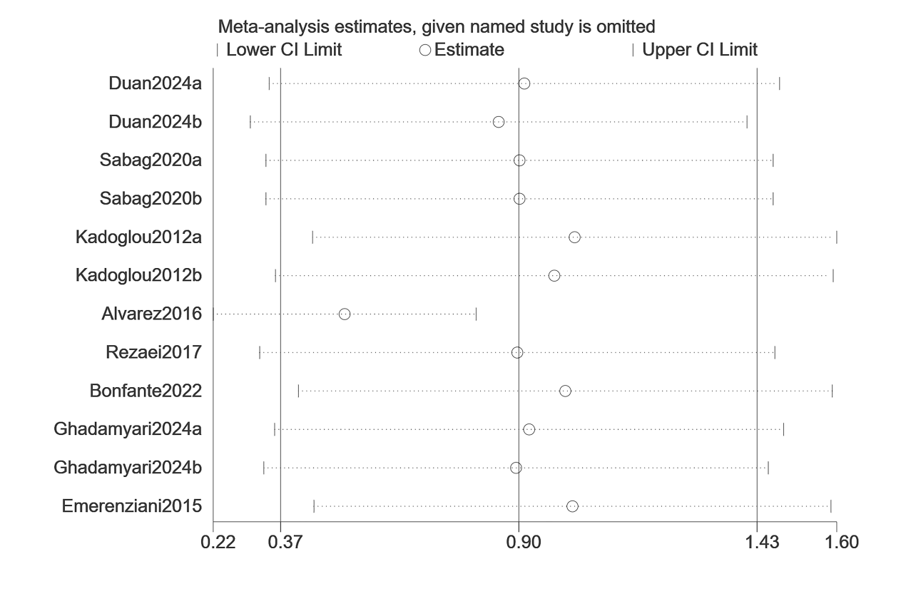
Figure 10.Sensitivity analyses for HDL.
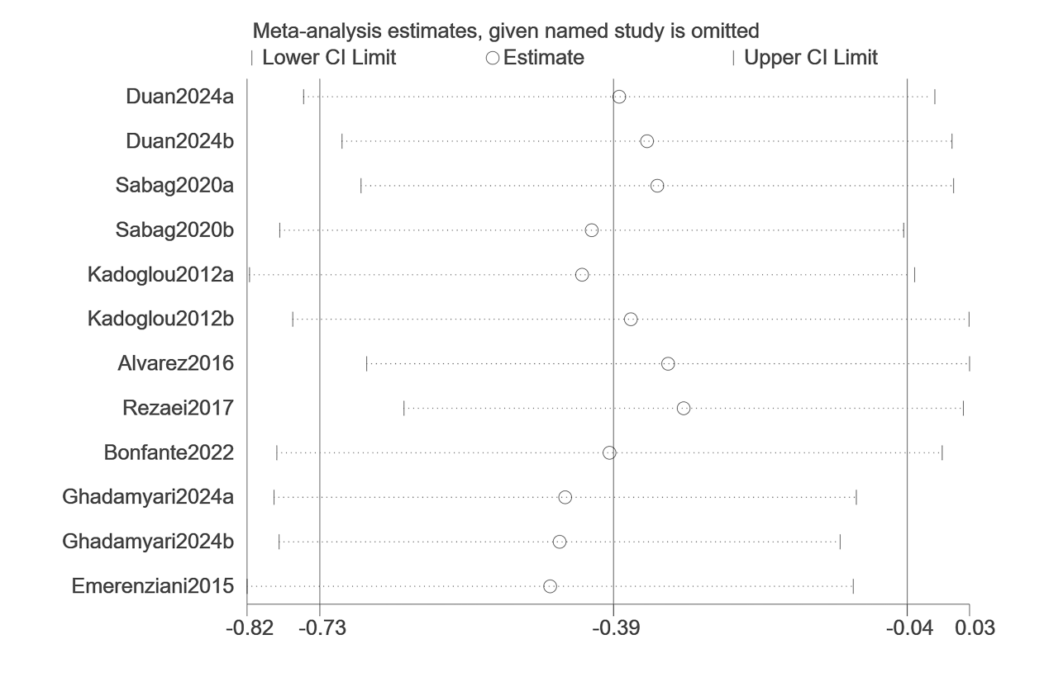
Figure 11.Sensitivity analyses for LDL.
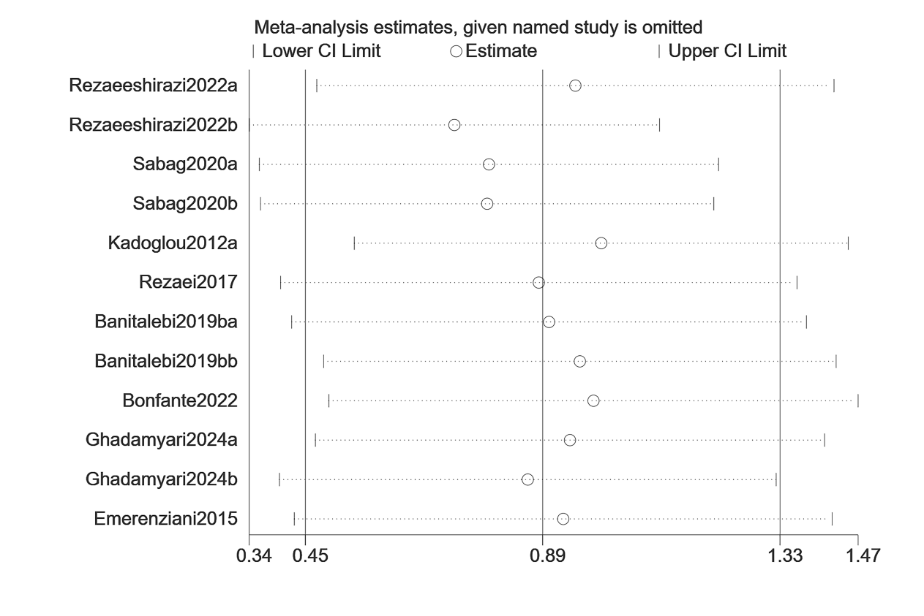
Figure 12.Sensitivity analyses for VO₂max.
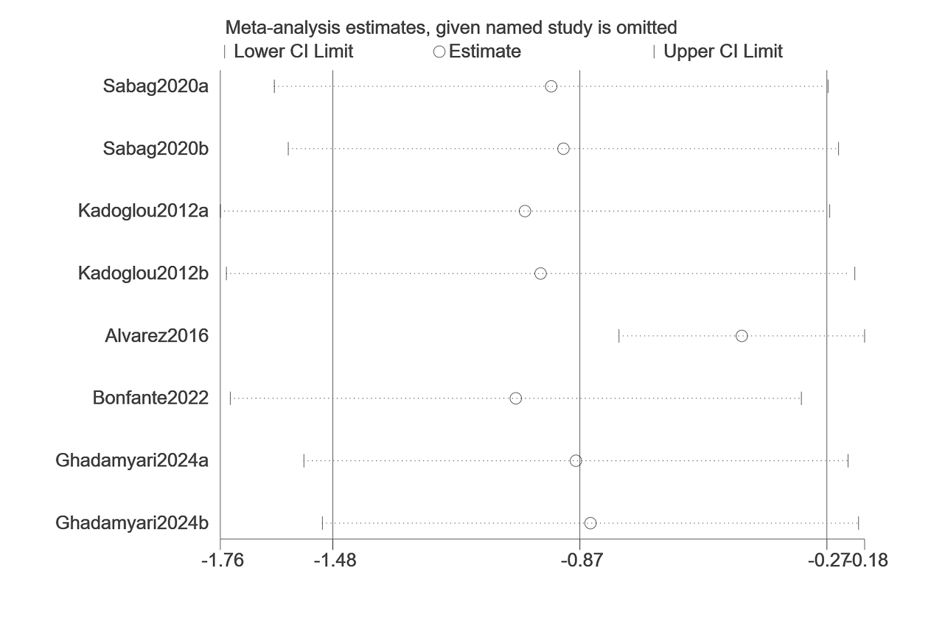
Figure 13.Sensitivity analyses for SBP.
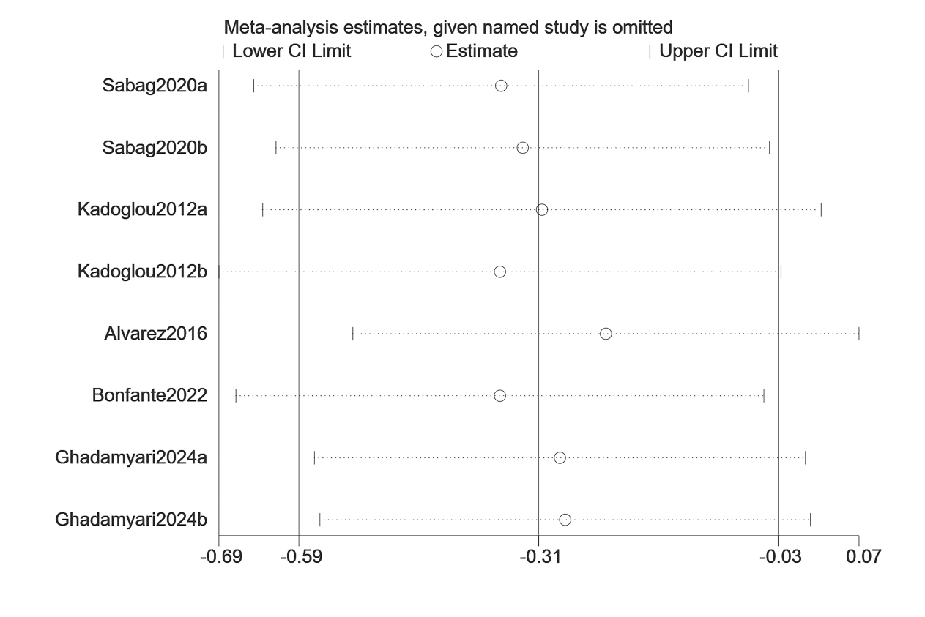
Figure 14.Sensitivity analyses for DBP.

