Figure 1. Comparison of continuous covariate distributions before and after multivariate imputation, with baseline missingness percentages.
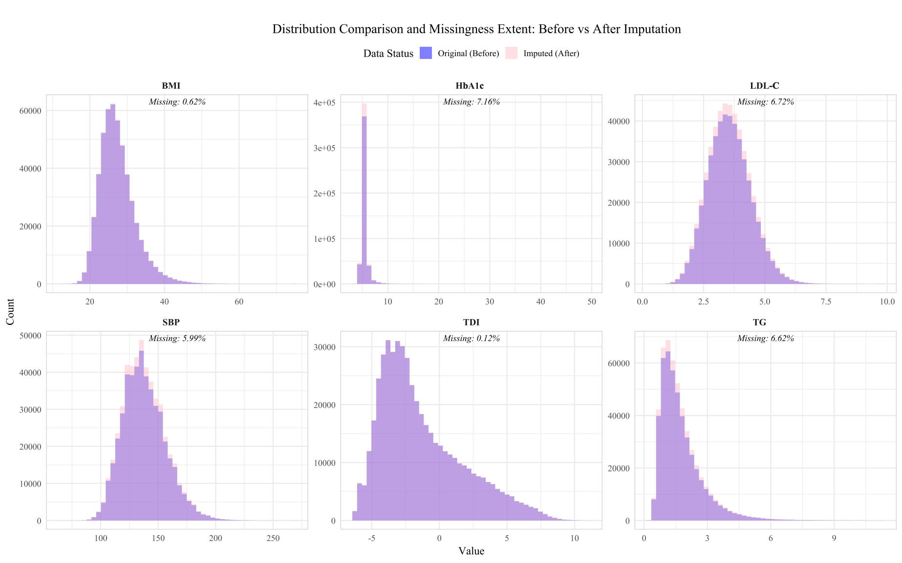

Figure 2. Compositional stability and missingness of categorical variables before and after multivariate imputation.
