Supplementary table 1. Key secondary and secondary end points primary outcome of three statin therapies (N=729)
Variable | Atorvastatin (atorvastatin calcium) 20 mg/Tab QD  (n =243) |  |  |  | LN-FDC (lovastatin–niacin fixed-dose combination) 500/20mg QD  (n =243) |  |  |  | Rosuvastatin (niacin plus lovastatin) 10mg/Tab QD  (n =243) |  |  |  | P value  Change from baseline between groups
Variable | Mean  (S.D.) | CFB  (S.D.) | CFB  P value |  | Mean  (S.D.) | CFB  (S.D.) | CFB  P value |  | Mean  (S.D.) | CFB  (S.D.) | CFB  P value |  | Among  3 groups | Atorvastatin VS.  LN-FDC | LN-FDC  VS. Rosuvastatin | Rosuvastatin VS.  Atorvastatin
Liver biochemistries
AST (U/L)
n = 655 | 243 | --- | --- |  | 169 | --- | --- |  | 243 | --- | ---
Baseline, mean  (S.D.) | 29.1(16.9) | --- | --- |  | 31.5(17.8) | --- | --- |  | 29.3(15.9) | --- | --- |  | 0.105 | 0.121 | 0.299 | > 0.999
3 months | 26.8(14.3) | -2.3(10.7) | < 0.001 |  | 28.5(12.6) | -2.8(18.1) | 0.065 |  | 29.7(21.2) | 0.5(16.4) | 0.656 |  | 0.385 | > 0.999 | > 0.999 | 0.504
6 months | 30.9(80.7) | 1.8(78.0) | 0.7121 |  | 24.7(11.1) | -5.3(18.3) | < 0.001 |  | 25.7(19.7) | -3.5(22.0) | 0.013 |  | > 0.999 | > 0.999 | > 0.999 | > 0.999
ALT (U/L)
n = 729 | 243 | --- | --- |  | 243 | --- | --- |  | 243 | --- | ---
Baseline, mean  (S.D.) | 36.8(28.5) | --- | --- |  | 37.5(27.6) | --- | --- |  | 35.2(26.5) | --- | --- |  | 0.367 | > 0.999 | 0.473 | > 0.999
3 months | 33.0(23.9) | 3.9(18.8) | 0.001 |  | 33.8(24.8) | 5.4(27.2) | 0.013 |  | 34.9(30.8) | 5.6(25.0) | <0.001 |  | 0.829 | > 0.999 | > 0.999 | > 0.999
6 months | 32.2(45.6) | 3.1(42.5) | 0.259 |  | 28.1(18.9) | -0.4(22.9) | 0.822 |  | 29.9(31.6) | 0.7(32.1) | 0.751 |  | 0.551 | > 0.999 | > 0.999 | > 0.980
Lipid profiles
LDL-cholesterol
(mg/dL)
n = 612 | 203 | --- | --- |  | 207 | --- | --- |  | 202 | --- | ---
Baseline, mean  (S.D.) | 148.3(45.3) | --- | --- |  | 143.4(44.3) | --- | --- |  | 144.1(42.6) | --- | --- |  | 0.473 | > 0.999 | > 0.999 | 0.678
3 months | 97.8(35.9) | -45.9(43.0) | < 0.001 |  | 111.1(35.8) | -33.0(40.1) | < 0.001 |  | 96.0(33.6) | -45.3(46.2) | < 0.001 |  | 0.008 | 0.0194 | 0.0293 | > 0.999
6 months | 94.4(33.3) | -52.2(43.8) | < 0.001 |  | 111.7(33.4) | -30.1(45.4) | < 0.001 |  | 98.8(35.2) | -42.8(46.7) | < 0.001 |  | < 0.001 | < 0.001 | 0.028 | 0.155
HDL-cholesterol
(mg/dL)
n = 437 | 169 | --- | --- |  | 83 | --- | --- |  | 185 | --- | ---
Baseline, mean  (S.D.) | 49.4(10.9) | --- | --- |  | 43.5(12.0) | --- | --- |  | 48.5(12.2) | --- | --- |  | < 0.001 | < 0.001 | 0.001 | > 0.999
3 months | 48.4(11.1) | -0.3(6.8) | 0.601 |  | 45.4(12.7) | 2.1(7.6) | 0.024 |  | 48.6(12.3) | -0.2(6.5) | 0.633 |  | 0.079 | 0.124 | 0.112 | > 0.999
6 months | 50.2(12.4) | 1.2(7.3) | 0.052 |  | 47.8(12.8) | 4.9(7.6) | < 0.001 |  | 50.9(14.6) | 2.5(8.8) | < 0.001 |  | 0.006 | 0.004 | 0.043 | 0.997
Triglyceride
(mg/dL)
n = 615 | 197 | --- | --- |  | 224 | --- | --- |  | 194 | --- | ---
Baseline, mean  (S.D.) | 173.7(111.4) | --- | --- |  | 245.2(208.4) | --- | --- |  | 173.1(93.3) | --- | --- |  | < 0.001* | < 0.001* | < 0.001* | - 0.999
3 months | 138.0(82.9) | -34.4(84.3) | < 0.001 |  | 222.2(235.2) | -23.2(212.5) | 0.118 |  | 151.7(80.2) | -24.3(76.8) | <0.001 |  | 0.525 | > 0.999 | > 0.999 | 0.794
6 months | 141.6(84.2) | -23.5(79.8) | < 0.001 |  | 194.2(193.9) | -58.2(204.4) | <0.001 |  | 144.8(77.8) | -26.0(90.9) | <0.001 |  | 0.097 | 0.202 | 0.1944 | > 0.999
Laboratory data
Fasting blood sugar
(mg/dL)
n = 367 | 140 | --- | --- |  | 82 | --- | --- |  | 145 | --- | ---
Baseline, Mean  (S.D.) | 6.4(1.2) | --- | --- |  | 6.6(1.1) | --- | --- |  | 6.5(1.2) | --- | --- |  | 0.177 | 0.199 | 0.495 | > 0.999
3 months | 6.4(1.0) | 0.0(0.8) | 0.556 |  | 6.6(1.0) | 0.1(0.8) | 0.331 |  | 6.5(1.3) | 0.0(1.0) | 0.653 |  | 0.597 | 0.935 | > 0.999 | > 0.999
Glycated hemoglobin (%)
n = 563 | 184 | --- | --- |  | 191 | --- | --- |  | 188 | --- | ---
Baseline, Mean  (S.D.) | 115.5(32.7) | --- | --- |  | 115.5(31.2) | --- | --- |  | 118.2(39.9) | --- | --- |  | 0.750 | > 0.999 | > 0.999 | > 0.999
3 months | 117.0(38.9) | 1.2(37.0) | 0.686 |  | 115.2(35.4) | -0.1(33.0) | 0.978 |  | 114.3(35.9) | -2.2(28.7) | 0.305 |  | 0.380 | > 0.999 | 0.641 | 0.743
Note: CFB - Change from Baseline; HDL-C, high-density lipoprotein cholesterol; LDL-C, low-density lipoprotein cholesterol; LN-FDC: lovastatin–niacin fixed-dose combination; Atorvastatin: Atorvastatin calcium, Rosuvastatin: Rosuvastatin Mylan.

Supplementary table 2. Key secondary and secondary endpoints (mITT population) with baseline ALT ≤ 39 U/L (N=552)
Variable | Atorvastatin (atorvastatin calcium) 20 mg/Tab QD  (n =230) |  |  |  | LN-FDC (lovastatin–niacin fixed-dose combination) 500/20mg QD  (n =248) |  |  |  | Rosuvastatin (rosuvastatin calcium) 10mg/Tab QD  (n =191) |  |  |  | P value  Change from baseline between groups
Variable | Mean  (S.D.) | CFB  (S.D.) | CFB  P value |  | Mean  (S.D.) | CFB  (S.D.) | CFB  P value |  | Mean  (S.D.) | CFB  (S.D.) | CFB  P value |  | Among  3 groups | Atorvastatin VS.  LN-FDC | LN-FDC  VS. Rosuvastatin | Rosuvastatin VS.  Atorvastatin
Liver biochemistries
AST (GOT) (U/L)
n = 467 | 173 | --- | --- |  | 117 | --- | --- |  | 177 | --- | --- |  | --- | --- | --- | ---
Baseline, mean  (S.D.) | 22.6(6.5) | --- | --- |  | 24.1(7.2) | --- | --- |  | 23.5(7.6) | --- | --- |  | --- | --- | --- | ---
3 months | 22.8(6.4) | 0.2(6.6) | 0.689 |  | 24.6(9.7) | 1.1(9.5) | 0.256 |  | 25.4(13.8) | 1.9(11.2) | 0.024* |  | 0.397 | > 0.999 | > 0.999 | 0.541
6 months | 25.7(53.9) | 3.1(53.5) | 0.448 |  | 23.3(11.5) | 0.9(11.7) | 0.438 |  | 23.9(20.2) | 0.4(19.9) | 0.792 |  | 0.411 | 0.560 | > 0.999 | >0.999
ALT (GPT) (U/L)
n = 522 | 173 | --- | --- |  | 172 | --- | --- |  | 177 | --- | ---
Baseline, mean  (S.D.) | 22.8(8.1) | --- | --- |  | 23.7(7.6) | --- | --- |  | 22.5(8.3) | --- | --- |  | 0.274 | 0.861 | 0.344 | >0.999
3 months | 24.1(10.7) | 1.5(11.2) | 0.075 |  | 24.5(13.4) | 1.4(14.7) | 0.316 |  | 25.3(15.4) | 1.8(13.7) | 0.084 |  | 0.817 | >0.999 | >0.999 | >0.999
6 months | 24.6(26.4) | 2.0(26.4) | 0.314 |  | 23.1(14.8) | 0.8(15.7) | 0.598 |  | 24.3(29.5) | 0.8(29.9) | 0.732 |  | 0.358 | >0.999 | 0.786 | 0.589
Lipid profiles
LDL-cholesterol
(mg/dL)
n = 446 | 152 | --- | --- |  | 145 | --- | --- |  | 149 | --- | ---
Baseline, mean  (S.D.) | 146.9(44.9) | --- | --- |  | 142.9(42.4) | --- | --- |  | 145.6(41.6) | --- | --- |  | 0.863 | >0.999 | >0.999 | >0.999
3 months | 98.0(37.1) | -45.4(42.7) | <0.001* |  | 112.3(36.6) | -32.8(39.2) | <0.001* |  | 95.9(33.3) | -47.8(45.0) | <0.001* |  | 0.014* | 0.057 | 0.020* | >0.999
6 months | 93.0(33.8) | -52.4(43.5) | <0.001* |  | 114.2(35.0) | -27.5(44.7) | <0.001* |  | 98.7(35.6) | -46.0(46.2) | <0.001* |  | <0.001* | <0.001* | 0.003* | 0.747
HDL-cholesterol
(mg/dL)
n = 314 | 123 | --- | --- |  | 57 | --- | --- |  | 134 | --- | ---
Baseline, mean  (S.D.) | 49.6(11.6) | --- | --- |  | 43.9(11.6) | --- | --- |  | 49.9(12.6) | --- | --- |  | 0.002* | 0.004* | 0.002* | >0.999
3 months | 49.6(12.1) | 0.2(6.9) | 0.830 |  | 46.6(13.0) | 2.9(7.6) | 0.012* |  | 49.8(12.6) | -0.2(6.9) | 0.747 |  | 0.046* | 0.114 | 0.045* | >0.999
6 months | 51.3(12.6) | 1.7(7.1) | 0.021* |  | 47.9(12.2) | 5.1(7.3) | <0.001* |  | 52.3(15.0) | 2.7(9.4) | 0.003* |  | 0.045* | 0.045* | 0.102 | >0.999
Triglyceride (mg/dL)
n = 446 | 145 | --- | --- |  | 160 | --- | --- |  | 141 | --- | ---
Baseline, mean  (S.D.) | 166.7(113.6) | --- | --- |  | 234.3(170.8) | --- | --- |  | 164.1(91.1) | --- | --- |  | <0.001* | <0.001* | <0.001* | >0.999
3 months | 136.7(88.5) | -29.0(74.2) | <0.001* |  | 218.7(248.5) | -9.4(226.3) | 0.617 |  | 141.3(70.1) | -24.9(69.8) | <0.001* |  | 0.724 | >0.999 | >0.999 | >0.999
6 months | 136.2(87.9) | -25.9(75.1) | <0.001* |  | 193.3(196.5) | -45.1(170.1) | 0.001* |  | 132.5(62.8) | -30.5(86.5) | <0.001* |  | 0.279 | 0.749 | 0.392 | >0.999
Laboratory data
Fasting blood sugar
(mg/dL)
n = 257 | 104 | --- | --- |  | 53 | --- | --- |  | 100 | --- | ---
Baseline, Mean  (S.D.) | 6.4(1.3) | --- | --- |  | 6.7(1.2) | --- | --- |  | 6.4(1.1) | --- | --- |  | 0.043* | 0.038* | 0.177 | >0.999
3 months | 6.5(1.1) | 0.0(0.8) | 0.801 |  | 6.6(1.0) | 0.1(0.8) | 0.507 |  | 6.6(1.3) | 0.2(1.0) | 0.040* |  | 0.484 | >0.999 | >0.999 | 0.702
Glycated
hemoglobin (%)
n = 407 | 131 | --- | --- |  | 136 | --- | --- |  | 140 | --- | ---
Baseline, Mean  (S.D.) | 114.2(33.1) | --- | --- |  | 114.6(31.5) | --- | --- |  | 118.4(39.6) | --- | --- |  | 0.463 | >0.999 | >0.999 | 0.647
3 months | 114.3(36.1) | -0.3(31.6) | 0.926 |  | 116.1(39.0) | 2.0(34.7) | 0.498 |  | 114.1(34.9) | -1.7(30.4) | 0.513 |  | 0.347 | >0.999 | 0.442 | >0.999
Note: HDL-C, high-density lipoprotein cholesterol; LDL-C, low-density lipoprotein cholesterol; LN-FDC: lovastatin–niacin fixed-dose combination; Atorvastatin: Atorvastatin calcium, Rosuvastatin: Rosuvastatin Mylan.

Supplementary table 3. Liver biochemistry and lipid profiles from baseline to 3 and 6 months of treatment, with baseline ALT ≤ 39 U/L (N=552)
Characteristics | ALT (U/L) |  |  |  | AST (U/L) |  |  |  | Fasting blood sugar (mg/dL) |  |  |  | HbA1C (a) (mg/dL)
Characteristics | Estimate | Standard error | P value |  | Estimate | Standard error | P value |  | Estimate | Standard error | P value |  | Estimate |  | Standard error |  | P value
Drug (reference: Rosuvastatin Myla)
LN-FDC. | 1.89 | 2.62 | 0.471 |  | 0.62 | 3.79 | 0.871 |  | 0.23 | 0.28 | 0.419 |  | -8.90 |  | 6.98 |  | 0.203
Atorvastatin calcium | -0.37 | 2.59 | 0.885 |  | -3.33 | 3.42 | 0.331 |  | 0.16 | 0.23 | 0.483 |  | -5.26 |  | 7.06 |  | 0.457
Time
 | 0.86 | 0.81 | 0.286 |  | 0.20 | 1.09 | 0.856 |  | 0.17 | 0.09 | 0.066 |  | -2.68 |  | 2.76 |  | 0.333
Drug* Time
LN-FDC * Time | -1.18 | 1.16 | 0.308 |  | -0.60 | 1.70 | 0.726 |  | -0.21 | 0.15 | 0.155 |  | 4.36 |  | 3.90 |  | 0.265
Atorvastatin calcium * Time | 0.07 | 1.15 | 0.954 |  | 1.35 | 1.55 | 0.386 |  | -0.20 | 0.13 | 0.117 |  | 2.39 |  | 3.97 |  | 0.549
Type 2 diabetes (reference=No)
 | -0.65 | 1.17 | 0.577 |  | -0.74 | 1.43 | 0.603 |  | 1.18 | 0.11 | < 0.001* |  | 15.36 |  | 3.72 |  | < 0.001*
Hypertension (reference=No)
 | -1.41 | 1.00 | 0.160 |  | -2.13 | 1.24 | 0.087 |  | 0.10 | 0.11 | 0.347 |  | 7.33 |  | 3.03 |  | 0.016*
Characteristics | LDL-cholesterol (mg/dL) |  |  |  | HDL-cholesterol (mg/dL) |  |  |  | Triglyceride (mg/dL)
Characteristics | Estimate | Standard error | P value |  | Estimate | Standard error | P value |  | Estimate | Standard error | P value
Drug (reference: Rosuvastatin Myla)
LN-FDC | -9.76 | 6.25 | 0.119 |  | -5.69 | 2.15 | 0.008* |  | 82.72 | 20.26 | < 0.001*
Atorvastatin calcium | 5.95 | 6.14 | 0.333 |  | 0.51 | 1.71 | 0.764 |  | -1.78 | 20.50 | 0.931
Time
 | -23.23 | 1.83 | < 0.001* |  | 1.24 | 0.34 | <0.001* |  | -15.28 | 5.58 | 0.006*
Drug* Time
LN-FDC * Time | 8.76 | 2.61 | < 0.001* |  | 1.16 | 0.65 | 0.072 |  | -6.47 | 7.64 | 0.397
Atorvastatin calcium * Time | -3.23 | 2.57 | 0.209 |  | -0.45 | 0.50 | 0.371 |  | 1.08 | 7.82 | 0.890
Type 2 diabetes (reference=No)
 | 3.92 | 3.25 | 0.228 |  | -1.05 | 1.35 | 0.439 |  | -3.19 | 12.88 | 0.804
Hypertension (reference=No)
 | -5.04 | 2.83 | 0.075 |  | -1.78 | 1.27 | 0.161 |  | 13.03 | 11.07 | 0.240
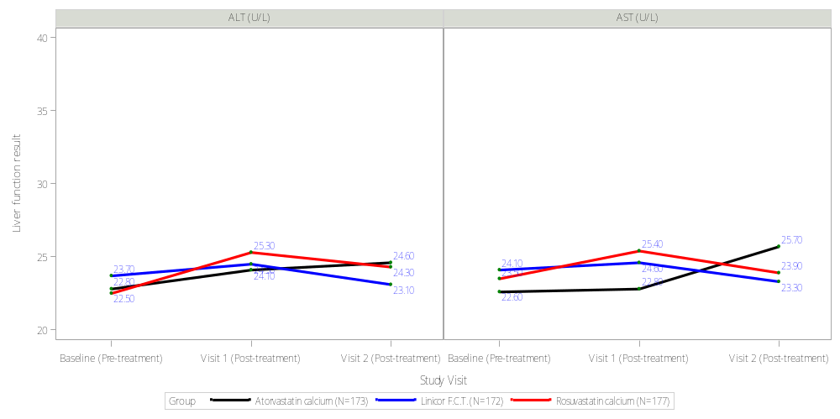
LN-FDC

Supplementary figure 1 Liver Biochemistries (AST, ALT) across baseline, 3 months, and 6 months for different statin treatments, with baseline ALT ≤ 39 U/L (N=522)

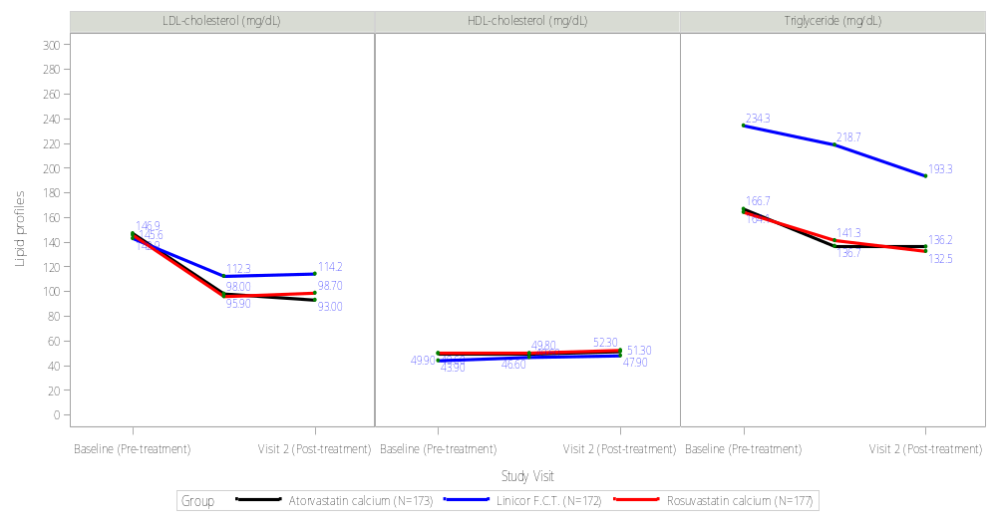

Supplementary figure 2 Live Lipid Profiles (LDL-Cholesterol, HDL-Cholesterol, Triglycerides) across baseline, 3 months, and 6 months for different statin treatments, with baseline ALT ≤ 39 U/L (N=522)

Supplementary table 4. Demographic and baseline characteristics with baseline ALT 40〜59 U/L (N= 103)
Variable | Overall  n =103 | Atorvastatin (atorvastatin calcium) 20 mg/Tab QD  n =35 (33.98%) | LN-FDC (lovastatin–niacin fixed-dose combination)  500/20mg QD  n =36 (34.95%) | Rosuvastatin (rosuvastatin calcium) 10mg/Tab QD  n =32 (31.07%) | P-value
Demographics
Sex
Female | 28 (27.2%) | 8 (22.9%) | 9 (25.0%) | 11 (34.4%) | 0.534
Male | 75 (72.8%) | 27 (77.1%) | 27 (75.0%) | 21 (65.6%)
Age (years)
Mean (S.D.) | 56.7 (12.1) | 56.7 (13.6) | 59.0 (11.1) | 54.1(11.1) | 0.244
≥ 65 | 29 (28.2%) | 10 (28.6%) | 13 (36.1%) | 6 (18.8%) | 0.720
55 – 64 | 28 (27.2%) | 8 (22.9%) | 10 (27.8%) | 10 (31.3%)
45 – 54 | 30 (29.1%) | 10 (28.6%) | 9 (25.0%) | 11 (34.4%)
≤ 44 | 16 (15.5%) | 7 (20.0%) | 4 (11.1%) | 5 (15.6%)
Height (cm), Mean (S.D.) | 164.9 (8.4) | 165.5 (7.7) | 164.6 (9.0) | 164.5 (8.5) | 0.889
Weight (kg), Mean (S.D.) | 75.4 (15.6) | 75.7 (13.3) | 73.3 (17.9) | 77.4 (15.4) | 0.517
BMI (kg/m²), Mean (S.D.) | 27.7 (4.9) | 27.5 (3.9) | 26.8 (5.1) | 28.7 (5.6) | 0.373
Waistline (cm)
<80 | 15 (15.3%) | 4 (12.1%) | 7 (20.6%) | 4 (12.9%) | 0.611
81-90 | 62 (63.3%) | 22 (66.7%) | 18 (52.9%) | 22 (71.0%)
>90 | 21 (21.4%) | 7 (21.2%) | 9 (26.5%) | 5 (16.1%)
Missing | 5 | 2 | 2 | 1
Smoke use
None | 90 (87.4%) | 30 (85.7%) | 32 (88.9%) | 28 (87.5%) | 0.922
Yes | 13 (12.6%) | 5 (14.3%) | 4 (11.1%) | 4 (12.5%)
Alcohol use
None | 87 (84.5%) | 32 (91.4%) | 29 (80.6%) | 26 (81.3%) | 0.374
Yes | 16 (15.5%) | 3 (8.6%) | 7 (19.4%) | 6 (18.8%)
Comorbidities
Type 2 diabetes
None | 25 (24.3%) | 7 (20.0%) | 6 (16.7%) | 12 (37.5%) | 0.104
Yes | 78 (75.7%) | 28 (80.0%) | 30 (83.3%) | 20 (62.5%)
Hypertension
None | 56 (54.4%) | 16 (45.7%) | 22 (61.1%) | 18 (56.3%) | 0.414
Yes | 47 (45.6%) | 19 (54.3%) | 14 (38.9%) | 14 (43.8%)
Hepatitis B
None | 93 (90.3%) | 32 (91.4%) | 30 (83.3%) | 31 (96.9%) | 0.163
Yes | 10 (9.7%) | 3 (8.6%) | 6 (16.7%) | 1 (3.1%)
Hepatitis C
None | 98 (95.1%) | 34 (97.1%) | 34 (94.4%) | 30 (93.8%) | 0.788
Yes | 5 (4.9%) | 1 (2.9%) | 2 (5.6%) | 2 (6.3%)
Liver biochemistries
ALT (U/L)
Mean (S.D.) | 48.3 (6.0) | 47.4 (6.2) | 49.4 (5.6) | 47.9 (6.1) | 0.284
Median [Q1, Q3] | 48.0 [43.0, 54.0] | 47.0 [42.0, 53.0] | 49.0 [46.0, 54.5] | 47.0 [42.5, 54.0]
AST (U/L)
Mean (S.D.) | 34.7 (13.7) | 32.6 (9.0) | 38.2 (20.7) | 34.4 (11.1) | 0.610
Median [Q1, Q3] | 31.0 [28.0, 38.0] | 31.0 [28.0, 34.0] | 31.5 [28.5, 43.5] | 32.5 [27.5, 39.0]
Fatty liver
 |  |  |  |  | 0.356
Mild | 44 (42.7%) | 14 (40.0%) | 21 (58.3%) | 9 (28.1%)
Moderate | 50 (48.5%) | 17 (48.5%) | 13 (36.1%) | 20 (62.5%)
Severe | 9 (8.8%) | 4 (11.5%) | 2 (5.6%) | 3 (9.4%)
Lipid profiles
LDL-cholesterol (mg/dL)
Mean (S.D.) | 138.4 (45.8) | 137.3 (46.8) | 146.0 (44.5) | 130.4 (46.5) | 0.283
Median [Q1, Q3] | 142.1 [102.2, 172.3] | 142.1 [109.6, 178.1] | 162.4 [108.4, 176.4] | 127.2 [87.0, 160.0]
HDL-cholesterol (mg/dL)
Mean (S.D.) | 46.7 (12.4) | 47.8 (8.7) | 43.0 (18.1) | 47.1 (12.8) | 0.562
Median [Q1, Q3] | 46.5 [37.6, 53.3] | 47.3 [41.1, 52.7] | 36.3 [30.0, 52.6] | 46.5 [36.9, 54.5]
Triglyceride (mg/dL)
Mean (S.D.) | 203.9 (124.7) | 203.4 (128.2) | 211.5 (131.1) | 194.5 (116.3) | 0.767
Median [Q1, Q3] | 163.0 [119.0, 245.0] | 160.0 [111.5, 246.0] | 181.0 [143.0, 244.0] | 156.0 [109.0, 258.5]

Supplementary table 5. Key secondary and secondary endpoints (mITT population) with baseline ALT 40〜59 U/L (N=103)
Variable | Atorvastatin (atorvastatin calcium) 20 mg/Tab QD  (n =230) |  |  |  |  | LN-FDC (lovastatin–niacin fixed-dose combination) 500/20mg QD  (n =248) |  |  |  |  | Rosuvastatin (rosuvastatin calcium) 10mg/Tab QD  (n =191) |  |  |  |  | P value  Change from baseline between groups
Variable | Mean  (S.D.) | CFB  (S.D.) | CFB  P value |  |  |  | Mean  (S.D.) | CFB  (S.D.) | CFB  P value |  | Mean  (S.D.) | CFB  (S.D.) | CFB  P value |  | Among  3 groups |  | Atorvastatin VS.  LN-FDC | LN-FDC  VS. Rosuvastatin | Rosuvastatin VS.  Atorvastatin
Liver biochemistries
AST (GOT) (U/L)
n = 91 | 35 | --- | --- |  |  |  | 24 | --- | --- |  | 32 | --- | ---
Baseline, mean  (S.D.) | 32.6(9.0) | --- | --- |  |  |  | 38.2(20.7) | --- | --- |  | 34.4(11.1) | --- | --- |  | 0.610 |  | >0.999 | >0.999 | >0.999
3 months | 25.4(7.2) | -7.2(9.8) | <0.001* |  |  |  | 34.6(14.8) | -2.6(23.4) | 0.598 |  | 32.8(29.3) | -1.6(30.3) | 0.768 |  | 0.122 |  | 0.122 | 0.730 | >0.999
6 months | 23.6(8.2) | -9.0(11.8) | <0.001* |  |  |  | 25.6(8.0) | -10.0(19.2) | 0.027* |  | 25.1(8.4) | -9.3(13.6) | <0.001* |  | 0.717 |  | >0.999 | >0.999 | >0.999
ALT (GPT) (U/L)
n = 103 | 35 | --- | --- |  |  |  | 36 | --- | --- |  | 32 | --- | ---
Baseline, mean  (S.D.) | 47.4(6.2) | --- | --- |  |  |  | 49.4(5.6) | --- | --- |  | 47.9(6.1) | --- | --- |  | 0.284 |  | 0.391 | 0.783 | >0.999
3 months | 36.5(13.4) | 3.9(18.0) | 0.212 |  |  |  | 42.4(19.3) | 9.3(32.6) | 0.175 |  | 46.4(49.6) | 12.0(50.1) | 0.185 |  | 0.311 |  | 0.428 | 0.716 | >0.999
6 months | 33.9(17.9) | 1.3(22.9) | 0.735 |  |  |  | 33.5(13.4) | 0.0(25.1) | >0.999 |  | 35.5(15.4) | 1.1(20.3) | 0.755 |  | 0.875 |  | >0.999 | >0.999 | >0.999
Lipid profiles
LDL-cholesterol
(mg/dL)
n = 85 | 29 | --- | --- |  |  |  | 31 | --- | --- |  | 25 | --- | ---
Baseline, mean  (S.D.) | 137.3(46.8) | --- | --- |  |  |  | 146.0(44.5) | --- | --- |  | 130.4(46.5) | --- | --- |  | 0.283 |  | >0.999 | 0.3459 | >0.999
3 months | 91.8(33.1) | -40.9(45.6) | <0.001* |  |  |  | 107.8(33.2) | -33.6(39.0) | <0.001* |  | 105.5(36.0) | -28.7(58.8) | 0.028* |  | 0.670 |  | >0.999 | >0.999 | >0.999
6 months | 95.1(22.7) | -39.1(41.9) | <0.001* |  |  |  | 97.2(27.1) | -45.3(38.7) | <0.001* |  | 103.6(37.7) | -20.0(44.1) | 0.050 |  | 0.107 |  | >0.999 | 0.119 | 0.382
HDL-cholesterol
(mg/dL)
n = 60 | 24 | --- | --- |  |  |  | 11 | --- | --- |  | 25 | --- | ---
Baseline, mean  (S.D.) | 47.8(8.7) | --- | --- |  |  |  | 43.0(18.1) | --- | --- |  | 47.1(12.8) | --- | --- |  | 0.562 |  | 0.891 | >0.999 | >0.999
3 months | 44.8(7.5) | -1.4(6.5) | 0.363 |  |  |  | 43.1(14.4) | 0.0(8.7) | 0.994 |  | 47.0(12.8) | -0.6(5.5) | 0.624 |  | 0.845 |  | >0.999 | >0.999 | >0.999
6 months | 47.7(11.8) | -0.1(8.9) | 0.962 |  |  |  | 49.3(19.4) | 4.1(9.1) | 0.215 |  | 48.9(14.4) | 1.7(7.0) | 0.313 |  | 0.447 |  | 0.636 | >0.999 | >0.999
Triglyceride (mg/dL)
n = 83 | 28 | --- | --- |  |  |  | 31 | --- | --- |  | 24 | --- | ---
Baseline, mean  (S.D.) | 203.4(128.2) | --- | --- |  |  |  | 211.5(131.1) | --- | --- |  | 194.5(116.3) | --- | --- |  | 0.767 |  | >0.999 | >0.999 | >0.999
3 months | 131.2(71.4) | -67.5(133.8) | 0.027* |  |  |  | 217.3(175.6) | -21.8(84.9) | 0.177 |  | 176.0(117.4) | -22.1(104.1) | 0.341 |  | 0.712 |  | >0.999 | >0.999 | >0.999
6 months | 156.6(86.0) | -18.6(119.3) | 0.472 |  |  |  | 206.0(256.8) | -33.9(66.8) | 0.015* |  | 178.4(127.6) | 3.8(114.4) | 0.890 |  | 0.475 |  | >0.999 | 0.673 | >0.999
Laboratory data
Fasting blood sugar
(mg/dL)
n = 56 | 19 | --- | --- |  |  |  | 17 | --- | --- |  | 20 | --- | ---
Baseline, Mean  (S.D.) | 6.6(1.1) | --- | --- |  |  |  | 6.6(1.0) | --- | --- |  | 6.6(1.3) | --- | --- |  | 0.903 |  | >0.999 | >0.999 | >0.999
3 months | 6.3(0.7) | -0.2(0.8) | 0.207 |  |  |  | 6.5(0.8) | -0.1(0.6) | 0.718 |  | 6.2(0.9) | -0.3(1.2) | 0.209 |  | 0.542 |  | >0.999 | 0.838 | >0.999
Glycated
hemoglobin (%)
n = 77 | 27 | --- | --- |  |  |  | 27 | --- | --- |  | 23 | --- | ---
Baseline, Mean  (S.D.) | 111.9(22.2) | --- | --- |  |  |  | 126.0(38.3) | --- | --- |  | 108.8(20.9) | --- | --- |  | 0.422 |  | 0.097 | >0.999
3 months | 117.0(38.8) | 4.3(37.2) | 0.550 |  |  |  | 117.0(20.5) | -9.1(28.9) | 0.113 |  | 113.0(32.5) | 3.7(25.1) | 0.511 |  | >0.999 |  | >0.999 | >0.999
Note: HDL-C, high-density lipoprotein cholesterol; LDL-C, low-density lipoprotein cholesterol; LN-FDC: lovastatin–niacin fixed-dose combination; Atorvastatin: Atorvastatin calcium, Rosuvastatin: Rosuvastatin Mylan.

Supplementary table 6. Liver biochemistry and lipid profiles from baseline to 3 and 6 months of treatment, with baseline ALT 40〜59 U/L (N=103)
Characteristics | ALT (U/L) |  |  |  | AST (U/L) |  |  |  | Fasting blood sugar (mg/dL) |  |  |  | HbA1C (a) (mg/dL)
Characteristics | Estimate | Standard error | P value |  | Estimate | Standard error | P value |  | Estimate | Standard error | P value |  | Estimate |  | Standard error |  | P value
Drug (reference: Rosuvastatin Myla)
LN-FDC | 1.59 | 7.15 | 0.825 |  | 5.18 | 5.51 | 0.350 |  | -0.60 | 0.50 | 0.232 |  | 29.35 |  | 14.74 |  | 0.050*
Atorvastatin calcium | -3.14 | 7.18 | 0.663 |  | -3.42 | 5.05 | 0.500 |  | -0.32 | 0.48 | 0.510 |  | -0.87 |  | 14.75 |  | 0.953
Time
 | -6.17 | 2.31 | 0.008* |  | -4.66 | 1.61 | 0.004* |  | -0.43 | 0.20 | 0.040* |  | 3.94 |  | 6.48 |  | 0.545
Drug* Time
LN-FDC * Time | -1.82 | 3.19 | 0.568 |  | -1.55 | 2.39 | 0.517 |  | 0.29 | 0.30 | 0.342 |  | -13.36 |  | 8.66 |  | 0.127
Atorvastatin calcium * Time | -0.54 | 3.20 | 0.865 |  | 0.16 | 2.23 | 0.944 |  | 0.05 | 0.28 | 0.857 |  | 0.96 |  | 8.60 |  | 0.911
Type 2 diabetes (reference=No)
 | 2.27 | 3.10 | 0.467 |  | -1.59 | 2.28 | 0.488 |  | 1.07 | 0.16 | <0.001* |  | 11.92 |  | 6.53 |  | 0.072
Hypertension (reference=No)
 | -1.66 | 2.64 | 0.530 |  | -1.49 | 1.94 | 0.445 |  | 0.37 | 0.15 | 0.017* |  | 13.13 |  | 5.41 |  | 0.017*
Characteristics | LDL-cholesterol (mg/dL) |  |  |  | HDL-cholesterol (mg/dL) |  |  |  | Triglyceride (mg/dL)
Characteristics | Estimate | Standard error | P value |  | Estimate | Standard error | P value |  | Estimate | Standard error | P value
Drug (reference: Rosuvastatin Myla)
LN-FDC | 22.07 | 13.68 | 0.110 |  | -5.91 | 4.93 | 0.235 |  | 51.35 | 46.88 | 0.276
Atorvastatin calcium | 8.32 | 13.93 | 0.552 |  | 2.47 | 3.87 | 0.526 |  | 5.49 | 47.74 | 0.909
Time
 | -12.82 | 4.30 | 0.003* |  | 0.64 | 0.82 | 0.440 |  | -4.87 | 11.63 | 0.676
Drug* Time
LN-FDC * Time | -10.72 | 5.76 | 0.065 |  | 1.76 | 1.46 | 0.231 |  | -8.85 | 15.26 | 0.563
Atorvastatin calcium * Time | -7.50 | 5.93 | 0.208 |  | -0.54 | 1.16 | 0.643 |  | -11.76 | 15.82 | 0.458
Type 2 diabetes (reference=No)
 | 11.46 | 6.90 | 0.100 |  | -3.61 | 2.98 | 0.230 |  | 29.67 | 34.17 | 0.387
Hypertension (reference=No)
 | -2.01 | 5.98 | 0.738 |  | -0.64 | 2.84 | 0.822 |  | -2.13 | 29.31 | 0.942
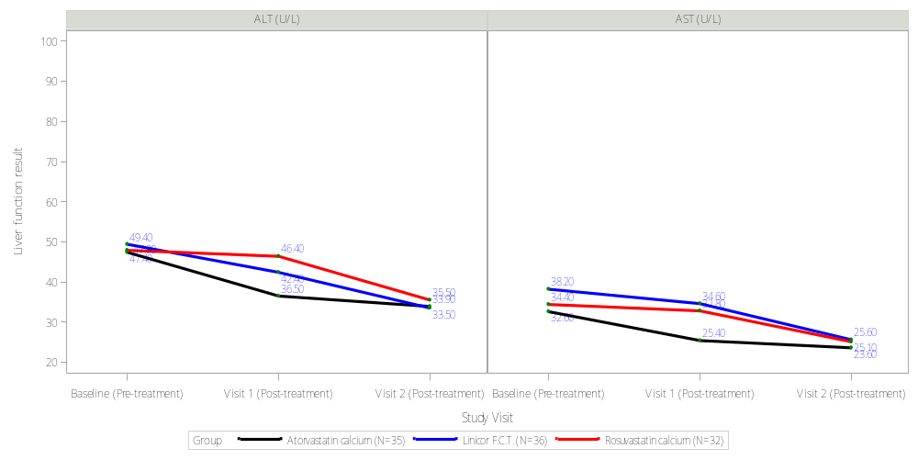

Supplementary figure 3. Liver Biochemistries (AST, ALT) across baseline, 3 months, and 6 months for different statin treatments,

with baseline ALT 40〜59 U/L (N=103)

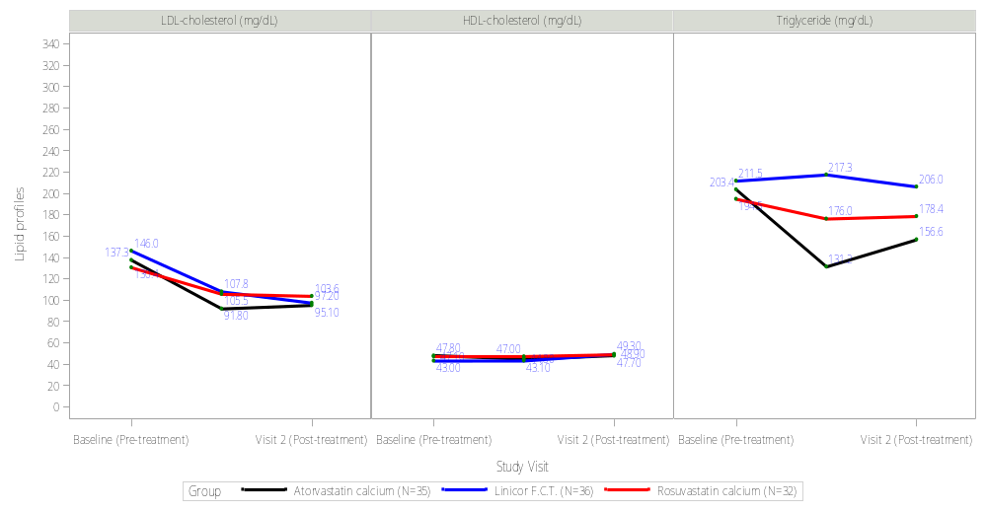

Supplementary figure 4. Live Lipid Profiles (LDL-Cholesterol, HDL-Cholesterol, Triglycerides) across baseline, 3 months, and 6 months for different statin treatments, with baseline ALT 40〜59 U/L (N=103).

Supplementary table 7. Demographic and baseline characteristics with baseline ALT ≥ 60 U/L (N= 104)
Variable | Overall  n =104 | Atorvastatin (atorvastatin calcium) 20 mg/Tab QD  n =173 (33.14%) | LN-FDC (lovastatin–niacin fixed-dose combination) 500/20mg QD  n =172 (32.95%) | Rosuvastatin (rosuvastatin calcium) 10mg/Tab QD  n =177 (33.91%) | P-value
Demographics
Sex
Female | 29 (27.9%) | 10 (28.6%) | 8 (22.9%) | 11 (32.4%) | 0.675
Male | 75 (72.1%) | 25 (71.4%) | 27 (77.1%) | 23 (67.6%)
Age (years)
Mean (S.D.) | 54.6 (13.8) | 55.8 (13.9) | 54.9 (14.5) | 53.2 (13.2) | 0.735
≥ 65 | 30 (28.8%) | 11 (31.4%) | 12 (34.3%) | 7 (20.6%) | 0.718
55 – 64 | 25 (24.0%) | 9 (25.7%) | 6 (17.1%) | 10 (29.4%)
45 – 54 | 22 (21.2%) | 8 (22.9%) | 8 (22.9%) | 6 (17.6%)
≤ 44 | 27 (26.0%) | 7 (20.0%) | 9 (25.7%) | 11 (32.4%)
Height (cm), Mean (S.D.) | 165.9 (8.9) | 168.1 (9.5) | 164.0 (8.6) | 165.4(8.3) | 0.153
Weight (kg), Mean (S.D.) | 75.1 (16.0) | 76.5 (19.1) | 73.7 (14.7) | 75.1(14.2) | 0.779
BMI (kg/m²), Mean (S.D.) | 27.2 (4.8) | 26.9 (5.6) | 27.3 (4.3) | 27.4(4.5) | 0.616
Waistline (cm)
<80 | 22 (22.2%) | 7 (20.6%) | 7 (21.9%) | 8 (24.2%) | 0.911
81-90 | 58 (58.6%) | 22 (64.7%) | 18 (56.3%) | 18 (54.5%)
>90 | 19 (19.2%) | 5 (14.7%) | 7 (21.9%) | 7 (21.2%)
Missing | 5 | 1 | 3 | 1
Smoke use
None | 88 (84.6%) | 28 (80.0%) | 29 (82.9%) | 31 (91.2%) | 0.411
Yes | 16 (15.4%) | 7 (20.0%) | 6 (17.1%) | 3 (8.8%)
Alcohol use |  |  |  |  | 0.221
None | 77 (74.0%) | 25 (71.4%) | 27 (77.1%) | 25 (73.5%)
Yes | 27 (26.0%) | 10 (28.6%) | 8 (22.9%) | 9 (26.5%)
Comorbidities
Type 2 diabetes
None | 25 (24.0%) | 7 (20.0%) | 7 (20.0%) | 13 (38.2%) | 0.053
Yes | 79 (76.0%) | 28 (80.0%) | 28 (80.0%) | 21 (61.8%)
Hypertension
None | 64 (61.5%) | 23 (65.7%) | 26 (74.3%) | 15 (44.1%) | 0.030*
Yes | 40 (38.5%) | 12 (34.3%) | 9 (25.7%) | 19 (55.9%)
Hepatitis B
None | 93 (89.4%) | 31 (88.6%) | 32 (91.4%) | 30 (88.2%) | 0.893
Yes | 11 (10.6%) | 4 (11.4%) | 3 (8.6%) | 4 (11.8%)
Hepatitis C
None | 102 (98.1%) | 35 (100.0%) | 35 (100.0%) | 32 (94.1%) | 0.123
Yes | 2 (1.9%) | 0 (0.0%) | 0 (0.0%) | 2 (5.9%)
Liver biochemistries
ALT (U/L)
Mean (S.D.) | 92.8 (26.9) | 95.9 (26.0) | 93.2 (28.0) | 89.2 (27.0) | 0.283
Median [Q1, Q3] | 85.0 [73.5, 107.0] | 88.0 [78.0, 105.0] | 85.0 [72.0, 110.0] | 78.0 [68.0, 106.0]
AST (U/L)
Mean (S.D.) | 56.1 (23.7) | 57.5 (25.8) | 56.3 (21.6) | 54.4 (23.7) | 0.704
Median [Q1, Q3] | 49.0 [41.0, 62.0] | 49.0 [40.0, 67.0] | 53.0 [43.0, 59.5] | 45.5 [39.0, 63.0]
Fatty liver
Mild | 43 (41.3%) | 14 (40.0%) | 21 (60.0%) | 8 (23.5%) | 0.324
Moderate | 51 (49.0%) | 17 (48.5%) | 11 (31.4%) | 23 (67.6%)
Severe | 10 (9.7%) | 4 (11.5%) | 3 (8.6%) | 3 (8.9%)
Lipid profiles
LDL-cholesterol (mg/dL)
Mean (S.D.) | 153.0 (47.6) | 172.5 (38.4) | 143.6 (53.8) | 148.0 (43.7) | 0.072
Median [Q1, Q3] | 161.1 [129.0, 186.3] | 177.0 [145.6, 187.7] | 144.0 [108.0, 186.9] | 150.0 [122.4, 175.7]
HDL-cholesterol (mg/dL)
Mean (S.D.) | 45.1 (8.7) | 50.1 (9.3) | 42.0 (7.8) | 42.8 (6.8) | 0.002*
Median [Q1, Q3] | 44.1 [39.0, 50.9] | 51.8 [42.5, 55.0] | 41.6 [37.4, 48.4] | 44.2 [39.8, 47.1]
Triglyceride (mg/dL)
Mean (S.D.) | 244.3 (240.0) | 181.5 (64.4) | 329.7 (364.0) | 199.0 (77.0) | 0.074

Supplementary table 8. Key secondary and secondary endpoints (mITT population) with baseline ALT ≥ 60 U/L (N=104)
Variable | Atorvastatin (atorvastatin calcium) 20 mg/Tab QD  (n =230) |  |  |  | LN-FDC (lovastatin–niacin fixed-dose combination) 500/20mg QD  (n =248) |  |  |  | Rosuvastatin (rosuvastatin calcium) 10mg/Tab QD  (n =191) |  |  |  | P value  Change from baseline between groups
Variable | Mean  (S.D.) | CFB  (S.D.) | CFB  P value |  | Mean  (S.D.) | CFB  (S.D.) | CFB  P value |  | Mean  (S.D.) | CFB  (S.D.) | CFB  P value |  | Among  3 groups | Atorvastatin VS.  LN-FDC | LN-FDC  VS. Rosuvastatin | Rosuvastatin VS.  Atorvastatin
Liver biochemistries
AST (GOT) (U/L) | 35 | --- | --- |  | 28 | --- | --- |  | 34 | --- | ---
n = 97 | 57.5(25.8) | --- | --- |  | 56.3(21.6) | --- | --- |  | 54.4(23.7) | --- | --- |  | 0.704 | >0.999 | >0.999 | >0.999
Baseline, mean  (S.D.) | 47.6(26.0) | -9.9(19.7) | 0.005* |  | 39.0(13.4) | -16.9(27.2) | 0.004* |  | 49.3(31.0) | -5.1(19.8) | 0.143 |  | 0.352 | >0.999 | 0.468 | >0.999
3 months | 64.1(174.0) | 6.6(168.8) | 0.819 |  | 30.1(10.8) | -24.9(23.1) | <0.001* |  | 36.0(21.6) | -18.4(30.4) | 0.001* |  | 0.465 | >0.999 | 0.695 | >0.999
6 months
ALT (GPT) (U/L)
n = 104 | 35 | --- | --- |  | 35 | --- | --- |  | 34 | --- | ---
Baseline, mean  (S.D.) | 95.9(26.0) | --- | --- |  | 93.2(28.0) | --- | --- |  | 89.2(27.0) | --- | --- |  | 0.283 | >0.999 | >0.999 | 0.346
3 months | 73.3(35.2) | 15.7(37.3) | 0.017* |  | 68.5(35.8) | 17.7(49.4) | 0.073 |  | 73.9(34.5) | 19.4(30.2) | <0.001* |  | 0.924 | >0.999 | >0.999 | >0.999
6 months | 67.6(96.8) | 10.1(93.4) | 0.528 |  | 46.5(26.9) | -5.5(40.0) | 0.473 |  | 54.0(40.6) | -0.4(49.2) | 0.964 |  | 0.908 | >0.999 | >0.999 | >0.999
Lipid profiles
LDL-cholesterol
(mg/dL)
n = 81 | 22 | --- | --- |  | 31 | --- | --- |  | 28 | --- | ---
Baseline, mean  (S.D.) | 172.5(38.4) | --- | --- |  | 143.6(53.8) | --- | --- |  | 148.0(43.7) | --- | --- |  | 0.072 | 0.087 | >0.999 | 0.206
3 months | 103.3(32.4) | -56.5(42.3) | <0.001* |  | 108.8(35.2) | -33.3(46.3) | <0.001* |  | 85.8(31.0) | -47.6(34.7) | <0.001* |  | 0.200 | 0.225 | >0.999 | 0.989
6 months | 102.0(39.1) | -67.5(45.5) | <0.001* |  | 115.2(28.7) | -27.3(52.7) | 0.010* |  | 94.5(31.1) | -45.1(48.3) | <0.001* |  | 0.029* | 0.024* | 0.673 | 0.486
HDL-cholesterol
(mg/dL)
n = 63 | 22 | --- | --- |  | 15 | --- | --- |  | 26 | --- | ---
Baseline, mean  (S.D.) | 50.1(9.3) | --- | --- |  | 42.0(7.8) | --- | --- |  | 42.8(6.8) | --- | --- |  | 0.002* | 0.011* | >0.999 | 0.007*
3 months | 46.6(7.4) | -1.7(6.3) | 0.288 |  | 42.8(10.0) | 0.9(6.6) | 0.602 |  | 42.1(6.4) | -0.1(5.4) | 0.932 |  | 0.480 | 0.704 | >0.999 | >0.999
6 months | 47.6(11.5) | 0.3(6.8) | 0.875 |  | 45.4(6.7) | 4.6(8.3) | 0.111 |  | 43.8(8.9) | 1.9(6.3) | 0.279 |  | 0.309 | 0.384 | >0.999 | >0.999
Triglyceride (mg/dL)
n = 86 | 24 | --- | --- |  | 33 | --- | --- |  | 29 | --- | ---
Baseline, mean  (S.D.) | 181.5(64.4) | --- | --- |  | 329.7(364.0) | --- | --- |  | 199.0(77.0) | --- | --- |  | 0.074 | 0.084 | 0.365 | >0.999
3 months | 152.6(58.8) | -30.8(67.3) | 0.061 |  | 242.4(225.8) | -84.8(221.5) | 0.035* |  | 190.7(75.3) | -22.9(88.7) | 0.263 |  | 0.793 | >0.999 | >0.999 | >0.999
6 months | 158.3(51.3) | -12.8(52.5) | 0.300 |  | 187.2(93.1) | -141(361.6) | 0.040* |  | 184.4(77.3) | -26.0(93.4) | 0.229 |  | 0.590 | 0.989 | >0.999 | >0.999
Laboratory data
Fasting blood sugar
(mg/dL)
n = 54 | 17 | --- | --- |  | 12 | --- | --- |  | 25 | --- | ---
Baseline, Mean  (S.D.) | 6.4(0.6) | --- | --- |  | 6.4(1.0) | --- | --- |  | 6.8(1.6) | --- | --- |  | 0.619 | >0.999 | >0.999 | >0.999
3 months | 6.5(0.9) | 0.1(0.6) | 0.574 |  | 6.5(1.3) | 0.3(1.0) | 0.2772 |  | 6.4(1.4) | -0.4(1.0) | 0.107 |  | 0.470 | >0.999 | 0.736 | >0.999
Glycated
hemoglobin (%)
n = 79 | 26 | --- | --- |  | 28 | --- | --- |  | 25 | --- | ---
Baseline, Mean  (S.D.) | 125.9(38.5) | --- | --- |  | 109.5(18.1) | --- | --- |  | 126.0(52.7) | --- | --- |  | 0.279 | 0.404 | 0.713 | >0.999
3 months | 131.7(50.0) | 5.0(59.6) | 0.697 |  | 109.2(28.1) | -1.4(26.9) | 0.7912 |  | 116.8(45.1) | -10.0(20.2) | 0.023* |  | 0.523 | >0.999 | >0.999 | 0.870
Note: HDL-C, high-density lipoprotein cholesterol; LDL-C, low-density lipoprotein cholesterol; LN-FDC: lovastatin–niacin fixed-dose combination; Atorvastatin: Atorvastatin calcium, Rosuvastatin: Rosuvastatin Mylan.

Supplementary table 9. Liver biochemistry and lipid profiles from baseline to 3 and 6 months of treatment, with baseline ALT ≥ 60 U/L (N=104)
Characteristics | ALT (U/L) |  |  |  | AST (U/L) |  |  |  | Fasting blood sugar (mg/dL) |  |  |  | HbA1C (a) (mg/dL)
Characteristics | Estimate | Standard error | P value |  | Estimate | Standard error | P value |  | Estimate | Standard error | P value |  | Estimate |  | Standard error |  | P value
Drug (reference: Rosuvastatin Myla)
LN-FDC | 7.05 | 15.35 | 0.647 |  | 1.74 | 23.54 | 0.941 |  | -0.97 | 0.58 | 0.101 |  | -27.32 |  | 17.98 |  | 0.132
Atorvastatin calcium | -2.14 | 15.32 | 0.889 |  | -15.77 | 22.39 | 0.483 |  | -1.06 | 0.52 | 0.047* |  | -20.82 |  | 18.42 |  | 0.262
Time
 | -17.57 | 4.79 | <0.001* |  | -9.22 | 7.15 | 0.199 |  | -0.37 | 0.19 | 0.052 |  | -9.54 |  | 7.52 |  | 0.208
Drug* Time
LN-FDC * Time | -5.78 | 6.72 | 0.390 |  | -3.76 | 10.45 | 0.719 |  | 0.58 | 0.32 | 0.077 |  | 8.48 |  | 10.21 |  | 0.409
Atorvastatin calcium * Time | 3.42 | 6.72 | 0.612 |  | 12.51 | 10.04 | 0.214 |  | 0.41 | 0.29 | 0.166 |  | 15.18 |  | 10.64 |  | 0.158
Type 2 diabetes (reference=No)
 | 7.86 | 7.26 | 0.281 |  | -0.20 | 10.02 | 0.984 |  | 1.28 | 0.25 | <0.001* |  | 25.07 |  | 9.24 |  | 0.008*
Hypertension (reference=No)
 | -0.02 | 6.39 | 0.998 |  | -3.06 | 8.78 | 0.728 |  | 0.46 | 0.24 | 0.064 |  | 9.46 |  | 8.19 |  | 0.251
Characteristics | LDL-cholesterol (mg/dL) |  |  |  | HDL-cholesterol (mg/dL) |  |  |  | Triglyceride (mg/dL)
Characteristics | Estimate | Standard error | P value |  | Estimate | Standard error | P value |  | Estimate | Standard error | P value
Drug (reference: Rosuvastatin Myla)
LN-FDC | -16.46 | 14.43 | 0.257 |  | -2.38 | 3.23 | 0.465 |  | 188.93 | 57.84 | 0.002*
Atorvastatin calcium | 23.78 | 15.50 | 0.128 |  | 8.43 | 2.84 | 0.004* |  | -23.74 | 62.02 | 0.703
Time
 | -25.26 | 4.56 | <0.001* |  | 0.96 | 0.78 | 0.221 |  | -9.35 | 18.52 | 0.614
Drug* Time
LN-FDC * Time | 11.02 | 6.11 | 0.073 |  | 1.47 | 1.23 | 0.233 |  | -60.52 | 24.53 | 0.015*
Atorvastatin calcium * Time | -7.99 | 6.57 | 0.226 |  | -1.17 | 1.07 | 0.277 |  | -0.83 | 26.61 | 0.975
Type 2 diabetes (reference=No)
 | 13.43 | 7.93 | 0.094 |  | -5.43 | 1.97 | 0.008* |  | 44.43 | 33.42 | 0.187
Hypertension (reference=No)
 | -5.44 | 7.05 | 0.443 |  | -1.30 | 1.86 | 0.487 |  | 35.05 | 29.56 | 0.239
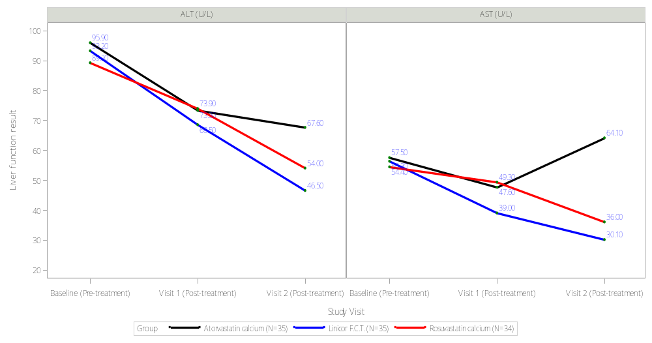

Supplementary figure 5. Liver biochemistries (AST, ALT) across baseline, 3 months, and 6 months for different statin treatments,

with baseline ALT ≥ 60 U/L (N=104)

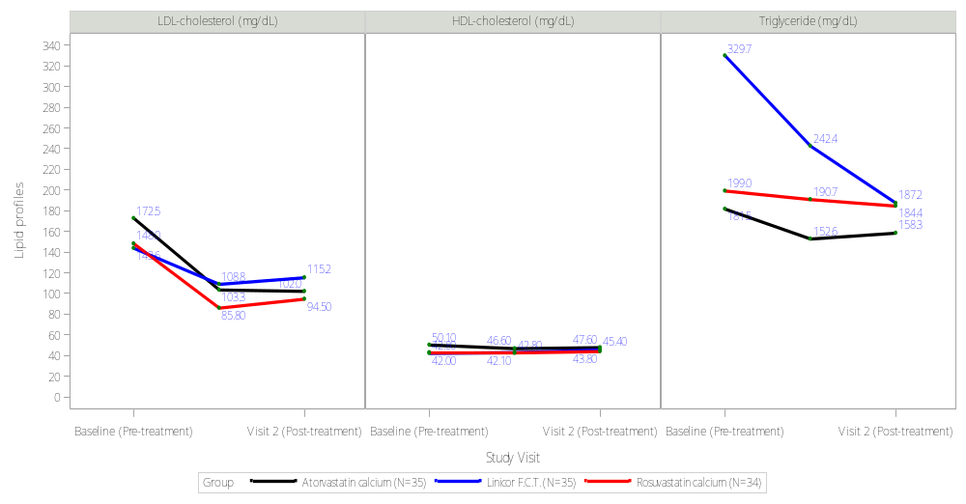

Supplementary figure 6. Live lipid profiles (LDL-Cholesterol, HDL-Cholesterol, Triglycerides) Across Baseline, 3 Months, and 6 Months for Different Statin Treatments, with baseline ALT ≥ 60 U/L (N=104)

Supplementary table 10. Three-month cost analysis, ALT control efficacy, and cost-effectiveness ratios of different statin treatments
Characteristics | Atorvastatin (atorvastatin calcium) 20 mg/Tab QD (n =242) |  | LN-FDC (lovastatin–niacin fixed-dose combination) 500/20mg QD  (n =233) |  | Rosuvastatin (rosuvastatin calcium) 10mg/Tab QD  (n =241) |  | P value
3-Month medication cost
Medication (NTD)-median [Q1, Q3] | 3249 [1663, 5802] |  | 2429 [1138, 4243] |  | 2672 [1431, 5418]
Pharmaceutical service fee (NTD)-median [Q1, Q3] | 760 [422, 1328] |  | 773 [348, 1336] |  | 950 [428, 1886]
Total cost (NTD)-median [Q1, Q3] | 4265 [2241, 7630] |  | 3293 [1566, 5803] |  | 4245 [1952, 7506]
ALT control efficacy at 3 months |  |  |  |  |  |  | 0.781
ALT < 40 (success) - N (%) | 201 (83.06) |  | 199 (85.41) |  | 203 (84.23)
ALT ≥ 40 (failure) - N (%) | 41 (16.94) |  | 34 (14.59) |  | 38 (15.77)
Cost-effectiveness analysis (reference: Atorvastatin calcium)
Median cost (C) (NTD) | 4265 |  | 3293 |  | 4245
Effectiveness (E) (success rate) | 0.83 |  | 0.85 |  | 0.84
Cost-effectiveness ratio (CER = C/E) (NTD) | 5139 |  | 3874 |  | 5054
Incremental cost-effectiveness
Cost difference (∆C=C_{a}-C_{b}) (NTD) | reference |  | -972 |  | -20
Effectiveness difference (∆E=E_{a}-E_{b}) | reference |  | 0.02 |  | 0.01
Incremental cost-effectiveness ratio (ICER=∆C/∆E) (NTD) | reference |  | -48,600 |  | -2,000
Note: using September 2024 as the base period, adjusted for the price index, NTD- New Taiwan Dollars.

Supplementary table 11. Comparative effects of Linicor, Atorvastatin, and Rosuvastatin on HbA1c reduction and glycemic response in MASLD patients (N=729)
Variable | Overall  n =729 | Atorvastatin (atorvastatin calcium) 20 mg/Tab QD  n =243 (33.33%) | LN-FDC (lovastatin–niacin fixed-dose combination)  500/20mg QD  n =243 (33.33%) | Rosuvastatin (rosuvastatin calcium) 10mg/Tab QD  n =243 (33.33%) | P-value
HbA1C (%)
Baseline (Pre-treatment)
N | 367 | 140 | 82 | 145
Mean (S.D.) | 6.5(1.2) | 6.4(1.2) | 6.6(1.1) | 6.5(1.2) | 0.177
Median | 6.2 | 6.1 | 6.4 | 6.2
Range [Min, Max] | 8.3 [4.6, 12.9) | 7.7 (5.2, 12.9) | 6.3 (5.3, 11.6) | 6.7 (4.6, 11.3)
IQR [Q1, Q3] | 1.2 [5.7, 6.9) | 1.2 (5.7, 6.9) | 1.2 (5.8, 7.0) | 1.0 (5.8, 6.8)
95% CI | 6.40, 6.64 | (6.25, 6.65) | (6.39, 6.88) | (6.33, 6.73)
Pair-wise comparisons |  | Atorvastatin VS.  LN-FDC | LN-FDC VS.  Rosuvastatin | Rosuvastatin VS. Atorvastatin
P-value |  | 0.199 | 0.495 | >0.999
Visit 1 (post-treatment)
N | 446 | 175 | 116 | 155
Mean (S.D.) | 6.5(1.1) | 6.4(1.0) | 6.6(1.0) | 6.5(1.3) | 0.148
Median | 6.2 | 6.2 | 6.3 | 6.1
Range [Min, Max] | 8.4 [4.8, 13.2] | 8.4 [4.8, 13.2] | 5.1 [5.2, 10.3] | 8.1 [4.9, 13.0]
IQR [Q1, Q3] | 1.0 [5.8, 6.8] | 1.0 [5.8, 6.8] | 1.2 [5.9, 7.1] | 0.9 [5.8, 6.7]
95% CI | 6.40, 6.61 | 6.28, 6.59 | 6.42, 6.78 | 6.31, 6.71
Pair-wise comparisons |  | Atorvastatin VS.  LN-FDC | LN-FDC VS.  Rosuvastatin | Rosuvastatin VS. Atorvastatin
P-value |  | 0.295 | 0.210 | >0.999
Change from baseline in HbA1C (Visit 1- baseline)
N | 347 | 126 | 80 | 141
Mean (S.D.) | 0.0(0.9) | 0.0(0.8) | 0.1(0.8) | 0.0(1.0) | 0.597
Median | 0.1 | 0.1 | 0.1 | 0.1
Range [Min, Max] | 9.8 [-4.0, 5.8] | 6.4 [-4.0, 2.4] | 6.8 [-3.3, 3.5] | 9.7 [-3.9, 5.8]
IQR [Q1, Q3] | 0.5 [-0.2, 0.3] | 0.5 [-0.2, 0.3] | 0.5 [-0.2, 0.3] | 0.7 [-0.3, 0.4]
95% CI | -0.07, 0.12 | -0.18, 0.10 | -0.09, 0.27 | -0.13, 0.21
Pair-wise comparisons |  | Atorvastatin VS.  LN-FDC | LN-FDC VS.  Rosuvastatin | Rosuvastatin VS. Atorvastatin
P-value |  | 0.935 | >0.999 | >0.999
Target Response: Achieved 0.5% Increase in HbA1c
Target Response Achieved 0.5% Increase in HbA1c at 3 Months
Responders (Achieved 30% Decline) | 58 (8.0%) | 20 (8.2%) | 12 (4.9%) | 26 (10.7%) | 0.063
Non-Responders | 671 (92.0%) | 223 (91.8%) | 231 (95.1%) | 217 (89.3%)

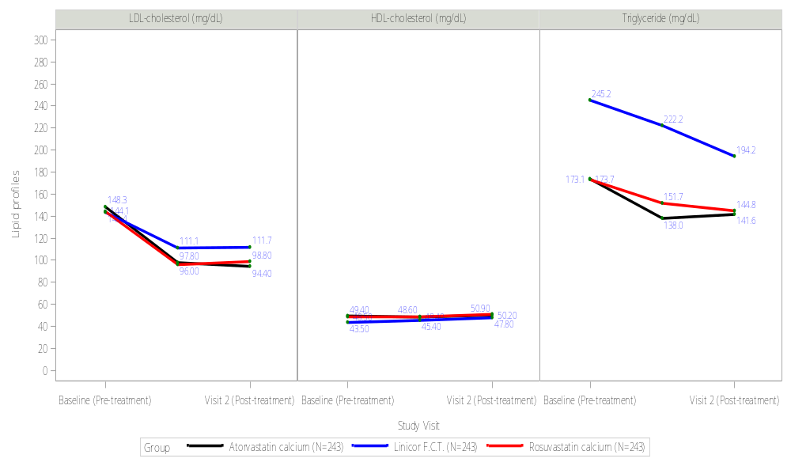
Supplementary figure 7. Live lipid profiles (LDL-Cholesterol, HDL-Cholesterol, Triglycerides) across baseline, 3 months, and 6 months for different statin treatments (N=729)

Supplementary Table 12. Time-dependent changes in liver biochemistry and lipid profiles from baseline to 3 and 6 months after treatment initiation among patients without type 2 diabetes mellitus (non-DM subgroup; n = 178), adjusted for hypertension, baseline HDL-cholesterol, and triglyceride levels
Characteristics | ALT (U/L) |  |  |  | AST (U/L) |  |  |  | Fasting blood sugar (mg/dL) |  |  |  | HbA1C (a) (mg/dL)
Characteristics | Estimate | Standard error | P value |  | Estimate | Standard error | P value |  | Estimate | Standard error | P value |  | Estimate | Standard error | P value
Drug (ref: Rosuvastatin)
LN-FDC | 5.15 | 9.03 | 0.569 |  | 5.21 | 15.34 | 0.735 |  | 2.19 | 6.72 | 0.746 |  | 0.16 | 0.14 | 0.240
Atorvastatin | -7.41 | 6.90 | 0.285 |  | -11.86 | 11.03 | 0.284 |  | -3.37 | 5.11 | 0.511 |  | -0.04 | 0.11 | 0.681
Time | -4.67 | 1.93 | 0.016 |  | -3.48 | 3.34 | 0.298 |  | -0.54 | 2.23 | 0.808 |  | -0.10 | 0.04 | 0.014
Drug* Time
LN-FDC * Time | -2.24 | 3.69 | 0.544 |  | 0.12 | 6.82 | 0.987 |  | -1.23 | 4.04 | 0.762 |  | -0.06 | 0.08 | 0.466
Atorvastatin * Time | 3.64 | 2.89 | 0.209 |  | 7.69 | 5.00 | 0.125 |  | 2.27 | 3.07 | 0.462 |  | 0.04 | 0.06 | 0.540
Hypertension (reference= no)
 | -0.17 | 3.46 | 0.961 |  | -3.87 | 4.33 | 0.373 |  | 3.05 | 1.99 | 0.129 |  | 0.10 | 0.05 | 0.034
High-Density Lipoprotein
(HDL) (reference= no)
 | -0.26 | 0.16 | 0.102 |  | -0.28 | 0.20 | 0.151 |  | -0.09 | 0.09 | 0.331 |  | -0.002 | 0.002 | 0.404
Triglyceride (TG)
(reference= no)
 | -0.01 | 0.02 | 0.453 |  | -0.03 | 0.02 | 0.172 |  | 0.03 | 0.01 | 0.008 |  | -0.0001 | 0.0002 | 0.770
Characteristics | LDL-cholesterol (mg/dL) |  |  |  | HDL-cholesterol (mg/dL) |  |  |  | Triglyceride (mg/dL)
Characteristics | Estimate | Standard error | P value |  | Estimate | Standard error | P value |  | Estimate | Standard error | P value
Drug (ref: Rosuvastatin)
LN-FDC | -16.30 | 13.84 | 0.241 |  | -2.02 | 1.98 | 0.310 |  | 51.37 | 27.55 | 0.065
Atorvastatin | 4.01 | 10.56 | 0.705 |  | -0.55 | 1.53 | 0.719 |  | -15.46 | 21.36 | 0.470
Time | -20.61 | 2.93 | <0.001 |  | 0.77 | 0.46 | 0.094 |  | -16.39 | 6.44 | 0.012
Drug* Time
LN-FDC* Time | 6.90 | 5.76 | 0.232 |  | 2.17 | 0.88 | 0.015 |  | -12.42 | 12.20 | 0.310
Atorvastatin * Time | -5.19 | 4.51 | 0.251 |  | 0.50 | 0.69 | 0.474 |  | 10.34 | 9.69 | 0.287
Hypertension (reference=
no)
 | -2.46 | 5.40 | 0.650 |  | -0.94 | 0.71 | 0.188 |  | 15.33 | 9.61 | 0.113
High-Density Lipoprotein
(HDL) (reference= no)
 | 0.47 | 0.25 | 0.059 |  | 0.91 | 0.03 | <0.001 |  | -0.08 | 0.44 | 0.852
Triglyceride (TG)
(reference= no)
 | 0.02 | 0.02 | 0.402 |  | 0.001 | 0.003 | 0.730 |  | 0.75 | 0.04 | <0.001
Note: *Estimates were obtained from linear mixed-effects models that included treatment group, time, the treatment-by-time interaction, and covariates for hypertension, baseline HDL-cholesterol (continuous), and baseline triglycerides (continuous). Type 2 diabetes mellitus was used as a stratification variable; therefore, it was not included as a covariate in subgroup-specific models. Repeated measures were modeled using a compound symmetrical covariance structure.

Supplementary Table 13. Time-dependent changes in liver biochemistry and lipid profiles from baseline to 3 and 6 months after treatment initiation among patients with type 2 diabetes mellitus (DM subgroup; n = 551)
Characteristics | ALT (U/L) |  |  |  | AST (U/L) |  |  |  | Fasting blood sugar (mg/dL) |  |  |  | HbA1C (a) (mg/dL)
Characteristics | Estimate | Standard error | P value |  | Estimate | Standard error | P value |  | Estimate | Standard error | P value |  | Estimate | Standard error | P value
Drug (ref: Rosuvastatin)
LN-FDC | 4.46 | 5.72 | 0.436 |  | -0.0004 | 3.92 | 1.000 |  | -10.50 | 11.99 | 0.382 |  | 0.05 | 0.51 | 0.915
Atorvastatin | 3.22 | 4.49 | 0.473 |  | -0.43 | 2.68 | 0.871 |  | -3.98 | 9.36 | 0.671 |  | -0.30 | 0.44 | 0.494
Time | -2.97 | 1.17 | 0.012 |  | -1.91 | 0.70 | 0.007 |  | -4.28 | 3.48 | 0.220 |  | 0.28 | 0.19 | 0.146
Drug* Time
LN-FDC * Time | -3.41 | 2.11 | 0.106 |  | -1.74 | 1.48 | 0.241 |  | 9.54 | 6.49 | 0.143 |  | -0.21 | 0.31 | 0.490
Atorvastatin * Time | -1.11 | 1.68 | 0.509 |  | -0.42 | 1.00 | 0.676 |  | 1.74 | 5.21 | 0.738 |  | 0.04 | 0.27 | 0.888
Hypertension (reference=
no)
 | -4.90 | 2.70 | 0.071 |  | -2.25 | 1.63 | 0.169 |  | 9.91 | 4.67 | 0.035 |  | 0.21 | 0.19 | 0.257
High-Density Lipoprotein
(HDL) (reference= no)
 | -0.09 | 0.12 | 0.451 |  | 0.10 | 0.07 | 0.149 |  | -0.60 | 0.20 | 0.003 |  | -0.01 | 0.01 | 0.113
Triglyceride (TG) (reference= no)
 | 0.01 | 0.01 | 0.221 |  | 0.01 | 0.01 | 0.044 |  | 0.03 | 0.01 | 0.019 |  | 0.001 | 0.001 | 0.084
Characteristics | LDL-cholesterol (mg/dL) |  |  |  | HDL-cholesterol (mg/dL) |  |  |  | Triglyceride (mg/dL)
Characteristics | Estimate | Standard error | P value |  | Estimate | Standard error | P value |  | Estimate | Standard error | P value
Drug (ref: Rosuvastatin)
LN-FDC | -37.41 | 9.71 | <0.001 |  | -1.36 | 1.46 | 0.351 |  | 100.10 | 31.12 | 0.002
Atorvastatin | 2.11 | 7.56 | 0.780 |  | 1.54 | 1.16 | 0.185 |  | -2.32 | 24.82 | 0.925
Time | -24.64 | 2.33 | <0.001 |  | 1.44 | 0.38 | <0.001 |  | -14.87 | 8.03 | 0.065
Drug* Time
LN-FDC* Time | 15.14 | 4.19 | <0.001 |  | 0.49 | 0.67 | 0.463 |  | -28.60 | 14.17 | 0.044
Atorvastatin * Time | -0.44 | 3.27 | 0.892 |  | -1.25 | 0.54 | 0.021 |  | 0.36 | 11.36 | 0.974
Hypertension (reference=
no)
 | -6.98 | 3.71 | 0.061 |  | -0.36 | 0.51 | 0.485 |  | -4.21 | 10.72 | 0.695
High-Density Lipoprotein
(HDL) (reference= no)
 | 0.40 | 0.16 | 0.015 |  | 0.95 | 0.02 | <0.001 |  | -1.19 | 0.46 | 0.011
Triglyceride (TG) (reference= no)
 | -0.01 | 0.01 | 0.228 |  | 0.003 | 0.002 | 0.042 |  | 0.62 | 0.03 | <0.001
Note: *Estimates were obtained from linear mixed-effects models that included treatment group, time, the treatment-by-time interaction, and covariates for hypertension, baseline HDL-cholesterol (continuous), and baseline triglycerides (continuous). Type 2 diabetes mellitus was used as a stratification variable; therefore, it was not included as a covariate in subgroup-specific models. Repeated measures were modeled using a compound symmetrical covariance structure.

Supplementary Table 14. Time-dependent changes in liver biochemistry and lipid profiles from baseline to 3 and 6 months after treatment initiation among patients without hypertension (non-hypertension subgroup; n = 394).
Characteristics | ALT (U/L) |  |  |  | AST (U/L) |  |  |  | Fasting blood sugar (mg/dL) |  |  |  | HbA1C (a) (mg/dL)
Characteristics | Estimate | Standard error | P value |  | Estimate | Standard error | P value |  | Estimate | Standard error | P value |  | Estimate | Standard error | P value
Drug (ref: Rosuvastatin)
LN-FDC | 1.02 | 7.74 | 0.896 |  | -1.55 | 10.93 | 0.887 |  | -3.85 | 12.09 | 0.750 |  | 0.25 | 0.45 | 0.587
Atorvastatin | -5.73 | 6.28 | 0.363 |  | -9.66 | 7.77 | 0.215 |  | 5.51 | 10.01 | 0.583 |  | -0.09 | 0.39 | 0.824
Time | -5.19 | 1.79 | 0.004 |  | -3.14 | 2.48 | 0.207 |  | -2.37 | 4.16 | 0.570 |  | 0.03 | 0.18 | 0.857
Drug* Time
LN-FDC * Time | -1.41 | 2.97 | 0.636 |  | -0.45 | 4.72 | 0.923 |  | 14.95 | 7.02 | 0.035 |  | -0.14 | 0.27 | 0.595
Atorvastatin * Time | 3.65 | 2.49 | 0.143 |  | 5.21 | 3.46 | 0.133 |  | -0.82 | 5.96 | 0.890 |  | -0.05 | 0.24 | 0.829
Type 2 diabetes (reference= no)
 | 3.06 | 3.82 | 0.424 |  | -3.19 | 3.60 | 0.375 |  | 11.69 | 4.57 | 0.011 |  | 1.14 | 0.16 | <0.001
High-Density Lipoprotein
(HDL) (reference= no)
 | -0.24 | 0.16 | 0.137 |  | -0.13 | 0.15 | 0.387 |  | -0.28 | 0.19 | 0.141 |  | -0.01 | 0.01 | 0.500
Triglyceride (TG)
(reference= no)
 | -0.003 | 0.01 | 0.801 |  | -0.003 | 0.01 | 0.756 |  | 0.02 | 0.01 | 0.189 |  | 0.0002 | 0.0005 | 0.611
Characteristics | LDL-cholesterol (mg/dL) |  |  |  | HDL-cholesterol (mg/dL) |  |  |  | Triglyceride (mg/dL)
Characteristics | Estimate | Standard error | P value |  | Estimate | Standard error | P value |  | Estimate | Standard error | P value
Drug (ref: Rosuvastatin)
LN-FDC | -38.26 | 11.21 | <0.001 |  | -1.98 | 1.47 | 0.179 |  | 103.41 | 36.38 | 0.005
Atorvastatin | 1.70 | 9.09 | 0.852 |  | 1.00 | 1.23 | 0.417 |  | 5.39 | 30.01 | 0.858
Time | -24.02 | 2.77 | <0.001 |  | 1.24 | 0.42 | 0.003 |  | -8.84 | 9.56 | 0.356
Drug* Time
LN-FDC* Time | 14.78 | 4.66 | 0.002 |  | 1.35 | 0.68 | 0.048 |  | -36.35 | 15.84 | 0.022
Atorvastatin * Time | -1.66 | 3.89 | 0.669 |  | -0.80 | 0.58 | 0.169 |  | -7.39 | 13.42 | 0.582
Type 2 diabetes (reference=
no)
 | 6.33 | 5.10 | 0.216 |  | -1.02 | 0.55 | 0.063 |  | 13.30 | 15.51 | 0.392
High-Density Lipoprotein
(HDL) (reference= no)
 | 0.49 | 0.21 | 0.023 |  | 0.91 | 0.02 | <0.001 |  | -0.87 | 0.65 | 0.181
Triglyceride (TG)
(reference= no)
 | -0.03 | 0.02 | 0.075 |  | 0.002 | 0.002 | 0.298 |  | 0.68 | 0.05 | <0.001
Note: *Estimates were obtained from linear mixed-effects models that included treatment group, time, the treatment-by-time interaction, and covariates for type 2 diabetes mellitus, baseline HDL-cholesterol (continuous), and baseline triglycerides (continuous). Hypertension was used as a stratification variable and was not included as a covariate in subgroup-specific models. Repeated measures were modeled using a compound symmetrical covariance structure.

Supplementary Table 15. Time-dependent changes in liver biochemistry and lipid profiles from baseline to 3 and 6 months after treatment initiation among patients with hypertension (hypertension subgroup; n = 335).
Characteristics | ALT (U/L) |  |  |  | AST (U/L) |  |  |  | Fasting blood sugar (mg/dL) |  |  |  | HbA1C (a) (mg/dL)
Characteristics | Estimate | Standard error | P value |  | Estimate | Standard error | P value |  | Estimate | Standard error | P value |  | Estimate | Standard error | P value
Drug (ref: Rosuvastatin)
LN-FDC | 6.63 | 5.73 | 0.249 |  | 3.83 | 4.02 | 0.342 |  | 0.20 | 12.05 | 0.987 |  | -0.27 | 0.36 | 0.453
Atorvastatin | 4.36 | 4.24 | 0.306 |  | 0.54 | 2.74 | 0.845 |  | -10.22 | 8.54 | 0.233 |  | -0.34 | 0.28 | 0.236
Time | -2.26 | 1.06 | 0.034 |  | -1.91 | 0.71 | 0.008 |  | -3.81 | 2.89 | 0.189 |  | 0.07 | 0.10 | 0.481
Drug* Time
LN-FDC * Time | -4.17 | 2.19 | 0.057 |  | -1.90 | 1.60 | 0.235 |  | -9.02 | 6.02 | 0.136 |  | -0.01 | 0.20 | 0.980
Atorvastatin * Time | -2.64 | 1.61 | 0.101 |  | -1.01 | 1.08 | 0.348 |  | 4.54 | 4.27 | 0.290 |  | 0.18 | 0.16 | 0.280
Type 2 diabetes (reference= no)
 | -2.09 | 2.61 | 0.424 |  | -1.30 | 1.60 | 0.415 |  | 16.10 | 5.40 | 0.003 |  | 1.22 | 0.15 | <0.001
High-Density Lipoprotein
(HDL) (reference= no)
 | -0.05 | 0.11 | 0.644 |  | 0.12 | 0.07 | 0.083 |  | -0.52 | 0.22 | 0.018 |  | -0.01 | 0.01 | 0.155
Triglyceride (TG)
(reference= no)
 | 0.02 | 0.01 | 0.076 |  | 0.01 | 0.01 | 0.079 |  | 0.05 | 0.02 | 0.006 |  | 0.001 | 0.0005 | 0.009
Characteristics | LDL-cholesterol (mg/dL) |  |  |  | HDL-cholesterol (mg/dL) |  |  |  | Triglyceride (mg/dL)
Characteristics | Estimate | Standard error | P value |  | Estimate | Standard error | P value |  | Estimate | Standard error | P value
Drug (ref: Rosuvastatin)
LN-FDC | -16.79 | 11.37 | 0.142 |  | -1.08 | 1.88 | 0.566 |  | 64.34 | 27.64 | 0.021
Atorvastatin | 5.06 | 8.28 | 0.541 |  | 0.56 | 1.39 | 0.687 |  | -16.06 | 20.68 | 0.438
Time | -22.36 | 2.42 | <0.001 |  | 1.15 | 0.41 | 0.006 |  | -21.31 | 6.62 | 0.001
Drug* Time
LN-FDC* Time | 8.61 | 5.04 | 0.088 |  | 0.47 | 0.86 | 0.582 |  | -7.64 | 13.22 | 0.564
Atorvastatin * Time | -2.52 | 3.61 | 0.486 |  | -0.57 | 0.62 | 0.353 |  | 13.98 | 9.84 | 0.156
Type 2 diabetes (reference=
no)
 | 0.47 | 4.02 | 0.908 |  | -0.17 | 0.68 | 0.802 |  | -2.89 | 7.33 | 0.693
High-Density Lipoprotein
(HDL) (reference= no)
 | 0.24 | 0.17 | 0.150 |  | 0.97 | 0.03 | <0.001 |  | -0.95 | 0.30 | 0.002
Triglyceride (TG)
(reference= no)
 | 0.02 | 0.01 | 0.130 |  | 0.004 | 0.002 | 0.117 |  | 0.59 | 0.02 | <0.001
Note: *Estimates were obtained from linear mixed-effects models that included treatment group, time, the treatment-by-time interaction, and covariates for type 2 diabetes mellitus, baseline HDL-cholesterol (continuous), and baseline triglycerides (continuous). Hypertension was used as a stratification variable and was not included as a covariate in subgroup-specific models. Repeated measures were modeled using a compound symmetrical covariance structure.

Supplementary Table 16. Time-dependent changes in liver biochemistry and lipid profiles from baseline to 3 and 6 months after treatment initiation among patients without hypertriglyceridemia (TG <150 mg/dL subgroup; n = 285)
Characteristics | ALT (U/L) |  |  |  | AST (U/L) |  |  |  | Fasting blood sugar (mg/dL) |  |  |  | HbA1C (a) (mg/dL)
Characteristics | Estimate | Standard error | P value |  | Estimate | Standard error | P value |  | Estimate | Standard error | P value |  | Estimate | Standard error | P value
Drug (ref: Rosuvastatin)
LN-FDC | -1.57 | 10.07 | 0.876 |  | 1.30 | 14.52 | 0.929 |  | -8.45 | 11.04 | 0.445 |  | 0.27 | 0.49 | 0.583
Atorvastatin | -5.45 | 5.61 | 0.332 |  | -8.95 | 7.32 | 0.223 |  | 4.93 | 6.13 | 0.422 |  | -0.20 | 0.26 | 0.450
Time | -5.22 | 1.62 | 0.001 |  | -3.52 | 2.33 | 0.132 |  | -2.18 | 2.60 | 0.405 |  | 0.08 | 0.11 | 0.499
Drug* Time
LN-FDC * Time | 2.67 | 4.21 | 0.527 |  | 0.16 | 6.81 | 0.981 |  | 3.69 | 6.43 | 0.567 |  | -0.22 | 0.30 | 0.479
Atorvastatin * Time | 3.40 | 2.31 | 0.142 |  | 5.33 | 3.33 | 0.111 |  | -0.86 | 3.62 | 0.813 |  | 0.13 | 0.16 | 0.407
Type 2 diabetes
(reference= no)
 | -1.15 | 3.18 | 0.718 |  | -5.03 | 3.06 | 0.102 |  | 6.35 | 2.92 | 0.031 |  | 0.96 | 0.11 | <0.001
Hypertension (reference=
no)
 | -7.56 | 3.07 | 0.015 |  | -4.90 | 2.95 | 0.099 |  | 7.31 | 2.76 | 0.009 |  | 0.23 | 0.11 | 0.039
High-Density Lipoprotein
(HDL) (reference= no)
 | -0.19 | 0.12 | 0.104 |  | -0.10 | 0.11 | 0.401 |  | -0.19 | 0.11 | 0.085 |  | -0.001 | 0.004 | 0.900
Characteristics | LDL-cholesterol (mg/dL) |  |  |  | HDL-cholesterol (mg/dL) |  |  |  | Triglyceride (mg/dL)
Characteristics | Estimate | Standard error | P value |  | Estimate | Standard error | P value |  | Estimate | Standard error | P value
Drug (ref: Rosuvastatin)
LN-FDC | 16.26 | 15.35 | 0.291 |  | -0.78 | 2.08 | 0.709 |  | -5.35 | 15.70 | 0.734
Atorvastatin | 1.42 | 8.66 | 0.870 |  | 0.29 | 1.14 | 0.798 |  | -1.70 | 8.81 | 0.847
Time | -19.05 | 2.57 | <0.001 |  | 0.54 | 0.37 | 0.145 |  | 4.55 | 2.62 | 0.084
Drug* Time
LN-FDC* Time | -6.38 | 6.71 | 0.343 |  | 0.95 | 1.00 | 0.343 |  | 15.05 | 6.64 | 0.024
Atorvastatin * Time | -3.88 | 3.71 | 0.296 |  | -0.09 | 0.52 | 0.859 |  | -2.70 | 3.71 | 0.468
Type 2 diabetes
(reference= no)
 | 6.19 | 4.76 | 0.195 |  | -0.44 | 0.56 | 0.427 |  | 1.67 | 5.13 | 0.745
Hypertension (reference=
no)
 | -11.76 | 4.60 | 0.011 |  | 0.01 | 0.54 | 0.987 |  | -0.81 | 4.96 | 0.870
High-Density Lipoprotein
(HDL) (reference= no)
 | 0.51 | 0.17 | 0.004 |  | 0.93 | 0.02 | <0.001 |  | -0.80 | 0.19 | <0.001
Note: *Estimates were obtained from linear mixed-effects models that included treatment group, time, the treatment-by-time interaction, and covariates for type 2 diabetes mellitus, hypertension, and baseline HDL-cholesterol (continuous). Triglyceride level was used as the stratification criterion and was not included as a covariate in subgroup-specific models. Repeated measures were modeled using a compound symmetrical covariance structure.

Supplementary Table 17. Time-dependent changes in liver biochemistry and lipid profiles from baseline to 3 and 6 months after treatment initiation among patients with borderline hypertriglyceridemia (TG ≥150~ 199 mg/dL subgroup; n = 330)
Characteristics | ALT (U/L) |  |  |  | AST (U/L) |  |  |  | Fasting blood sugar (mg/dL) |  |  |  | HbA1C (a) (mg/dL)
Characteristics | Estimate | Standard error | P value |  | Estimate | Standard error | P value |  | Estimate | Standard error | P value |  | Estimate | Standard error | P value
Drug (ref: Rosuvastatin)
LN-FDC | 8.80 | 5.39 | 0.104 |  | 2.27 | 4.14 | 0.584 |  | -8.74 | 12.85 | 0.497 |  | -0.11 | 0.37 | 0.777
Atorvastatin | 5.13 | 5.02 | 0.308 |  | 1.39 | 3.45 | 0.688 |  | -13.37 | 12.23 | 0.276 |  | -0.15 | 0.37 | 0.692
Time | -1.85 | 1.24 | 0.136 |  | -1.36 | 0.84 | 0.105 |  | -4.07 | 4.33 | 0.349 |  | 0.05 | 0.14 | 0.712
Drug* Time
LN-FDC * Time | -5.70 | 1.95 | 0.004 |  | -1.95 | 1.50 | 0.194 |  | 8.08 | 6.98 | 0.249 |  | -0.06 | 0.21 | 0.767
Atorvastatin * Time | -2.82 | 1.83 | 0.125 |  | -1.40 | 1.24 | 0.258 |  | 6.02 | 6.72 | 0.372 |  | -0.04 | 0.22 | 0.839
Type 2 diabetes
(reference= no)
 | 0.79 | 3.23 | 0.807 |  | -0.38 | 2.28 | 0.868 |  | 24.34 | 6.45 | <0.001 |  | 1.40 | 0.17 | <0.001
Hypertension (reference=
no)
 | -0.20 | 2.96 | 0.947 |  | -1.56 | 2.09 | 0.455 |  | 8.27 | 5.83 | 0.158 |  | 0.14 | 0.17 | 0.395
High-Density Lipoprotein
(HDL) (reference= no)
 | -0.01 | 0.16 | 0.944 |  | 0.15 | 0.12 | 0.187 |  | -0.94 | 0.32 | 0.003 |  | -0.02 | 0.01 | 0.017
Characteristics | LDL-cholesterol (mg/dL) |  |  |  | HDL-cholesterol (mg/dL) |  |  |  | Triglyceride (mg/dL)
Characteristics | Estimate | Standard error | P value |  | Estimate | Standard error | P value |  | Estimate | Standard error | P value
Drug (ref: Rosuvastatin)
LN-FDC | -50.79 | 9.32 | <0.001 |  | -0.76 | 1.55 | 0.623 |  | 161.33 | 41.49 | <0.001
Atorvastatin | 4.31 | 8.55 | 0.615 |  | 1.50 | 1.46 | 0.307 |  | -1.36 | 39.00 | 0.972
Time | -27.69 | 2.56 | <0.001 |  | 1.88 | 0.46 | <0.001 |  | -36.97 | 11.09 | <0.001
Drug* Time
LN-FDC* Time | 20.87 | 4.02 | <0.001 |  | 0.56 | 0.71 | 0.424 |  | -16.43 | 17.09 | 0.337
Atorvastatin * Time | -0.22 | 3.71 | 0.953 |  | -1.28 | 0.67 | 0.057 |  | 6.80 | 16.32 | 0.677
Type 2 diabetes
(reference= no)
 | 0.62 | 4.34 | 0.887 |  | -0.71 | 0.66 | 0.285 |  | 14.25 | 22.46 | 0.526
Hypertension (reference=
no)
 | -1.21 | 4.00 | 0.763 |  | -1.14 | 0.62 | 0.067 |  | 3.91 | 20.71 | 0.850
High-Density Lipoprotein
(HDL) (reference= no)
 | 0.46 | 0.22 | 0.038 |  | 0.96 | 0.03 | <0.001 |  | -4.22 | 1.15 | <0.001
Note: *Estimates were obtained from linear mixed-effects models that included treatment group, time, the treatment-by-time interaction, and covariates for type 2 diabetes mellitus, hypertension, and baseline HDL-cholesterol (continuous). Triglyceride level was used as the stratification criterion and was not included as a covariate in subgroup-specific models. Repeated measures were modeled using a compound symmetrical covariance structure.

Supplementary Table 18. Time-dependent changes in liver biochemistry and lipid profiles from baseline to 3 and 6 months after treatment initiation among patients with severe hypertriglyceridemia (TG >200 mg/dL subgroup; n = 205)
Characteristics | ALT (U/L) |  |  |  | AST (U/L) |  |  |  | Fasting blood sugar (mg/dL) |  |  |  | HbA1C (a) (mg/dL)
Characteristics | Estimate | Standard error | P value |  | Estimate | Standard error | P value |  | Estimate | Standard error | P value |  | Estimate | Standard error | P value
Drug (ref: Rosuvastatin)
LN-FDC | -2.80 | 6.66 | 0.675 |  | -4.26 | 5.23 | 0.417 |  | -18.11 | 17.94 | 0.315 |  | 0.01 | 0.51 | 0.986
Atorvastatin | -4.46 | 6.87 | 0.517 |  | -1.37 | 4.94 | 0.782 |  | -17.34 | 19.10 | 0.366 |  | -0.01 | 0.56 | 0.991
Time | -4.20 | 1.73 | 0.016 |  | -1.78 | 1.24 | 0.152 |  | -4.59 | 6.66 | 0.493 |  | 0.17 | 0.21 | 0.411
Drug* Time
LN-FDC * Time | -2.44 | 2.44 | 0.320 |  | -0.41 | 1.93 | 0.832 |  | 13.83 | 9.71 | 0.157 |  | -0.23 | 0.29 | 0.423
Atorvastatin * Time | -1.05 | 2.54 | 0.679 |  | -1.31 | 1.81 | 0.471 |  | 6.51 | 10.48 | 0.536 |  | -0.22 | 0.32 | 0.502
Type 2 diabetes
(reference= no)
 | 0.01 | 4.04 | 0.999 |  | -0.85 | 2.98 | 0.775 |  | 29.84 | 9.11 | 0.001 |  | 1.60 | 0.24 | <.0001
Hypertension (reference=
no)
 | -2.47 | 3.79 | 0.516 |  | -3.10 | 2.79 | 0.269 |  | 9.39 | 8.69 | 0.282 |  | 0.16 | 0.23 | 0.503
High-Density Lipoprotein
(HDL) (reference= no)
 | 0.08 | 0.20 | 0.677 |  | 0.30 | 0.14 | 0.037 |  | -0.96 | 0.43 | 0.029 |  | -0.02 | 0.01 | 0.273
Characteristics | LDL-cholesterol (mg/dL) |  |  |  | HDL-cholesterol (mg/dL) |  |  |  | Triglyceride (mg/dL)
Characteristics | Estimate | Standard error | P value |  | Estimate | Standard error | P value |  | Estimate | Standard error | P value
Drug (ref: Rosuvastatin)
LN-FDC | -51.19 | 11.21 | <.0001 |  | -1.42 | 1.92 | 0.461 |  | 173.96 | 60.77 | 0.005
Atorvastatin | 11.84 | 11.45 | 0.303 |  | 0.10 | 2.00 | 0.960 |  | 14.11 | 63.00 | 0.823
Time | -22.44 | 3.52 | <.0001 |  | 1.31 | 0.62 | 0.037 |  | -46.46 | 18.57 | 0.013
Drug* Time
LN-FDC* Time | 19.21 | 4.91 | <0.001 |  | 1.24 | 0.87 | 0.156 |  | -18.72 | 25.59 | 0.465
Atorvastatin * Time | -2.86 | 5.04 | 0.571 |  | -0.09 | 0.90 | 0.925 |  | 3.87 | 26.86 | 0.886
Type 2 diabetes
(reference= no)
 | -1.36 | 5.30 | 0.798 |  | -0.46 | 0.88 | 0.603 |  | 21.85 | 32.76 | 0.506
Hypertension (reference=
no)
 | -0.38 | 4.95 | 0.940 |  | -0.57 | 0.83 | 0.498 |  | 4.44 | 30.76 | 0.886
High-Density Lipoprotein
(HDL) (reference= no)
 | 0.57 | 0.26 | 0.030 |  | 1.00 | 0.04 | <.0001 |  | -4.22 | 1.60 | 0.009
Note: *Estimates were obtained from linear mixed-effects models that included treatment group, time, the treatment-by-time interaction, and covariates for type 2 diabetes mellitus, hypertension, and baseline HDL-cholesterol (continuous). Triglyceride level was used as the stratification criterion and was not included as a covariate in subgroup-specific models. Repeated measures were modeled using a compound symmetrical covariance structure.

Supplementary Table 19. Baseline demographic and clinical characteristics of the study cohort after inverse probability of treatment weighting (IPTW) (N=956)
Variable | Atorvastatin (atorvastatin calcium) 20 mg/Tab QD | LN-FDC (lovastatin–niacin fixed-dose combination) 500/20mg QD |  | Rosuvastatin (rosuvastatin calcium) 10mg/Tab QD | P-value
Demographics
Sex |  |  |  |  | 0.708
Female | 59 (35.85%) | 57 (32.42%) |  | 47 (36.52%)
Male | 105 (64.15%) | 120 (67.58%) |  | 82 (63.48%)
Age (years)
Mean (S.D.) | 58.90 (11.82) | 56.43 (14.90) |  | 58.61 (11.68) | 0.143
≥ 65 | 56 (34.34%) | 43 (24.34%) |  | 45 (35.21%) | 0.227
55 – 64 | 46 (28.26%) | 54 (30.59%) |  | 37 (28.59%)
45 – 54 | 43 (26.05%) | 54 (30.52%) |  | 26 (20.39%)
≤ 44 | 19 (11.35%) | 26 (14.55%) |  | 20 (15.80%)
BMI (kg/m²), Mean (S.D.) | 26.28 (4.57) | 26.50 (5.56) |  | 26.63 (4.01) | 0.802
Comorbidities
Type 2 diabetes |  |  |  |  | 0.919
None | 55 (33.70%) | 57 (32.03%) |  | 44 (34.04%)
Yes | 109 (66.30%) | 120 (67.97%) |  | 85 (65.96%)
Hypertension |  |  |  |  | 0.270
None | 87 (52.74%) | 78 (43.99%) |  | 62 (47.88%)
Yes | 78 (47.26%) | 99 (56.01%) |  | 67 (52.12%)
Hepatitis B |  |  |  |  | 0.932
None | 157 (95.52%) | 171 (96.26%) |  | 124 (96.18%)
Yes | 7 (4.48%) | 7 (3.74%) |  | 5 (3.8%2)
Hepatitis C |  |  |  |  | 0.990
None | 159 (96.68%) | 171 (96.42%) |  | 124 (96.45%)
Yes | 5 (3.32%) | 6 (3.58%) |  | 5 (3.55%)
Liver biochemistries
ALT (U/L)
Mean (S.D.) | 36.01 (28.88) | 39.20 (43.27) |  | 37.34 (21.56) | 0.625
Median [Q1, Q3] | 27 [18, 39] | 27 [20, 49] |  | 29 [19, 49]
Fatty liver |  |  |  |  | 0.960
Mild | 88 (53.98%) | 100 (56.49%) |  | 69 (53.49%)
Moderate | 67 (41.12%) | 71 (40.11%) |  | 53 (41.09%)
Severe | 8 (4.90%) | 6 (3.40%) |  | 7 (5.42%)
HDL-cholesterol (mg/dL)
Mean (S.D.) | 47.06 (11.50) | 46.22 (15.09) |  | 47.67 (10.15) | 0.568
Median [Q1, Q3] | 45 [38.2, 54] | 43.3 [38.1, 52.5] |  | 46.8 [39.9, 54.1]
Triglyceride (mg/dL)
Mean (S.D.) | 229.15 (178.75) | 237.88 (257.73) |  | 197.12 (99.92) | 0.126
Median [Q1, Q3] | 163 [111, 247] | 187 [139, 284] | 155 [113, 239]
Note: Inverse probability of treatment weighting (IPTW) was applied to the full pre-matched cohort (n = 956) to assess residual between-group differences following weight adjustment. Stabilized weights were derived from a multinomial logistic regression model incorporating the following covariates: age, sex, body mass index (BMI), type 2 diabetes mellitus, hypertension, hepatitis B virus infection, hepatitis C virus infection, fatty liver severity, baseline ALT, baseline HDL-cholesterol, and baseline triglyceride. The table presents weighted baseline characteristics across treatment groups; P-values ≥ 0.05 across all covariates indicate adequate covariate balance following IPTW adjustment.

