Fig S1. Kaplan–Meier curves for cumulative incidence of cardiovascular outcomes by TyG-CVAI index categories.
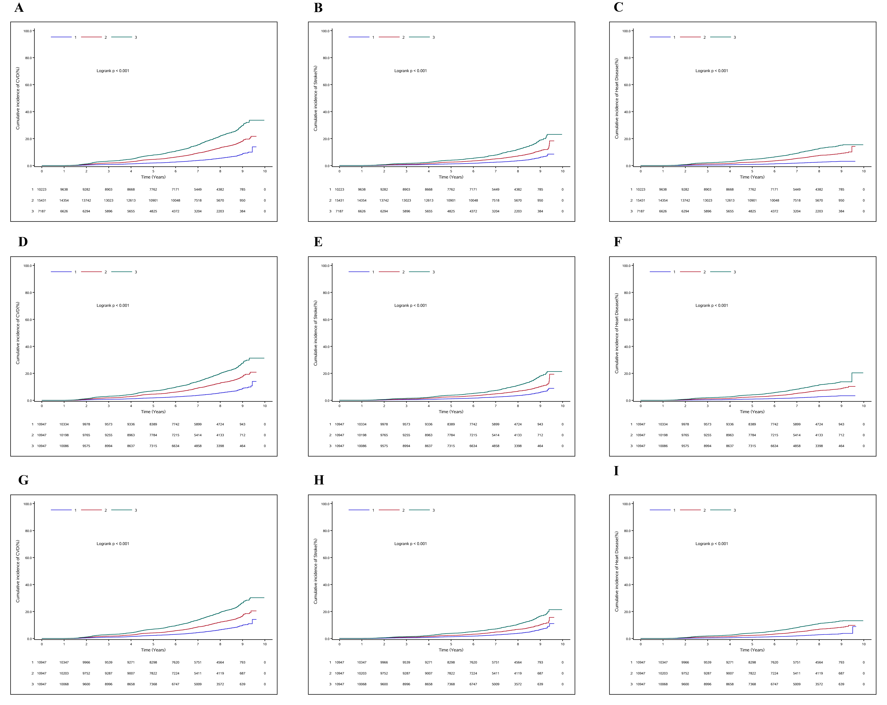
Cumulative incidence of total cardiovascular disease (A, D, G), stroke (B, E, H), and heart disease (C, F, I) stratified by dynamic change clusters (A-C), cumulative TyG-CVAI tertiles (D-F), and baseline TyG-CVAI tertiles (G-I). Differences between groups were assessed using the log-rank test. TyG-CVAI, triglyceride glucose-Chinese visceral adiposity index.

Fig S2.Subgroup analyses of the association between the TyG-CVAI index and CVD risk
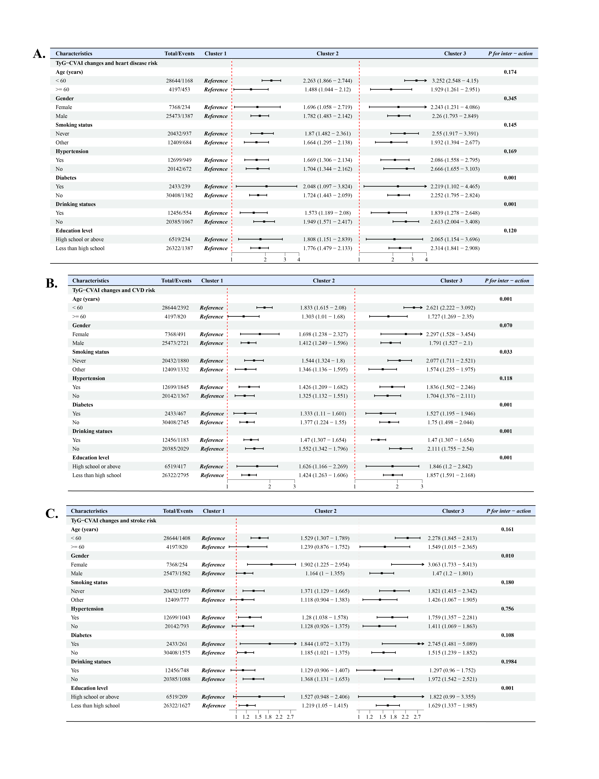

The model was adjusted for important feature calculated by XGBoost algorithm including: gender, age, DBP, smoking status,SBP, UA, TC, TG, FBG, CRP,WC,LDL,HDL,eGFR. (excluding the variable for subgroup stratification)

Fig S3. Relationship between TyG-CVAI and Cardiovascular Disease risk in different sensitivity analyses
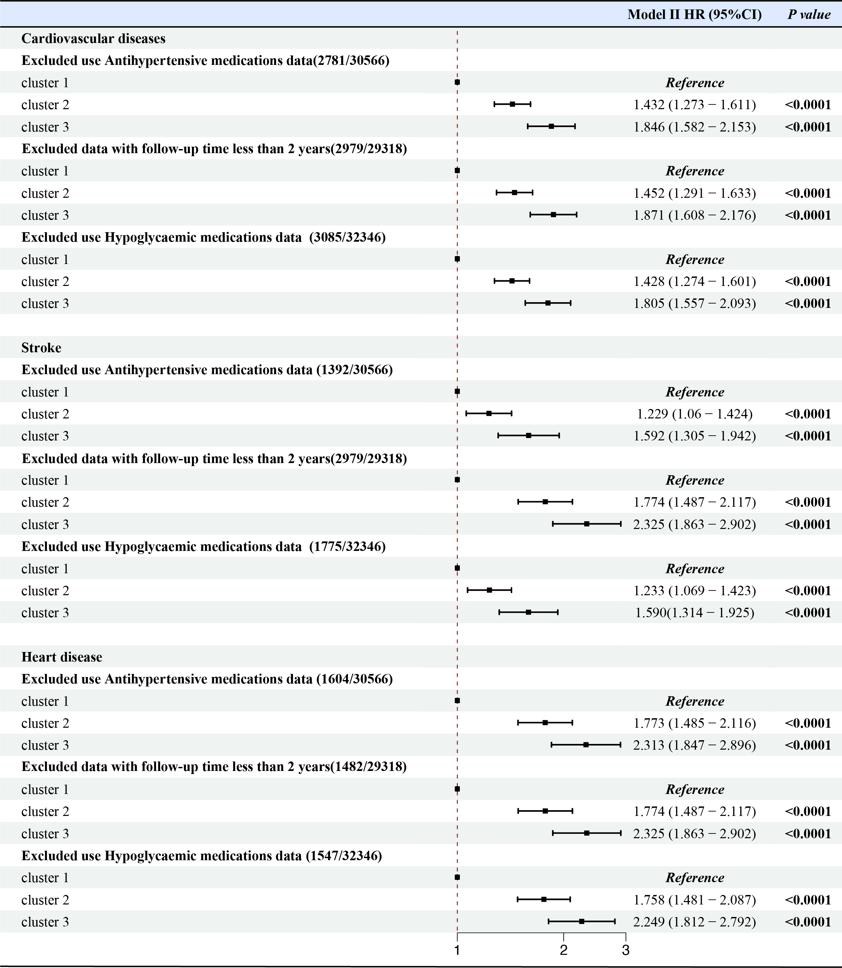
The model was adjusted for important feature calculated by XGBoost algorithm including: gender, age, DBP, smoking status,SBP, UA, TC, TG, FBG, CRP,WC,LDL,HDL,eGFR.

