Supplementary Figure S1. Validation of the Anthropometric Prediction Equation against Dual-Energy X-ray Absorptiometry (DXA) Measurements in the NHANES Cohort
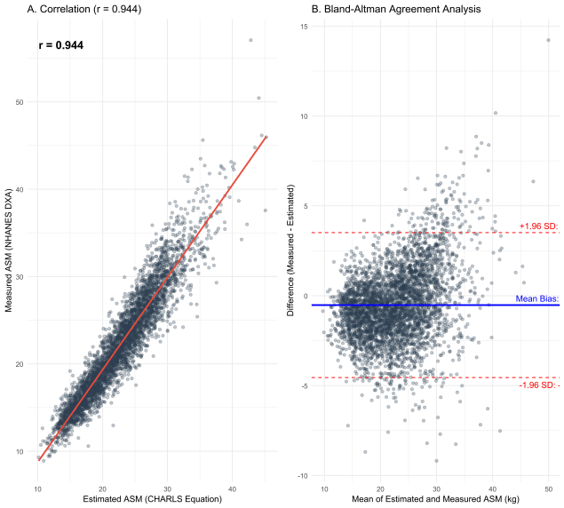

(A) Scatter plot illustrating the correlation between appendicular skeletal muscle mass (ASM) estimated using the anthropometric equation (Wen et al., 2011) and ASM measured by DXA. The Pearson correlation coefficient (r = 0.944) indicates a strong positive linear relationship. The red line represents the linear regression fit. (B) Bland-Altman plot assessing the agreement between the estimated and measured ASM. The blue solid line represents the mean bias, and the red dashed lines indicate the 95% limits of agreement (±1.96 SD). Abbreviation: ASM, appendicular skeletal muscle mass; DXA, dual-energy X-ray absorptiometry; SD, standard deviation.

Supplementary Table S1. Fine–Gray Competing Risk Regression for Incident CVD Events.
Phenotype | SHR (95% CI) | P-Value
Normal | 1.00 (Ref) | -
Obesity Only | 1.48 (1.29–1.70) | <0.001
Sarcopenia Only | 1.22 (1.03–1.43) | 0.018
Sarcopenic Obesity | 2.01 (1.71–2.35) | <0.001
Supplementary Table S1. Fine–Gray Competing Risk Regression for Incident CVD Events. The Fine–Gray subdistribution hazards model treated incident CVD as the event of interest and death before incident CVD as the competing event. Participants without incident CVD or death were censored at the last available follow-up. The model was adjusted for age, sex, residence, education level, marital status, smoking status, and alcohol consumption. Abbreviations: CI, confidence interval; CVD, cardiovascular disease; SHR, subdistribution hazard ratio.
Supplementary Table S2. Sensitivity Analysis Excluding CVD Events within the First 2 Years of Follow-up
Phenotype Group | Model 1 HR (95% CI) | P-value | Model 3 HR (95% CI) | P-value
Normal | 1.00 (Ref) | — | 1.00 (Ref) | —
Obesity Only | 1.58 (1.36-1.85) | <0.001 | 1.56 (1.33-1.82) | <0.001
Sarcopenia Only | 1.42 (1.19-1.70) | <0.001 | 1.24 (1.03-1.49) | 0.023
Sarcopenic Obesity | 2.39 (2.01-2.84) | <0.001 | 2.09 (1.75-2.51) | <0.001
Note: Sensitivity Analysis Excluding CVD Events within the First 2 Years of Follow-up. Participants who developed incident CVD within the first 2 years after baseline were excluded to reduce potential reverse causation. Cox proportional hazards models were refitted among the remaining participants. Model 1 was unadjusted, and Model 3 was adjusted for age, sex, residence, education level, marital status, smoking status, and alcohol consumption. Abbreviations: CI, confidence interval; CVD, cardiovascular disease; HR, hazard ratio.

Supplementary Table S3. Restricted longitudinal analysis among participants free of advanced CKM at baseline
Phenotype | Model 1 HR (95% CI) | P-value | Model 2 HR (95% CI) | P-value | Model 3 HR (95% CI) | P-value
Normal | 1.00 (Ref) | — | 1.00 (Ref) | — | 1.00 (Ref) | —
Obesity Only | 1.64 (1.44–1.87) | <0.001 | 1.53 (1.34–1.75) | <0.001 | 1.54 (1.34–1.76) | <0.001
Sarcopenia Only | 1.43 (1.21–1.69) | <0.001 | 1.27 (1.07–1.50) | 0.006 | 1.28 (1.08–1.51) | 0.005
Sarcopenic Obesity | 2.33 (1.98–2.73) | <0.001 | 1.91 (1.62–2.26) | <0.001 | 1.93 (1.63–2.28) | <0.001

Note: The analysis was restricted to participants with baseline CKM Stage 0–2. Participants with baseline CKM Stage 3 or Stage 4 were excluded. Hazard ratios were estimated using Cox proportional hazards models. Model 1 was unadjusted. Model 2 was adjusted for age, sex, residence, education level, and marital status. Model 3 was further adjusted for smoking status and alcohol consumption. CKM, cardiovascular-kidney-metabolic; CVD, cardiovascular disease; HR, hazard ratio; CI, confidence interval.

