Supplementary Table 1. SMD values of baseline characteristics after PSM
Variable | nDME | DME | p | SMD
Age, years | 61.00 [55.00, 69.75] | 60.00 [53.50, 71.00] | 0.881 | 0.036
Female, n (%) | 80 (42.1%) | 37 (38.9%) | 0.702 | 0.064
Diabetes duration, years | 11.00 [8.25, 20.00] | 10.00 [8.00, 20.00] | 0.822 | 0.007
Fasting blood glucose, mmol/L | 8.46 [6.09, 11.78] | 7.79 [6.24, 9.89] | 0.469 | 0.086
HbA1c, % | 7.80 [6.53, 9.00] | 7.50 [6.55, 9.15] | 0.824 | 0.035
SBP, mmHg | 138.00 [125.00, 151.00] | 137.00 [125.50, 154.50] | 0.895 | 0.016
DBP, mmHg | 81.50 [74.00, 90.00] | 82.00 [76.00, 88.50] | 0.986 | 0.025
Blood urea nitrogen, mmol/L | 7.05 [5.40, 10.55] | 6.88 [5.56, 9.25] | 0.574 | 0.280
Serum creatinine, μmol/L | 69.00 [50.25, 131.00] | 81.00 [64.00, 106.00] | 0.194 | 0.284
eGFR, mL/min/1.73 m² | 93.12 [45.92, 106.84] | 86.21 [63.31, 100.84] | 0.564 | 0.045
eGFR <60 mL/min/1.73 m², n (%) | 58 (30.5%) | 22 (23.2%) | 0.244 | 0.167
Neutrophil count, ×10⁹/L | 3.86 [2.84, 5.17] | 4.11 [3.22, 5.10] | 0.210 | 0.144
Lymphocyte count, ×10⁹/L | 1.64 [1.24, 2.14] | 1.64 [1.40, 2.02] | 0.738 | 0.008
Platelet count, ×10⁹/L | 187.50 [147.25, 234.75] | 211.00 [160.50, 242.50] | 0.174 | 0.140
NLR | 2.22 [1.55, 3.51] | 2.39 [1.87, 3.14] | 0.196 | 0.030
PLR | 110.22 [82.61, 158.20] | 121.28 [96.68, 147.57] | 0.289 | 0.082
SII | 429.50 [243.02, 732.65] | 487.18 [343.29, 663.60] | 0.094 | 0.096
TG, mmol/L | 1.20 [0.87, 1.56] | 1.43 [1.04, 2.24] | <0.001 | 0.573
HDL-C, mmol/L | 1.04 [0.84, 1.29] | 1.13 [0.94, 1.39] | 0.009 | 0.357
LDL-C, mmol/L | 2.33 [1.85, 3.18] | 2.79 [2.12, 3.47] | 0.007 | 0.319
TC, mmol/L | 4.24 [3.57, 5.00] | 4.52 [3.90, 5.67] | 0.017 | 0.314
Total bilirubin, μmol/L | 9.90 [7.23, 12.60] | 10.60 [8.05, 13.95] | 0.160 | 0.199
Direct bilirubin, μmol/L | 3.10 [1.92, 4.00] | 2.40 [1.60, 3.35] | 0.009 | 0.245
Indirect bilirubin, μmol/L | 6.95 [4.80, 9.45] | 8.30 [6.30, 10.25] | 0.004 | 0.356
TyG index | 8.98 [8.55, 9.32] | 9.21 [8.76, 9.69] | 0.002 | 0.428
Data are presented as median [interquartile range] for continuous variables and n (%) for categorical variables. P values were calculated using the Mann–Whitney U test for continuous variables and the chi-square test or Fisher’s exact test for categorical variables, as appropriate. OCT structural characteristics were summarized only among patients with DME and were not compared with the nDME group.
Abbreviations: BUN, blood urea nitrogen; DBIL, direct bilirubin; DBP, diastolic blood pressure; DME, diabetic macular edema; DRIL, disorganization of retinal inner layers; eGFR, estimated glomerular filtration rate; EZ/ELM, ellipsoid zone/external limiting membrane; HbA1c, hemoglobin A1c; HDL-C, high-density lipoprotein cholesterol; IBIL, indirect bilirubin; LDL-C, low-density lipoprotein cholesterol; NLR, neutrophil-to-lymphocyte ratio; PLR, platelet-to-lymphocyte ratio; SBP, systolic blood pressure; SII, systemic immune-inflammation index; SRF, subretinal fluid; TBIL, total bilirubin; TC, total cholesterol; TG, triglycerides; TyG index, triglyceride-glucose index.

Supplementary Table 2. Extended logistic regression models for the associations of individual lipid indicators with DME
Lipid indicator | Extended model OR (95% CI) | P value
TG | 2.19 (1.50–3.20) | <0.001
HDL-C | 2.19 (0.98–4.91) | 0.056
LDL-C | 1.19 (0.89–1.59) | 0.238
TC | 1.17 (0.94–1.45) | 0.156
TyG index | 1.90 (1.25–2.90) | 0.003

The extended model was adjusted for age, sex, HbA1c, diabetes duration, systolic blood pressure, estimated glomerular filtration rate, direct bilirubin, indirect bilirubin, neutrophil count, and lymphocyte count. Each lipid indicator was evaluated in a separate logistic regression model using the same covariate adjustment

Supplementary Table 3. Sensitivity analyses for the associations of individual lipid indicators with DME after accounting for renal function.
Lipid indicator | eGFR <60 as binary covariate  (n=285) |  | Excluding eGFR <15  (n=266) |  |  | Excluding eGFR <30  (n=248) |  |  | Excluding eGFR <60  (n=205)
 | OR (95% CI) | P value | OR (95% CI) | P value | OR (95% CI) |  | P value | OR (95% CI) |  | P value
TG | 2.37 (1.64–3.45) | <0.001 | 2.16 (1.50–3.11) | <0.001 | 2.07 (1.42–3.01) |  | <0.001 | 1.80 (1.23–2.64) |  | 0.003
HDL-C | 3.10 (1.47–6.51) | 0.003 | 3.24 (1.50–6.98) | 0.003 | 3.18 (1.44–6.99) |  | 0.004 | 4.08 (1.64–10.12) |  | 0.002
LDL-C | 1.43 (1.10–1.86) | 0.008 | 1.42 (1.08–1.86) | 0.011 | 1.36 (1.03–1.78) |  | 0.029 | 1.28 (0.95–1.73) |  | 0.105
TC | 1.32 (1.08–1.61) | 0.006 | 1.30 (1.06–1.59) | 0.013 | 1.28 (1.04–1.57) |  | 0.022 | 1.23 (0.98–1.54) |  | 0.076
TyG index | 2.04 (1.36–3.05) | <0.001 | 1.87 (1.25–2.81) | 0.002 | 1.82 (1.19–2.77) |  | 0.006 | 1.58 (0.99–2.53) |  | 0.054

Sensitivity model A replaced continuous eGFR with a binary renal function indicator (eGFR <60 mL/min/1.73 m²) and was adjusted for age, sex, HbA1c, diabetes duration, SBP, and eGFR <60 mL/min/1.73 m². Sensitivity models B–D were restricted to participants with eGFR ≥15, ≥30, and ≥60 mL/min/1.73 m², respectively, and were adjusted for age, sex, HbA1c, diabetes duration, and SBP.
Each lipid indicator was evaluated in a separate logistic regression model using the same covariate adjustment set within each sensitivity analysis to avoid multicollinearity among lipid-related variables. ORs and 95% CIs were estimated for the association between each lipid indicator and the presence of DME.
Abbreviations: CI, confidence interval; DME, diabetic macular edema; eGFR, estimated glomerular filtration rate; HbA1c, hemoglobin A1c; HDL-C, high-density lipoprotein cholesterol; LDL-C, low-density lipoprotein cholesterol; OR, odds ratio; SBP, systolic blood pressure; TC, total cholesterol; TG, triglycerides; TyG index, triglyceride-glucose index.
Supplementary figure 1. Spearman correlation matrix of clinical, metabolic, inflammatory, and renal function indicators
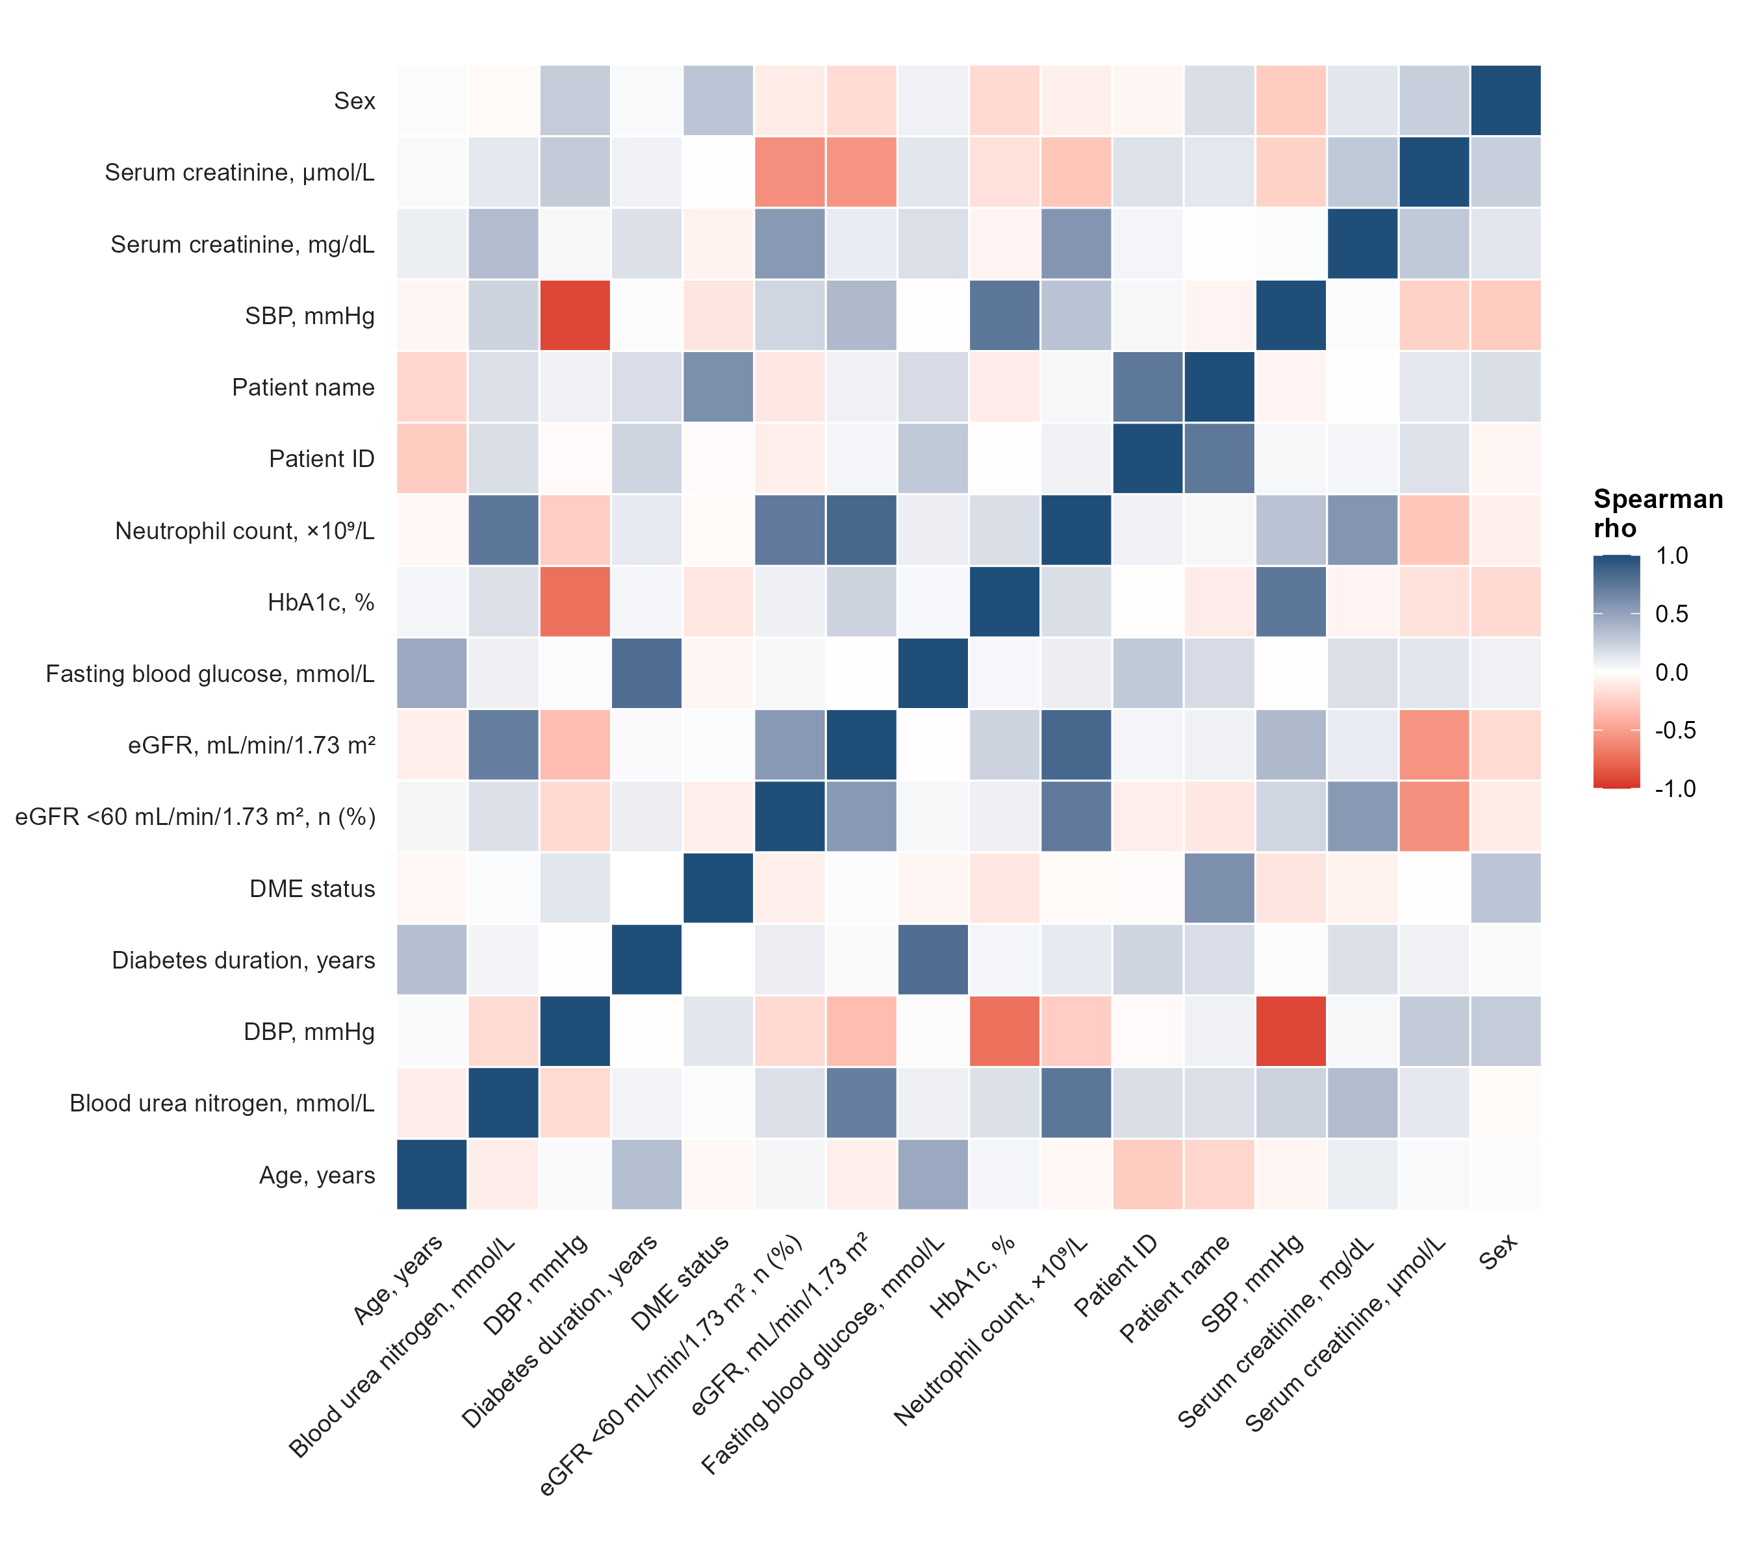

Pairwise Spearman correlation coefficients were calculated among demographic characteristics, glycemic indicators, lipid profiles, inflammatory markers, and renal function parameters. Blue indicates positive correlations, red indicates negative correlations, and color intensity represents the magnitude of Spearman’s rho.

Supplementary figure 2. Associations of individual lipid indicators with DME.
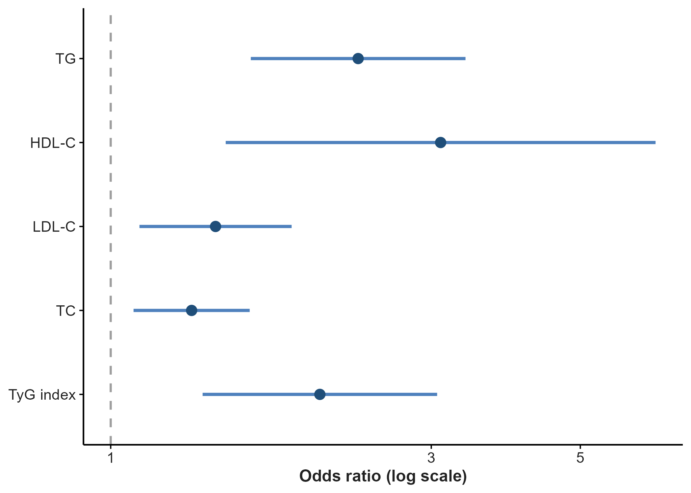
Forest plot showing the associations between individual lipid indicators and DME after adjustment for renal function. ORs and 95% confidence intervals (CIs) were estimated using logistic regression models. Each lipid indicator was entered into a separate model to avoid multicollinearity among lipid-related variables. Models were adjusted for age, sex, HbA1c, diabetes duration, systolic blood pressure, and estimated glomerular filtration rate (eGFR). The dashed vertical line represents an OR of 1.0. The x-axis is shown on a logarithmic scale.

HDL-C, high-density lipoprotein cholesterol; LDL-C, low-density lipoprotein cholesterol; OR, odds ratio; TC, total cholesterol; TG, triglycerides; TyG index, triglyceride-glucose index.

