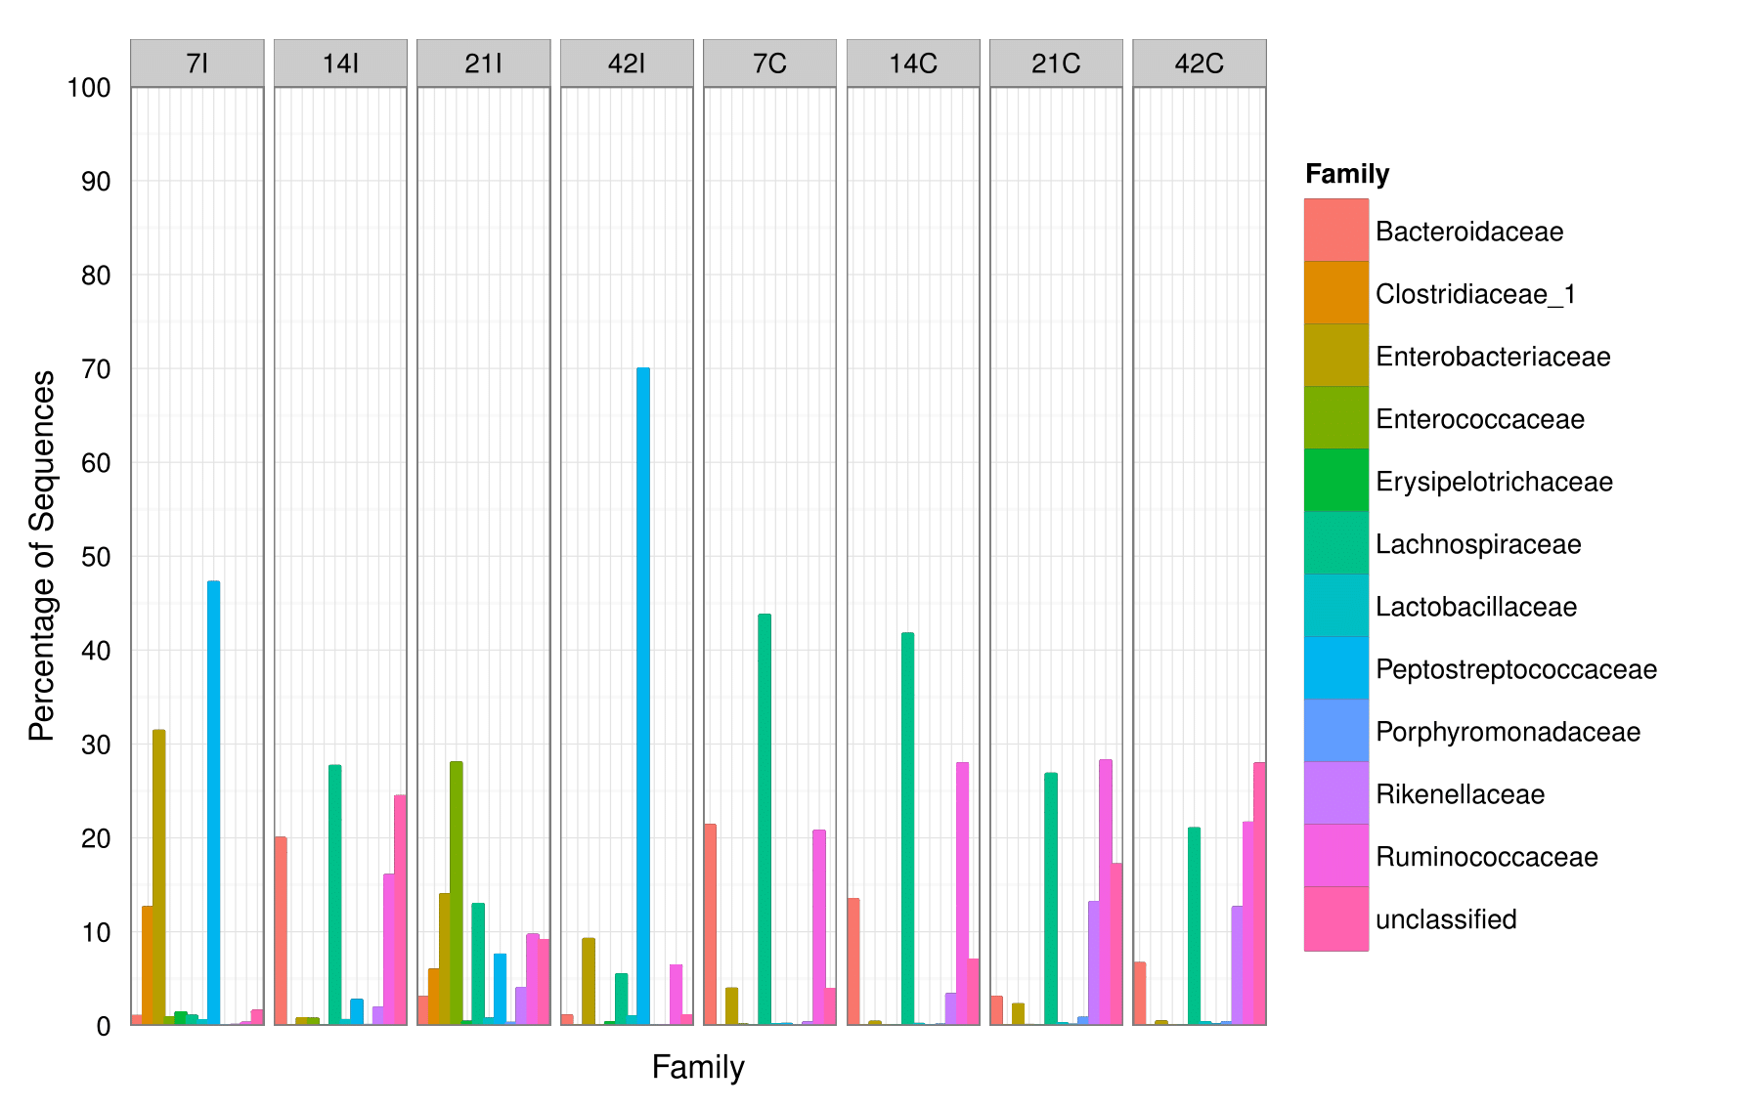
Additional file 3: Bacteria family distributions using V3 amplicon sequencing (n = Top 50 OTUs). For each timepoint (Day 7, 14, 21 and 42) and part of intestine (I = ilea, C = caeca).

