ADDITIONAL FIGURES

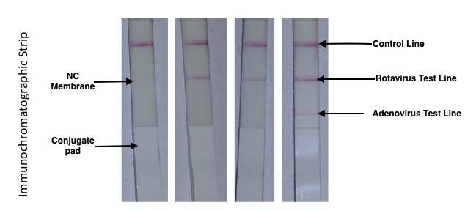

A B C D

Additional Figure-1: Representative picture of Immunochromatographic test.

Negative Test Result-Upper reddish-purple line appears at the Control line in upper most reason no other band is present (A).

Positive Test Result-
In addition to reddish-purple band at the control line a visible reddish-purple line after top most red line indicated Rotavirus positive test (B & C).
Appearance of 3 lines on strip indicates both Rotavirus and Adenovirus positive test (D).

Note- Intensity of the test line may vary according to the quantity of antigen found in the sample.

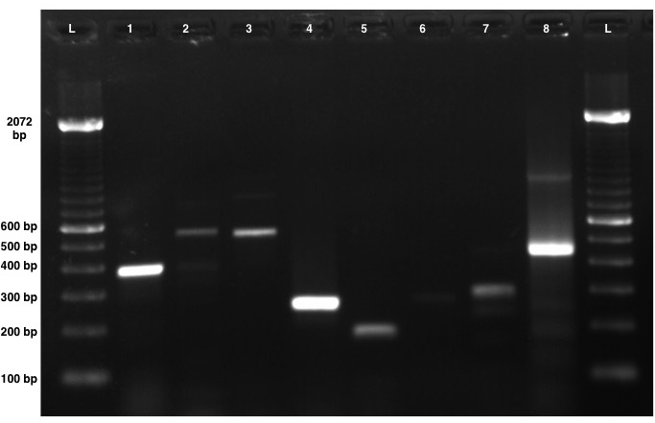

Additional Figure-2: Gel image of representative samples tested positive by PCR employing species-specific primer sets

Primer information is provided in Table-1 in the main manuscript.

Lane 1 to 9 sample sequences are given below-

L- 100 bp ladder
- EPCE positive sample
- Shigella positive sample
- EHEC positive sample
- E. coli stx 2 positive sample
- E. coli stx 1 positive sample
- E. coli O157 positive sample
- Cryptosporidium positive sample
- Giardia positive sample

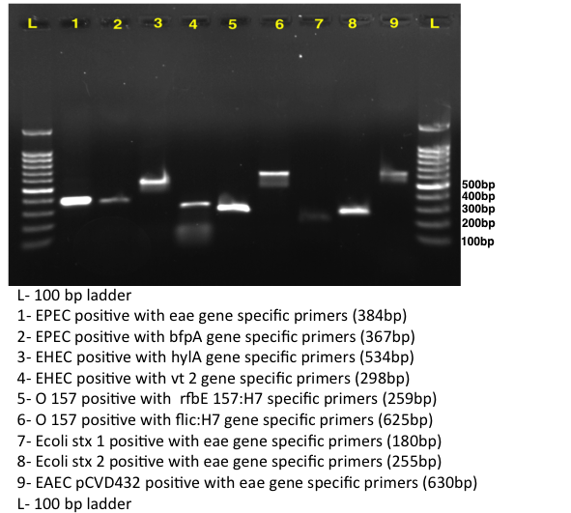

Additional Figure-3: Gel image of representative samples tested positive by PCR employing species-specific primer sets

Primer information is provided in Table-1 in the main manuscript.

