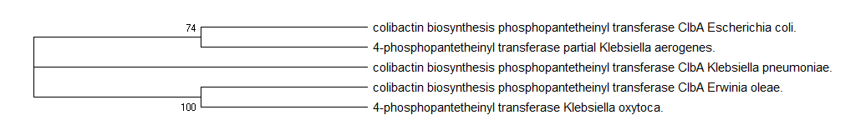

Figure S1: Phylogenetic tree of homologues aligned against E. coli ClbA as determine by Maximum Likelihood method.

The bootstrap consensus tree was inferred from 5000 replicates to represent the evolutionary history of the taxa analyzed. The Branches corresponding to partitions reproduced in less than 50% bootstrap replicates were collapsed and the percentage of replicate trees in which the associated taxa clustered together is shown next to the branches. This analysis included 5 amino acid sequences and there were a total of 208 positions in the final dataset.

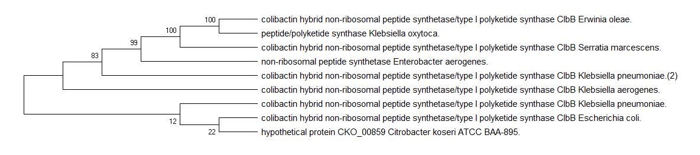
Figure S2: Phylogenetic tree of homologues aligned against E. coli ClbB as determine by Maximum Likelihood method.

The bootstrap consensus tree was inferred from 5000 replicates to represent the evolutionary history of the taxa analyzed. The Branches corresponding to partitions reproduced in less than 50% bootstrap replicates were collapsed and the percentage of replicate trees in which the associated taxa clustered together is shown next to the branches. This analysis included 9 amino acid sequences and there were a total of 3222 positions in the final dataset.

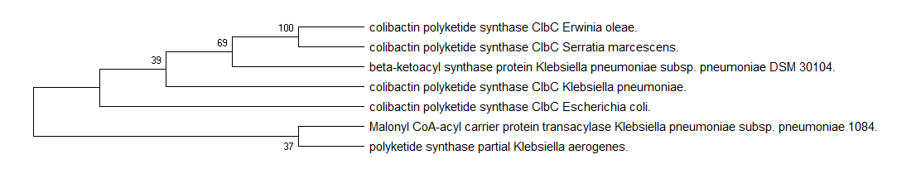

Figure S3: Phylogenetic tree of homologues aligned against E. coli ClbC as determine by Maximum Likelihood method.

The bootstrap consensus tree was inferred from 5000 replicates to represent the evolutionary history of the taxa analyzed. The Branches corresponding to partitions reproduced in less than 50% bootstrap replicates were collapsed and the percentage of replicate trees in which the associated taxa clustered together is shown next to the branches. This analysis included 7 amino acid sequences and there were a total of 778 positions in the final dataset.

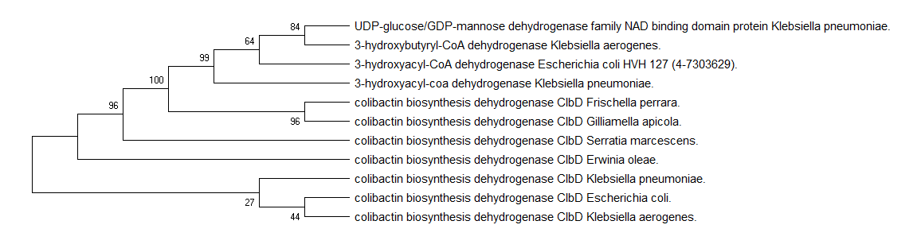
Figure S4: Phylogenetic tree of homologues aligned against E. coli ClbD as determine by Maximum Likelihood method.

The bootstrap consensus tree was inferred from 5000 replicates to represent the evolutionary history of the taxa analyzed. The Branches corresponding to partitions reproduced in less than 50% bootstrap replicates were collapsed and the percentage of replicate trees in which the associated taxa clustered together is shown next to the branches. This analysis included 11 amino acid sequences and there were a total of 287 positions in the final dataset.

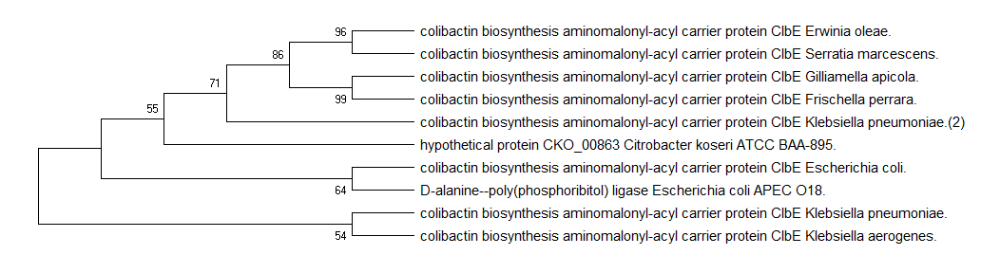
Figure S5: Phylogenetic tree of homologues aligned against E. coli ClbE as determine by Maximum Likelihood method.

The bootstrap consensus tree was inferred from 5000 replicates to represent the evolutionary history of the taxa analyzed. The Branches corresponding to partitions reproduced in less than 50% bootstrap replicates were collapsed and the percentage of replicate trees in which the associated taxa clustered together is shown next to the branches. This analysis included 10 amino acid sequences and there were a total of 84 positions in the final dataset.

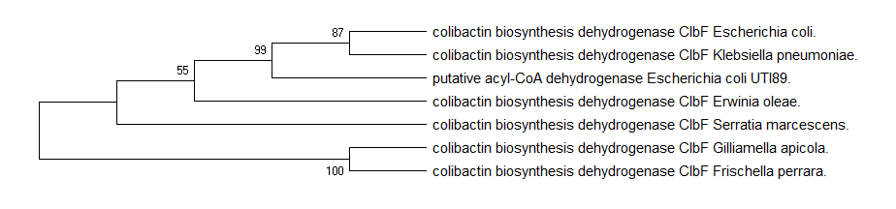
Figure S6: Phylogenetic tree of homologues aligned against E. coli ClbF as determine by Maximum Likelihood method.

The bootstrap consensus tree was inferred from 5000 replicates to represent the evolutionary history of the taxa analyzed. The Branches corresponding to partitions reproduced in less than 50% bootstrap replicates were collapsed and the percentage of replicate trees in which the associated taxa clustered together is shown next to the branches. This analysis included 7 amino acid sequences and there were a total of 376 positions in the final dataset.

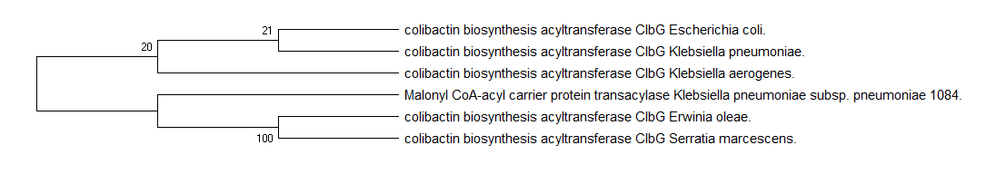
Figure S7: Phylogenetic tree of homologues aligned against E. coli ClbG as determine by Maximum Likelihood method.

The bootstrap consensus tree was inferred from 5000 replicates to represent the evolutionary history of the taxa analyzed. The Branches corresponding to partitions reproduced in less than 50% bootstrap replicates were collapsed and the percentage of replicate trees in which the associated taxa clustered together is shown next to the branches. This analysis included 6 amino acid sequences and there were a total of 422 positions in the final dataset.

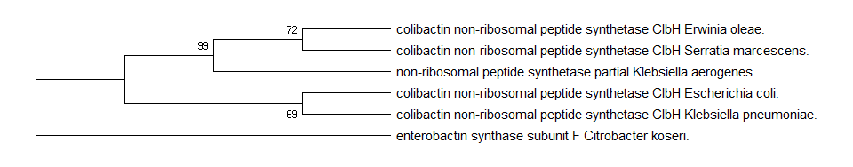
Figure S8: Phylogenetic tree of homologues aligned against E. coli ClbH as determine by Maximum Likelihood method.

The bootstrap consensus tree was inferred from 5000 replicates to represent the evolutionary history of the taxa analyzed. The Branches corresponding to partitions reproduced in less than 50% bootstrap replicates were collapsed and the percentage of replicate trees in which the associated taxa clustered together is shown next to the branches. This analysis included 6 amino acid sequences and there were a total of 981 positions in the final dataset.

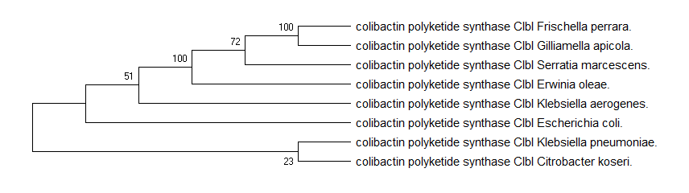
Figure S9: Phylogenetic tree of homologues aligned against E. coli ClbI as determine by Maximum Likelihood method.

The bootstrap consensus tree was inferred from 5000 replicates to represent the evolutionary history of the taxa analyzed. The Branches corresponding to partitions reproduced in less than 50% bootstrap replicates were collapsed and the percentage of replicate trees in which the associated taxa clustered together is shown next to the branches. This analysis included 8 amino acid sequences and there were a total of 1012 positions in the final dataset.

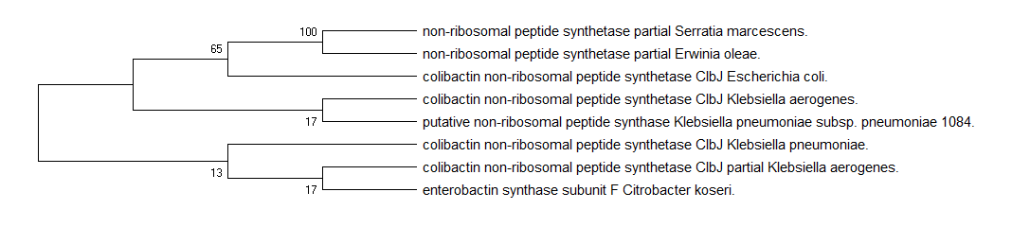
Figure S10: Phylogenetic tree of homologues aligned against E. coli ClbJ as determine by Maximum Likelihood method.

The bootstrap consensus tree was inferred from 5000 replicates to represent the evolutionary history of the taxa analyzed. The Branches corresponding to partitions reproduced in less than 50% bootstrap replicates were collapsed and the percentage of replicate trees in which the associated taxa clustered together is shown next to the branches. This analysis included 8 amino acid sequences and there were a total of 1639 positions in the final dataset.

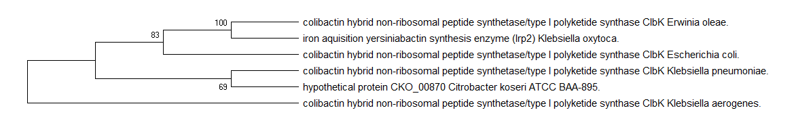
Figure S11: Phylogenetic tree of homologues aligned against E. coli ClbK as determine by Maximum Likelihood method.

The bootstrap consensus tree was inferred from 5000 replicates to represent the evolutionary history of the taxa analyzed. The Branches corresponding to partitions reproduced in less than 50% bootstrap replicates were collapsed and the percentage of replicate trees in which the associated taxa clustered together is shown next to the branches. This analysis included 6 amino acid sequences and there were a total of 2177 positions in the final dataset.

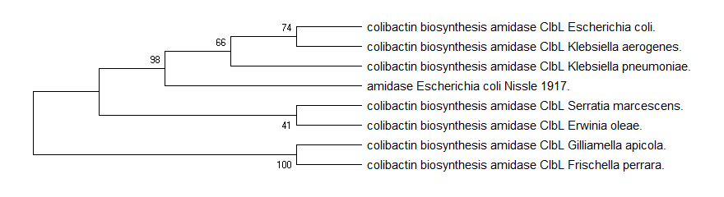
Figure S12: Phylogenetic tree of homologues aligned against E. coli ClbL as determine by Maximum Likelihood method.

The bootstrap consensus tree was inferred from 5000 replicates to represent the evolutionary history of the taxa analyzed. The Branches corresponding to partitions reproduced in less than 50% bootstrap replicates were collapsed and the percentage of replicate trees in which the associated taxa clustered together is shown next to the branches. This analysis included 8 amino acid sequences and there were a total of 488 positions in the final dataset.

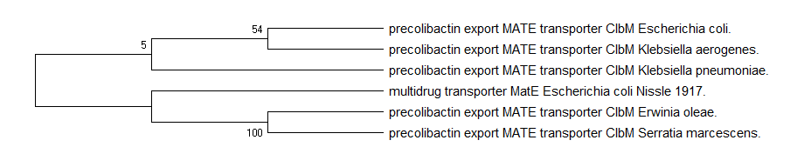
Figure S13: Phylogenetic tree of homologues aligned against E. coli ClbM as determine by Maximum Likelihood method.

The bootstrap consensus tree was inferred from 5000 replicates to represent the evolutionary history of the taxa analyzed. The Branches corresponding to partitions reproduced in less than 50% bootstrap replicates were collapsed and the percentage of replicate trees in which the associated taxa clustered together is shown next to the branches. This analysis included 6 amino acid sequences and there were a total of 479 positions in the final dataset.

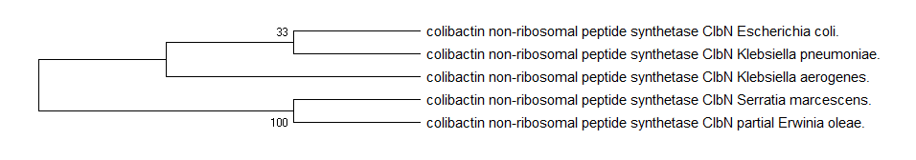
Figure S14: Phylogenetic tree of homologues aligned against E. coli ClbN as determine by Maximum Likelihood method.

The bootstrap consensus tree was inferred from 5000 replicates to represent the evolutionary history of the taxa analyzed. The Branches corresponding to partitions reproduced in less than 50% bootstrap replicates were collapsed and the percentage of replicate trees in which the associated taxa clustered together is shown next to the branches. This analysis included 5 amino acid sequences and there were a total of 778 positions in the final dataset.

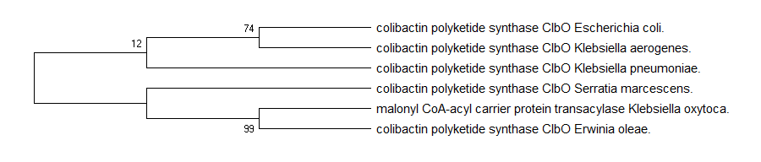
Figure S15: Phylogenetic tree of homologues aligned against E. coli ClbO as determine by Maximum Likelihood method

The bootstrap consensus tree was inferred from 5000 replicates to represent the evolutionary history of the taxa analyzed. The Branches corresponding to partitions reproduced in less than 50% bootstrap replicates were collapsed and the percentage of replicate trees in which the associated taxa clustered together is shown next to the branches. This analysis included 6 amino acid sequences and there were a total of 819 positions in the final dataset.
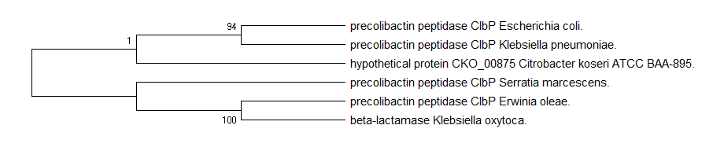
Figure S16: Phylogenetic tree of homologues aligned against E. coli ClbP as determine by Maximum Likelihood method.

The bootstrap consensus tree was inferred from 5000 replicates to represent the evolutionary history of the taxa analyzed. The Branches corresponding to partitions reproduced in less than 50% bootstrap replicates were collapsed and the percentage of replicate trees in which the associated taxa clustered together is shown next to the branches. This analysis included 6 amino acid sequences and there were a total of 504 positions in the final dataset.

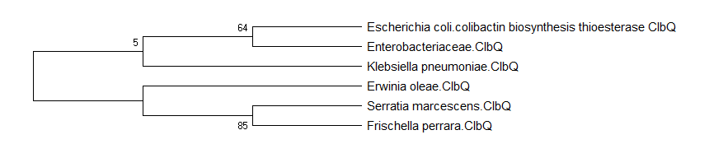

Figure S17: Phylogenetic tree of homologues aligned against E. coli ClbQ as determine by Maximum Likelihood method.

The bootstrap consensus tree was inferred from 5000 replicates to represent the evolutionary history of the taxa analyzed. The Branches corresponding to partitions reproduced in less than 50% bootstrap replicates were collapsed and the percentage of replicate trees in which the associated taxa clustered together is shown next to the branches. This analysis included 6 amino acid sequences and there were a total of 237 positions in the final dataset.

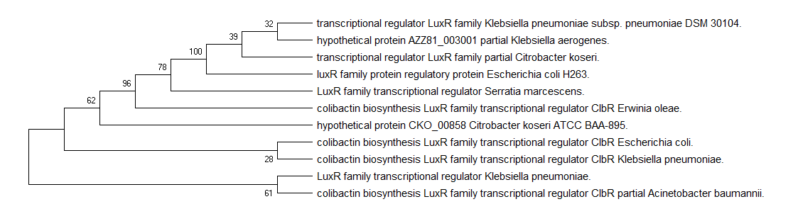
Figure S18: Phylogenetic tree of homologues aligned against E. coli ClbR as determine by Maximum Likelihood method.

The bootstrap consensus tree was inferred from 5000 replicates to represent the evolutionary history of the taxa analyzed. The Branches corresponding to partitions reproduced in less than 50% bootstrap replicates were collapsed and the percentage of replicate trees in which the associated taxa clustered together is shown next to the branches. This analysis included 11 amino acid sequences and there were a total of 97 positions in the final dataset.

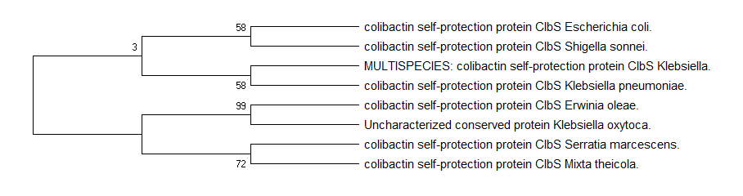
Figure S19: Phylogenetic tree of homologues aligned against E. coli ClbS as determine by Maximum Likelihood method.

The bootstrap consensus tree was inferred from 5000 replicates to represent the evolutionary history of the taxa analyzed. The Branches corresponding to partitions reproduced in less than 50% bootstrap replicates were collapsed and the percentage of replicate trees in which the associated taxa clustered together is shown next to the branches. This analysis included 8 amino acid sequences and there were a total of 170 positions in the final dataset.

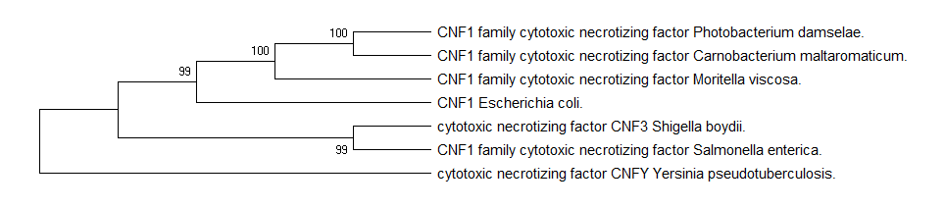
Figure S20: Phylogenetic tree of homologues aligned against E. coli Cnf 1 as determine by Maximum Likelihood method.

The bootstrap consensus tree was inferred from 5000 replicates to represent the evolutionary history of the taxa analyzed. The Branches corresponding to partitions reproduced in less than 50% bootstrap replicates were collapsed and the percentage of replicate trees in which the associated taxa clustered together is shown next to the branches. This analysis included 7 amino acid sequences and there were a total of 1020 positions in the final dataset.

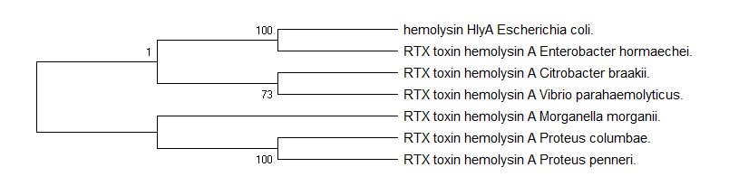
Figure S21: Phylogenetic tree of homologues aligned against E. coli HlyA as determine by Maximum Likelihood method.

The bootstrap consensus tree was inferred from 5000 replicates to represent the evolutionary history of the taxa analyzed. The Branches corresponding to partitions reproduced in less than 50% bootstrap replicates were collapsed and the percentage of replicate trees in which the associated taxa clustered together is shown next to the branches. This analysis included 7 amino acid sequences and there were a total of 1023 positions in the final dataset.

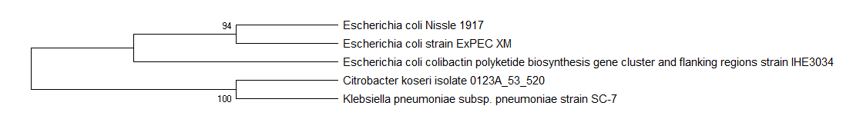
Figure S22: Phylogenetic tree of genomic islands aligned against E. coli colibactin pks island as determine by Maximum Likelihood method.

The bootstrap consensus tree was inferred from 5000 replicates to represent the evolutionary history of the taxa analyzed. The Branches corresponding to partitions reproduced in less than 50% bootstrap replicates were collapsed and the percentage of replicate trees in which the associated taxa clustered together is shown next to the branches. This analysis included 5 nucleotide sequences. Codon positions included were 1st+2nd+3rd+Noncoding. There were a total of 54637 positions in the final dataset.

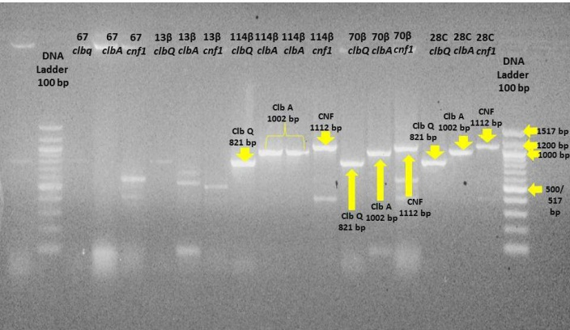

Figure S23: Agarose gel electrophoresis of the PCR products for the three tested genes (cnf 1, clbA, clbQ).

Representative hemolytic E. coli isolates (114β, 70β, 13β); non-hemolytic E. coli isolate coded (67); the reference E. coli strain 28C.

Table S1. Pairwise distances among homologues aligned against E. coli ClbA

 | Bacterial species | 1 | 2 | 3 | 4
1 | Escherichia coli
2 | Klebsiella pneumonia | 0.0145
3 | Erwinia oleae | 0.1363 | 0.1307
4 | Klebsiella aerogenes | 0.0097 | 0.0145 | 0.1363
5 | Klebsiella oxytoca | 0.1363 | 0.1307 | 0.0000 | 0.1363

Table S2. Pairwise distances among homologues aligned against E. coli ClbB

 | Bacterial species | 1 | 2 | 3 | 4 | 5 | 6 | 7 | 8
1 | Escherichia coli.
2 | Klebsiella pneumoniae | 0.0007
3 | Citrobacter koseri ATCC BAA 895 | 0.0003 | 0.0003
4 | Klebsiella aerogenes | 0.0007 | 0.0007 | 0.0003
5 | Enterobacter aerogenes | 0.0011 | 0.0011 | 0.0007 | 0.0011
6 | Erwinia oleae | 0.0851 | 0.0851 | 0.0847 | 0.0851 | 0.0772
7 | Klebsiella oxytoca | 0.0854 | 0.0854 | 0.0851 | 0.0854 | 0.0772 | 0.0024
8 | Serratia marcescens | 0.1621 | 0.1621 | 0.1618 | 0.1621 | 0.1476 | 0.1193 | 0.1194

Table S3. Pairwise distances among homologues aligned against E. coli ClbC

 | Bacterial species | 1 | 2 | 3 | 4 | 5
1 | Escherichia coli
2 | Klebsiella pneumoniae | 0.0026
3 | Klebsiella aerogenes | 0.0013 | 0.0013
4 | Erwinia oleae | 0.0962 | 0.0948 | 0.0948
5 | Serratia marcescens | 0.1429 | 0.1429 | 0.1429 | 0.0902

Table S4. Pairwise distances among homologues aligned against E. coli ClbD

 | Bacterial species | 1 | 2 | 3 | 4 | 5 | 6 | 7 | 8
1 | Escherichia coli
2 | Klebsiella pneumoniae | 0.0070
3 | Klebsiella aerogenes | 0.0070 | 0.0070
4 | Klebsiella aerogenes | 2.9514 | 2.9514 | 2.9514
5 | Erwinia oleae | 0.0427 | 0.0427 | 0.0427 | 3.0204
6 | Serratia marcescens | 0.0988 | 0.0950 | 0.0988 | 3.0945 | 0.0873
7 | Frischella perrara | 3.1746 | 3.1746 | 3.1746 | 0.2345 | 3.1746 | 3.2616
8 | Gilliamella apicola | 3.0204 | 3.0204 | 3.0204 | 0.2434 | 3.0945 | 3.1746 | 0.1065

Table S5. Pairwise distances among homologues aligned against E. coli ClbE

 | Bacterial species | 1 | 3 | 4 | 5 | 7 | 8 | 9 | 10
1 | Escherichia coli
3 | Citrobacter koseri ATCC BAA 895 | 0.0134
4 | Klebsiella pneumoniae | 0.0263 | 0.0134
5 | Klebsiella aerogenes | 0.0263 | 0.0134 | 0.0263
7 | Erwinia oleae | 0.0953 | 0.0834 | 0.0953 | 0.0953
8 | Serratia marcescens | 0.1391 | 0.1278 | 0.1391 | 0.1391 | 0.0397
9 | Gilliamella apicola | 0.2167 | 0.1904 | 0.2167 | 0.2167 | 0.1542 | 0.2007
10 | Frischella perrara | 0.2167 | 0.1904 | 0.2167 | 0.2167 | 0.1694 | 0.2167 | 0.0533

Table S6. Pairwise distances among homologues aligned against E. coli ClbF

 | Bacterial species | 1 | 2 | 3 | 5 | 6 | 7
1 | Escherichia coli
2 | Klebsiella pneumonia | 0.0059
3 | Erwinia oleae | 0.0665 | 0.0696
5 | Serratia marcescens | 0.1112 | 0.1145 | 0.0572
6 | Gilliamella apicola | 0.3266 | 0.3306 | 0.2906 | 0.2985
7 | Frischella perrara | 0.3388 | 0.3429 | 0.3025 | 0.3144 | 0.1211

Table S7. Pairwise distances among homologues aligned against E. coli ClbG

 | Bacterial species | 1 | 2 | 3 | 5 | 6
1 | Escherichia coli
2 | Klebsiella pneumoniae | 0.0048
3 | Klebsiella aerogenes | 0.0048 | 0.0048
5 | Erwinia oleae | 0.0673 | 0.0673 | 0.0673
6 | Serratia marcescens | 0.1094 | 0.1094 | 0.1094 | 0.0494

Table S8. Pairwise distances among homologues aligned against E. coli ClbH

 | Bacterial species | 1 | 2 | 3 | 4 | 5 | 6
1 | Escherichia coli
2 | Klebsiella pneumonia | 0.0011
3 | Erwinia oleae | 0.0792 | 0.0780
4 | Serratia marcescens | 0.1165 | 0.1165 | 0.0655
5 | Klebsiella aerogenes | 1.8587 | 1.8517 | 1.8173 | 1.8241
6 | Citrobacter koseri | 0.0042 | 0.0032 | 0.0815 | 0.1200 | 1.8517

Table S9. Pairwise distances among homologues aligned against E. coli ClbI

 | Bacterial species | 1 | 2 | 3 | 4 | 5 | 6 | 7 | 8
1 | Escherichia coli
2 | Klebsiella aerogenes | 0.0020
3 | Klebsiella pneumonia | 0.0020 | 0.0020
4 | Citrobacter koseri | 0.0020 | 0.0020 | 0.0020
5 | Erwinia oleae | 0.0561 | 0.0561 | 0.0561 | 0.0561
6 | Serratia marcescens | 0.0783 | 0.0783 | 0.0783 | 0.0783 | 0.0508
7 | Frischella perrara | 0.3313 | 0.3299 | 0.3313 | 0.3313 | 0.3176 | 0.3176
8 | Gilliamella apicola | 0.3443 | 0.3429 | 0.3443 | 0.3443 | 0.3290 | 0.3345 | 0.1740

Table S10. Pairwise distances among homologues aligned against E. coli ClbJ

 | Bacterial species | 1 | 2 | 3 | 4 | 5 | 6
1 | Escherichia coli
2 | Klebsiella aerogenes | 0.0013
3 | Klebsiella pneumonia | 0.0019 | 0.0006
4 | Citrobacter koseri | 0.0013 | 0.0000 | 0.0006
5 | Serratia marcescens | 0.1408 | 0.1408 | 0.1415 | 0.1408
6 | Erwinia oleae | 0.1262 | 0.1262 | 0.1269 | 0.1262 | 0.0652

Table S11. Pairwise distances among homologues aligned against E. coli ClbK

 | Bacterial species | 1 | 2 | 3 | 4 | 5 | 6
1 | Escherichia coli
2 | Klebsiella pneumonia | 0.0010
3 | Klebsiella aerogenes | 0.0010 | 0.0010
4 | Citrobacter koseri ATCC BAA 895 | 0.0010 | 0.0005 | 0.0010
5 | Erwinia oleae | 0.0875 | 0.0885 | 0.0885 | 0.0891
6 | Klebsiella oxytoca | 0.0842 | 0.0853 | 0.0853 | 0.0858 | 0.0148

Table S12. Pairwise distances among homologues aligned against E. coli ClbL

 | Bacterial species | 1 | 2 | 3 | 4 | 5 | 6 | 7 | 8
1 | Escherichia coli
2 | Klebsiella aerogenes | 0.0045
3 | Klebsiella pneumonia | 0.0091 | 0.0091
4 | Serratia marcescens | 0.0582 | 0.0558 | 0.0558
5 | Erwinia oleae | 0.0825 | 0.0800 | 0.0850 | 0.0511
6 | Escherichia coli Nissle 1917 | 0.0597 | 0.0597 | 0.0624 | 0.1090 | 0.1289
7 | Gilliamella apicola | 0.3397 | 0.3365 | 0.3333 | 0.3176 | 0.3176 | 0.3574
8 | Frischella perrara | 0.3207 | 0.3176 | 0.3176 | 0.3052 | 0.3176 | 0.3431 | 0.1617

Table S13. Pairwise distances among homologues aligned against E. coli ClbM

 | Bacterial species | 1 | 2 | 3 | 4 | 5 | 6
1 | Escherichia coli
2 | Klebsiella aerogenes | 0.0042
3 | Klebsiella pneumonia | 0.0042 | 0.0042
4 | Erwinia oleae | 0.0987 | 0.0987 | 0.0964
5 | Serratia marcescens | 0.1126 | 0.1126 | 0.1102 | 0.0558
6 | Escherichia coli Nissle 1917 | 0.1531 | 0.1507 | 0.1531 | 0.2474 | 0.2663

Table S14. Pairwise distances among homologues aligned against E. coli ClbN

 | Bacterial species | 1 | 2 | 3 | 4 | 5 | 6 | 7 | 8
1 | Escherichia coli
2 | Klebsiella pneumonia | 0.0026
3 | Klebsiella aerogenes | 0.0026 | 0.0026
4 | Serratia marcescens | 0.1600 | 0.1600 | 0.1600
5 | Erwinia oleae | 0.0929 | 0.0929 | 0.0929 | 0.1042
6 | Klebsiella oxytoca | 2.2031 | 2.2031 | 2.2031 | 2.2388 | 2.1686
7 | Citrobacter koseri | 2.1640 | 2.1640 | 2.1640 | 2.2122 | 2.1180 | 0.1101
8 | Escherichia coli Nissle 1917 | 2.1073 | 2.1073 | 2.1073 | 2.1235 | 2.1401 | 0.1829 | 0.1940

Table S15. Pairwise distances among homologues aligned against E. coli ClbO

 | Bacterial species | 1 | 2 | 3 | 4 | 5 | 6
1 | Escherichia coli
2 | Klebsiella aerogenes | 0.0024
3 | Klebsiella pneumonia | 0.0037 | 0.0037
4 | Klebsiella oxytoca | 0.0920 | 0.0920 | 0.0907
5 | Erwinia oleae | 0.0947 | 0.0947 | 0.0934 | 0.0049
6 | Serratia marcescens | 0.1471 | 0.1471 | 0.1456 | 0.0947 | 0.0947

Table S16. Pairwise distances among homologues aligned against E. coli ClbP

 | Bacterial species | 1 | 2 | 3 | 4 | 5 | 6
1 | Escherichia coli
2 | Klebsiella pneumonia | 0.0041
3 | Citrobacter koseri ATCC BAA 895 | 0.0021 | 0.0021
4 | Erwinia oleae | 0.1350 | 0.1350 | 0.1266
5 | Klebsiella oxytoca | 0.1350 | 0.1350 | 0.1266 | 0.0124
6 | Serratia marcescens | 0.2088 | 0.2113 | 0.1964 | 0.1483 | 0.1483

Table S17. Pairwise distances among homologues aligned against E. coli ClbQ

 | Bacterial species | 1 | 2 | 3 | 4 | 5
1 | Escherichia coli
2 | Klebsiella pneumonia | 0.0086
3 | Erwinia oleae | 0.0851 | 0.0945
4 | Serratia marcescens | 0.1317 | 0.1317 | 0.0992
5 | Frischella perrara | 0.3658 | 0.3782 | 0.3759 | 0.3658

Table S18. Pairwise distances among homologues aligned against E. coli ClbR

 | Bacterial species | 1 | 2 | 3 | 4 | 5 | 6 | 7
1 | Escherichia_coli
2 | Citrobacter koseri ATCC BAA 895 | 0.0165
3 | Klebsiella aerogenes | 1.6740 | 1.5870
4 | Klebsiella pneumoniae | 0.0313 | 0.0165 | 1.6740
5 | Acinetobacter baumannii | 0.0155 | 0.0000 | 1.6740 | 0.0155
6 | Erwinia oleae | 0.1313 | 0.1035 | 1.6740 | 0.1313 | 0.1139
7 | Serratia marcescens | 0.2426 | 0.2191 | 1.5686 | 0.2426 | 0.2231 | 0.1854

Table S19. Pairwise distances among homologues aligned against E. coli ClbS

 | Bacterial species | 1 | 3 | 4 | 5 | 6 | 7 | 8
1 | Escherichia coli
3 | Shigella sonnei | 0.0118
4 | Klebsiella pneumonia | 0.0178 | 0.0178
5 | Erwinia oleae | 0.0859 | 0.0859 | 0.0859
6 | Klebsiella oxytoca | 0.0924 | 0.0924 | 0.0924 | 0.0059
7 | Serratia marcescens | 0.1522 | 0.1522 | 0.1522 | 0.1454 | 0.1522
8 | Mixta theicola | 0.2305 | 0.2305 | 0.2305 | 0.2158 | 0.2158 | 0.2305

Table S20. Pairwise distances among homologues aligned against E. coli Cnf 1

 | Bacterial species | 1 | 2 | 3 | 4 | 5 | 6 | 7
1 | Escherichia coli
2 | Shigella boydii | 0.3520
3 | Salmonella enterica | 0.3648 | 0.1442
4 | Photobacterium damselae | 0.4300 | 0.4099 | 0.3951
5 | Carnobacterium maltaromaticum | 0.4182 | 0.4070 | 0.3919 | 0.0235
6 | Moritella viscosa | 0.4720 | 0.4521 | 0.4444 | 0.2180 | 0.2007
7 | Yersinia pseudotuberculosis | 0.4971 | 0.3859 | 0.3830 | 0.5205 | 0.5145 | 0.5315

Table S21. Pairwise distances among homologues aligned against E. coli HlyA

 | Bacterial species | 1 | 2 | 3 | 4 | 5 | 6
1 | Escherichia coli
2 | Enterobacter hormaechei | 0.0195
3 | Citrobacter braakii | 0.2003 | 0.1966
4 | Morganella morganii | 0.2030 | 0.2068 | 0.2672
5 | Vibrio parahaemolyticus | 0.1959 | 0.1997 | 0.2337 | 0.2539
6 | Proteus columbae | 0.2489 | 0.2593 | 0.3120 | 0.2158 | 0.2944

Table S22. Pairwise distances among genomic islands aligned against E. coli colibacting pks genomic islands

 | Bacterial species | 1 | 2 | 3 | 4 | 5 | 6
1 | Escherichia_coli
2 | Escherichia coli Nissle 1917 | 0.0002
3 | Citrobacter koseri | 9.0120 | 9.0120
4 | Klebsiella aerogenes | 0.0004 | 0.0005 | 9.0811
5 | Klebsiella pneumonia | 0.0005 | 0.0006 | 9.0798 | 0.0002
6 | Citrobacter koseri | 0.0003 | 0.0003 | 9.0768 | 0.0005 | 0.0004

Table S23. Identities, functions of proteins encoded by the 19 genes of E. coli PKS island and their relative phylogenetic distances from corresponding homologues of other bacterial species.

Protein | Protein ID | Protein name | Function |  | Prevalence among bacterial species^{(a)} | Pairwise distance^{(b)}
Protein | Protein ID | Protein name | Molecular function | Biological process | Prevalence among bacterial species^{(a)} | Pairwise distance^{(b)}
ClbA | Q0P7J0 | 4'-phosphopantetheinyl transferase | Holo-[acyl-carrier-protein] synthase activity  Magnesium ion binding  Transferase | None predicted | Escherichia coli
 |  |  |  |  | Klebsiella pneumoniae | 0.0145
 |  |  |  |  | Erwinia oleae | 0.1363
 |  |  |  |  | Klebsiella aerogenes | 0.0097
 |  |  |  |  | Klebsiella oxytoca | 0.1363
ClbB | Q0P7J2 | Colibactin hybrid non-ribosomal peptide synthetase/type I polyketide synthase ClbB | Ligase activity  Oxidoreductase activity  Phosphopantetheine binding  Transferase activity | Oxidation-reduction process | Escherichia coli
 |  |  |  |  | Klebsiella pneumoniae | 0.0007
 |  |  |  |  | Citrobacter koseri | 0.0003
 |  |  |  |  | Klebsiella aerogenes | 0.0007
 |  |  |  |  | Enterobacter aerogenes | 0.0011
 |  |  |  |  | Erwinia oleae | 0.0851
 |  |  |  |  | Klebsiella oxytoca | 0.0854
 |  |  |  |  | Serratia marcescens | 0.1621
ClbC | Q0P7J3 | Colibactin polyketide synthase ClbC | Catalytic activity  Phosphopantetheine binding | Metabolic process | Escherichia coli
 |  |  |  |  | Klebsiella pneumoniae | 0.0026
 |  |  |  |  | Klebsiella aerogenes | 0.0013
 |  |  |  |  | Erwinia oleae | 0.0962
 |  |  |  |  | Serratia marcescens | 0.1429
ClbD | Q0P7J4 | 3-hydroxybutyryl-CoA dehydrogenase | 3-hydroxyacyl-CoA dehydrogenase activity  NAD+ binding | Fatty acid metabolic process | Escherichia coli
 |  |  |  |  | Klebsiella pneumoniae | 0.007
 |  |  |  |  | Klebsiella aerogenes | 0.007
 |  |  |  |  | Erwinia oleae | 0.0427
 |  |  |  |  | Serratia marcescens | 0.0988
 |  |  |  |  | Frischella perrara | 3.1746
 |  |  |  |  | Gilliamella apicola | 3.0204
ClbE | Q0P7J5 | Alanine-phosphoribitol ligase | ligase activity | None predicted | Escherichia coli
 |  |  |  |  | Citrobacter koseri | 0.0134
 |  |  |  |  | Klebsiella pneumoniae | 0.0263
 |  |  |  |  | Klebsiella aerogenes | 0.0263
 |  |  |  |  | Erwinia oleae | 0.0953
 |  |  |  |  | Serratia marcescens | 0.1391
 |  |  |  |  | Gilliamella apicola | 0.2167
 |  |  |  |  | Frischella perrara | 0.2167
ClbF | Q0P7J6 | Acyl-CoA dehydrogenase | Flavin adenine dinucleotide binding  Oxidoreductase activity, acting on the CH-CH group of donors | None predicted | Escherichia coli
 |  |  |  |  | Klebsiella pneumoniae | 0.0059
 |  |  |  |  | Erwinia oleae | 0.0665
 |  |  |  |  | Serratia marcescens | 0.1112
 |  |  |  |  | Gilliamella apicola | 0.3266
 |  |  |  |  | Frischella perrara | 0.3388
ClbG | Q0P7J7 | Colibactin biosynthesis acyltransferase ClbG | Transferase activity, transferring acyl groups | Metabolic process | Escherichia coli
 |  |  |  |  | Klebsiella pneumoniae | 0.00483
 |  |  |  |  | Klebsiella aerogenes | 0.00483
 |  |  |  |  | Erwinia oleae | 0.06727
 |  |  |  |  | Serratia marcescens | 0.10938
ClbH | Q0P7J8 | Colibactin non-ribosomal peptide synthetase | Ligase activity  Phosphopantetheine binding | Metabolic process | Escherichia coli
 |  |  |  |  | Klebsiella pneumoniae | 0.0011
 |  |  |  |  | Erwinia oleae | 0.0792
 |  |  |  |  | Serratia marcescens | 0.1165
 |  |  |  |  | Klebsiella aerogenes | 1.8587
 |  |  |  |  | Citrobacter koseri | 0.0042
ClbI | Q0P7J9 | Colibactin polyketide synthase ClbI | Transferase activity | Metabolic process | Escherichia coli
 |  |  |  |  | Klebsiella aerogenes | 0.0020
 |  |  |  |  | Klebsiella pneumoniae | 0.0020
 |  |  |  |  | Citrobacter koseri | 0.0020
 |  |  |  |  | Erwinia oleae | 0.0561
 |  |  |  |  | Serratia marcescens | 0.0783
 |  |  |  |  | Frischella perrara | 0.3313
 |  |  |  |  | Gilliamella apicola | 0.3443
ClbJ | Q0P7K0 | Colibactin non-ribosomal peptide synthetase ClbJ | Ligase activity  Phosphopantetheine binding | Metabolic process | Escherichia coli
 |  |  |  |  | Klebsiella aerogenes | 0.0013
 |  |  |  |  | Klebsiella pneumoniae | 0.0019
 |  |  |  |  | Citrobacter koseri | 0.0013
 |  |  |  |  | Serratia marcescens | 0.1408
 |  |  |  |  | Erwinia oleae | 0.1262
ClbK | Q0P7K1 | Colibactin hybrid non-ribosomal peptide | Oxidoreductase activity  Phosphopantetheine binding | None predicted | Escherichia coli
 |  |  |  |  | Klebsiella pneumoniae | 0.0010
 |  |  |  |  | Klebsiella aerogenes | 0.0010
 |  |  |  |  | Citrobacter koseri | 0.0010
 |  |  |  |  | Erwinia oleae. | 0.0875
 |  |  |  |  | Klebsiella oxytoca | 0.0842
ClbL | Q0P7K2 | Amidase | None predicted | None predicted | Escherichia coli
 |  |  |  |  | Klebsiella aerogenes | 0.00454
 |  |  |  |  | Klebsiella pneumoniae | 0.00909
 |  |  |  |  | Serratia marcescens | 0.05822
 |  |  |  |  | Erwinia oleae | 0.08250
 |  |  |  |  | Escherichia coli Nissle 1917 | 0.05968
 |  |  |  |  | Gilliamella apicola | 0.33965
 |  |  |  |  | Frischella perrara | 0.32072
ClbM | Q0P7K3 | Drug/sodium antiporter | Antiporter activity  Drug transmembrane transporter activity | None predicted | Escherichia coli
 |  |  |  |  | Klebsiella aerogenes | 0.0042
 |  |  |  |  | Klebsiella pneumoniae | 0.0042
 |  |  |  |  | Erwinia oleae | 0.0987
 |  |  |  |  | Serratia marcescens | 0.1126
 |  |  |  |  | Escherichia coli Nissle 1917 | 0.1531
ClbN | Q0P7K4 | Colibactin non-ribosomal peptide synthetase ClbN | Ligase activity | Metabolic process | Escherichia coli
 |  |  |  |  | Klebsiella pneumoniae | 0.0026
 |  |  |  |  | Klebsiella aerogenes | 0.0026
 |  |  |  |  | Serratia marcescens | 0.1600
 |  |  |  |  | Erwinia oleae | 0.0929
 |  |  |  |  | Klebsiella oxytoca | 2.2031
 |  |  |  |  | Citrobacter koseri | 2.1640
 |  |  |  |  | Escherichia coli Nissle 1917 | 2.1073
ClbO | Q0P7K5 | Colibactin polyketide synthase ClbO | Catalytic activity | Metabolic process | Escherichia coli
 |  |  |  |  | Klebsiella aerogenes | 0.0024
 |  |  |  |  | Klebsiella pneumoniae | 0.0037
 |  |  |  |  | Klebsiella oxytoca | 0.0920
 |  |  |  |  | Erwinia oleae | 0.0947
 |  |  |  |  | Serratia marcescens | 0.1471
ClbP | Q0P7K6 | Beta-lactamase | Beta-lactamase activity | Antibiotic catabolic process  Response to antibiotic | Escherichia coli
 |  |  |  |  | Klebsiella pneumoniae | 0.0041
 |  |  |  |  | Citrobacter koseri | 0.0021
 |  |  |  |  | Erwinia oleae | 0.1350
 |  |  |  |  | Klebsiella oxytoca | 0.1350
 |  |  |  |  | Serratia marcescens | 0.2088
ClbQ | Q0P7K7 | Colibactin biosynthesis thioesterase ClbQ | Hydrolase activity | Biosynthetic process | Escherichia coli
 |  |  |  |  | Klebsiella pneumoniae | 0.0085
 |  |  |  |  | Erwinia oleae | 0.0851
 |  |  |  |  | Serratia marcescens | 0.1317
 |  |  |  |  | Frischella perrara | 0.3658
ClbR | Q0P7J1 | Colibactin biosynthesis LuxR family transcriptional | DNA binding | Regulation of transcription, DNA-templated  Transcription, DNA-templated | Escherichia coli
 |  |  |  |  | Citrobacter koseri | 0.0165
 |  |  |  |  | Klebsiella aerogenes | 1.6740
 |  |  |  |  | Klebsiella pneumoniae | 0.0357
 |  |  |  |  | Acinetobacter baumannii | 0.0155
 |  |  |  |  | Erwinia oleae | 0.1313
 |  |  |  |  | Serratia marcescens | 0.2426
ClbS | Q0P7K8 | Colibactin self-protection protein ClbS | None predicted | None predicted | Escherichia coli
 |  |  |  |  | Shigella sonnei | 0.0118
 |  |  |  |  | Klebsiella pneumoniae | 0.0178
 |  |  |  |  | Erwinia oleae | 0.0859
 |  |  |  |  | Klebsiella oxytoca | 0.0924
 |  |  |  |  | Serratia marcescens | 0.1522
 |  |  |  |  | Mixta theicola | 0.2305
Cnf 1^{(c)} | Q47106 | Cytotoxic necrotizing factor 1 | None predicted | None predicted | Escherichia coli
 |  |  |  |  | Shigella boydii | 0.3520
 |  |  |  |  | Salmonella enterica | 0.3648
 |  |  |  |  | Photobacterium damselae | 0.4300
 |  |  |  |  | Carnobacterium maltaromaticum | 0.4182
 |  |  |  |  | Moritella viscosa | 0.4720
 |  |  |  |  | Yersinia pseudotuberculosis | 0.4971
HlyA^{(c)} | P09983 | Hemolysin, chromosomal | Calcium ion binding  Toxin activity | Hemolysis in other organism:  Toxin transport: | Escherichia coli
 |  |  |  |  | Enterobacter hormaechei | 0.0195
 |  |  |  |  | Citrobacter braakii | 0.2003
 |  |  |  |  | Morganella morganii | 0.2030
 |  |  |  |  | Vibrio parahaemolyticus | 0.1959
 |  |  |  |  | Proteus columbae | 0.2489
 |  |  |  |  | Proteus penneri | 0.2672
pks ^{(d)} | clb(A-S) |  |  |  | Escherichia coli
 |  |  |  |  | Escherichia coli Nissle 1917 | 0.0002
 |  |  |  |  | Klebsiella aerogenes | 0.0004
 |  |  |  |  | Klebsiella pneumoniae | 0.0005
 |  |  |  |  | Citrobacter koseri | 0.0003
(a) As revealed when the E. coli protein was aligned using BLASTP (protein-protein BLAST) at query coverage not less 80% and identity not less 70% in most cases.
(b) Relative to that of E. coli
(c) Proteins other than pks proteins
(d) pks island genes (19 genes)

