This supplementary file contains the analysis results via PathwayConnector for all our studied phenotypes except B3 and E2 due to the limited amount of statistically significant genes after the initial GWAS analysis.
For each phenotype we report the top 10 statistically significant pathways after enrichment, the newly associated pathways via the construction of a complementary network and finally the network’s visual representation.
All the network visualization figures are high resolution and can be saved and viewed individually.
Index
Page 2: Crohn’s Disease
Page 3: B1 CD
Page 4: B2 CD
Page 5: Ulcerative Colitis
Page 6: E1 UC
Page 7: E3 UC

Crohn’s Disease

Top 10 statistically significant pathways after enrichment
Description | Combined Score
Inflammatory bowel disease (IBD) | 13.264081
HIF-1 signaling pathway | 10.548006
Toxoplasmosis | 10.389376
Measles | 9.382529
Hepatitis B | 9.403571
Proteoglycans in cancer | 8.461796
Thyroid cancer | 5.583223
SNARE interactions in vesicular transport | 5.119122
Malaria | 5.180126
Pathways in cancer | 6.052924

Newly associated pathways via the complementary network
Th17 cell differentiation, Kaposi's sarcoma-associated herpesvirus infection, Thyroid hormone signaling pathway, Citrate cycle (TCA cycle), Phospholipase D signaling pathway, Apoptosis, Ras signaling pathway, mTOR signaling pathway, MAPK signaling pathway, Renal cell carcinoma, Autophagy, Thyroid hormone synthesis, Endocytosis, Calcium signaling pathway, Lysosome, Cell adhesion molecules (CAMs), Phosphatidylinositol signaling system, TGF-beta signaling pathway, Sphingolipid signaling pathway, GABAergic synapse, Fc gamma R-mediated phagocytosis, Ubiquitin mediated proteolysis, Cytokine-cytokine receptor interaction
Visualization of the complementary network (green nodes = newly associated)
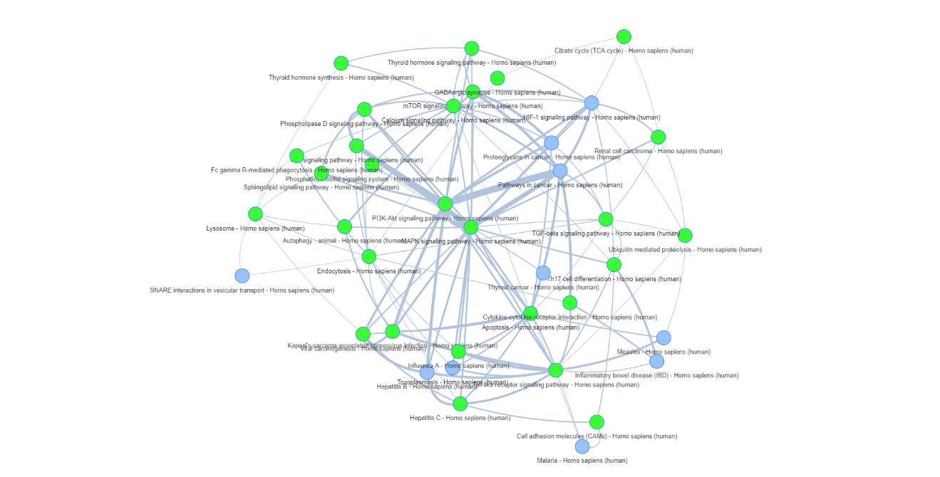

B1 CD subphenotype

Top 10 statistically significant pathways after enrichment
Description | Combined Score
SNARE interactions in vesicular transport | 6.965793
Malaria | 6.363446
Legionellosis | 5.887479
Pathogenic Escherichia coli infection | 5.579274
Inflammatory bowel disease (IBD) | 5.53752
Leishmaniasis | 5.013654
Pertussis | 4.483722
Salmonella infection | 4.201795
Rheumatoid arthritis | 4.214469
NF-kappa B signaling pathway | 4.072872

Newly associated pathways via the complementary network
Viral carcinogenesis, Kaposi's sarcoma-associated herpesvirus infection, Th17 cell differentiation, Phospholipase D signaling pathway, Shigellosis, Apoptosis, Ras signaling pathway, Hepatitis C, T cell receptor signaling pathway, Prion diseases, MAPK signaling pathway, Adherens junction, Autophagy, Bacterial invasion of epithelial cells, Thyroid hormone synthesis, Endocytosis, Lysosome, Cell adhesion molecules (CAMs), Vitamin digestion and absorption, Antifolate resistance, Bile secretion, TGF-beta signaling pathway, Sphingolipid signaling pathway, Fc gamma R-mediated phagocytosis, Phosphatidylinositol signaling system, Complement and coagulation cascades, Regulation of actin cytoskeleton, Tight junction, Endocrine and other factor-regulated calcium reabsorption, Vasopressin-regulated water reabsorption, Cytokine-cytokine receptor interaction
Visualization of the complementary network (green nodes = newly associated)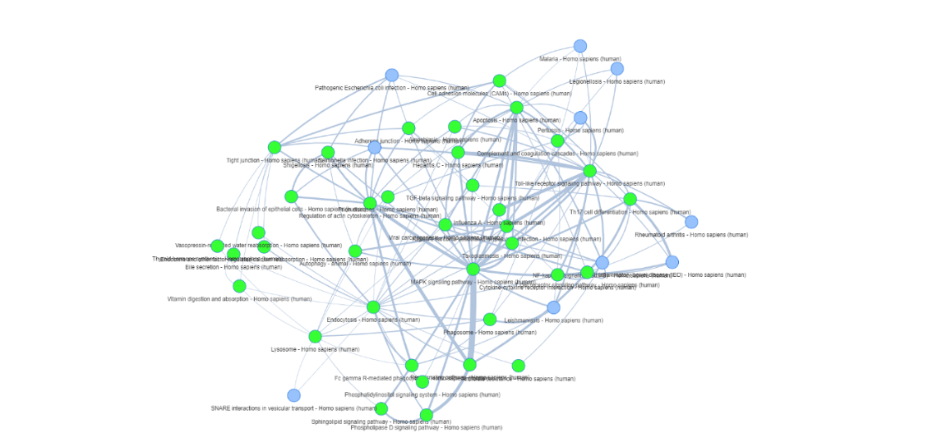

B2 CD subphenotype

Top 10 statistically significant pathways after enrichment
Description | Combined Score
Thyroid cancer | 8.243498
PPAR signaling pathway | 6.106493
Longevity regulating pathway | 6.148715
AMPK signaling pathway | 5.189774
Osteoclast differentiation | 5.218721
Transcriptional misregulation in cancer | 4.344855
Huntington's disease | 4.54671
Pathways in cancer | 3.67099

Newly associated pathways via the complementary network
Viral carcinogenesis, PI3K-Akt signaling pathway, NF-kappa B signaling pathway, Non-alcoholic fatty liver disease (NAFLD), Apoptosis, Hepatitis C, mTOR signaling pathway, MAPK signaling pathway, Jak-STAT signaling pathway, Insulin signaling pathway, Calcium signaling pathway, p53 signaling pathway, Basal transcription factors, Adipocytokine signaling pathway, Oxidative phosphorylation
Visualization of the complementary network (green nodes = newly associated)
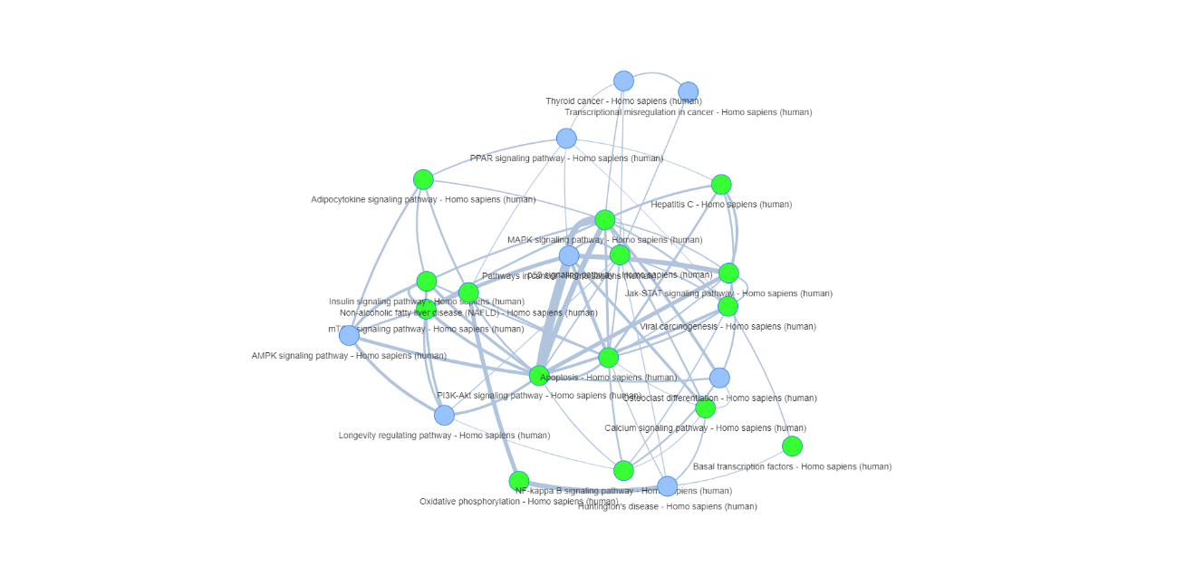

Ulcerative Colitis

Top 10 statistically significant pathways after enrichment
Description | Combined Score
SNARE interactions in vesicular transport | 8.144566
VEGF signaling pathway | 7.391471
B cell receptor signaling pathway | 6.845003
Choline metabolism in cancer | 5.999651
T cell receptor signaling pathway | 5.660978
Axon guidance | 4.947552
Osteoclast differentiation | 5.065285
Natural killer cell mediated cytotoxicity | 4.910702
Wnt signaling pathway | 4.849445
Hepatitis B | 4.891771

Newly associated pathways via the complementary network
Kaposi's sarcoma-associated herpesvirus infection, Pathways in cancer, Proteoglycans in cancer, Hepatocellular carcinoma, Focal adhesion, MAPK signaling pathway, Parathyroid hormone synthesis, secretion and action, Endocytosis, TGF-beta signaling pathway, p53 signaling pathway, Ubiquitin mediated proteolysis
Visualization of the complementary network (green nodes = newly associated)
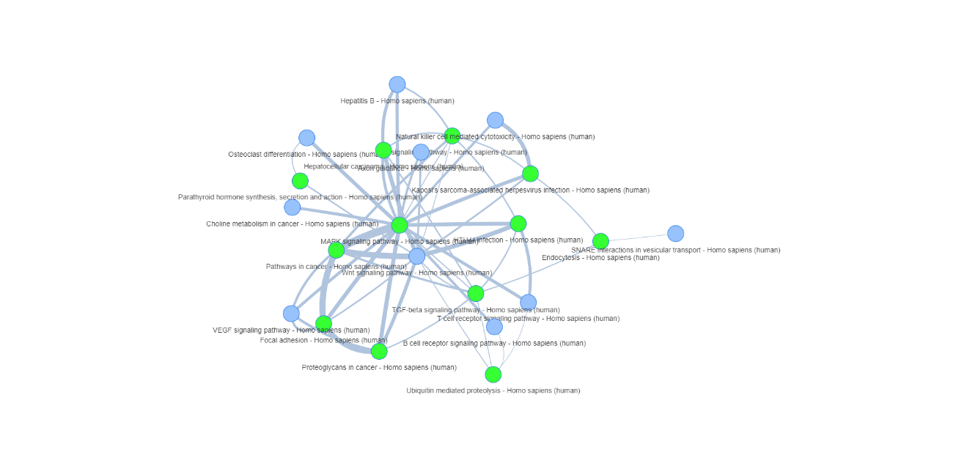

UC E1 subphenotype

Top 10 statistically significant pathways after enrichment
Description | Combined Score
Osteoclast differentiation | 13.097704
RIG-I-like receptor signaling pathway | 6.320374
Leishmaniasis | 6.659327
Leukocyte transendothelial migration | 5.284945
Phagosome | 4.740785

Newly associated pathways via the complementary network
PI3K-Akt signaling pathway, Epstein-Barr virus infection, Influenza A, NF-kappa B signaling pathway, Toll-like receptor signaling pathway, HTLV-I infection, Herpes simplex infection, Measles, Apoptosis, Hepatitis C, Systemic lupus erythematosus, Hepatitis B, MAPK signaling pathway, Jak-STAT signaling pathway, Rheumatoid arthritis, Endocytosis, Calcium signaling pathway, Cell adhesion molecules (CAMs), Fc gamma R-mediated phagocytosis, Intestinal immune network for IgA production, Complement and coagulation cascades, Regulation of actin cytoskeleton, Antigen processing and presentation, Ubiquitin mediated proteolysis
Visualization of the complementary network (green nodes = newly associated)
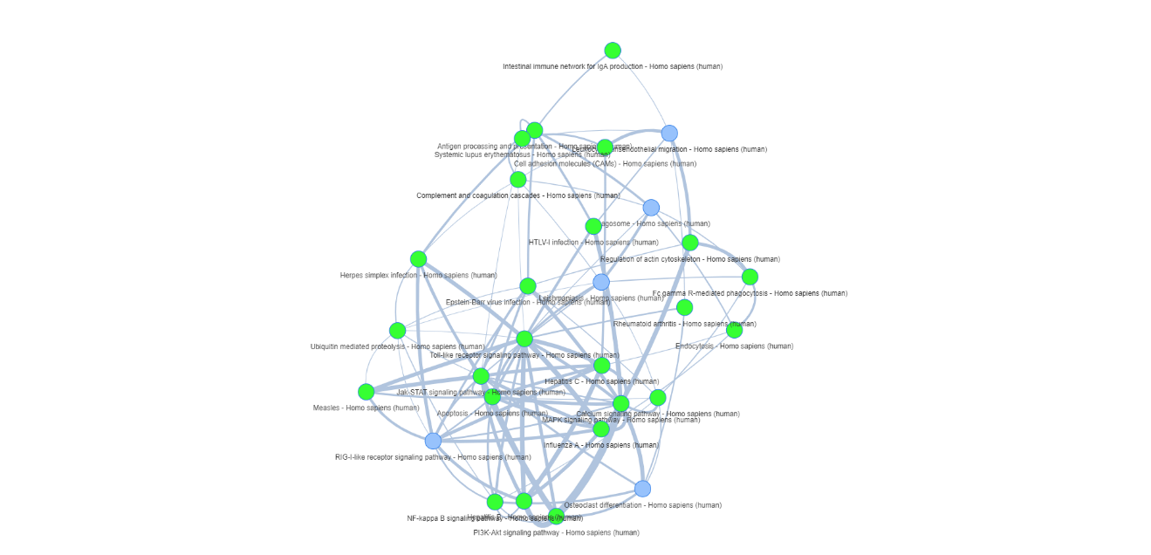

UC E3 subphenotype

Top 10 statistically significant pathways after enrichment
Description | Combined Score
SNARE interactions in vesicular transport | 7.54655
VEGF signaling pathway | 6.768247
B cell receptor signaling pathway | 6.240694
Choline metabolism in cancer | 5.421347
T cell receptor signaling pathway | 5.110807
Axon guidance | 4.438165
Osteoclast differentiation | 4.537768
Natural killer cell mediated cytotoxicity | 4.395839
Wnt signaling pathway | 4.333201
Hepatitis B | 4.366603

Newly associated pathways via the complementary network
Kaposi's sarcoma-associated herpesvirus infection, Pathways in cancer, Proteoglycans in cancer, Hepatocellular carcinoma, Focal adhesion, MAPK signaling pathway, Parathyroid hormone synthesis, secretion and action, Endocytosis, TGF-beta signaling pathway, p53 signaling pathway, Ubiquitin mediated proteolysis

Visualization of the complementary network (green nodes = newly associated)
