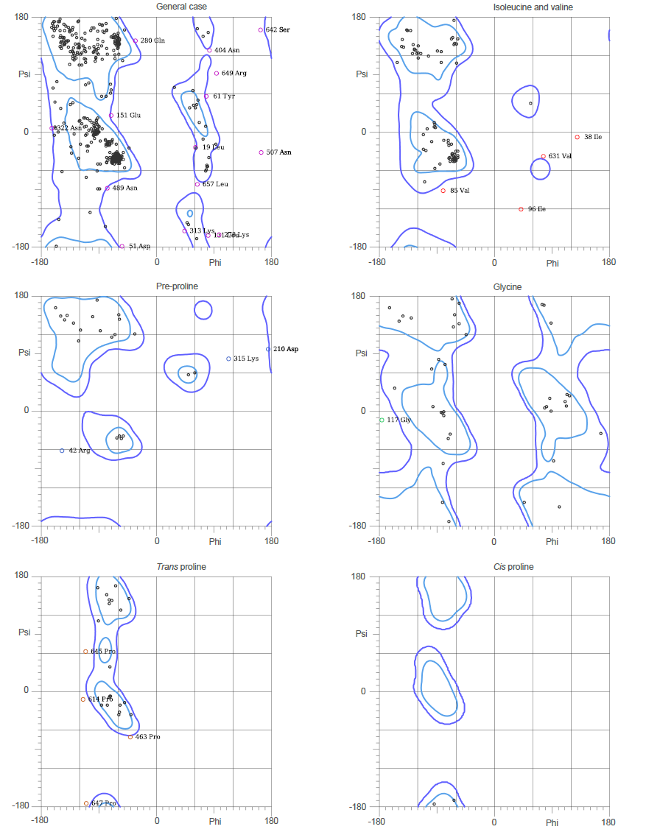

Figure S1. Ramachandran plot of the minimized structure. The most favorable regions and residues in the favored regions were shown in blue lines and dark gray points, respectively. Residues in less favorable regions were depicted in purple and red points.

