SUPPLEMENTARY FIGURES & TABLES

Supplementary Table: S1. The body weight of the mice in the experimental study.
Group | Initial Weight  (g) | Weight after STZ injection  (g) | Changes in body weight (%)
Group | Mean±SEM | Mean±SEM | Changes in body weight (%)
Control  (n=10) | 19.51 ± 0.27 | 21.39 ± 0.34 | 10.72 | Body Weight Gain
Model (T1DM)  (n=50) | 20.56 ± 0.14 | 19.63 ± 0.16 | -5.30 | Body Weight Loss

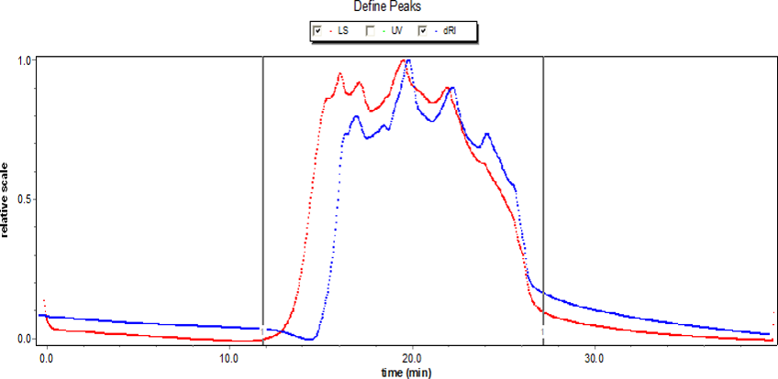
Supplementary Figure: S1. High performance liquid chromatography (HPLC) analysis of crude polysaccharide (CDDP) from seaweed, Dictyopteris divaricata.
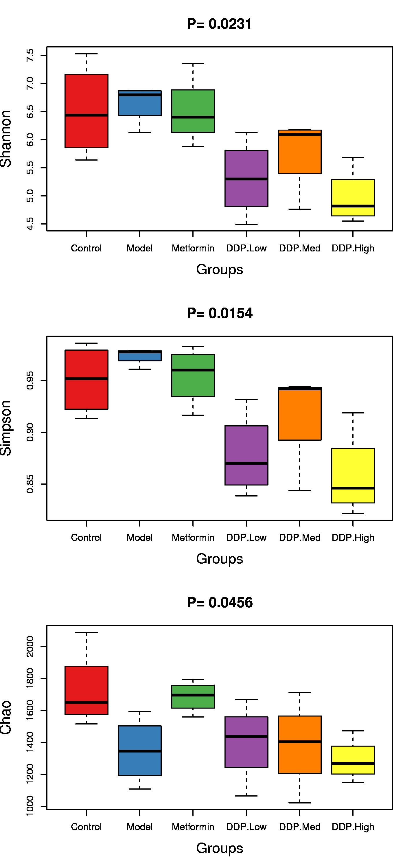
Supplementary Figure: S2. Box-plot of Shannon index (0.0231), Simpson index (0.0154) and Chao1 (0.0456) was plotted to observe the changes in species richness and evenness.

Supplementary Table: S2. List of Primers used for qPCR.
Cytokines | Primer | Sequence (5' - 3')
IL-1β | F | GAAATGCCACCTTTTGACAGTG
IL-1β | R | CTGGATGCTCTCATCAGGACA
IL-2 | F | CCTGAGCAGGATGGAGAATTACA
IL-2 | R | TCCAGAACATGCCGCAGAG
IL-6 | F | GAGGATACCACTCCCAACAGACC
IL-6 | R | AAGTGCATCATCGTTGTTCATACA
TNF-α | F | CATCTTCTCAAAATTCGAGTGACAA
TNF-α | R | TGGGAGTAGACAAGGTACAACCC
IFN-γ | F | TCAAGTGGCATAGATGTGGAAGAA
IFN-γ | R | TGGCTGTGCAGGATTTTCATG

^{*F = Forward Primer} ^{*R = Reverse Primer}

Supplementary Table: S3. The relative abundance (%) of all the phyla at phylum level.
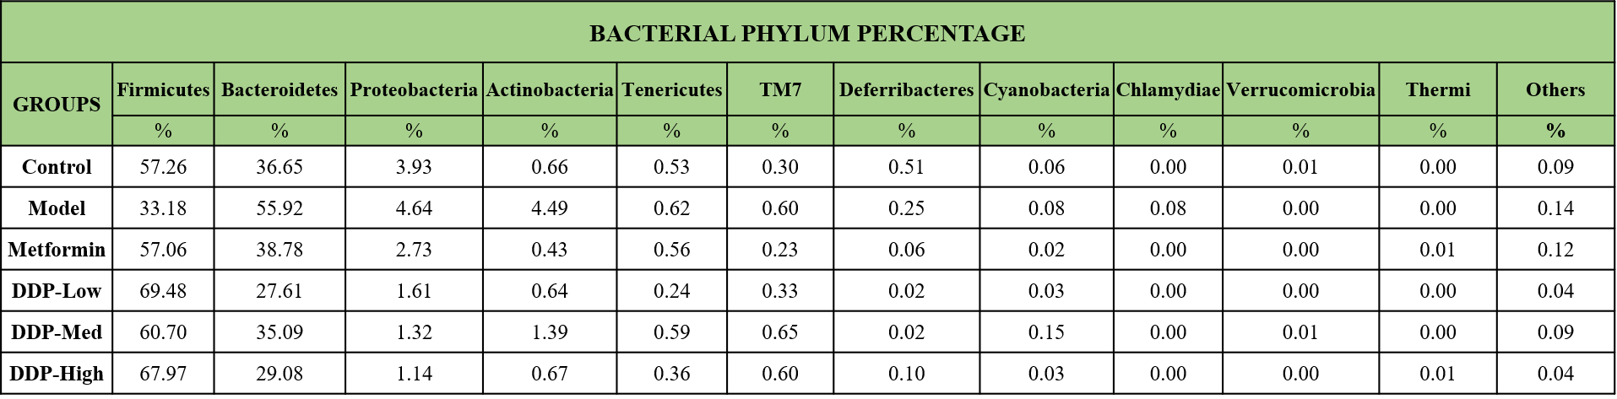

Supplementary Table: S4. The differences (%) between the proportion of bacteria at family level.
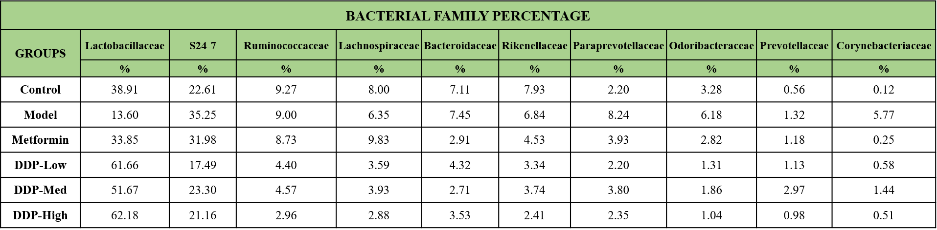

Supplementary table: S5. Representation of bacterial microbial community (%) at genus level.
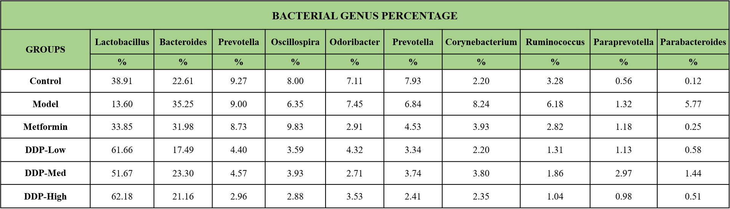

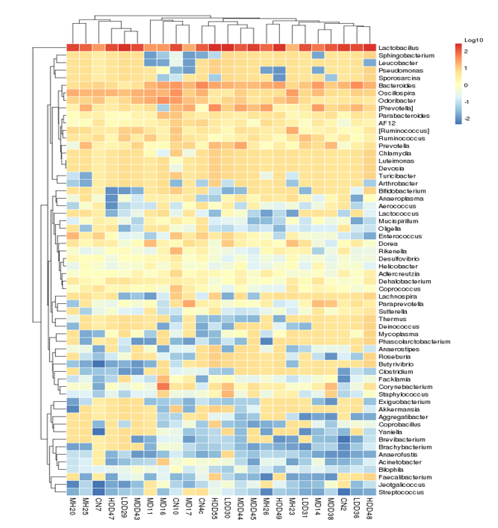
Supplementary Figure: S3. Heatmap of different taxa at genus level. Data represents the degree of similarity among the groups in the form of cluster and dissimilarity arranged individually. Data is a representative of twenty-four samples.

