Supplementary Materials
Network inference of gut microbial communities in a multiple sclerosis cohort with Mycobacterium avium subspecies paratuberculosis infection
Hajra Ashraf^{1,4}, Plamena Dikarlo², Aurora Masia³, Ignazio R. Zarbo³, Paolo Solla³, Umer Zeeshan Ijaz^{4,5,6,*}, Leonardo A. Sechi^{1,7,*}
¹Department of Biomedical Sciences; University of Sassari, Sassari, Italy
²BIOMES NGS GmbH, Schwartzkopffstraße 1, 15745, Halle 21, Wildau, Germany
³Department of Medicine and Pharmacy, Neurology, University of Sassari, Italy
⁴Water & Environment Research Group, University of Glasgow, Mazumdar-Shaw Advanced Research Centre, Glasgow, United Kingdom
⁵National University of Ireland, Galway, University Road, Galway, Ireland
⁶Department of Molecular and Clinical Cancer Medicine, University of Liverpool, Liverpool, United Kingdom
⁷ Complex Structure of Microbiology and Virology; AOU Sassari, Sassari, Italy

* Joint corresponding authors (both authors jointly directed this work)

Contact:
Hajra Ashraf, h.ashraf@studenti.uniss.it
Plamena Dikarlo, plamena.dikarlo@biomes.world
Aurora Masia, masia.aurora@tiscali.it
Ignazio R. Zarbo, irzarbo@uniss.it
Paolo Solla, psolla@uniss.it
Umer Zeeshan Ijaz*, Umer.Ijaz@glasgow.ac.uk (http://userweb.eng.gla.ac.uk/umer.ijaz)
Leonardo A. Sechi*, sechila@uniss.it

Having obtained the network topologies, we have calculated several network wide statistics using numerous R packages including igraph [1], influential [2], and centiserve [3]. These are summarised in Supplementary Table S1.
Supplementary Table S1: Key centrality measures employed to ascertain influential nodes recovered in this study.
Measure | Description | R’s Package
Degree centrality | The degree centrality of a node is simply its degree - the number of edges it has. The higher the degree, the more central the node is. | igraph
Closeness centrality | How close a given node is to any other node, and defined as the inverse of the average of the shortest path between a node and all other nodes | igraph
Betweenness centrality | The number of shortest paths passing through a node. | igraph
Eigenvector centrality | The importance of a node is recursively related to the importance of the nodes pointing to it. A higher value implies that a node’s neighbours are more prestigious than the neighbours of other nodes | igraph
Subgraph centrality | It sums up all closed walks weighting them by the inverse factorial of its length | igraph
Coreness | The k-core of a graph is a maximal subgraph in which each vertex has at least degree k. The coreness of a vertex is k if it belongs to the k-core but not to the (k+1)-core | igraph
Kleinberg’s authority centrality score | The authority scores of vertices are defined as principal eigenvector of t(A)*A, where A is the adjacency matrix of the network | igraph
Eccentricity | Shortest path distance from the farthest other node in the graph | igraph
Neighborhood Connectivity | Average number of edges connected to immediate neighbors | influential
H-index | Semi-local centrality measure inspired from its application in assessing the impact of researchers | influential
Local H-index | An improved version of the H-index centrality that leverages the H-index to the second order neighbors of a node | influential
Spreading Score | Spreading score reflects the spreading potential of each node within a network, and is calculated as  ${Spreading}_{{score}_{i}}=({NC}_{i}^{'}+{CR}_{i}^{'})({BC}_{i}^{'}+{CI}_{i}^{'})$ where ${NC}_{i}^{'}$, ${CR}_{i}^{'}$, ${BC}_{i}^{'}$, ${CI}_{i}^{'}$ are range normalized neighborhood connectivity, cluster rank, betweenness centrality, and collective influence of node i. A node with high spreading potential will disproportionally disrupt more secondary nodes than those that have a low spreading potential. | influential
Collective Influence | A global centrality measure that calculates the product of the reduced degree (degree – 1) of a node and the total reduced degree of all nodes at a distance d from the node. | influential
Cluster Rank | ClusterRank is a local centrality measure that makes a connection between local and semi-local characteristics of a node and at the same time removes the negative effects of local clustering. | influential
Integrated View of Influence (IVI) | A method for the identification of network most influential nodes  in a way that captures all network topological dimensions, and is calculated as  $${IVI}_{i}=({Hubness}_{{score}_{i}})({Spreading}_{{score}_{i}})$$ | influential
Hubness Score | Reflects the power of each node in its surrounding environment, and is calculated as ${Hubness}_{{score}_{i}}={DC}_{i}^{'}+{LH}_{{index}_{i}}^{'}$, where ${DC}_{i}^{'}$ and ${LH}_{{index}_{i}}^{'}$are ranged normalized degree centrality and local H index of node i, respectively. | influential
Topological coefficient | The extent to which a node shares neighbours with other nodes. | centiserve
Diffusion degree | The cumulative contribution score of the node itself and its neighbors. | centiserve
Density of maximum neighborhood component (DMNC) | It explores and identifies hubs/essential nodes in a network based on (23) | centiserve
Geodesic K-path centrality | Counts neighbours as those that are on a geodesic path less than "k" away | centiserve
Lin centrality | It considers closeness not as the inverse of a sum of distances, but rather than the inverse of the average distances | centiserve
Lobby Index | The l-index or lobby index of a node x is the largest integer k such that x has at least k neighbors with a degree of at least k | centiserve
Markov centrality score | The Markov centrality score uses the concept of a random walk through the graph to calculate the centrality of each vertex | centiserve
Latora closeness centrality | This variant (sum of inversed distances  to all other nodes instead of the inversed of the sum of distances to all other nodes) applicable to both connected and unconnected graphs | centiserve
Entropy centrality | Measures centrality of nodes depending on their contribution to the entropy of the graph | centiserve
Laplacian centrality | It is defined as the drop in the Laplacian energy (i.e. sum of squares of the eigenvalues in the Laplacian matrix) of the  graph when the vertex is removed. | centiserve
Leverage centrality | Leverage centrality considers the degree of a node relative to its neighbors and operates under the principle that a node in a network is central if its immediate neighbors rely on that node for information. | centiserve
Maximum neighborhood component (MNC) | The neighborhood of a node v, nodes adjacent to v, induce a subnetwork N(v).The score of node v, MNC(v), is defined to be the size of the maximum connected component of N(v). The neighborhood N(v) is the set of nodes adjacent to v and does not contain node v. | centiserve
Residual closeness centrality | Calculates the closeness of a vertex using (24) | centiserve

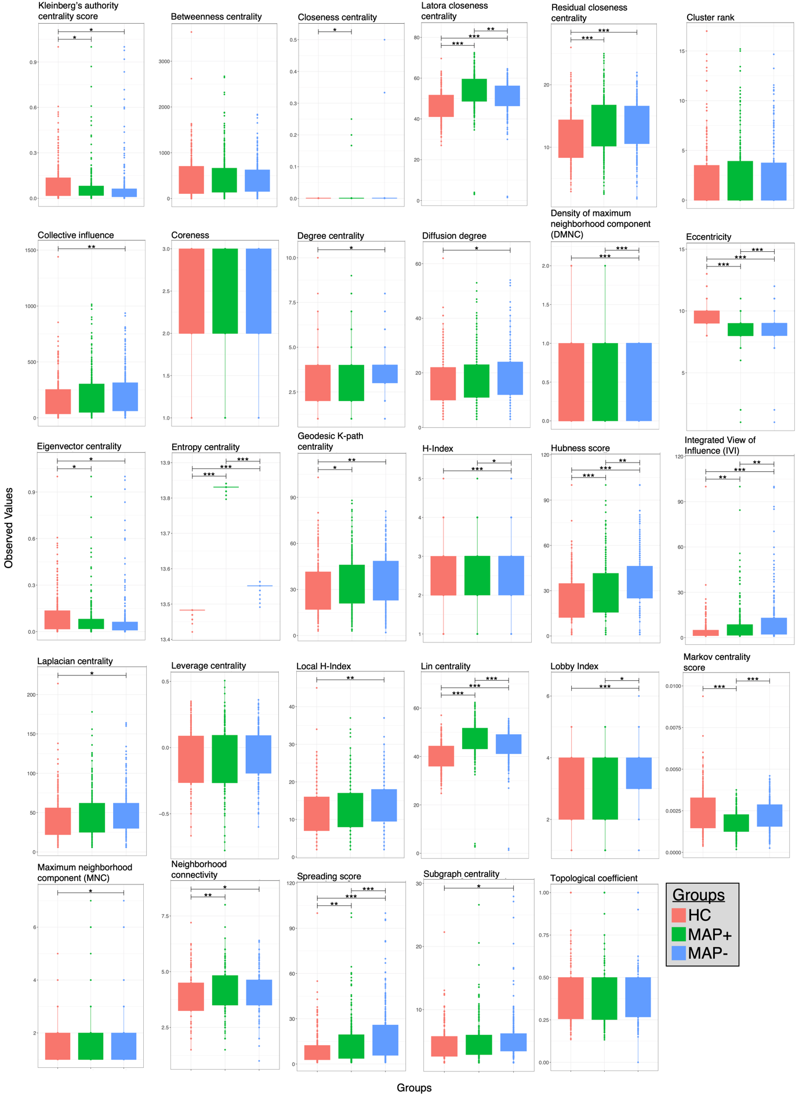
Supplementary Figure S1: Comparison of network-wide statistics for the networks obtained for HC, MAP+, and MAP- varieties. Lines for panels A and B connect two sample groups at statistically significant levels (ANOVA) indicated by asterisks as * (p < 0.05), **(p < 0.01) or ***(p < 0.001).

Supplementary Figure S2: 𝜷− coefficients returned from GLLVM procedure for covariates considered in this study, and the top 20 influential nodes returned for HC samples in Figure 1 using IVI metric. Those coefficients which are positively associated with the microbial abundance of a particular genera are represented in red color whilst those that are negatively associated are represented with blue color, respectively. Non-significant associations, if any, are represented with the black color. For categorical variables, one level acts as a reference and is annotated with REF. Genera also found influential for MAP+ and MAP- cohort are represented with red color, whilst those found in either of MAP- and MAP+ cohort are represented with green and blue colors, respectively.
Supplementary Figure S3: 𝜷− coefficients returned from GLLVM procedure for covariates considered in this study, and for the top 20 most influential nodes returned for MAP+ samples in Figure 2 using IVI metric. Those coefficients which are positively associated with the microbial abundance of a particular genera are represented in red color whilst those that are negatively associated are represented with blue color, respectively. Non-significant associations, if any, are represented with the black color. For categorical variables, one level acts as a reference and is annotated with REF. Genera also found influential for HC and MAP- cohort are represented with red color, whilst those found in either of MAP- and HC cohort are represented with green and blue colors, respectively.
Supplementary Figure S4: 𝜷− coefficients returned from GLLVM procedure for covariates considered in this study, and for the top 20 most influential nodes returned for MAP- samples in Figure 3 using IVI metric. Those coefficients which are positively associated with the microbial abundance of a particular genera are represented in red color whilst those that are negatively associated are represented with blue color, respectively. Non-significant associations, if any, are represented with the black color. For categorical variables, one level acts as a reference and is is annotated with REF. Genera also found influential for HC and MAP+ cohort are represented with red color, whilst those found in either of HC and MAP+ cohort are represented with blue color.
References:
- Csardi, G., & Nepusz, T. (2006). The igraph software package for complex network research. InterJournal, complex systems, 1695(5), 1-9.
- Salavaty, A., Ramialison, M., & Currie, P. D. (2020). Integrated value of influence: an integrative method for the identification of the most influential nodes within networks. Patterns, 1(5).
- Jalili, M., Salehzadeh-Yazdi, A., Asgari, Y., Arab, S. S., Yaghmaie, M., Ghavamzadeh, A., & Alimoghaddam, K. (2015). CentiServer: a comprehensive resource, web-based application and R package for centrality analysis. PloS one, 10(11), e0143111.

