Supplementary Figure S1. Alpha diversities of covariate groups.
*Statistically significant differences (p < 0.05). FHC, Finnish HC; FPDAC, Finnish PDAC; HC, healthy control; IHC, Iranian HC; IPDAC, Iranian PDAC; PDAC, pancreatic ductal adenocarcinoma.

- Both cohorts – All PC vs. All HC*
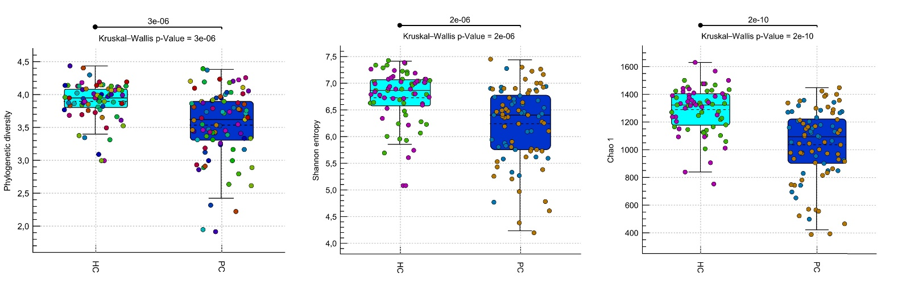
*
*
*

- Both cohorts – Population (Finnish/Iranian)
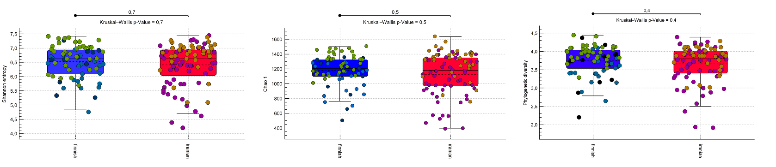

- Finnish cohort – Age (2 = 40-59, 3 = 60-80 years)
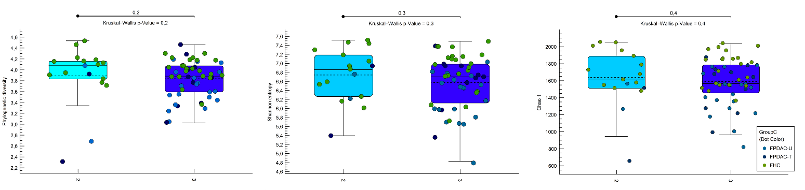

- Finnish cohort – Alcohol use (1 = no, 2 = yes)
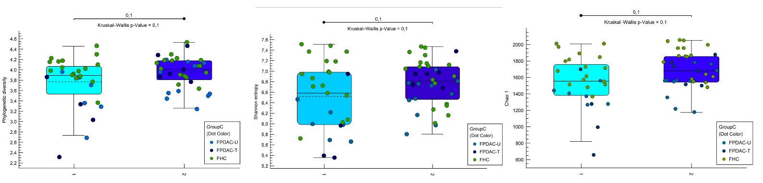

- Finnish cohort – Biliary stent (1 = no, 2 = yes)
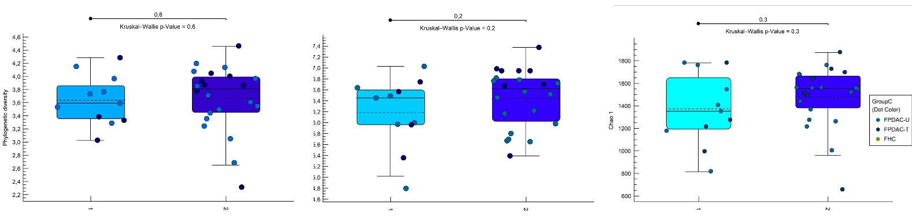

- Finnish cohort – BMI categorical (1 < 20 (underweight), 2 = 20-26,99 (normal), 3 = 27-29,99 (overweight), 4 > 30 (obese))*
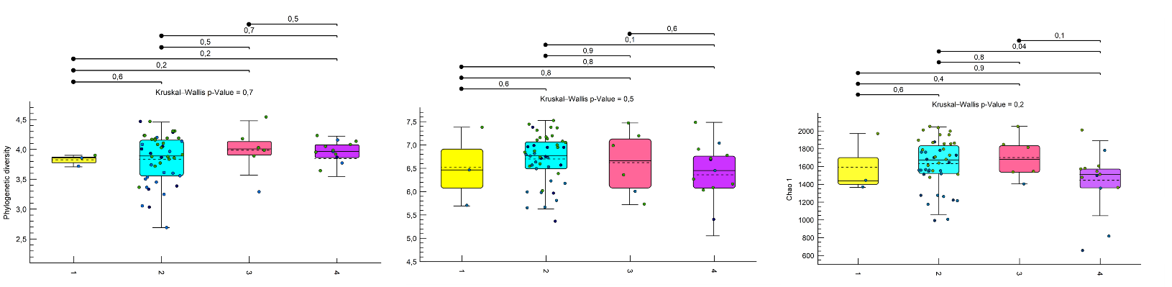
*

- Finnish cohort – Neoadjuvant treatment (1 = no, 2 = yes)
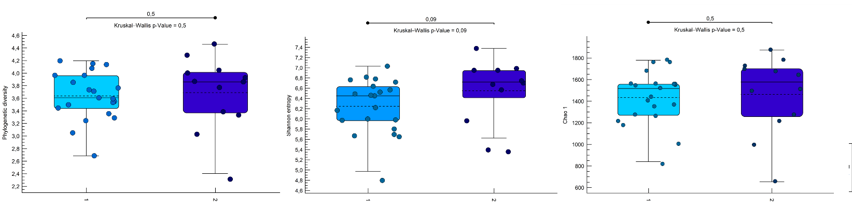
- Finnish cohort – Sex (f = female, m = male)
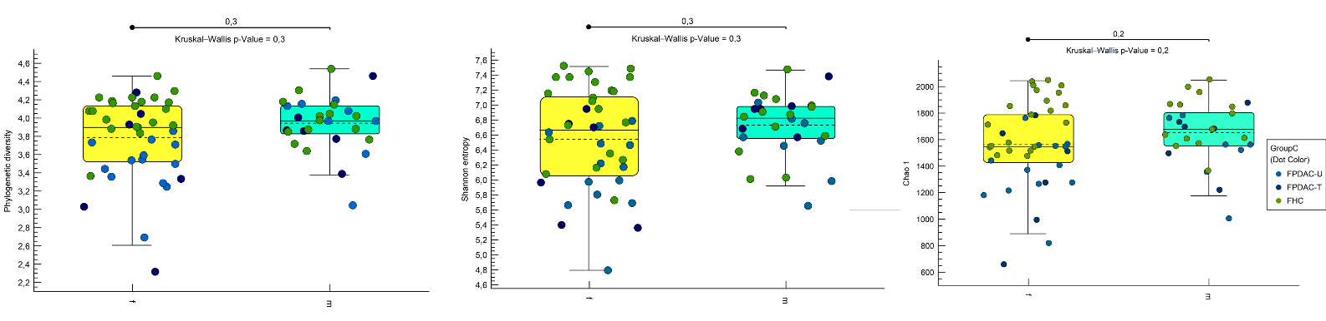

- Finnish cohort – Smokers (1 = no, 2 = yes)
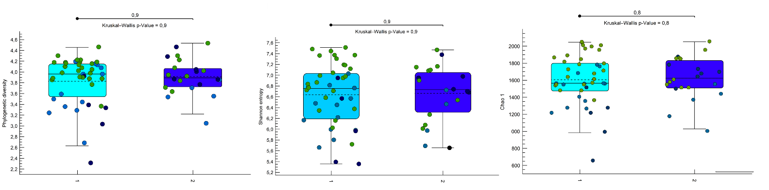
- Iranian cohort – Age (1 < 40, 2 = 40-59, 3 = 60-80 years)*
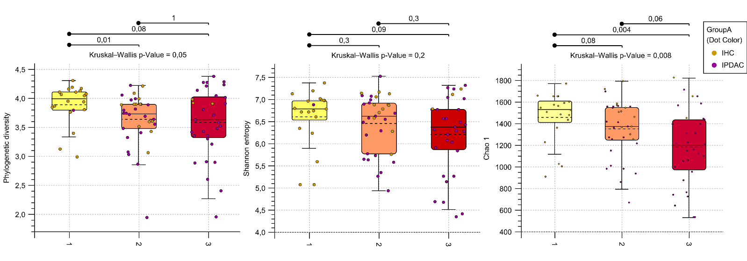
*
*

- Iranian cohort – Alcohol use (1 = no, 2 = yes)
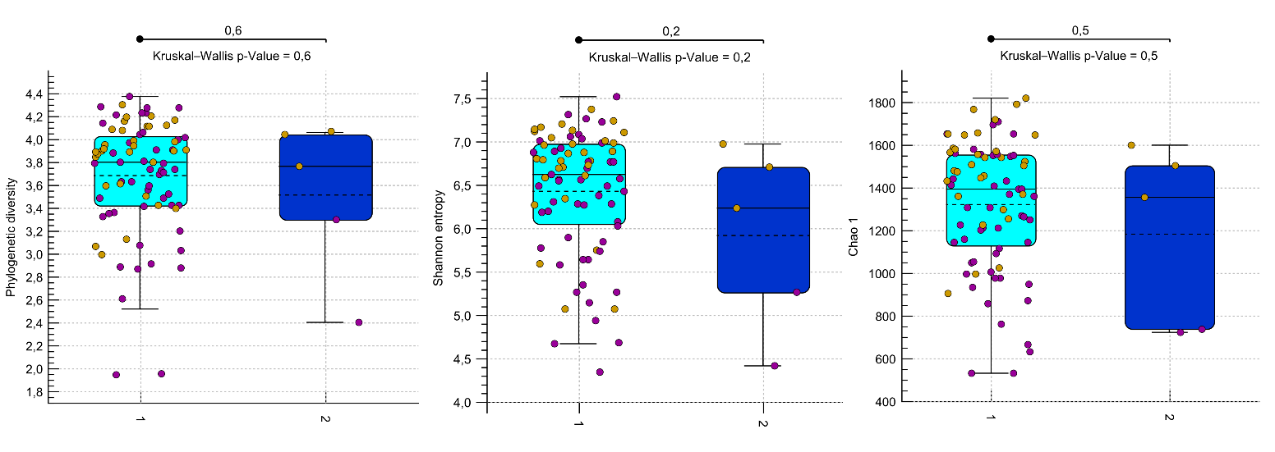
- Iranian cohort – Sex (f = female, m = male)
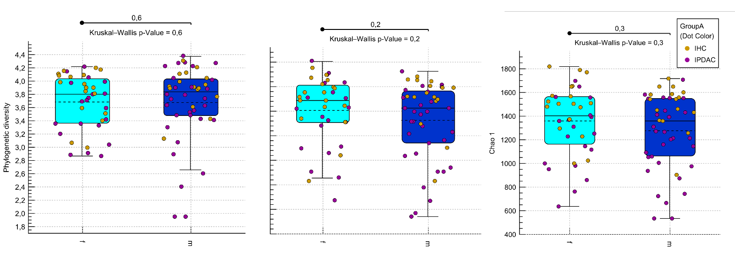
- Iranian cohort – Smokers (1 = no, 2 = yes)*




