Supplementary Figures 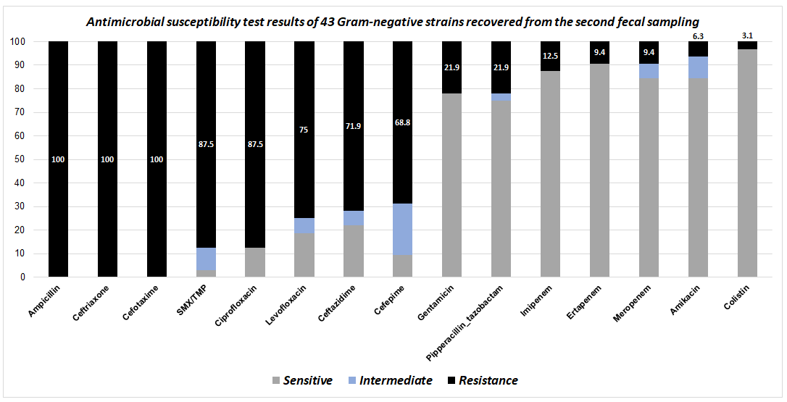
Figure S1. Results of antimicrobial susceptibility testing for 43 Gram-negative isolates obtained from the second fecal samples

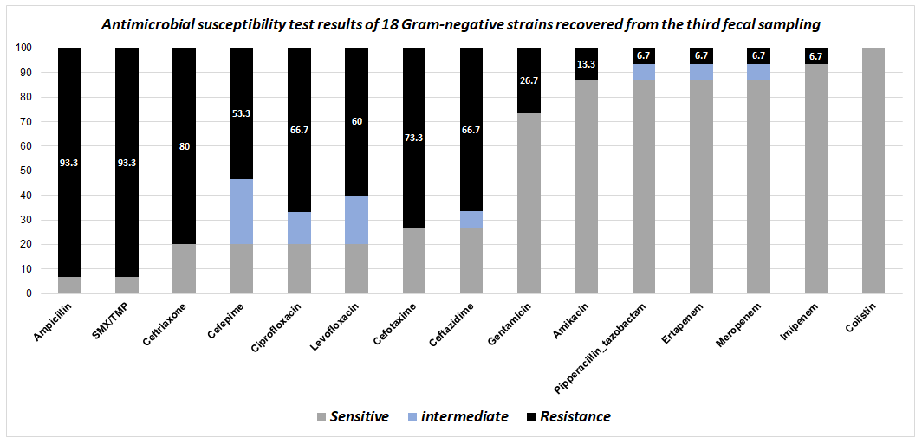
Figure S2. Results of antimicrobial susceptibility testing for 18 Gram-negative isolates obtained from the third fecal sample

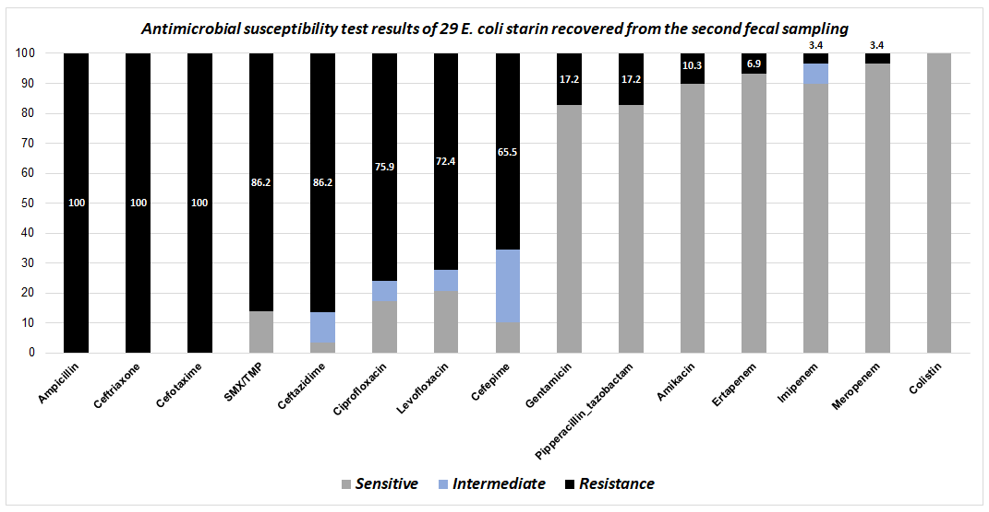
Figure S3. Results of antimicrobial susceptibility testing for 29 E. coli isolates obtained from the second fecal samples

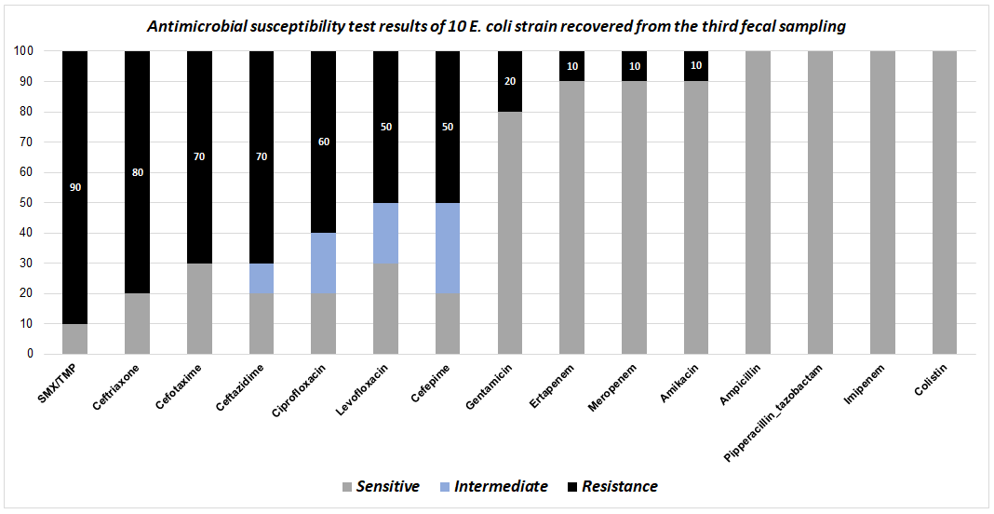
Figure S4. Results of antimicrobial susceptibility testing for 10 E. coli isolates obtained from the third fecal sample

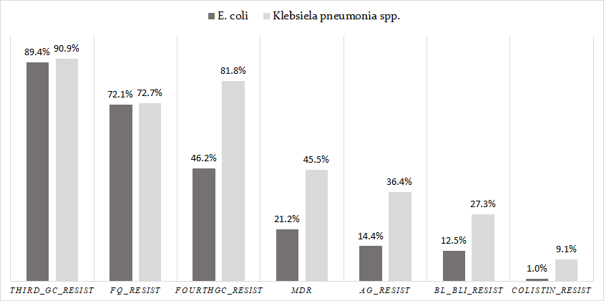
Figure S5. Comparative assessment for antibiotic resistance rate between E. coli and ‎K. pneumoniae ‎spp.‎ obtained from fecal samples

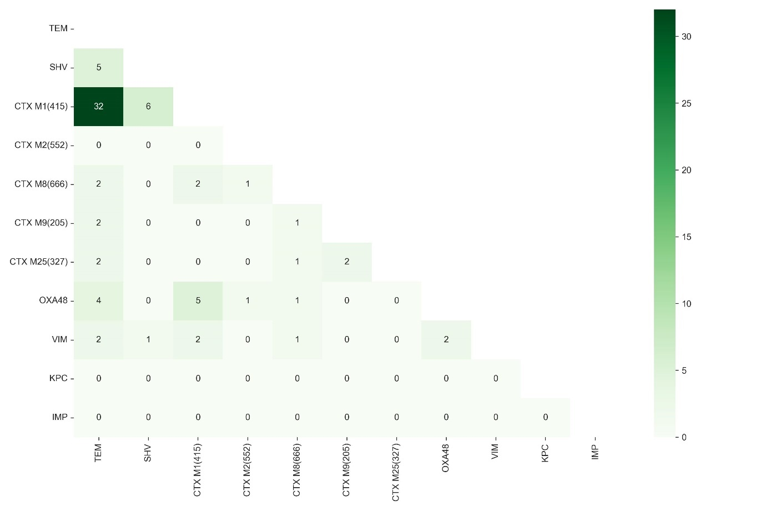
Figure S6. Co-occurrence of Resistance Genes

