Supplementary materials

Supplementary table 1: Characteristics according to ratio of intact to total provirus at inclusion

Characteristics | High  N = 14¹ | Low  N = 16¹ | Overall  N = 30¹ | p-value²
Sex |  |  |  | 0.7
Male | 9 (64%) | 9 (56%) | 18 (60%)
Female | 5 (36%) | 7 (44%) | 12 (40%)
Age (years) | 56 (44, 68) | 50 (44, 60) | 54 (44, 68) | 0.3
CD4⁺ T-cell count | 560 (270, 730) | 640 (470, 685) | 630 (290, 720) | 0.8
Nadir CD4⁺ T-cell count | 160 (70, 400) | 310 (179, 431) | 261 (80, 410) | 0.4
CD4⁺/CD8⁺ ratio | 0.87 (0.40, 1.74) | 1.09 (0.69, 1.38) | 1.05 (0.55, 1.40) | 0.6
HIV RNA <50 copies/ml | 12 (86%) | 15 (94%) | 27 (90%) | 0.5
Duration of ART (years) | 9 (4, 15) | 8 (4, 18) | 8 (4, 15) | 0.5
ART regimen |  |  |  | 0.6
INSTI-based | 11 (79%) | 14 (88%) | 25 (83%)
NNRTI-based | 3 (21%) | 2 (13%) | 5 (17%)
BMI (kg/m²) | 25.1 (21.0, 30.0) | 24.5 (22.9, 26.8) | 25.0 (22.9, 27.0) | 0.7
Diet |  |  |  | 0.7
Omnivorous | 13 (93%) | 15 (94%) | 28 (93%)
Others/Unknown | 1 (7.1%) | 0 (0%) | 1 (3.3%)
Vegetarian | 0 (0%) | 1 (6.3%) | 1 (3.3%)
Ethnicity |  |  |  | 0.4
Asian | 2 (14%) | 4 (25%) | 6 (20%)
Black | 1 (7.1%) | 3 (19%) | 4 (13%)
Caucasian | 11 (79%) | 8 (50%) | 19 (63%)
Latino | 0 (0%) | 1 (6.3%) | 1 (3.3%)
Route of transmission |  |  |  | 0.3
Heterosexual | 7 (50%) | 11 (69%) | 18 (60%)
MSM | 7 (50%) | 5 (31%) | 12 (40%)
Intact provirus | 193 (72, 391) | 36 (31, 53) | 60 (34, 196) | <0.001
5´defective provirus | 265 (138, 997) | 306 (163, 388) | 281 (142, 832) | 0.9
3´defective provirus | 282 (96, 902) | 143 (110, 257) | 190 (104, 342) | 0.2
Total defective provirus | 530 (229, 1,899) | 480 (274, 701) | 527 (272, 1,099) | 0.8
Total provirus | 679 (282, 2,230) | 526 (310, 762) | 632 (307, 1,138) | 0.4
Ratio intact-to-total provirus | 0.20 (0.18, 0.29) | 0.09 (0.05, 0.12) | 0.12 (0.08, 0.19) | <0.001
ART, antiretroviral therapy; INSTI, integrase strand transfer inhibitor; NNRTI, non-nucleoside analogue reverse transcriptase inhibitor; MSM, men who have sex with men; BMI, body mass index. CD4⁺ T-cell count (cells/mm³); Nadir CD4⁺ T-cell count (cells/mm³); provirus (proviral HIV DNA copies/million resting CD4⁺ T-cells).
¹ n (%); Median (Q1, Q3)
² Pearson’s Chi-squared test; Wilcoxon rank sum test; Fisher’s exact test; Wilcoxon rank sum exact test
³ False discovery rate correction for multiple testing

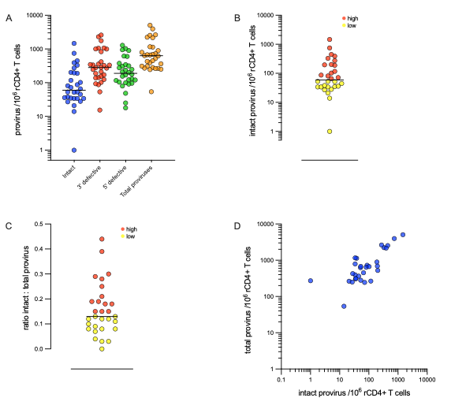
Supplementary Figure 1: Intact Proviral DNA Assay (IPDA) analysis of peripheral blood resting CD4⁺ T cells (rCD4⁺ T cells). (A) Frequencies of intact and defective proviruses per million rCD4⁺ T cells. Total proviruses were estimated with the sum of intact, 5′ defective, and 3′ defective proviruses from each participant. Horizontal lines indicate median values (n=30). Median values as cutoff for low and high groups of intact proviruses (60 copies/10⁶ rCD4⁺ T cells) (B) and ratio of intact to total proviruses (0.13) (C). (D) Correlation of intact to total proviruses per million rCD4⁺ T cells (spearman r=0.68, p<0.0001).

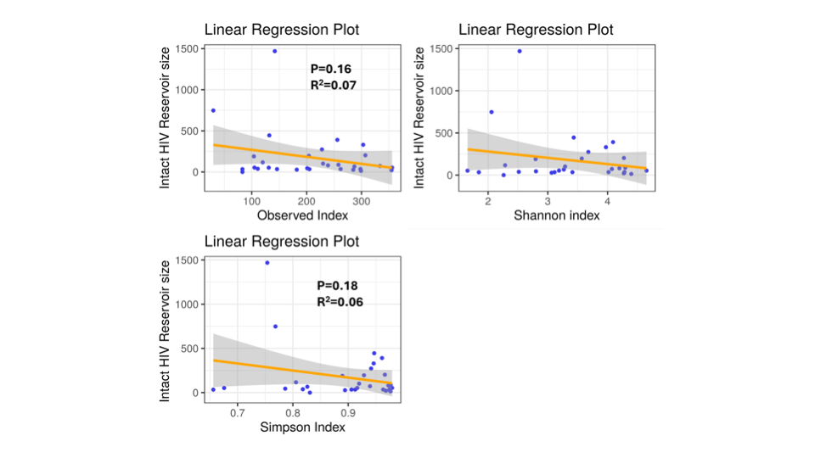
Supplementary Figure 2: Regression analysis plot showing the association between alpha diversity indices and intact proviral reservoir size.

A B
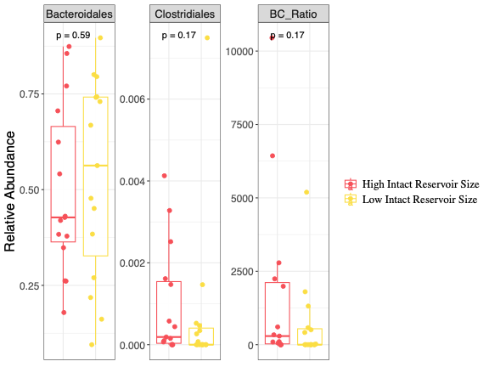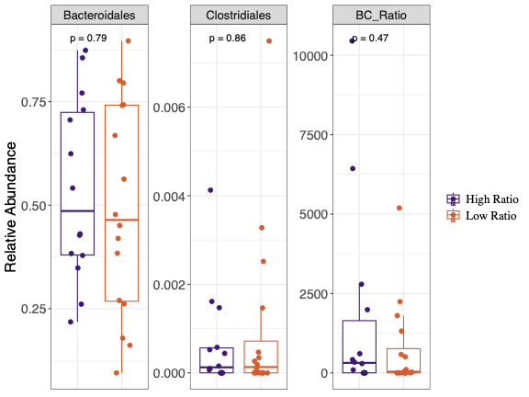
Supplementary Figure 3: Boxplot showing the differences in Bacteriodales, Clostridiales and Bacteriodales/Clostridiales ratio between high and low groups based on intact proviral reservoir size (A) and ratio of intact-to-total proviruses (B).

