Title: Systematic Review and Meta-analysis on the Prevalence of Cryptosporidiosis among Children in India.
Authors: Ann Mary Sebastian¹, Bijulal Aswathy¹, ER Sathya¹, Sananthya Karthikeyan¹, Muralidhara Rao Maradana¹*, Madhumitha Haridoss¹*
¹ Division of Medical Research, SRM Medical College Hospital & Research Centre, SRM Institute of Science & Technology, Kattankulathur, Chengalpattu, Tamil Nadu, India

Supplementary Material
Supplementary Tables: (1-4) Supplementary Figures: (1-11)

Supplementary Table 1. Search strategy and results in PubMed

Search # | Search Terms | Search Hits as on 14-05- 2024
#1 | Child OR School OR children OR Infants OR Newborn OR Childhood OR Juvenile OR Toddlers OR preschool OR Pre-school OR "Child"[Mesh] OR "Infant"[Mesh] OR "Child, Preschool"[Mesh] OR "Infant, Newborn"[Mesh] | 10,617,103
#2 | Cryptosporidiosis OR Cryptosporidioses OR Cryptosporidium OR Cryptosporidium spp OR Cryptosporidium parvum OR Cryptosporidium hominis OR C. parvum OR C. hominis OR "Cryptosporidiosis"[Mesh] | 18,839
#3 | Prevalence OR Epidemiology OR Occurrence OR “Prevalent Rate” OR cases OR incidence OR burden OR “incident rate” OR "Prevalence"[Mesh] OR "Epidemiology"[Mesh] OR "Incidence"[Mesh] OR “risk factor” | 6,671,153
#4 | India OR Indian OR "India"[Mesh] | 976,137
 | #1 AND #2 AND #3 AND #4 | 182

Supplementary Table 2. Search strategy and results in Scopus

Search # | Search Terms | Search Hits as of 14-05-2024
#1 | TITLE-ABS-KEY ( child OR school OR children OR infants OR newborn OR childhood OR juvenile OR toddlers OR preschool OR "pre school" ) | 5,751,977 results
#2 | ALL(cryptosporidiosis OR cryptosporidioses OR cryptosporidium ) | 54,193 results
#3 | ALL ( prevalence OR epidemiology OR occurrence OR "prevalent rate" OR cases OR incidence OR burden OR "incident rate" OR "risk factor" ) | 29,333,677 results
#4 | TITLE-ABS-KEY (india OR indian ) | 870,254 results
 | #1 AND #2 AND #3 AND #4 | 245 results

Supplementary Table 3. Search strategy and results in Google Scholar

Search # | Search Terms | Search hits as of 14-05-2024
#1 | India cryptosporidium
#2 | Child OR School OR children OR Infants OR Newborn OR Childhood OR Juvenile OR Toddlers OR preschool OR "Pre school"
#3 | Cattle OR buffalo OR lambs OR kids OR piglets OR livestock OR rodents OR tortoise OR horse OR cat
#4 | Anywhere in the article | 765 215 results

Supplementary Table 4: Table of exclusion with the corresponding reasons
S. No. | Study Label | Title | Exclusion Reason
1. | McMurry TL et al., 2021 (1) | Duration of Post diarrheal Enteric Pathogen Carriage in Young Children in Low-resource Settings. | Wrong Study settings
2 | Levine MM et al., 2020 (2) | Diarrhoeal disease and subsequent risk of death in infants and children residing in low-income and middle-income countries: analysis of the GEMS case-control study and 12-month GEMS-1A follow-on study. | Excluded during meta-analysis
3 | Rogawski ET et al., 2018 (3) | Use of quantitative molecular diagnostic methods to investigate the effect of enteropathogen infections on linear growth in children in low-resource settings: longitudinal analysis of results from the MAL-ED cohort study. | Excluded during meta-analysis
4 | Daniels ME et al., 2018 (4) | Estimating Cryptosporidium and Giardia disease burdens for children drinking untreated groundwater in a rural population in India. | Excluded during meta-analysis
5. | Korpe et al., 2018 (5) | Epidemiology and Risk Factors for Cryptosporidiosis in  Children From 8 Low-income Sites: Results From the  MAL-ED Study | Wrong Study type
6. | Mills JA et al., 2018 (6) | Use of quantitative molecular diagnostic methods to assess the aetiology, burden, and clinical characteristics of diarrhoea in children in low-resource settings: a reanalysis of the MAL-ED cohort study | Wrong Study type
7. | Operario DJ et al., 2017 (7) | Etiology of Severe Acute Watery Diarrhea in Children in the Global Rotavirus Surveillance Network Using Quantitative Polymerase Chain Reaction. | Excluded during meta-analysis
8. | Kattula D et al., 2017(8) | Natural History of Cryptosporidiosis in a Birth Cohort in Southern India | Wrong Study type
9. | Taneja et al., 2017 (9) | A perspective on infectious etiology of chronic diarrhoea in India | Full text unavailable
10. | Bhatia V et al., 2014 (10) | Prevalence of Cryptosporidium in immunocompetent Indian children with recurrent abdominal pain. | Full text unavailable
11. | Collinet S et al., 2015 (11) | Environmental Factors Associated with High Fly Densities and Diarrhea in Vellore, India. | Wrong exposure
12 | Lazarus R et al., 2015 (12) | Serum Anti-Cryptosporidial gp15 Antibodies in Mothers and Children Less than 2 Years of Age in India | Wrong Study type
13. | Bera P et al., 2014 (13) | Pathogen-specific burdens of community diarrhoea in  developing countries: a multisite birth cohort study (MAL-ED) | Wrong Study type
14. | Sarkar R et al., 2014 (14) | Risk factors for cryptosporidiosis among children in a semi urban slum in southern India: a nested case-control study. | Full text unavailable
15. | Kumar et al., 2014 (15) | Prevalence of intestinal parasitic infections in patients attending a tertiary care hospital in Eastern Bihar | Full text unavailable
16 | Sarkar R et al., 2013 (16) | Pathogen-specific burdens of community diarrhoea in  developing countries: a multisite birth cohort study (MAL-ED) | Wrong Study type
17. | Gupta et al., 2011 (17) | Intestinal coccidian parasitic infections in rural community in and around Loni, Maharashtra | Wrong exposure
18. | Ajjampur SS et al., 2010 (18) | Symptomatic and asymptomatic Cryptosporidium infections in children in a semi-urban slum community in southern India | Wrong Study type
19. | Mukherjee AK et al., 2009 (19) | Hospital-based surveillance of enteric parasites in Kolkata. | Excluded during meta-analysis
20. | Berry V et al., 2007 (20) | Cryptosporidiosis in children suffering from diarrhoel diseases in a hospital of Ludhiana. | Wrong publication type
21. | Ajjampur SS et al., 2007 (21) | Molecular and Spatial Epidemiology of Cryptosporidiosis in Children in a Semiurban Community in South India | Wrong Study type
22. | Bentley C et al., 2004 (22) | Relationship of cryptosporidiosis to abdominal pain and diarrhea in Mayan Indians. | Wrong Study settings
23. | Ballai M et al., 2002 (23) | Rotavirus and enteric pathogens in infantile diarrhoea in Manipal, South India. | Full text unavailable
24. | Nath G et al., 1999 (24) | Prevalence of Cryptosporidium associated diarrhea in a community. | Full text unavailable
25. | Sethi S et al., 1999 (25) | Cryptosporidiosis in a tertiary care hospital. | Full text unavailable
26. | Kang G et al., 1998 (26) | Prevalence of intestinal parasites in rural Southern Indians. | Excluded during meta-analysis
27. | Goyal A et al., 1997 (27) | Incidence of cryptosporidiosis in children with acute and persistent diarrhoea in and around Shimla. | Full text unavailable
28. | Khubnani H et al., 1997 (28) | Study of cryptosporidiosis in a rural area of Maharashtra. | Excluded during meta-analysis
29. | Coppola M et al., 1996 (29) | Intestinal parasitosis: our series from 1992 to 1995 | Full text unavailable
30. | Jindal N et al., 1995 (30) | A study of infective aetiology of chronic diarrhoea in children in Amritsar. | Full text unavailable
31. | Das P et al., 1993 (31) | Significance of Cryptosporidium as an aetiologic agent of acute diarrhoea in Calcutta: a hospital based study. | Full text unavailable
32. | Nath G et al., 1992 (32) | Childhood diarrhoea due to rotavirus in a community. | Full text unavailable
33. | Mahajan M et al., 1992 (33) | Cryptosporidiosis in east Delhi children. | Full text unavailable
34. | Mathew M et al., 1991 (34) | The relationship of microbial pathogens to acute infectious diarrhoea of childhood. | Full text unavailable
35. | Uppal B et al., 1991 (35) | Detection of cryptosporidium oocysts in acute diarrheal stools. | Full text unavailable
36. | Kaur N et al., 1991 (36) | Cryptosporidiosis in north Indian children. | Full text unavailable
37. | Pal S et al., 1991 (37) | The problems of acute diarrhoeal diseases in children in India. | Full text unavailable
38. | Constantiniu S et al., 1991 (38) | Studies of bacterial, rotaviral and Cryptosporidium etiology of acute diarrheal diseases in hospitalized children. | Full text unavailable
39. | Pal S et al., 1989 (39) | Occurrence and significance of Cryptosporidium infection in Calcutta. | Full text unavailable
40. | Subramanyam VR et al., 1989 (40) | Cryptosporidiosis in children of eastern India. | Full text unavailable
41. | Reinthaler FF et al., 1989 (41) | Epidemiology of cryptosporidiosis in children in tropical countries. | Full text unavailable
42. | Sehgal R et al., 1989 (42) | Cryptosporidium as a cause of diarrhoea in children | Full text unavailable
43. | Malla N et al., 1989 (43) | Cryptosporidiosis--the Indian scene. | Wrong publication type
44. | Sengupta P et al., 1988 (44) | Childhood diarrhoea associated with cryptosporidium species in a rural community near Calcutta. | Full text unavailable
45. | Saraswathi K et al., 1988 (45) | Prevalence of cryptosporidia in patients with diarrhoea in Bombay. | Full text unavailable
46. | Das P et al., 1987 (46) | Cryptosporidiosis in Bengali children with acute diarrhoea. | Excluded during Meta analysis
47. | Bartczak S et al., 1987 (47) | Cryptosporidiosis among children in developing countries. | Full text unavailable
48. | MH et al., 1948 (48) | Diarrhea | Wrong publication type

Supplementary Figure 1: Risk of bias of the included studies

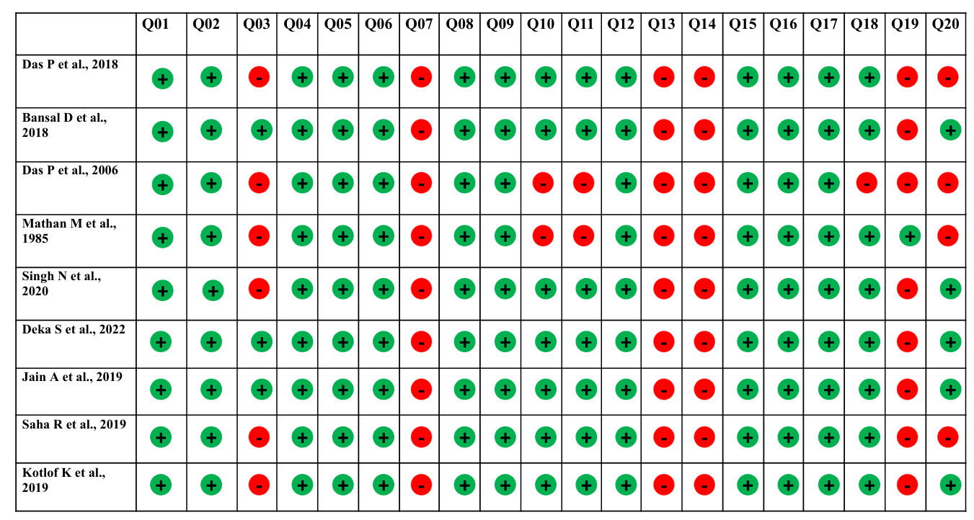

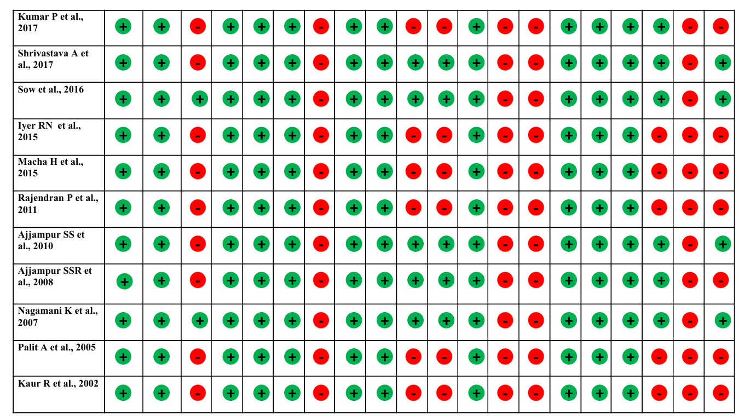

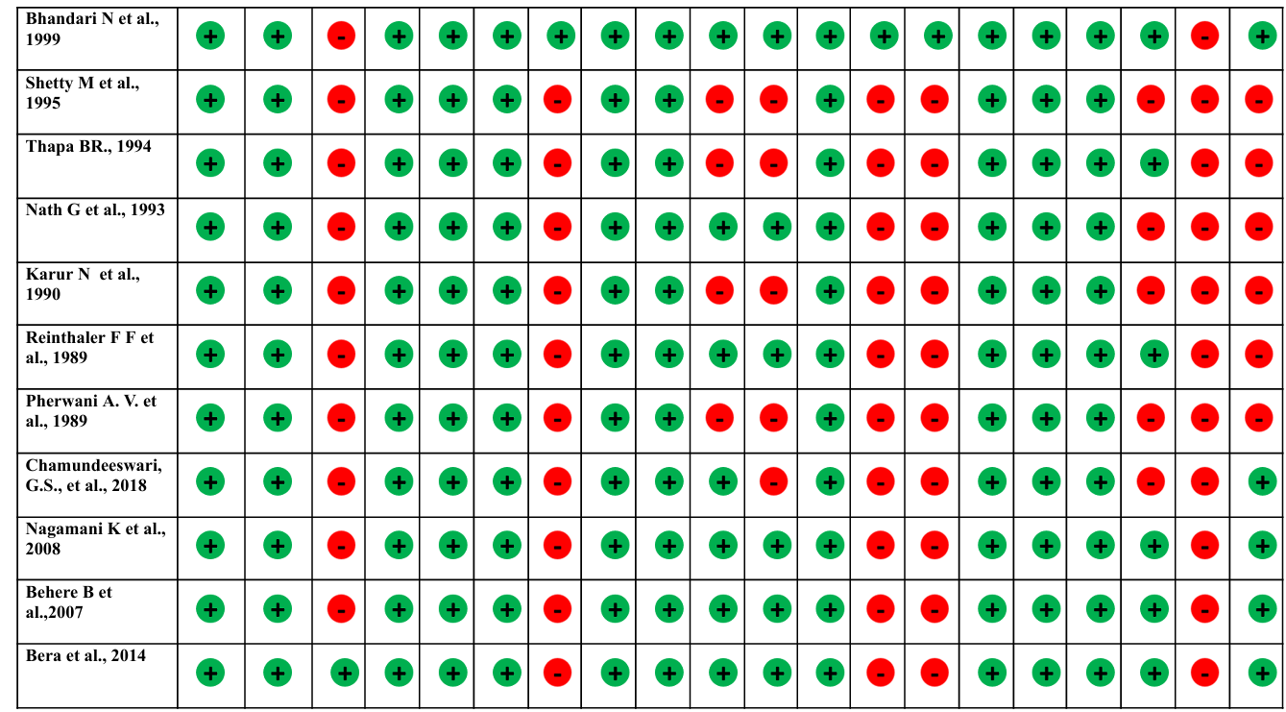

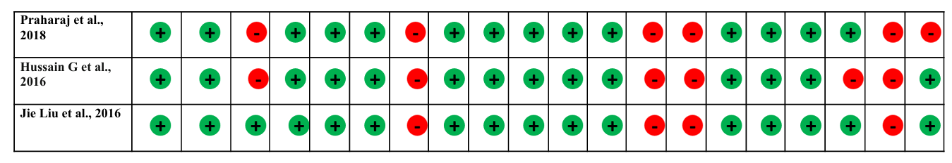

Questions used for risk of bias assessment:
Q1: Were the aim/objective of the study clear?
Q2: Was the study design appropriate for the stated aim?
Q3: Was the sample size justified?
Q4: Was the target /reference population clearly defined
Q5: Was the sample frame taken from an appropriate population base so that it is closely representative of the target/ reference population under investigation?
Q6: Was the selection process likely to select subjects / participants that were representative of the target/reference population under investigation?
Q7: Were measures undertaken to address and categorise non-responders?
Q8: Were the risk factor and outcome variables measured appropriate to the aims of the study?
Q9: Were the risk factor and outcome variables measured correctly using instruments/ measurements that had been trialled, piloted or published previously?
Q10: Is it clear what was used to determine statistical significance and/or precision estimates?
Q11: Were the methods (including statistical methods) sufficiently described to enable them to be repeated?
Q12: Were the basic data adequately described?
Q13: Does the response rate raise concerns about non-response bias?
Q14: If appropriate, was there information about the non-responders bias?
Q15: Were the results internally consistent?
Q16: Were the results presented for all the analyses described in the methods?
Q17: Were the author's discussion and conclusion justified by the results?
Q18: Were the limitations of the study discussed
Q19: Were there any funding sources or conflicts of interest that may affect the author's interpretation of the results?
Q20: Was the ethical approval or consent of the participants attained?

Supplementary Figure 2: Funnel Plot Showing Prevalence of Cryptosporidium Among Diarrheic Children. The plot demonstrates asymmetry, and Egger’s regression test did not demonstrate statistically significant evidence of publication bias With Test result: t = -1.55, df = 25, p-value = 0.1329. Bias estimate: -2.4791 (SE = 1.5960).
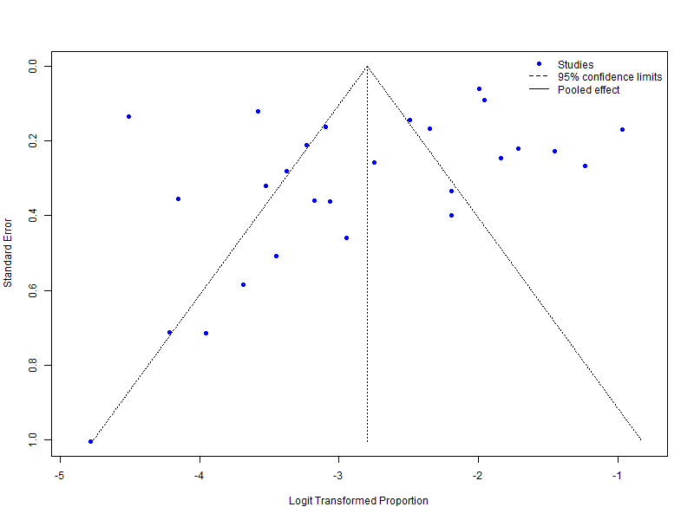
Supplementary Figure 3: Leave-one-out sensitivity analysis for a pooled prevalence of Cryptosporidium among diarrheic children.
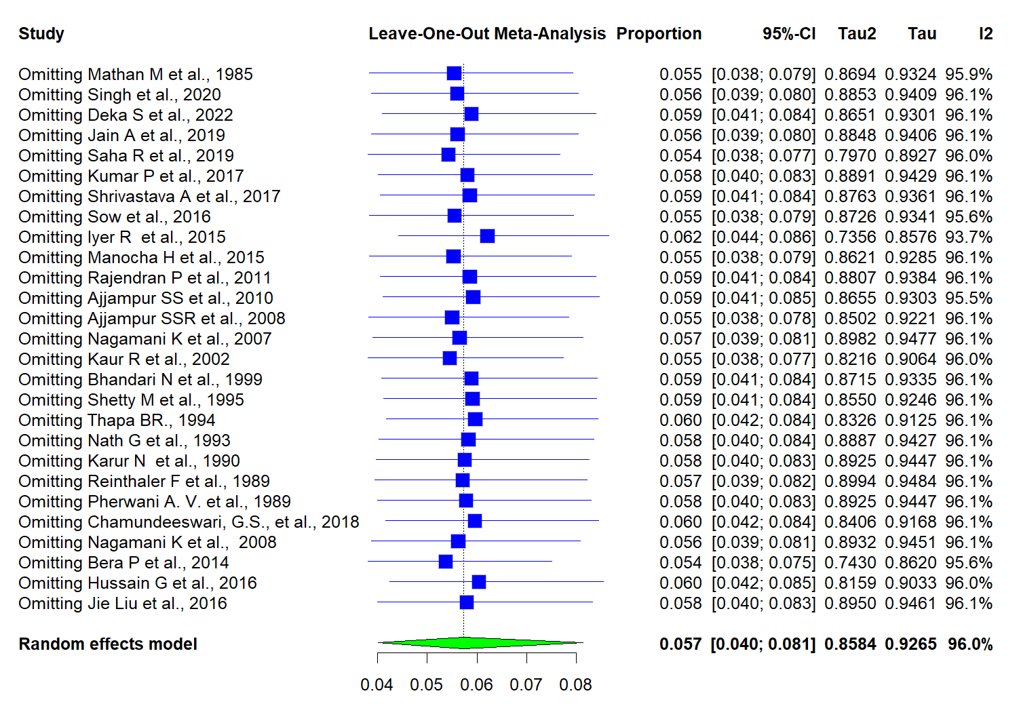

Supplementary Figure 4: Funnel Plot Showing Prevalence of Cryptosporidium Among Non-Diarrheic Children. The plot demonstrates asymmetry, and Egger’s regression test confirms the presence of significant small-study effects. Test result: t = -3.79, df = 12, p-value = 0.0026. Bias estimate: -2.5231 (SE = 0.6652), suggesting the presence of publication bias.
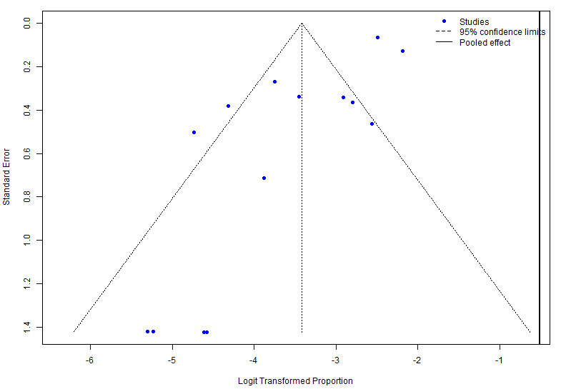

Supplementary Figure 5: Leave-one-out sensitivity analysis for a pooled prevalence of Cryptosporidium among non-diarrheic children
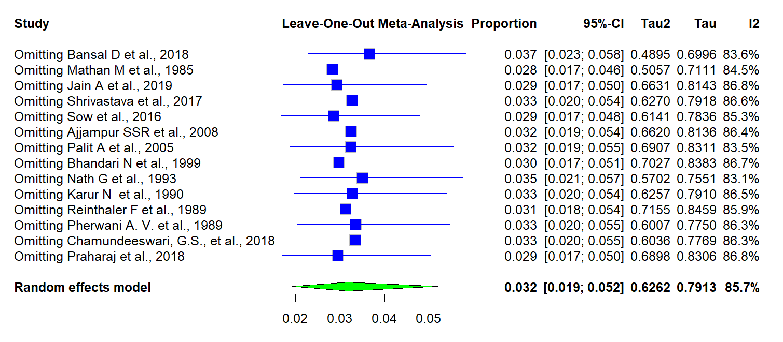

Supplementary Figure 6: Age-wise distribution of Cryptosporidium prevalence among diarrheic children (a) The forest plot representing the prevalence of Cryptosporidium among diarrheic children below 2 years. The pooled prevalence was determined as 8.8% (95 % CI: 5.3% – 14.1%, I² =87.4%). (b) The forest plot represents the prevalence of Cryptosporidium among diarrheic children between 2 – 5 years. The pooled prevalence was determined to be 6.0% (95% CI: 3.3% -11.0%, I² = 72.5%). (c) The forest plot represents the prevalence of Cryptosporidium among diarrheic children aged above 5 years. The pooled prevalence was determined to be 3.6% (95% CI: 1.9% - 6.7%, I² = 51.3%).

(a)

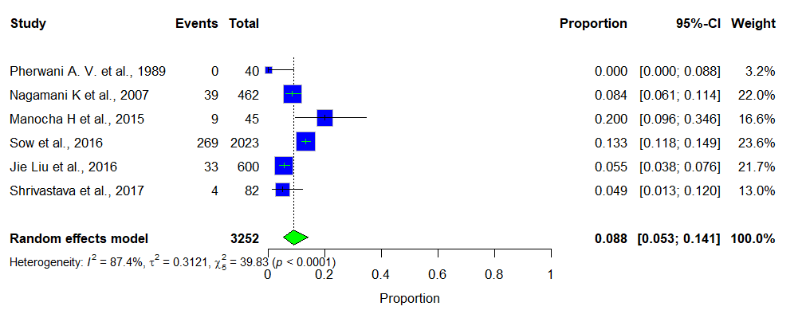
(b)

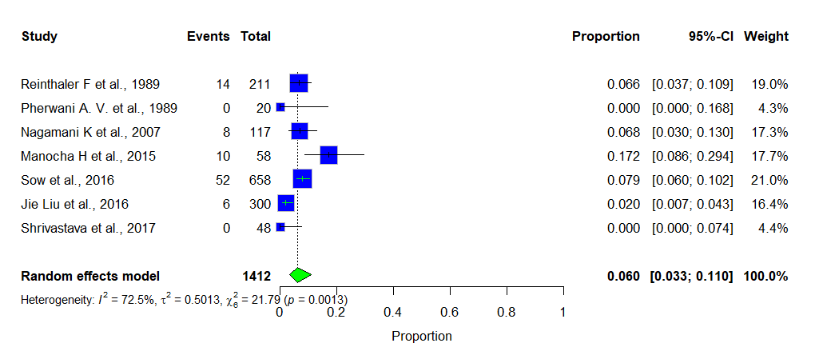

(c)

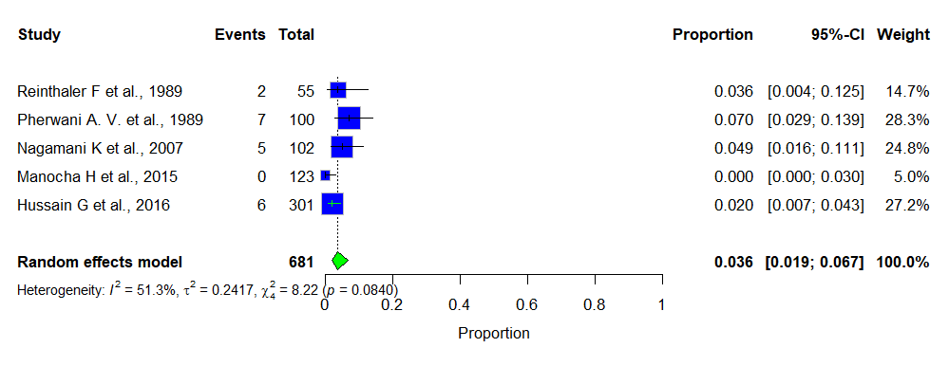

Supplementary Figure 7: Age-wise distribution of Cryptosporidium prevalence among non-diarrheic children.

(a) The forest plot represents the prevalence of Cryptosporidium among non-diarrheic children below 2 years. The pooled prevalence was determined as 4.5% (95% CI: 2.8% - 7.2%, I² = 50.2%). (b) The forest plot represents the prevalence of Cryptosporidium among non-diarrheic children between 2 – 5 years. The pooled prevalence was determined to be 3.6% (95% CI: 1.2% - 10.2%, I² = 81.4%). (c) The forest plot represents the prevalence of Cryptosporidium among non-diarrheic children above 5 years. The pooled prevalence was determined to be 1.6 % (95% CI: 0.5% - 4.8%, I² = 0.0%).

(a)

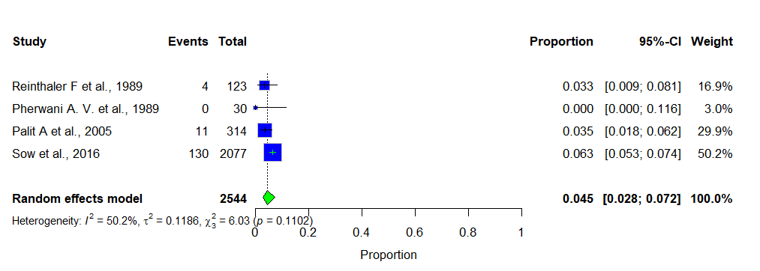

(b)

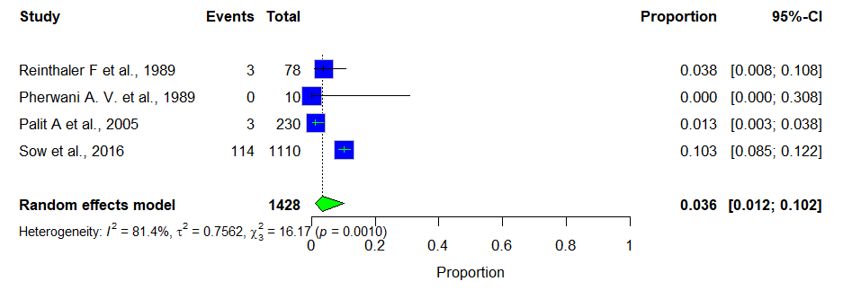

(c)

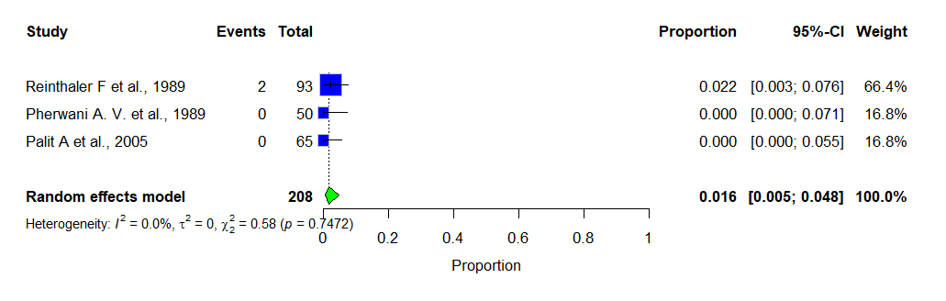

Supplementary Figure 8: Forest plot showing the prevalence of Cryptosporidium among various diagnostic methods.

(a)Forest plot showing the prevalence of Cryptosporidium among various diagnostic methods in the diarrheic population. (b) Forest plot showing the prevalence of Cryptosporidium among various diagnostic methods in the non-diarrheic population.

(a)

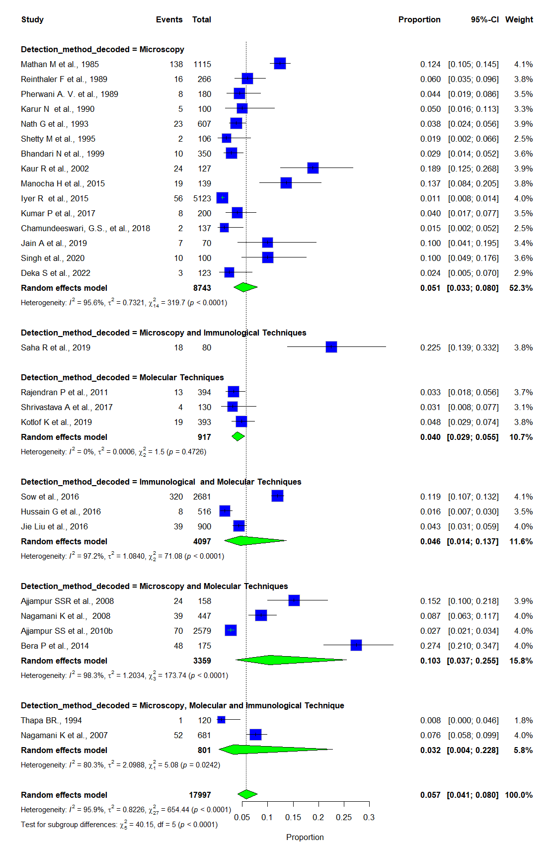

(b)

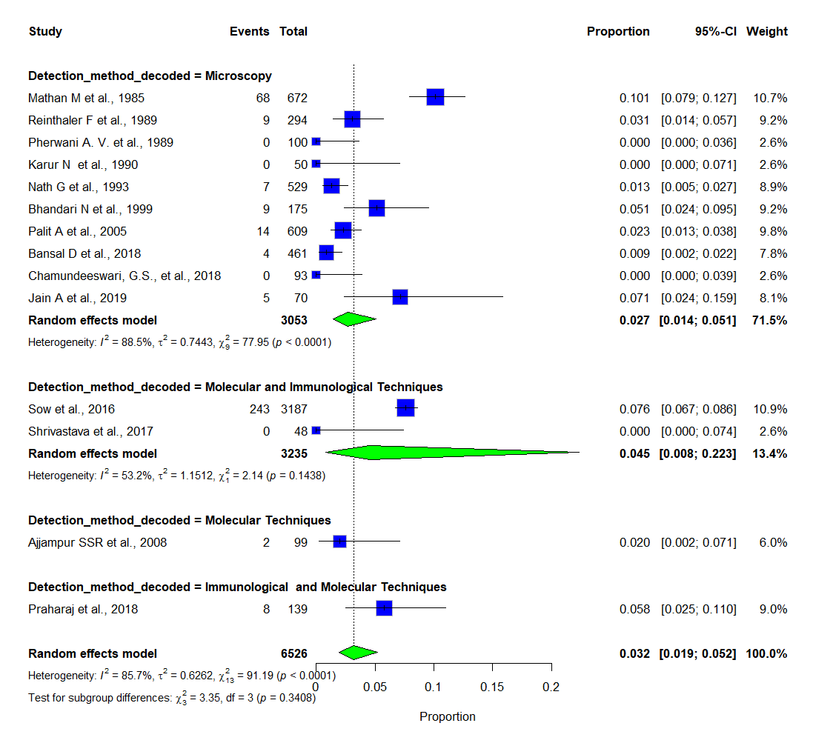

Supplementary Figure 9: Forest plot showing the prevalence of Cryptosporidium stratified by study decades.

(a)Forest plot showing the prevalence of Cryptosporidium stratified by study decades among the diarrheic population. (b) Forest plot showing the prevalence of Cryptosporidium stratified by study decades among the non- diarrheic population.

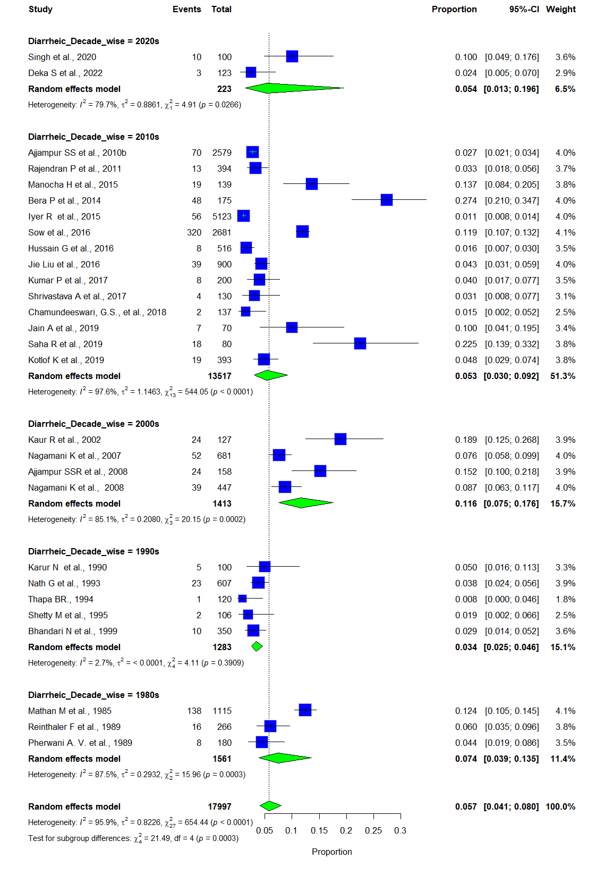

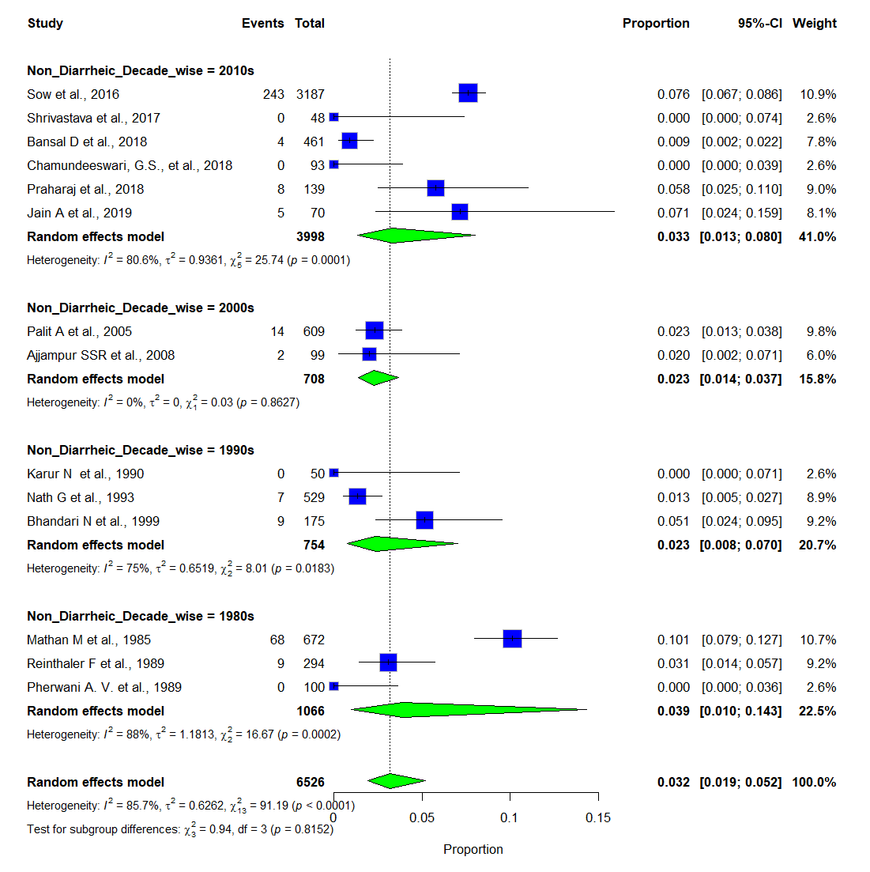

Supplementary Figure 10: Forest plot showing the prevalence of Cryptosporidium stratified by study settings.

(a)Forest plot showing the prevalence of Cryptosporidium stratified by study settings among the diarrheic population. (b) Forest plot showing the prevalence of Cryptosporidium stratified by study settings among the non- diarrheic population.

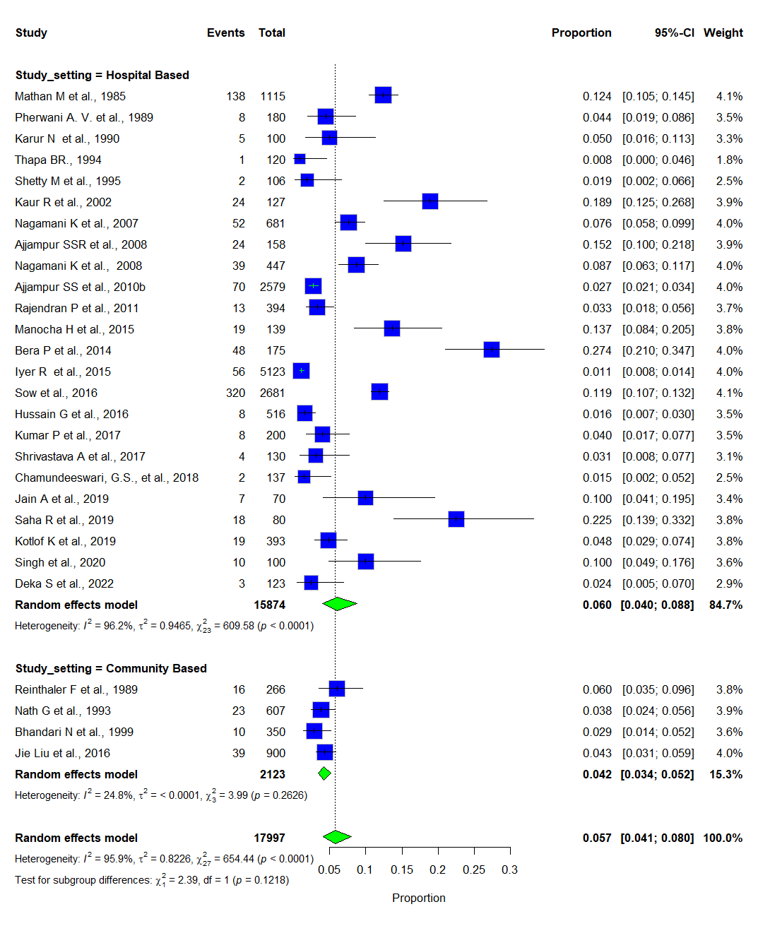

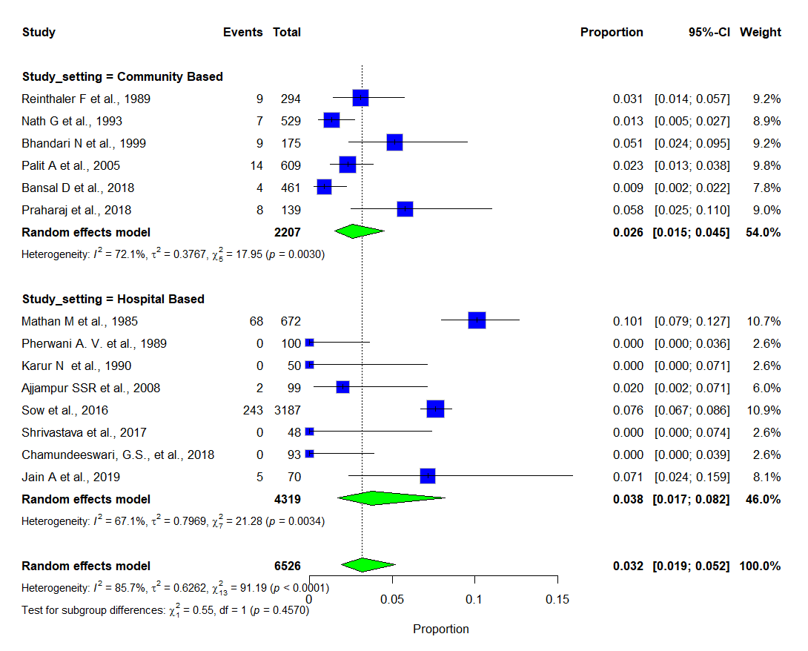

Supplementary Figure 11: Geographical representation of 34 included studies on India map.

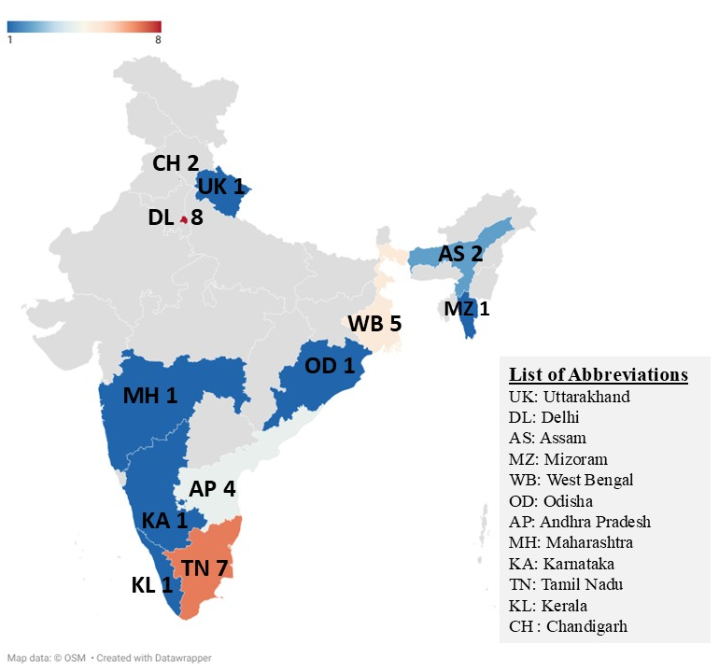

References:

1. McMurry TL, McQuade ETR, Liu J, Kang G, Kosek MN, Lima AAM, et al. Duration of Postdiarrheal Enteric Pathogen Carriage in Young Children in Low-resource Settings. Clin Infect Dis Off Publ Infect Dis Soc Am. 2021 June 1;72(11):e806–14.
2. Levine MM, Nasrin D, Acácio S, Bassat Q, Powell H, Tennant SM, et al. Diarrhoeal disease and subsequent risk of death in infants and children residing in low-income and middle-income countries: analysis of the GEMS case-control study and 12-month GEMS-1A follow-on study. Lancet Glob Health. 2020 Feb;8(2):e204–14.
3. Rogawski ET, Liu J, Platts-Mills JA, Kabir F, Lertsethtakarn P, Siguas M, et al. Use of quantitative molecular diagnostic methods to investigate the effect of enteropathogen infections on linear growth in children in low-resource settings: longitudinal analysis of results from the MAL-ED cohort study. Lancet Glob Health. 2018 Dec;6(12):e1319–28.
4. Daniels ME, Smith WA, Jenkins MW. Estimating Cryptosporidium and Giardia disease burdens for children drinking untreated groundwater in a rural population in India. PLoS Negl Trop Dis. 2018 Jan;12(1):e0006231.
5. Korpe PS, Valencia C, Haque R, Mahfuz M, McGrath M, Houpt E, et al. Epidemiology and Risk Factors for Cryptosporidiosis in Children From 8 Low-income Sites: Results From the MAL-ED Study. Clin Infect Dis Off Publ Infect Dis Soc Am. 2018 Nov 13;67(11):1660–9.
6. Platts-Mills JA, Liu J, Rogawski ET, Kabir F, Lertsethtakarn P, Siguas M, et al. Use of quantitative molecular diagnostic methods to assess the aetiology, burden, and clinical characteristics of diarrhoea in children in low-resource settings: a reanalysis of the MAL-ED cohort study. Lancet Glob Health. 2018 Dec;6(12):e1309–18.
7. Operario DJ, Platts-Mills JA, Nadan S, Page N, Seheri M, Mphahlele J, et al. Etiology of Severe Acute Watery Diarrhea in Children in the Global Rotavirus Surveillance Network Using Quantitative Polymerase Chain Reaction. J Infect Dis. 2017 July 15;216(2):220–7.
8. Kattula D, Jeyavelu N, Prabhakaran AD, Premkumar PS, Velusamy V, Venugopal S, et al. Natural History of Cryptosporidiosis in a Birth Cohort in Southern India. Clin Infect Dis Off Publ Infect Dis Soc Am. 2017 Feb 1;64(3):347–54.
9. Taneja et al.,. A perspective on infectious etiology of chronic diarrhoea in India. 2017;
10. Bhatia V, Kapoor A, Sibal A. Prevalence of Cryptosporidium in immunocompetent Indian children with recurrent abdominal pain. Trop Gastroenterol Off J Dig Dis Found. 2014;35(4):277.
11. Collinet-Adler S, Babji S, Francis M, Kattula D, Premkumar PS, Sarkar R, et al. Environmental Factors Associated with High Fly Densities and Diarrhea in Vellore, India. Appl Environ Microbiol. 2015 Sept 1;81(17):6053–8.
12. Lazarus RP, Ajjampur SSR, Sarkar R, Geetha JC, Prabakaran AD, Velusamy V, et al. Serum Anti-Cryptosporidial gp15 Antibodies in Mothers and Children Less than 2 Years of Age in India. Am J Trop Med Hyg. 2015 Nov;93(5):931–8.
13. Bera P, Das S, Saha R, Ramachandran VG, Shah D. Cryptosporidium in children with diarrhea: a hospital-based Study. Indian Pediatr. 2014 Nov;51(11):906–8.
14. Sarkar R, Kattula D, Francis MR, Ajjampur SSR, Prabakaran AD, Jayavelu N, et al. Risk factors for cryptosporidiosis among children in a semi urban slum in southern India: a nested case-control study. Am J Trop Med Hyg. 2014 Dec;91(6):1128–37.
15. Kumar et al.,. Prevalence of intestinal parasitic infections in patients attending a tertiary care hospital in Eastern Bihar. 2014;
16. Sarkar R, Ajjampur SSR, Prabakaran AD, Geetha JC, Sowmyanarayanan TV, Kane A, et al. Cryptosporidiosis among children in an endemic semiurban community in southern India: does a protected drinking water source decrease infection? Clin Infect Dis Off Publ Infect Dis Soc Am. 2013 Aug;57(3):398–406.
17. Gupta AK. Intestinal coccidian parasitic infections in rural community in and around Loni, Maharashtra. J Parasit Dis Off Organ Indian Soc Parasitol. 2011 June;35(1):54–6.
18. Ajjampur SSR, Sarkar R, Sankaran P, Kannan A, Menon VK, Muliyil J, et al. Symptomatic and asymptomatic Cryptosporidium infections in children in a semi-urban slum community in southern India. Am J Trop Med Hyg. 2010 Nov;83(5):1110–5.
19. Mukherjee AK, Chowdhury P, Bhattacharya MK, Ghosh M, Rajendran K, Ganguly S. Hospital-based surveillance of enteric parasites in Kolkata. BMC Res Notes. 2009 June 19;2:110.
20. Berry V, Sagar V. Cryptosporidiosis in children suffering from diarrhoel diseases in a hospital of Ludhiana. Indian J Public Health. 2007;51(2):136.
21. Ajjampur SSR, Gladstone BP, Selvapandian D, Muliyil JP, Ward H, Kang G. Molecular and spatial epidemiology of cryptosporidiosis in children in a semiurban community in South India. J Clin Microbiol. 2007 Mar;45(3):915–20.
22. Bentley C, Laubach H, Spalter J, Ginter E, Jensen L. Relationship of cryptosporidiosis to abdominal pain and diarrhea in Mayan Indians. Rev Inst Med Trop Sao Paulo. 2004;46(4):235–7.
23. Ballal M, Shivananda PG. Rotavirus and enteric pathogens in infantile diarrhoea in Manipal, South India. Indian J Pediatr. 2002 May;69(5):393–6.
24. Nath G, Singh TB, Singh SP. Prevalence of Cryptosporidium associated diarrhea in a community. Indian Pediatr. 1999 Feb;36(2):180–3.
25. Sethi S, Sehgal R, Malla N, Mahajan RC. Cryptosporidiosis in a tertiary care hospital. Natl Med J India. 1999;12(5):207–9.
26. Kang G, Mathew MS, Rajan DP, Daniel JD, Mathan MM, Mathan VI, et al. Prevalence of intestinal parasites in rural Southern Indians. Trop Med Int Health TM IH. 1998 Jan;3(1):70–5.
27. Goyal A, Thakur R, Singh T, Kanga A, Sharma V. Incidence of cryptosporidiosis in children with acute and persistent diarrhoea in and around Shimla. J Commun Dis. 1997 Mar;29(1):67–8.
28. Khubnani H, Sivarajan K, Khubnani AH. Study of cryptosporidiosis in a rural area of Maharashtra. Indian J Pathol Microbiol. 1997 Jan;40(1):33–6.
29. Coppola MG, Ercolini D, Romano I, Iannaccone P, Altier S. [Intestinal parasitosis: our series from 1992 to 1995]. Infez Med. 1996;4(4):221–7.
30. Jindal N, Arora R, Bhushan B, Arora S. A study of infective aetiology of chronic diarrhoea in children in Amritsar. J Indian Med Assoc. 1995 May;93(5):169–70.
31. Das P, Sengupta K, Dutta P, Bhattacharya MK, Pal SC, Bhattacharya SK. Significance of Cryptosporidium as an aetiologic agent of acute diarrhoea in Calcutta: a hospital based study. J Trop Med Hyg. 1993 Apr;96(2):124–7.
32. Nath G, Singh SP, Sanyal SC. Childhood diarrhoea due to rotavirus in a community. Indian J Med Res. 1992 Nov;95:259–62.
33. Mahajan M, Mathur M, Talwar V. Cryptosporidiosis in east Delhi children. J Commun Dis. 1992 Sept;24(3):133–7.
34. Mathew M, Mathan MM, Mani K, George R, Jebakumar K, Dharamsi R, et al. The relationship of microbial pathogens to acute infectious diarrhoea of childhood. J Trop Med Hyg. 1991 Aug;94(4):253–60.
35. Uppal B, Natarajan R. Detection of cryptosporidium oocysts in acute diarrheal stools. Indian Pediatr. 1991 Aug;28(8):917–20.
36. Kaur N, Diwan N. Cryptosporidiosis in north Indian children. Indian J Med Sci. 1991 June;45(6):143–5.
37. Pal SC. The problems of acute diarrhoeal diseases in children in India. Indian J Public Health. 1991;35(2):31–7.
38. Constantiniu S, Avram G, Ambăruş A, Zavate O. Studies of bacterial, rotaviral and Cryptosporidium etiology of acute diarrheal diseases in hospitalized children. Roum Arch Microbiol Immunol. 1991;50(1):53–60.
39. Pal S, Bhattacharya SK, Das P, Chaudhuri P, Dutta P, De SP, et al. Occurrence and significance of Cryptosporidium infection in Calcutta. Trans R Soc Trop Med Hyg. 1989;83(4):520–1.
40. Subramanyam VR, Broadhead RL, Pal BB, Pati JB, Mohanty G. Cryptosporidiosis in children of eastern India. Ann Trop Paediatr. 1989 June;9(2):122–5.
41. Reinthaler FF. Epidemiology of cryptosporidiosis in children in tropical countries. J Hyg Epidemiol Microbiol Immunol. 1989;33(4 Suppl):505–13.
42. Sehgal R, Rai SK, Sharma P, Malla N, Gangully NK, Wallia BNS, et al. Cryptosporidium as a cause of diarrhoea in children. Indian J Med Microbiol. 1989;7(3):130–2.
43. Malla N, Sehgal R, Ganguly NK, Mahajan RC. Cryptosporidiosis--the Indian scene. Indian J Pediatr. 1989;56(1):6–7.
44. Sengupta PG, Mondal S, Gupta DN, Sarkar S, Saha NC, Ghosh S, et al. Childhood diarrhoea associated with cryptosporidium species in a rural community near Calcutta. Indian J Public Health. 1988;32(4):205–6.
45. Saraswathi K, Pandit DV, Deodhar LP, Bichile LS. Prevalence of cryptosporidia in patients with diarrhoea in Bombay. Indian J Med Res. 1988 Mar;87:221–4.
46. Das P, Pal S, Dutta D, Bhattacharya MK, Pal SC. Cryptosporidiosis in Bengali children with acute diarrhoea. Trans R Soc Trop Med Hyg. 1987;81(2):241.
47. Bartczak S et al.,. Cryptosporidiosis among children in developing countries. 1987;
48. MH et al.,. Diarrhea. 1948;

