Additional File 1. Mapping Tn5 transposition events

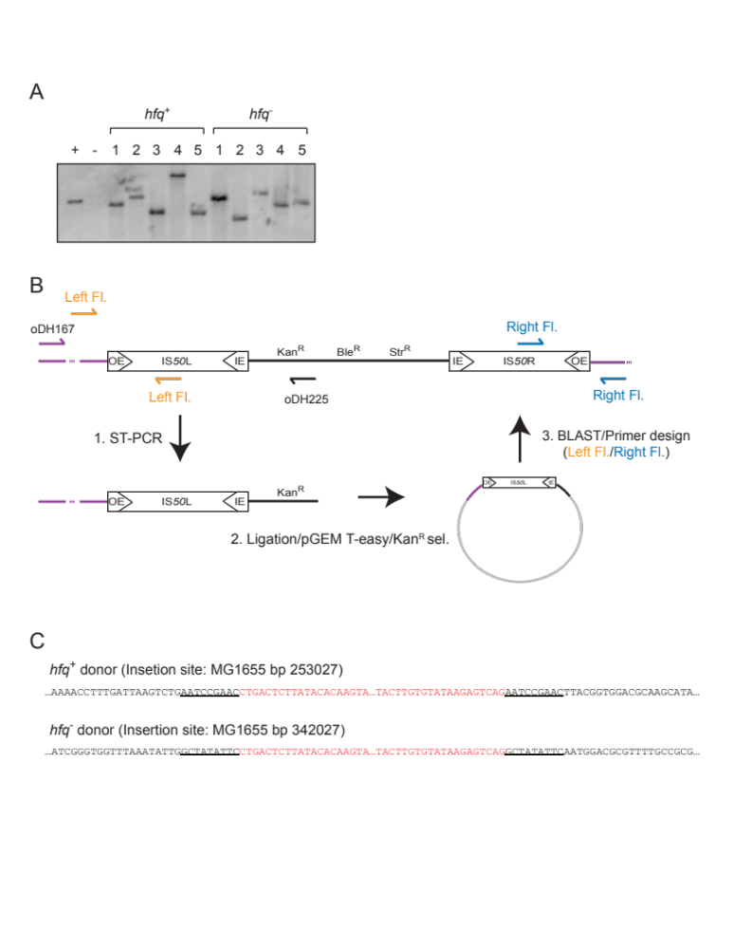

A. Southern blot analysis of colonies selected on ‘hop plates’
Genomic DNA was isolated from Kan^{R} Sm^{R} colonies selected on ‘hop plates’ using Sigma Genomic DNA kit; 1.5 μg of genomic DNA was digested with AccI (cuts once in Tn5 in the kan^{R} gene) and resolved on a 1% agarose gel, before capillary transfer to Hybond N membrane (GE Healthcare) as follows: the gel was soaked in alkaline denaturing buffer (1.5 M NaCl, 0.5 M NaOH) for 40 minutes, neutralized (30 minutes and then 15 minutes) in neutralizing buffer (250 mM Tris-HCl, pH 7.5, 750 mM NaCl), and transferred overnight in 10x SSC. The membrane was UV cross-linked and then incubated with a ³²P-labeled RNA probe (complementary to the 5’ portion of the Tn5 kan^{R} gene) in UltraHyb buffer (Ambion) according to the manufacturer’s protocol for RNA:DNA hybridization. The probe was generated by in vitro transcription, as described for Northern blot analysis, from a DNA template made by PCR with primers oDH236 and oDH237. In the experiment shown 5 ‘hop’ colonies from each of hfq⁺ (DBH179) and hfq⁻ (DBH184) were analyzed. ‘+’ indicates DNA derived from a donor colony before mating and ‘-’ indicates DNA derived from a recipient colony before mating.

B. Mapping Tn5 tranposition events via ST-PCR
Putative transposition events from mating out assays were characterized using a semi-random, two-step PCR protocol (ST-PCR) for uncharacterized transposon-linked sequences (Chun et al, 1997). Briefly, genomic DNA from Kan^{R} Sm^{R} colonies selected on ‘hop plates’ was PCR-amplified with a Tn5-specific primer (oDH225) and a partially randomized primer (oDH167). The resulting amplicons were ligated into the pGEM T-easy vector (Promega), transformed into DH5α by electroporation and transformants were selected on LB plates containing kanamycin (50 μg/mL). Plasmid DNA was isolated (Sigma miniprep kit) and the inserts were sequenced using M13 primers. Sequences thusly obtained were aligned to the E. coli MG1655 reference genome (BLAST) to identify the ‘target’ sequence immediately flanking one host-OE junction. This information was used to design ‘insert-specific’ primers (different for each insertion event), complementary to DNA flanking the Tn5 insertion site. These primers were used to amplify and sequence DNA flanking Tn5.

C. DNA sequence for two independent Tn5 transposition events
Tn5 insertion sites for two clones are shown. Tn5 sequence is in red and flanking donor sequence is in black. Target site duplications are underlined.

