Additional File 2. Impact of SgrS over-expression on growth rate in M9-glucose

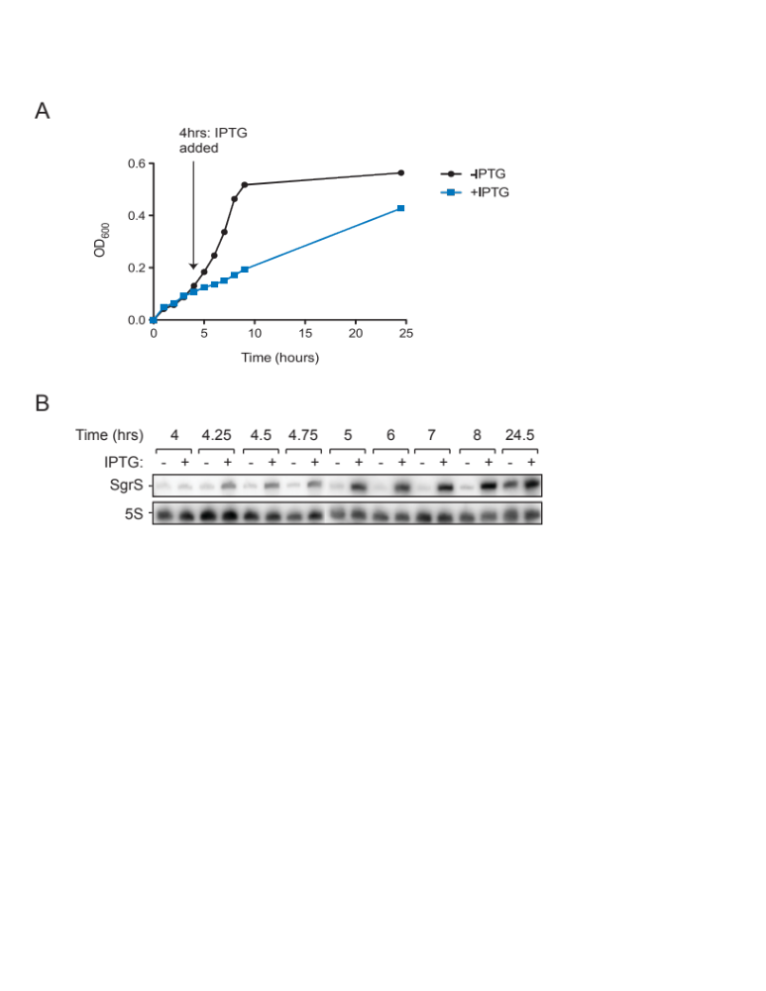
A. Growth curve for cells harboring the SgrS-encoding plasmid with and without IPTG treatment. A saturated culture of cells (DBH33) harboring the SgrS-overexpression plasmid (pDH764) was sub-cultured (in duplicate) into M9-glucose and grown for 4 hours. At this time IPTG (0.1 mM) was added to one of the sub-cultures. Cell density (OD₆₀₀) was measured at the indicated time points.

B. Measurement of SgrS RNA levels. SgrS RNA levels were measured in cells from (A) at the indicated times after sub-culture by performing Northern blot analysis with ³²P-labeled RNA probes complementary to SgrS or 5S rRNA (internal standard). Northern blot analysis was performed as described in Figure 8C.

