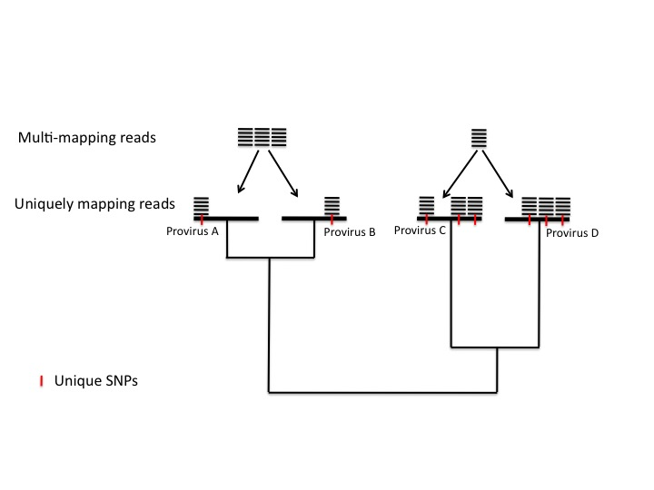
Illustration of problem found in mapping reads to proviruses that have similar sequences. Proviruses A and B are closely related (diverged from a common ancestor recently) and so have few unique SNPs. Few reads therefore map uniquely to either provirus A or B but many reads map equally well to both. In contrast, proviruses C and D are more distantly related to each other and so have many unique SNPs. Many reads therefore map uniquely to either provirus C or D but few reads map equally well to both.

