Table S1: Correlations between recombination rates of dysgenic and non-dysgenic flies and high fecund and low fecund dysgenic flies in 250 kb intervals. Pearson’s correlation coefficients (R) and significance (p-value) are listed. All correlations are significant.

Comparison |  | Chromosome |  |  |  |  | Total | Total minus  zero CO
 |  | X | 2 | 3 | 4 | 5 | Total | Total minus  zero CO
Dysgenic vs Non-Dys | R | 0.49 | 0.68 | 0.58 | 0.67 | 0.70 | 0.63 | 0.43
Dysgenic vs Non-Dys | p | 3.24E-09 | 1.11E-18 | 3.91E-13 | 2.64E-18 | 2.41E-20 | 7.16E-72 | 2.59E-24
High fecund vs low fecund | R | 0.51 | 0.44 | 0.55 | 0.68 | 0.67 | 0.57 | 0.41
High fecund vs low fecund | p | 6.97E-10 | 1.76E-07 | 1.83E-11 | 9.60E-19 | 2.27E-18 | 9.25E-57 | 2.70E-20

Table S2: Maximum likelihood parameter estimates and model comparisons (degrees of freedom = 1).

Model | Description | Parameter estimates |  | ln (L) | Model Comparison | p valueª
 |  | α (95% CIs)^{b} | β (95% CIs)
1 | α and β all F1 mothers | 0.084 (0.038, 0.15) | 0.67 (0.60, 0.74) | -81.7
2 | Separate α for dys and non-dys | Dys: 0.12 (0.054, 0.23)  Non: 0.026 (0.00, 0.11) | 0.67 (0.59, 0.74) | -80.1 | M1 vs M2 | 0.066
3 | Separate β for dys and non-dys | 0.12 (0.057, 0.22) | Dys: 0.78 (0.71, 0.85)  Non: 0.11 (0.038, 0.23) | -56.0 | M1 vs M3 | 6.9E-13
4 | Separate α and β for dys and non-dys | Dys: 0.11  Non: > 1.0 | Dys: 0.78  Non: 0.066 | -55.0 | M3 vs M4 | 0.17

ª Likelihood ratio test assuming a χ² distribution
^{b} 95% CIs were not calculated for Model 4, parameter estimations were over-dispersed and not contained within reasonable boundaries.
Table S3: Sampling of BC1 progeny from F1 females in our experiment. Dysgenic F1 females were categorized as low or high fecundity based on the number of total progeny produced.
F1 Parent Identifier | Dys or  Non-Dys | Batch  Number | Low or High Fecundity | Progeny collected F1  < 10 days old | Progeny  collected F1 >10 days old | Total  Progeny Collected
101 | Dysgenic | 1 | low | 2 | 0 | 2
102 | Non-dys | 1 | NA | 11 | 0 | 11
111 | Dysgenic | 1 | low | 10 | 0 | 10
112 | Non-dys | 1 | NA | 9 | 0 | 9
122 | Non-dys | 1 | NA | 11 | 0 | 11
132 | Non-dys | 1 | NA | 9 | 0 | 9
142 | Non-dys | 1 | NA | 8 | 0 | 8
211 | Dysgenic | 1 | low | 2 | 0 | 2
221 | Dysgenic | 1 | low | 3 | 0 | 3
301 | Dysgenic | 1 | low | 16 | 0 | 16
601 | Dysgenic | 1 | low | 5 | 0 | 5
701 | Dysgenic | 1 | high | 49 | 0 | 49
702 | Non-dys | 1 | NA | 10 | 0 | 10
801 | Dysgenic | 1 | low | 3 | 0 | 3
802 | Non-dys | 1 | NA | 9 | 0 | 9
902 | Non-dys | 1 | NA | 9 | 0 | 9
1 | Non-dys | 2 | NA | 13 | 0 | 13
2 | Non-dys | 2 | NA | 8 | 0 | 8
3 | Non-dys | 2 | NA | 29 | 0 | 29
5 | Non-dys | 2 | NA | 19 | 0 | 19
8 | Non-dys | 2 | NA | 14 | 0 | 14
9 | Non-dys | 2 | NA | 9 | 0 | 9
10 | Non-dys | 2 | NA | 12 | 0 | 12
12 | Non-dys | 2 | NA | 20 | 0 | 20
14 | Non-dys | 2 | NA | 12 | 0 | 12
15 | Non-dys | 2 | NA | 17 | 0 | 17
16 | Non-dys | 2 | NA | 20 | 0 | 20
20 | Non-dys | 2 | NA | 26 | 0 | 26
4003 | Dysgenic | 2 | low | 0 | 3 | 3
4004 | Dysgenic | 2 | low | 2 | 2 | 4
4006 | Dysgenic | 2 | low | 2 | 0 | 2
4010 | Dysgenic | 2 | low | 2 | 8 | 10
4012 | Dysgenic | 2 | low | 7 | 7 | 14
4013 | Dysgenic | 2 | low | 9 | 4 | 13
4016 | Dysgenic | 2 | high | 24 | 0 | 24
4018 | Dysgenic | 2 | low | 2 | 0 | 2
4019 | Dysgenic | 2 | low | 14 | 0 | 14
4021 | Dysgenic | 2 | low | 2 | 0 | 2
4022 | Dysgenic | 2 | low | 1 | 0 | 1
4027 | Dysgenic | 2 | low | 2 | 0 | 2
4029 | Dysgenic | 2 | high | 32 | 0 | 32
4031 | Dysgenic | 2 | low | 5 | 0 | 5
4040 | Dysgenic | 2 | low | 1 | 0 | 1
4050 | Dysgenic | 2 | low | 1 | 0 | 1
4065 | Dysgenic | 2 | low | 0 | 1 | 1
4070 | Dysgenic | 2 | low | 1 | 0 | 1
4071 | Dysgenic | 2 | low | 1 | 0 | 1
4078 | Dysgenic | 2 | low | 5 | 0 | 5
4084 | Dysgenic | 2 | low | 11 | 0 | 11
4086 | Dysgenic | 2 | low | 4 | 0 | 4
4087 | Dysgenic | 2 | low | 1 | 0 | 1
4092 | Dysgenic | 2 | low | 9 | 1 | 10
4097 | Dysgenic | 2 | low | 6 | 0 | 6
4099 | Dysgenic | 2 | low | 2 | 1 | 3
4100 | Dysgenic | 2 | low | 11 | 2 | 13
4101 | Dysgenic | 2 | low | 6 | 4 | 10
4102 | Dysgenic | 2 | low | 2 | 0 | 2
4104 | Dysgenic | 2 | low | 9 | 0 | 9
4108 | Dysgenic | 2 | low | 6 | 0 | 6
4109 | Dysgenic | 2 | low | 1 | 0 | 1
4120 | Dysgenic | 2 | low | 1 | 0 | 1
4133 | Dysgenic | 2 | low | 0 | 1 | 1
4144 | Dysgenic | 2 | low | 0 | 1 | 1
4147 | Dysgenic | 2 | low | 2 | 1 | 3
5001 | Dysgenic | 2 | low | 9 | 1 | 10
5002 | Dysgenic | 2 | low | 2 | 0 | 2
5006 | Dysgenic | 2 | low | 1 | 0 | 1
5007 | Dysgenic | 2 | low | 1 | 1 | 2
5010 | Dysgenic | 2 | low | 2 | 1 | 3
5011 | Dysgenic | 2 | high | 32 | 0 | 32
5016 | Dysgenic | 2 | low | 2 | 0 | 2
5017 | Dysgenic | 2 | low | 6 | 0 | 6
5019 | Dysgenic | 2 | high | 30 | 0 | 30
5020 | Dysgenic | 2 | low | 2 | 0 | 2
5022 | Dysgenic | 2 | low | 10 | 1 | 11
5023 | Dysgenic | 2 | low | 0 | 1 | 1
5024 | Dysgenic | 2 | low | 4 | 0 | 4
5025 | Dysgenic | 2 | low | 1 | 0 | 1
5026 | Dysgenic | 2 | low | 1 | 0 | 1
5027 | Dysgenic | 2 | high | 35 | 0 | 35
5033 | Dysgenic | 2 | low | 0 | 1 | 1
5040 | Dysgenic | 2 | low | 1 | 0 | 1
5066 | Dysgenic | 2 | low | 2 | 0 | 2
5089 | Dysgenic | 2 | low | 8 | 3 | 11
5092 | Dysgenic | 2 | low | 3 | 0 | 3
5095 | Dysgenic | 2 | low | 3 | 1 | 4
5096 | Dysgenic | 2 | high | 40 | 0 | 40
5097 | Dysgenic | 2 | low | 4 | 0 | 4
5100 | Dysgenic | 2 | low | 6 | 2 | 8
5104 | Dysgenic | 2 | low | 10 | 0 | 10
5105 | Dysgenic | 2 | low | 3 | 1 | 4
5108 | Dysgenic | 2 | low | 0 | 2 | 2
5111 | Dysgenic | 2 | low | 8 | 2 | 10

Table S4: FC1 bar-coded primers and FC2 primer used for PCR amplification for multiplex shotgun sequencing of the pilot batch in this study.
NAME | FC1 Index Barcode | PRIMER (5'-3') | FC1 Demultiplex Orientation
FC1_PCR_Index5 | CACTGT | CAAGCAGAAGACGGCATACGAGATCACTGTGTGACTGGAGTTCAGACGTGTGCTC*T | ACAGTG
FC1_PCR_Index19 | TTTCAC | CAAGCAGAAGACGGCATACGAGATTTTCACGTGACTGGAGTTCAGACGTGTGCTC*T | GTCAAA
FC2_PCR_Primer | -- | AATGATACGGCGACCACCGAGATCTACACTCTTTCCCTACACGACGCTCTTCCGATC*T | --

Table S5: Barcodes used for demultiplexing the pilot batch of BC1 progeny in this study. The barcodes are a part of the FC1 and FC2 oligonucleotide adaptors. The FC2 oligonucleotide sequence is ACACTCTTTCCCTACACGACGCTCTTCCGANNNNNN where NNNNNN is one of the six base-pair barcodes and the FC1 oligonucleotide sequence is p-TAnnnnnnTCGGA
AGAGCTCGTATGCCGTCTTCTGCTTG where p is a phosphate and nnnnnn is the reverse complement of the corresponding FC2 barcode.
CGTCTG | CTCTAC | GCGCGT | AAGGAC | TATATG | GGCATT | CAATAT | GATGAG
TCTCGT | CATAGC | CTTGCG | ATATGG | GGTTAC | AAGCGA | AAACGG | TCTATT
CCCTAT | TCCACG | GGGAAT | TTCCTG | TAGTCG | CACTGA | GAGAGT | GGAATG
AGGCGT | GTTCAG | ACTGTT | GACAAT | CGATAC | ATCACG | GTCGAT | GATCTG
CTCGGT | ACGTAC | CTAACG | GCGTAT | TTAGCG | ACCGAT | TAAGCA | GAATAC
ATTCTG | GCTGAT | CTGACA | TAGACA | GGAAGT | TATAGT | AGCTCA | CTCTGG
TGAATT | CAACTG | ATGATG | GTCCGG | GCACAG | ATCCAG | GAATGG | TGTAAT
TCTCTG | AAATAG | AACCTG | TAATTG | GAGTAG | AATCCG | GTAACA | AAGCAG
AATGCC | TTACTT | AAGGTT | AGAGTT | AGTCAC | CAGGTG | ATCTTG | GGACCA
TTTCAT | CATTGT | AACTCG | AATAAG | GGGTTG | CCACCA | GTTGCA | CCCACA
GTCCTT | GCCGTG | GACACG | TGACTG | GCCTGG | TCGAGT | ATACCG | GGCCGT
GAAGTG | AGGCTG | CGCTTG | CTTCGG | AATGTG | GGCCTG | ATAGGT | AATGGT

Table S6: i7 primers used for Tn5 tagging and PCR amplification for multiplex shotgun sequencing in the second batch of this study.
NAME | i7 Index Barcode | PRIMER (5'-3') | i7 Demultiplex Orientation
jpbhb701 | AACGTGAT | CAAGCAGAAGACGGCATACGAGATAACGTGATGTCTCGTGGGCTCGG | ATCACGTT
jpbhb702 | AAACATCG | CAAGCAGAAGACGGCATACGAGATAAACATCGGTCTCGTGGGCTCGG | CGATGTTT
jpbhb703 | ATGCCTAA | CAAGCAGAAGACGGCATACGAGATATGCCTAAGTCTCGTGGGCTCGG | TTAGGCAT
jpbhb704 | AGTGGTCA | CAAGCAGAAGACGGCATACGAGATAGTGGTCAGTCTCGTGGGCTCGG | TGACCACT
jpbhb705 | ACCACTGT | CAAGCAGAAGACGGCATACGAGATACCACTGTGTCTCGTGGGCTCGG | ACAGTGGT
jpbhb706 | ACATTGGC | CAAGCAGAAGACGGCATACGAGATACATTGGCGTCTCGTGGGCTCGG | GCCAATGT
jpbhb707 | CAGATCTG | CAAGCAGAAGACGGCATACGAGATCAGATCTGGTCTCGTGGGCTCGG | CAGATCTG
jpbhb708 | CATCAAGT | CAAGCAGAAGACGGCATACGAGATCATCAAGTGTCTCGTGGGCTCGG | ACTTGATG
jpbhb709 | CGCTGATC | CAAGCAGAAGACGGCATACGAGATCGCTGATCGTCTCGTGGGCTCGG | GATCAGCG
jpbhb710 | ACAAGCTA | CAAGCAGAAGACGGCATACGAGATACAAGCTAGTCTCGTGGGCTCGG | TAGCTTGT
jpbhb711 | CTGTAGCC | CAAGCAGAAGACGGCATACGAGATCTGTAGCCGTCTCGTGGGCTCGG | GGCTACAG
jpbhb712 | AGTACAAG | CAAGCAGAAGACGGCATACGAGATAGTACAAGGTCTCGTGGGCTCGG | CTTGTACT
jpbhb713 | AACAACCA | CAAGCAGAAGACGGCATACGAGATAACAACCAGTCTCGTGGGCTCGG | TGGTTGTT
jpbhb714 | AACCGAGA | CAAGCAGAAGACGGCATACGAGATAACCGAGAGTCTCGTGGGCTCGG | TCTCGGTT
jpbhb715 | AACGCTTA | CAAGCAGAAGACGGCATACGAGATAACGCTTAGTCTCGTGGGCTCGG | TAAGCGTT
jpbhb716 | AAGACGGA | CAAGCAGAAGACGGCATACGAGATAAGACGGAGTCTCGTGGGCTCGG | TCCGTCTT
jpbhb717 | AAGGTACA | CAAGCAGAAGACGGCATACGAGATAAGGTACAGTCTCGTGGGCTCGG | TGTACCTT
jpbhb718 | ACACAGAA | CAAGCAGAAGACGGCATACGAGATACACAGAAGTCTCGTGGGCTCGG | TTCTGTGT
jpbhb719 | ACAGCAGA | CAAGCAGAAGACGGCATACGAGATACAGCAGAGTCTCGTGGGCTCGG | TCTGCTGT
jpbhb720 | ACCTCCAA | CAAGCAGAAGACGGCATACGAGATACCTCCAAGTCTCGTGGGCTCGG | TTGGAGGT
jpbhb721 | ACGCTCGA | CAAGCAGAAGACGGCATACGAGATACGCTCGAGTCTCGTGGGCTCGG | TCGAGCGT
jpbhb722 | ACGTATCA | CAAGCAGAAGACGGCATACGAGATACGTATCAGTCTCGTGGGCTCGG | TGATACGT
jpbhb723 | ACTATGCA | CAAGCAGAAGACGGCATACGAGATACTATGCAGTCTCGTGGGCTCGG | TGCATAGT
jpbhb724 | AGAGTCAA | CAAGCAGAAGACGGCATACGAGATAGAGTCAAGTCTCGTGGGCTCGG | TTGACTCT
jpbhb725 | AGATCGCA | CAAGCAGAAGACGGCATACGAGATAGATCGCAGTCTCGTGGGCTCGG | TGCGATCT
jpbhb726 | AGCAGGAA | CAAGCAGAAGACGGCATACGAGATAGCAGGAAGTCTCGTGGGCTCGG | TTCCTGCT
jpbhb727 | AGTCACTA | CAAGCAGAAGACGGCATACGAGATAGTCACTAGTCTCGTGGGCTCGG | TAGTGACT
jpbhb728 | ATCCTGTA | CAAGCAGAAGACGGCATACGAGATATCCTGTAGTCTCGTGGGCTCGG | TACAGGAT
jpbhb729 | ATTGAGGA | CAAGCAGAAGACGGCATACGAGATATTGAGGAGTCTCGTGGGCTCGG | TCCTCAAT
jpbhb730 | CAACCACA | CAAGCAGAAGACGGCATACGAGATCAACCACAGTCTCGTGGGCTCGG | TGTGGTTG
jpbhb731 | GACTAGTA | CAAGCAGAAGACGGCATACGAGATGACTAGTAGTCTCGTGGGCTCGG | TACTAGTC
jpbhb732 | CAATGGAA | CAAGCAGAAGACGGCATACGAGATCAATGGAAGTCTCGTGGGCTCGG | TTCCATTG
jpbhb733 | CACTTCGA | CAAGCAGAAGACGGCATACGAGATCACTTCGAGTCTCGTGGGCTCGG | TCGAAGTG
jpbhb734 | CAGCGTTA | CAAGCAGAAGACGGCATACGAGATCAGCGTTAGTCTCGTGGGCTCGG | TAACGCTG
jpbhb735 | CATACCAA | CAAGCAGAAGACGGCATACGAGATCATACCAAGTCTCGTGGGCTCGG | TTGGTATG
jpbhb736 | CCAGTTCA | CAAGCAGAAGACGGCATACGAGATCCAGTTCAGTCTCGTGGGCTCGG | TGAACTGG
jpbhb737 | CCGAAGTA | CAAGCAGAAGACGGCATACGAGATCCGAAGTAGTCTCGTGGGCTCGG | TACTTCGG
jpbhb738 | CCGTGAGA | CAAGCAGAAGACGGCATACGAGATCCGTGAGAGTCTCGTGGGCTCGG | TCTCACGG
jpbhb739 | CCTCCTGA | CAAGCAGAAGACGGCATACGAGATCCTCCTGAGTCTCGTGGGCTCGG | TCAGGAGG
jpbhb740 | CGAACTTA | CAAGCAGAAGACGGCATACGAGATCGAACTTAGTCTCGTGGGCTCGG | TAAGTTCG
jpbhb741 | CGACTGGA | CAAGCAGAAGACGGCATACGAGATCGACTGGAGTCTCGTGGGCTCGG | TCCAGTCG
jpbhb742 | CGCATACA | CAAGCAGAAGACGGCATACGAGATCGCATACAGTCTCGTGGGCTCGG | TGTATGCG
jpbhb743 | CTCAATGA | CAAGCAGAAGACGGCATACGAGATCTCAATGAGTCTCGTGGGCTCGG | TCATTGAG
jpbhb744 | CTGAGCCA | CAAGCAGAAGACGGCATACGAGATCTGAGCCAGTCTCGTGGGCTCGG | TGGCTCAG
jpbhb745 | CTGGCATA | CAAGCAGAAGACGGCATACGAGATCTGGCATAGTCTCGTGGGCTCGG | TATGCCAG
jpbhb746 | GAATCTGA | CAAGCAGAAGACGGCATACGAGATGAATCTGAGTCTCGTGGGCTCGG | TCAGATTC
jpbhb747 | CAAGACTA | CAAGCAGAAGACGGCATACGAGATCAAGACTAGTCTCGTGGGCTCGG | TAGTCTTG
jpbhb748 | GAGCTGAA | CAAGCAGAAGACGGCATACGAGATGAGCTGAAGTCTCGTGGGCTCGG | TTCAGCTC
jpbhb749 | GATAGACA | CAAGCAGAAGACGGCATACGAGATGATAGACAGTCTCGTGGGCTCGG | TGTCTATC
jpbhb750 | GCCACATA | CAAGCAGAAGACGGCATACGAGATGCCACATAGTCTCGTGGGCTCGG | TATGTGGC
jpbhb751 | GCGAGTAA | CAAGCAGAAGACGGCATACGAGATGCGAGTAAGTCTCGTGGGCTCGG | TTACTCGC
jpbhb752 | GCTAACGA | CAAGCAGAAGACGGCATACGAGATGCTAACGAGTCTCGTGGGCTCGG | TCGTTAGC
jpbhb753 | GCTCGGTA | CAAGCAGAAGACGGCATACGAGATGCTCGGTAGTCTCGTGGGCTCGG | TACCGAGC
jpbhb754 | GGAGAACA | CAAGCAGAAGACGGCATACGAGATGGAGAACAGTCTCGTGGGCTCGG | TGTTCTCC
jpbhb755 | GGTGCGAA | CAAGCAGAAGACGGCATACGAGATGGTGCGAAGTCTCGTGGGCTCGG | TTCGCACC
jpbhb756 | GTACGCAA | CAAGCAGAAGACGGCATACGAGATGTACGCAAGTCTCGTGGGCTCGG | TTGCGTAC
jpbhb757 | GTCGTAGA | CAAGCAGAAGACGGCATACGAGATGTCGTAGAGTCTCGTGGGCTCGG | TCTACGAC
jpbhb758 | GTCTGTCA | CAAGCAGAAGACGGCATACGAGATGTCTGTCAGTCTCGTGGGCTCGG | TGACAGAC
jpbhb759 | GTGTTCTA | CAAGCAGAAGACGGCATACGAGATGTGTTCTAGTCTCGTGGGCTCGG | TAGAACAC
jpbhb760 | TAGGATGA | CAAGCAGAAGACGGCATACGAGATTAGGATGAGTCTCGTGGGCTCGG | TCATCCTA
jpbhb761 | TATCAGCA | CAAGCAGAAGACGGCATACGAGATTATCAGCAGTCTCGTGGGCTCGG | TGCTGATA
jpbhb762 | TCCGTCTA | CAAGCAGAAGACGGCATACGAGATTCCGTCTAGTCTCGTGGGCTCGG | TAGACGGA
jpbhb763 | TCTTCACA | CAAGCAGAAGACGGCATACGAGATTCTTCACAGTCTCGTGGGCTCGG | TGTGAAGA
jpbhb764 | TGAAGAGA | CAAGCAGAAGACGGCATACGAGATTGAAGAGAGTCTCGTGGGCTCGG | TCTCTTCA
jpbhb765 | TGGAACAA | CAAGCAGAAGACGGCATACGAGATTGGAACAAGTCTCGTGGGCTCGG | TTGTTCCA
jpbhb766 | TGGCTTCA | CAAGCAGAAGACGGCATACGAGATTGGCTTCAGTCTCGTGGGCTCGG | TGAAGCCA
jpbhb767 | TGGTGGTA | CAAGCAGAAGACGGCATACGAGATTGGTGGTAGTCTCGTGGGCTCGG | TACCACCA
jpbhb768 | TTCACGCA | CAAGCAGAAGACGGCATACGAGATTTCACGCAGTCTCGTGGGCTCGG | TGCGTGAA
jpbhb769 | AACTCACC | CAAGCAGAAGACGGCATACGAGATAACTCACCGTCTCGTGGGCTCGG | GGTGAGTT
jpbhb770 | AAGAGATC | CAAGCAGAAGACGGCATACGAGATAAGAGATCGTCTCGTGGGCTCGG | GATCTCTT
jpbhb771 | AAGGACAC | CAAGCAGAAGACGGCATACGAGATAAGGACACGTCTCGTGGGCTCGG | GTGTCCTT
jpbhb772 | AATCCGTC | CAAGCAGAAGACGGCATACGAGATAATCCGTCGTCTCGTGGGCTCGG | GACGGATT
jpbhb773 | AATGTTGC | CAAGCAGAAGACGGCATACGAGATAATGTTGCGTCTCGTGGGCTCGG | GCAACATT
jpbhb774 | ACACGACC | CAAGCAGAAGACGGCATACGAGATACACGACCGTCTCGTGGGCTCGG | GGTCGTGT
jpbhb775 | ACAGATTC | CAAGCAGAAGACGGCATACGAGATACAGATTCGTCTCGTGGGCTCGG | GAATCTGT
jpbhb776 | AGATGTAC | CAAGCAGAAGACGGCATACGAGATAGATGTACGTCTCGTGGGCTCGG | GTACATCT
jpbhb777 | AGCACCTC | CAAGCAGAAGACGGCATACGAGATAGCACCTCGTCTCGTGGGCTCGG | GAGGTGCT
jpbhb778 | AGCCATGC | CAAGCAGAAGACGGCATACGAGATAGCCATGCGTCTCGTGGGCTCGG | GCATGGCT
jpbhb779 | AGGCTAAC | CAAGCAGAAGACGGCATACGAGATAGGCTAACGTCTCGTGGGCTCGG | GTTAGCCT
jpbhb780 | ATAGCGAC | CAAGCAGAAGACGGCATACGAGATATAGCGACGTCTCGTGGGCTCGG | GTCGCTAT
jpbhb781 | ATCATTCC | CAAGCAGAAGACGGCATACGAGATATCATTCCGTCTCGTGGGCTCGG | GGAATGAT
jpbhb782 | ATTGGCTC | CAAGCAGAAGACGGCATACGAGATATTGGCTCGTCTCGTGGGCTCGG | GAGCCAAT
jpbhb783 | CAAGGAGC | CAAGCAGAAGACGGCATACGAGATCAAGGAGCGTCTCGTGGGCTCGG | GCTCCTTG
jpbhb784 | CACCTTAC | CAAGCAGAAGACGGCATACGAGATCACCTTACGTCTCGTGGGCTCGG | GTAAGGTG
jpbhb785 | CCATCCTC | CAAGCAGAAGACGGCATACGAGATCCATCCTCGTCTCGTGGGCTCGG | GAGGATGG
jpbhb786 | CCGACAAC | CAAGCAGAAGACGGCATACGAGATCCGACAACGTCTCGTGGGCTCGG | GTTGTCGG
jpbhb787 | CCTAATCC | CAAGCAGAAGACGGCATACGAGATCCTAATCCGTCTCGTGGGCTCGG | GGATTAGG
jpbhb788 | CCTCTATC | CAAGCAGAAGACGGCATACGAGATCCTCTATCGTCTCGTGGGCTCGG | GATAGAGG
jpbhb789 | CGACACAC | CAAGCAGAAGACGGCATACGAGATCGACACACGTCTCGTGGGCTCGG | GTGTGTCG
jpbhb790 | CGGATTGC | CAAGCAGAAGACGGCATACGAGATCGGATTGCGTCTCGTGGGCTCGG | GCAATCCG
jpbhb791 | CTAAGGTC | CAAGCAGAAGACGGCATACGAGATCTAAGGTCGTCTCGTGGGCTCGG | GACCTTAG
jpbhb792 | GAACAGGC | CAAGCAGAAGACGGCATACGAGATGAACAGGCGTCTCGTGGGCTCGG | GCCTGTTC
jpbhb793 | GACAGTGC | CAAGCAGAAGACGGCATACGAGATGACAGTGCGTCTCGTGGGCTCGG | GCACTGTC
jpbhb794 | GAGTTAGC | CAAGCAGAAGACGGCATACGAGATGAGTTAGCGTCTCGTGGGCTCGG | GCTAACTC
jpbhb795 | GATGAATC | CAAGCAGAAGACGGCATACGAGATGATGAATCGTCTCGTGGGCTCGG | GATTCATC
jpbhb796 | GCCAAGAC | CAAGCAGAAGACGGCATACGAGATGCCAAGACGTCTCGTGGGCTCGG | GTCTTGGC

Table S7: i5 primers used for Tn5 tagging and PCR amplification for multiplex shotgun sequencing.

NAME | i5 Index Barcode | FINAL PRIMER (5'-3') | i5 Demultiplex Orientation
sjmhb501 | TAGATCGC | AATGATACGGCGACCACCGAGATCTACACTAGATCGCTCGTCGGCAGCGTC | TAGATCGC
sjmhb502 | CTCTCTAT | AATGATACGGCGACCACCGAGATCTACACCTCTCTATTCGTCGGCAGCGTC | CTCTCTAT
sjmhb503 | TATCCTCT | AATGATACGGCGACCACCGAGATCTACACTATCCTCTTCGTCGGCAGCGTC | TATCCTCT
sjmhb504 | AGAGTAGA | AATGATACGGCGACCACCGAGATCTACACAGAGTAGATCGTCGGCAGCGTC | AGAGTAGA
sjmhb505 | GTAAGGAG | AATGATACGGCGACCACCGAGATCTACACGTAAGGAGTCGTCGGCAGCGTC | GTAAGGAG
sjmhb506 | ACTGCATA | AATGATACGGCGACCACCGAGATCTACACACTGCATATCGTCGGCAGCGTC | ACTGCATA
sjmhb507 | AAGGAGTA | AATGATACGGCGACCACCGAGATCTACACAAGGAGTATCGTCGGCAGCGTC | AAGGAGTA
sjmhb508 | CTAAGCCT | AATGATACGGCGACCACCGAGATCTACACCTAAGCCTTCGTCGGCAGCGTC | CTAAGCCT

Table S8: PacBio assembly statistics for D. virilis strain 160.
Statistic | Value
Length (bp) | 169,775,145
# of contigs | 211
# of scaffolds | 45
Contig N50 (bp) | 5,099,607
Scaffold N50 (bp) | 31,075,311
# of unplaced contigs* | 39
Length of unplaced contigs (bp)* | 4,275,011
BUSCO Complete (%)** | 98.8
Single copy | 98.2
Duplicated | 0.6
BUSCO Fragmented** | 0.6
BUSCO Missing** | 0.6

* Unplaced contigs are contigs that could not be assigned to one of the chromosome arms based on alignments to the reference.
** BUSCO score expressed as the percentage of genes within each category. The Diptera ortholog gene set v9 with 2,799 genes was used in the search.
Figure S1: Correlations between recombination rate and A) SNP Density and B) TE density with and without non-recombining regions. Density is the percentage of a 250 kb interval made up of either SNPs or TEs. The data is the summation of intervals across all chromosomes.

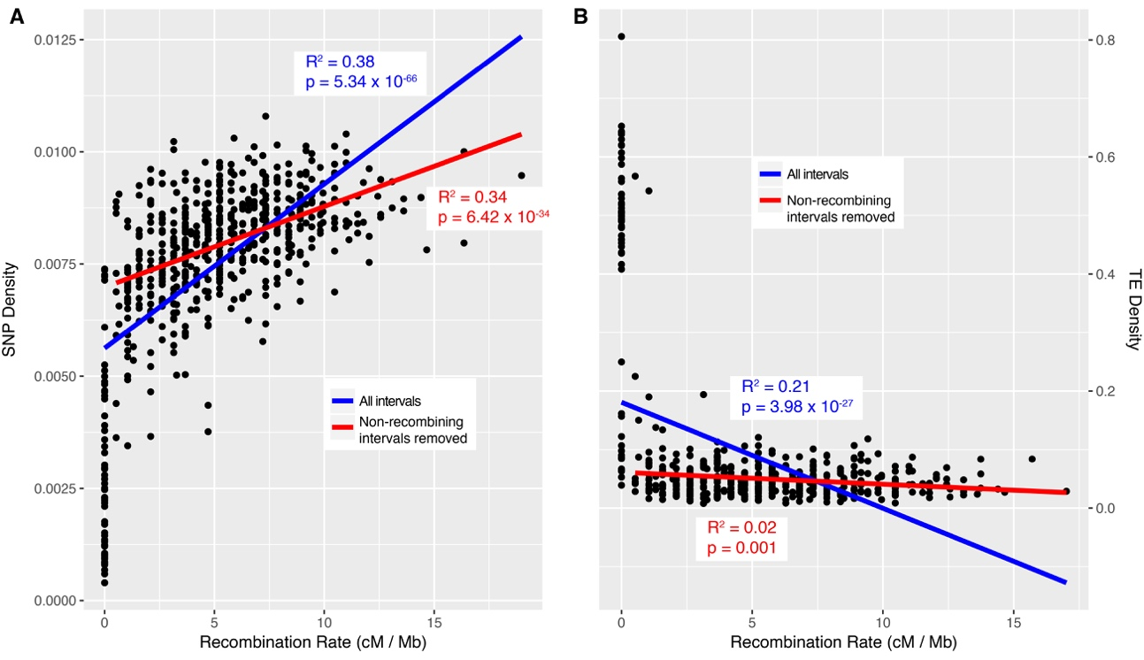
Figure S2: Haplotypes of additional BC1 progeny from single F1 mothers with clusters of recombination and potential mitotic recombination events. The haplotypes are from progeny of the following F1 mothers (dysgenic unless specified): A) X chromosome of non-dysgenic 3, B) X chromosome of 4013, C) X chromosome of 5089, D) 3rd chromosome of 5019, E) 3rd chromosome of 111, and F) 3rd chromosome of 5022.
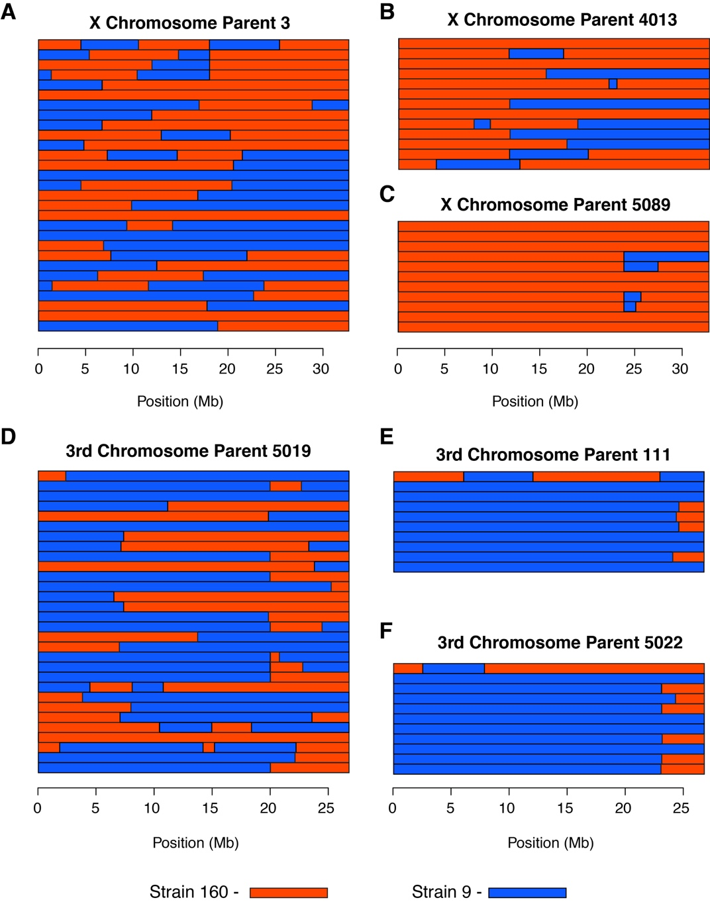

Figure S3: Marey maps of all the D. virilis chromosomes without clusters of recombination. Changes to the genetic lengths of the chromosomes were minimal, the most significant change was a 5 cM increase of the X chromosome with the removal of progeny with a loss of heterozygosity.
