Supporting information for
HERV-K HML-2 transcriptional profiling and splicing pattern unveiled by direct single-molecule long-read RNA sequencing

Mariana Polychronopoulou, Eleni Kyriakou, Filiana Sotiriadou, Magda Bletsa, Gkikas Magiorkinis
Corresponding author: Gkikas Magiorkinis
Email: gmagi@med.uoa.gr

Identifying the human endogenous retrovirus (HERV)-K HML-2 (HK2) centromeric transcription
To assemble our reference genome with the correct centromeric HK2 sequences, we sought to find the genomic sequences of centromeric HK2 proviruses known in literature. The two centromeric HK2 proviruses found to date, are termed K111 (or K105) and K222 and their recombinant form, which is also found in pericentromeric regions, is termed K222/K111. Details are provided in the table S1 below.
Table S1. Pericentromeric HK2 proviruses found in human genome
Provirus | Accession | Literature
K111 | JN675097 (K105), GU476554 (K111) | (1, 2)
K222 | AADC01167561.1 | (3)
K222/K111 | KF651980 (firstly annotated as K222) | (3)
We initially wanted to test the K105 and K111 provirus sequence similarity, as literature often referred to them as one provirus. We extracted the FASTA sequences from Genbank (4) based on the accession numbers and used the Clustal EMBOSS Water alignment tool (5) (EMBOSS Water uses the Smith-Waterman algorithm -modified for speed enhancements- to calculate the local alignment of two sequences), as well as the EMBOSS Needle (5) (EMBOSS Needle creates an optimal global alignment of two sequences using the Needleman-Wunsch algorithm). Results demonstrate that the proviruses are completely identical and the length difference of the sequences under the accession numbers JN675097 and GU476554 is due to the inclusion of CERs in GU476554 flanking the proviral sequence. CERs are centromeric repeat elements found in the centromeres of several human chromosomes that host HK2 proviruses. Thus, we kept the K111 genome under the accession number JN675097 for our reference genome assembly as it contains only the HK2 provirus without the flanking CERs.
It is known that both K222 and K222/K111 are missing the 5’LTR (Long Terminal Repeats) and gag regions and therefore have a length of approximately 6 kb (3). We extracted the recombinant sequence of K222/K111 from accession number KF651980 and did BLAST (6) (somewhat similar, blastn). The results showed 99% identities of e-value 0.0 with GU476554 (K111) that contains the CER elements. We found that K222/K111 shares this identity with the part of the K111 that starts within the gag-pol-pro region at position 3509 (until end of annotation of K111). Also, the similar part of K222/K111 starts at position 932 of KF651980, which is also within the pro-pol region. Therefore, K222/K111 seems to comprise a large part of K111 that spans the region 932-7630 (including the 3’ end CERs). The initial part of KF651980, i.e., position 1-931 belongs to K222.
We then checked AADC01167561.1, that has been reported to encompass K222 (3) with blastn. We found a hit of full-length similarity of KF651980 (K222/K111) with positions 10815-18435 of AADC01167561.1. However, because the hit included the whole recombinant provirus, we again selected everything except for the CER elements. Therefore, based on the abovementioned analysis for K222/K111, where between positions 932-7630 we have the pol-pro, env and the 3’ LTR regions, we deduced the K222 sequence as follows. As mentioned above, we know from the literature, that K222 lacks the 5’ LTR and gag regions. Hence, it contains only the CER elements flanking the pol-pro gene and 3’LTR. The hit implied a close similarity (97%) but not identity as expected due to the fact that the recombinant K222/K111 hosts a part of K111. As K222 sequence is not provided as such in Genbank, the hit of similarity with K222/K111 gives us a hint of the existence of the K222 provirus in positions 10815-18435 of AADC01167561.1.
After concatenating the sequences to a final reference genome, we rerun the same protocol as previously mentioned in the Materials & Methods section (see main text). The mapping metrics were identical to the ones of the initial mapping (the one with reference genome just the hg38p14). The new alignment results show that no read was assigned towards the centromeric proviruses genome, without affecting the performance of the experiment's initial analysis. Concluding, the results were not affected by introducing centromeric genomes into the reference. The slight changes regarding the assignments of supplementary reads we observe could most likely be stochastic events probably arising from reads ambiguity.

Functional Annotation Supplementary Database
Based on manual observation of the Human Reference Genome (GRCh38/hg38) on the UCSC Genome Browser (7), we created an annotation database of the flanking regions of the expressed HK2 loci, both proviral and solo LTR regions. The flanking regions were calculated by a 10kb extension of both of each HK2 locus coordinates (start, end). We included the annotations provided by Annotation Release NCBI RefSeq GCF_000001405.40-RS_2024_08 (2024-08-27) and GENCODE v46 Ensembl 112, as seen on the browser. The final functional annotations for the HK2 proviruses and solo LTRs can be viewed separately within Additional File 4 and Additional File 5.
Orthogonal validation of non-canonically spliced isoforms
Publicly available short-read NCCIT RNA-Seq data were retrieved from SRA (8, 9) under BioProject accession number PRJNA562689. Sample SRR10042972 was downloaded and subjected to quality assessment (FastQC v0.11.9 (10)). Reads were trimmed (Trimmomatic (11) version 0.39) for adapter sequences and subsequently mapped to a custom transcriptome reference. For the assembly of this reference, we selected representative raw long fasta sequences from each of the seven categories of non-canonically spliced transcripts, as previously shown in Table 2 and Figure 2D. These representative sequences were obtained from the provirus expressing all of the identified categories (provirus 11q23.3, see Table 2). However, given the potential rare representation of some categories within the NCCITs retrotranscriptome, additional sequences derived from two additional proviruses (5q33.3 and 1q22) were also included. The fasta sequences were indexed and used as reference transcriptome for mapping the independent short-read data with Bowtie2 (12)(version 2.5.2). Splice junctions were manually annotated based on the raw sequence data and are provided for each isoform. IGV (Integrative Genomics Viewer) (13) (version 2.16.2) screenshots were generated to facilitate visualization of short-read coverage across the splice junctions of the selected transcriptome reference.
Alignment of 56,622,452 filtered short reads to the custom transcriptome reference resulted in 266,899 primary alignments with MAPQ>0 (~0,5% to the total filtered data). Short-reads spanning the splice junctions of the non-canonically spliced isoforms were identified, as shown on Figure S5 and on Table S2, based on representative reads derived from the three most highly expressed proviruses. More specifically, categories 1,3,4,7 were identified from proviral locus 11q23.3, category 2 from 1q22 and category 6 from 5q33.3 (Table S2). No short-reads were mapped on representative sequences corresponding to category 5 (Table S2). We provide IGV screenshots illustrating splice-junctions covered by short reads from the independent NCCIT sample (Figure S5).

Table S2. Overview of the non-canonically spliced isoforms categories and the respective proviruses by which they were obtained. An (x) indicates junctions supported by spanning short reads, whereas (-) denotes unsuccessful attempts of mapping reads to the corresponding transcripts.
 | Non-canonically spliced transcripts categories
 | Alternatively spliced rec/np9 (1) | Beginning before 5’LTR and ending inside the provirus (2) | Two exons in the 5’LTR  (3) | Ignored SD1 & SA1  (4) | Beginning before 5’LTR or in the 5’LTR that also end in the 5’LTR (5) | Extending beyond the 3’end of the provirus (6) | Ending in the U3 region of the 3’LTR (7)
11q23.3 | x |  | x | x | - |  | x
5q33.3 |  |  |  |  | - | x
1q22 |  | x |  |  | -

Coding potential of canonically and non-canonically spliced isoforms
According to literature (14, 15), the full-length transcript produced through transcription of an HK2 proviral locus is alternatively spliced to produce more mRNA isoforms (Figure 2B-C). The full-length transcript holds the coding potential for Gag and Pol polyproteins as well as for the proviral protease (Pro) that cleaves the polyproteins and releases the individual proteinic domains. The alternative canonically spliced isoforms (Figure 2C) have been found to encode each, the Envelope proteins, the accessory protein Np9 (for type I proviruses) and the accessory protein Rec (for type II proviruses). The shortest transcript produced from alternative splicing of the full-length mRNA is the allegedly non-coding hel transcript (Figure 2C).
The ability to produce proteins of each proviral locus depends heavily on the level of proviral DNA sequence degeneration, caused by mutations throughout the thousands or millions of years of the existence of an integration. Thus, more recent integrations such as the polymorphic HK2 proviruses host more intact ORFs. HERV-K113 is an example of such an HK2 integration, that has intact ORFs for all proviral proteins (16). The introduction of the HERV-K113 sequence as a query into the ORFfinder tool of NCBI (17) resulted in the identification of all four core proviral ORFs (Figure S6).
The Rec ORF, which emerges after further splicing of the env transcript, can be identified only after the introduction of the sequence of the rec transcript to the ORFfinder tool (Figure S7). We deduced the rec transcript sequence in silico from the HERV-K113 proviral sequence, according to Mayer et al. 2004.
Contrary to the intactness of ORFs found in HERV-K113, other HK2 loci are lightly or heavily packed with mutations, resulting in partial or complete loss of coding capacity.
As mentioned in the Discussion section of the main text, although long-read Direct RNA Sequencing (DRS) by Oxford Nanopore is a great and probably the only solution for studying the structure of transcript isoforms, the quality of resulting reads is rather low compared to the existing short-read sequencing technologies. Thus, reads often contain substitutions and insertions/deletions (indels), mostly due to errors introduced during the sequencing procedure itself. Therefore, the detection of ORFs in these reads using ORFfinder is expected to be unsuccessful.
For these reasons, we created BLAST (18, 19) alignments of one selected read for each category of the five canonically and the seven non-canonically spliced isoforms of Figure 2C-D and Table 2, with its respective genomic proviral sequence (without introns). On these alignments (see the “Nucleotide alignments” section at the end of this document), we annotated putative proviral genes, regulatory regions and splicing sites. We also used the genomic “mirror” sequence in each case to deduce the coding potential of the read through ORFfinder.
All representative reads of canonically spliced transcripts, besides rec were taken from provirus 11q23.3 (Table 2). According to the annotation in the Genbank deposit of 11q23.3 (JN675065) by Subramanian et al. (20), this provirus encodes nonfunctional gag, pol and env polyproteins. The read chosen for canonically spliced rec transcript originated from provirus 6q14.1 (Table 2).
By introducing the genomic mirror of a full-length read from 11q23.3 to ORFfinder, we obtained several ORFs with different sequences from the core proviral proteins, thus strengthening the claim of Subramanian et al. (20) about non-functionality. We then BLAST aligned the amino acid sequences deduced from these ORFs with UniProt (21) deposited, experimentally found HK2 proteins (see the “Amino acid alignments” section at the end of this document). The Gag and Pol proteins putatively produced by the full-length transcript of 11q23.3 are shorter by ~200aa and ~700aa respectively, compared to functional HK2 Gag and Pol, thus they are probably non-functional. However, the potential protease that is produced by this transcript is almost identical to a functional protease (see the “Amino acid alignments” section), hence it is probably functional. The env transcript of 11q23.3 codes for a putative env protein that is ~250aa shorter than the functional one, also due to the fact that it comes from a type I provirus that contains a 292bp deletion in the env ORF. We did not find any env transcript reads of type II proviruses in our study (Table 2). The env transcript of type I proviruses cannot yield a functional envelope protein (22).
On the other hand, the amino acid sequence of the Np9 protein possibly produced by the np9 transcript of 11q23.3 is very similar to a functional np9 protein, deposited in UniProt. Likewise, the canonical rec transcript of 6q14.1 encodes a Rec protein with identical amino acid sequence compared to the UniProt deposited, experimentally identified Rec. Canonical hel transcripts are known from literature to be non-coding (23, 24).
The same steps were undertaken to trace the coding potential of non-canonically spliced isoforms (Figure 2D). We isolated the sequence of representative reads from the seven isoform categories depicted in Figure 2D, aligned them with their genetic “mirror” sequences (without introns) and annotated proviral genes and regulatory elements (see “Nucleotide alignments” section at the end of this document). We then used ORFfinder to find ORFs using as input the genomic “mirror” sequence, due to the fact that the actual read sequence contains substitutions and indels as an artifact of long-read sequencing.
A category 1 (Figure 2D, Table 2) representative was chosen from 11q23.3 provirus and is an alternatively spliced np9 transcript, where an earlier SA1 is utilized thus resulting in a longer second exon. However, the np9 ORF is intact and therefore possibly functional (see “Amino acid alignment” section at the end of this document).
For category 2, i.e., isoforms beginning before the 5’LTR and ending inside the provirus (Figure 2D), a read was chosen from 1q22 provirus (Table 2). Apart from non-HK2 sequences, this four-exon read contains only the 3’LTR and does not host any ORF resembling a known protein-coding ORF.
Category 3 (Figure 2D) representative read that has two exons in the 5’LTR was selected from 11q23.3 provirus. It resembles a hel transcript and thus has no coding capacity.
A category 4 (Figure 2D) representative read was also selected from 11q23.3 and includes transcripts where SD1 and SA1 (Figure 2) are ignored. This read contained a partial pol-coding ORF and a -what seems like- a functional np9-coding ORF (see “Amino acid alignment” section at the end of this document).
For category 5 a read was chosen from 5q33.3 that began before the 5’LTR and ended in the 5’LTR. This read contains only the 5’LTR region and is thus non-coding.
A representative read for category 6 was selected again from 5q33.3 provirus. It is basically a hel-like transcript that extends beyond the 3’ end of the provirus. The last 164bp of 3’LTR together with 357bp from the non-HK2 part encode a 171aa protein that resembles parts of uncharacterized proteins deposited in UniProt (see “Amino acid alignment” section at the end of this document).
Finally, for category 7 which includes transcripts ending in the U3 region of the 3’LTR we chose a 11q23.3 read, which is a hel-like transcript with an early 3’ end and is therefore non-coding.
All raw reads used in this analysis were deposited to Genbank (accession numbers PZ122232-PZ122243).

Transcripts generated from highly mutated proviral HK2 genomes
Of the HK2 genomes that were found to be expressed in the present study (Table 1), the following proviruses do not have the typical proviral structure due to extended mutations, therefore, transcripts produced will be examined separately for each locus (Figure S8).
7p22.1
HK2 locus in 7p22.1 actually consists of two tandem proviruses sharing a central LTR (Figure S8). Deposited in Refseq (25) is the env transcript of the first provirus (bearing the 5’LTR). The env gene of this locus (HERV-K108) has been proven to be intact and encodes a functional envelope protein with fusogenic (infectious) capacity (26). However, in NCCIT cells we detected env transcripts only from the second provirus. We also noticed that transcripts from the second provirus are far more abundant compared to the first provirus (only 11 reads, mainly of rec-type were appointed to the first provirus out of 502 total reads for this locus). The vast majority of reads of the first provirus were also of rec-type or alternatively spliced rec transcripts. Some potentially full-length transcripts were also detected as well as some strange reads initiated in the 5’LTR that have rec-type exons from both proviruses and end in the 3’LTR (second provirus). HERV-K108 is found to be highly expressed in transformed tissues such as melanomas (27).
22q11.23
Provirus in 22q11.23 has been found to be upregulated in cases of prostate cancer (28), in hepatocellular carcinomas (29) and in teratocarcinoma cell lines (23). This provirus is a complex locus, as it consists of two 5’LTRs, separated by a 163bp gag sequence and also a longer non-HK2 sequence. It contains a functional gag gene, an impaired by mutations pol gene and an env gene which is also non-functional due to the insertion of an inverted Alu element. 3’LTR sequence is also interrupted by a MER11A LTR sequence (28) (Figure S8). Since it is of Type II, it can produce a rec transcript which due to mutations is more np9-like (28). This transcript, known in literature as PCAT14 (prostate cancer–associated ncRNA transcript 14) was uncovered during a study of non-coding RNAs (ncRNAs) through RNAseq in 102 prostate cancer tissue samples and cell lines (30) and has been studied extensively ever since for its implication in disease diagnosis, progression and prognosis (31). Some studies claim that PCAT14 is in fact a coding transcript (28). Since in 22q11.23 there is a functional open reading frame (ORF) for the gag gene (only), a second type of transcript has been reported in literature for this locus, which produces the Gag protein and is expressed predominantly in prostate, testes and ovaries (23). This transcript was initially thought to be a long ncRNA (28). In NCCITs we discovered both transcript types as well as some transcripts with combinations of exons of the two aforementioned types and also some transcripts extending beyond the 3’ end of the provirus (Figure S8).
1q21.3
Another highly mutated provirus lies in chromosomal position 1q21.3. It consists of a small fraction of a 5’LTR U3 region on the plus strand, a part of the pol gene on the minus strand, the last 321bp of an env gene together with a 3’LTR that is lacking most of the U5 part, both on the plus strand (Figure S8, Table 1). In the Telescope database that we used as our reference annotation database (see main text, Materials & Methods section, and (32)) only the pol gene was identified as an HK2 element and thus a length of 1777bp was attributed to this HK2 locus. In Subramanian et al. (20) the coordinates given for this locus cover the whole 3077bp of the provirus. Due to the unusual nature of this provirus, as well as the partial recognition in the Telescope database, we sought to find whether the read count generated by our analytical pipeline (6 reads, Table 1) was in fact accurate for the complete 1q21.3 locus, by manual assessment in IGV. We indeed found 78 additional reads spanning areas of the provirus that were unrecognised in the Telescope database. According to Refseq database, this degenerated provirus is part of an uncharacterized gene, called LOC112268239 and the last exons of two non-coding RNA isoforms produced from this gene (XR_007066603.1 and XR_002958362.2) occupy the territory covered by the env and 3’LTR fractions of 1q21.3 provirus (Figure S8). We in fact found multiple reads in the NCCIT cell line similar to these two ncRNAs, as well as slightly differentiated isoforms exploiting alternative splice donor (SD) and splice acceptor (SA) sites either in the provirus region or before entering the provirus. These are not typical HK2 transcripts as the 5’LTR region is severely truncated and cannot initiate transcription. Thus, transcripts begin approximately 3 kb upstream from the start of the provirus. On the other hand, the 3’LTR has preserved its polyadenylation signal and therefore, transcripts are terminated at the end of the 3’LTR of this provirus. The use and necessity of these ncRNAs is currently unknown. We also found additional isoforms either covering the whole provirus or extending beyond its 3’ end.
11q12.3b
The old type II provirus in the minus strand of 11q12.3 is highly degenerated as it is missing the entire 3’LTR, the second half of env and Alu elements inhabit the first part of env and also the 5’LTR (Figure S8). At the same coordinates on the other strand lies a part of the ASRGL1 (asparaginase-like protein 1) gene. ASRGL1, which is the only beta-aspartyl peptidase in mammals, catalyzes the hydrolysis of L-asparagine (Asn) to Aspartic Acid (Asp) and ammonia (33, 34). ASRGL1 is correlated with tumorigenesis, as its expression has been found altered in tumors like HCC (hepatocellular carcinoma) and endometrial carcinomas, where it has been used as a biomarker. Moreover, ASRGL1 has been used to treat acute lymphoblastic leukemia (33, 35). ALS (amyotrophic lateral sclerosis) is another pathology where ASRGL1 seems to play a significant role. A recent study showed that loss of ASRGL1 leads to TDP-43 (TAR DNA-binding protein 43) proteinopathy in brain cells, which is the central cause of ALS. Moreover, overexpression of the 11q12.3b provirus which lies in the opposite strand leads to ASRGL1 silencing through a possible mechanism of HK2 RNA hybridization with the pre-mRNA of ASRGL1, thus interfering with mature RNA production (34). Interestingly, in a search for the impact of surrounding genes on the general proviral expression, which would indicate read-through transcription due to intron retention, the only significant correlation uncovered was between the provirus 11q12.3 and the ASRGL1 gene (36). We did not find traces of proviral transcription for this locus, as all reads found in NCCITs that contained parts of the provirus were in an antisense direction in respect to the provirus and were parts of ASRGL1 transcriptional isoforms, as the ones deposited in Refseq.
8p22
HK2 provirus in chromosomal locus 8p22 has a highly degenerate sequence. According to annotation by Subramanian et al. (20) in the published sequence (Genbank accession number JN675048.1), it contains partial 5’ and 3’ LTRs and nonfunctional gag and pol and env polyproteins. BLAST comparison of the Genbank deposited sequence with the coordinates in the human genome given for this provirus, reveal that the actual gag and pol gene is divided into three parts (289bp, 2284bp and 2520bp) separated by two non-proviral sequences of 459bp and 293bp. Another non-proviral sequence lies between 5’LTR and the beginning of gag (811bp) (Figure S8). 8p22 provirus overlaps with a RefSeq sequence of a transcript termed LOC124901892 endogenous retrovirus group K member 25 Env polyprotein-like (acc. number XM_047422511.1). The beginning of this transcript is located inside the 811bp non-proviral sequence between 5’LTR and gag and transcription ends ~5kb downstream from the 3’LTR. Since the LTRs of this provirus are highly degenerated and lack the R and U5 regions, they could not initiate transcription nor provide polyadenylation signals. Thus, it is anticipated that any transcripts produced by this locus will begin and end at different sites. We did not find the LOC124901892 transcript as deposited in Refseq to be produced in NCCIT cells. However, we detected transcript isoforms spanning parts where LOC124901892 and 8p22 provirus sequences coincided and also parts that belonged only to LOC124901892 (Figure S8). Moreover, we detected splice variants of the gene FGL1 (fibrinogen like 1) that is located downstream from the 3’ end of LOC124901892 transcript, some exons of which covered parts of the provirus (Figure S8). As a matter of fact, 8p22 provirus spans the 5’ untranslated region (UTR), the first exon, and the first intron of FGL1 (37). It should be noted that 8p22 provirus, LOC124901892 transcript and FGL1 gene are all located in the minus strand. FGL1 is a proliferation- and metabolism-related protein secreted by the liver and has been found upregulated in many solid tumors (38).
Supplementary Figures
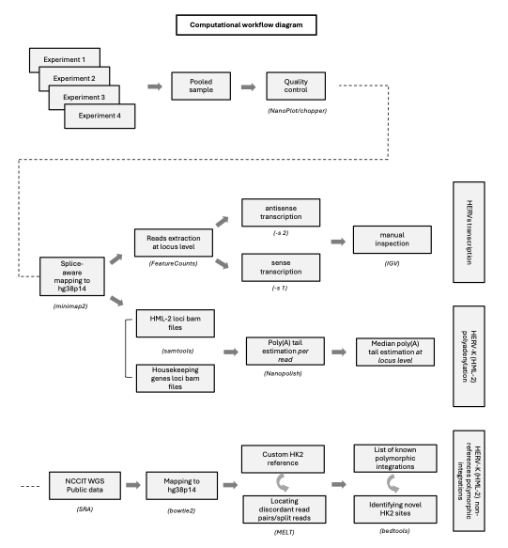
Figure S1. Diagram of the bioinformatics workflow used to analyze the retrotranscriptome in the NCCIT pooled sample and characterize HERV-K (HML-2) transcription.

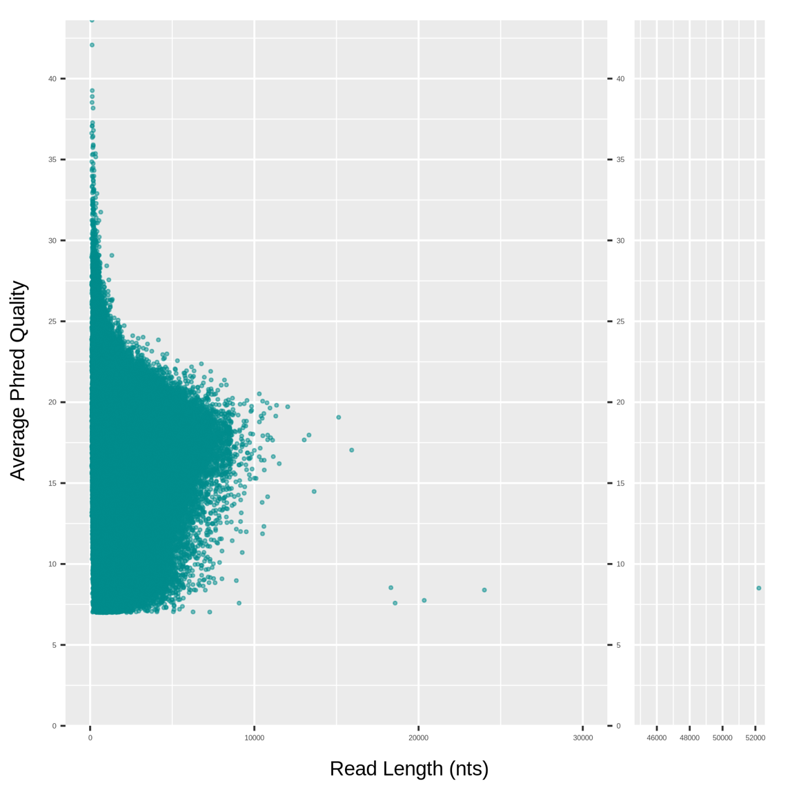
Figure S2. Scatterplot of the pooled sample mapped transcripts Average PhredQ quality score in comparison to the transcripts read length (nucleotides). The low cutoff threshold at PhredQ=7 is consistent with the quality threshold provided during the base calling, as described in the protocol.
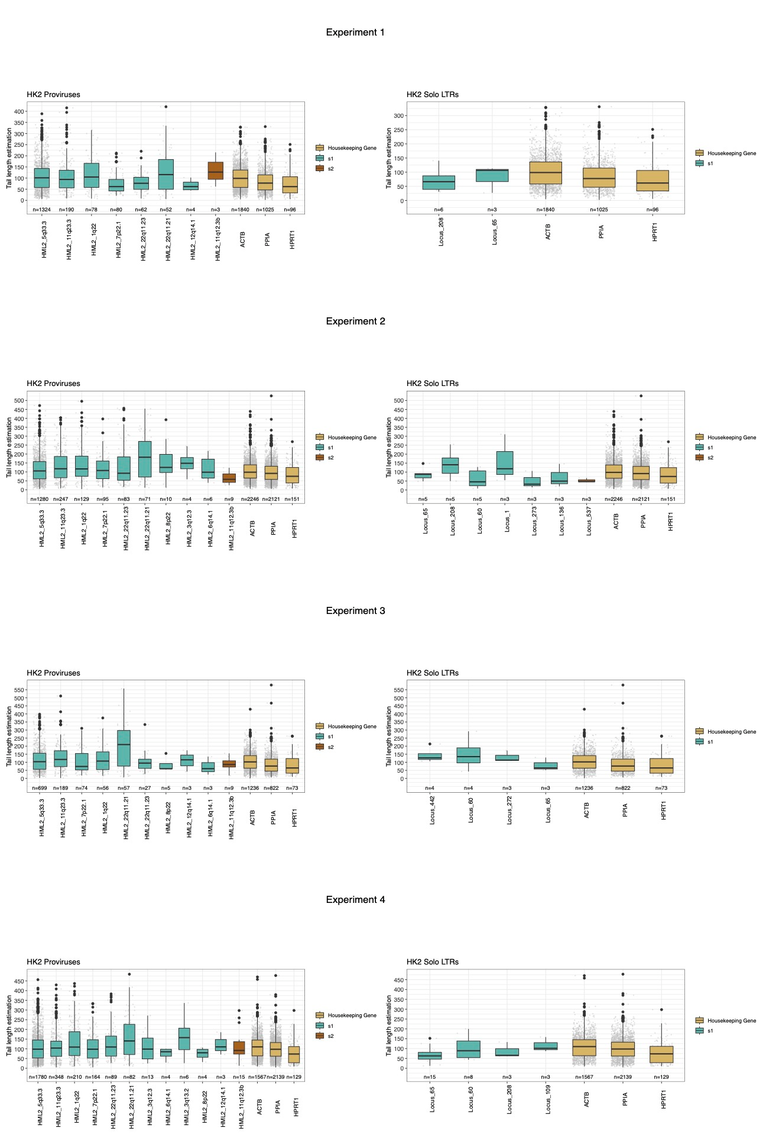
Figure S3. Poly(A) tail length estimates of HML-2 elements across individual experiments. Poly(A) tail length distributions for the expressed HK2 proviral (left) and solo LTR (right) loci are shown separately for each experiment, using the same bioinformatics workflow applied to the pooled sample. Cyan-colored boxplots correspond to the s1 (sense) expression counting method, brown-colored boxplots correspond to the s2 (antisense) method, and ochre-colored boxplots represent the three housekeeping genes (ACTB, PPIA, HPRT1). The number of transcripts (≥ 3 “PASS” reads per locus) indicated below each HK2 locus reflects the reads used for tail-length estimation. Tail lengths represent approximate counts of adenine (“A”) nucleotides (nts). Each boxplot summarizes the distribution of estimated poly(A) tail lengths for transcripts originating from a single locus, displaying the mean (black line), the median (red dot), the interquartile range (IQR), and outliers (black dots). Detailed per-run metrics are provided in Additional File 2.

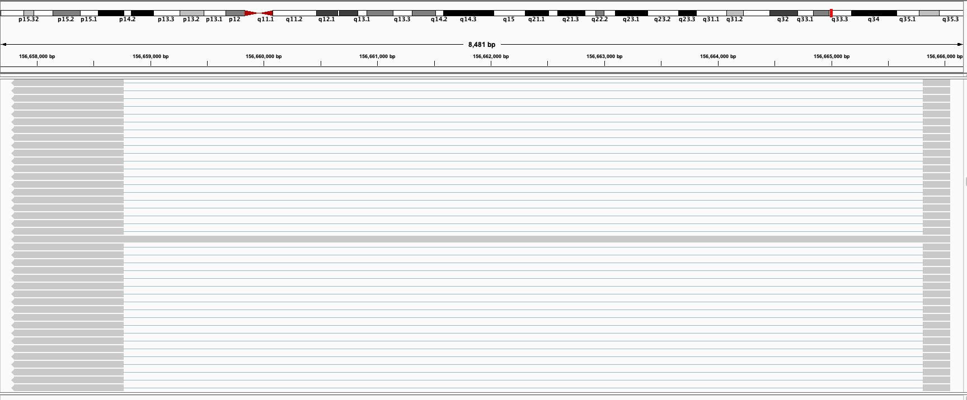
Figure S4. IGV screenshot from HK2 provirus 5q33.3 (chr5:156,657,706-156,666,885 (-)). Among the proviral reads, we observe at least one of ~8.3kb that corresponds to the unspliced produced transcript emerging from this locus.

Category 1 – Alternatively spliced np9/rec

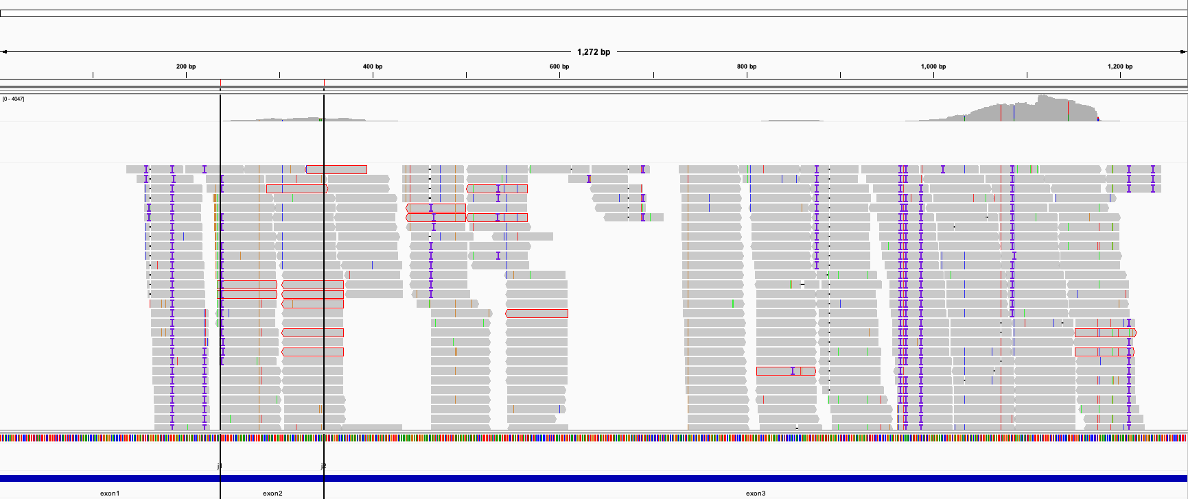

Category 2 – Beginning before 5’ LTR and ending inside the provirus
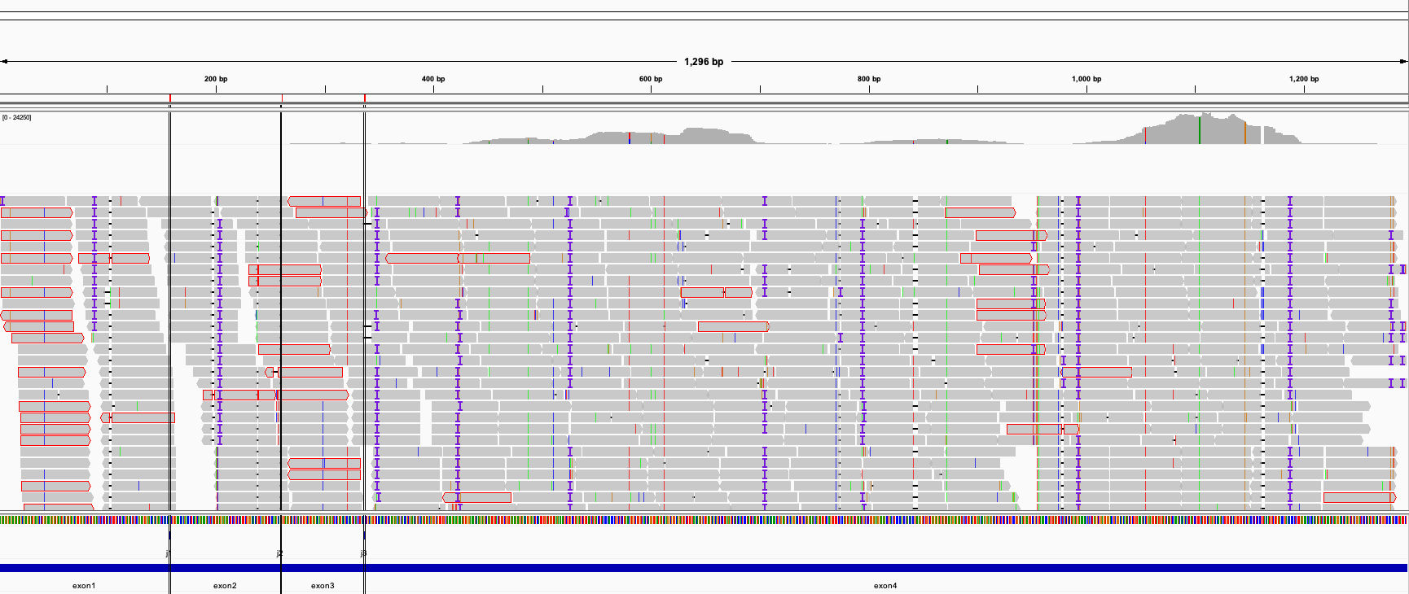

Category 3 – Two exons in the 5’ LTR

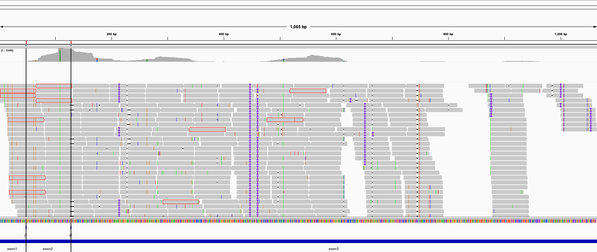

Category 4 – Ignored SD1 & SA1

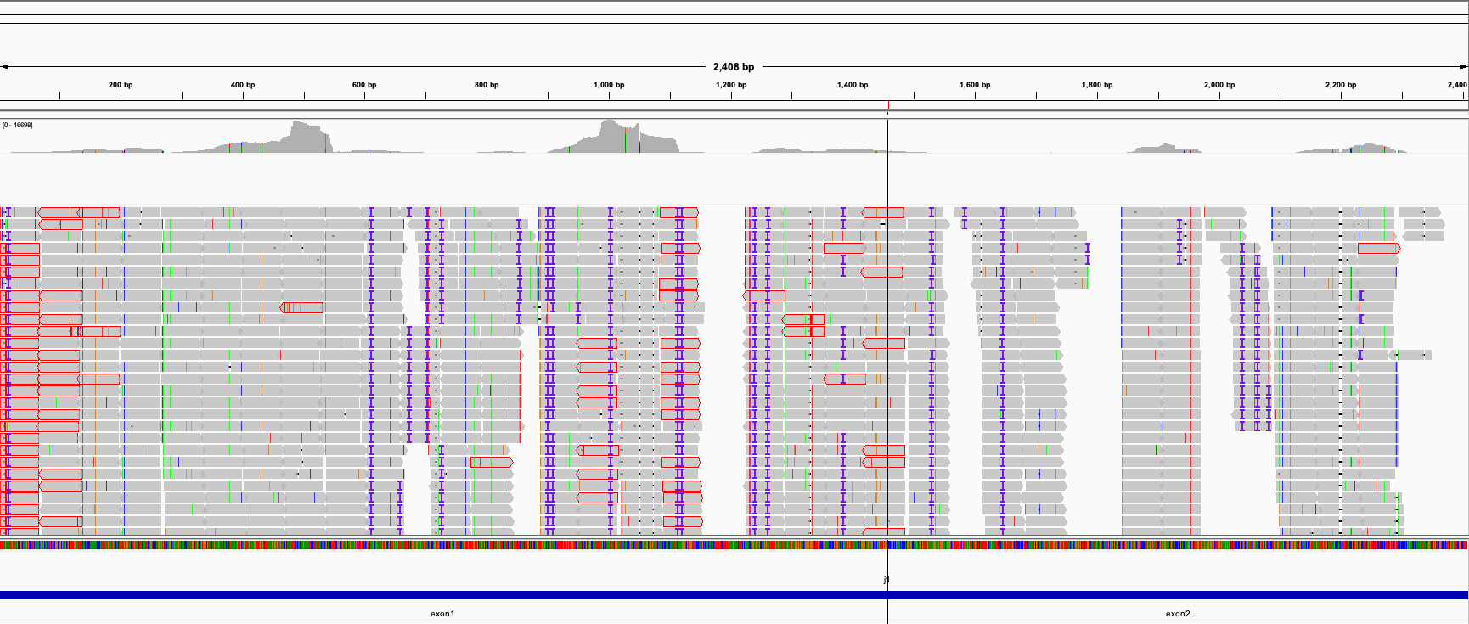

Category 6 – Extending beyond the 3’ LTR of the provirus

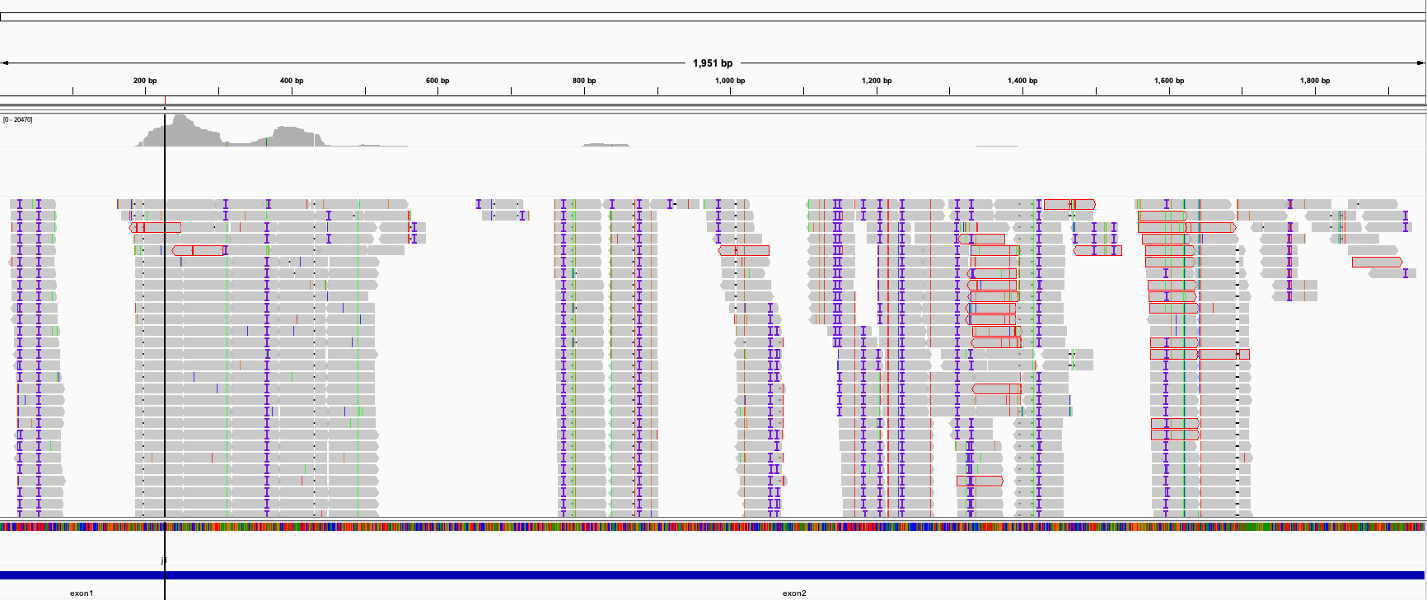

Category 7 – Ending in the U3 region of the 3’ LTR

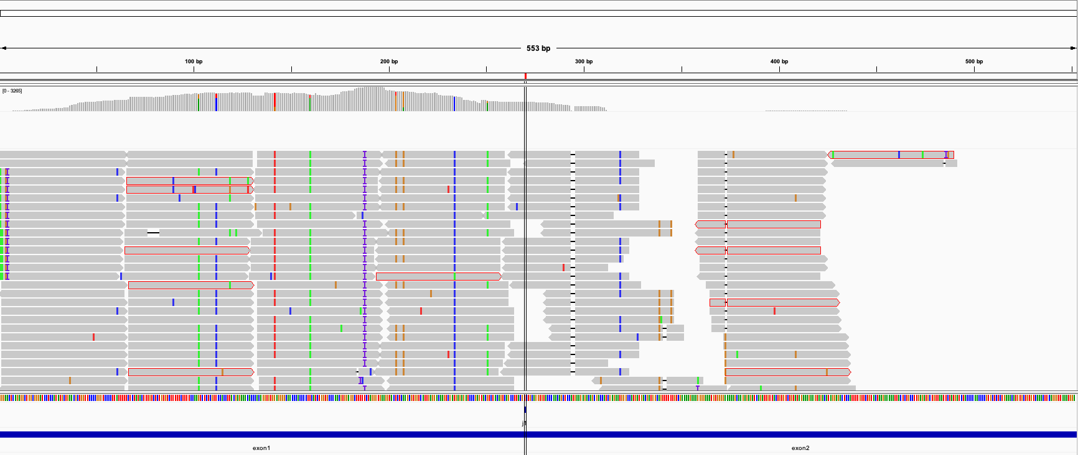

Figure S5. IGV screenshots depicting short reads coverage (grey) across the splice junctions (blue, bottom panel) of the non-canonical isoform categories 1-4,6, and 7. Red vertical lines indicate the boundaries between the exons and thus the splice junctions. Each figure corresponds to a representative read that was used as a reference to assess splice junction presence in the NCCIT cells.

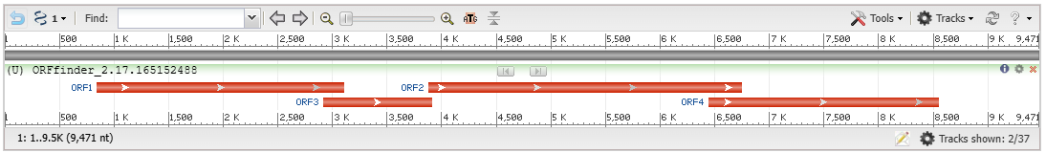
Figure S6: Output of ORFfinder for full proviral sequence of HERV-K113 (Genbank accession number JN675077). The minimal ORF length was set to 600 nucleotides. The use of any sense codon as the ORF start codon was permitted. ORF1, 2, 3 and 4 is for Gag, Pro, Pol and Env, accordingly.

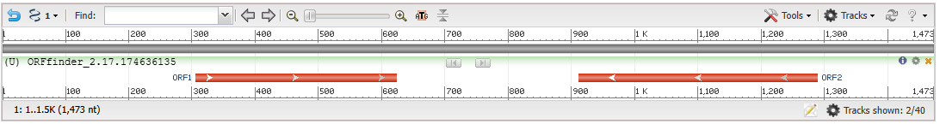
Figure S7: Output of ORFfinder for sequence of HERV-K113 rec transcript. ORF1, which is sense to the rec transcript, actually corresponds to the 105 amino-acid rec protein of HERV-K113 (see UniProt entry P61574).

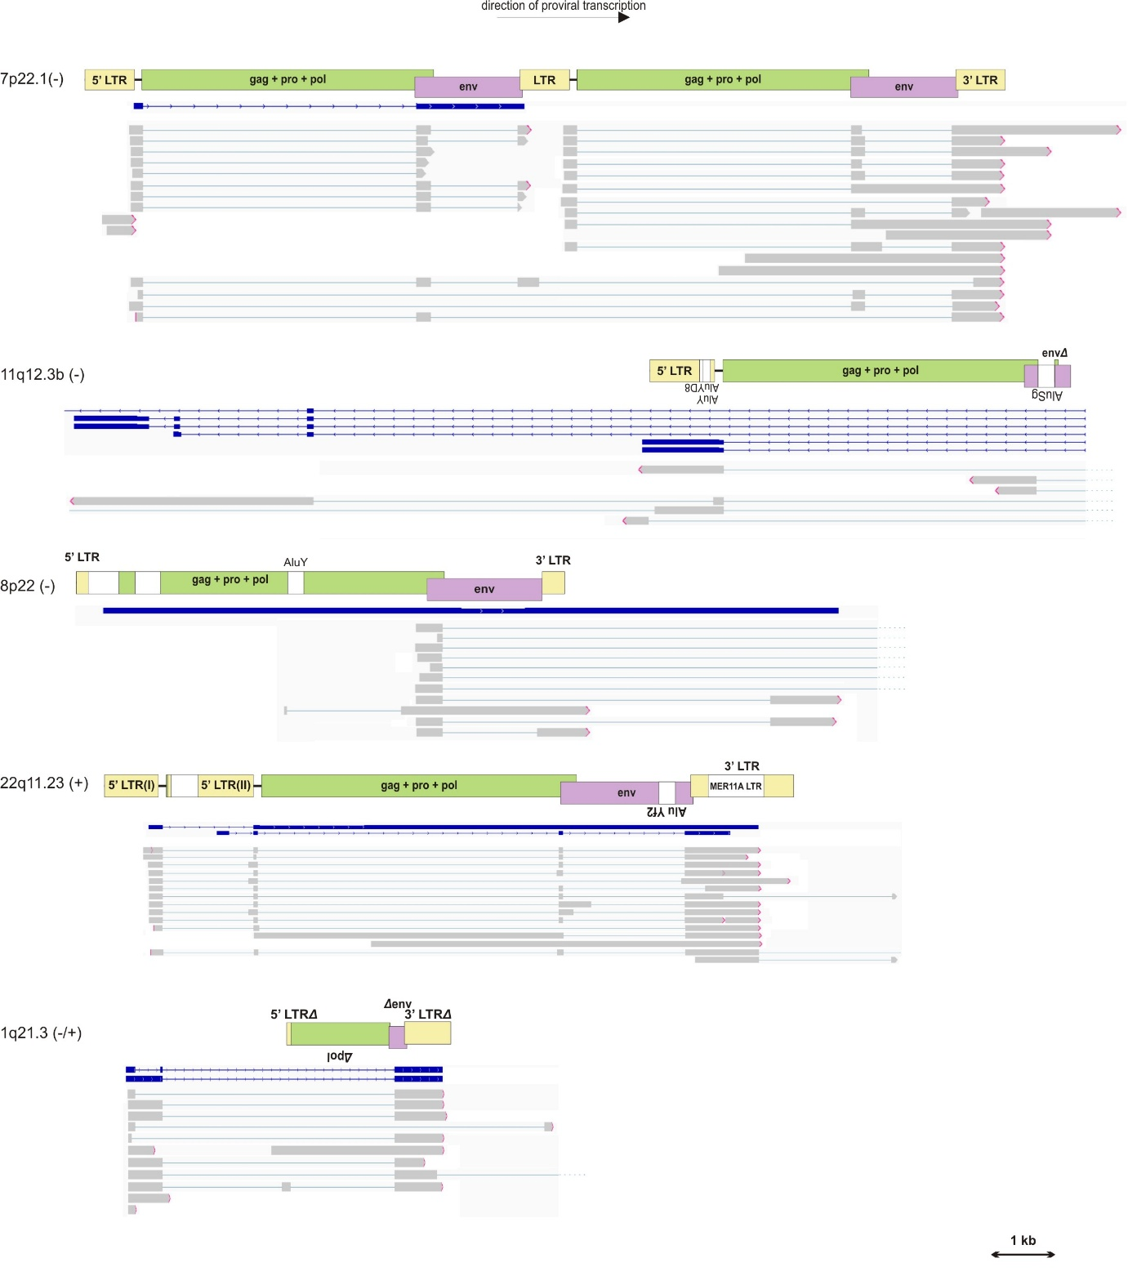Figure S8. Genome structure of highly mutated proviral HK2 genomes and cases of reads transcribed from them in NCCITs (for proviruses with ≥3 reads). Schematic representation of proviral genomes includes the 5’ and 3’ LTR regions (yellow), the gag-pro-pol cluster (green) and the env gene (lilac). White areas are non-proviral sequences, either recognized in literature as other repetitive elements or with unidentified yet origin. The symbol “Δ” before or after a gene/region name designates the deletion of a part of the respective gene or region in the beginning or end accordingly. The signs (+) and (-) near the chromosomal loci of each provirus indicate the strand. Genetic elements that are positioned in the opposite strand from the strand of the provirus have inverted names that are written from right to left. Shown in blue are transcripts of the DNA regions where the proviruses lie, deposited in the Refseq database. The transcripts that we found in NCCITs are represented in grey.

A)4p16.1a
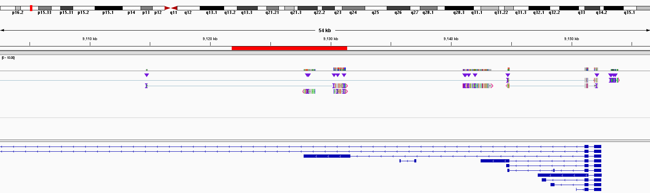
B)1q22
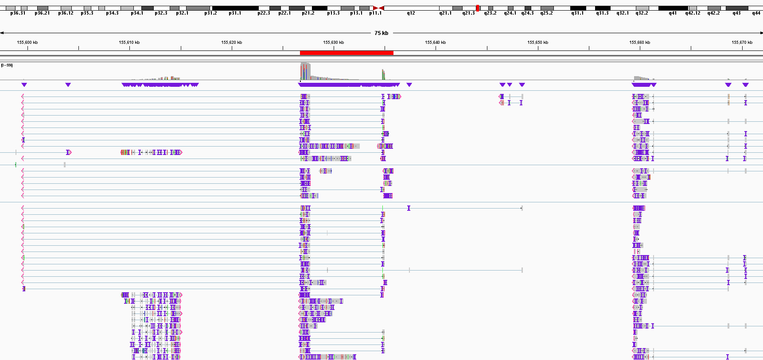
Figure S9. Screenshots taken directly from the Integrated Genome Viewer browser (IGV) during manual inspection of two HK2 proviruses with read-through transcripts. The proviral region is highlighted with a red band on top of the IGV viewer window, indicating the span of the locus. The depicted read-through transcripts are incorporating the proviral splicing sites and/or polyadenylation signals.
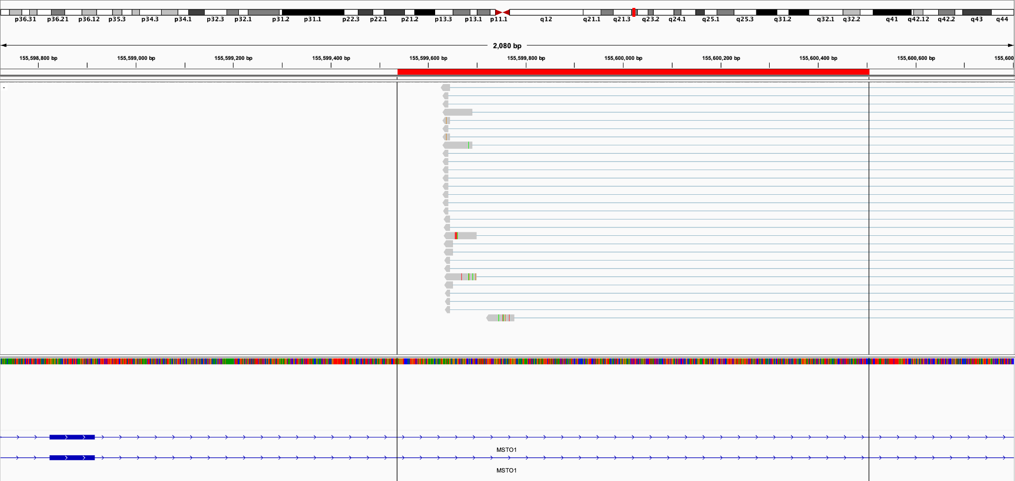
(A)
(B)
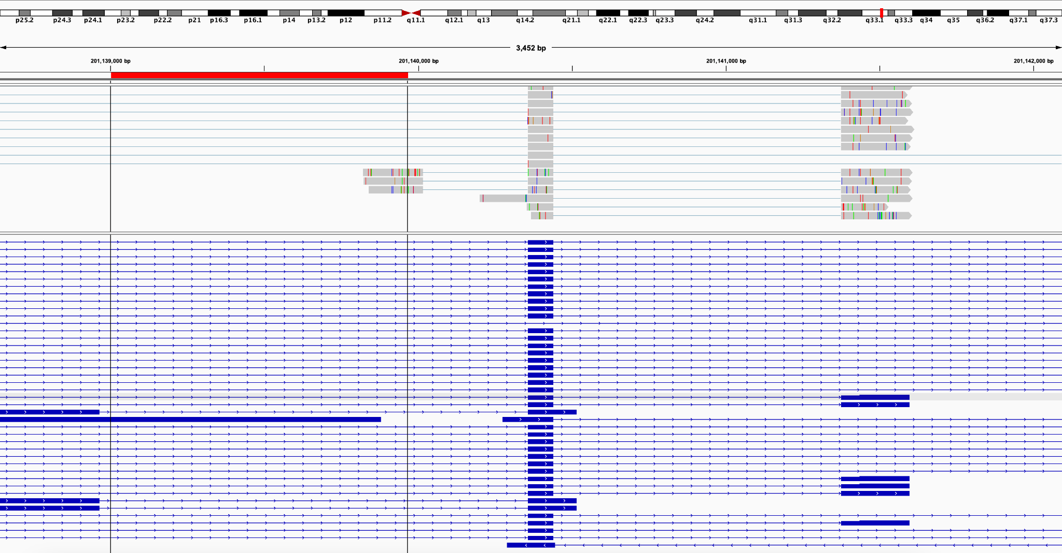

(C)
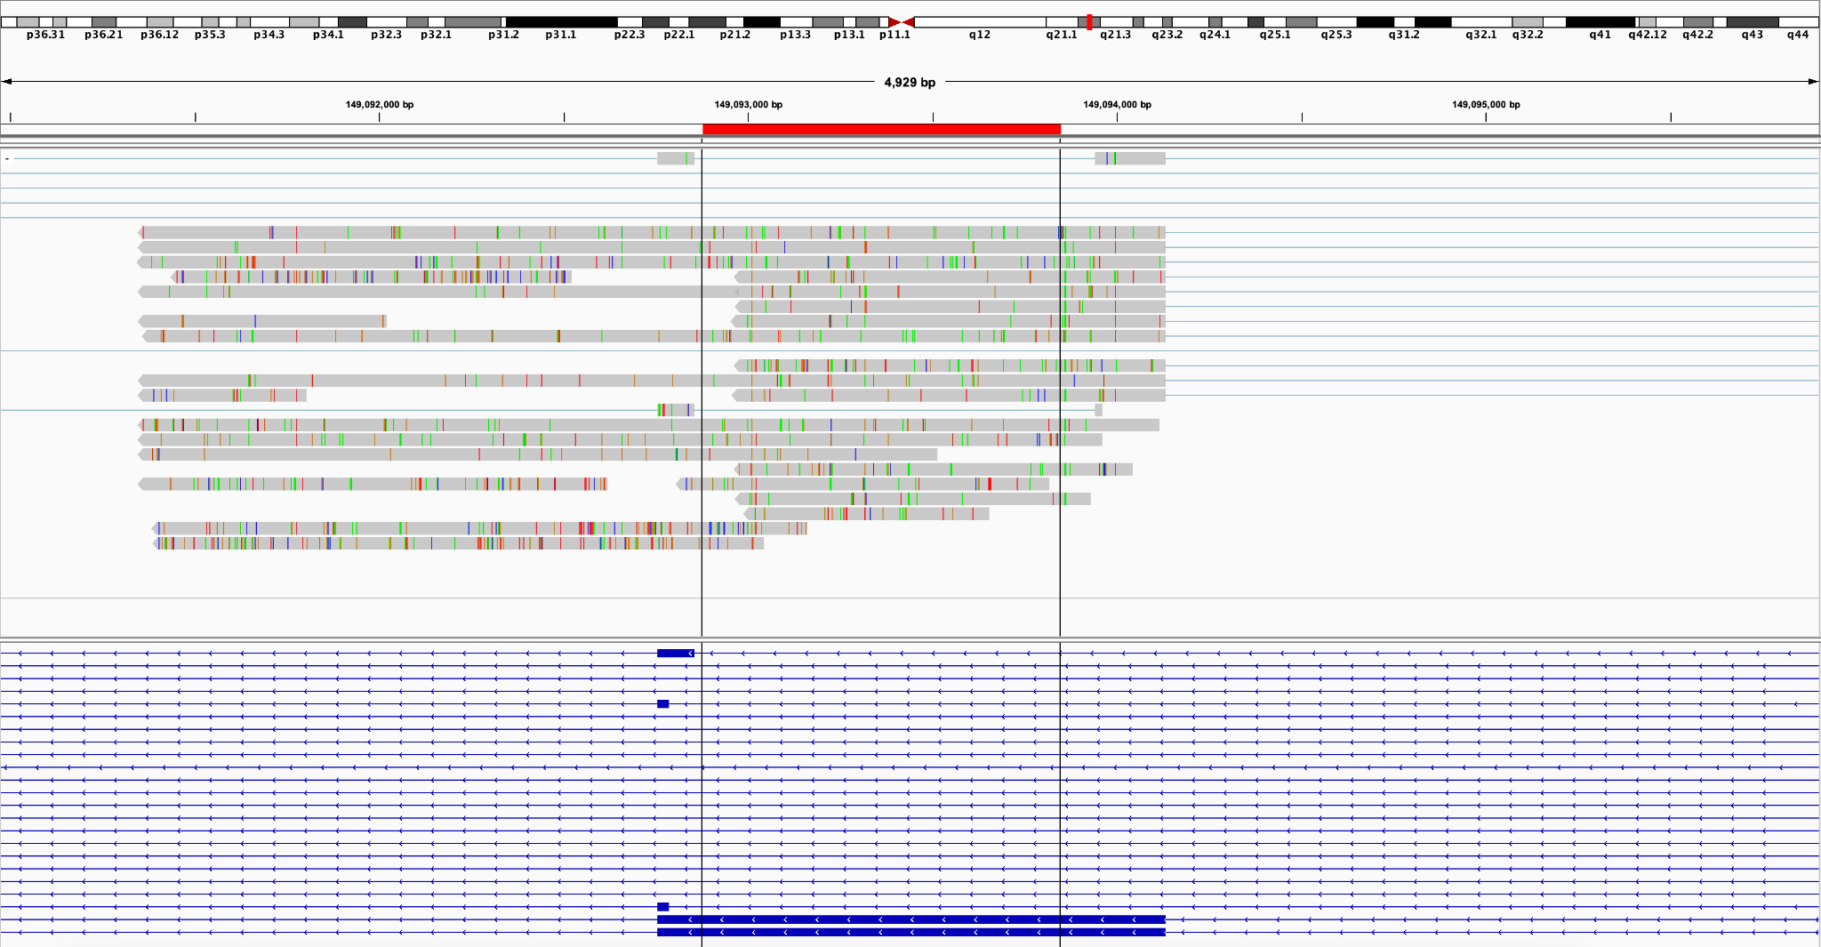
Figure S10. Screenshots taken from IGV, of HK2 solo LTR loci. We provide an example of the observed solo LTR role types/categories based on manual inspection of the alignments (the red bar denotes the solo LTR region). (A) In this case, we observe that the solo LTR locus at position chr1:155,599,537-155,600,505) provides the polyadenylation signal for transcripts belonging to MSTO1 (misato mitochondrial distribution and morphology regulator 1) gene and eventually facilitates the creation of alternative isoforms not included within the RefSeq database. (B) In this case, we observe the initiation of transcripts within the solo LTR locus at position chr2:201,139,002-201,139,967. More specifically, in this example the LTR provides the initiation site for three transcripts of CFLAR (CASP8 and FADD-like apoptosis regulator) that are possibly alternative isoforms (C) Part of the transcripts of the solo LTR on position chr1:149,092,877-149,093,848, demonstrate an example of read-through transcription, where the whole LTR region belongs to the produced read, whose start is upstream of the LTR upper boundary and is also extending beyond the LTR end. We also observe the creation of alternative polyadenylation signal for these transcripts that belong to the NBPF9 gene (RefSeq database).

References
1. Barbulescu M, Turner G, Seaman MI, Deinard AS, Kidd KK, Lenz J. Many human endogenous retrovirus K (HERV-K) proviruses are unique to humans. Curr Biol. 1999;9(16):861-8.
2. Contreras-Galindo R, Kaplan MH, Contreras-Galindo AC, Gonzalez-Hernandez MJ, Ferlenghi I, Giusti F, et al. Characterization of human endogenous retroviral elements in the blood of HIV-1-infected individuals. J Virol. 2012;86(1):262-76.
3. Zahn J, Kaplan MH, Fischer S, Dai M, Meng F, Saha AK, et al. Expansion of a novel endogenous retrovirus throughout the pericentromeres of modern humans. Genome Biol. 2015;16(1):74.
4. Sayers EW, Cavanaugh M, Clark K, Ostell J, Pruitt KD, Karsch-Mizrachi I. GenBank. Nucleic Acids Res. 2020;48(D1):D84-d6.
5. Madeira F, Madhusoodanan N, Lee J, Eusebi A, Niewielska A, Tivey ARN, et al. The EMBL-EBI Job Dispatcher sequence analysis tools framework in 2024. Nucleic Acids Res. 2024;52(W1):W521-w5.
6. Johnson M, Zaretskaya I, Raytselis Y, Merezhuk Y, McGinnis S, Madden TL. NCBI BLAST: a better web interface. Nucleic Acids Res. 2008;36(Web Server issue):W5-9.
7. Raney BJ, Barber GP, Benet-Pagès A, Casper J, Clawson H, Cline MS, et al. The UCSC Genome Browser database: 2024 update. Nucleic Acids Res. 2024;52(D1):D1082-d8.
8. Kodama Y, Shumway M, Leinonen R, Collaboration obotINSD. The sequence read archive: explosive growth of sequencing data. Nucleic Acids Research. 2011;40(D1):D54-D6.
9. Katz K, Shutov O, Lapoint R, Kimelman M, Brister JR, O'Sullivan C. The Sequence Read Archive: a decade more of explosive growth. Nucleic Acids Res. 2022;50(D1):D387-d90.
10. Babraham Bioinformatics—FastQC A Quality Control tool for High Throughput Sequence Data. (n.d.). Retrieved October 29, 2025, from https://www.bioinformatics.babraham.ac.uk/projects/fastqc/ [Internet].
11. Bolger AM, Lohse M, Usadel B. Trimmomatic: a flexible trimmer for Illumina sequence data. Bioinformatics. 2014;30(15):2114-20.
12. Langmead B, Salzberg SL. Fast gapped-read alignment with Bowtie 2. Nature Methods. 2012;9(4):357-9.
13. Thorvaldsdóttir H, Robinson JT, Mesirov JP. Integrative Genomics Viewer (IGV): high-performance genomics data visualization and exploration. Brief Bioinform. 2013;14(2):178-92.
14. Garcia-Montojo M, Doucet-O'Hare T, Henderson L, Nath A. Human endogenous retrovirus-K (HML-2): a comprehensive review. Crit Rev Microbiol. 2018;44(6):715-38.
15. Müller MD, Holst PJ, Nielsen KN. A Systematic Review of Expression and Immunogenicity of Human Endogenous Retroviral Proteins in Cancer and Discussion of Therapeutic Approaches. Int J Mol Sci. 2022;23(3).
16. Turner G, Barbulescu M, Su M, Jensen-Seaman MI, Kidd KK, Lenz J. Insertional polymorphisms of full-length endogenous retroviruses in humans. Current Biology. 2001;11(19):1531-5.
17. Sayers EW, Beck J, Bolton EE, Brister JR, Chan J, Connor R, et al. Database resources of the National Center for Biotechnology Information in 2025. Nucleic Acids Res. 2025;53(D1):D20-d9.
18. Altschul SF, Gish W, Miller W, Myers EW, Lipman DJ. Basic local alignment search tool. J Mol Biol. 1990;215(3):403-10.
19. Camacho C, Coulouris G, Avagyan V, Ma N, Papadopoulos J, Bealer K, et al. BLAST+: architecture and applications. BMC Bioinformatics. 2009;10:421.
20. Subramanian RP, Wildschutte JH, Russo C, Coffin JM. Identification, characterization, and comparative genomic distribution of the HERV-K (HML-2) group of human endogenous retroviruses. Retrovirology. 2011;8:90.
21. The UniProt Consortium. UniProt: the universal protein knowledgebase. Nucleic Acids Research. 2016;45(D1):D158-D69.
22. Mayer J, Harz C, Sanchez L, Pereira GC, Maldener E, Heras SR, et al. Transcriptional profiling of HERV-K(HML-2) in amyotrophic lateral sclerosis and potential implications for expression of HML-2 proteins. Mol Neurodegener. 2018;13(1):39.
23. Bhardwaj N, Montesion M, Roy F, Coffin JM. Differential expression of HERV-K (HML-2) proviruses in cells and virions of the teratocarcinoma cell line Tera-1. Viruses. 2015;7(3):939-68.
24. Hohn O, Hanke K, Bannert N. HERV-K(HML-2), the Best Preserved Family of HERVs: Endogenization, Expression, and Implications in Health and Disease. Front Oncol. 2013;3:246.
25. O'Leary NA, Wright MW, Brister JR, Ciufo S, Haddad D, McVeigh R, et al. Reference sequence (RefSeq) database at NCBI: current status, taxonomic expansion, and functional annotation. Nucleic Acids Res. 2016;44(D1):D733-45.
26. Dewannieux M, Blaise S, Heidmann T. Identification of a functional envelope protein from the HERV-K family of human endogenous retroviruses. J Virol. 2005;79(24):15573-7.
27. Schmitt K, Reichrath J, Roesch A, Meese E, Mayer J. Transcriptional profiling of human endogenous retrovirus group HERV-K(HML-2) loci in melanoma. Genome Biol Evol. 2013;5(2):307-28.
28. Goering W, Schmitt K, Dostert M, Schaal H, Deenen R, Mayer J, et al. Human endogenous retrovirus HERV-K(HML-2) activity in prostate cancer is dominated by a few loci. Prostate. 2015;75(16):1958-71.
29. Wang Y, Hu Y, Wu G, Yang Y, Tang Y, Zhang W, et al. Long noncoding RNA PCAT-14 induces proliferation and invasion by hepatocellular carcinoma cells by inducing methylation of miR-372. Oncotarget. 2017;8(21):34429-41.
30. Prensner JR, Iyer MK, Balbin OA, Dhanasekaran SM, Cao Q, Brenner JC, et al. Transcriptome sequencing across a prostate cancer cohort identifies PCAT-1, an unannotated lincRNA implicated in disease progression. Nat Biotechnol. 2011;29(8):742-9.
31. An C, Wang I, Li X, Xia R, Deng F. Long non-coding RNA in prostate cancer. Am J Clin Exp Urol. 2022;10(3):170-9.
32. Bendall ML, de Mulder M, Iniguez LP, Lecanda-Sanchez A, Perez-Losada M, Ostrowski MA, et al. Telescope: Characterization of the retrotranscriptome by accurate estimation of transposable element expression. PLoS Comput Biol. 2019;15(9):e1006453.
33. Xue C, Gao P, Cui X, Zhang X, Lei J, Li R, et al. ASRGL1 Correlates With Immune Cell Infiltration in Hepatocellular Carcinoma and Can Serve as a Prognostic Biomarker. Front Oncol. 2021;11:680070.
34. Garcia-Montojo M, Fathi S, Rastegar C, Simula ER, Doucet-O'Hare T, Cheng YHH, et al. TDP-43 proteinopathy in ALS is triggered by loss of ASRGL1 and associated with HML-2 expression. Nat Commun. 2024;15(1):4163.
35. De Morais SB, De Souza T. Human L‑asparaginase: Acquiring knowledge of its activation (Review). Int J Oncol. 2021;58(4).
36. Burn A, Roy F, Freeman M, Coffin JM. Widespread expression of the ancient HERV-K (HML-2) provirus group in normal human tissues. PLoS Biol. 2022;20(10):e3001826.
37. Russ E, Mikhalkevich N, Iordanskiy S. Expression of Human Endogenous Retrovirus Group K (HERV-K) HML-2 Correlates with Immune Activation of Macrophages and Type I Interferon Response. Microbiol Spectr. 2023;11(2):e0443822.
38. Qian W, Zhao M, Wang R, Li H. Fibrinogen-like protein 1 (FGL1): the next immune checkpoint target. J Hematol Oncol. 2021;14(1):147.

Nucleotide alignments

Canonical full-length transcript (11q23.3)
5’LTR

Genomic 1 TATGCTGAACGCTGGTTCCCCGGGTCCCCTTATTTCTTTCTCTATACTTTGTCTCTGTGT 60
|||||||| || || |||||||||||||||||||| |||||||||||| |||||||
DRSread 1 TATGCTGA-CGTTG-TTCCCCGGGTCCCCTTATTT-----TCTATACTTTGTTTCTGTGT 53

Genomic 61 CTTTTTCTTTTCCAAGTCTCTCGTT-CCACCTTACGAGAAACACCCACAGGTGTGGAGGG 119
||||| ||||| ||||||||||| |||| ||||||| || ||||| | ||
DRSread 54 TTTTTT-TTTTC--AGTCTCTCGTTTCCAC---ACGAGAACTTCC---AGGTGA--AAGG 102
5’LTR

Genomic 120 GCAACCCACCCCTTCATCTGGTGCCCAACGTGGAGGCTTTTCTCTAGGGTGAAGGTACTC 179
||||||| || |||| | ||| || | | || | |||||||||
DRSread 103 GCAACCCTTCC-----------GCCCTA---GGAATATTCACACAAGCG--AAGGTACTC 146

Genomic 180 TCAAGCGTGGTCATTGAGGACA--AGTCGACGAGAGATCCCGAGTACGTCTAC--AGTCA 235
||||||||||||||| || ||| ||||||| |||||||| || ||| |||||
DRSread 147 TCAAGCGTGGTCATT-AGAACAGCAGTCGACAGGAGATCCCTGATA----TACCAAGTCA 201
gag

Genomic 236 GCCTTACGGTAAGCTTGTGGGCTCAGAAGAAGCTAGGGTGATAATGGGGCAAACTAAAGT 295
||| | || | |||||||||||||| ||||||||||||| |||||||||||
DRSread 202 GCCAT---GTCTGGCTGTGGGCTCAGAAG------GGGTGATAATGGG-CAAACTAAAGT 251

Genomic 296 AAAACTAAAA-GTAAATATGCCTCTTTTCTCAGCTTTATTAAAATTCTTTTAAAAAGAGG 354
|||||||||| |||||||||||| ||| |||||||||||||||||||| ||| |
DRSread 252 AAAACTAAAAAGTAAATATGCCTTTTT---CAGCTTTATTAAAATTCTTTCAAA-----G 303

Genomic 355 GGGAGTTAAAGTATCTACAAAAAATCTAATCAAGCTATTTCAAACAATAGAACAATTTTG 414
|||||| ||||||||||||||| |||||||||||||||||||| |||||||| ||
DRSread 304 GGGAGTCAAAGTATCTACAAAA--TCTAATCAAGCTATTTCAAA---TAGAACAAAGCTG 358

Genomic 415 CCCATGGTTT-CCAGAACAAGGAACTT-TAGATCTAAAAGATTGGAAAA-GAATTGTTAA 471
|| |||||| |||||||||||||||| ||||||||||||||||||||| ||||||||||
DRSread 359 CCTCTGGTTTTCCAGAACAAGGAACTTCTAGATCTAAAAGATTGGAAAAAGAATTGTTAA 418

Genomic 472 GGAACTAAAACAAGCAAGTAGGA-AGGGTAATATCATTCCACTTACAGTATGGAATGATT 530
||||||||||||||||||||||| | |||| |||||||||||||||||||||||||||||
DRSread 419 GGAACTAAAACAAGCAAGTAGGAGAAGGTA-TATCATTCCACTTACAGTATGGAATGATT 477

Genomic 531 GGGCCATTATTAAAGCAGCTTTAGAACCATTTCAAACAGAAGAAGATAGCGTTTCAGTTT 590
|| ||||||||| | ||| ||||||||||||||||||||||||||||||||||||||
DRSread 478 GG-CCATTATTACTGGTACTTAAGAACCATTTCAAACAGAAGAAGATAGCGTTTCAGTTT 536

Genomic 591 CTGATGCCCCTGGAAGCTGTTTAATAGATTGTAATGAAAA-GACAAGGAAAAAAATCCCA 649
||||||||| ||||||||||||||||||||||||||||| ||||||||||| |||||
DRSread 537 CTGATGCCCA-GGAAGCTGTTTAATAGATTGTAATGAAAAAGACAAGGAAAA---TCCCA 592

Genomic 650 GAAAGAAACGGAAGGTTTACATTGCGAATATGTAGCAGAGCCGGTAATGGCTCAGTCAAT 709
|||||||||||||||||||| ||||| |||||||||||| |||||||||||||||||
DRSread 593 GAAAGAAACGGAAGGTTTAC--TGCGA---TGTAGCAGAGCCAGTAATGGCTCAGTCAAT 647

Genomic 710 GCAAA-ATGTTGACTA-TAATCAATTACAGGAGGTGATATATCCTGAAACGTTAAAATTA 767
||||| ||||||||| ||||| | || |||||||||||||| |||| | |||||||
DRSread 648 GCAAATATGTTGACTGCTAATCGCT-AC-GGAGGTGATATATC---AAACAT-AAAATTA 701

Genomic 768 GAAGGAAAAGGTCCCGAATTAGTGGGGCCATCAGAGTCTAAACCACGAGGGCCAAGTCCT 827
||||||||| | ||||||||||||| |||||||||| || || ||||| ||
DRSread 702 GAAGGAAAAAGGTCCGAATTAGTGGG-CCATCAGAGT--AATTCA---GGGCCGGTACCA 755

Genomic 828 CTTCCAGCAGGTCAGGTGCCCGTAACATTACAACCTCAAACGCAGGTTAGAGAAAATAAG 887
||||||||||||||||||||||||||||||| || || | | || ||||||||||||
DRSread 756 CTTCCAGCAGGTCAGGTGCCCGTAACATTAC----TCCAAAGGAAGTAAGAGAAAATAAG 811

Genomic 888 AGCCAACCACCAGTAGCTTATCAATACTGGCCGCTGGCTGAACTTCAGTATCAGCCACCC 947
||||| |||||||||| |||||| ||| |||||||||||||||||| || |||
DRSread 812 AGCCATT-ACCAGTAGCTCATCAATT---GCCA-TGGCTGAACTTCAGTATCGGCTTCCC 866

Genomic 948 CCAGAAAGTCAGTATGGATATC-CAGGAATGCCCCCAGCACCACAGGGCAGGGCGCCATA 1006
||||||| ||||| | ||||||||||| ||| ||||||||||| | |||
DRSread 867 G--GAAAGTC-----GGATAACACAGGAATGCCC--AGCCTTTCAGGGCAGGGCAC-ATA 916

Genomic 1007 CCCTCAGCCGCCCACTAGGAGACTTAATCCT-ACGGCACCGCCTAGTAGACAGGGTAGTG 1065
|| | |||||| ||| ||||||||||||| |||||||||||| ||||||| || |||
DRSread 917 CCACCTGCCGCC-ACT--GAGACTTAATCCTTACGGCACCGCCTGGTAGACAAGG--GTG 971

Genomic 1066 AATTACATGAAATTATTGAGAAGAAAGGAAGGAGATACTGAGGCGTGGCAATTCCCAGTA 1125
|| |||||||||||||||||||||||||||| |||| ||||| ||||
DRSread 972 GCC-ACTCGAAATTATTGAGAAGAAAGGAAGGAGATTAA-AGGC------ATTCC-AGTA 1022

Genomic 1126 ACGTTAGAACCGATGCCACCTGGAGAAGAAGCCCAAGAGGGAGAGCCTCTCACAGTTGAG 1185
||||| |||| | |||||||| || |||| || ||||||| |||| ||
DRSread 1023 ACGTTGGAACTGG-----CCTGGAGAGGAG--CCAAAAG--AGAGCCTT---CAGTCGAC 1070

Genomic 1186 GCCAGATACAAGTCTTTTTTGATAAAAATGCTAAAAGATATGAAAGAGGGAGTAAAACAG 1245
|| ||||| |||||||| |||||||||| |||| | | |||||| | |||
DRSread 1071 GC-AGATA--AGTCTTTT--GATAAAAATGTTAAA-GTTCGAAAAGAGTG-------CAG 1117

Genomic 1246 TATGGACCCAACTCCCCTTATATGAGTACATTATTAGATTCCATTGCTCATGGACATAGA 1305
|| ||||||||||||||||||||||| ||||||||||||||||||||||||||||||
DRSread 1118 TA--GACCCAACTCCCCTTATATGAGT---TTATTAGATTCCATTGCTCATGGACATAGA 1172

Genomic 1306 CTCA---TTCCTTATGATTGGGAGATTCTGGCAAGATCATCTCTCTCACCCTCTCAATTT 1362
|||| |||||||||||||||||||||||||||||||||||||||| |||| || ||
DRSread 1173 CTCACCATTCCTTATGATTGGGAGATTCTGGCAAGATCATCTCTCTCTTCCTC--AAATT 1230

Genomic 1363 TTACAATTTAAGACTTGGTGGATTGATGGGGTACAAGAACAGGTCCGAAGAAATAGGGCT 1422
|| | || || | || |||||||| | | |||||||||||| ||||||| |||||
DRSread 1231 TTGC---TTTAG---TTGTAGATTGATGAGTT-CAAGAACAGGTCT-AAGAAATGGGGCT 1282

Genomic 1423 GCCAATCCTCCAGTTAACATAGATGCAGATCAACTATTAGGAAGAGGTCAAAA-TTGGAG 1481
|||||||||| |||||| | ||||||||||| ||||||| ||||||||||| ||||||
DRSread 1283 GCCAATCCTCG-GTTAACTT-GATGCAGATCA--TATTAGGTAGAGGTCAAAAATTGGAG 1338

Genomic 1482 TACTATTAGTCAACAAGCATTCATGCAAAATGAGGCCATTGAGCAAGTTAGAGCTATCTG 1541
||||| |||||||||||||| ||||| ||||||||||||||||||||||||||||||
DRSread 1339 TACTA---GTCAACAAGCATTCCCGCAAA-TGAGGCCATTGAGCAAGTTAGAGCTATCTG 1394

Genomic 1542 CCT-TAGAGCCTGGGAAAAAATCCAAGACCCAGGAAGCGCCTGCCCCTCATTTAA-TACA 1599
|| |||||||||| |||||||||||||||||||||| |||||| |||||||| ||||
DRSread 1395 CCACTAGAGCCTGG--AAAAATCCAAGACCCAGGAAGC--CTGCCC-TCATTTAAATACA 1449

Genomic 1600 GTAAGACAAGGTTCAAAAGAGCCCTACCCTGATTTTGTGGCAAGGCTCCAAGATGTTGCT 1659
||||||| |||| ||||||| |||| |||||||||||||||||||||||||| ||||
DRSread 1450 GTAAGACGGGGTTTCGAAGAGCC-TACC-TGATTTTGTGGCAAGGCTCCAAGATGCTGCT 1507

Genomic 1660 CAAAAGTCAATTGCCGACGAAAAAGCC-CATAAGGTCATAGTGGAGTTGAT-GGCATATG 1717
| |||||| | |||||||||||| |||||||||| ||||||| | |||
DRSread 1508 TTA--GTCAATATC-GACGAAAAAGCCACATAAGGTCAA--TGGAGTTAGTCGGCG---- 1558

Genomic 1718 AAAACGCCAATCCTGAGTGTCAATCAGCCATTAAGCCATTAAAAGGAAAGGTTCCCACAG 1777
|||||||||||||| || || || | ||||| ||||||||| ||||||||| |
DRSread 1559 -AAACGCCAATCCTG---GTGCGTCGGC-ACTAAGCG--TAAAAGGAA-GGTTCCCAC-G 1609

Genomic 1778 GGTCAGATGTAATCTCAGAGTATGTAAAAGCCTGTGATGGAATCGGAGGAGATATGCATA 1837
||||||||||| ||||| ||||||||||| ||||||||||||||||||||| ||
DRSread 1610 ATTCAGATGTAATACAAGAGTTCGTAAAAGCCTG--ATGGAATCGGAGGAGATATGC-TA 1666

Genomic 1838 AAGCTATGCTTATGGCTCAAGCAATAACAGGAGTTGTTTTAGGAGGACAAGTTAAAACAT 1897
|||||||||||||||||||||||||||| ||||||||| ||||||||||||| | | |
DRSread 1667 AAGCTATGCTTATGGCTCAAGCAATAAC-GGAGTTGTTG--GGAGGACAAGTTATA-CTT 1722

Genomic 1898 TTGGAGGAAAATGTTATAATTGTGG--TCAAATTGGTCATTTAAAAAAGAATTGGCCAGT 1955
|||||||||| || |||||||| |||||||||||||||||||||||||||||||||
DRSread 1723 TTGGAGGAAA-TGCTATAATTGCAAAATCAAATTGGTCATTTAAAAAAGAATTGGCCAGT 1781

Genomic 1956 CTTAAATAAACAGAATATAACTATTCAAGCAACTACAACAGGTAGAGAGCCACCTGACTT 2015
||||||||||||||||||||||||||||||| ||||| || |||||||||||||
DRSread 1782 CTTAAATAAACAGAATATAACTATTCAAGCAT-TACAATAG------AGCCACCTGACTT 1834

Genomic 2016 ATGTCCAAAATGTAAAAAAGGAAAACATGGGGCTAGTCAGTGTCATTCTAAATTTGATAA 2075
||||||||| |||| ||||||||| |||||| || |||||||||||| ||| | | |
DRSread 1835 ATGTCCAAA-TGTATAAAAGGAAA-CATGGG-CTGGTCAGTGTCATTTTAA--TACAGCA 1889
pro

Genomic 2076 AAACAGGCAACCATTGTC--GGGAAATGAACAAACGGGCCAGCCT-CAGGCCCCACAACA 2132
|||||||||||||| | | ||||||||||||||| ||||||||| |||||||| | ||
DRSread 1890 AAACAGGCAACCATCGACATGGGAAATGAACAAACAGGCCAGCCTTCAGGCCCCTTA-CA 1948

Genomic 2133 AACTGGGGCATTCCCAATTCAGCCATTTGTTCCTCAGGGTT-TTCAGGGACAAAAACCCC 2191
||||||| ||||||||||||||||||||| | |||||||| ||||||||||| |||
DRSread 1949 AACTGGG-CATTCCCAATTCAGCCATTTGCT--TCAGGGTTCTTCAGGGACAATT--CCC 2003

Genomic 2192 CACTGTCCCAAGTGTTTCAGGGAATAAGCCAGTTACCACAATACAACAATTGTCCCCCGC 2251
||||||||||||||||||||||||||| | ||| ||||||||||||||||||||| ||
DRSread 2004 CACTGTCCCAAGTGTTTCAGGGAATAAACGTGTT--CACAATACAACAATTGTCCCC-GC 2060
gag

Genomic 2252 CACAAGCGGCAGTGCAGCAGTAGATTTATGTACTATACAAGCAGTCTCTCTGCTTCCAGG 2311
||||||||||||||||||||||||| |||| ||||| |||||||||| |||||| ||
DRSread 2061 CACAAGCGGCAGTGCAGCAGTAGATC-ATGT-CTATA--AGCAGTCTCT--GCTTCC-GG 2113

Genomic 2312 GAAGCCCCCACAAAAAATCCCCACAGGGGTATATGGCCCACTGCCTGAGGGGACTGTAGG 2371
||||||| | |||||| ||||| ||| ||||||||||||||| ||||||||
DRSread 2114 GAAGCCCT-----ACAATCCC-ACAGG----TATTGCCCACTGCCTGAGG--ACTGTAGG 2161

Genomic 2372 ACTAATCTTGGGAAGATCAAGTCTAAATCTAAAAGGAGTTCAAATTCAT-ACTGGTGTGG 2430
||||||| |||||| ||||||||||||||||||||||||||||||| ||||||||||
DRSread 2162 ACTAATCACTTGAAGAT-AAGTCTAAATCTAAAAGGAGTTCAAATTCATCACTGGTGTGG 2220

Genomic 2431 TTGATTCAGACTATAAAGGCGAAATTCAATTGGTTATTAGCTCTTCAATTCCTTGGAGTG 2490
|||||||||||||||||||||||||||| | |||||||||||||||||||||| |||||
DRSread 2221 TTGATTCAGACTATAAAGGCGAAATTCACT-GGTTATTAGCTCTTCAATTCCT-GGAGTT 2278

Genomic 2491 CCAGTCCAGGAGACAGGATTGCTCGATTATTACTCCTGCCATATATT-AAGGTTGGAAAT 2549
||||||||||||||||||||||||||||||||||||||||||||||| |||||||||| |
DRSread 2279 CCAGTCCAGGAGACAGGATTGCTCGATTATTACTCCTGCCATATATTTAAGGTTGGAA-T 2337

Genomic 2550 AGTGAAATAAAAAGAACAGGAGGGTTTGGAAGCACTGATC-TGACAGGAAAGGCTGCATA 2608
|||||||||||| ||||||||||||||||||||||||||| ||||||||||||| |
DRSread 2338 AGTGAAATAAAA-GAACAGGAGGGTTTGGAAGCACTGATCATGACAGGAAAGGC-----A 2391

Genomic 2609 TTGGGCAAGTCAGGTCTCAAAGAACAGACCTGTGTGTAAGGCCAT-TATTCAAGGAA--- 2664
||| ||||||||||||| | ||||||| | ||||||||||||| | |||||||||
DRSread 2392 TTG--CAAGTCAGGTCTCGA-GAACAGATCC-TGTGTAAGGCCATATTTTCAAGGAACTG 2447

Genomic 2665 AA--CAGTTTGAAGGGTTGGTAGACAC-TGGAGCAGATGTCTCTATCATTGCT-TTAAAT 2720
|| || |||||||||| ||||||| ||||||||||| | || || || || |||
DRSread 2448 AAGTCAACCTGAAGGGTTG-TAGACACCTGGAGCAGATGCATTTAC--TTACTATTTAAT 2504

Genomic 2721 CAGTGGCCAAAAAATTGGCCTAAACAAAAG---GCTGTTACAGGATTTGTCGGCATAGGC 2777
|||||| ||||||||||||||||||||||| ||||||||||||| |||||||||||||
DRSread 2505 CAGTGGTCAAAAAATTGGCCTAAACAAAAGAAGGCTGTTACAGGATCTGTCGGCATAGGC 2564

Genomic 2778 ACAGCCTCAGAAGTGTATCAAAGTACTGAGATTTTACATTGCTTAGGGCCAGATAATCAA 2837
||||||||||||||||||| || | | |||||||| | |||||| |||||
DRSread 2565 ACAGCCTCAGAAGTGTATCTAA--AGTTTGATTTTACTAATCA-AGGGCCGGATAA---- 2617

Genomic 2838 GAAAGTACTGTTCAGCCCATGATTACTTCAATTCCTCTTAATCTGTGGGGTCGAGATTTA 2897
||||| | |||| ||| || ||||||| |||| || |||||||| | ||||||||
DRSread 2618 -AAAGTCC-GTTCCGCC--TG-TTACTTCGCTTCCACT-AATCTGTG---TTGAGATTTA 2668

Genomic 2898 TTACAACAATGGGGTGTGGAAATCACCATGCCCTCTCCATTATATAGCCCCAGGAGTCAA 2957
||||||||||| | ||||||||| | ||| | |||||||||||||| |||||||||
DRSread 2669 TTACAACAATGAG-TGTGGAAATTCTTCT-CCCACACCATTATATAGCCC-AGGAGTCAA 2725

Genomic 2958 AAAATCATGACCAAGATGGGATATATACCAGGAAAGGGACTAGGGAAAAATGAAGATGGC 3017
||||| |||||||||||||||||||||||||||||||||||| ||||||||||||
DRSread 2726 AAAATTC-GACCAAGATGGGATATATACCAGGAAAGGGACTAGG--AAAATGAAGATGAT 2782
pol

Genomic 3018 ATTAAAGTTCCAGTTGAGGCTAAAATAAATCA--AGAAAGAGAAGGAATAGGGTATCCTT 3075
| ||||| |||||||||||||||| ||| || |||||||||||||||||||||| |
DRSread 2783 ACTAAAGCTCCAGTTGAGGCTAAATAAAAACACGAGAAAGAGAAGGAATAGGGTATTCC- 2841
pro

Genomic 3076 GTTAGGGGCGGCCACTGTAGAGCCTCCTAAACACATACCATTAACTTGGAAAACAGAAAA 3135
||| |||||||||||||||||||| | || ||| ||||| |||| | | ||||
DRSread 2842 GTT--GGGCGGCCACTGTAGAGCCTTATTAA-ACACACCAT-AACTCGATTATGGAAAAA 2897

Genomic 3136 ACCGGTGTGGGTAAATCAGTGGCCGCTACCAAAACAAAAACTGGAGGCTTTACATTTATT 3195
|||| | || | || || | | ||||| | |||||| | |||||||
DRSread 2898 ACCGATT---GTGATTC-GTATACATTCTCAAAA-ACAAACTGAA---TTTACATC---- 2945

Genomic 3196 AGCAAATGAACAGTTAGAAAAGGGACATATTGAGCCTTCATTCTCGTCTTGGAATTCTCC 3255
||||| ||| ||| ||||||| ||||| |||| || |||||| |
DRSread 2946 ----AATGATTGGTTGGAA---GGACATA--GAGCCACCATTACCG-CTTGGATACCATT 2995

Genomic 3256 TGTGTTTGTAATTCAGAAGAAATCCGGCAAATGGCAT-ATGTTAACTGACTTGAGGGCCG 3314
||||||||| ||||||||||||||||||||||||||| ||| || | ||| || ||
DRSread 2996 TGTGTTTGTTATTCAGAAGAAATCCGGCAAATGGCATCATGCTA--TAGCTTTGGG--CG 3051

Genomic 3315 TAAACGCTGT--AATTCA-AC--CCATGGGGCCTCTCCAACCTGGGTCACCCTCTCTGGC 3369
|||||||| | ||||| || || | |||||| |||| ||| |||| ||||
DRSread 3052 TAAACGCTATTAAATTCTTACTTCCCTAGGGCCT-TCCACTCTGTT---CCCTTTCTGAT 3107

Genomic 3370 CATGATCCCAAAAGATTGGCCTTTAATTATAATTGATCAAAAGGATTGCTTTT-TTACCA 3428
|| |||||||||||||||||||||||||||||||| ||| |||||||| ||||||
DRSread 3108 T-TGTTCCCAAAAGATTGGCCTTTAATTATAATTGATTCAAAAGATTGCTTCACTTACCA 3166

Genomic 3429 TCCCTCTGGT-GGAGCAGGATTGCGAAAAA-TTTGCCTTTACTATACCAGCCATAAATAA 3486
||||| ||| ||||||||||||||||||| |||||||||||||||||||||||||||||
DRSread 3167 TCCCTTTGGGAGGAGCAGGATTGCGAAAAAATTTGCCTTTACTATACCAGCCATAAATAA 3226

Genomic 3487 TAAAGAACCAGCCACCAGGTTTCAGTGGAAAGTGTTACTTCAGGGAATGCTTAATAGTCC 3546
||| | ||||||||||||||||||||| |||||||||||||||| |||||||||||||||
DRSread 3227 TAA-GTACCAGCCACCAGGTTTCAGTG-AAAGTGTTACTTCAGG-AATGCTTAATAGTCC 3283

Genomic 3547 AACTATTTGTCAGACTTTTGTAGGT--CAAGCTCTTCAACCAGTTAGAGACAAGTTT-TC 3603
|||||| |||||||||| |||||| |||||| |||||| ||| |||||||||||| ||
DRSread 3284 AACTATCTGTCAGACTT--GTAGGTTTCAAGCT-TTCAACAAGTAAGAGACAAGTTTCTC 3340

Genomic 3604 AGACGGCTATATTATTCATTATTTTGATGATATT-TTATGTGCTGCAGAAACGAGAGATA 3662
||| ||||||||||||||||||| |||||| ||| ||| | ||| ||||||||||||||
DRSread 3341 AGATGGCTATATTATTCATTATTCTGATGACATTCTTACGCGCT--AGAAACGAGAGATA 3398

Genomic 3663 AATTAATTGACTGTTATACATTTCTGCAAGCCGA--GGTTGCCA-ATGCAGGACTGGCAA 3719
||||||| | |||| | |||||||||||| | ||| |||| | ||||||||||| |
DRSread 3399 AATTAATAGC---TTATTC-TTTCTGCAAGCCAAAAGGTCGCCATACGCAGGACTGGCTA 3454

Genomic 3720 TAGCATCTGATAAGATCCAAACCTCTACTCCTTTTCATTATTTAGG-GATGCAGATagaa 3778
|| || ||||||||||| | |||||||||||| ||||||| |||||||||||||
DRSread 3455 TATTAT-TGATAAGATCCGCTCTTCTACTCCTTTT----ATTTAGGAGATGCAGATAGAA 3509

Genomic 3779 aaattaagccacaaaa-aatagaaataagaaagacacattaaaaacactaaatgattttc 3837
|||||||||||||||| || | ||| || ||||| | |||| | |||||||||
DRSread 3510 AAATTAAGCCACAAAAGAAAATAAAGAA--AAGACTTACTAAATTAA--AAATGATTTC- 3564

Genomic 3838 aaaaaTTGCTGGGAGATATTAATTGGATTCG-GCCAACTCT-AGGCA--TTCCTACTTAT 3893
|||||||||| |||||||||| ||||||| ||||||||| ||||| |||||||||||
DRSread 3565 -AAAATTGCTGAGAGATATTAAATGGATTCTAGCCAACTCTGAGGCAATTTCCTACTTAT 3623

Genomic 3894 GCCATGTCAAATTTGTTCTCTATCTTAAGAG-GAGACTCA-GACTTAAATAGTAAAAGAA 3951
||||||||||||||||||||| ||| | ||| | |||||||||||||||||||
DRSread 3624 ATACCGTCAAATTTGTTCTCTATCTTTTGAGAGGGACAGAAGACTTAAATAGTAAAAGAA 3683

Genomic 3952 TGTTAACCCCAGAGGCAACAAAAGAAATTAAATTA-GTGGAAGAAAAAATTCAGTCAGCG 4010
||||||||| |||||||||||||||| |||||||| |||||||||||||| |||||||||
DRSread 3684 TGTTAACCCAAGAGGCAACAAAAGAA-TTAAATTAAGTGGAAGAAAAAAT-CAGTCAGCG 3741

Genomic 4011 C-AAATAAATAGAATAGATCCCTTAGCCCCATTCCAACTTTTGATTTTTGCCACTGCACA 4069
| ||||||||||||| |||||||| ||||||||| || | || | |||| |
DRSread 3742 CTAAATAAATAGAATGGATCCCTTG--CCCATTCCA----TTCAGCTT--CATCTGCTC- 3792

Genomic 4070 TTCTCCAACAGGCA-TCATTGTTCAAAATACTGATCTTGTGGAGTGGTCATTCCTTCCTC 4128
||||||||||||| |||||| | ||||||| | || || |||| ||||||| |
DRSread 3793 -TCTCCAACAGGCACTCATTGCTTCAAATACTAAATTT-TGCAGTGTTCATTCC-----C 3845

Genomic 4129 ACGGTACAGTTAAGACTTTTACATTGTACTTGGATCAAATAGCTACATTAATTGGTCAGA 4188
||||| ||||||||||||| |||||| ||||||| | |||||||||||||||||||
DRSread 3846 ACGGT-CAGTTAAGACTTT-ACATTGCT-TTGGATCGCA--GCTACATTAATTGGTCAGA 3900

Genomic 4189 CAAGATTATGAATAATAAAATTATGTGGAAATGACCCAGACAAAATAGTTGTCCCTTTAA 4248
|||| |||| | |||||| | || || |||||||||||||||| |||||
DRSread 3901 CAAGGGC--GAAT--TGAAATTACG---AAGTGCTCCAGACAAAATAGTTGCCCCTTATC 3953

Genomic 4249 CAAAGGAACAAGTT-AGACAAGCCTTTATC--AATTCTGGTGCATGGCAGATTGGT-CTT 4304
| || |||||| |||||||||||||| |||||||||||||||||||||||| | |
DRSread 3954 CT--GGGACAAGTCGAGACAAGCCTTTATTTAAATTCTGGTGCATGGCAGATTGGTACCT 4011

Genomic 4305 GCTAATTTTGTGGGAATTATTGACAATCGTTACCCAAAAACAAAAATCTTCCAGTTCTTA 4364
||||| | || ||||||||||||||| ||||||||||||||||||| ||||| || |
DRSread 4012 ATTAATTCT-TGTGAATTATTGACAATCATTACCCAAAAACAAAAATC--CCAGT-CTCA 4067

Genomic 4365 AAATTGACTACT-TGGATTCTACCTAAAATTAGCAGACGTGAACCTTTAGAAAATGCTCT 4423
||| ||| || ||||||| || | ||||||| ||||||||| |||| ||||||
DRSread 4068 AAA---ACTTCTCTGGATTCACCC---AGCTAGCAGATCTGAACCTTTGGAAA-TGCTCT 4120

Genomic 4424 AACAGT-ATTTACTGATGGTTCCAGCAATGGAAAAGTGGCTTACACAGGGCCGAAAGAAC 4482
|||||| |||||||||||||||||||||||||||||||||| ||||||||||||||||||
DRSread 4121 AACAGTTATTTACTGATGGTTCCAGCAATGGAAAAGTGGCTCACACAGGGCCGAAAGAAC 4180

Genomic 4483 GAGTAATCAAAACTCCATATCAATCGGCTCAAAGAGCAGAGTTGGTTGCAGTCATTACAG 4542
||||||||||||||||||||||||||||| || | |||||||||||||||||||||||
DRSread 4181 GAGTAATCAAAACTCCATATCAATCGGCTTAAGAA--AGAGTTGGTTGCAGTCATTACAG 4238

Genomic 4543 TGTTACAAGATTTTGACCAACCTATCTATATTATATCAGATTCTGCATATGTAGTACAGG 4602
|||| | ||||||||||||||||||||||||||||||||| |||||||||||||||||
DRSread 4239 TGTTTTA-GATTTTGACCAACCTATCTATATTATATCAGATCTTGCATATGTAGTACAGG 4297

Genomic 4603 CTACAAGGGATGTTGAGACAGCTCTAATTAAATATAGCATGGATGATCAGTTAAACCAGC 4662
|||||||| ||||||||||||||||||||||||||||||||||||||||||||| | |||
DRSread 4298 CTACAAGG-ATGTTGAGACAGCTCTAATTAAATATAGCATGGATGATCAGTTAATC-AGC 4355

Genomic 4663 TATTCAATTTATTACAACAAACTG-TAAGAAAAAGAAATTTCCCAT-TTTATATTACTCA 4720
|||||||||||||||||||||||| |||||||||| |||||||||| |||||||||||||
DRSread 4356 TATTCAATTTATTACAACAAACTGCTAAGAAAAAG-AATTTCCCATCTTTATATTACTCA 4414

Genomic 4721 TATTCAAGCACACACTAATTTACCAGGGCCTTTGACTAAAGCAAATGAACAAGCTGACTT 4780
||||||||||||||||||||||||||||||||||||||||||||||||||||||||||||
DRSread 4415 TATTCAAGCACACACTAATTTACCAGGGCCTTTGACTAAAGCAAATGAACAAGCTGACTT 4474

Genomic 4781 ACTGGTATCATCTGCATTCATAAAAGCACAAGAACTTCATGCTTTGACTCATGCAAATGC 4840
|||||||||||||||||||||||||||||||||||||||||| |||||||||||||||||
DRSread 4475 ACTGGTATCATCTGCATTCATAAAAGCACAAGAACTTCATGC-TTGACTCATGCAAATGC 4533

Genomic 4841 AGCAGGATTAAAAAACAAATTTGATGTCACATGGAAACAGGCAAAAGATATTGTACAACA 4900
||||||||| ||||||||||||||||| |||||||||||||||||| |||| |||
DRSread 4534 AGCAGGATT-AAAAACAAATTTGATGT-TCATGGAAACAGGCAAAAG--ATTG---CACA 4586

Genomic 4901 TTGCACCCAGTGTCAGGTCTTACACCTGCCCACTCAAGAGGCAGGAGTTAATCCCAGAGG 4960
|||||||||||||| |||||||||||||||||||||||||| |||||||||||||||||
DRSread 4587 CTGCACCCAGTGTCA-GTCTTACACCTGCCCACTCAAGAGGC-GGAGTTAATCCCAGAGG 4644

Genomic 4961 TCTGTGTCCTAATGCGTT--ATGGCAAATGGATGTCACGCATGTTCCTTCATTTGGAAGA 5018
|||||||||| ||||||| ||||| || || ||||||| ||||||||||||||||||
DRSread 4645 TCTGTGTCCT-ATGCGTTACATGGCCGAT-GACGTCACGC--GTTCCTTCATTTGGAAGA 4700

Genomic 5019 TTATCATATGTTCATGTAACAGTTGATACTTTTCACATTTCA-TATG-GGC-AGCTTGCC 5075
| |||||||||||||||||||||||| | |||||| |||| |||| ||| |||||
DRSread 4701 TCATCATATGTTCATGTAACAGTTGACA-TTTTCATTCTTCATTATGTGGCTAGCTT--- 4756

Genomic 5076 AAACAGGAGAAAGTACTTCCCATGTTAAAAAACATTTATTGTCTTGTTTTGCTGTCATGG 5135
| |||||||| | |||||||||| |||||||||||||||||| ||| | |||
DRSread 4757 ATACAGGAGA----AGTTCCCATGTT-AAAAACATTTATTGTCTTTGTTTAATCGTTTGG 4811

Genomic 5136 GAGTTCCAGAAAAAATCAAAACTGACAATGGACCAGGATATTGTAGTAAAGCTTTCCAAA 5195
||||||||||||||||| ||||||||||||||||||||||||||||||||||||||||||
DRSread 4812 GAGTTCCAGAAAAAATC-AAACTGACAATGGACCAGGATATTGTAGTAAAGCTTTCCAAA 4870

Genomic 5196 AATTCTTAAGTCAGTGGAAAATTTCACATACAACAGGAATTCCTTATAATTCCCAAGGAC 5255
||||| ||||||||||||||||| |||||||||||||||||| |||||||||||||||
DRSread 4871 AATTC--AAGTCAGTGGAAAATTT-ACATACAACAGGAATTCC--ATAATTCCCAAGGAC 4925

Genomic 5256 AGGCCATAGTTGAAAGAACTAATAGAACACTCAAAACTCAATTAGTTAAACAAAAAGAAG 5315
||||| ||| |||| |||||||||||||| || |||||| || ||||| |||||||
DRSread 4926 AGGCCTTAG-TGAAGGAACTAATAGAACA-TCTAAACTCTGTTGGTTAA--CAAAAGAA- 4980

Genomic 5316 GGGGAGACAGTAAGGAGTGTACCACTCCTCAGATGCAACTTAATCTAGCACTCTATACTT 5375
||||||||||||||||||||||||||||||||||||||||||||| | | ||||||
DRSread 4981 -GGGAGACAGTAAGGAGTGTACCACTCCTCAGATGCAACTTAATCTGTCTC---ATACTT 5036

Genomic 5376 TAAAtttttttAAACATTTATAGAAATCAGACTACT-ACTTCTGCAGAACAACATCTTAC 5434
|| ||| |||||||||||||||||| || |||| || | ||||||||||| |
DRSread 5037 AAA---TTTCTAAACATTTATAGAAATCGGATTACTCACAT----AGAACAACATCACA- 5088

Genomic 5435 TGGTAAAAAGAACAGCCCACATGAAGGAAAACTAATTTGGTGGAAAGATAATAAAAATAA 5494
|||||||| ||||||||| ||| |||| | |||||||||||||||||||||
DRSread 5089 TGGTAAAAGGAACAGCCC----------AAATTAATCT-GTGGAAAGATAATAAAAATAA 5137

Genomic 5495 GA--CATGGGAAATAGGGAAGGTGATAACGTGGGGGAGAGGTTTGCTTGTG---TTTCAC 5549
|| |||||||||| |||||||||||||||| |||||||||||| | || ||||||
DRSread 5138 GACTCATGGGAAAT-GGGAAGGTGATAACGT-GGGGAGAGGTTTTAATCTGTGTTTTCAC 5195

Genomic 5550 CAGGAGAAAATCAGCTTCCTGTTTGGATACCCACTAGACATTTGAAGTTCT-ACAATGAA 5608
||||||||||||||||||||||||||||||| | |||||||||||||||| || ||||
DRSread 5196 CAGGAGAAAATCAGCTTCCTGTTTGGATACCTA--AGACATTTGAAGTTCTCACTGTGAA 5253

Genomic 5609 CCC--ATCGGAGATGCAAAGAAAAGGGCCTCCACAGAGATGG-TAACACC-AGTCACATG 5664
||| |||||||||| ||||||| ||||||||||||||||| ||||||| ||| ||||
DRSread 5254 CCCTACTCGGAGATGC-AAGAAAA-GGCCTCCACAGAGATGGTTAACACCTAGT--CATG 5309
pol

Genomic 5665 GATGGATAATCCTATAGAAGTATATGTTAATGAT--AGTGTACGGGTACCTGGCCCCACA 5722
|||||||||||||||||||||||| ||||| | || | | || ||||||||||||
DRSread 5310 GATGGATAATCCTATAGAAGTATA---TAATGGTTAAGCG-GCAAGT-CCTGGCCCCACA 5364

Genomic 5723 GACGATCGCTGCCCTATCAAACCTGAGGAAGAAGGGATAATGATA-AATATTTCCACTGG 5781
|| ||| | ||||||||||||||||||||||||||||||||| ||||||||| | |
DRSread 5365 GATGATTG----CCTATCAAACCTGAGGAAGAAGGGATAATGATAGCATATTTCCA-TTG 5419

Genomic 5782 GTATCGTTATCCTATTTGCCTAGGGAGAGCACC---AGGATGT---TTAATACATGCAGT 5835
|||||||||||||||||||||| |||||||||| ||||||| ||||||||||||||
DRSread 5420 GTATCGTTATCCTATTTGCCTA-GGAGAGCACCAGAAGGATGTTGCTTAATACATGCAGT 5478

Genomic 5836 -CCAAAATTGGTTGGTAGAAGT---ACCTACTGTCA--GTCCTAAC--GGTAGATTCACT 5887
||||||||||||||||||||| ||| ||| || | |||||| | |||||| |
DRSread 5479 ACCAAAATTGGTTGGTAGAAGTCTCACCCACTTGCACTGACCTAACCGGAAAGATTC-TT 5537

Genomic 5888 TATCACATGGTAAGCGGGATGTCACTCAGGCCACGAGTAAATTATTTACAGGACTTTTCT 5947
||| |||||||||| |||||| |||||||||||||||||| ||||||||
DRSread 5538 TAT--CATGGTAAGC-GGATGTTTTCCAGGCCACGAGTAAATTA--CGCAGGACTT---C 5589

Genomic 5948 TATCAAAGATCATTAAAATTTAGACCTAAAGGAAAACCTTGCCCCAAGGAAATTCCCAAA 6007
|||| ||||| | |||||||||||||||||||||||||||||||| ||||||||||||||
DRSread 5590 TATC-AAGAT-ACTAAAATTTAGACCTAAAGGAAAACCTTGCCCC-AGGAAATTCCCAAA 5646

Genomic 6008 GAATCAAAAAATACAGAAGTTTTAGTT--TGGGAAGA-ATGTGTGGCCAATAGTGCGGTG 6064
||||| ||||||||||||||| || ||||| || | | ||| | ||||| |||
DRSread 5647 GAATC-AAAAATACAGAAGTTCATCTTGATGGGAGGATACGCGTGCGC---AGTGCAGTG 5702

Genomic 6065 ATATTACAAAACA--ATGAATTCGGAACTATTATAGATTG---GGCACCTCGAGGTCAAT 6119
||||||||||| ||||| |||||||||| ||||||| | ||| ||||| |||
DRSread 5703 --ATTACAAAACATTATGAA-TCGGAACTAT--TAGATTGAAAGCTTCCTTGAGGTTAAT 5757

Genomic 6120 TCGATCACAATT-GCTCAGGACAAACTCAG-TTGTGTCCAAGTGCACAAGTGAGTCCAGC 6177
||||| |||| ||||||||||| || |||||||||||||||||||||||||||||
DRSread 5758 TCGATTTTAATTAATTCAGGACAAACATAGTTTGTGTCCAAGTGCACAAGTGAGTCCAGC 5817

Genomic 6178 TGTTGATAGCGACTTAACAGAAAGTCT--AGACAAACATAAGCAT-AAAAAATTACAGTC 6234
||| | |||||||||||||||||| | |||||||||||||||| ||||||||||||||
DRSread 5818 TGTAG-CAGCGACTTAACAGAAAGTTTGGAGACAAACATAAGCATAAAAAAATTACAGTC 5876

Genomic 6235 TTT--GTACCCTTGGGAATGGGGAGAAAAAGGAATCTCTACCCCAAGACCAAAAAT-AAT 6291
||| | ||| ||||| ||||||||||||| |||| ||| ||||||||||| |||
DRSread 5877 TTTTATTCACCTAAGGAAT---GAGAAAAAGGAATTTCTA-CCCTAGACCAAAAATCAAT 5932

Genomic 6292 AAGTCCTGTTTCTGGTCC-TGAACATCCAGA---ATTATGGAGGC-TTATTGTGGCCTCA 6346
|||||||| || |||||| ||| ||||| ||||||||||| ||||||||||
DRSread 5933 AAGTCCTGCTT-TGGTCCAATTACA-CCAGAATTATTATGGAGGCAGTATTGTGGCCCTT 5990

Genomic 6347 CACCACATTAGAATTTGGTCTGGAAATCAAACT-TCAGAAACAAGAGATCGTAAGCCATT 6405
|||||| || ||||| |||||| ||||||||| | |||||||||||||| ||||||
DRSread 5991 CACCAC-TTGGAATTCTGTCTGG-AATCAAACTCACGGAAACAAGAGATCG-CAGCCAT- 6046

Genomic 6406 TTATACTATCGACCTAAATTCCAGTCTAACGGTTCCTTTACAGAGTTGCGTAAAGCCCCC 6465
|| || | | |||||| | | ||||| |||||||||||| |||||
DRSread 6047 ---CACCATTCAACCCAATTCC--GCCATGAGTTCC-ACACAGAGTTGCGTGGGTCCCCC 6100

Genomic 6466 TTATATGCTAGTTGTAGGAAATATAG-TTATTAAACCAGAC-TCCCAAACTATAACCTGT 6523
||||| |||||||||||||| || ||||||||||||| ||||||||||||||||||
DRSread 6101 TTATA---TAGTTGTAGGAAATCGAGACTATTAAACCAGACTTCCCAAACTATAACCTGT 6157

Genomic 6524 GAAAATTGTAGATTGTTTACTTGCATTGATTCAACTTTTAATTGGCAGCAGCGTATTCTG 6583
|||||||||||||||||||||||| ||||||| ||| ||||||||||||||||||||
DRSread 6158 GAAAATTGTAGATTGTTTACTTGCTGTGATTCA--TTTCAATTGGCAGCAGCGTATTCTA 6215

Genomic 6584 CTGGTGAGAGCAAGAGAAGGCGTGTGGA---TCCCTGTGTCCATGGACAGACCGTGGGAG 6640
|||| ||| ||||||||| |||| || |||||||||| | || |||||| |||||
DRSread 6216 ATGGT-AGAATAAGAGAAGGTGTGTAGAATTTCCCTGTGTCTGT-GATAGACCGCGGGAG 6273

Genomic 6641 GCC-TCGCCATCCATCCATA--TTTTGACTGAAGTATTAAAAGGCATTTT-AAATAGATC 6696
||| || ||||||||| || |||||||||||| | ||||||||||| |||||||||
DRSread 6274 GCCTTCAACATCCATCCTTACTATTTGACTGAAGTCATTAAAGGCATTTTCAAATAGATC 6333

Genomic 6697 CAAAAGATTCATT-TTTACTTTAATTGCAGTGATTATGGGATTAAT--TGCAGTCACAG- 6752
| |||||||| | |||| || ||||| | |||| |||| ||||||||
DRSread 6334 C-TGGGATTCATTCTCTACT---ATCGCAGTTGATCGGGGA-TAATCAATAAGTCACAGT 6388

Genomic 6753 CTACGGCTGCTGTGGCAGGAGTTGCATTGCACTCTTCTGTTCAGTCGGTAAACTTTGTTA 6812
||| |||||||||| |||||||| |||||||| ||||||||| |||||||||||||
DRSread 6389 GTACATGTGCTGTGGCA-GAGTTGCACTGCACTCTCTTGTTCAGTCAGTAAACTTTGTTA 6447

Genomic 6813 ATGATTGGCAAAAGAATTCTGCAAGATTGTGGAATTCACAATCTAGTATTGATC-AAAAA 6871
||||| ||||| | ||||||| |||| | ||||| ||||||||||| |||||
DRSread 6448 ATGAT-----AAAGA---TTACAAGATTATGGAGCT-ACAATTTAGTATTGATCAAAAAA 6498

Genomic 6872 TTGGCA-AATCAAATTAATCATCTTAGACAAACTCATT-TGGATAGGAGACAGACT-CAT 6928
|||||| | | || | |||| |||||||||||||||| |||||| || || || | |||
DRSread 6499 TTGGCAGCAGCTAAATCATCA-CTTAGACAAACTCATTCTGGATA-GAAACGGATTACAT 6556

Genomic 6929 GAGCTTAGAACGTCGTTTCCAGTTACAGTGTGACTGCAATACGTCAGACTTTTGTATTAC 6988
|||||||||||| |||||||||||||||||||||||||||||||||||| |||||||
DRSread 6557 GAGCTTAGAACGCCGTTTCCAGTTACAGTGTGACTGCAATACGTCAGAC--TTGTATT-- 6612

Genomic 6989 ACCCCAAATTTATAATGAGTCTGAGCATCACTGGGACATGGTTAGACACCATCTACAGGG 7048
|||| |||||||||||||||||||||| | | ||||||||||||||||||||||||||
DRSread 6613 ACCCGAAATTTATAATGAGTCTGAGCAAC-TTAAGACATGGTTAGACACCATCTACAGGG 6671

Genomic 7049 AAGAGAA-GATAATCTCACTTT---AGACATTTCCAAATTAAAAGAAAAAATTTTTGAAG 7104
||||||| ||||||| |||| || | |||||||||||||||||||| ||||||||
DRSread 6672 AAGAGAAGGATAATC---CTTTTCCAG-GACTTCCAAATTAAAAGAAAAAAATTTTGAAG 6727

Genomic 7105 CATC-AAAAGCCCATTTAAATTTGGTGCCAGGAACTGAGGC-AATTG--CAGGAG-TTGC 7159
|||| |||||||||||||||||||||||||||||||||||| ||||| |||||| ||||
DRSread 6728 CATCAAAAAGCCCATTTAAATTTGGTGCCAGGAACTGAGGCAAATTGCACAGGAGCTTGC 6787

Genomic 7160 TGAT-GGCCTCGCAAATCTTAACCCTGTCACTTGGGTT-AAGACCATCGGAAGTACTACA 7217
|||| | || |||||| |||||||||| ||| | || ||||||||||||||||||||
DRSread 6788 TGATATGGCTTGCAAAT-TTAACCCTGT-ACTCGATTTCGAGACCATCGGAAGTACTACA 6845

Genomic 7218 ATTATAA-ATCTCATATTAATCCTTGTGTGCCTGTTT---TGTCTGTTGTTAGTCTGCAG 7273
||||||| ||| | |||||||| ||||| ||||| ||||||||||||||||||||
DRSread 6846 ATTATAATTTCTTTAACTAATCCTTCTGTGCTTGTTTTTCTGTCTGTTGTTAGTCTGCAG 6905

Genomic 7274 GTGTACCCAACAGCTCCGAAGAGACA--GCGACCATCGAGAATGGGCCA-TG-ATGACGA 7329
|||||||||||||||||||||||||| |||||||||||||||||||| || | |||||
DRSread 6906 GTGTACCCAACAGCTCCGAAGAGACATGTCGACCATCGAGAATGGGCCACTGTACGACGA 6965
3’LTR

Genomic 7330 TGGCGGTTTTGTCGAAAAGAAAAGGGGGAAATGTGGGGAAAAGCAAGAGAGATCAGATTG 7389
|||||||||||| ||||| | || |||||||||||||| ||||||||||| |||||||||
DRSread 6966 TGGCGGTTTTGTTGAAAAAAGAAAGGGGAAATGTGGGG-AAAGCAAGAGA-ATCAGATTG 7023

Genomic 7390 TTACTGTGTCTGTATAGAAAGAAGTAGACATAGGAGACTCCA---TTTTGTTCTGTACTA 7446
|||||||||||||||||||||||||||||||||||||||||| |||||||||||||||
DRSread 7024 TTACTGTGTCTGTATAGAAAGAAGTAGACATAGGAGACTCCATACTTTTGTTCTGTACTA 7083

Genomic 7447 AGAAAAATTCTTCTGCCTTGAGATGCTG-TTAATCTATGACCTTACCCCCAACCCCGTGC 7505
||||||||| |||||||||||||||||| |||| |||||||||| |||||||||||||
DRSread 7084 AGAAAAATTATTCTGCCTTGAGATGCTGCATAATTTATGACCTTA-CCCCAACCCCGTG- 7141

Genomic 7506 TCTCTGAAACATGTGCT-----GTGTCAAACTCAGGGTTAAATGGATTAAGGGTTGTGCA 7560
|| ||||||||||||| || | ||||||| ||||||||||||| |||||||||||
DRSread 7142 -CTTTGAAACATGTGCTGTAGCGTTTAAAACTCA-GGTTAAATGGATT-AGGGTTGTGCA 7198

Genomic 7561 AGATGTGCTTTGTTAAACAAATGCTTGAAGGCAGC--ATGCTCTT---TAAGAGTCATCA 7615
||||||||||||||||||||||||||||||||||| || |||| ||||||||||||
DRSread 7199 AGATGTGCTTTGTTAAACAAATGCTTGAAGGCAGCAAATTTTCTTTACTAAGAGTCATCA 7258

Genomic 7616 CCACTCCCTAATCTCAAGTACCCAGGGACACAAACACTGCGGAAGGCCGCAGGGACCTCT 7675
||||||||||| ||||||||| ||||||||||||||| |||||||||| |||| |||
DRSread 7259 CCACTCCCTAA--TCAAGTACC--AGGACACAAACACTGCAGAAGGCCGCA-GGACATCT 7313

Genomic 7676 GCCTAGGAAAGCCAGGTATTGTCCAAGGTTTCTCCCCATGTGATAGTCTGAAATATGGCC 7735
|||||||||||||||||||||| ||||| ||| ||||||||||||||||||||| || ||
DRSread 7314 GCCTAGGAAAGCCAGGTATTGT-CAAGGGTTCACCCCATGTGATAGTCTGAAAT-TGTCC 7371

Genomic 7736 TCGTGGGAAGGGAAAGACCTGACCGTCCCCCAGCCCGACACCCATAAAGGGTCTGTG-TG 7794
||||||||||||||||||||||||||||| || |||||||||||| |||||||| ||
DRSread 7372 TCGTGGGAAGGGAAAGACCTGACCGTCCCTCA-CCCGACACCCAT---TGGTCTGTGCTG 7427

Genomic 7795 AGGAGGATTAGTATAAGAGGAAGGCATGCCTCTT-GCAGTTGAGACAAGAGGAAGGCGTC 7853
||||||||||||||||||||||||||||||| || |||||| ||||||||||||||
DRSread 7428 AGGAGGATTAGTATAAGAGGAAGGCATGCCTTTTAATAGTTGA-CCAAGAGGAAGGCGT- 7485

Genomic 7854 TGTCTCCTGC--CCGTCCCTGGACAATGGAATGTCTCGGTATAAAACCCGATTGTACGTT 7911
|||||||||| | |||||||||| ||||| || | |||||||| ||| || |
DRSread 7486 TGTCTCCTGCCTCAATCCCTGGACAGCGGAAT-ACT-TGCATAAAACC----TGT-CGCT 7538

Genomic 7912 CCATCTACTGAGATAGGGAAAAACGCCTTAGGGCTGGAGGTGGGACATGCGGGCAGCA-A 7970
||||||| |||| |||||||||||||| ||||||||||| |||| | |||||||
DRSread 7539 CCATCTA--AAGAT-GGGAAAAACGCCTTTGGGCTGGAGGT-GGACCAACAGGCAGCAGC 7594

Genomic 7971 TACTGCTTTGTAAAGCATTGAGATGTTTATGTGTATGCATATCTAAGAGCACAGCACTTA 8030
|||| |||| || ||||||||| | || | |||||||| |||||||||||||||||
DRSread 7595 TACTAATTTGCAA---ATTGAGATGCTCATACGCATGCATATTTAAGAGCACAGCACTTA 7651

Genomic 8031 ATCCTTTACCTCGTCTATGATGCAAAGACCTTTGTTCACGTGTTTGTCTGCTGACCCTCT 8090
||||| || | || || ||||| ||| || || | |
DRSread 7652 GACCTTT-----GTTTCTG--TCA-----CTTTG--CAC-----CATC----GATC--CC 7686

Genomic 8091 CCCCACTA-TTGTC-TTGTGACCCTGACACATCCCCCTCTCGGAGAAACACCCACGAATG 8148
||||||| ||||| ||||||||||||||||||||||||||||| | | | | ||||
DRSread 7687 ACCCACTACTTGTCACTGTGACCCTGACACATCCCCCTCTCGGAG-ATCCCTCTGCAATG 7745
polyadenylation signal

Genomic 8149 ATCAATAAATACTAAGGGAACT--CAGAGGCTGGCGGGATCCTCCATATGCTGAACGCTG 8206
||||||||||||| ||||||| |||||||||||||||| ||| |||||||| ||
DRSread 7746 ATCAATAAATACT--GGGAACTTCCAGAGGCTGGCGGGAT-TTCC----GCTGAACG-TG 7797
3’LTR

Genomic 8207 GTTCCCCGGGTCCCCTTATTT 8227
|||||| |||||||||||||
DRSread 7798 GTTCCC--GGTCCCCTTATTT 7816

Canonical env transcript (11q23.3)
5’LTR

Genomic 1 ATGCTGAACGCTGGTTCCCCGGGTCCCCTTATTTCTTTCTCTATACTTTGTCTCTGTGTC 60
|||||||||||||||||||||| ||||||||||| ||||||||||||||||||||||||
DRSread 1 ATGCTGAACGCTGGTTCCCCGG-TCCCCTTATTT-TTTCTCTATACTTTGTCTCTGTGT- 57

Genomic 61 TTTTTCTTTTCCAAGTCTCTCGTTCCACCTTACGAGAAACACCCACAGGTGTGGAGGGGC 120
|||||| |||||||||| | |||||| ||||||| |||||||||||||||||||
DRSread 58 ---TTCTTT-CCAAGTCTCTT-TGCCACCTCACGAGAACTTCCCACAGGTGTGGAGGGGC 112

Genomic 121 AACCCACCCCTTCATCTGGTGCCCAACGTGGAGGCTTTTCTCTAGGGTGAAGGTACTCTC 180
5’LTR
||||||||| || || |||||||||||||||||||||||||| ||||||||||||||||
DRSread 113 AACCCACCCTTT-AT-TGGTGCCCAACGTGGAGGCTTTTCTCG-GGGTGAAGGTACTCTC 169

Genomic 181 AAGCGTGGTCATTGAGGACAAGTCGACGAGAGATCCCGAGTACGTCTACAGTCAGCCTTA 240
|||||||||| |||||||||||||||||||||||||||||||||||||||||||||||||
DRSread 170 AAGCGTGGTC-TTGAGGACAAGTCGACGAGAGATCCCGAGTACGTCTACAGTCAGCCTTA 228
exon 1 exon 2
env
Genomic 241 CGACATTTGAAGTTCTACAATGAACCCATCGGAGATGCAAAGAAAAGGGCCTCCACAGAG 300
|||||||||||||||||||||||||||||| |||||||||||||||||||||||||||||
DRSread 229 CGACATTTGAAGTTCTACAATGAACCCATCAGAGATGCAAAGAAAAGGGCCTCCACAGAG 288

Genomic 301 ATGGTAACACCAGTCACATGGATGGATAATCCTATAGAAGTATATGTTAATGATAGTGTA 360
||||||||||||||||||||||||||||||||||||||||||||||||||||||||||||
DRSread 289 ATGGTAACACCAGTCACATGGATGGATAATCCTATAGAAGTATATGTTAATGATAGTGTA 348

Genomic 361 CGGGTACCTGGCCCCACAGACGATCGCTGCCCTATCAAACCTGAGGAAGAA-GGGATAAT 419
|||||||||||||||||||| |||||||||||||||||||||||||||||| ||||||||
DRSread 349 CGGGTACCTGGCCCCACAGATGATCGCTGCCCTATCAAACCTGAGGAAGAAAGGGATAAT 408

Genomic 420 GATAAATATTTCCACTGGGTATCGTTATCCTATTTGCCTAGGGAGAGCACCAG----GAT 475
||||||||||||||||||||||||||||||||||||||||||||||||||||| |||
DRSread 409 GATAAATATTTCCACTGGGTATCGTTATCCTATTTGCCTAGGGAGAGCACCAGCCAGGAT 468

Genomic 476 GTTTAATACATGCAGTCCAAAATTGGTTGGTAGAAGTACCTACTGTCAGTCCTAACGGTA 535
|||||||||||||||||||||||||||||||||||||||||||||||||||||| ||||
DRSread 469 GTTTAATACATGCAGTCCAAAATTGGTTGGTAGAAGTACCTACTGTCAGTCCTAT-GGTA 527

Genomic 536 GATTCACTTATCACATGGTAAGCGGGATGTCACTCAGGCCACGAGTAAATTATTTACAGG 595
||||||||||||||||||||||||||||||||||||||||| ||||| |||||||||||
DRSread 528 GATTCACTTATCACATGGTAAGCGGGATGTCACTCAGGCCA--AGTAA-TTATTTACAGG 584

Genomic 596 ACTTTTCTTATCAAAGATCATTAAAA--TTTAGACCTAAAGGAAAAC----CTTGCCCCA 649
|||||||||||||||||||||||||| |||||||||||||||||| |||||||||
DRSread 585 ACTTTTCTTATCAAAGATCATTAAAAATTTTAGACCTAAAGGAAAAAACCTCTTGCCCCA 644

Genomic 650 AGGAAATTCCCAAAGAATCAAAAAATACAGAAGTTT-TAGTTTGGGAAGAATGTGTGGCC 708
||||| |||||||||||||||||||||||||||||| |||||||||||||||||||||||
DRSread 645 AGGAA-TTCCCAAAGAATCAAAAAATACAGAAGTTTCTAGTTTGGGAAGAATGTGTGGCC 703

Genomic 709 AATAGTGCGGTGATATTACAAAACAATGAATTCGGAACTATTATAGATTGGGCACCTCGA 768
||||||||||||||||||||||||||||||| |||| |||||||||||||||||||||||
DRSread 704 AATAGTGCGGTGATATTACAAAACAATGAAT-CGGA-CTATTATAGATTGGGCACCTCGA 761

Genomic 769 GGTCAATTCGATCACAATTGCTCAGGACAAACTCAGTTGTGTCCAAGTGCACAAGTGAGT 828
||||||||||||||||||||||| |||||||||||||||||||||||||||||||||||
DRSread 762 GGTCAATTCGATCACAATTGCTCCTGACAAACTCAGTTGTGTCCAAGTGCACAAGTGAGT 821

Genomic 829 CCAGCTGTTGATAGCGACTTAACAGAAAGTCTAGACAAACATAAGCATAAAAAATTACAG 888
||||||||||||||||||||||||||||||||||||||||||||||||||||||||||||
DRSread 822 CCAGCTGTTGATAGCGACTTAACAGAAAGTCTAGACAAACATAAGCATAAAAAATTACAG 881

Genomic 889 TCTTTGTACCCTTGGGAATGGGGAGAAAAAGGAATCTCTACCCCAAGACCAAAAATAATA 948
|||||||||||| ||||||||||||||| ||||||||||||| |||||||||||||||
DRSread 882 TCTTTGTACCCTAAGGAATGGGGAGAAAA-GGAATCTCTACCC--AGACCAAAAATAATA 938

Genomic 949 AGTCCTGTTTCTGGTCCTGAACATCCAGAATTATGGAGG-CTTATTGTGGCCTCACACCA 1007
||||||||||||||||||||||||||||||||||||||| |||||||||||||||||||
DRSread 939 AGTCCTGTTTCTGGTCCTGAACATCCAGAATTATGGAGGTCTTATTGTGGCCTCACACCT 998

Genomic 1008 CATTAGAATTTGGTCTGGAAATCAAACTTCAGAAACAAGAGATCGTAAGCCATTTTATAC 1067
| |||||||||||||||||||||||||||||||||||||||||||||||||||||| |
DRSread 999 TACTAGAATTTGGTCTGGAAATCAAACTTCAGAAACAAGAGATCGTAAGCCATTTTACAT 1058

Genomic 1068 TATCGACCTAAATTCCAGTCTAACGGTTCCTTTACAGAGTTGCGTAAAGCCCCCTTATAT 1127
||||||||||| ||||||||||||||||||||||||||||||||||||||||||||||||
DRSread 1059 TATCGACCTAATTTCCAGTCTAACGGTTCCTTTACAGAGTTGCGTAAAGCCCCCTTATAT 1118

Genomic 1128 GCTAGTTGTAGGAAATATAGTTATTAAACCAGACTCCCAAACTATAACCTGTGAAAATTG 1187
||||||||||||||||||||||||||||||||||||||||||||||||||||||||||||
DRSread 1119 GCTAGTTGTAGGAAATATAGTTATTAAACCAGACTCCCAAACTATAACCTGTGAAAATTG 1178

Genomic 1188 TAGATTGTTTACTTGCATTGATT-CAACTTTTAATTGGCAGCAGCGTATTCTGCTG--GT 1244
||||||||||||||||||||||| |||||||||||||||||||||||||| | ||| ||
DRSread 1179 TAGATTGTTTACTTGCATTGATTTCAACTTTTAATTGGCAGCAGCGTATTATTCTGCTGT 1238

Genomic 1245 GAGAGCAAGAGAAGGCGTGTGGATCCCTGTGTCCATGGACAGACCGTGGGAGGCCTCGCC 1304
||||||||||||||||||||||||||||||||||||||||||||||||||||||||||||
DRSread 1239 GAGAGCAAGAGAAGGCGTGTGGATCCCTGTGTCCATGGACAGACCGTGGGAGGCCTCGCC 1298

Genomic 1305 ATCCATCCATATTTTGACTGAAGTATTAAAAGGCATTT-TAAATAGATCCAAAAGATTCA 1363
||||||||| || |||||| | |||||||||||||| |||||||||||||||||| ||
DRSread 1299 ATCCATCCAACTTCTGACTGTGG-ATTAAAAGGCATTTCTAAATAGATCCAAAAGAT-CA 1356

Genomic 1364 TTTTTACTTTAATTGCAGTGATTATGGGATTAATTGCAGTCACAGCTACGGCTGCTGTGG 1423
||| |||||||||||||||||||||||||||||||||||||||||||||||||||||||
DRSread 1357 TTT--ACTTTAATTGCAGTGATTATGGGATTAATTGCAGTCACAGCTACGGCTGCTGTGG 1414

Genomic 1424 CAGGAGTTGCATTGCACTCTTCTGTTCAGTCGGTAAACTTT-GTTAATGATTGGCAAAAG 1482
|||||||||| ||||||||||||||||||||||||||||| ||||||||||||||||
DRSread 1415 CAGGAGTTGC--TGCACTCTTCTGTTCAGTCGGTAAACTTTTGTTAATGATTGGCAAAGA 1472

Genomic 1483 AATTCTGCAAGATTGTGGAATTCACAATCTAGTATTGATCAAAAATTGGCAAATCAAATT 1542
|||||| |||||||||||||||||||||||||||||||||||||||||||||||||||||
DRSread 1473 AATTCTACAAGATTGTGGAATTCACAATCTAGTATTGATCAAAAATTGGCAAATCAAATT 1532

Genomic 1543 AATCATCTTAGACAAACTCATTTGGATAGGAGACAGACTCATGAGCTTAGAACGTCGTTT 1602
||||||||||||||||||||||||||||||||||||||||||||||||||||||||||||
DRSread 1533 AATCATCTTAGACAAACTCATTTGGATAGGAGACAGACTCATGAGCTTAGAACGTCGTTT 1592

Genomic 1603 CCAGTTACAGTGTGACTGCAATACGTCAGACTTTTGTATTACACCCCAAATTTATAATGA 1662
|||||||||||||||||||||||||||||||||| ||||||||||| |||||||||||||
DRSread 1593 CCAGTTACAGTGTGACTGCAATACGTCAGACTTT-GTATTACACCC-AAATTTATAATGA 1650

Genomic 1663 GTCTGAGCATCACTGGGACATGGTTAGACACCATCTACAGGGAAGAGAAGATAATCTCAC 1722
|||||||||||||||||||||||||||||||||| ||||||||||||||||||||||
DRSread 1651 GTCTGAGCATCACTGGGACATGGTTAGACACCAT----AGGGAAGAGAAGATAATCTCAC 1706

Genomic 1723 TTTAGACATTTCCAAATTAAAAGAAAAAA-TTTTTGAAGCATCAAAAGCCCATTTAAATT 1781
||||||||||||||||||||||||||||| ||||||||||||||||||||||||||||||
DRSread 1707 TTTAGACATTTCCAAATTAAAAGAAAAAAATTTTTGAAGCATCAAAAGCCCATTTAAATT 1766

Genomic 1782 TGGTGCCAGGAACTGAGGCAATTGCAGGAGTTGCTGATGGCCTCGCAAATCTTAACCCTG 1841
||||||||||||||||||||||||||||||||||||||||||||||||||||||||||||
DRSread 1767 TGGTGCCAGGAACTGAGGCAATTGCAGGAGTTGCTGATGGCCTCGCAAATCTTAACCCTG 1826

Genomic 1842 TCACTTGGGTTAAGACCATCGGAAGTACTACAATTATAAAT--CTCATATTAATCCTTGT 1899
|||||| | |||||||||||||||||||||||||||||||| ||||||||||||||| |
DRSread 1827 TCACTTAG-TTAAGACCATCGGAAGTACTACAATTATAAATATCTCATATTAATCCTT-T 1884

Genomic 1900 GTGCCTGTTTTGTCTGTTGTTAGTCTGCAGGTGTACCCAACAGCTCCGAAGAGACAGCGA 1959
|||| |||||||||||||||||||||||||||||||||||||||||||||||||||||||
DRSread 1885 GTGCTTGTTTTGTCTGTTGTTAGTCTGCAGGTGTACCCAACAGCTCCGAAGAGACAGCGA 1944
3’LTR

Genomic 1960 CCATCGAGAATGGGCCATGATGACGATGGCGGTTTTGTCGAAAAGAAAAGGGGGAAATGT 2019
||||||||||||||||||||||||||||||||||||||||||||||||||||| ||||||
DRSread 1945 CCATCGAGAATGGGCCATGATGACGATGGCGGTTTTGTCGAAAAGAAAAGGGGAAAATGT 2004
env

Genomic 2020 GGGGAAAAGCAAGAGAGATCAGATTGTTACTGTGTCTGTATAGAAAGAAGTAGACATAGG 2079
||||||||||||||||||||||||||||||||||||||||||||||||||||||||||||
DRSread 2005 GGGGAAAAGCAAGAGAGATCAGATTGTTACTGTGTCTGTATAGAAAGAAGTAGACATAGG 2064

Genomic 2080 AGACTCCATTTTGTTCTGTACTAAGAAAAATTCTTCTGCCTTGAGATGCTGTTAATCTAT 2139
|||||||||||||||||||||||||||||||| |||||||||||||||||||||||||||
DRSread 2065 AGACTCCATTTTGTTCTGTACTAAGAAAAATTATTCTGCCTTGAGATGCTGTTAATCTAT 2124

Genomic 2140 GACCTTACCCCCAACCCCGTGCTCTCTGAAACATGTGCTGTGTCAAACTCAGGGTTAAAT 2199
||||||||||||||||||||| |||||||||||||||||||||||||||||||||||||
DRSread 2125 GACCTTACCCCCAACCCCGTG--CTCTGAAACATGTGCTGTGTCAAACTCAGGGTTAAAT 2182

Genomic 2200 GGATTAAGGGTTGTGCAAGATGTGCTTTGTTAAACAAATGCTTGAA-GGCAGCATGCTCT 2258
|||||||||||||||||||||||||||||||||||||||||||||| |||||||||||||
DRSread 2183 GGATTAAGGGTTGTGCAAGATGTGCTTTGTTAAACAAATGCTTGAAGGGCAGCATGCTCT 2242

Genomic 2259 TT-AAGAGTCATCACCACTCCCTAATCTCAAGTACCCAGGGACACAAACACT--GCGGAA 2315
|| ||||||||||||||||||||||||||||||||||||||||||||||||| |||
DRSread 2243 TTAAAGAGTCATCACCACTCCCTAATCTCAAGTACCCAGGGACACAAACACTAATGAGAA 2302

Genomic 2316 GGCCGCAGGGACCTCTGCCTAGGAAAGCCAGGTATTGTCCAAGGTTTCTCCCCATGTGAT 2375
||||||||||||||||||||||||||||||||||||||||||||||||||||||||||||
DRSread 2303 GGCCGCAGGGACCTCTGCCTAGGAAAGCCAGGTATTGTCCAAGGTTTCTCCCCATGTGAT 2362

Genomic 2376 AGTCTGAAATATGGCCTCGTGGGAAGGGAAAGACCTGACCGTCCCCCAGCCCGACACCCA 2435
|||||||||||||||||||||||||||||||||||||||||||||| |||||||||||
DRSread 2363 AGTCTGAAATATGGCCTCGTGGGAAGGGAAAGACCTGACCGTCCCC--ACCCGACACCCA 2420

Genomic 2436 TAAAGGGTCTGTG-TGAGGAGGATTAGTATAAGAGGAA-GGCATGCCTCTTGCAGTTGAG 2493
||||||||||||| |||||||||||||||||||||||| |||||||||||||||||||||
DRSread 2421 TAAAGGGTCTGTGCTGAGGAGGATTAGTATAAGAGGAAGGGCATGCCTCTTGCAGTTGAG 2480

Genomic 2494 ACAAGAGGAAGGCGTCTGTCTCCTGCCCGTCCCTGGACAATGGAATGTCTCGGTATAAAA 2553
|||||||||||||||||||||||||||| |||||||||||||||| ||||| ||||
DRSread 2481 ACAAGAGGAAGGCGTCTGTCTCCTGCCCTGACCTGGACAATGGAATG-CTCGG--CAAAA 2537

Genomic 2554 CCCGATTGTACGTTCCATCTACTGAGATAGGGAAAAACGCCTTAGGGCTGGAGGTGGGAC 2613
|||||||||||||||||||| |||||||||||||||||||||||||||||||||||||||
DRSread 2538 CCCGATTGTACGTTCCATCT-CTGAGATAGGGAAAAACGCCTTAGGGCTGGAGGTGGGAC 2596

Genomic 2614 ATGCGGGCAGCAATACTGCTTTGTAAAGCATTGAGATGTTTATGTGTATGCATATCTAAG 2673
||||||||||||||||||||||||||||||||||||||||| ||||||||||||||
DRSread 2597 CGCAGGGCAGCAATACTGCTTTGTAAAGCATTGAGATGTTTATGTATATGCATATCTAAG 2656

Genomic 2674 AGCACAGCACTTAATCCTTTACC-TCGTCTATGATGCAAAGACCTTTGTTCACGTGTTTG 2732
||||||||||||||||||||||| ||||||||||||||||||||||||||||||||||||
DRSread 2657 AGCACAGCACTTAATCCTTTACCATCGTCTATGATGCAAAGACCTTTGTTCACGTGTTTG 2716

Genomic 2733 TCTGCTGACCCTCTCCCCACTA-----TTGTCTTGTGACCCTGACACATCCCCCT-CTCG 2786
|||||||| ||||||||||||| | | ||||||||||||||||||||||| |
DRSread 2717 TCTGCTGA-CCTCTCCCCACTATATATTAGCTTTGTGACCCTGACACATCCCCCTACATA 2775
polyadenylation signal

Genomic 2787 GAGAAACACCCACGAATGATCAATAAATACTAAGGGAACTCAGAGGCTGGCGGGATCC-T 2845
||||| |||||||||||||| ||||||||||||||||||||||||||||||||| |
DRSread 2776 GAGAA-----CACGAATGATCAAT-AATACTAAGGGAACTCAGAGGCTGGCGGGATCCTT 2829
3’LTR

Genomic 2846 CCATATGCTGAACGCTGGTTCCCCGGGTCCCCTTATTT 2883
|||||||||||||| |||||||||||||||||||||||
DRSread 2830 CCATATGCTGAACG-TGGTTCCCCGGGTCCCCTTATTT 2866

Canonical np9 transcript (11q23.3)
5’LTR

Genomic 1 ATGCTGAACGCTGGTTCCCCGGGTCCCCTTATTTCTTTCTCTATACTTTGTCTCTGTGTC 60
|||||||||| |||||||| ||||||||||||||||||||||||||| || ||||||||
DRSread 1 ATGCTGAACG-TGGTTCCC-GGGTCCCCTTATTTCTTTCTCTATACTC-GT-TCTGTGTC 56

Genomic 61 TTTTTCTTTTCCAAGTCTCTCGTTCCACCTTACGAGAAACACCCACAGGTGTGGAGGGGC 120
||||| |||||||| || | || ||||||||||||| |||||||||||| |
DRSread 57 TTTTT----TCCAAGTCACTTATCCC---TTACGAGAAACAC----AGGTGTGGAGGG-C 104
5’LTR

Genomic 121 AACCCACCCCTTCATCTGGTGCCCAACGTGGAGGCTTTTCTCTAGGGTGAAGGTACTCTC 180
||||||||||||||| ||||||||||||||||||||||| ||||||||||||||||||
DRSread 105 AACCCACCCCTTCAT-TGGTGCCCAACGTGGAGGCTTTT---TAGGGTGAAGGTACTCTC 160

Genomic 181 AAGCGTGGTCATTGAGGACAAGTCGACGAGAGATCCCGAGTACGTCTACAGTCAGCCTT- 239
|||||||||||||||||||||||||||||||||||||||||||||||||||||||||||
DRSread 161 AAGCGTGGTCATTGAGGACAAGTCGACGAGAGATCCCGAGTACGTCTACAGTCAGCCTTT 220
exon 1 exon 2
np9

Genomic 240 ACGACATTT-GAAGTTCTACAATGAACCCATCGGAGATGCAAAGAAAAGGGCCTCCACAG 298
||||||||| ||||||||||| ||||||||||||||||||||||||||||||| |||||
DRSread 221 ACGACATTTTGAAGTTCTACA-TGAACCCATCGGAGATGCAAAGAAAAGGGCC--CACAG 277
exon 2 exon 3

Genomic 299 AGATGTCTGCAGGTGTACCCAACAGCTCCGAAGAGACAGCGACCATCGAGAATGGGCCAT 358
|||||||||||||||||||||||||||| |||||||||||||||||||||||||||||
DRSread 278 AGATGTCTGCAGGTGTACCCAACAGCTC---AGAGACAGCGACCATCGAGAATGGGCCAT 334
3’LTR

Genomic 359 GATGACGATGGCGGTTTTGTCGAAAAGAAAA-GGGGGAAATGTGGGGAAAAGCAAGAGAG 417
||||||||||||||||||||||||||||||| ||||||||||||||||||||||||||||
DRSread 335 GATGACGATGGCGGTTTTGTCGAAAAGAAAAAGGGGGAAATGTGGGGAAAAGCAAGAGAG 394

Genomic 418 ATCAGATTGTTACTGTGTCTGTATAGAAAGAAGTAGACATAGGAGACTCCA---TTTTGT 474
||||||||||||||||||||||| |||||||||||||||| |||||||| ||||||
DRSread 395 ATCAGATTGTTACTGTGTCTGTA-AGAAAGAAGTAGACAT---AGACTCCATTTTTTTGT 450
np9

Genomic 475 TCTGTACTAAGAAAAATTCTTCTGCCTTGAGATGCTGTTAATCTATGACCTTACCCCCAA 534
|||||||||||||||||| |||||||||||||||||||||||||||||||||||||||||
DRSread 451 TCTGTACTAAGAAAAATTATTCTGCCTTGAGATGCTGTTAATCTATGACCTTACCCCCAA 510

Genomic 535 CCCCGTGCTCTCTGAAACATGTGCTGTGTCAAACTCAGGGTTAAATGGATTAAGGGTTGT 594
||||||||| ||||||||||||||||||||||||||||||||||||||||||||||||||
DRSread 511 CCCCGTGCTTTCTGAAACATGTGCTGTGTCAAACTCAGGGTTAAATGGATTAAGGGTTGT 570

Genomic 595 GCAAGATGTGCTTTGTTAAACAAATGCTTGAAGGCAGCATGCTCTTTAAGAG-TCATCAC 653
|||||||||||||||||||||||||||||||||||||||||||||||||||| |||||||
DRSread 571 GCAAGATGTGCTTTGTTAAACAAATGCTTGAAGGCAGCATGCTCTTTAAGAGTTCATCAC 630

Genomic 654 CACTCCCTAATCTCAAGTACCCAGGGACACAAACACTGCGGAAGGCCGCAGGGACCTCTG 713
||||||||||||||||||||||| ||||||||||||||| ||||||||||||||||||||
DRSread 631 CACTCCCTAATCTCAAGTACCCA-GGACACAAACACTGCAGAAGGCCGCAGGGACCTCTG 689

Genomic 714 CCTAGGAAAGCCAGGTATTGTCCAAGGTTTCTCCCCATGTGATAGTCTGAAATATGGCCT 773
||||||||||||||||||||||||||||||||||||||||||||||||||||||||||||
DRSread 690 CCTAGGAAAGCCAGGTATTGTCCAAGGTTTCTCCCCATGTGATAGTCTGAAATATGGCCT 749

Genomic 774 CGTGGGAAGGGAAAGACCTGACCGTCCCCCAGCCCGACACCCAT---AAAGGGTCTGTGT 830
|||| |||||||||||||||||||||||| |||||||||||| |||||||||||||
DRSread 750 CGTGAGAAGGGAAAGACCTGACCGTCCCC--ACCCGACACCCATACAAAAGGGTCTGTGT 807

Genomic 831 GAGGAGGATTAGTAT--AAGAGGAAGGCATGCCTCTTGCAGTTGAGACAAGAGGAAGGCG 888
|||||||||||| |||||||||||||||||||||||||||||||||||||||||||
DRSread 808 --TGAGGATTAGTATCAAAGAGGAAGGCATGCCTCTTGCAGTTGAGACAAGAGGAAGGCG 865

Genomic 889 TCTGTCTCCTGCCCGTCCCTGGACAATGG-AATGTCTCGGTATAAAACCCGATTG-TACG 946
|||||||||||||||| |||||||||||| |||||||| | |||||||||||| | ||||
DRSread 866 TCTGTCTCCTGCCCGT-CCTGGACAATGGAAATGTCTCAGCATAAAACCCGATAGTTACG 924

Genomic 947 TTCCATCTACTGAGATAGGGAAAAACGCCTTAGGGCTGGAGGTGGGACATGCGGGCAGCA 1006
| |||||||||||||||||||||||||||||||||||||||||||||||||||||||||
DRSread 925 CT-CATCTACTGAGATAGGGAAAAACGCCTTAGGGCTGGAGGTGGGACATGCGGGCAGCA 983

Genomic 1007 ATACTGCTTTGTAAAGCATTGAGATGTTTATGTGTATGCATATCTAAGAGCACAGCACTT 1066
|||||||||||||||||||||||||||||||||||||||||||| |||||||||||||||
DRSread 984 ATACTGCTTTGTAAAGCATTGAGATGTTTATGTGTATGCATATC-AAGAGCACAGCACTT 1042

Genomic 1067 AATCCTTTACCTCGTCTATGATGCAAAGACCTTTGTTCACGTGTTTGTCTGCTGA-CCCT 1125
|||||||||||||||||||||| |||||||||||||||||||||||||| || ||||
DRSread 1043 AATCCTTTACCTCGTCTATGAT--AAAGACCTTTGTTCACGTGTTTGTCT--AGACCCCT 1098

Genomic 1126 CTCCCCACTATTGTCTTGTGACCCTGACACATCCCCCTCTCGGAGAAACACC-CACGAAT 1184
||||||||||||||||| || |||||||||| |||||||| |||||||||| |||||||
DRSread 1099 TTCCCCACTATTGTCTTGCGATCCTGACACAT-CCCCTCTCAGAGAAACACCTCACGAAT 1157
polyadenylation signal

Genomic 1185 GATCAATAAATACTAAGGGAACTCAGAGGCTGGCGGGATCCTCCATATGCTGAACGCTGG 1244
|||||||||||||| |||||| ||||||||||||| ||| |||||||||||||||||||
DRSread 1158 GATCAATAAATACT-GGGGAAC-CAGAGGCTGGCGGAATCGTCCATATGCTGAACGCTGG 1215
3’LTR

Genomic 1245 TTCCCCGGGTCCCCTTATTT 1264
| ||||||| |||||||||
DRSread 1216 T--CCCGGGT-CCCTTATTT 1232

Canonical hel transcript (11q23.3)
5’LTR

Genomic 1 TATGCTGAACGCTGGTTCCCCGGGTCCCCTTATTTCTTTCTCTATACTTTGTCTCTGTGT 60
||||||||||||||||| || |||||||||||||||||||||||||||||||||||||||
DRSread 1 TATGCTGAACGCTGGTTTCC-GGGTCCCCTTATTTCTTTCTCTATACTTTGTCTCTGTGT 59

Genomic 61 CTTTTTCTTTT-CCAAGTCTCTCGTTCCACCTTACGAGAAACACCCACAGGTGTGGAGGG 119
||||||||||| |||||||||||||||||| |||||||||||||||||||||||||
DRSread 60 CTTTTTCTTTTTCCAAGTCTCTCGTTCCAC-----GAGAAACACCCACAGGTGTGGAGGG 114
5’LTR

Genomic 120 GCAACCCACCCCTTCATCTGGTGCCCAACGTGGAGGCTTTTCTCTAGGGTGAAGGTACTC 179
|||||||||||||||||||||||||||||||||||||||||||||||||||||||||||
DRSread 115 -CAACCCACCCCTTCATCTGGTGCCCAACGTGGAGGCTTTTCTCTAGGGTGAAGGTACTC 173

Genomic 180 TCAAGCGTGGTCATTGAGGACAAGTCGACGAGAGATCCCGAGTACGTCTACAGTCAGCCT 239
||||||||||||||||||||||||||||||||||||||||||||||||||||||||||||
DRSread 174 TCAAGCGTGGTCATTGAGGACAAGTCGACGAGAGATCCCGAGTACGTCTACAGTCAGCCT 233
exon 1 exon 2

Genomic 240 TACGTCTGCAGGTGTACCCA--ACAGCTCCGAAGAGACAGCGACCATCGAGAATGGGCCA 297
|||||||||||||||||||| ||||||||||||||||||||||||||||||||||||||
DRSread 234 TACGTCTGCAGGTGTACCCATAACAGCTCCGAAGAGACAGCGACCATCGAGAATGGGCCA 293
3’LTR

Genomic 298 TGATGACGATGGCGGTTTTGTCGAAAAGAAAAGGGGGAAATGTGGGGAAAAGCAAGAGAG 357
||||||||||||||||||||||||||||||||||||||||||||| |||||||||||||
DRSread 294 TGATGACGATGGCGGTTTTGTCGAAAAGAAAAGGGGGAAATGTGG--AAAAGCAAGAGAG 351

Genomic 358 ATCAGATTGTTACTGTGTCTGTATAGAAAGAAGTAGACATAGGAGACTCCATTTTGTTCT 417
||||||||||||||||||||||||||||||||||||||||||||||||||||||||||||
DRSread 352 ATCAGATTGTTACTGTGTCTGTATAGAAAGAAGTAGACATAGGAGACTCCATTTTGTTCT 411

Genomic 418 GTACTAAGAAAAATTCTTCTGCCTTGAGATGCTGTTAATCTATGACCTTACCCCCAACCC 477
||||||||||||||| |||||||||||||||||||||||||||||||||||||| |||||
DRSread 412 GTACTAAGAAAAATTATTCTGCCTTGAGATGCTGTTAATCTATGACCTTACCCC-AACCC 470

Genomic 478 CGTGCTCTCTGAAACATGTGCTGTGTCAAACTCAGGGTTAAATGGATTAAGGGTTGTGCA 537
|||||| |||||||||||||||||||||||||||||||||||||||||||||||||||||
DRSread 471 CGTGCTTTCTGAAACATGTGCTGTGTCAAACTCAGGGTTAAATGGATTAAGGGTTGTGCA 530

Genomic 538 AGATGTGCTTTGTTAAACAAATGCTTGAAGGCAGCATGCTCTTTAAGAGTCATCACCACT 597
|||||||||||||||||||||||||||||||||||||||||| | |||||||||||||||
DRSread 531 AGATGTGCTTTGTTAAACAAATGCTTGAAGGCAGCATGCTCTCTTAGAGTCATCACCACT 590

Genomic 598 CCCT-AATCTCAAGTACCCAGGGACACAAACACTGCGGAAGGCCGCAGGGACCTCTGCCT 656
|||| ||| ||||||||||| |||||||||||||||||||||||||||||||||||||||
DRSread 591 CCCTAAATTTCAAGTACCCA-GGACACAAACACTGCGGAAGGCCGCAGGGACCTCTGCCT 649

Genomic 657 AGGAAAGCC-AGGTATTGTCCAAGGTTTCTCCCCATGTGATAGTCTGAAATATGGCCTCG 715
||||||||| ||||||||||||||||||||||||||||||||||||||| |||||||||
DRSread 650 AGGAAAGCCAAGGTATTGTCCAAGGTTTCTCCCCATGTGATAGTCTGAA--ATGGCCTCG 707

Genomic 716 TGGGAAGGGAAAGACCTGACCGTCCCCCAGCCCGACACCCATAAAGGGTCTGTGTGAGGA 775
|||||||||||||||||||||||||||| |||||||||||||||||||| |||| ||
DRSread 708 TGGGAAGGGAAAGACCTGACCGTCCCCCTTCCCGACACCCATAAAGGGTC--TGTGCTGA 765

Genomic 776 GGATTAGTATAAGAGGAAGGCATGCCTCTTGCAGTTGAGACAAGAGGAAGGCGTCTGTCT 835
||||||||||||||||||||||||||||||||||||||||||||||||||||||||||||
DRSread 766 GGATTAGTATAAGAGGAAGGCATGCCTCTTGCAGTTGAGACAAGAGGAAGGCGTCTGTCT 825

Genomic 836 CCTGCCCGTCCCTGGACAATGGAATGT--CTCGGTATAAAACCCGATTGTACGTTCCATC 893
||||||||| ||||||||||||||||| | ||| |||||||||||||||||| ||||||
DRSread 826 CCTGCCCGT-CCTGGACAATGGAATGTCCCGCGGCATAAAACCCGATTGTACGCTCCATC 884

Genomic 894 TACTGAGATAGGGAAAAACGCCTTAGGGCTGGAGGTGGGACATGCGGGCAGCAATACTGC 953
|||||||| |||||| | ||||||||||||||||||||||||||||||| |||
DRSread 885 -ACTGAGAT--GGAAAACGTCACTAGGGCTGGAGGTGGGACATGCGGGCAGCAAATCTGT 941

Genomic 954 TTTGTAAAGCATTGAGATGTTTATGTGTATGCATATCTAAGAGCACAGCACTTAATCCTT 1013
|||||||||||||||||||||||||||||||||||||||||||||||||||||
DRSread 942 TTTGTAAAGCATTGAGATGTTTATGTGTATGCATATCTAAGAGCACAGCACTT------- 994

Genomic 1014 TACCTCGTCTATGATGCAAAGACCTTTGTTCACGTGTTTGTCTGCTGACCCTCTCCCCAC 1073
|||||||||||||||||||||||||||||||||||||||||
DRSread 995 -------------------AGACCTTTGTTCACGTGTTTGTCTGCTGACCCTCTCCCCAC 1035
polyadenylation signal

Genomic 1074 TATTGTCTTGTGACCCTGACACATCCCCCTCTCGGAGAAACACCCACGAATGATCAATAA 1133
|||||||||||||||||||||||||||||||||||||||||||||||||||||||||| |
DRSread 1036 TATTGTCTTGTGACCCTGACACATCCCCCTCTCGGAGAAACACCCACGAATGATCAAT-A 1094

Genomic 1134 ATACTAAGGGAACTCAGAGGCTGGCGGGATCCTCCATATGC-TGAACGCTGGTTCCCCGG 1192
||||||||||||||||||||||||||||||||||||||||| ||||||| | || | |
DRSread 1095 ATACTAAGGGAACTCAGAGGCTGGCGGGATCCTCCATATGCTTGAACGCAG---CCTCAG 1151
3’LTR

Genomic 1193 GTCCCCTTATTT 1204
||||||||||||
DRSread 1152 GTCCCCTTATTT 1163

Canonical rec transcript (6q14.1)
5’LTR

Genomic 1 TCCATATGCTGAACGCTGGTTCCCCGGGTCCCCTTATTTCTTTCTCTATACTTTGTCTCT 60
||||||||||||||||||||||| |||||||||||||| |||||||||||||||||||
DRSread 1 TCCATATGCTGAACGCTGGTTCCT-GGGTCCCCTTATTT--TTCTCTATACTTTGTCTCT 57

Genomic 61 GTGTCTTTTTCTTTTCCAAATCTCTCGTCCCACCTTACGAGAAACACCCACAGGTGTGTA 120
|||||||||| | |||||||||||||||||||||||||||||||||||||||||||||||
DRSread 58 GTGTCTTTTTTTCTTCCAAATCTCTCGTCCCACCTTACGAGAAACACCCACAGGTGTGTA 117
5’LTR

Genomic 121 GGGGCAACCCACCCCTACATCTGGTGCCCAACG-TGGAGGCTTTTCTCTAGGGTGAAGGT 179
||||||||||||||||||||||||||||||||| |||||||||| || ||| |||
DRSread 118 GGGGCAACCCACCCCTACATCTGGTGCCCAACGCTGGAGGCTTTCTTCA---GTG--GGT 172

Genomic 180 ACGCTCGAGCGTGGTCATTGAGGACAAGTCGACGAGAGATCCCGAGTACGTCTACAGTCA 239
||||||||||||||||||||||||||||||||||||||||||||||||||| |||||||
DRSread 173 ACGCTCGAGCGTGGTCATTGAGGACAAGTCGACGAGAGATCCCGAGTACGT--ACAGTCA 230
exon 1 exon 2
rec

Genomic 240 GCCTTACGACCTTTGAAGTTCTACAATGAACCCATCAGAGATGCAAAGAAAAGCACCTCC 299
|||||||||| |||||||||||||||||||||||||||||||||||||||| |||||
DRSread 231 GCCTTACGACATTTGAAGTTCTACAATGAACCCATCAGAGATGCAAAGAAA-GCACC--- 286

Genomic 300 GCGGAGACGGAGACACCGCAATCGAGCACCGTTGACTCACAAGATGAACAAAATGGTGAC 359
||||||||||||||||||||||||||||||||||||||||||||||||||||||||||||
DRSread 287 GCGGAGACGGAGACACCGCAATCGAGCACCGTTGACTCACAAGATGAACAAAATGGTGAC 346

Genomic 360 GTCAGAAGAACAGATGAAGTTGCCATCCACCAAGAAGGCAGAGCCGCCGACTTGGGCACA 419
||||||||||||||||| ||||||||||||||||||||||||||||||||||||||||||
DRSread 347 GTCAGAAGAACAGATGA-GTTGCCATCCACCAAGAAGGCAGAGCCGCCGACTTGGGCACA 405

Genomic 420 ACTAAAGAAGCTGACGCAGTTAGCTACAAAATATCTAGAGAACACAAAGGTGACACAAAC 479
||||||||||||||||||||||||||||||||||||||||||||||||||||||||||||
DRSread 406 ACTAAAGAAGCTGACGCAGTTAGCTACAAAATATCTAGAGAACACAAAGGTGACACAAAC 465
exon 2 exon 3

Genomic 480 CCCAGAGAGTATGCTGCTTGCAGCCTTGATGATTGTATCAATGGTGTCTGCAGGTGTACC 539
||||||||||||||||||||| |||||||||||||||||||||||||||||||
DRSread 466 CCCAGAGAGTATGCTGCTTGCTC------TGATTGTATCAATGGTGTCTGCAGGTGTACC 519
rec

Genomic 540 CAACAGCTCCGAAGAGA-CAGCGACCATCGAGAACGGGCCATGATGACGATGGCGGTTTT 598
|||||||||| |||||| |||||||||| ||||||||||||||||||||||||||||||
DRSread 520 CAACAGCTCCTAAGAGAACAGCGACCATAAAGAACGGGCCATGATGACGATGGCGGTTTT 579
3’LTR
Genomic 599 GTCGAAAAGAAAAGGGGGAAATGTGGGG-AAAAGCAAGAGAGATCAGATTGTTACTGTGT 657
|||||||||||| ||||||||||||||| ||||||||||||||||||||||||||||||
DRSread 580 GTCGAAAAGAAA-GGGGGAAATGTGGGGGAAAAGCAAGAGAGATCAGATTGTTACTGTGC 638

Genomic 658 ---CTGTGTAGAAAGAAGTAGACATAGGAGACTCCATTTT-GTTATGTACTAAGAAAAAT 713
|||||||||||||||||||||||| |||||||||||| |||||||||||||||||||
DRSread 639 TTACTGTGTAGAAAGAAGTAGACATAG-AGACTCCATTTTTGTTATGTACTAAGAAAAAT 697

Genomic 714 TCTTCTGCCTTGAGATTCT----GTGACCTTACCCCCAACCCCGTGCTCTCTGAAATGTG 769
||||||||||||||||||| ||||||| |||||||||||||||||||||||||||
DRSread 698 TCTTCTGCCTTGAGATTCTTGCTGTGACCTCTACCCCAACCCCGTGCTCTCTGAAATGTG 757

Genomic 770 TGCTGTGTCAACTCAGAGTTAAA-TGGATTAAGGGCGGTGCAGGATGTGCTTTGTTAAAC 828
||||||||||||||||||||||| ||||||||||||||||||||||||||||||||||||
DRSread 758 TGCTGTGTCAACTCAGAGTTAAAATGGATTAAGGGCGGTGCAGGATGTGCTTTGTTAAAC 817

Genomic 829 AGATGCTTGAAGGCAGCAT--GCTCCTTAAGAGTCATCACCACTCCCTAATCTCAAGTAC 886
||||||||||||||||||| |||||||||||||||||||||||||||||| | ||||||
DRSread 818 AGATGCTTGAAGGCAGCATCTGCTCCTTAAGAGTCATCACCACTCCCTAATTT-AAGTAC 876

Genomic 887 CCAGGGACACAAAAACTGCGGAAGGCCGCAGGGACCTCTGCCTAGGAAAGCCAGGTATTG 946
|||||||||||||| ||||||| |||| ||||||||||||||||||||||||||||||||
DRSread 877 CCAGGGACACAAAA-CTGCGGA-GGCCACAGGGACCTCTGCCTAGGAAAGCCAGGTATTG 934

Genomic 947 TCCAAGGTTTCTCCCCATGTGATAGTCTGAAATATGGCCTCGTGGGAAGGGAAAGACCTG 1006
|||||||||| ||||||||||||||||| || |||||||||||||||||||||||||||
DRSread 935 TCCAAGGTTT-TCCCCATGTGATAGTCTTGAA-ATGGCCTCGTGGGAAGGGAAAGACCTG 992

Genomic 1007 ACCGTCCCCCAGCCCGACACCCGTAAAGGGTCTGTGCTGAGGAGGATTAGTAAAAGAGGA 1066
|||||||||||||| | | ||||||||||||||||||||||||||||||||||||||||
DRSread 993 ACCGTCCCCCAGCCTGTC--CCGTAAAGGGTCTGTGCTGAGGAGGATTAGTAAAAGAGGA 1050

Genomic 1067 AGGAATGCCTCTTGCAGTTGAGACAAGAGGAAGGCATCTGTCTCCTGCCTGTCCCTGGGC 1126
||||||||||||||||||||||||||||||||||||||||||||||||||||||||||||
DRSread 1051 AGGAATGCCTCTTGCAGTTGAGACAAGAGGAAGGCATCTGTCTCCTGCCTGTCCCTGGGC 1110

Genomic 1127 AATGGAATGTCTCGGTATAAAACCTGATTGTATGCTCCATCTACTGAGATAGGGAAAAAC 1186
||||||||||||||||||||||||||||||||||||||||||||||||||||||||||||
DRSread 1111 AATGGAATGTCTCGGTATAAAACCTGATTGTATGCTCCATCTACTGAGATAGGGAAAAAC 1170

Genomic 1187 CGCCTTAGGGCTGGAGGTGGGACCTGCGGGCAGCAATACTGCTTTGTAAAGCACTGAGAT 1246
||||||||||||||||||||||||||||||||||||||||||||||||||||||||||||
DRSread 1171 CGCCTTAGGGCTGGAGGTGGGACCTGCGGGCAGCAATACTGCTTTGTAAAGCACTGAGAT 1230

Genomic 1247 GTTTATGTGTATGCATATCTAAAAGCACAGCACTTAATCCTTTACATTGTCTATGATGCC 1306
| |||||||||||||||||| ||||||||||||||| || ||||||||||||||
DRSread 1231 GCTTATGTGTATGCATATCT-AAAGCACAGCACTTA------TA-TTTGTCTATGATGCC 1282

Genomic 1307 AAGACCTTTGTTCACGTGTTTGTCTGCTGACCCTCTCCCCACAATTGTCTTGTGACCCTG 1366
||||||||||||||||||||||||||||||||||||||||||||||||||||||||||||
DRSread 1283 AAGACCTTTGTTCACGTGTTTGTCTGCTGACCCTCTCCCCACAATTGTCTTGTGACCCTG 1342
polyadenylation signal

Genomic 1367 ACACATCCCCCTCTTTGAGAAACACCCACAGATGATCAATAAATACGAAGGGAACTCAGA 1426
||||||||||||||||||||||||||||||||||||||||||||||| ||||||||||
DRSread 1343 --ACATCCCCCTCTTTGAGAAACACCCACAGATGATCAATAAATACGAA-GGAACTCAGA 1399

Genomic 1427 GGCTGGCGGGATCCTCCATATGCTGAACGCTGGTTCCCCGGGTCCCCTTATTTCT 1481
3’LTR
||||||||||| ||||||||||||||||||||| |||||||||||||||||||
DRSread 1400 GGCTGGCGGGA---TCCATATGCTGAACGCTGGTT-CCCGGGTCCCCTTATTTCT 1450

Non-canonically spliced isoform 1 (11q23.3)
5’LTR

Genomic 1 ATGCTGAACGC--TGGTTCCCCGGGTCCCCTTATTTCTTTCTCTATACTTTGTCTCTGTG 58
||||||||||| |||||||| |||||||||||||| ||||||||||||||||||||||
DRSread 1 ATGCTGAACGCAATGGTTCCC-GGGTCCCCTTATTT--TTCTCTATACTTTGTCTCTGTG 57

Genomic 59 TCTTTTTCTTTTCCAAGTCTCTCGTTCCACCTTACGAGAAACACCC---ACAGGT--GTG 113
| || ||||| |||||||||||||||||||||||||||||||||| |||||| |||
DRSread 58 T--TTCTCTTT-CCAAGTCTCTCGTTCCACCTTACGAGAAACACCCTCAACAGGTCTGTG 114
5’LTR

Genomic 114 GAGGGGCAACCCACCCCTTCATCTGGTGCCCAACGTGGAGGCTTTTCTCTAGGG-TGAAG 172
|||||||||||||||| ||||| |||||||||||||||||||||| |||||| |||||
DRSread 115 GAGGGGCAACCCACCC-TTCATTTGGTGCCCAACGTGGAGGCTTT---CTAGGGGTGAAG 170

Genomic 173 GTACTCTCAAGCGTGGTCATTGAGGACAAGTCGACGAGAGATCCCGAGTACGTCTACAGT 232
||||||||||||||| | ||||||||||||||||||||||||||||||||| |||||
DRSread 171 GTACTCTCAAGCGTGTT---TGAGGACAAGTCGACGAGAGATCCCGAGTACGT--ACAGT 225
exon 1 exon 2 (usage of upstream SA)

Genomic 233 CAGCCTTACGAGGTTTGCTTGTGTTTCACCAGGAGAAAATCAGCTTCCTGTTTGGATACC 292
||||||||||||||||||||||||||||||||||||||||||||||||||||| ||||||
DRSread 226 CAGCCTTACGAGGTTTGCTTGTGTTTCACCAGGAGAAAATCAGCTTCCTGTTTTGATACC 285
Ignored SA1
np9

Genomic 293 CACTAGACATTTGAAGTTCTACAATGAACCCATCGGAGATGCAAAGAAAAGGGCCTCCAC 352
|||||||||||||||||| |||||||||||||||||||||||||||||||||||||||||
DRSread 286 CACTAGACATTTGAAGTTTTACAATGAACCCATCGGAGATGCAAAGAAAAGGGCCTCCAC 345
exon 2 exon 3

Genomic 353 AGAGATGTCTGCAGGTGTACCCAACAGCTCCGAAGAGACAGCGACCATCGAGAATGGGCC 412
||||||||||||||||||||||||||||||||||||||||||||||||||||||||||||
DRSread 346 AGAGATGTCTGCAGGTGTACCCAACAGCTCCGAAGAGACAGCGACCATCGAGAATGGGCC 405
3’LTR

Genomic 413 ATGATGACGATGGCGGTTTTGTCGAAAAGA--AAAGGGGGAAATGTGGGGAAAAGCAAGA 470
|||||||||||||||||||||||||||| | ||| ||||||||||||||||||||| |
DRSread 406 ATGATGACGATGGCGGTTTTGTCGAAAAAAAGAAAAGGGGAAATGTGGGGAAAAGCA--A 463

Genomic 471 GAGATCAGATTGTTACTGTGTCTGTATAGAAAGAAGTAGACATAGGAGACTCCATTTTGT 530
||||||||||||||||||||||||||||||||||||||||||||||||||||||||||||
DRSread 464 GAGATCAGATTGTTACTGTGTCTGTATAGAAAGAAGTAGACATAGGAGACTCCATTTTGT 523
np9

Genomic 531 TCTGTACTAAGAAAAATTCTTCTGCCTTGAGATGCTGTTAATCTATGACCTTACCCCCAA 590
||||||||||| |||||| || ||||||||||||||||||||||||||||||||||||||
DRSread 524 TCTGTACTAAG-AAAATTATTTTGCCTTGAGATGCTGTTAATCTATGACCTTACCCCCAA 582

Genomic 591 CCCCGTGCTCTCTGAAACATGTGCTGTGTCAAACTCAGGGTTAAATGGATTAAGGGTTGT 650
||||||||||||||||||||||||||||||||||||||||||||||||| | |||||||
DRSread 583 CCCCGTGCTCTCTGAAACATGTGCTGTGTCAAACTCAGGGTTAAATGGA-TCTGGGTTGT 641

Genomic 651 GCAAGATGTGCTTTGTTAAACAAATGCTTGAA-GGCAGCATGCTCTTTAAGAGTCATCAC 709
|||||||||||||||||||||||||||||||| ||||||||||||| | |||||||| |
DRSread 642 GCAAGATGTGCTTTGTTAAACAAATGCTTGAAGGGCAGCATGCTCTCT--GAGTCATCGC 699

Genomic 710 CACTCCCTAATCTCAAGTACCCAGGGACACAAACACTGCGGAAGGCCGCAGGGACCTCTG 769
|||||||||||||||||||||||||| ||||||||||| ||||||||||||||||||||
DRSread 700 CACTCCCTAATCTCAAGTACCCAGGG-TACAAACACTGCAGAAGGCCGCAGGGACCTCTG 758

Genomic 770 CCTAGGAAAGCCAGGTATTGTCCAAGGTTTCTCCCCATGTGATAGTCTGAAATATGGCCT 829
||||||||||||||||||||||||||||||||||||||||||| || |||||||||||||
DRSread 759 CCTAGGAAAGCCAGGTATTGTCCAAGGTTTCTCCCCATGTGATGGTTTGAAATATGGCCT 818

Genomic 830 CGTGGGAAGGGAAAGACCTGACCGTCCCCCAGCCCGACACCCATAAAGGGTCTGTGTGAG 889
||||||||||||||||||||||||||||||| |||||||||||||||||||| ||||
DRSread 819 CGTGGGAAGGGAAAGACCTGACCGTCCCCCA-CCCGACACCCATAAAGGGTC--TGTGCT 875

Genomic 890 GAGGATTAGTATA-AGAGGAAGGCATGCCTCTTGCAGTTGAGACAAGAGGAAGGCGTCTG 948
||||||||||||| ||||||||||||||||||||||||||||||||||||||||||||||
DRSread 876 GAGGATTAGTATATAGAGGAAGGCATGCCTCTTGCAGTTGAGACAAGAGGAAGGCGTCTG 935

Genomic 949 TCTCCTGCCCGTCCCTGGACAATGGAATGTCTCGGTATAAAACCCGATTGTACGTTCCAT 1008
||||||||||||||||||||||||||||| |||| | |||||||||||||||| |||||
DRSread 936 TCTCCTGCCCGTCCCTGGACAATGGAATG--TCGGCA-AAAACCCGATTGTACG-TCCAT 991

Genomic 1009 CTACTGAGATAGGGAAAAACGCCTTAGGGCTGGAGGTGGGACATGCGGGCAGCAATACTG 1068
||||||||||||||||||||||||||||||||||||||||||||||||||||||||||||
DRSread 992 CTACTGAGATAGGGAAAAACGCCTTAGGGCTGGAGGTGGGACATGCGGGCAGCAATACTG 1051

Genomic 1069 CTTTGTAAAGCATTGAGATGTTTATGTGTATGCATATCTAAGAGCACAGCACTTAATCCT 1128
||||||||||||||||||||| ||||||||||| || ||||||||||||||||
DRSread 1052 CTTTGTAAAGCATTGAGATGTCTATGTGTATGC--ATTTAAGAGCACAGCACTT------ 1103

Genomic 1129 TTACCTCGTCTATGATGCAAAGACCTTTGTTCACGTGTTTGTCTGCTGACCCTCTCCCCA 1188
||||||||||||||||||||||||||||||||||||||||
DRSread 1104 --------------------AGACCTTTGTTCACGTGTTTGTCTGCTGACCCTCTCCCCA 1143
polyadenylation signal

Genomic 1189 CTATTGTCTTGTGACCCTGACACATCCCCCTCTCGGAGAAACACCCACGAATGATCAATA 1248
||||||||||||||||||||||||||||||||||||||||||||||||||||||||||||
DRSread 1144 CTATTGTCTTGTGACCCTGACACATCCCCCTCTCGGAGAAACACCCACGAATGATCAATA 1203

Genomic 1249 AATACTAAGGGAACTCAGAGGCTGGCGGGATCCTCCATATGCTGAACGCTGGTTCCCCGG 1308
|||||| |||||||||||||||||||||||||| |||||||||| ||||| |||||
DRSread 1204 AATACT-AGGGAACTCAGAGGCTGGCGGGATCC-----ATGCTGAACG-TGGTT-CCCGG 1255
3’LTR

Genomic 1309 GTCCCCTTATTTCTTTCT 1326
||||||||| |||||||
DRSread 1256 GTCCCCTTA--TCTTTCT 1271

Non-canonically spliced isoform 2 (1q22)
Non-HK2 upstream sequence

Genomic 1 GAAGAAGAGGAAGAAGAAGAAGCAGAAGGAATGGAAAGCCTGGAGAAAGAGGATGAAATG 60
||||||||||||||||||||||||||||||||||||||||||||||||||||||||||||
DRSread 1 GAAGAAGAGGAAGAAGAAGAAGCAGAAGGAATGGAAAGCCTGGAGAAAGAGGATGAAATG 60

Genomic 61 acggatgaagCAGTTGGAGACTCTGCTGAGAAGCCTCCTTCTACT--TTTGCCTCACCTG 118
|||||||||||||||||||||||||||| |||||||||||||||| |||||||||||||
DRSread 61 ACGGATGAAGCAGTTGGAGACTCTGCTG-GAAGCCTCCTTCTACTCTTTTGCCTCACCTG 119
exon 1 (non-HK2) exon 2 (non-HK2)

Genomic 119 AGACTGCTCCAGAAGTGGAGACCAGCAGAACTCCACCAGCCTGTGAAACCACGAACCCTT 178
||||||||||||||||||||||||||||||||||||||||||||||||||||||||||||
DRSread 120 AGACTGCTCCAGAAGTGGAGACCAGCAGAACTCCACCAGCCTGTGAAACCACGAACCCTT 179

Genomic 179 CAATCAAGAAAAGACCT--TTGATCAGGAGAAGACTTCTCGTCTCATTTCTGGGGACACA 236
||||||||||||||||| ||||| |||||||||||||||||||||||||||||||||||
DRSread 180 CAATCAAGAAAAGACCTCATTGAT-AGGAGAAGACTTCTCGTCTCATTTCTGGGGACACA 238
exon 2 (non-HK2) exon 3 (HK2)

Genomic 237 TT-CAGGATTTCTCCAAAGCAGG-TGAAGGTACGCTCGAGCGTGGTCATTGAGGACAAGT 294
|| |||||||||||||||||||| ||||||||||||||||||||||||||||||||||||
DRSread 239 TTTCAGGATTTCTCCAAAGCAGGGTGAAGGTACGCTCGAGCGTGGTCATTGAGGACAAGT 298
exon 3 exon 4

Genomic 295 CGACGAGAGATCCCGAGTACATCTACAGTCAGCCTTACGTCTGCAGGTGTACCCAACAGC 354
|||||||||||||||||||||| |||||||||||||||||||||||||| |||||||||
DRSread 299 TGACGAGAGATCCCGAGTACATCCACAGTCAGCCTTACGTCTGCAGGTGT-CCCAACAGC 357

Genomic 355 TCCGAAGAGACAGCGACCATCGAGAACGGGCCATGATGACGATGGCGGTTTTGTCGAAAA 414
||||||||||||||||||||||||||||||||||||||||||||||||||||||||||||
DRSread 358 TCCGAAGAGACAGCGACCATCGAGAACGGGCCATGATGACGATGGCGGTTTTGTCGAAAA 417
3’LTR

Genomic 415 GAAAAGGGGGAAATGTGGGGAAAAGCAAGAGAGATCAGATTGTTACTGTGTCTGTGTAGA 474
|||||| ||||||||||||||||||||||||||||||||||||||||||||||||||
DRSread 418 GAAAAGA---AAATGTGGGGAAAAGCAAGAGAGATCAGATTGTTACTGTGTCTGTGTAGA 474

Genomic 475 AAGAAGTAGACATGGGAGACTCCATTTTGTTATGTGTTAAGAAAAATTCTTCTGCCTTGA 534
||||||||||||||||||||||||||||||||||||||||||||||||||| ||||||||
DRSread 475 AAGAAGTAGACATGGGAGACTCCATTTTGTTATGTGTTAAGAAAAATTCTT-TGCCTTGA 533

Genomic 535 GATTCTGTTAATCTATGACCTTACCCCCAACCCCGTGCTCTCTGAAACGTGTGCTGTGTC 594
||||||||||||||||||||||||||||||||||||||||||||||||||||||||||||
DRSread 534 GATTCTGTTAATCTATGACCTTACCCCCAACCCCGTGCTCTCTGAAACGTGTGCTGTGTC 593

Genomic 595 AACTCAGGGTTGAATGGATTAAGGGCGGTGCAGGATGTGCTTTGTTAAACAGATGCTTGA 654
||||||||||||||||||| ||||||||||||||||||||||||||||||||||||||||
DRSread 594 AACTCAGGGTTGAATGGATCAAGGGCGGTGCAGGATGTGCTTTGTTAAACAGATGCTTGA 653

Genomic 655 AGGCAGCATGCTCCTTAAGAGTCATCACCACTCCCTAATCTCAAGTACCCAGGGACACAA 714
||||||||||||||||||||||||||||||||||||||||||||||||||| ||||||||
DRSread 654 AGGCAGCATGCTCCTTAAGAGTCATCACCACTCCCTAATCTCAAGTACCCA-GGACACAA 712

Genomic 715 AAACTGCGGAAGGCCGCAGGGACCTCTGCCTAGGAAAGCCAGGTATTGTCCAAGGTTTCT 774
|||||||||||||||||||||||||||||||||||||||||||||||||||||||||| |
DRSread 713 AAACTGCGGAAGGCCGCAGGGACCTCTGCCTAGGAAAGCCAGGTATTGTCCAAGGTTTTT 772

Genomic 775 C-CCCATGTGATAGTCTGAAATATGGCCTCGTGGGAAGGGAAAGACCTGACCGTCCCCCA 833
| |||||||||||||||||||| ||||||||||||||||||||||||||||||||||||
DRSread 773 CTCCCATGTGATAGTCTGAAAT-CGGCCTCGTGGGAAGGGAAAGACCTGACCGTCCCCCA 831

Genomic 834 GCCCGACACCCGTAAAGGGTCTGTGCTGAGGAGGATTAGTATAAGAGGAAGGAATGCCTC 893
||||||||||||||||||||||||||||||||||||||||||||||||||||||||||||
DRSread 832 GCCCGACACCCGTAAAGGGTCTGTGCTGAGGAGGATTAGTATAAGAGGAAGGAATGCCTC 891

Genomic 894 TTGCAGTTGAGACAAGAGGAAGGCATCTGTCTCCTGCCTGTCCCTGGGCAATGGAATGTC 953
||||||||||||||||||||||||||||||||||||||||||||||||||||||||||||
DRSread 892 TTGCAGTTGAGACAAGAGGAAGGCATCTGTCTCCTGCCTGTCCCTGGGCAATGGAATGTC 951

Genomic 954 TCGGTATAAAACCCGATTGTATGCTC--CATCTACTGAGATAGGGAAAAACCGCCTTAGG 1011
| ||||||||||||||||| || ||||||||||||| || |||||||||||||||
DRSread 952 CGGCGTTAAAACCCGATTGTATGTTCCTCATCTACTGAGAT-GGAAAAAACCGCCTTAGG 1010

Genomic 1012 GCTGGAGGTGGGACCTGCGGGCAGCAATACTGCTTTGTAAAGCACTGAGATGTTTATGTG 1071
||||||||||||||||||||||||||||||||||||||||||||||||||||||||||||
DRSread 1011 GCTGGAGGTGGGACCTGCGGGCAGCAATACTGCTTTGTAAAGCACTGAGATGTTTATGTG 1070

Genomic 1072 TATGCATATCCAAAAGCACAGCACTTAATCCTTTACATTGTCTATGATGCCAAGACCTTT 1131
|||||||||||||||||||||||||||||||||| |||||||||||||||||||||||||
DRSread 1071 TATGCATATCCAAAAGCACAGCACTTAATCCTTTTCATTGTCTATGATGCCAAGACCTTT 1130

Genomic 1132 GTTCACGTGTTTGTCTGCTGACCCTCTCCCC---ACAATTGTCTTGTGACCCTGACACAT 1188
|||||||||||||||| |||||||||||||| |||||||||||||||||||||||
DRSread 1131 GTTCACGTGTTTGTCTACTGACCCTCTCCCCTTTACAATTGTCTTGTGACCCTGACA--- 1187
polyadenylation signal

Genomic 1189 CCCCCTCTTTGAGAAACACCCACAGATGATCAATAAATACTAAGGGAACTCAGAGGCTGG 1248
||||||||||||||||||||||||||||||||||||||||||||||||||||||||||||
DRSread 1188 CCCCCTCTTTGAGAAACACCCACAGATGATCAATAAATACTAAGGGAACTCAGAGGCTGG 1247
3’LTR

Genomic 1249 CGGGATCCTCCATATGCTGAACGCTGGTTCCCCGGGTCCCCTTATTTCT 1297
||||||||||||||||||||||||||||||||| ||||||||||||||
DRSread 1248 CGGGATCCTCCATATGCTGAACGCTGGTTCCCC-AGTCCCCTTATTTCT 1295

Non-canonically spliced isoform 3 (11q23.3)
exon 1 exon 2
5’LTR
5’LTR

Genomic 1 GGACACAAACACTGCGGAAGGCCGCAGGGACCTCTGCCTAGGAAAGCCAGGGTGAAGGTA 60
||||||||||||||| ||||||| ||||||||||||||||||||||||||||||||||||
DRSread 1 GGACACAAACACTGCAGAAGGCCACAGGGACCTCTGCCTAGGAAAGCCAGGGTGAAGGTA 60

Genomic 61 CTCTCAAGCGTGGTCATTGAGGACAAGTCGACGAGAGATCCCGAGTACGTCTACAGTCAG 120
||||||||||||||||||||||||||||||||||||||||||||||||||||||||||||
DRSread 61 CTCTCAAGCGTGGTCATTGAGGACAAGTCGACGAGAGATCCCGAGTACGTCTACAGTCAG 120
exon 2 exon 3

Genomic 121 CCTTACGTCTGCAGGTGTACCCAACAGCTCCGAAGAGACAGCGACCATCGAGAATGGGCC 180
||||||||||||||||||||||||||||||||||||||||||||||||||||||||||||
DRSread 121 CCTTACGTCTGCAGGTGTACCCAACAGCTCCGAAGAGACAGCGACCATCGAGAATGGGCC 180
3’LTR

Genomic 181 ATGATGACGATGGCGGTTTTGTCGAAAAGAAAAGGGGGAAATGTGGGG-AAAAGCAAGAG 239
||||||||||||||||||||||||||||||||| |||||||||||||| |||||||||||
DRSread 181 ATGATGACGATGGCGGTTTTGTCGAAAAGAAAA-GGGGAAATGTGGGGAAAAAGCAAGAG 239

Genomic 240 AGATCAGATTGTTACTGTGTCTGTATAGAAAGAAGTAGACATAGGAGACTCCATTTTGTT 299
||||||||||||||||||||||||||||||||||||||||||||||||||||||||||||
DRSread 240 AGATCAGATTGTTACTGTGTCTGTATAGAAAGAAGTAGACATAGGAGACTCCATTTTGTT 299

Genomic 300 CTGTACTAAGAAAAATTCTTCTGCCTTGAGATGCTGTTAATCTATGACCTTACCCCCAAC 359
||||||||||||||||| ||||||||||||||||||||||||||||||||||||||||||
DRSread 300 CTGTACTAAGAAAAATTATTCTGCCTTGAGATGCTGTTAATCTATGACCTTACCCCCAAC 359

Genomic 360 CCCGTGCTCTCTGAAACATGTGCTGTGTCAAACTCAGGGTTAAATGGATTAAGGGTTGTG 419
||||||||||||||||||||||||||||||||||||||||||||||||||||||||||||
DRSread 360 CCCGTGCTCTCTGAAACATGTGCTGTGTCAAACTCAGGGTTAAATGGATTAAGGGTTGTG 419

Genomic 420 CAAGATGTGCTTTGTTAAACAAATGCTTGAAGGCAGCATGCTCTTTAAGAGTCATCACCA 479
||||||||||||||||||||||||||| |||||||||||||| ||||||||||||||
DRSread 420 CAAGATGTGCTTTGTTAAACAAATGCT--AAGGCAGCATGCTC--AAAGAGTCATCACCA 475

Genomic 480 CTCCCTAATCTCAAGTACCCAGGGACACAAACACTGCGGAAGGCCGCAGGGACCTCTGCC 539
||||||||||||||||||||||||||||||||||||||||||||||||||||||||||||
DRSread 476 CTCCCTAATCTCAAGTACCCAGGGACACAAACACTGCGGAAGGCCGCAGGGACCTCTGCC 535

Genomic 540 TAGGAAAGCCAGGTATTGTCCAAGGTTTCTCCCCATGTGATAGTCTGAAATATGGCCTCG 599
||||||||||||||||||||||||||||||||||||||||||||||||||||||||||||
DRSread 536 TAGGAAAGCCAGGTATTGTCCAAGGTTTCTCCCCATGTGATAGTCTGAAATATGGCCTCG 595

Genomic 600 TGGGAAGGGAAAGACCTG-ACCGTCCCCCAGCCCGACACCCATAAAGGGTCTGTGTGAGG 658
|||||||||||||||||| ||||||||||| |||||||||||||||||||| |||| |
DRSread 596 TGGGAAGGGAAAGACCTGTACCGTCCCCCA-CCCGACACCCATAAAGGGTC--TGTGCTG 652

Genomic 659 AGGATTAGTATA-AGAGGAAGGCATGCCTCTTGCAGTTGAGACAAGAGGAAGGCGTCTGT 717
|||||||||||| |||||||||||||||||||||||||||||||||||||||||||||||
DRSread 653 AGGATTAGTATATAGAGGAAGGCATGCCTCTTGCAGTTGAGACAAGAGGAAGGCGTCTGT 712

Genomic 718 CTCCTGCCCGTCCCTGGACAATGGAATGTCT---CGGTATAAAACCCGATTGTACGTTCC 774
||||||||||||||||||||||||||||||| | | ||||||||||||||||||||||
DRSread 713 CTCCTGCCCGTCCCTGGACAATGGAATGTCTCCGCAGCATAAAACCCGATTGTACGTTCC 772

Genomic 775 ATCTACTGAGATAGGGAAAAACGCCTTA-GGGCTGGAGGTGGGACATGC-GGGCAGC-AA 831
|||||||||||||||||||||||||||| |||||||||||||||||||| ||||||| ||
DRSread 773 ATCTACTGAGATAGGGAAAAACGCCTTAGGGGCTGGAGGTGGGACATGCGGGGCAGCAAA 832

Genomic 832 TACTGCTTTGTAAAGCATTGAGATGTTTATGTGTATGCATATCTAAGAGCACAGCACTTA 891
||||||||||||||||||||||||||||||||||| ||| | ||||||||||||||
DRSread 833 TACTGCTTTGTAAAGCATTGAGATGTTTATGTGTAACGTTATGT-AGAGCACAGCACTT- 890

Genomic 892 ATCCTTTACCTCGTCTATGATGCAAAGACCTTTGTTCACGTGTTTGTCTGCTGACCCTCT 951
|||||||||||||||||||||||||||||||||||
DRSread 891 -------------------------AGACCTTTGTTCACGTGTTTGTCTGCTGACCCTCT 925

Genomic 952 CCCCACTATTGTCTTGTGACCCTGACACATCCCCCTCTCGGAGAAACACCCACGAATGA- 1010
|||||||||||||||||||||||||||||||||||||||||||||||||||||||||||
DRSread 926 CCCCACTATTGTCTTGTGACCCTGACACATCCCCCTCTCGGAGAAACACCCACGAATGAT 985
polyadenylation signal

Genomic 1011 -TCAATAAATACTAAGGGAACTCAGAGGCTGGCGGGATCCTCCATATGCTGAACGCTGGT 1069
|||||||||||||| ||||| |||||||||||||||||||||||||||||||||||||
DRSread 986 TTCAATAAATACTAA-GGAACATAGAGGCTGGCGGGATCCTCCATATGCTGAACGCTGGT 1044
3’LTR

Genomic 1070 TCCCCGGGTCCCCTTATTTCT 1090
||| | ||| |||||||||||
DRSread 1045 TCCTCAGGT-CCCTTATTTCT 1064

Non-canonically spliced isoform 4 (11q23.3)
pol partial sequence

Genomic 1 AGATTATGAAT--AATAAAATTATGTGGAAATGACCCAGACAAAATAGTTGTCCCTTTAA 58
|||| |||||| |||||| ||||||||||||||||||||||||||||||||||||||||
DRSread 1 AGATCATGAATTGAATAAA-TTATGTGGAAATGACCCAGACAAAATAGTTGTCCCTTTAA 59

Genomic 59 CAAAGGAACAAGTTAGACAAGCCTTTATCAATTCTGGTGCATGGCAGATTGGTCTTGCTA 118
||||||||||||||||||||||||||||||||||||||||||||||||||||||||||||
DRSread 60 CAAAGGAACAAGTTAGACAAGCCTTTATCAATTCTGGTGCATGGCAGATTGGTCTTGCTA 119

Genomic 119 ATTTTGTGGGAATTATTGACAATCGTTACCCAAAAACAAAAATCTTCCAGTTCTTAAAAT 178
|||||||||||||||||||||||| |||||||||||||||||||||||||||||||||||
DRSread 120 ATTTTGTGGGAATTATTGACAATCATTACCCAAAAACAAAAATCTTCCAGTTCTTAAAAT 179

Genomic 179 TGACTACTTGGATTCTACCTAAAATTAGCAGACGTGAACCTTTAGAAAATGCTCTAACAG 238
||||||||||||||||||||||||||||||||||||||||||||||||||||||||||||
DRSread 180 TGACTACTTGGATTCTACCTAAAATTAGCAGACGTGAACCTTTAGAAAATGCTCTAACAG 239

Genomic 239 TATTTACTGATGGTTCCAGCAATGGAAAAGTGGCTTACACAGGGCCGAAAGAACGAGTAA 298
||||||||||||||||||||||||||||||||||||||||||||||||||||||||||||
DRSread 240 TATTTACTGATGGTTCCAGCAATGGAAAAGTGGCTTACACAGGGCCGAAAGAACGAGTAA 299

Genomic 299 TCAAAACTCCATATCAATCGGCTCAAAGAGCAGAGTTGGTTGCAGTCATTACAGTGTTAC 358
||||||||||||||||||||||||||||||||||||||||||||||||||||||||||||
DRSread 300 TCAAAACTCCATATCAATCGGCTCAAAGAGCAGAGTTGGTTGCAGTCATTACAGTGTTAC 359

Genomic 359 AAGATTTTGACCAACCTATCTATATTATATCAGATTCTGCATATGTAGTACAGGCTACAA 418
||||||||||||||||||||||||||||||||||||||||||||||||||||||||||||
DRSread 360 AAGATTTTGACCAACCTATCTATATTATATCAGATTCTGCATATGTAGTACAGGCTACAA 419

Genomic 419 GGGATGTTGAGACAGCTCTAATTAAATATAGCATGGATGATCAGTTAAACCAGCTATTCA 478
||||||||||||||||||||||||||||||||||||||||||||||||||||||||||||
DRSread 420 GGGATGTTGAGACAGCTCTAATTAAATATAGCATGGATGATCAGTTAAACCAGCTATTCA 479

Genomic 479 ATTTATTACAACAAACTGTAAGAAAAAGAAATTTCCCATTTTATATTACTCATATTCAAG 538
||||||||||||||||||||||||||||||||||||||||||||||||||||||||||||
DRSread 480 ATTTATTACAACAAACTGTAAGAAAAAGAAATTTCCCATTTTATATTACTCATATTCAAG 539

Genomic 539 CACACACTAATTTACCAGGGCCTTTGACTAAAGCAAATGAACAAGCTGACTTACTGGTAT 598
||||||||||||||||||||||||||||||||||||||||||||||||||||||||||||
DRSread 540 CACACACTAATTTACCAGGGCCTTTGACTAAAGCAAATGAACAAGCTGACTTACTGGTAT 599

Genomic 599 CATCTGCATTCATAAAAGCACAAGAACTTCATGCTTTGACTCATGCAAATGCAGCAGGAT 658
||||||||||| |||||||||||||||||||||||||||||||||||||||||||||||
DRSread 600 CATCTGCATTC--AAAAGCACAAGAACTTCATGCTTTGACTCATGCAAATGCAGCAGGAT 657

Genomic 659 TAAAAAACAAATTTGATGTCACATGGAAACAGGCAAAAGATATTGTACAACATTGCACCC 718
| ||||||||||||||| ||||||||||||||||||||||||||||| | | |||||||
DRSread 658 T--AAAACAAATTTGATG-CACATGGAAACAGGCAAAAGATATTGTAC-ATACTGCACCC 713

Genomic 719 AGTG-TCAGGTCTTACACCTGCCCACTCAAGAGGCAGGAGTTAATCCCAGAGGTCTGTGT 777
|||| ||||||| ||||||||||||||||||||||||||||||||||||||||| |||||
DRSread 714 AGTGTTCAGGTC-TACACCTGCCCACTCAAGAGGCAGGAGTTAATCCCAGAGGTTTGTGT 772

Genomic 778 CCTAATGCGTTATGGCAAATGGATGTCACGCATGTTCCTTCATTTGGAAGATTATCATAT 837
||||||||||||||||||||||||||||||||||||||||||||||||||||||||||||
DRSread 773 CCTAATGCGTTATGGCAAATGGATGTCACGCATGTTCCTTCATTTGGAAGATTATCATAT 832

Genomic 838 GTTCATGTAACAGTTGATACTTTTCACATTTCATATGGGCAGCTTGCCAAACAG----GA 893
|||||||||||||||||||| ||||||||||||||||||||||||||||||| | ||
DRSread 833 GTTCATGTAACAGTTGATAC-TTTCACATTTCATATGGGCAGCTTGCCAAACGGTGTTGA 891

Genomic 894 GAAAGTACTTCCCATGTTAAAAAACATTTATTGTCTTGTTTTGCTGTCATGGGAGTTCCA 953
|||||||| |||||||| |||||||||||||||||||||||||||||||||||||||||
DRSread 892 GAAAGTAC-ACCCATGTT-AAAAACATTTATTGTCTTGTTTTGCTGTCATGGGAGTTCCA 949

Genomic 954 GAAAAAATCAAAACTGACAATGGACCAGGATATTGTAGTAAAGCTTTCCAAAAATTCTTA 1013
| ||||||||||||||||||||||||||||||||||||||||||||||||||||| |||
DRSread 950 G-AAAAATCAAAACTGACAATGGACCAGGATATTGTAGTAAAGCTTTCCAAAAAT--TTA 1006

Genomic 1014 AGTCAGTGGAAAATT--TCACATACAACAGGAATTCCTTATAATT-CCCAAGGACAGGCC 1070
||||||||||||||| |||||||||||||||||||||||||||| ||||||||||||||
DRSread 1007 AGTCAGTGGAAAATTTCTCACATACAACAGGAATTCCTTATAATTCCCCAAGGACAGGCC 1066

Genomic 1071 ATAGTTG-AAAGAACTAATAGAACACTCAAAACTCAATTAGTTAAACAAAAAGAAGGGGG 1129
||||||| ||||||||||||||||||||||||||||||||||||||| ||||||| ||||
DRSread 1067 ATAGTTGAAAAGAACTAATAGAACACTCAAAACTCAATTAGTTAAAC-AAAAGAA-GGGG 1124

Genomic 1130 AGACAGTAAGGAGTGTACCACTCCTCAGATGCAACTTAATCTAGCACTCTATACTTTAAA 1189
|||||||||||||||||||||||||||||||||||||||||||||||||||||||||||
DRSread 1125 AGACAGTAAGGAGTGTACCACTCCTCAGATGCAACTTAATCTAGCACTCTATACTTTAA- 1183

Genomic 1190 tttttttAAACATTTAT-AGAAATCAGACTACTACTT-CTGCAGAACAACATCTTACTGG 1247
|| | ||||| ||||||||||||||||||| || | | | |||||| | |||
DRSread 1184 -----TTCCATTTTTATAAGAAATCAGACTACTACTTCCTTCTGCAGAACATCACATTGG 1238

Genomic 1248 TAAAAAGAACAGCCCACATGAAGGAAAACTAATTTGGTGGAAAGATAATAAAAA-TAAGA 1306
| ||||||||||||||||||||| ||||||||||||||||||||||||||||| |||||
DRSread 1239 T--AAAGAACAGCCCACATGAAGG-AAACTAATTTGGTGGAAAGATAATAAAAATTAAGA 1295

Genomic 1307 CATGGGAAATAGGGAAGGTGATAACGTGGGGGAGA--GGTTTGCTTGTGTTTCACCAGGA 1364
||||||||||||||||||||||||||||||||||| |||||||||||||||||||||||
DRSread 1296 CATGGGAAATAGGGAAGGTGATAACGTGGGGGAGAGGGGTTTGCTTGTGTTTCACCAGGA 1355
Ignored SA1
np9

Genomic 1365 GAAAATCAGCTTCCTGTTTGGATACCCACTAGACATTTGAAGTTCTACAATGAACCCATC 1424
||||||||||||||||||||||||||||| ||||||||||||||||||||||||||||||
DRSread 1356 GAAAATCAGCTTCCTGTTTGGATACCCAC-AGACATTTGAAGTTCTACAATGAACCCATC 1414
pol partial sequence
exon 1 exon 2

Genomic 1425 GGAGATGCAAAGAAAAGGGCCTCCACAGAGATGTCTGCAGGTGTACCCAACAGCTCCGAA 1484
||||||||||||||||||||||||||||||||||||||||||||||||||||||||||||
DRSread 1415 GGAGATGCAAAGAAAAGGGCCTCCACAGAGATGTCTGCAGGTGTACCCAACAGCTCCGAA 1474

Genomic 1485 GAGACAGCGACCATCGAGAATGGGCCATGATGACGATGGCGGTTTTGTCGAAAAGAAAAG 1544
||||||||||||||||||||||||||||||||||||||||||||||||||||||| ||||
DRSread 1475 GAGACAGCGACCATCGAGAATGGGCCATGATGACGATGGCGGTTTTGTCGAAAAG-AAAG 1533
3’LTR

Genomic 1545 GGGGAAATGTGGGGAAAAGCAAGAGAGATCAGATTGTTACTGTGTCTGTATAGAAAGAAG 1604
||| |||||||||||||||||||||||||||||||||||||||||||||| |||||||||
DRSread 1534 GGGAAAATGTGGGGAAAAGCAAGAGAGATCAGATTGTTACTGTGTCTGTA-AGAAAGAAG 1592
np9

Genomic 1605 TAGACATAGGAGACTCCA-TTTTGTTCTGTACTAAGAAAAATTCTTCTGCCTTGAGATGC 1663
|||||||||||||||||| |||||||||||||||||||||||| ||||||||| ||||||
DRSread 1593 TAGACATAGGAGACTCCATTTTTGTTCTGTACTAAGAAAAATTATTCTGCCTT-AGATGC 1651

Genomic 1664 TGTTAATCTATGACCTTACCCCCAACCCCGTGCTCTCTGAAACATGTGCTGTGTCAAACT 1723
||||||||||||||||||||||||||||||||||||||||||||||||||||||||||||
DRSread 1652 TGTTAATCTATGACCTTACCCCCAACCCCGTGCTCTCTGAAACATGTGCTGTGTCAAACT 1711

Genomic 1724 CAGGGTTAAATGGATTAAGGGTTGTGCAAGATGTGCTTTGTTAAACAAATGCTT-GAAGG 1782
|||||||||||||||||||||||||||||||||||||||||||||||||||||| |||||
DRSread 1712 CAGGGTTAAATGGATTAAGGGTTGTGCAAGATGTGCTTTGTTAAACAAATGCTTGGAAGG 1771

Genomic 1783 CAGCATGCTCTTTAAGAGTCATCACCACTCCCTAATCTCAAGTACCCAGGGACACAAACA 1842
||||||||||||| || |||||||| ||||||| |||||||||||||||
DRSread 1772 CAGCATGCTCTTTGAG------------TCCCTAAT-TCAAGTA-CCAGGGACACAAACA 1817

Genomic 1843 CTGCGGAAGGCCGCAGGGACCTC-TGCCTAGGAAAGCCAGGTATTGTCCAAGGTTTCTCC 1901
|||| |||||||||||||||||| | ||||||||||||||||||||||||||||||||||
DRSread 1818 CTGCAGAAGGCCGCAGGGACCTCGTCCCTAGGAAAGCCAGGTATTGTCCAAGGTTTCTCC 1877

Genomic 1902 CCATGTGATAGTCTGAAATATGGCCTCGTGGGAAGGGAAAGACCTGACCGTCCCCCAGCC 1961
||||||||||||||||||||||||||||||||||||||||||||||||||||||||| ||
DRSread 1878 CCATGTGATAGTCTGAAATATGGCCTCGTGGGAAGGGAAAGACCTGACCGTCCCCCA-CC 1936

Genomic 1962 CGACACCCATAAAGGGTCTGTG-TGAGGAGGATTAGTAT---AAGAGGAAGGCATGCCTC 2017
||||||||||||||||| ||| |||||||||||||||| ||||||||||||||||||
DRSread 1937 CGACACCCATAAAGGGTTCGTGCTGAGGAGGATTAGTATTGAAAGAGGAAGGCATGCCTC 1996

Genomic 2018 TTGCAGTTGAGACAAGAGGAAGGCGTCTGTCTCCTGCCCGTCCCTGGACAATGGAATGTC 2077
||||||||||||||||||||||||||||||||||||||||| ||||||||||||||||||
DRSread 1997 TTGCAGTTGAGACAAGAGGAAGGCGTCTGTCTCCTGCCCGT-CCTGGACAATGGAATGTC 2055

Genomic 2078 TCGGTATAAAACCCGATTGTACGTTCCATCTAC---TGAGATAGGG-AAAAACGCCTTAG 2133
|||| || ||||||||||||||||||| || || |||||||||| |||||||||||||
DRSread 2056 TCGGCAT-AAACCCGATTGTACGTTCC-TCAACCTTTGAGATAGGGTAAAAACGCCTTAG 2113

Genomic 2134 GGCTGGAGGTGGGACATGCGGGCAGCAATACTGCTTTGTAAAGCATTGAGATGTTTATGT 2193
|||| |||||||||||||||||||||||||||||||||||||||||||||||||||||||
DRSread 2114 GGCTAGAGGTGGGACATGCGGGCAGCAATACTGCTTTGTAAAGCATTGAGATGTTTATGT 2173

Genomic 2194 GTATGCATATCTAAGAGCACAGCA-----CTTAATCCTTTACCTCGTCTATGATGCAAAG 2248
|||||||||||||||||||||||| |||||||||||||||||||||||||||||||
DRSread 2174 GTATGCATATCTAAGAGCACAGCACTCACCTTAATCCTTTACCTCGTCTATGATGCAAAG 2233

Genomic 2249 ACCTTTGTTCACGTGTTTGTCTGCTGACCCTCTCCCCACTATTGTCTTGTGACCCTG--- 2305
|||||||||||||||||||||||||||||||||||||||||||||||||||||||||
DRSread 2234 ACCTTTGTTCACGTGTTTGTCTGCTGACCCTCTCCCCACTATTGTCTTGTGACCCTGGTT 2293
polyadenylation signal

Genomic 2306 ACACATCCCCCTCTCGGAGAAACACCCACGAATGATCAATAAA-TACTAAGGGAACTCAG 2364
|||||||||||||| ||||||||||||||||||||||||||| ||||||||||||||||
DRSread 2294 CCACATCCCCCTCTCAGAGAAACACCCACGAATGATCAATAAATTACTAAGGGAACTCAG 2353
3’LTR

Genomic 2365 AGGCTGGCGGGATCCT--CCATATGCTGAACGCTGGTTCCCCGGGTCCCCTTATTT 2418
|||||||||||||||| |||||||||||||| ||||| |||||||||||||||||
DRSread 2354 AGGCTGGCGGGATCCTCACCATATGCTGAACG-TGGTT-CCCGGGTCCCCTTATTT 2407

Non-canonically spliced isoform 5 (5q33.3)
5’LTR

Genomic 1 GCTGTGGGGAAAAGCAAGAGAGATCAAATTGTTACTGTGTCTGTGTAGAAAGAAGTAGAC 60
|||| |||||||||| ||||||||| || | ||||||||||||||||||||||||||
DRSread 1 GCTGCGGGGAAAAGCCAGAGAGATC----TGCTTCTGTGTCTGTGTAGAAAGAAGTAGAC 56

Genomic 61 ATAGGAGACT--CCAT----------TTTGTTATGTGCTAA-GAAAAATTCTTCTGCCTT 107
|||||||||| |||| ||| | |||||||| |||||||||| ||| |
DRSread 57 ATAGGAGACTGCCCATCTAAAGGTTTTTTTTCATGTGCTACTGAAAAATTCT---GCCCT 113

Genomic 108 GAGATTCTGTTAATCTATGACCTTACCCCCAACCCCGTGCTCTCTGAAACGTGTGCTGTG 167
|||||| ||||||| ||||||||||||| ||||||||||| |||| ||||||||||
DRSread 114 GAGATT-TGTTAATTTATGACCTTACCC--AACCCCGTGCTTCCTGAT--GTGTGCTGTG 168

Genomic 168 TC--AACTCAGGGTTGAAT-GGA-TTAAGGGCGGTGCAGGATGTGCTTTGTTAAACAGAT 223
|| ||| |||||| |||| ||| || |||| |||||||||||||| || ||||||||
DRSread 169 TCTTAAC-CAGGGTGGAATAGGACTTTGGGGCAGTGCAGGATGTGCTCTGC-AAACAGAT 226

Genomic 224 GCTTGAAGGCAGCATGCTCCTTAAGAGTCATCACCACTCCCTAATCTCAAGTACCCAGGG 283
||||||||||||| ||||||||||||||||| | ||| | ||||||||||||||
DRSread 227 GCTTGAAGGCAGC----TCCTTAAGAGTCATCACTCC--CCTGCT-TCAAGTACCCAGGG 279

Genomic 284 ACACAAAAACTGCGGAAGGCCGCAGGGACCTCTGCCTAGGAAAGCCAGG-TATTGTCCAA 342
||||| |||| ||||||| ||||||||||||||||||||||||| ||||||||||
DRSread 280 TTCCAAAA-CTGCAGAAGGCCT--GGGACCTCTGCCTAGGAAAGCCAGGGTATTGTCCAA 336

Genomic 343 GGTTT--CTCCCCATGT-GATAGTCTGAAATATGGCCTCGTGGGAAGGGAAAGACCTGAC 399
||||| |||||||||| |||||||||||||||||||||||||||||| |||||||||||
DRSread 337 GGTTTTTCTCCCCATGTTGATAGTCTGAAATATGGCCTCGTGGGAAGG-AAAGACCTGAC 395

Genomic 400 CGTCCCCCAGCCCGACACCTGTA-AAGGGTCTGTGCTGAGGAGGATTAGTAAAAGAGGAA 458
||||||| |||||||||||||| || ||||||||||||||| ||||||||||||||||
DRSread 396 CGTCCCC-AGCCCGACACCTGTTGAAAGGTCTGTGCTGAGGA--ATTAGTAAAAGAGGAA 452

Genomic 459 GGAATGCCTCTTGCAGTTGAGACAAGAGGAAGGCATCTGTCTCCTGCC-TGTCCC-TGGG 516
|||||||| |||||||||||| |||||||||||||||||||| |||||| ||||
DRSread 453 AGAATGCCT-TTGCAGTTGAGA------GAAGGCATCTGTCTCCTGCCCTGTCCCCTGGG 505

Genomic 517 CAATGGAATGTCTCGGTATAAAACCCGATTGTATGCTCCATCTACTGAGATAGGGAAAAA 576
|||| ||||||||| | | |||| | ||||||||||| ||||||| |||| ||
DRSread 506 CAATAGAATGTCTCAGCA---AACCTG-TTGTATGCTCCT----CTGAGAT-GGGAGAAT 556

Genomic 577 CCGCCTTAGGGCTGGAGGTGGGACCTGCGGGCAGCAATACTGCTTTGTAAAGCATTGAGA 636
| ||| ||||| || | ||||| |||| || || ||| ||||||| |||||
DRSread 557 CAGCCA---GGCTGAAGTTC---CCTGCAGGCA--AACACC-CTTGGTAAAGC--TGAGA 605

Genomic 637 TGTTTATGTGTATGCATATCCAAAAGCACAG-CACTTAATCCTTTACATTGTCTATGATG 695
||| ||||||||||||||||| | || |||||||| ||||||||| | ||||
DRSread 606 TGT----GTGTATGCATATCCAAAGTCCTAGTCACTTAAT---TTACATTGTTT--GATG 656

Genomic 696 CCAAGACCTTTGTTCACGTGTTTGTCTGCTGACCCT-CTCC-CTACAATTGTCTTGTGAC 753
|| || || |||| |||||||||||||||||| |||| ||| |||| ||||
DRSread 657 TCAGTACTTTGGTTCTTCTGTTTGTCTGCTGACCCTTCTCCTCTAATATTGC----TGAC 712
polyadenylation signal

Genomic 754 CCTGACACATCCCCC-TCTTTGAGAAACACCCACAGATGATCAATAAATACTAAGGGAAC 812
| | ||| || | | |||||||||||||||||||||||||||||||||||||||||
DRSread 713 CTAGTTACACCCACAGTACTTGAGAAACACCCACAGATGATCAATAAATACTAAGGGAAC 772

Genomic 813 TC---AGA-GGCTGGCGGGATCCTCCATATGCTGAACGCTGGTTCCCCGGGTCCCCTTAT 868
|| ||| ||||||| ||||||| ||||||||||||| | | ||| ||||| | |
DRSread 773 TCTGTAGAGGGCTGGC-GGATCCT-CATATGCTGAACG-TAATCCCC---GTCCCAT--T 824
5’LTR

Genomic 869 TTCTTTCT 876
||||||||
DRSread 825 TTCTTTCT 832

Non-canonically spliced isoform 6 (5q33.3)
5’LTR

Genomic 1 TGAACGCTGGTTCCCCGGGTCCCCTTATTTCTTTCTCTATACTTTGTCTCTGTGTCTTTT 60
||||||||||||||| |||||||||||||| ||||||||||||||||||||||||||||
DRSread 1 TGAACGCTGGTTCCC-GGGTCCCCTTATTT--TTCTCTATACTTTGTCTCTGTGTCTTTT 57

Genomic 61 TCTTTTCCAAATCTCTCGTCCCACCTTACGAGAAACACCCACAGGTGTGTAGGGGCAACC 120
||||||||||||||||||||||||||||||||| | | |||||||||||||||||||
DRSread 58 -CTTTTCCAAATCTCTCGTCCCACCTTACGAGAA---CACGCAGGTGTGTAGGGGCAACC 113
5’LTR

Genomic 121 CACCCCTACATCTGGTGCCC-AACGTGGAGGCTTTTCTCTAGGGTGAAGGTACGCTCGAG 179
||||||| | |||||||| ||||||||||||| |||||||| |||||||| ||
DRSread 114 CACCCCTTTCT-TGGTGCCCCAACGTGGAGGCTT----CTAGGGTG--GGTACGCTTAAG 166

Genomic 180 CGTGGTCATTGAGGACAAGT-CGACGAGAGAT-CCCGAGTACATCTACAGTCAGCCTTAC 237
||||||||||||||| |||| ||||||||||| |||||||||||||||||||||||||||
DRSread 167 CGTGGTCATTGAGGATAAGTTCGACGAGAGATTCCCGAGTACATCTACAGTCAGCCTTAC 226
exon 1 exon 2

Genomic 238 GTCTGCAGGTGTACCCAACAGCTCCGAAGAGACAGCGACCATCGAGAACGGGCCATGATG 297
||||||||||||||||||||||||||||||||||||||||||||||||||||||||||||
DRSread 227 GTCTGCAGGTGTACCCAACAGCTCCGAAGAGACAGCGACCATCGAGAACGGGCCATGATG 286
3’LTR

Genomic 298 ATGATGGCGGTTTTGTCGAAAAGAAAAGGGGGAAATGTGGGGAAAAGCAAGAGAGATCAA 357
| ||||||||||||||||||||| ||||||||||||||||||||||||||||||||||||
DRSread 287 ACGATGGCGGTTTTGTCGAAAAG-AAAGGGGGAAATGTGGGGAAAAGCAAGAGAGATCAA 345

Genomic 358 ATTGTTACTGTGTCTGTGTAGAAAGAAGTAGACATAGGAGACTCCATTTTGTTATGTGCT 417
||||||||||||||||||||| |||||||||||||||||||||||||||||||||||||
DRSread 346 ATTGTTACTGTGTCTGTGTAG-TAGAAGTAGACATAGGAGACTCCATTTTGTTATGTGCT 404

Genomic 418 AAGAAAAATTCTTCTGCCTTGAGATTC-TGTTAATCTATGACCTTACCCCAAACCCCGTG 476
||||||||||||||||||||||||||| |||||||||||||||||||||| |||||||||
DRSread 405 AAGAAAAATTCTTCTGCCTTGAGATTCTTGTTAATCTATGACCTTACCCC-AACCCCGTG 463

Genomic 477 CTCTCTGAAACGTGTGCTGTGTCAACTCAGGGTTGAATGGATTAAGGGCGGTGCAGGATG 536
|||||||||| ||||||||||||||||| |||||||||||||||||||||||||||||||
DRSread 464 CTCTCTGAAATGTGTGCTGTGTCAACTCGGGGTTGAATGGATTAAGGGCGGTGCAGGATG 523

Genomic 537 TGCTTTGTTAAACAGATGCTTGAAGGCAGCATGCTCCTTA-AGAGTCATCACCACTCCCT 595
||||||||||||||||||||||||||||||||||||| | |||| ||||||||||||
DRSread 524 TGCTTTGTTAAACAGATGCTTGAAGGCAGCATGCTCCACATAGAG---TCACCACTCCCT 580

Genomic 596 AATCTCAAGT-ACCCAGGGACACAAAAACTGCGGAAGGCCGCAGGGACCTCTGCCTAGGA 654
|||||||||| |||||| |||| ||||||||||||||||| |||||||||||||||||
DRSread 581 AATCTCAAGTCTCCCAGGTACAC--AAACTGCGGAAGGCCGC-GGGACCTCTGCCTAGGA 637

Genomic 655 AAGCCAGGTATTGTCCAAGGTTTCTCCCCATGTGATAGTCTG-AAATATGGCCTCGTGGG 713
||||||||| |||||||||| |||||||||||||||||| || |||||||||||||||||
DRSread 638 AAGCCAGGT-TTGTCCAAGG-TTCTCCCCATGTGATAGTTTGAAAATATGGCCTCGTGGG 695

Genomic 714 AAGGGAAAGACCTG-ACCGTCCCCCAGCCCGACACCTGTAAAGGGTCTGTGCTGAGGAGG 772
|||||||||||||| ||||| ||||||||| |||| || ||||||||||||||| |
DRSread 696 AAGGGAAAGACCTGTACCGT-CCCCAGCCCTGTCCCTG--AAAGGTCTGTGCTGAGGA-G 751

Genomic 773 ATTAGTAAAAGAGGAAGGAATGCCTCTTGCAGTTGAG-ACAAGAGGAAGGCATCTGTCTC 831
|||||||||| ||||||||||| |||||||||||| || |||||||||||||||||
DRSread 752 ATTAGTAAAA---GAAGGAATGCC-CTTGCAGTTGAGTTCAGAAGGAAGGCATCTGTCTC 807

Genomic 832 CTGCCTGTCCCTGGGCAATGGAATGTCTCGGTATAAAACCCGATTGTATGCTCCATCTAC 891
||||||||||||||||||||||||||||||| |||||||||||||||||||||||||
DRSread 808 CTGCCTGTCCCTGGGCAATGGAATGTCTCGG---CAAACCCGATTGTATGCTCCATCTAC 864

Genomic 892 TGA-GATAGGGAAAAACCGCCTTAGGGCTGGAGGTGGGACCTGCGGGCAGCAATACTGCT 950
||| || |||| ||||||||||||||||| |||||||||||||||||||||||| |||||
DRSread 865 TGATGACAGGG-AAAACCGCCTTAGGGCTAGAGGTGGGACCTGCGGGCAGCAAT-CTGCT 922

Genomic 951 T---TGTAAAGCATTGAGATGTTTATGTGTATGCATATCCAAAAGCACAGCACTTAATCC 1007
| ||||||||||||||||| |||||||||||||||||| || |||||||||||||
DRSread 923 TTTCTGTAAAGCATTGAGATGCTTATGTGTATGCATATCC---TGCTCAGCACTTAATCC 979

Genomic 1008 TTTACATTGTCTATGATGCCAAGACCTTTG--TTCACGTGTTTGTCTGCTGACCCTCTCC 1065
||||| ||||||||||||||||||||||| |||||||||| ||||||||||||||||
DRSread 980 TTTAC--TGTCTATGATGCCAAGACCTTTGTTTTCACGTGTTGTTCTGCTGACCCTCTCC 1037

Genomic 1066 CCACAATTGTCTTGTGACCCTGACACATCCCCCTCTTTGAGAAACACCCACAGATGATCA 1125
||||||||||||||||| |||||||||| ||||||| |||||||||||||||||||
DRSread 1038 CCACAATTGTCTTGTGA-CCTGACACAT-CCCCTCTCATAGAAACACCCACAGATGAT-T 1094

Genomic 1126 ATAAATACTAAGGGA-ACTCAGAGGCTGGCGGGATCCTCCATATGCTGAACGCTGGTTCC 1184
||||||| |||||| ||||||||||||| |||||| |||||||||||||| ||||| |
DRSread 1095 ATAAATA--AAGGGACTCTCAGAGGCTGGCAGGATCCACCATATGCTGAACG-TGGTT-C 1150

Genomic 1185 CCGGGTCCCCTTATTTCTTTCTCTATACTTTGTCTCTGTGTCTTTTTCTTTTCCAAATCT 1244
||||||||||||||||||||| |||||||||| |||||||||||||||||||||| |
DRSread 1151 CCGGGTCCCCTTATTTCTTTCACTATACTTTG--TCTGTGTCTTTTTCTTTTCCAA---T 1205
Non-HK2 sequence
3’LTR

Genomic 1245 CTCGTCCCACCTTACGAGAAACACCCACAGGTGTGTAGGGGCAACCCACCCCTACAACTG 1304
||||||||||| |||||||||||| |||| ||||||||||||||||||||||||||||
DRSread 1206 CTCGTCCCACCACACGAGAAACACCTACAG--GTGTAGGGGCAACCCACCCCTACAACTG 1263

Genomic 1305 CAACCTCCGCCTCCTAGTTCAAGTGATTCTCCTGCCTCAGCCTCCCAACTAGCTGGGATT 1364
||||||||||| ||||||||||||||||||||||||||||||||||| |||||||||||
DRSread 1264 CAACCTCCGCCACCTAGTTCAAGTGATTCTCCTGCCTCAGCCTCCCA--TAGCTGGGATT 1321

Genomic 1365 ACCGGCATGCACCACCACACCCAGCTAATTTTTGTATTTTTAGTAGAGATGGGGTTTCAC 1424
||||||||| ||||||||||||||||||||||||||||||||||||||||||||||||
DRSread 1322 ACCGGCATG---CACCACACCCAGCTAATTTTTGTATTTTTAGTAGAGATGGGGTTTCAC 1378

Genomic 1425 CATGGTGGCCAGGCTGAT-CTGGAACTCCTGAGCT-CAGGTGATCCTCCTGCCTCAGCCT 1482
|||||||||||||||||| |||||||||||||||| | |||||| |||||||||||||
DRSread 1379 CATGGTGGCCAGGCTGATCCTGGAACTCCTGAGCTCCGGGTGAT--ACCTGCCTCAGCCT 1436

Genomic 1483 CCCAAAGTGCTGGGATCATAGGCATGAGCCAC----CCCACACCTGGCCTCAACCTGTAT 1538
||||||||||||||||||||||||||||| | ||||||||||||||||||||||||
DRSread 1437 CCCAAAGTGCTGGGATCATAGGCATGAGCTTCCTCTCCCACACCTGGCCTCAACCTGTAT 1496

Genomic 1539 GTTTTTAATGAGAACACATGGACACAGGAAGGGGAACATCACACT-CCGGGGACTACTGT 1597
| ||||||||||||||| | |||||||||| |||||||||||||| ||||||||| |||
DRSread 1497 G-TTTTAATGAGAACACCTAGACACAGGAA-GGGAACATCACACTACCGGGGACT-GTGT 1553

Genomic 1598 GGGGTGGGGGGAGGGGGGAGGGATAGCATTAGGAGATATACCTAATGCTAAATGACCAGT 1657
||||||| || |||||||||||||||||||||||||||||||| | ||||||||||
DRSread 1554 GGGGTGG-----GGAGGGAGGGATAGCATTAGGAGATATACCTAATG-TTAATGACCAGT 1607

Genomic 1658 TAATGGGTGCAGCACACCAACATGGCACATGTATACATATGTAACAAACCTGCACATTGT 1717
||||||||||||| |||||||||||||||||| | ||||||||||||||||||||||
DRSread 1608 TAATGGGTGCAGCTTTCCAACATGGCACATGTATTTACATGTAACAAACCTGCACATTGT 1667

Genomic 1718 GCACATGTACCCtaaaacttaatgt----ataataataataaaataaaataaaagagaga 1773
||||||||||||||||||||||||| |||||||||||||||||||||||||||||||
DRSread 1668 GCACATGTACCCTAAAACTTAATGTTGCAATAATAATAATAAAATAAAATAAAAGAGAGA 1727

Genomic 1774 ggaaaaaaaaaaaGTCAGACTATTTATCCAATATTTTGGTACTGTAACTGTCAGTGGTGT 1833
|||||||||||||||||||||||||||||||||||| | || |||||||||||||||
DRSread 1728 GGAAAAAAAAAAAGTCAGACTATTTATCCAATATTTAG---TTGCAACTGTCAGTGGTGT 1784

Genomic 1834 GCGGAGAATTACCAAGCCTCTAATTAATTCACCCCTAA-GGCTCTAATAGACT-GTTTTG 1891
|| ||||||||||||||||||||||||||||||||||| ||||||||| || | || ||
DRSread 1785 GCAGAGAATTACCAAGCCTCTAATTAATTCACCCCTAAGGGCTCTAATGGATTAATTCTG 1844

Genomic 1892 ATAGTTTAAATTTATAAATCACAGAAAGCCTATAAATATTTAGTTGGTTATAGACATCCT 1951
||||||||||||||||||||||||||||||||||||||||||||||||||||||||||||
DRSread 1845 ATAGTTTAAATTTATAAATCACAGAAAGCCTATAAATATTTAGTTGGTTATAGACATCCT 1904
polyadenylation signal

Genomic 1952 AACATAAAATTAAAGAAATAAATTCATTTTTGTCAACTTGTGCAAGC 1998
||||||||||||||||||| |||||||||||||||||||||||||||
DRSread 1905 AACATAAAATTAAAGAAAT-AATTCATTTTTGTCAACTTGTGCAAGC 1950

Non-canonically spliced isoform 7 (11q23.3)
5’LTR

Genomic 1 GGGAACTCAGAGGCTGGCGGGATCCTCCATATGCTGAACGCTGGTTCCCCGGGTCCCCTT 60
||||||||||||||||||||||||||||||||||||||||||||||||||||||||||||
DRSread 1 GGGAACTCAGAGGCTGGCGGGATCCTCCATATGCTGAACGCTGGTTCCCCGGGTCCCCTT 60

Genomic 61 ATTTCTTTCTCTATACTTTGTCTCTGTGTCTTTTTCTTTTCCAAGTCTCTCGTTCCACCT 120
|||| ||||||||||||||||||||||||||||||||||||||||||||||||||||||
DRSread 61 ATTT--TTCTCTATACTTTGTCTCTGTGTCTTTTTCTTTTCCAAGTCTCTCGTTCCACCT 118
5’LTR

Genomic 121 TACGAGAAACACCCACAGGTGTGGAGGGGCAACCCACCCCTTCATCTGGTGCCCAACGTG 180
||||||||||||||||||||||||||||||||||||||||||||||||||||||||||||
DRSread 119 TACGAGAAACACCCACAGGTGTGGAGGGGCAACCCACCCCTTCATCTGGTGCCCAACGTG 178

Genomic 181 GAGGCTTTTCTCTAGGGTGAAGGTACTCTCAAGCGTGGTCATTGAGGACAAGTCGACGAG 240
||||||||| |||||||||||||||||||||||||||||||||||||||||||||| |||
DRSread 179 GAGGCTTTT-TCTAGGGTGAAGGTACTCTCAAGCGTGGTCATTGAGGACAAGTCGATGAG 237
exon 1 exon 2

Genomic 241 AGATCCCGAGTACGTCTACAGTCAGCCTTACGTCTGCAGGTGTACCCAACAGCTCC--GA 298
|||||||||||||||||||||||||||||||||||||||||||||||||||||||| ||
DRSread 238 AGATCCCGAGTACGTCTACAGTCAGCCTTACGTCTGCAGGTGTACCCAACAGCTCCATGA 297

Genomic 299 AGAGACAGCGACCATCGAGAATGGGCCATGATGACGATGGCGG--TTTTGTCGAAAAGAA 356
||||||||||||||||||||||||||||||||||||||||| | |||||||||||||||
DRSread 298 AGAGACAGCGACCATCGAGAATGGGCCATGATGACGATGGCAGTTTTTTGTCGAAAAGAA 357
3’LTR

Genomic 357 AAGGGGGAAATGTGGGG-AAAAGCAAGAGAGATCAGATTGTTACTGTGTCTGTATAGAAA 415
| |||||||||||||| ||||||||||||||||||||||||||||||||||||||||||
DRSread 358 A--GGGGAAATGTGGGGAAAAAGCAAGAGAGATCAGATTGTTACTGTGTCTGTATAGAAA 415

Genomic 416 GAAGTAGACATAGGAGACTCCATTTTGTTCTGTACTAAGAAAAATTCTTCTGCCTTGAGA 475
|||||||||||||||||||||||||||||||||||||||||||||| ||||||||||||
DRSread 416 GAAGTAGACATAGGAGACTCCATTTTGTTCTGTACTAAGAAAAATTACTCTGCCTTGAGA 475

Genomic 476 TGCTGTTAA-TCTATGACCTTACCCCCAACCCCGTGCTCTCTGAAACATGTGCTGTGTCA 534
||||||||| ||||||| || |||||||||||||||||||||||||||||||||||||
DRSread 476 TGCTGTTAATTCTATGATCT--ACCCCAACCCCGTGCTCTCTGAAACATGTGCTGTGTCA 533
3’LTR

Genomic 535 AAC-TCAGGGTTAAATGGA 552
||| |||||||||||||||
DRSread 534 AACTTCAGGGTTAAATGGA 552

Amino-acid alignments

Canonically spliced transcripts

Full length transcript (11q23.3)

11q23.3 Gag: 456aa

11q23 47 HRLVDRVVNYMKLLRRKEGDTEAWQFPVTLEPMPPGEEAQEGEPLTVEARYKSFLIKMLK 106
H ++D+ RKEGDTEAWQFPVTLEPMPPGE AQEGEP TVEARYKSF IKMLK
P7889 265 HEIIDK--------SRKEGDTEAWQFPVTLEPMPPGEGAQEGEPPTVEARYKSFSIKMLK 316

11q23 107 DMKEGVKQYGPNSPYMSTLLDSIAHGHRLIPYDWEILARSSLSPSQFLQFKTWWIDGVQE 166
DMKEGVKQYGPNSPYM TLLDSIA+GHRLIPYDWEILA+SSLSPSQFLQFKTWWIDGVQE
P7889 317 DMKEGVKQYGPNSPYMRTLLDSIAYGHRLIPYDWEILAKSSLSPSQFLQFKTWWIDGVQE 376

11q23 167 QVRRNRAANPPVNIDADQLLGRGQNWSTISQQAFMQNEAIEQVRAICLRAWEKIQDPGSA 226
QVRRNRAANPPVNIDADQLLG GQNWSTISQQA MQNEAIEQVRAICLRAWEKIQDPGS
P7889 377 QVRRNRAANPPVNIDADQLLGIGQNWSTISQQALMQNEAIEQVRAICLRAWEKIQDPGST 436

11q23 227 CPSFNTVRQGSKEPYPDFVARLQDVAQKSIADEKAHKVIVELMAYENANPECQSAIKPLK 286
CPSFNTVRQGSKEPYPDFVARLQDVAQKSIADEKA KVIVELMAYENANPECQSAIKPLK
P7889 437 CPSFNTVRQGSKEPYPDFVARLQDVAQKSIADEKAGKVIVELMAYENANPECQSAIKPLK 496

11q23 287 GKVPTGSDVISEYVKACDGIGGDMHKAMLMAQAITGVVLGGQVKTFGGKCYNCGQIGHLK 346
GKVP GSDVISEYVKACDGIGG MHKAMLMAQAITGVVLGGQV+TFGGKCYNCGQIGHLK
P7889 497 GKVPAGSDVISEYVKACDGIGGAMHKAMLMAQAITGVVLGGQVRTFGGKCYNCGQIGHLK 556

11q23 347 KNWPVLNKQNITIQATTTGREPPDLCPKCKKGKHGASQCHSKFDKNRQPLSGNEQTGQPQ 406
KN PVLNKQNITIQATTTGREPPDLCP+CKKGKH ASQC SKFDKN QPLSGNEQ GQPQ
P7889 557 KNCPVLNKQNITIQATTTGREPPDLCPRCKKGKHWASQCRSKFDKNGQPLSGNEQRGQPQ 616

11q23 407 APQQTGAFPIQPFVPQGFQGQKPPLSQVFQGISQLPQYNNCPPPQAAVQQ 456
APQQTGAFPIQPFVPQGFQGQ+PPLSQVFQGISQLPQYNNCP PQAAVQQ
P7889 617 APQQTGAFPIQPFVPQGFQGQQPPLSQVFQGISQLPQYNNCPSPQAAVQQ 666

11q23.3 Pro: 325aa

11q23 170 WASQVSKNRPVCKAIIQGKQFEGLVDTGADVSIIALNQWPKNWPKQKAVTGFVGIGTASE 229
WASQVS+NRPVCKAIIQGKQFEGLVDTGADVSIIALNQWPKNWPKQKAVTG VGIGTASE
P10265 1 WASQVSENRPVCKAIIQGKQFEGLVDTGADVSIIALNQWPKNWPKQKAVTGLVGIGTASE 60

11q23 230 VYQSTEILHCLGPDNQESTVQPMITSIPLNLWGRDLLQQWGVEITMPSPLYSPRSQKIMT 289
VYQS EILHCLGPDNQESTVQPMITSIPLNLWGRDLLQQWG EITMP+PLYSP SQKIMT
P10265 61 VYQSMEILHCLGPDNQESTVQPMITSIPLNLWGRDLLQQWGAEITMPAPLYSPTSQKIMT 120

11q23 290 KMGYIPGKGLGKNEDGIKVPVEAKINQEREGIGYP 324
KMGYIPGKGLGKNEDGIKVPVEAKINQEREGIGYP
P10265 121 KMGYIPGKGLGKNEDGIKVPVEAKINQEREGIGYP 155

11q23.3 Pol: 252aa

11q23 1 NKSRKRRNRVSLLGAATVEPPKHIPLTWKTEKPVWVNQWPLPKQKLEALHLLANEQLEKG 60
NKSRKRRNRVS LGAATVEPPK IPLTWKTEKPVWVNQWPLPKQKLEALHLLANEQLEKG
Q9UQG0 1 NKSRKRRNRVSFLGAATVEPPKPIPLTWKTEKPVWVNQWPLPKQKLEALHLLANEQLEKG 60

11q23 61 HIEPSFSSWNSPVFVIQKKSGKWHMLTDLRAVNAVIQPMGPLQPGSPSLAMIPKDWPLII 120
HIEPSFS WNSPVFVIQKKSGKW MLTDLRAVNAVIQPMGPLQPG PS AMIPKDWPLII
Q9UQG0 61 HIEPSFSPWNSPVFVIQKKSGKWRMLTDLRAVNAVIQPMGPLQPGLPSPAMIPKDWPLII 120

11q23 121 IDQKDCFFTIPLVEQDCEKFAFTIPAINNKEPATRFQWKVLLQGMLNSPTICQTFVGQAL 180
ID KDCFFTIPL EQDCEKFAFTIPAINNKEPATRFQWKVL QGMLNSPTICQTFVG+AL
Q9UQG0 121 IDLKDCFFTIPLAEQDCEKFAFTIPAINNKEPATRFQWKVLPQGMLNSPTICQTFVGRAL 180

11q23 181 QPVRDKFSDGYIIHYFDDILCAAETRDKLIDCYTFLQAEVANAGLAIASDKIQTSTPFHY 240
QPVR+KFSD YIIHY DDILCAAET+DKLIDCYTFLQAEVANAGLAIASDKIQTSTPFHY
Q9UQG0 181 QPVREKFSDCYIIHYIDDILCAAETKDKLIDCYTFLQAEVANAGLAIASDKIQTSTPFHY 240

11q23 241 LGMQIE 246
LGMQIE
Q9UQG0 241 LGMQIE 246

Env transcript (11q23.3)

11q23.3 env: 438aa

11q23 1 MVTPVTWMDNPIEVYVNDSVRVPGPTDDRCPIKPEEEGIMINISTGYRYP-ICLGRAPGC 59
++ VTWMDNP EVYVNDSV VPGP DDRCP KPEEEG+MINIS GY YP ICLGRAPGC
Q69384 112 LIRAVTWMDNPTEVYVNDSVWVPGPIDDRCPAKPEEEGMMINISIGYHYPPICLGRAPGC 171

11q23 60 LIHAVQNWLVEVPTVSPNGRFTYHMVSGMSLRPRVNYLQDFSYQRSLKFRPKGKPCPKEI 119
L+ AVQNWLVEVPTVSP RFTYHMVSGMSLRPRVNYLQDFSYQRSLKFRPKGKPCPKEI
Q69384 172 LMPAVQNWLVEVPTVSPICRFTYHMVSGMSLRPRVNYLQDFSYQRSLKFRPKGKPCPKEI 231

11q23 120 PKESKNTEVLVWEECVANSAVILQNNEFGTIIDWAPRGQFDHNCSGQTQLCPSAQVSPAV 179
PKESKNTEVLVWEECVANSAVILQNNEFGTIIDWAPRGQF HNCSGQTQ CPSAQVSPAV
Q69384 232 PKESKNTEVLVWEECVANSAVILQNNEFGTIIDWAPRGQFYHNCSGQTQSCPSAQVSPAV 291

11q23 180 DSDLTESLDKHKHKKLQSLYPWEWGEKGISTPRPKIISPVSGPEHPELWRLIVASHHIRI 239
DSDLTESLDKHKHKKLQS YPWEWGEKGISTPRPKI+SPVSGPEHPELWRL VASHHIRI
Q69384 292 DSDLTESLDKHKHKKLQSFYPWEWGEKGISTPRPKIVSPVSGPEHPELWRLTVASHHIRI 351

11q23 240 WSGNQTSETRDRKPFYTIDLNSSLTVPLQSCVKPPYMLVVGNIVIKPDSQTITCENCRLF 299
WSGNQT ETRDRKPFYTIDLNSSLTVPLQSCVKPPYMLVVGNIVIKPDSQTITCENCRL
Q69384 352 WSGNQTLETRDRKPFYTIDLNSSLTVPLQSCVKPPYMLVVGNIVIKPDSQTITCENCRLL 411

11q23 300 TCIDSTFNWQQRILLVRAREGVWIPVSMDRPWEASPSIHILTEVLKGILNRSKRFIFTLI 359
TCIDSTFNWQ RILLVRAREGVWIPVSMDRPWEASPS+HILTEVLKG+LNRSKRFIFTLI
Q69384 412 TCIDSTFNWQHRILLVRAREGVWIPVSMDRPWEASPSVHILTEVLKGVLNRSKRFIFTLI 471

11q23 360 AVIMGLIAVTATAAVAGVALHSSVQSVNFVNDWQKNSARLWNSQSSIDQKLANQINHLRQ 419
AVIMGLIAVTATAAVAGVALHSSVQSVNFVNDWQKNS RLWNSQSSIDQKLANQIN LRQ
Q69384 472 AVIMGLIAVTATAAVAGVALHSSVQSVNFVNDWQKNSTRLWNSQSSIDQKLANQINDLRQ 531

11q23 420 THL---DRRQTHELR 431
T + DR + E R
Q69384 532 TVIWMGDRLMSLEHR 546
Np9 transcript (11q23.3)

11q23.3 Np9: 74aa

11q23 1 MNPSEMQRKGPPQR-CLQVYPTAPKRQRPSRMGHDDDGGFVEKKRGKCGEKQERSDCYCV 59
MNPSEMQRKGPP+R CLQVYPTAPKRQRPSR GHDDDGGFVEKKRGKCGEKQERSDCYCV
P61581 1 MNPSEMQRKGPPRRWCLQVYPTAPKRQRPSRTGHDDDGGFVEKKRGKCGEKQERSDCYCV 60

11q23 60 CIERSRHRRLHFVL 73
C+ERSRHRRLHFV+
P61581 61 CVERSRHRRLHFVM 74

Rec transcript (6q14.1)

6q14.1 Rec: 105aa

6q14.1 1 MNPSEMQRKAPPRRRRHRNRAPLTHKMNKMVTSEEQMKLPSTKKAEPPTWAQLKKLTQLA 60
MNPSEMQRKAPPRRRRHRNRAPLTHKMNKMVTSEEQMKLPSTKKAEPPTWAQLKKLTQLA
Q69383 1 MNPSEMQRKAPPRRRRHRNRAPLTHKMNKMVTSEEQMKLPSTKKAEPPTWAQLKKLTQLA 60

6q14.1 61 TKYLENTKVTQTPESMLLAALMIVSMVSAGVPNSSEETATIENGP 105
TKYLENTKVTQTPESMLLAALMIVSMVSAGVPNSSEETATIENGP
Q69383 61 TKYLENTKVTQTPESMLLAALMIVSMVSAGVPNSSEETATIENGP 105

Non-canonically spliced transcripts

Category 1 from 11q23.3 (alternatively spliced np9)

11q23 1 MNPSEMQRKGPPQR-CLQVYPTAPKRQRPSRMGHDDDGGFVEKKRGKCGEKQERSDCYCV 59
MNPSEMQRKGPP+R CLQVYPTAPKRQRPSR GHDDDGGFVEKKRGKCGEKQERSDCYCV
P61581 1 MNPSEMQRKGPPRRWCLQVYPTAPKRQRPSRTGHDDDGGFVEKKRGKCGEKQERSDCYCV 60

11q23 60 CIERSRHRRLHFVL 73
C+ERSRHRRLHFV+
P61581 61 CVERSRHRRLHFVM 74

Category 4 from 11q23.3 (ignored SD1 & SA1)

Encodes a partial pol (284 aa)

11q23 1 IIKLCGNDPDKIVVPLTKEQVRQAFINSGAWQIGLANFVGIIDNRYPKTKIFQFLKLTTW 60
IIKLCGNDPDKIVVPLTKEQVRQAFINSGAWQIGLANFVGIIDN YPKTKIFQFLK+TTW
Q9UQG0 390 IIKLCGNDPDKIVVPLTKEQVRQAFINSGAWQIGLANFVGIIDNHYPKTKIFQFLKMTTW 449

11q23 61 ILPKISRREPLENALTVFTDGSSNGKVAYTGPKERVIKTPYQSAQRAELVAVITVLQDFD 120
ILPKI+RREPLENALTVFTDGSSNGK AYTGPKERVIKTPYQSAQRAELVAVITVLQDFD
Q9UQG0 450 ILPKITRREPLENALTVFTDGSSNGKAAYTGPKERVIKTPYQSAQRAELVAVITVLQDFD 509

11q23 121 QPIYIISDSAYVVQATRDVETALIKYSMDDQLNQLFNLLQQTVRKRNFPFYITHIQAHTN 180
QPI IISDSAYVVQATRDVETALIKYSMDDQLNQLFNLLQQTVRKRNFPFYITHI+AHTN
Q9UQG0 510 QPINIISDSAYVVQATRDVETALIKYSMDDQLNQLFNLLQQTVRKRNFPFYITHIRAHTN 569

11q23 181 LPGPLTKANEQADLLVSSAFIKAQELHALTHANAAGLKNKFDVTWKQAKDIVQHCTQCQV 240
LPGPLTKANE+ADLLVSSA IKAQELHALTH NAAGLKNKFDVTWKQAKDIVQHCTQCQV
Q9UQG0 570 LPGPLTKANEEADLLVSSALIKAQELHALTHVNAAGLKNKFDVTWKQAKDIVQHCTQCQV 629

11q23 241 LHLPTQEAGVNPRGLCPNALWQMDVTHVPSFGRLSYVHVTVDTF 284
LHLPTQEAGVNPRGLCPNALWQMDVTHVPSFGRLSYVHVTVDT+
Q9UQG0 630 LHLPTQEAGVNPRGLCPNALWQMDVTHVPSFGRLSYVHVTVDTY 673

Also encodes an Np9:

11q23 1 MNPSEMQRKGPPQR-CLQVYPTAPKRQRPSRMGHDDDGGFVEKKRGKCGEKQERSDCYCV 59
MNPSEMQRKGPP+R CLQVYPTAPKRQRPSR GHDDDGGFVEKKRGKCGEKQERSDCYCV
P61581 1 MNPSEMQRKGPPRRWCLQVYPTAPKRQRPSRTGHDDDGGFVEKKRGKCGEKQERSDCYCV 60

11q23 60 CIERSRHRRLHFVL 73
C+ERSRHRRLHFV+
P61581 61 CVERSRHRRLHFVM 74

Category 6 from 5q33.3 (Extending beyond the 3’ end of the provirus)

The last 164bp of 3’LTR as well as 357bp from the part extending beyond the provirus encode a 171aa protein that resemble parts of uncharacterized proteins deposited in Uniprot:

Query 63 SSDSPASASQLAGITGMHHHTQLIFVFLVEMGFHHGGQADLELLSSGDPPASASQSAGII 122
SS+SP ASQ+ ITG HHHT+LIFVFLVE GFHH G A LELL+S DPP AS+SAGI
Q8N976 14 SSESPTLASQVGEITGTHHHTRLIFVFLVETGFHHVGHAGLELLTSSDPPTLASRSAGIT 73

Query 123 GMSH 126
GMSH
Q8N976 74 GMSH 77

