Supplementary results – first muscle twitch

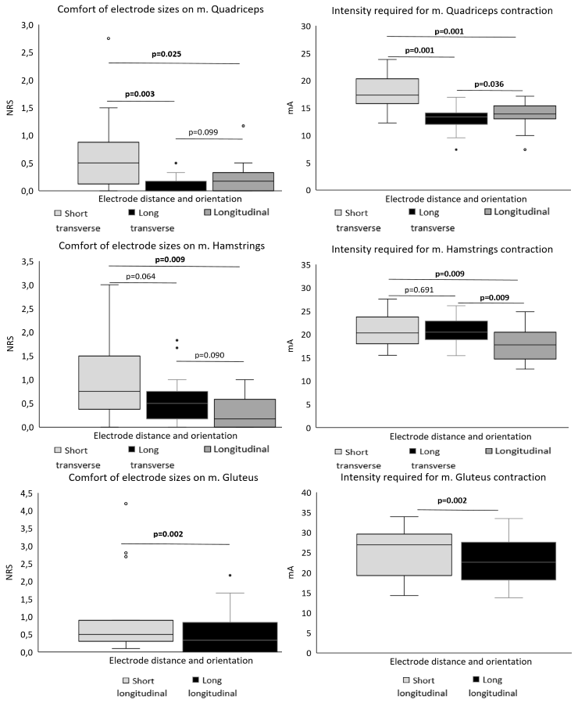Figure S1. Comfort according the Numeric Rating Scale for pain (NRS) and intensity needed for visible muscle twitch for different placements of the electrodes on the quadriceps, hamstrings and gluteus. Intensity describes the total intensity (mA) needed for the first visible muscle twitch of the muscles for each electrode size. P-values calculated with Wilcoxon sign rank test, significant values are bold.
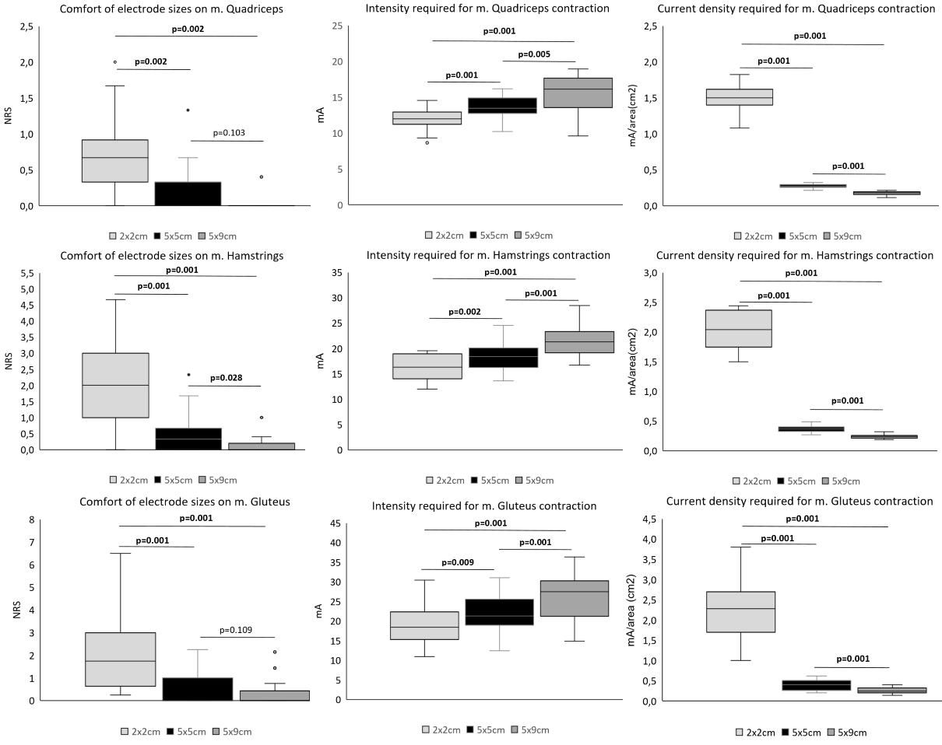
Figure S2. Comfort according the Numeric Rating Scale for pain (NRS) and intensity of the NMES-stimulation require for first visible muscle twitch for the different electrode sizes (2x2cm, 5x5cm and 5x9cm) on the quadriceps, hamstrings and gluteus. Intensity describes the total intensity (mA) and current density describes the intensity/area (mA/cm²) needed for the first visible muscle twitch of the muscles for each electrode size. P-values calculated with Wilcoxon sign rank test, significant values are bold.
Table S1. Comfort and intensity needed for first muscle for horizontal vs vertical placement of the 5x9cm electrodes.
 | Quadriceps |  | Hamstrings |  | Gluteus
 |  | p-value ª |  | p-value ª |  | p-value ª
NRS – vertical placement | 0 (0-0.09) | 0.068 | 0 (0-0) | 0.83 | 0 (0-0.75) | 0.60
NRS – horizontal placement | 0 (0-0) | 0.068 | 0 (0-0.13) | 0.83 | 0 (0-0) | 0.60
Amplitude (mA) – vertical placement | 16 (14-17) | 0.55 | 20 (19-22) | 0.41 | 27 (21-30) | 0.73
Amplitude (mA) – horizontal placement | 15 (13-17) | 0.55 | 21 (19-23) | 0.41 | 26 (20-31)
ª P-values calculated with Wilcoxon sign rank test. Data are expressed as median (inter-quartile range). NRS=Numeric Rating Scale for pain. mA=MilliAmpere.

