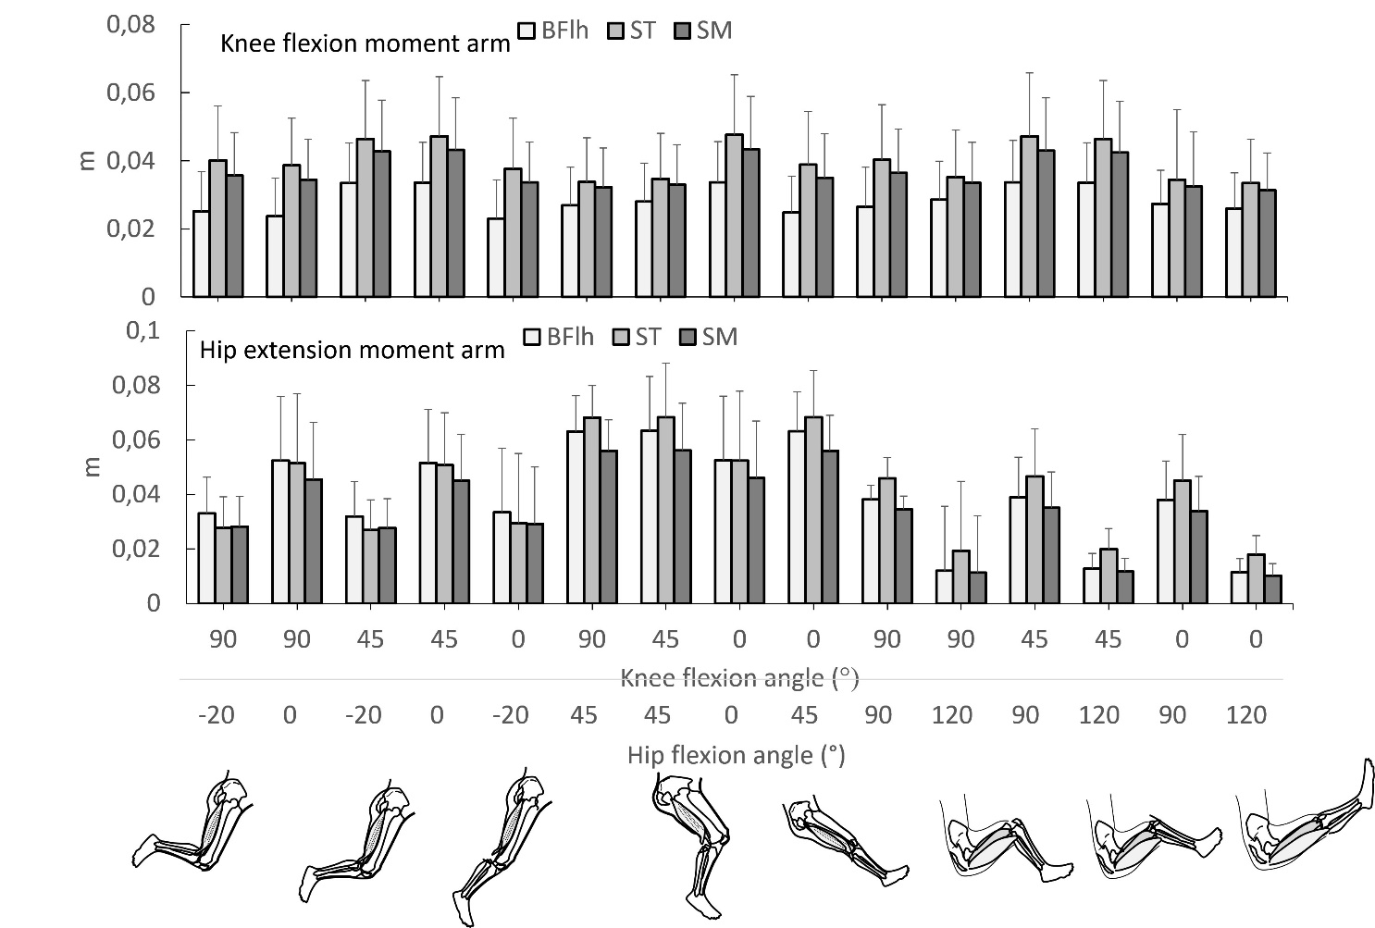
Additional file 4 Figure: Mean (SD) knee flexion and hip extension moment arm values of biceps femoris long head (BFlh) and semimembranosus (SM) (upper graph) and semitendinosus (ST) (lower graph) at 15 different hip (H) and knee (K) flexion angles as predicted using forward simulation modeling. Values were obtained from the full-body running model [57], the London lower limb model [239], the refined musculoskeletal model [54], and the Gait2354_simbody model [51, 58] and the full body model [55] using OpenSim version 4.2 software [59]. Using each model, the hamstrings muscles were fixed at five hip flexion angles (0° = neutral, -20°, 45°, 90° and 120°) and data were obtained at each 10° of knee joint motion from 0° (full extension) to 100° of flexion. Error bars indicate standard deviation.

