Supplementary materials

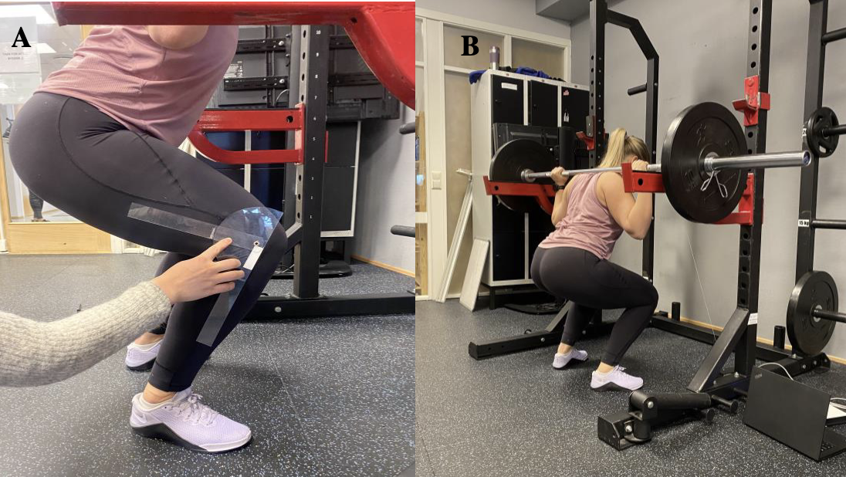
Figure S1. Illustration of knee angle assessment for the barbell half squat using a goniometer with a 90° knee angle between femur and tibia (A). Illustration of a participant in the bottom position of a barbell half squat (B).

