Supplementary materials

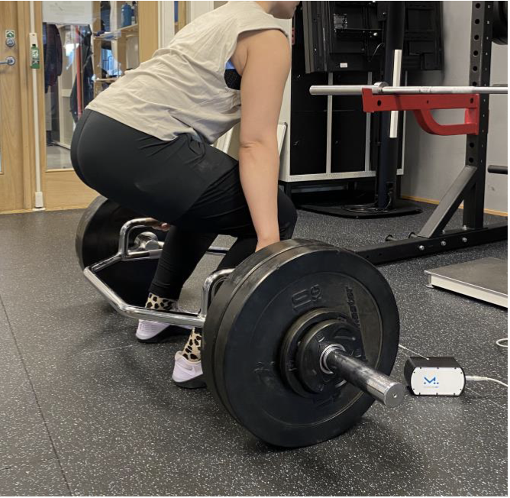
Figure S2. Illustration of a participant in the bottom position of the trap bar deadlift

