Additional File 2
Sensitivity Analysis
The concussive impacts variable was split into groups of four based on previous literature (0, 1-2, 3-5, 6+; [37]). Due to too few cases of 6+ concussive impacts group among females (n = 6), results must be interpreted with caution. Male athletes who reported 6+ concussive impacts endorsed higher BSMAS scores than those with 3-5 impacts, p = .047. They also reported higher PHQ-9 scores than those none, p = .02., while for females, those reporting 3-5 impacts had higher scores than those with none, p = .02 and 1-2 impacts, p = .02. Lastly, male athletes endorsed higher GAD-7 scores than those with none, p = .005. All results are illustrated in Figure 1S.

Figure 1S
Effect of concussive impacts on mental health symptom burden by sex (Sensitivity Analysis)
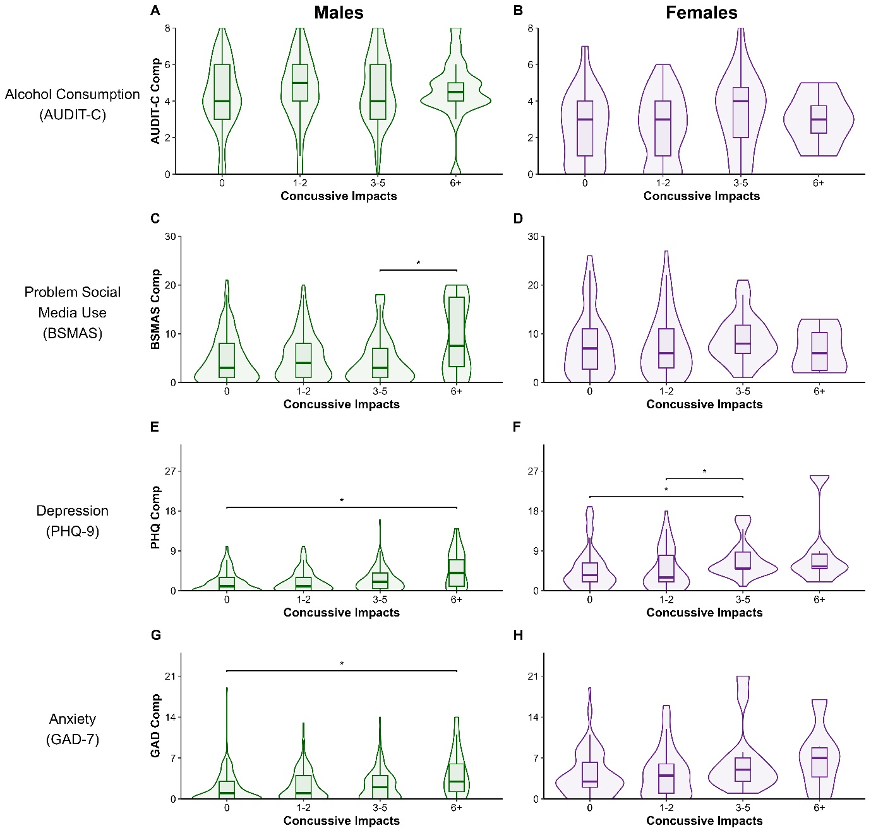
Note. (A) AUDIT-C scores compared using ANOVA for males and (B) female. (C) Kruskal-Wallis and Dunn tests comparing BSMAS scores for males and (D) females. (C) Kruskal-Wallis and Dunn tests comparing PHQ-9 scores for males and (F) females. (G) Kruskal-Wallis and Dunn tests comparing GAD-7 scores for males and (H) females. AUDIT-C = Alcohol Use Disorder Identification Test – Consumption. BSMAS = Bergen Social Media Addiction Scale, PHQ-9 = Patient Health Questionnaire-9, GAD-7 = Generalize Anxiety Disorder-7 scale. *p < .05.

