SnPM{F} Continuum for the ground reaction forces models.

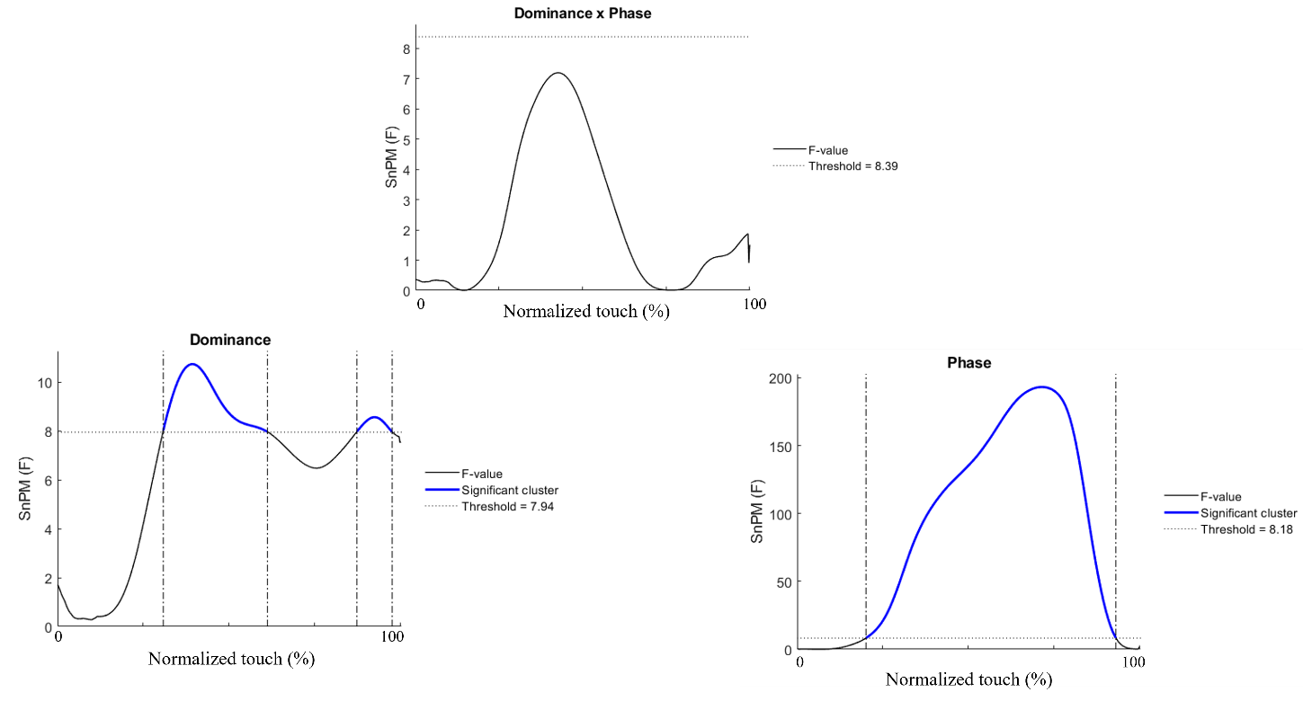
Figure S1. SnPM{F} continuum for Dominance*Phase; dominance and phase effects on the medial ground reaction forces.

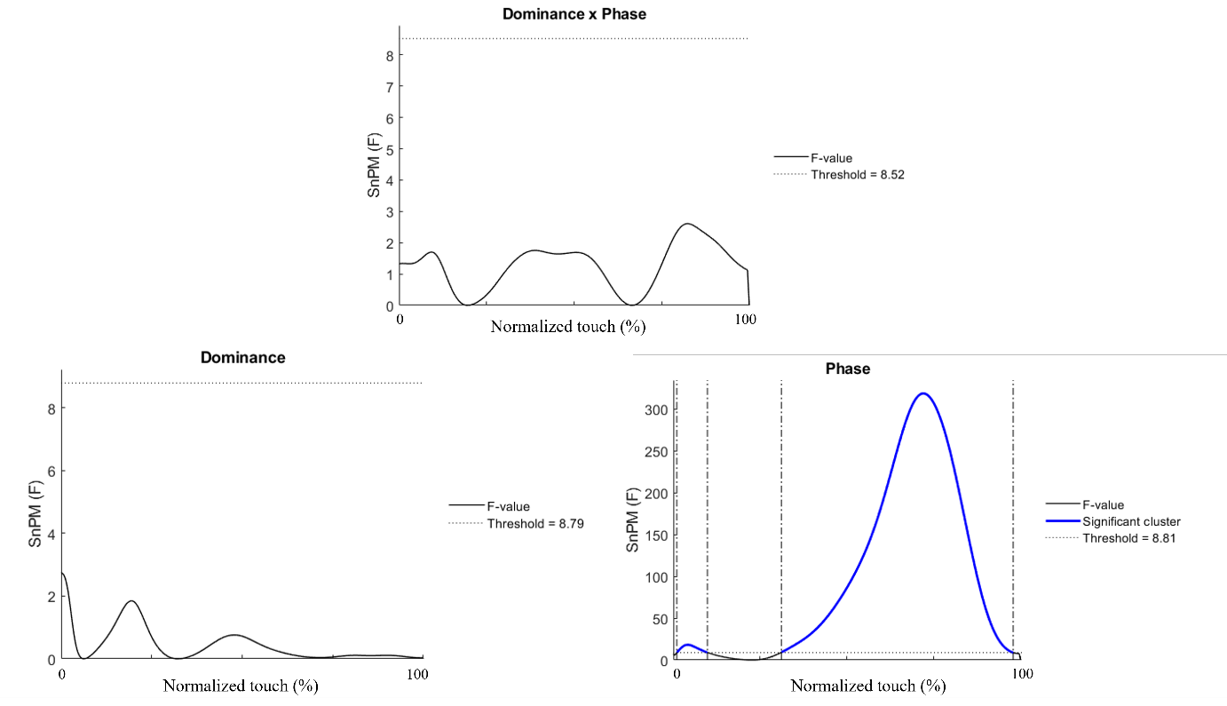
Figure S2. SnPM{F} continuum for Dominance*Phase; dominance and phase effects on the vertical ground reaction forces.

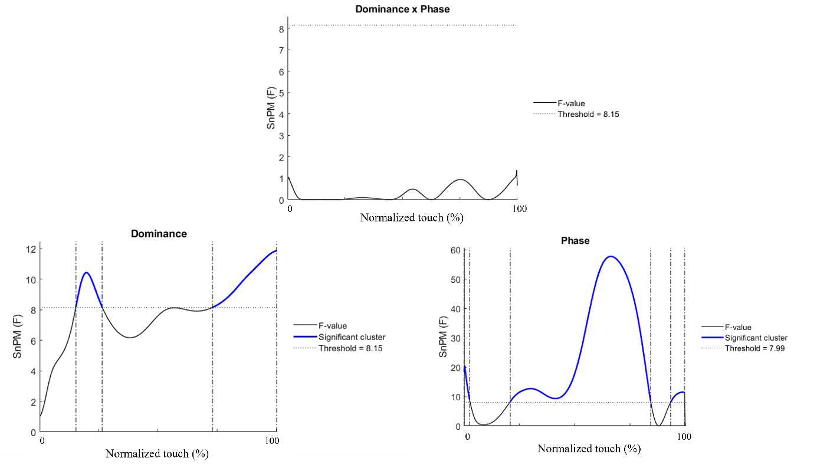
Figure S3. SnPM{F} continuum for Dominance*Phase; dominance and phase effects on the posterior ground reaction forces.

Post-hoc pairwise comparisons and effect sizes of supporting upper extremity ground reaction forces.

Table S1. Ground reaction forces (min;max) in % of body weight and time interval [start;end] for which significant differences were observed between the takeoff and landing phase.
Direction | Takeoff | Landing
Vertical | (58;75) [16;49] | (65;76) [52;85]
Medial | (20;32) [10;47] | (22;32) [53;90]
Posterior | (14;16) [10;42] | (16;18) [58;90]

Table S2. (minimal;maximal) values of ground reaction forces expressed in % of body weight, and [start;end] of the time interval expressed in % of the normalized m-CKUEST touch duration for which significant differences were observed between the dominant and nondominant upper extremities.
Direction | Dominant | Nondominant | Time interval
Medial | (21;22)  (30;33)  (32;33)  (26;30) | (20;22)  (29;31)  (31;32)  (25;28) | [15;34]  [44;49]  [51;57]  [69;85]
Posterior | (12;15)  (13;14)  (13;16)  (29;31) | (14;16)  (15;17)  (24;28)  (31;32) | [8;14]  [36;50]  [51;65]  [87;93]
Vertical | - | - | -

SnPM{F} Continuum for the muscle activity models.

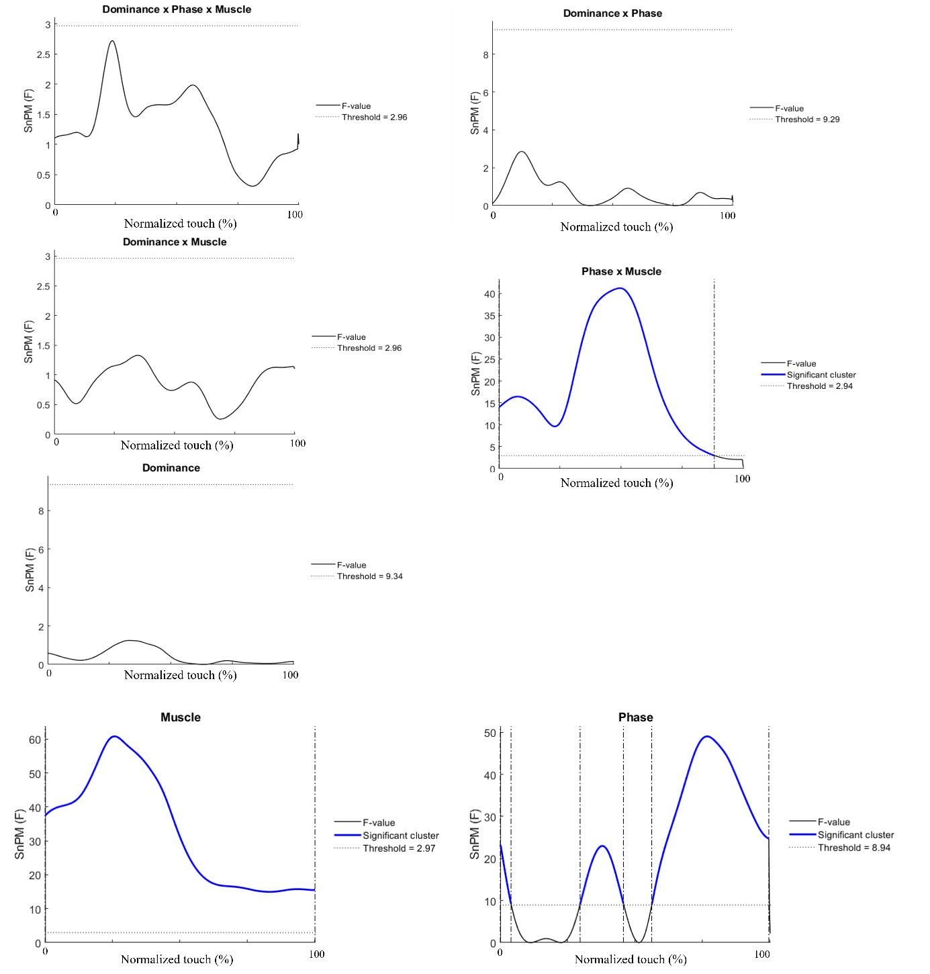
Figure S4. SnPM{F} continuum for Dominance*Phase*Muscle; Dominance*Phase; Dominance*Muscle; Phase*Muscle; Muscle; Dominance; Phase effects on muscle activity levels.

Post-hoc pairwise comparisons and effect sizes of the supporting upper extremity muscle activity.
Table S3 presents the intervals of time during which the muscular activity of one muscle was significantly different from that of another muscle. The activity of a muscle presented in line is greater or lower than the activity of a muscle presented in column. For example, the activity of the upper trapezius was significantly greater than that of the middle trapezius from 1% to 21% of the normalized m-CKCUEST touch duration (line 1, column 3).

Table S3. Pairwise comparisons between muscles during the m-CKCUEST touch. Values in brackets correspond to the interval of time [start;end], expressed in % of the total m-CKCUEST touch duration during which a muscle presented significantly greater or lower activity than another muscle.
 |  | Middle trapezius | Lower trapezius | Serratus anterior | Posterior deltoid | Middle deltoid | Anterior deltoid | Triceps brachii | Takeoff vs landing
Upper trapezius | Greater | [1;21] | [14;20] |  |  |  | [31;37]  [45;55] |  | [4;18] vs [81;95]
Upper trapezius | Lower | [45;55]  [56;64] | [45;55]  [56;67] | [6;33]  [66;100] | [24;55]  [56;65] | [23;38]  [78;93] | [7;13]  [69;94] | [22;36]  [81;100]
Middle trapezius | Greater |  |  | [45;55] |  | [45;55] | [30;55]  [56;64]
Middle trapezius | Lower |  | [1;6] | [1;26]  [68;100] | [19;41] | [15;32] | [1;20]  [70;100] | [16;34]  [79;100]
Lower trapezius | Greater |  |  | [45;55] |  | [45;55] | [32;55]  [56;64] | [45;55]
Lower trapezius | Lower |  |  | [1;27]  [69;100] | [21;36] | [17;30]  [86;98] | [3;20]  [72;96] | [18;33]  [81;100]
Serratus anterior | Greater |  |  |  | [1;15]  [69;93] | [1;17]  [66;93] | [14;55]  [87;93] | [7;17]  [68;88]
Serratus anterior | Lower |  |  |  | [45;55] |  |  |  | [13;27] vs [72;86]
Posterior deltoid | Greater |  |  |  |  | [33;55]  [56;64] | [23;55]  [56;64] | [45;63] | [20;41] vs [59;80]
Posterior deltoid | Lower |  |  |  |  | [77;86] | [1;13]  [72;90] | [79;100]
Middle  deltoid | Greater |  |  |  |  |  | [23;55] |  | [25;43] vs [56;74]
Middle  deltoid | Lower |  |  |  |  |  | [1;15]  [72;90] | [1;9]  [88;100]
Anterior deltoid | Greater |  |  |  |  |  |  | [7;13]  [75;86] | [22;42] vs [57;77]
Anterior deltoid | Lower |  |  |  |  |  |  | [22;41]  [45;55]  [93;100] | [1;6] vs [95;100]

Table S4. Absolute effect size (min;max) values for of the significant pairwise comparisons between muscles activity during the m-CKCUEST touch.
 |  | Middle trapezius | Lower trapezius | Serratus anterior | Posterior deltoid | Middle deltoid | Anterior deltoid | Triceps brachii | Takeoff vs landing
Upper trapezius | Greater | (1.22;1.62) | (1.21;1.33) |  |  |  | (0.99;1.29)  (1.27;1.31) |  | (1.12;1.47)
Upper trapezius | Lower | (1.69;1.25)  (0.81;1.32) | (1.25;1.27)  (1.04;1.18) | (0.86;1.53)  (1.11;3.80) | (1.13;2.45)  (0.96;1.51) | (1.05;1.99)  (1.06;1.54) | (0.92;1.11)  (1.20;2.81) | (1.21;2.25)  (1.26;2.49)
Middle trapezius | Greater |  |  | (0.64;1.06) |  | (1.04;1.55) | (1.12;2.15)  (1.43;2.55)
Middle trapezius | Lower |  | (0.85;1.18) | (1.57;3.66)  (1.34;3.94) | (1.03;1.84) | (1.06;1.82) | (1.19;3.69)  (1.29;2.74) | (1.06;2.18)  (1.03;2.75)
Lower trapezius | Greater |  |  | (1.13;0.85) |  | (1.04;1.55) | (1.15;2.10)  (1.43;2.55) | (0.90;1.01)
Lower trapezius | Lower |  |  | (1.20;2.60)  (1.37;3;64) | (1.16;1.80) | (1.24;1.84)  (1.26;1.67) | (1.26;2.57)  (1.29;2.74) | (1.12;2.18)  (1.30;2.69)
Serratus anterior | Greater |  |  |  | (1.46;2.47)  (1.24;3.47) | (1.32;2.58)  (0.87;2.81) | (0.73;2.00)  (0.71;0.80) | (1.38;1.83)  (0.99;2.50)
Serratus anterior | Lower |  |  |  | (0.86;1.26) |  |  |  | (0.81;1.50)
Posterior deltoid | Greater |  |  |  |  | (0.88;1.18)  (0.71;1.02) | (0.77;1.08)  (1.21;3.63) | (0.91;1.10) | (0.89;1.90)
Posterior deltoid | Lower |  |  |  |  | (0.72;1.55) | (1.30;2.23)  (1.20;2.88) | (0.70;1.10)
Middle deltoid | Greater |  |  |  |  |  | (1.39;2.79) |  | (0.80;1.56)
Middle deltoid | Lower |  |  |  |  |  | (1.42;2.42)  (1.28;1.91) | (0.55;0.94)  (1.09;1.57)
Anterior deltoid | Greater |  |  |  |  |  |  | (1.31;1.70)  (1.22;1.81)
Anterior deltoid | Lower |  |  |  |  |  |  | (1.10;2.77)  (0.82;0.99)  (0.96;1.16) | (1.05;2.36)
Triceps brachii | Greater |  |  |  |  |  |  |  | (0.48;1.57)
Triceps brachii | Lower |  |  |  |  |  |  |  | (1.47;1.73)

