Supplementary Table 1 Fried frailty phenotype
Fried frailty phenotypeª
Unintentional weight loss | Weight loss (not due to dieting or exercise) more than 4.5 kg or 5% of the total weight in last 12 months
Self-reported exhaustion | You felt that everything you did was an effort or you could not get going, either of these two feelings appeared more than 3 days in last 7 days.
Low physical activity | Answering “yes” to either of the following two questions was considered as a positive result: “Having limits to some activities in daily life due to physical reasons, including moving the table, sweeping the floor, playing tai-chi, and simple gymnastics, climbing a few flights of stairs and so on” and “In the last month, the things (work or daily activities) you wanted to do only could be done in half due to physical reasons, or the type of work or daily activities was limited”.
Slow walking speed | Walk 4.5 m, men (≤ 173 cm) or women (≤ 159 cm) need more than 7s, men (> 173 cm) or women (> 159 cm) need more than 6s.
Weak grip strength^{b} | Men: BMI ≤ 24, grip strength ≤ 29 kg; BMI 24.1–28, grip strength ≤ 30 kg; BMI > 28, grip strength ≤ 32 kg. Women: BMI ≤ 23,grip strength ≤ 17 kg; BMI 23.1–26, grip strength ≤ 17.3 kg; BMI 26.1–29, grip strength ≤ 18 kg; BMI> 29, grip strength ≤ 21 kg
ªScore: 1 criterion represented 1 point; the total score was 5 points. The higher the score, the more severe the frailty states, those with 3 or more points were considered frailty, with 0 points were considered non-frailty and those with 1–2 points were hypothesized to be pre-frail. ^{b}Weak grip strength was measured dominant hand three times and recorded mean value, then stratified by gender and BMI.

Supplementary Table 2 Interventions between the two groups
 |  | Intervention group | Control group
Beginning |  | Individualized exercise health education;  Free access to elastic band exercise videos
During the trail | Online | Wechat communication if there were questions
During the trail | Online | Receive exercise reminders three times a week;  Upload exercise videos after exercises three times a week;  Telephone follow-ups monthly | Exercise on their own
During the trail | Offline | A home visit monthly
End |  | A follow-up hospital appointment was scheduled

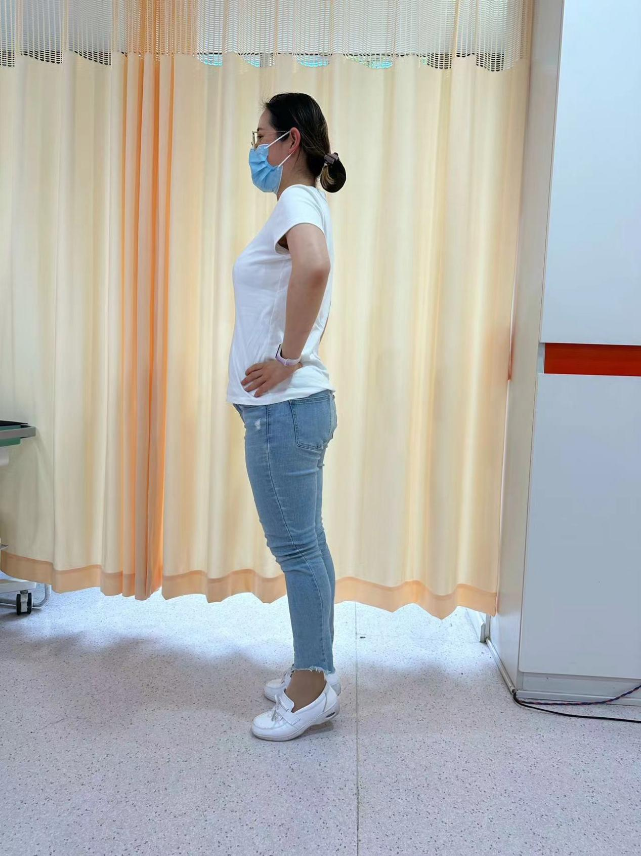
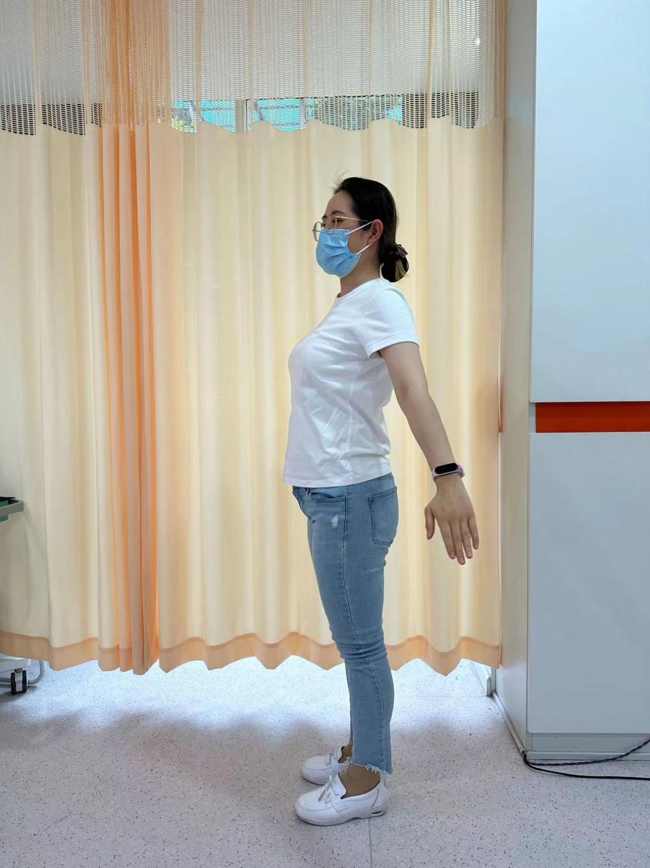
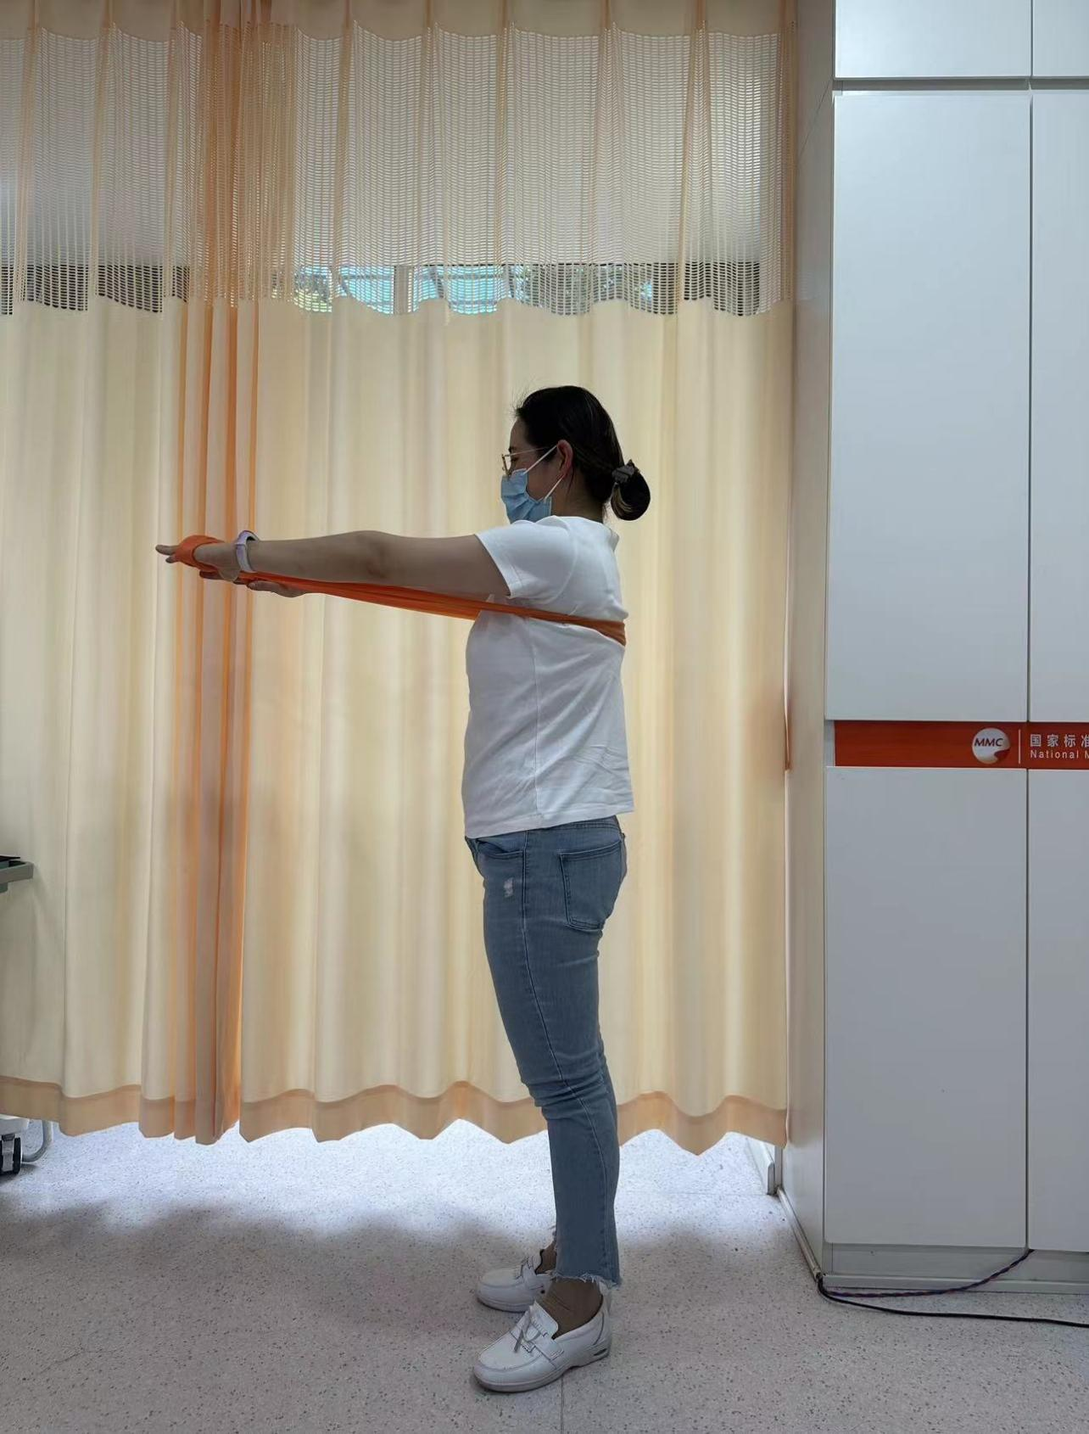
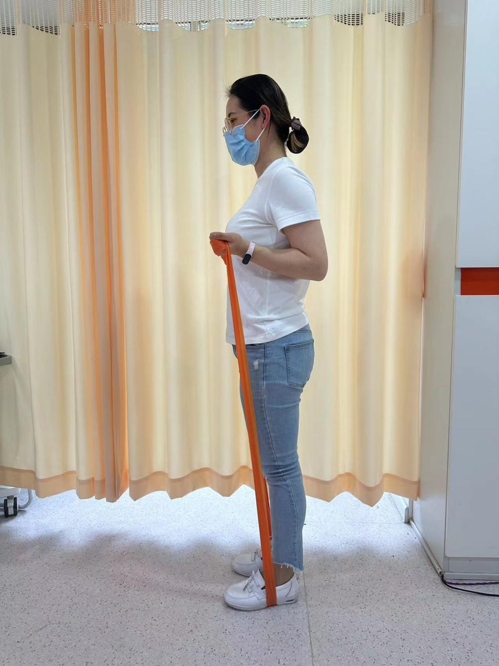
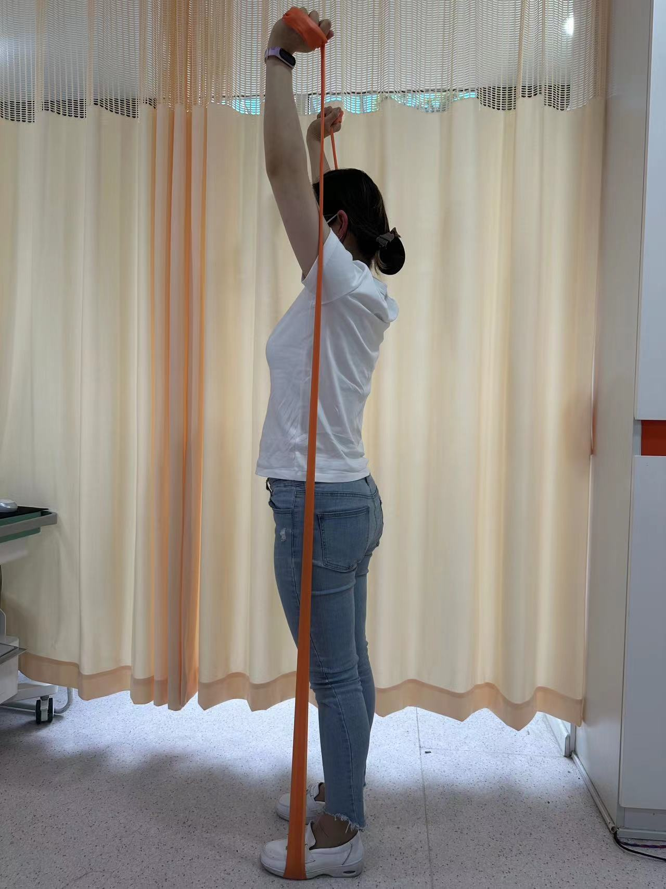
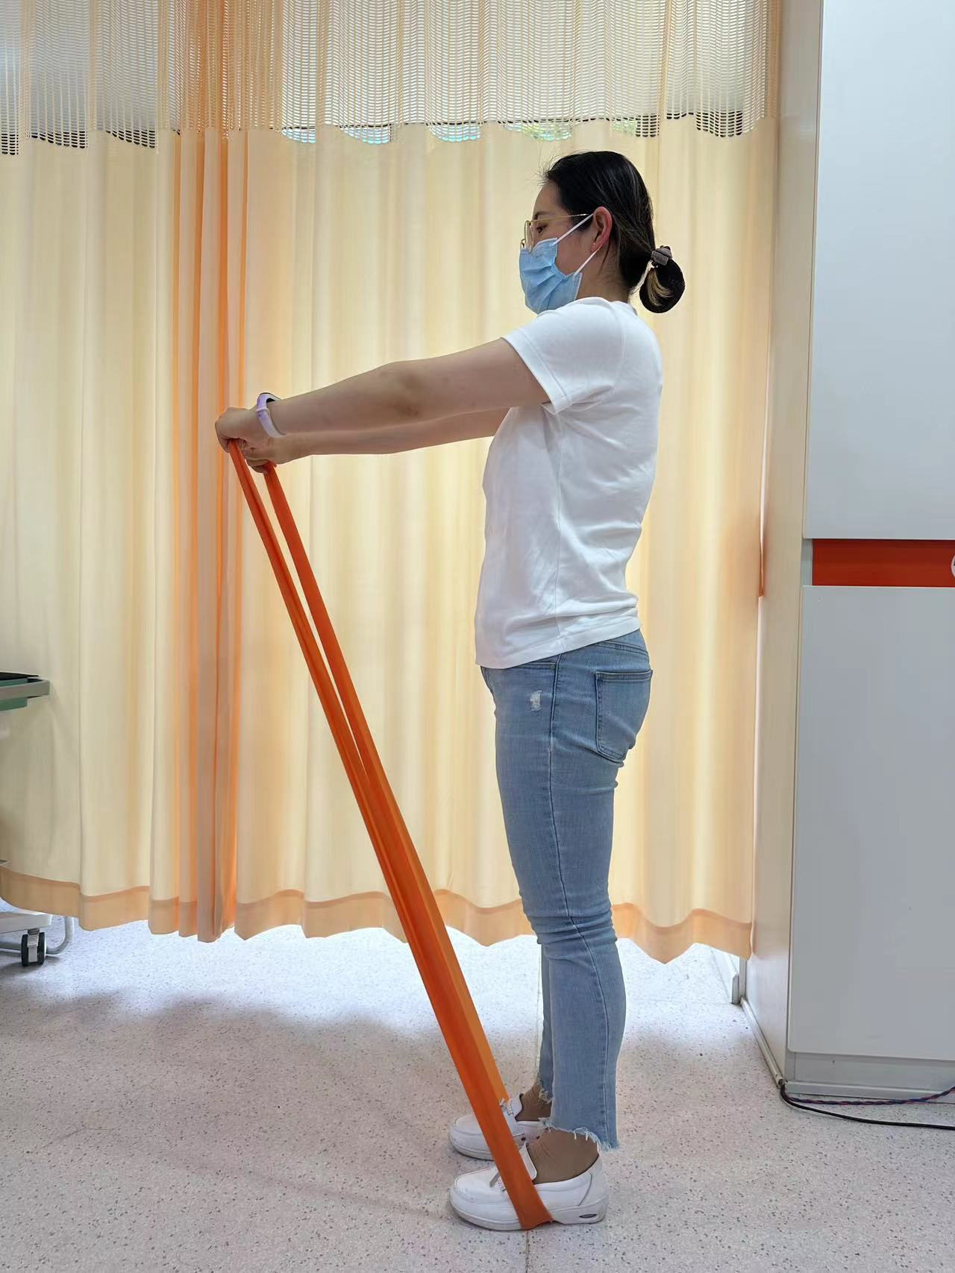
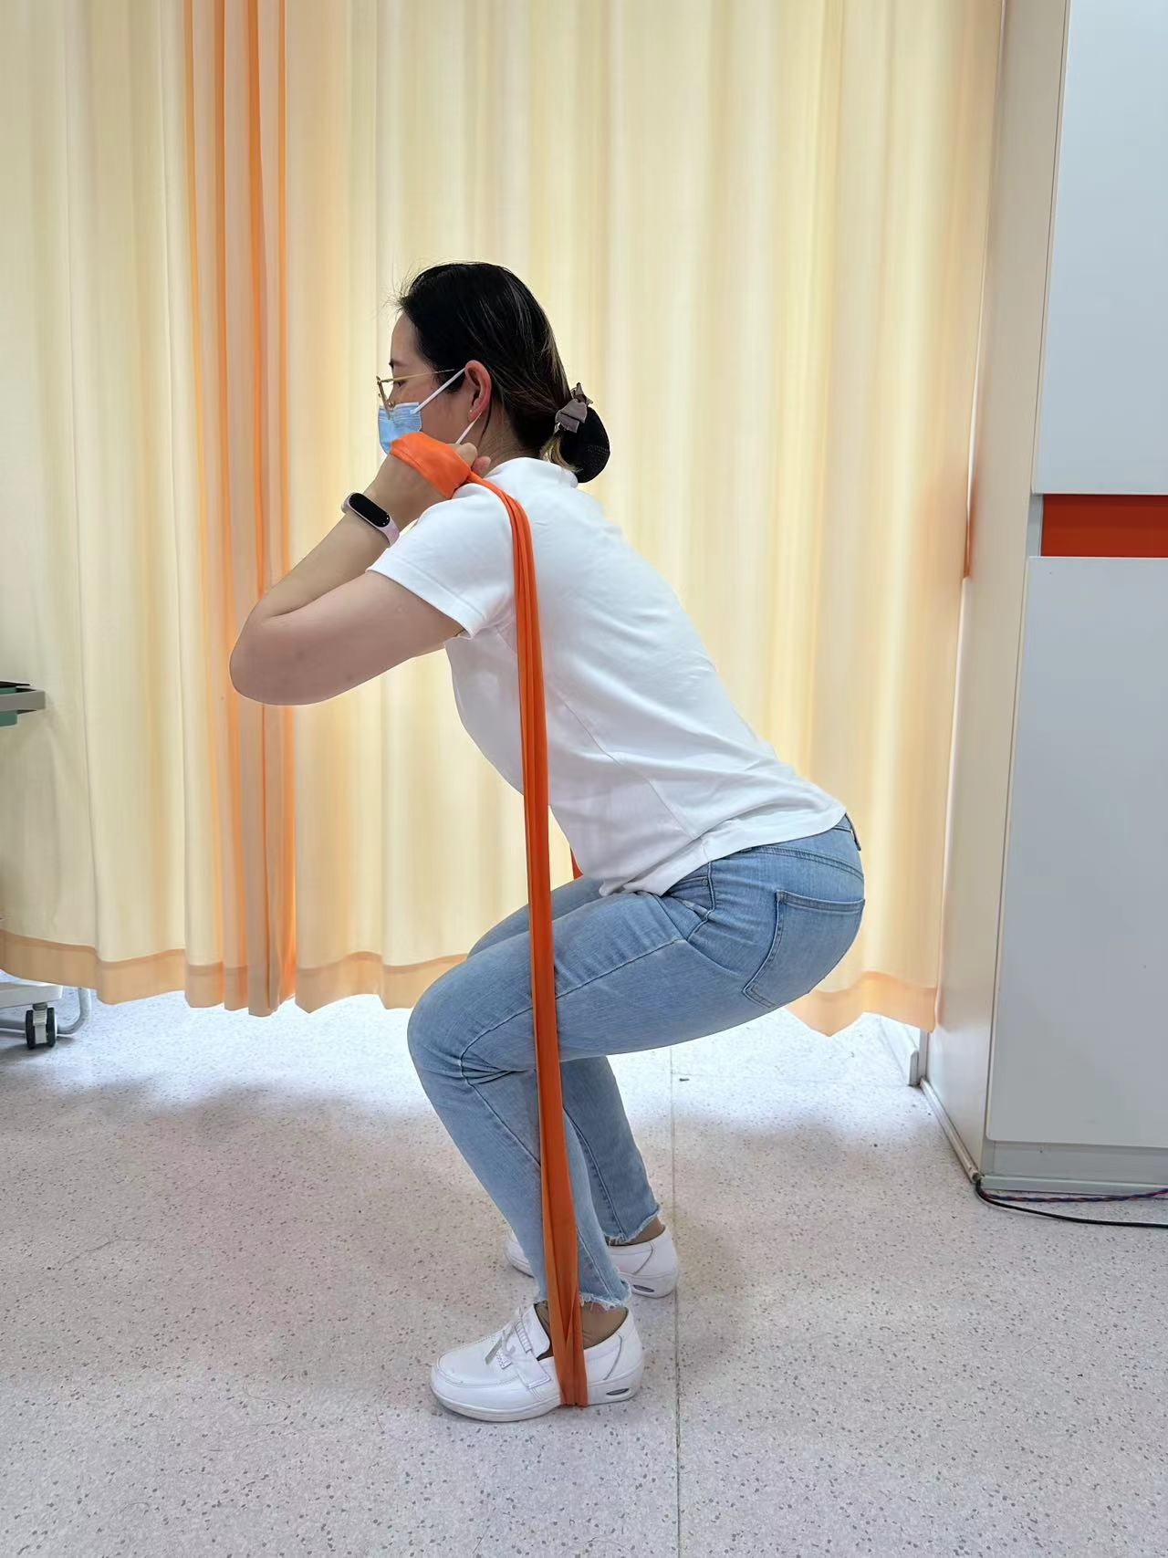
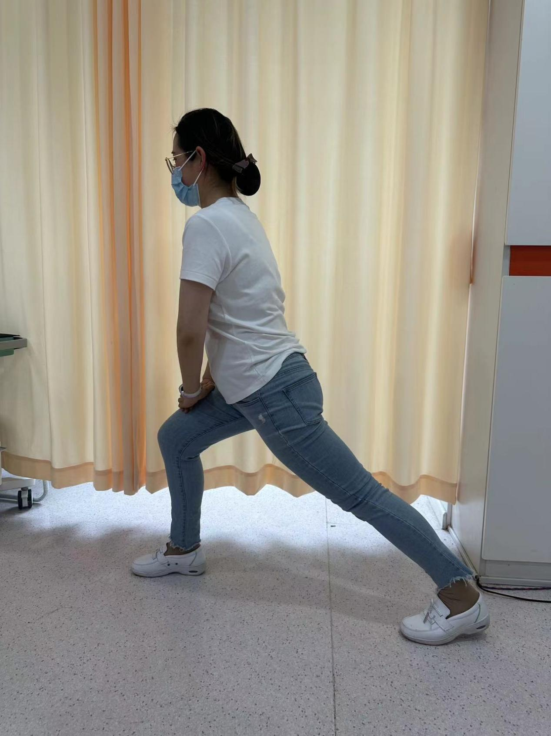
（1）
（2）
（3）
（4）
（5）
（6）
（7）
（8）

Supplementary Figure 1 Exercise movements of elastic band exercise: (1-2) Warm up exercise. (3) Push the chest forward with the elastic band in standing position. (4) Resistance band standing bicep curls. (5) Side lift Elastic belt; (6) Weight-bearing squats with elastic band. (7) Arrow squat with elastic band. (8) Relaxation exercise.

