Appendices

Appendix 1: Search strategy details for each database
Database | Search Strategy
PubMed | ((("core"[All Fields] AND ("education"[MeSH Subheading] OR "education"[All Fields] OR "training"[All Fields] OR "education"[MeSH Terms] OR "train"[All Fields] OR "train s"[All Fields] OR "trained"[All Fields] OR "training s"[All Fields] OR "trainings"[All Fields] OR "trains"[All Fields])) OR ("core"[All Fields] AND ("resistance training"[MeSH Terms] OR ("resistance"[All Fields] AND "training"[All Fields]) OR "resistance training"[All Fields] OR ("strength"[All Fields] AND "training"[All Fields]) OR "strength training"[All Fields])) OR ("core stability"[MeSH Terms] OR ("core"[All Fields] AND "stability"[All Fields]) OR "core stability"[All Fields])) AND ("athletic performance"[MeSH Terms] OR ("athletic"[All Fields] AND "performance"[All Fields]) OR "athletic performance"[All Fields] OR ("athletic performance"[MeSH Terms] OR ("athletic"[All Fields] AND "performance"[All Fields]) OR "athletic performance"[All Fields] OR ("sports"[All Fields] AND "performance"[All Fields]) OR "sports performance"[All Fields])) AND ("randomized controlled trial"[Publication Type] OR "randomized controlled trials as topic"[MeSH Terms] OR "randomized controlled trial"[All Fields] OR "randomised controlled trial"[All Fields] OR ("controlled"[All Fields] AND ("clinical trials as topic"[MeSH Terms] OR ("clinical"[All Fields] AND "trials"[All Fields] AND "topic"[All Fields]) OR "clinical trials as topic"[All Fields] OR "trial"[All Fields] OR "trial s"[All Fields] OR "trialed"[All Fields] OR "trialing"[All Fields] OR "trials"[All Fields])))) AND ((excludepreprints[Filter]) AND (clinicaltrial[Filter] OR randomizedcontrolledtrial[Filter]) AND (fft[Filter]) AND (humans[Filter]) AND (2014/1/1:2024/9/30[pdat]) AND (english[Filter]) AND ((excludepreprints[Filter]) AND (clinicaltrial[Filter] OR randomizedcontrolledtrial[Filter]) AND (fft[Filter]) AND (humans[Filter]) AND (2014/1/1:2024/9/30[pdat]) AND (english[Filter]))
Scopus | ( TITLE-ABS-KEY ( "core" AND ( "education" OR "training" OR "trained" OR "trainings" ) ) OR TITLE-ABS-KEY ( "core" AND ( "resistance training" OR "strength training" ) ) OR TITLE-ABS-KEY ( "core stability" ) ) AND ( TITLE-ABS-KEY ( "athletic performance" ) OR TITLE-ABS-KEY ( "sports performance" ) ) AND ( TITLE-ABS-KEY ( "randomized controlled trial" ) OR TITLE-ABS-KEY ( "randomised controlled trial" ) OR TITLE-ABS-KEY ( "controlled clinical trial" ) ) AND ( LIMIT-TO ( DOCTYPE , "ar" ) OR LIMIT-TO ( DOCTYPE , "English" ) OR LIMIT-TO ( DOCTYPE , "j" ) OR LIMIT-TO ( DOCTYPE , "t PUBYEAR &lt; 2025" ) )
Web of Science | TS=("core training" OR "core stability" OR "resistance training" OR "strength training") AND TS=("athletic performance" OR "sports performance") and Article or Clinical Trial (Document Types) and English (Languages) and 2014 or 2024 or 2023 or 2022 or 2021 or 2020 or 2019 or 2018 or 2017 or 2016 or 2015 (Publication Years) and Web of Science Core Collection (Database) and Sport Sciences (Research Areas) and IECON 2023 49TH ANNUAL CONFERENCE OF THE IEEE INDUSTRIAL ELECTRONICS SOCIETY (Exclude – Conferences/Meeting Titles) and Humans or Athletic Performance (MeSH Headings)
SPORTDiscus | AB core training OR AB core strength AND AB athlete performance OR AB sports performance AND AB athletes AND SU (randomized controlled trials OR rtc OR randomised control trials) NOT (injured athletes OR injured OR injuries OR patients)  Filters: Full Text; Peer Reviewed; 01/01/2014 - 10/30/2024; English; Article; Clinical Trial; Academic Journal
Google Scholar | allintitle: "core training" OR "core strength" OR "athletic performance" OR "sports performance" OR "randomized controlled trial" OR "randomised controlled trial" OR "clinical trial" "core training" "core strength" -review -"meta analysis" -"meta analysis" -injury -injuries -rehabilitation -patient

Appendix 2: Funnel plots - publication bias
- Balance  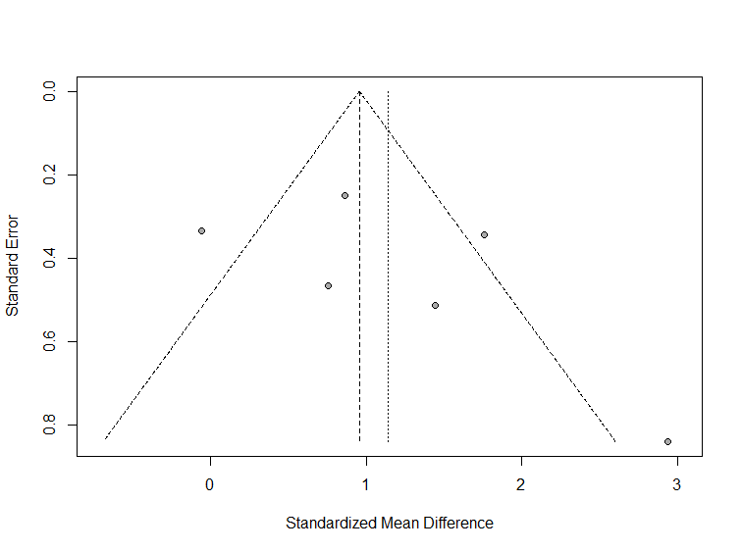 | - Change of Direction  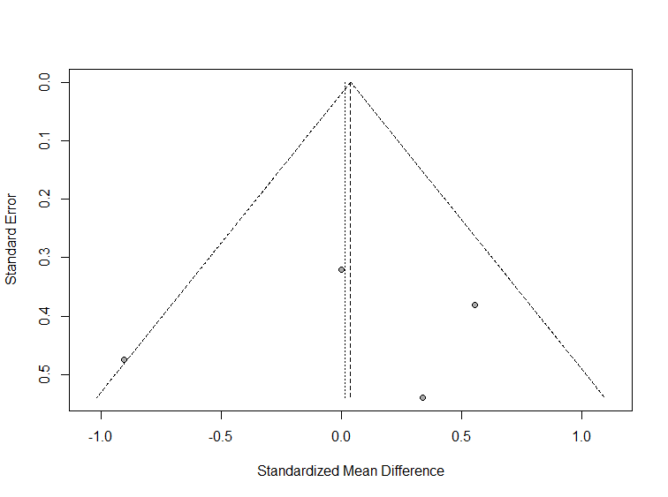
- Core endurance  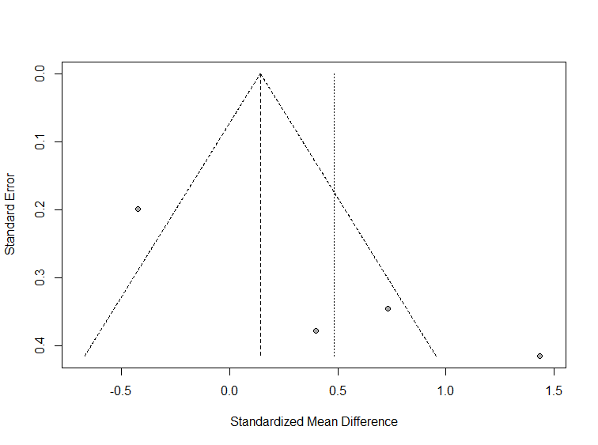 | - Flexibility  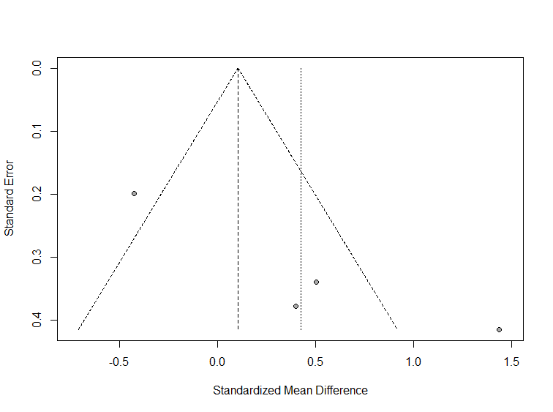
- Speed  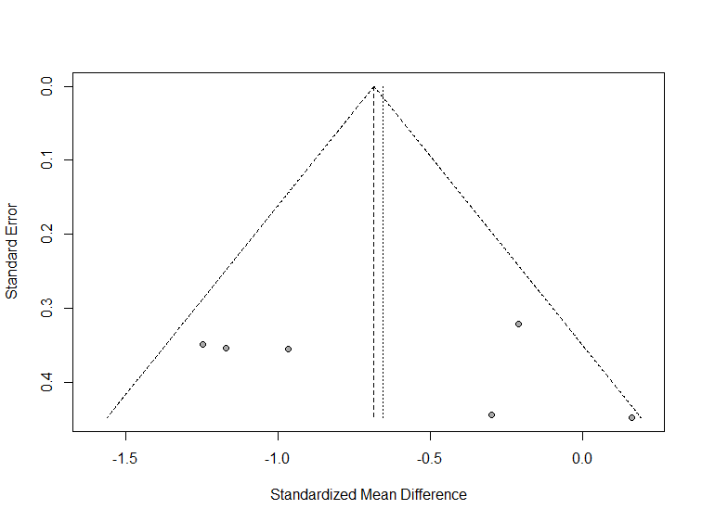 | - Technical Skill  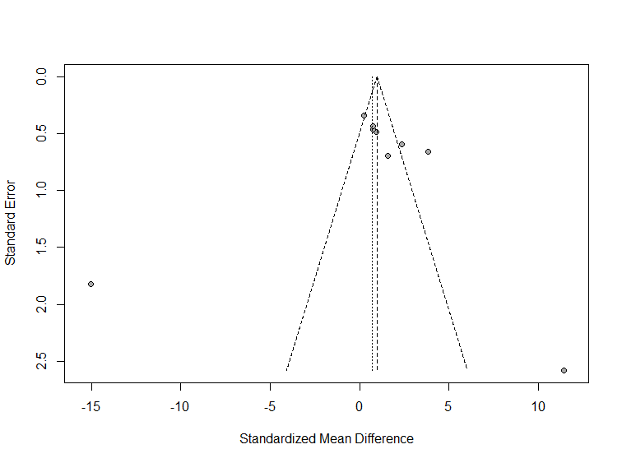
- Throwing Velocity  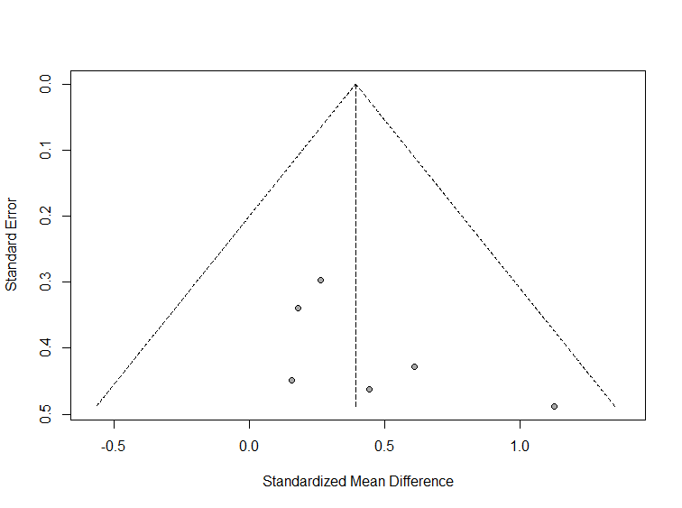 | - Vertical Jump  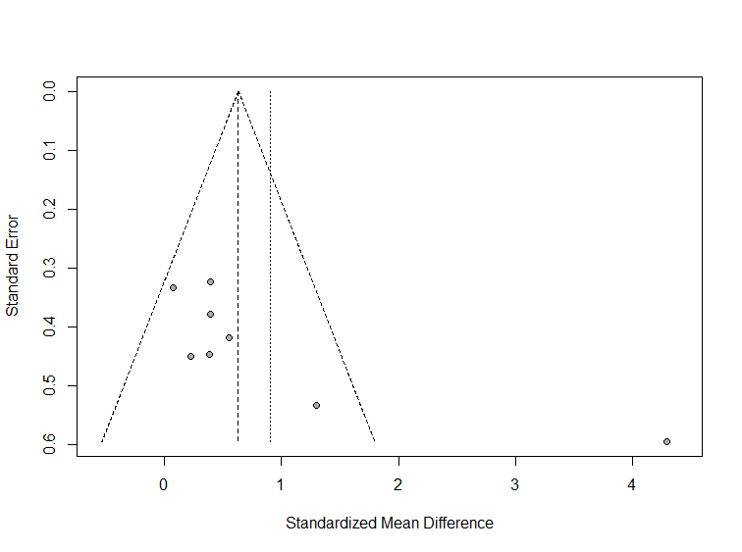

Series of funnel plots examining publication bias across eight outcome measures: (a) Balance, (b) Change of Direction, (c) Core endurance, (d) Flexibility, (e) Speed, (f) Technical Skill, (g) Throwing Velocity, and (h) Vertical Jump. X-axis represents standardized mean differences; Y-axis represents standard errors. Asymmetry indicates potential publication bias.

Appendix 3: Forest plots of the effects of core training on athlete performance outcomes
- Core Endurance
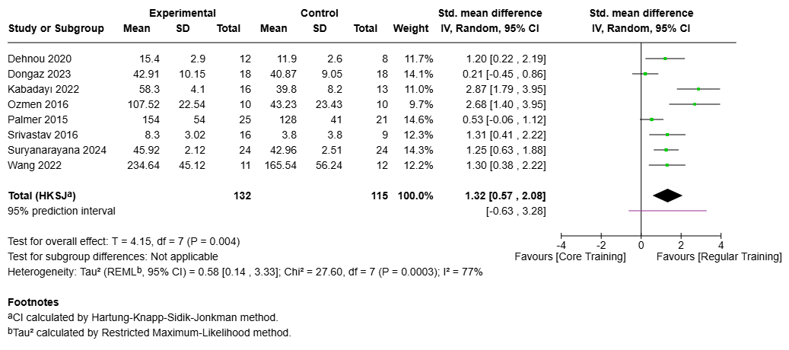
Meta-analysis results of core training's impact on core endurance across 8 studies (n=247 participants). SMD = 1.32 seconds [95% CI: 0.57, 2.08], p < 0.004, I² = 77%. Effect sizes and weights shown for individual studies and pooled results.
- Balance
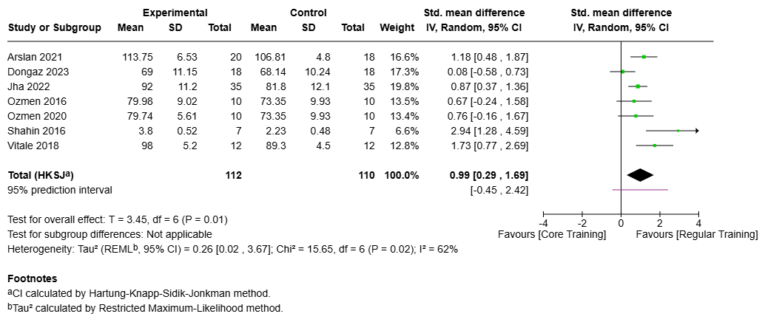
Analysis of core training's effects on balance measures across 7 studies (n=222 participants). SMD = 0.99 [95% CI: 0.29, 1.69], p = 0.01, I² = 62%. Individual study contributions and overall effect size displayed with confidence intervals.

- Speed performance
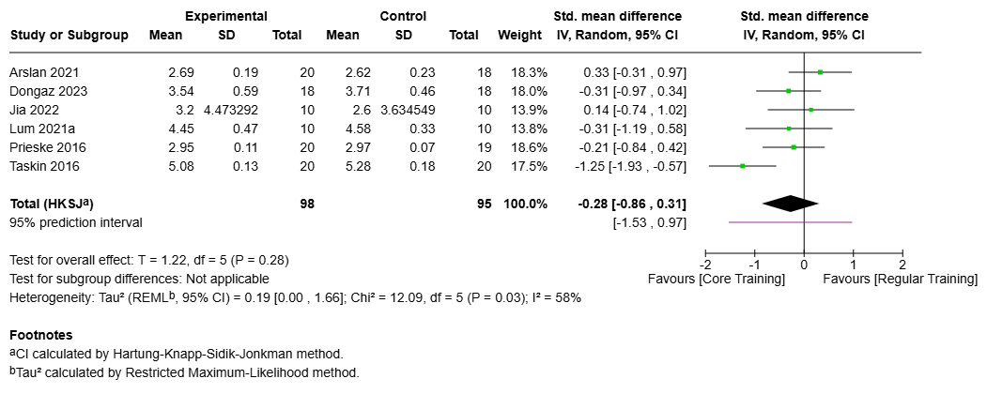
Meta-analysis of speed performance outcomes across 6 studies (n=193 participants). SMD = -0.28 [95% CI: -0.86, 0.31], p = 0.28, I² = 58%. Negative values indicate faster performance times.
- Maximal Strength
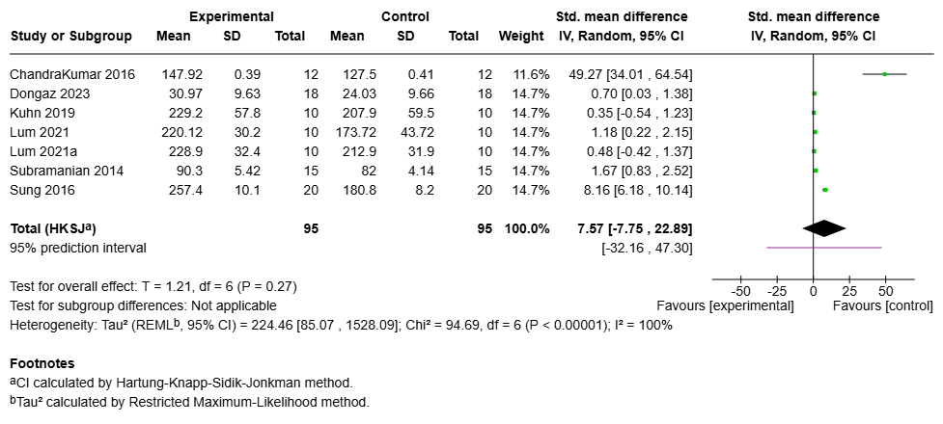
Analysis of maximal strength outcomes across 7studies (n= 190 participants). SMD = 7.57 [95% CI: -7.75, 22.89], p = 0.27, I² = 100%. Effect sizes shown for individual studies and pooled results.
- Flexibility
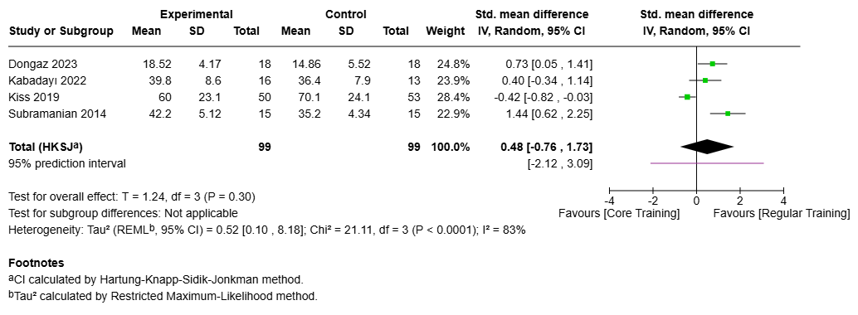
Meta-analysis results for flexibility measures across 4 studies (n=198 participants). SMD = 0.48 [95% CI: -0.76, 1.73], p = 0.30, I² = 83%. Study-specific and pooled effects displayed with confidence intervals.
- Change of Direction
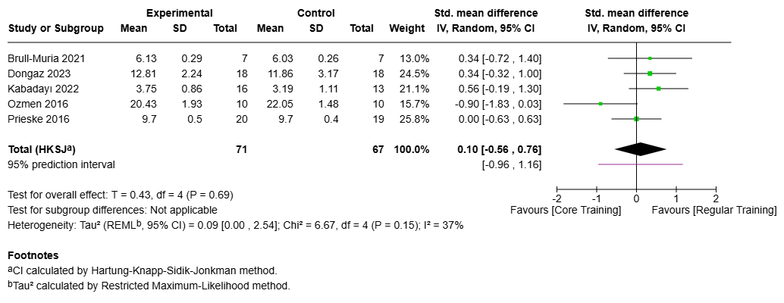
Analysis of change of direction performance across 5 studies (n=138 participants). SMD = 0.10 [95% CI: -0.56, 0.76], p = 0.69, I² = 37%. Individual study effects and pooled results shown.
- Technical Skill Performance
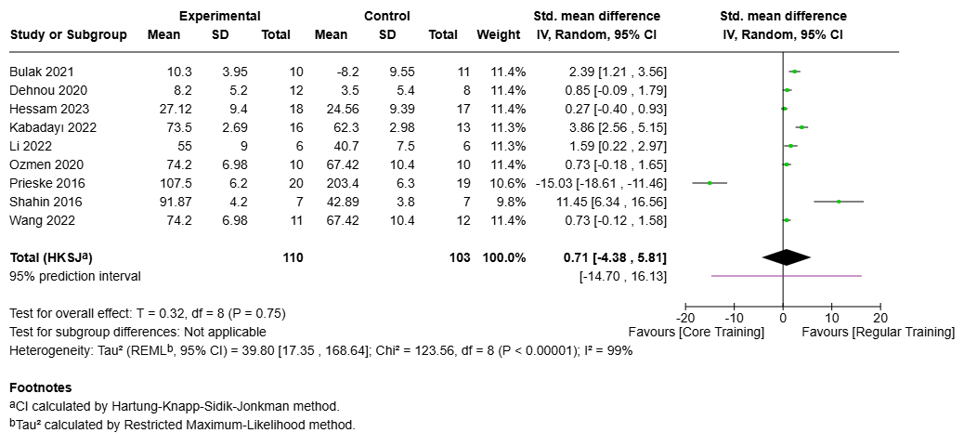
Meta-analysis of technical skill outcomes across 9 studies (n=213 participants). SMD = 0.71[95% CI: -4.38, 5.81], p = 0.75, I² = 99%. Study-specific and overall effects presented with confidence intervals.

- Throwing Velocity
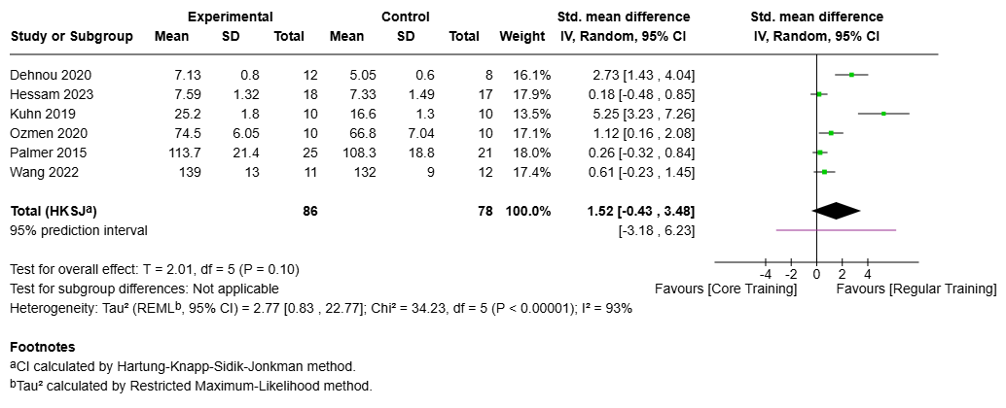
Analysis of throwing velocity/distance across 6 studies (n=164 participants). SMD = 1.52 [95% CI: -0.43, 3.48], p = 0.10, I² = 93%. Individual study contributions and pooled effects displayed.
- Vertical Jump Performance
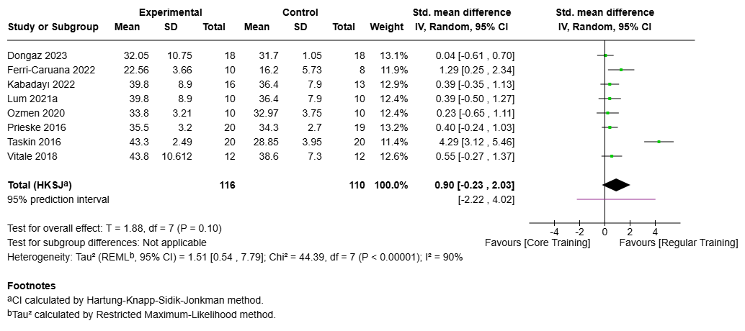
Meta-analysis results for vertical jump performance across 8 studies (n=226 participants). SMD = 0.90 [95% CI: -0.23, 2.03], p = 0.10, I² = 90%. Study-specific and overall effects shown with confidence intervals.

Appendix 4: Sensitivity analysis (one study removed) results
Outcome | Studies | Effect Size | p-value | I² (%)
Balance | Arslan 2021 | 0.98 [0.07, 1.89] | 0.04 | 70
Balance | Dongaz 2023 | 1.07 [0.51, 1.64] | 0.004 | 7
Balance | Jha 2022 | 1.06 [0.13, 1.98] | 0.03 | 69
Balance | Ozmen 2016 | 1.07 [0.19, 1.95] | 0.03 | 71
Balance | Ozmen 2020 | 1.05 [0.16 , 1.95] | 0.03 | 72
Balance | Shahin 2016 | 0.84 [0.28 , 1.39] | 0.01 | 48
Balance | Vitale 2018 | 0.86 [0.10 , 1.62] | 0.03 | 55
Speed | Arslan 2021 | -0.42 [-1.06 , 0.23] | 0.15 | 49
Speed | Dongaz 2023 | -0.27 [-1.04 , 0.51] | 0.39 | 66
Speed | Jia 2022 | -0.34 [-1.06 , 0.37] | 0.25 | 64
Speed | Lum 2021a | -0.27 [-1.03 , 0.49] | 0.38 | 67
Speed | Prieske 2016 | -0.29 [-1.06 , 0.48] | 0.36 | 65
Speed | Taskin 2016 | -0.07 [-0.44 , 0.30] | 0.63 | 0
Change of Direction | Brull-Muria 2021 | 0.05 [-0.89 , 1.00] | 0.87 | 54
Change of Direction | Dongaz 2023 | 0.02 [-0.96 , 1.00] | 0.96 | 51
Change of Direction | Kabadayı 2022 | -0.02 [-0.88 , 0.84] | 0.95 | 38
Change of Direction | Ozmen 2016 | 0.28 [-0.12 , 0.67] | 0.11 | 0
Change of Direction | Prieske 2016 | 0.12 [-0.91 , 1.15] | 0.74 | 55
Core Endurance | Dehnou 2020 | 1.36 [0.45 , 2.26] | 0.01 | 81
Core Endurance | Dongaz 2023 | 1.49 [0.73 , 2.25] | 0.003 | 70
Core Endurance | Kabadayı 2022 | 1.09 [0.43 , 1.76] | 0.007 | 64
Core Endurance | Ozmen 2016 | 1.17 [0.42 , 1.92] | 0.009 | 74
Core Endurance | Palmer 2015 | 1.46 [0.62 , 2.30] | 0.005 | 75
Core Endurance | Srivastav 2016 | 1.34 [0.44 , 2.25] | 0.01 | 81
Core Endurance | Suryanarayana 2024 | 1.35 [0.44 , 2.27] | 0.01 | 80
Core Endurance | Wang 2022 | 1.34 [0.44 , 2.25] | 0.01 | 81
Flexibility | Dongaz 2023 | 0.42 [-1.90 , 2.74] | 0.52 | 88
Flexibility | Kabadayı 2022 | 0.53 [-1.81 , 2.88] | 0.43 | 89
Flexibility | Kiss 2019 | 0.83 [-0.44 , 2.10] | 0.11 | 42
Flexibility | Subramanian 2014 | 0.19 [-1.34 , 1.71] | 0.65 | 77
Maximal Strength | ChandraKumar 2016 | 1.99 [-1.07 , 5.05] | 0.16 | 97
Maximal Strength | Dongaz 2023 | 9.00 [-10.05 , 28.04] | 0.28 | 100
Maximal Strength | Kuhn 2019 | 9.05 [-9.95 , 28.06] | 0.28 | 100
Maximal Strength | Lum 2021 | 8.92 [-10.18 , 28.02] | 0.28 | 100
Maximal Strength | Lum 2021a | 9.03 [-9.99 , 28.05] | 0.28 | 100
Maximal Strength | Subramanian 2014 | 8.84 [-10.31 , 27.99] | 0.29 | 100
Maximal Strength | Sung 2016 | 7.76 [-11.68 , 27.20] | 0.35 | 100
Technical Skill Performance | Bulak 2021 | 0.51 [-5.43 , 6.44] | 0.85 | 99
Technical Skill Performance | Dehnou 2020 | 0.70 [-5.26 , 6.66] | 0.79 | 99
Technical Skill Performance | Hessam 2023 | 0.78 [-5.18 , 6.74] | 0.77 | 99
Technical Skill Performance | Kabadayı 2022 | 0.32 [-5.54 , 6.17] | 0.9 | 99
Technical Skill Performance | Li 2022 | 0.61 [-5.34 , 6.56] | 0.82 | 99
Technical Skill Performance | Ozmen 2020 | 0.72 [-5.24 , 6.68] | 0.78 | 99
Technical Skill Performance | Prieske 2016 | 1.92 [-0.21 , 4.05] | 0.07 | 92
Technical Skill Performance | Shahin 2016 | -0.41 [-5.22 , 4.40] | 0.84 | 99
Technical Skill Performance | Wang 2022 | 0.72 [-5.24 , 6.68] | 0.78 | 99
Throwing Velocity/Distance | Dehnou 2020 | 1.31 [-1.16 , 3.77] | 0.21 | 95
Throwing Velocity/Distance | Hessam 2023 | 1.83 [-0.60 , 4.26] | 0.1 | 93
Throwing Velocity/Distance | Kuhn 2019 | 0.86 [-0.34 , 2.06] | 0.12 | 79
Throwing Velocity/Distance | Ozmen 2020 | 1.65 [-0.96 , 4.26] | 0.15 | 95
Throwing Velocity/Distance | Palmer 2015 | 1.82 [-0.63 , 4.28] | 0.11 | 93
Throwing Velocity/Distance | Wang 2022 | 1.75 [-0.79 , 4.29] | 0.13 | 94
Vertical Jump Height | Dongaz 2023 | 1.03 [-0.28 , 2.34] | 0.1 | 90
Vertical Jump Height | Ferri-Caruana 2022 | 0.85 [-0.49 , 2.20] | 0.17 | 92
Vertical Jump Height | Kabadayı 2022 | 0.98 [-0.36 , 2.32] | 0.12 | 91
Vertical Jump Height | Ozmen 2020 | 1.00 [-0.33 , 2.33] | 0.11 | 91
Vertical Jump Height | Lum 2021a | 0.98 [-0.36 , 2.32] | 0.12 | 91
Vertical Jump Height | Prieske 2016 | 0.98 [-0.36 , 2.33] | 0.12 | 91
Vertical Jump Height | Taskin 2016 | 0.40 [0.09 , 0.70] | 0.02 | 0
Vertical Jump Height | Vitale 2018 | 0.96 [-0.39 , 2.31] | 0.13 | 91

