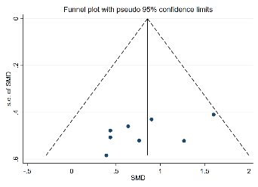
Fig.1 Funnel chart for endurance performance
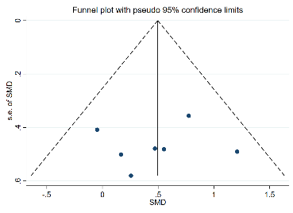
Fig.2 Funnel chart for lower limb explosive performance
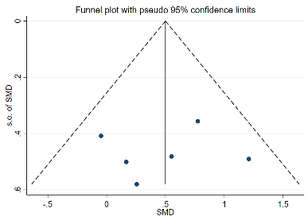
Fig.3 Funnel chart for agility performance

